URL = <http://kfhib10:8110/kfh_consumer_7000>

Credential = echannels / Qwert1!

Acct Type = 13 ; Class code = 10

Account Enquiry

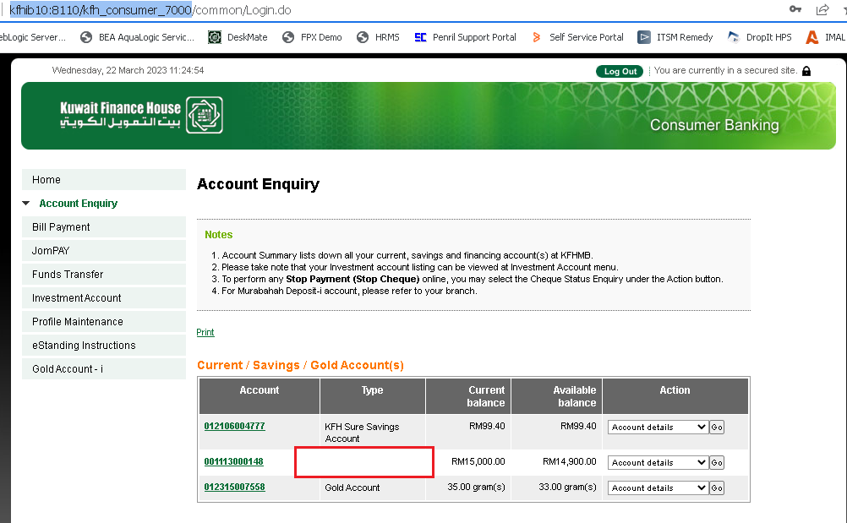

Account Details

