SCPID#6586
Test Title: |  | CDB Reports not sync with data in database
Test Description: |  | Finding:  - BSNeBiz Summary-Currently got two filter date, initiated and effective date.  - BSNeBiz Single Transaction by State-Jompay trnx data not sync with db because once approval, effective date is not updated.  Solution:  - Filter by effective date only.  - Update effective date once approval based on current date.
Test Functionality: |  | To make sure the data for BSNeBiz Summary Report and BSNeBiz Single Transaction by State Report are synchronized.
Test Procedure: |  | Test steps:  - BSNeBiz Summary  - Perform online trnx with initiated date and effective date with same month.  - Perform online trnx with initiated date this month and effective date next month.  - Generate BSNeBiz Summary report with the selected date. Data in the report should display based on effective date only.  (Trnx status - Successful, Accepted)  - BSNeBiz Single Transaction by State  Jompay data not sync with data in DB.  - Perform jompay trnx using initiator.  - Approve the trnx. Check DB make sure effective date is updated to the current dateTime.  - Generate BSNeBiz Single Transaction by State report with the selected date.  Compare data in report with data in DB. Make sure the data synchronized. (Trnx status - Successful, Accepted)
Response Message:
Test Result: | Pass: Fail: |  | Tested by: | Nor Athirah Umairah (10/03/2023-15/03/2023)
Reason for Failure:
Remarks: |  | - BSNeBiz Summary  - Perform online trnx with initiated date and effective date with same month.  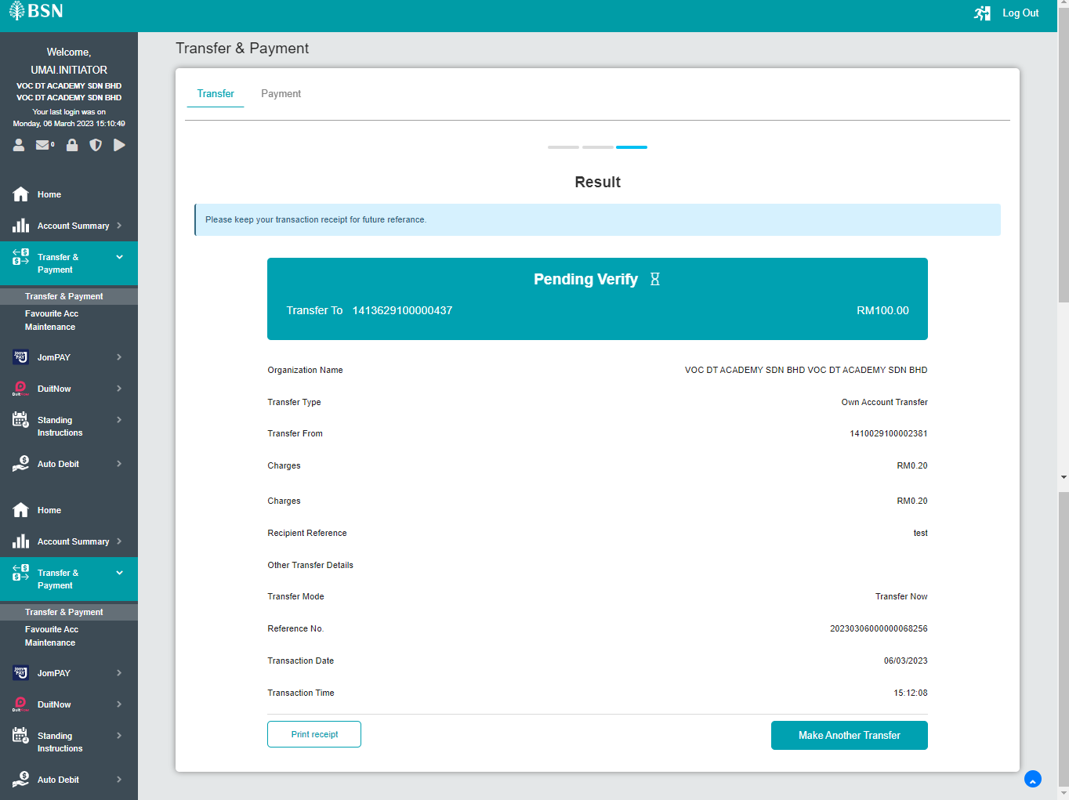  Figure 1: Own Account Transfer (Initiator)  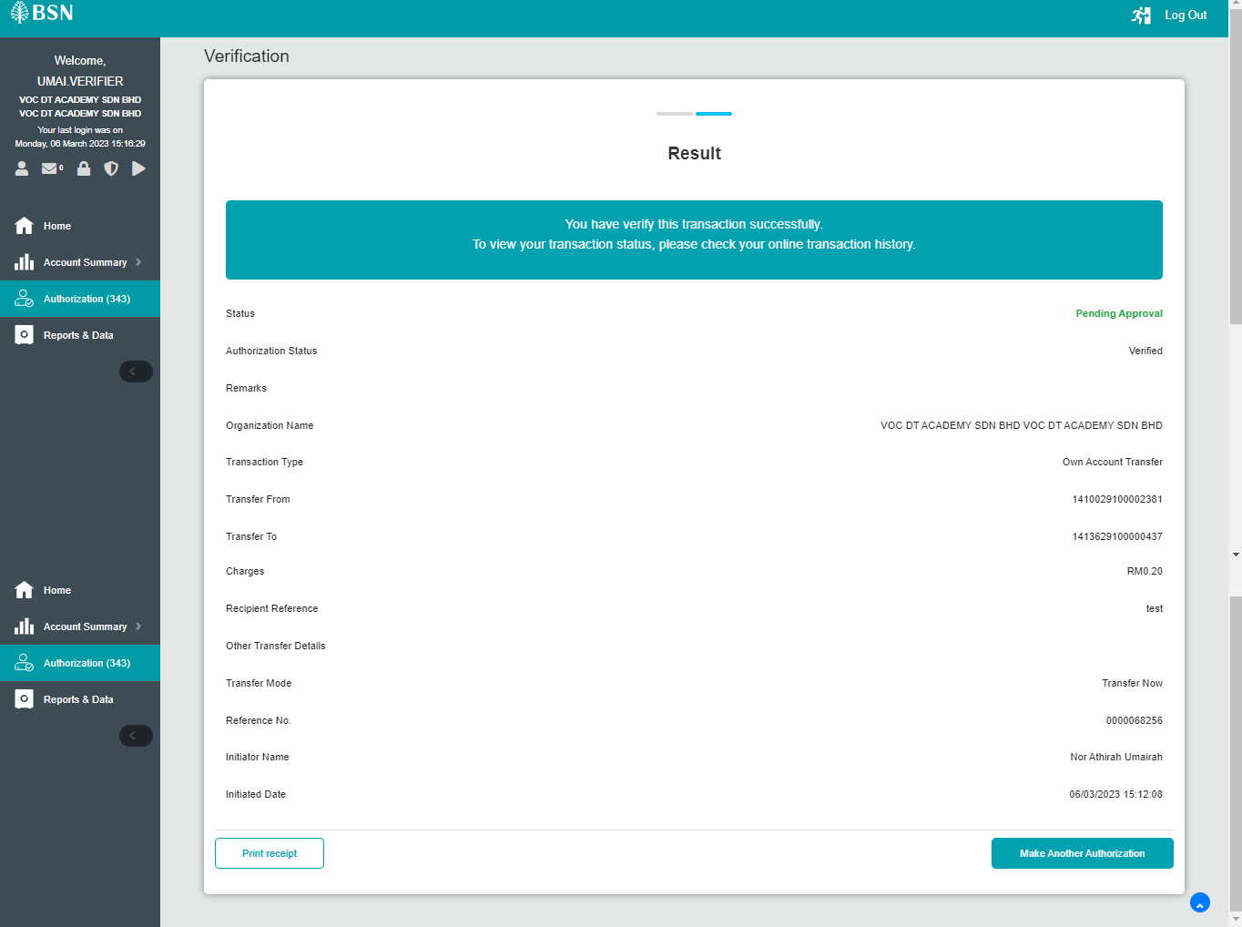  Figure 2: Own Account Transfer (Verifier)  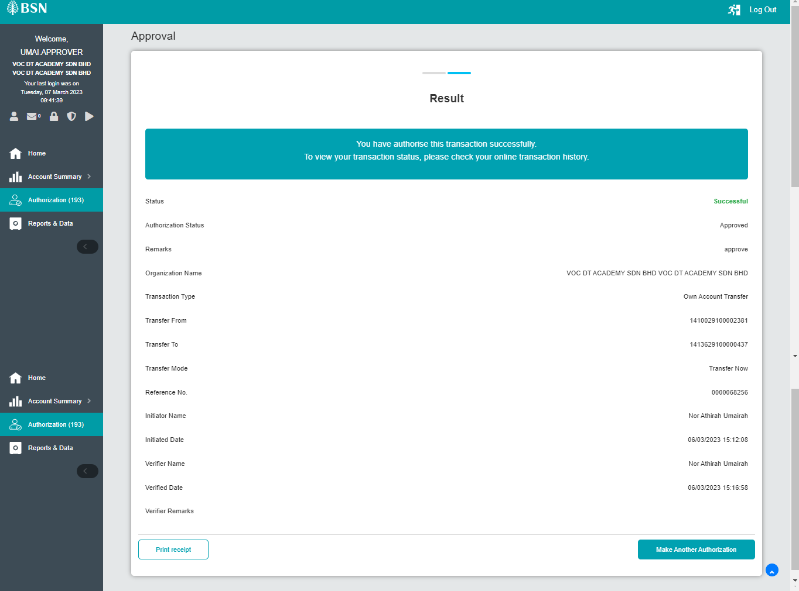  Figure 3: Own Account Transfer (Approver)  - Perform online trnx with initiated date this month and effective date next month  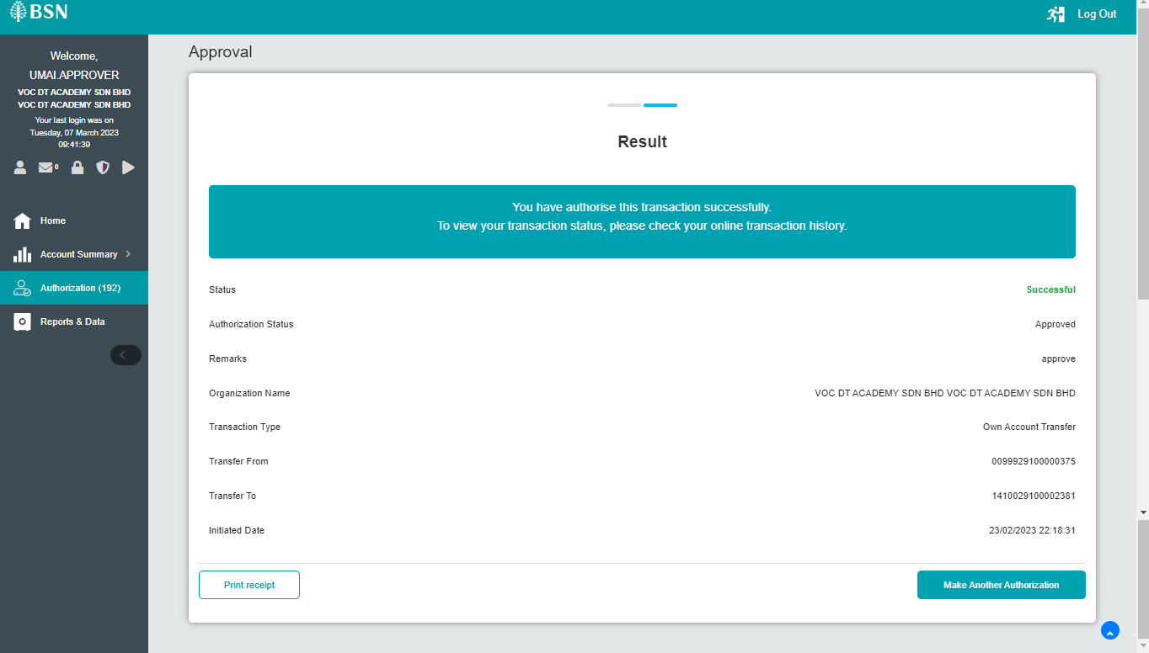  Figure 4: Own Account Transfer (Approver)  - Generate BSNeBiz Summary report with the selected date. Data in the report should display based on effective date only.  (Trnx status - Successful, Accepted)  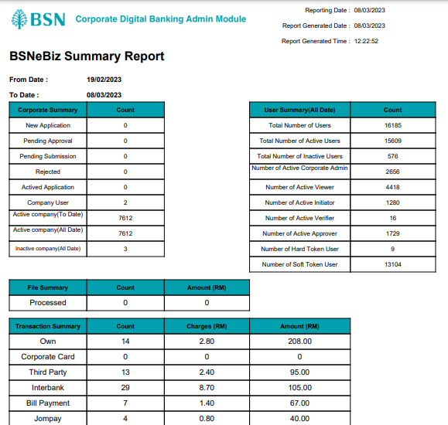  Figure 5: BSNeBiz Summary report  - BSNeBiz Single Transaction by State  Jompay data not sync with data in DB.  - Perform jompay trnx using initiator.  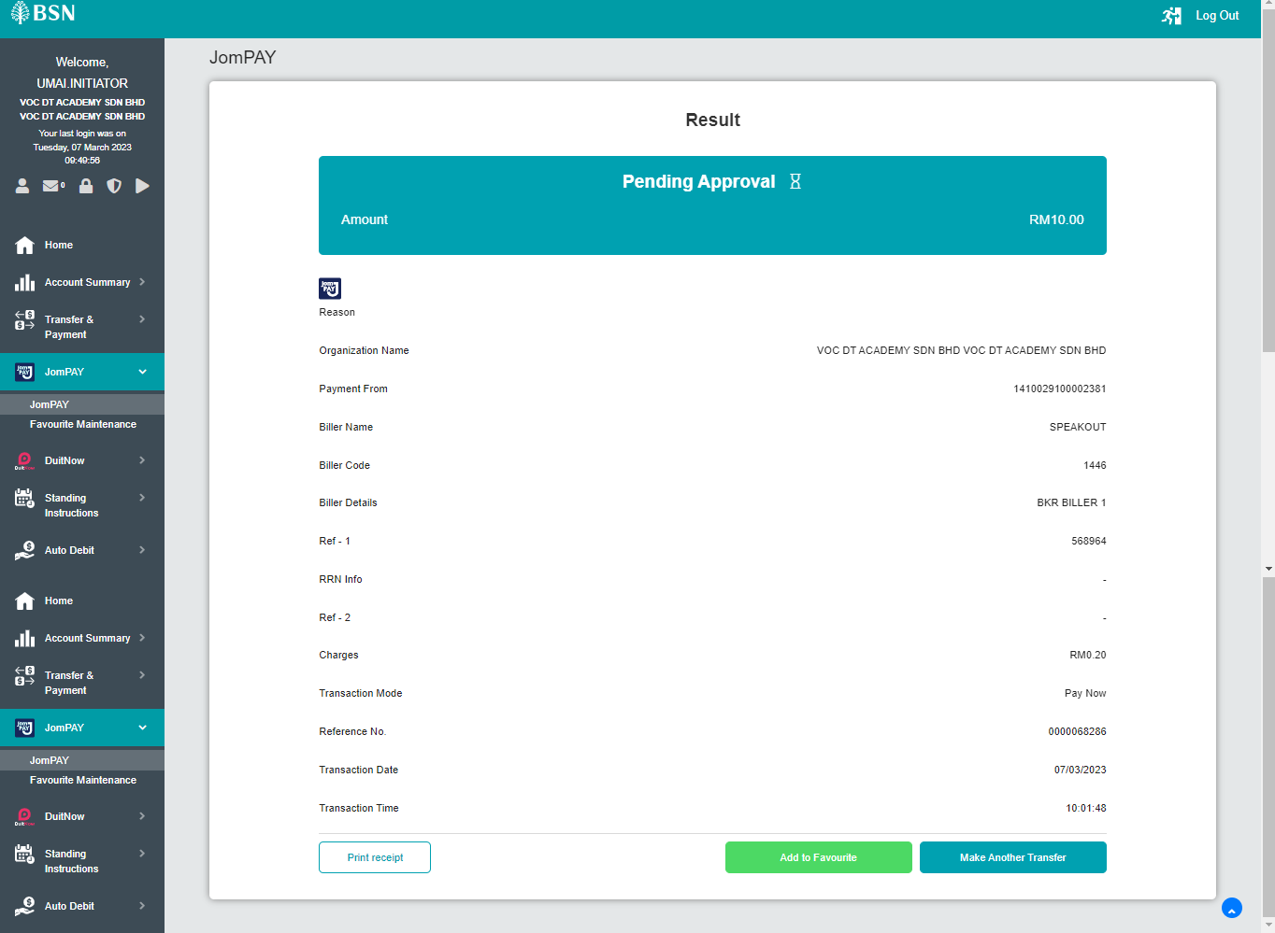  Figure 6: New JomPAY (Initiator)  - Approve the trnx. Check DB make sure effective date is updated to the current dateTime.  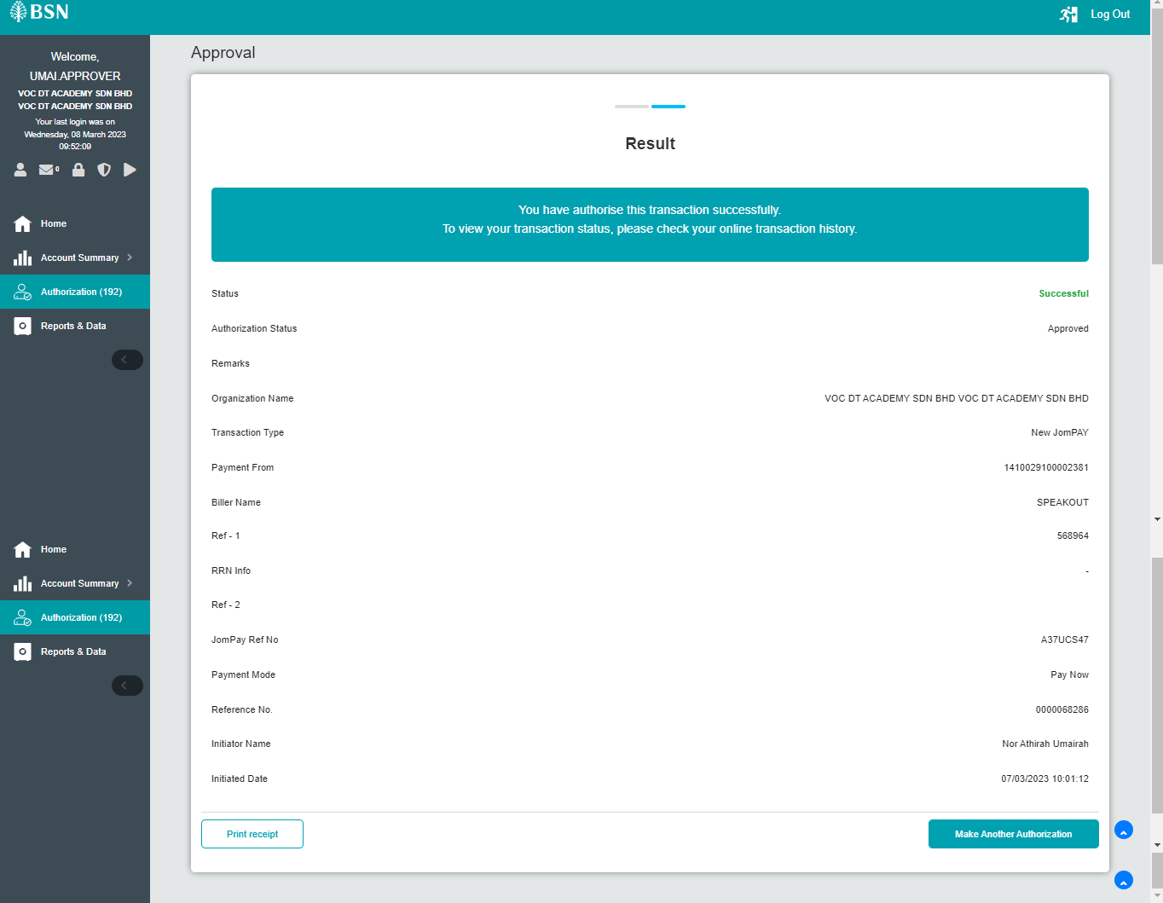  Figure 7: New JomPAY (Approver)  - Generate BSNeBiz Single Transaction by State report with the selected date. Compare data in report with data in DB. Make sure the data synchronized. (Trnx status - Successful, Accepted)  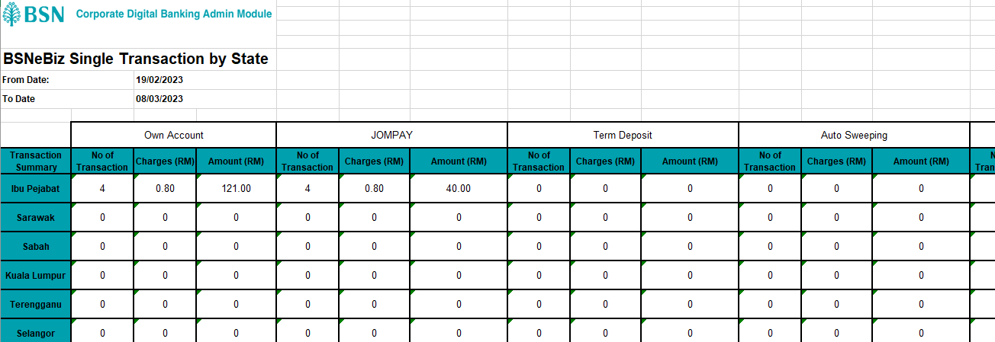  Figure 8: BSNeBiz Single Transaction by State report  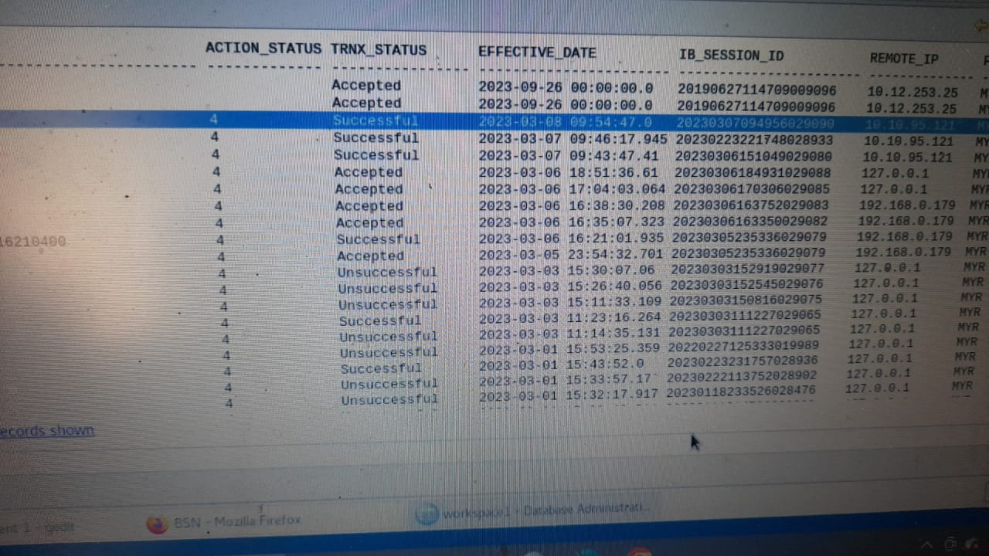  Figure 9: Database (effective date)  