CR - GST
Test Title: |  | Goods and Services Tax (GST) for IBAM and BSNeBiz
Test Description: |  | - FUNC_2.1 - View and Edit Service Info  - FUNC_2.2 - View GST in BSNeBiz Report  - FUNC_3.1 - View GST on Transfer & Payment  - FUNC_3.2 - View GST on JomPAY  - FUNC_3.3 - View GST on Bulk Payment  - FUNC_4.1 - Mobile - View GST on Transfer & Payment
Test Functionality: |  | To ensure that the new fields functioning as requirement.
Test Procedure: |  | *As provided in test script
Response Message:
Test Result: | FUNC_2.1 - Pass: Fail:  FUNC_2.2 - Pass: Fail:  FUNC_3.1 - Pass: Fail:  FUNC_3.2 - Pass: Fail:  FUNC_3.3 - Pass: Fail:  FUNC_4.1 - Pass: Fail: |  | Tested by: | Nor Athirah Umairah (21/02/2023-22/03/23)
Reason for Failure:
Remarks
FUNC_2.1 - View and Edit Service Info
Login > Home > BBE > Content >Service Info
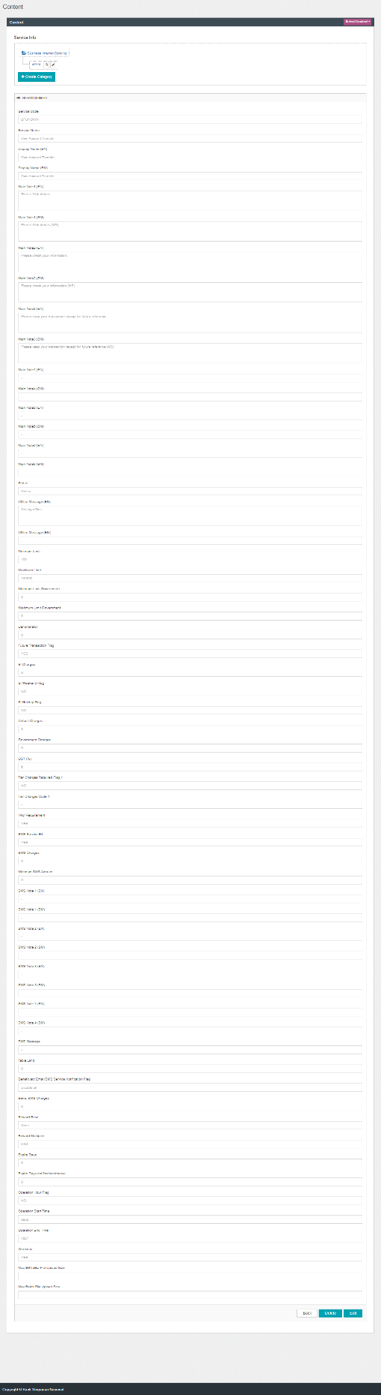
Figure 1: Service Info

FUNC_2.2 - View GST in BSNeBiz Report
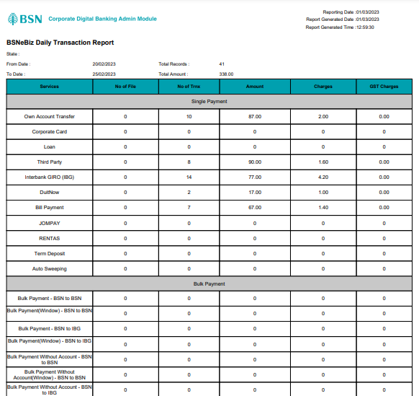
Figure 2: Daily Transaction Report (PDF)

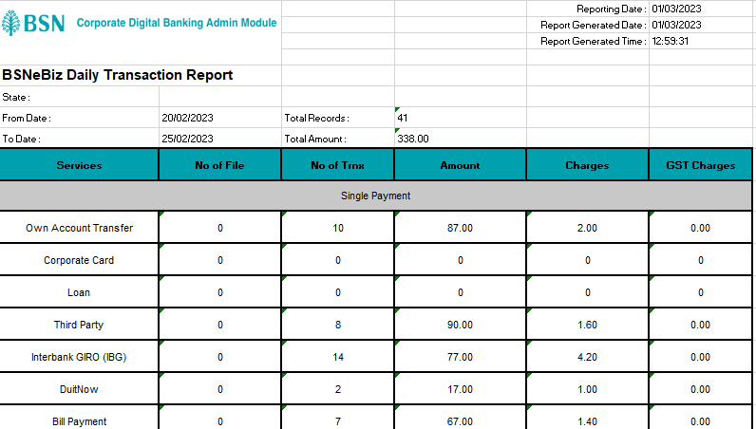
Figure 3: Daily Transaction Report (Excel)

FUNC_3.1 - View GST on Transfer & Payment

Screenshot: https://drive.google.com/drive/folders/1NkxgdPhVaJ-rFWGpU3HN-VS8zykrexK5?usp=sharing

Service Info > GST is empty (-/0)
✓ = Pass (System does not display GST field)
✖ = Failed (System display GST field)
Transaction | Confirm Screen | Result Screen | Receipt | Status
Own Account Transfer – Transfer Now | ✓ | ✓ | ✓ | Pass
Own Account Transfer – Transfer Later | ✓ | ✓ | ✓ | Pass
Own Account Transfer – Recurring Transfer | ✓ | ✓ | ✓ | Pass
3rd Party Transfer – Transfer Now | ✓ | ✓ | ✓ | Pass
3rd Party Transfer – Transfer Later | ✓ | ✓ | ✓ | Pass
3rd Party Transfer – Recurring Transfer | ✓ | ✓ | ✓ | Pass
IBG – Transfer Now | ✓ | ✓ | ✓ | Pass
IBG – Transfer Later | ✓ | ✓ | ✓ | Pass
IBG – Recurring Transfer | ✓ | ✓ | ✓ | Pass
RENTAS – Transfer Now | ✓ | ✓ | ✓ | Pass
RENTAS – Transfer Later | ✓ | ✓ | ✓ | Pass
RENTAS – Recurring Transfer | ✓ | ✓ | ✓ | Pass
Favorite Account – Transfer Now | - | - | -
Favorite Account – Transfer Later | - | - | -
Favorite Account – Recurring Transfer | - | - | -
New Bill Payment | ✓ | ✓ | ✓ | Pass
Favorite Bill Payment | ✓ | ✓ | ✓ | Pass

Service Info > GST is NOT empty.
✓ = Pass (System display GST field)
✖ = Failed (System does not display GST field) / (GST field = blank/not display RM)
Workflow trnx,transfer later and recurring are not displaying gst amount as the trnx is not directly debited and success for ICBS to return response for gst amount. Only success charges, will return the gst amount.
Gst Charges field will not be displayed when amount = 0 or 0.00
Transaction | Confirm Screen | Result Screen | Receipt | Status
Own Account Transfer – Transfer Now | ✓ | ✓ | ✓ | Pass
Own Account Transfer – Transfer Later | ✓ | ✓ | ✓ | Pass
Own Account Transfer – Recurring Transfer | ✓ | ✓ | ✓ | Pass
3rd Party Transfer – Transfer Now | ✓ | ✓ | ✓ | Pass
3rd Party Transfer – Transfer Later | ✓ | ✓ | ✓ | Pass
3rd Party Transfer – Recurring Transfer | ✓ | ✓ | ✓ | Pass
IBG – Transfer Now | ✓ | ✓ | ✓ | Pass
IBG – Transfer Later | ✓ | ✓ | ✓ | Pass
IBG – Recurring Transfer | ✓ | ✓ | ✓ | Pass
RENTAS – Transfer Now | ✓ | ✓ | ✓ | Pass
RENTAS – Transfer Later | ✓ | ✓ | ✓ | Pass
RENTAS – Recurring Transfer | ✓ | ✓ | ✓ | Pass
Favorite Account – Transfer Now | - | - | -
Favorite Account – Transfer Later | - | - | -
Favorite Account – Recurring Transfer | - | - | -
New Bill Payment | ✓ | ✓ | ✓ | Pass
Favorite Bill Payment | ✓ | ✓ | ✓ | Pass

FUNC_3.2 - View GST on JomPAY

Screenshot: https://drive.google.com/drive/folders/1yw90Dhyz6yWZPgGyLFvLpCAPVEcB0x8U?usp=sharing

Service Info > GST is empty (-/0)
✓ = Pass (System does not display GST field)
✖ = Failed (System display GST field)
Transaction | Confirm Screen | Result Screen | Receipt | Status
New JomPAY – Transfer Now | ✓ | ✓ | ✓ | Pass
New JomPAY – Transfer Later | ✓ | ✓ | ✓ | Pass
Favorite JomPAY – Transfer Now | ✓ | ✓ | ✓ | Pass
Favorite JomPAY – Transfer Later | ✓ | ✓ | ✓ | Pass

Service Info > GST is NOT empty.
✓ = Pass (System display GST field)
✖ = Failed (System does not display GST field) / (GST field = blank/not display RM)
Workflow trnx,transfer later and recurring are not displaying gst amount as the trnx is not directly debited and success for ICBS to return response for gst amount. Only success charges, will return the gst amount.
Gst Charges field will not be displayed when amount = 0 or 0.00
Transaction | Confirm Screen | Result Screen | Receipt | Status
New JomPAY – Transfer Now | ✓ | ✓ | ✓ | Pass
New JomPAY – Transfer Later | ✓ | ✓ | ✓ | Pass
Favorite JomPAY – Transfer Now | ✓ | ✓ | ✓ | Pass
Favorite JomPAY – Transfer Later | ✓ | ✓ | ✓ | Pass

FUNC_3.3 - View GST on Bulk Payment

Screenshot: https://drive.google.com/drive/folders/1H_eJub8-9TmkptwLxWE3nh2S7YFJNHtq?usp=sharing

Service Info > GST is empty (-/0)
✓ = Pass (System does not display GST field)
✖ = Failed (System display GST field)
Transaction | Confirm Screen | Result Screen | Receipt | Status
File Upload – IBG | ✓ | ✓ | ✓ | Pass
Data Entry – IBG | ✓ | ✓ | ✓ | Pass
Edit Data – IBG | ✓ | ✓ | ✓ | Pass

Service Info > GST is NOT empty.
✓ = Pass (System display GST field)
✖ = Failed (System does not display GST field) / (GST field = blank/not display RM)
Transaction | Confirm Screen | Result Screen | Receipt | Status
File Upload – IBG | ✓ | ✓ | ✓ | Pass
Data Entry – IBG | ✓ | ✓ | ✓ | Pass
Edit Data – IBG | ✓ | ✓ | ✓ | Pass

FUNC_4.1 - Mobile - View GST on Transfer & Payment
ANDROID
Service Info > GST is NOT empty
✓ = Pass (System display GST field)
✖ = Failed (System does not display GST field) / (GST field = not in correct format)
Transaction | Confirm Screen | Result Screen | Receipt | Status
Own Account – Transfer Now | ✓ | ✓ | ✓ | Pass
Own Account – Transfer Later | ✓ | ✓ | ✓ | Pass
3rd Party Transfer – Transfer Now | ✓ | ✓ | ✓ | Pass
3rd Party Transfer – Transfer Later | ✓ | ✓ | ✓ | Pass
IBG – Transfer Now | ✓ | ✓ | ✓ | Pass
IBG – Transfer Later | ✓ | ✓ | ✓ | Pass
RENTAS – Transfer Now | ✓ | ✓ | ✓ | Pass
RENTAS – Transfer Later | ✓ | ✓ | ✓ | Pass
JomPAY – Transfer Now | ✓ | ✓ | ✓ | Pass
JomPAY – Transfer Later | ✓ | ✓ | ✓ | Pass
New Bill Payment – Transfer Now | ✓ | ✓ | ✓ | Pass
New Bill Payment – Transfer Later | ✓ | ✓ | ✓ | Pass

