Participant User Group (Change Own Password ticked)

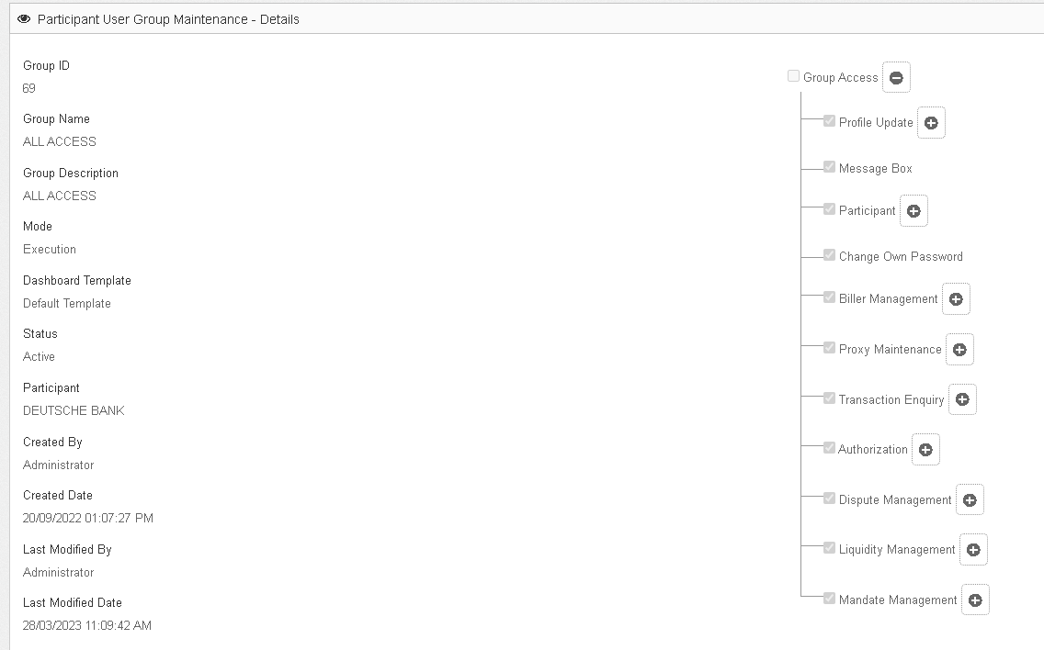

Participant User Detail (Still have access to Change Own Password)

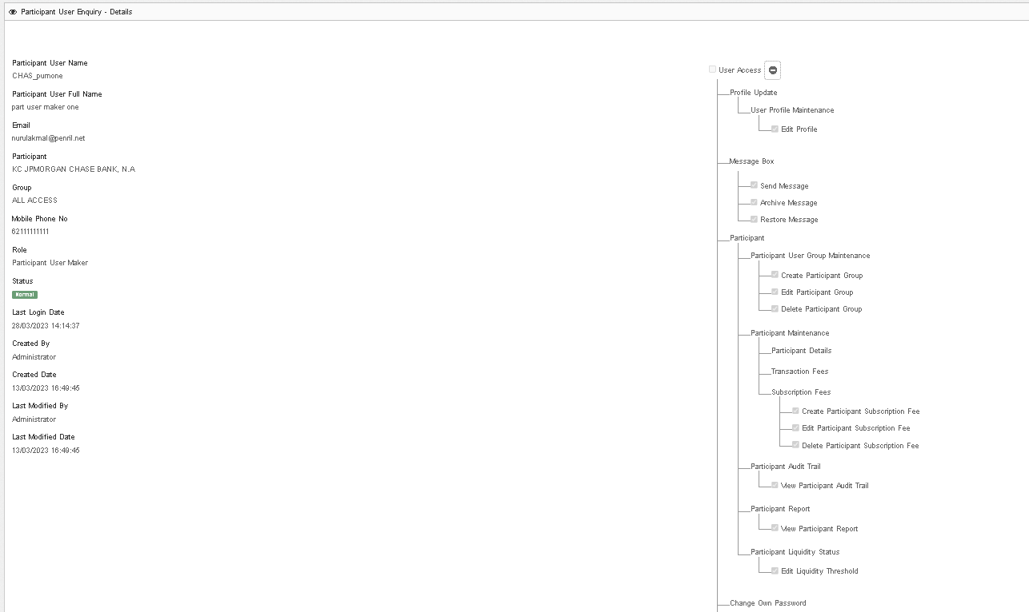

Still showing the Change Own Password menu

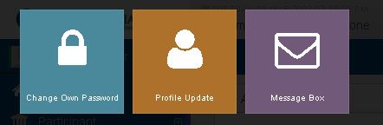

Participant User Group (Change Own Password untick)

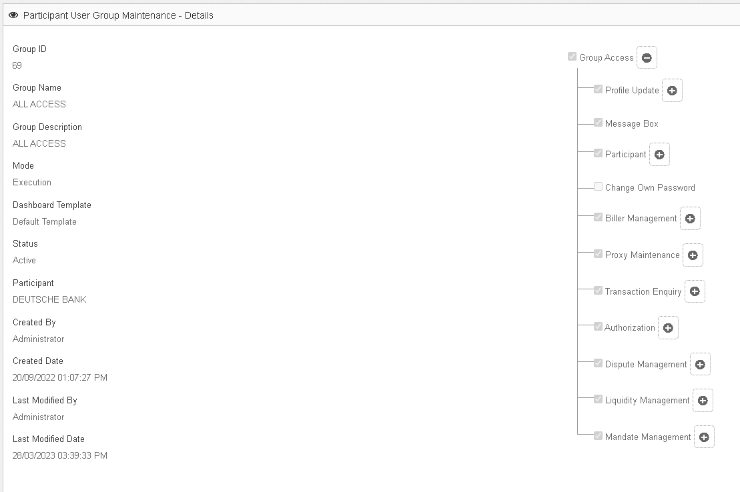

the Change Own Password menu will not show

