SCPID# 6249
Test Title: |  | Mobile Pentest Remediation - Pentest - L9 - DuitNow Recipient Name Enumeration
Test Description: |  | DuitNow fund transfers will look up the DuitNow ID and display the recipient's full name to allow the sender to verify and confirm the intended recipient of the transaction. At the time of assessment, the application does not limit the number of DuitNow ID look ups which allow malicious users to enumerate and identify recipient names without performing an actual fund transfer.
Test Functionality: |  | DuitNow host enquiry limit to 3 times.
Test Procedure: |  | Test step:  - Access BSNeBiz DuitNow module.  - Set Public Bank with account number 5000040430. Can use other valid accounts.  - Set Beneficiary Name. Refer img01.png  - Click Next. Confirm page shows Account Holder Name and Beneficiary Name from DuitNow host. Refer img02.png. This is 1st host request.  - Click Back. Details page shows Beneficiary Name from DuitNow host. Edit it for testing. Refer img03.png.  - Click Next. Confirm page shows Account Holder Name and Beneficiary Name from DuitNow host. Refer img02.png. This is 2nd host request.  - Click Back. Details page shows Beneficiary Name from DuitNow host. Edit it for testing. Refer img03.png.  - Click Next. Confirm page shows Account Holder Name and Beneficiary Name from DuitNow host. Refer img02.png. This is 3rd host request.  - Click Back. Details page shows Beneficiary Name from DuitNow host. Edit it for testing. Refer img03.png.  - Click Next. Confirm page shows Account Holder Name and Beneficiary Name from Details page. Refer img04.png. This is 4th host request.  - Click Confirm on the Confirm page to go to Result page.  - Click make another transfer and make another DuitNow transfer.  - The host limit should reset and the next confirm page should be like step 4.
Response Message:

Test Result: | Pass: Fail: |  | Tested by: | Nor Athirah Umairah (29/3/2023)
Reason for Failure:
Remarks: |  | 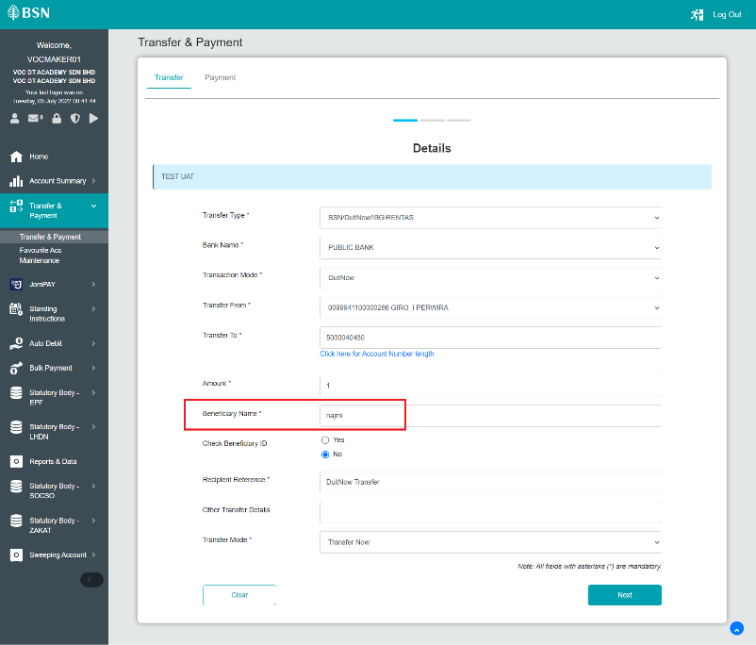  img01.png  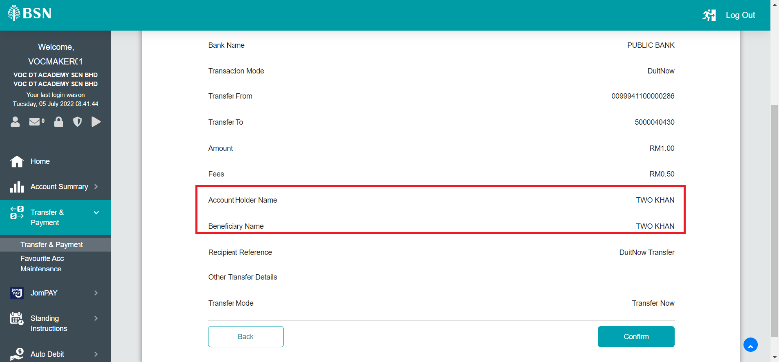  img02.png  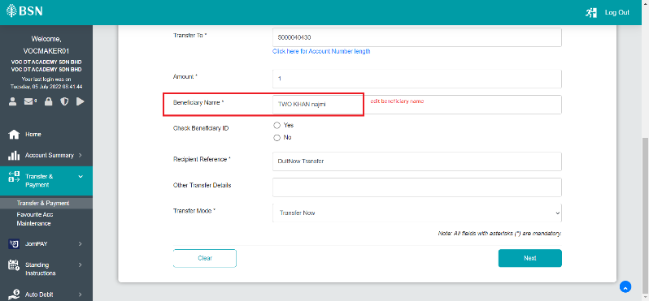  img03.png  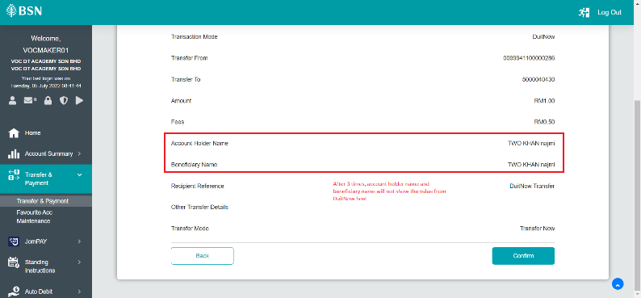  img04.png  Username: umai.initiator  Step 3 & 4:  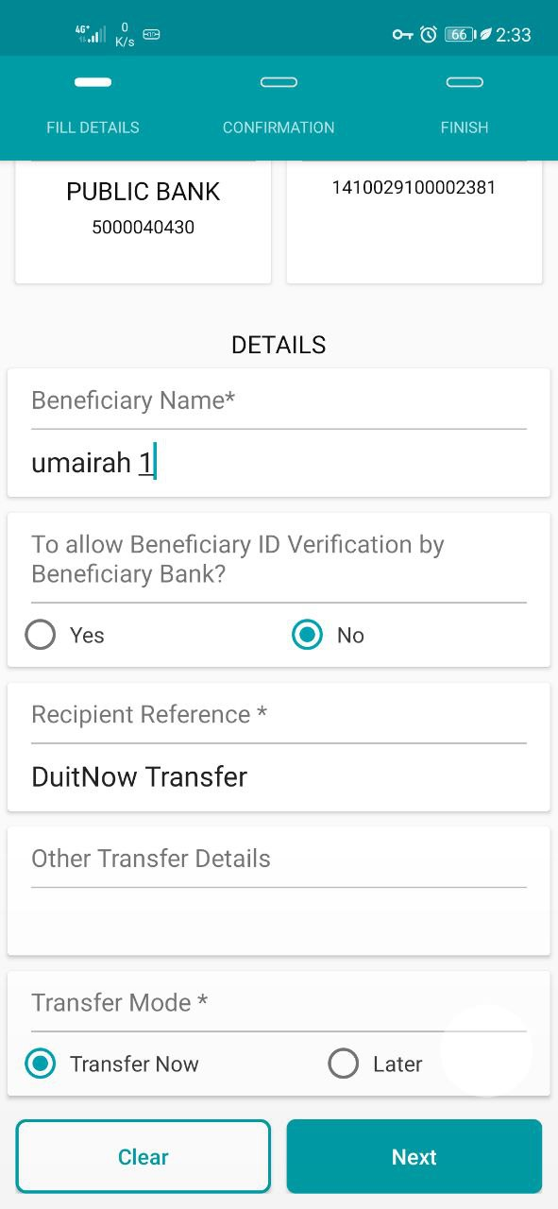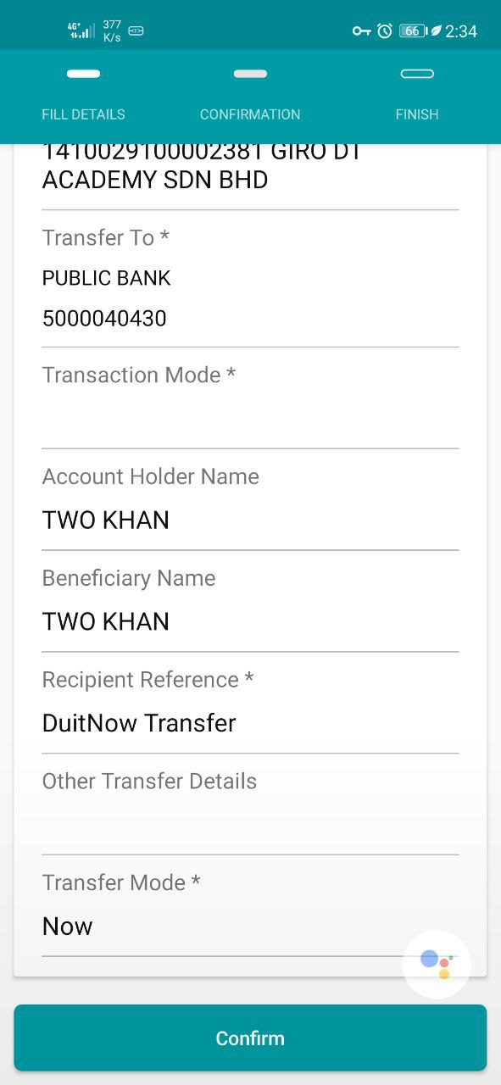  Step 5 & 6:  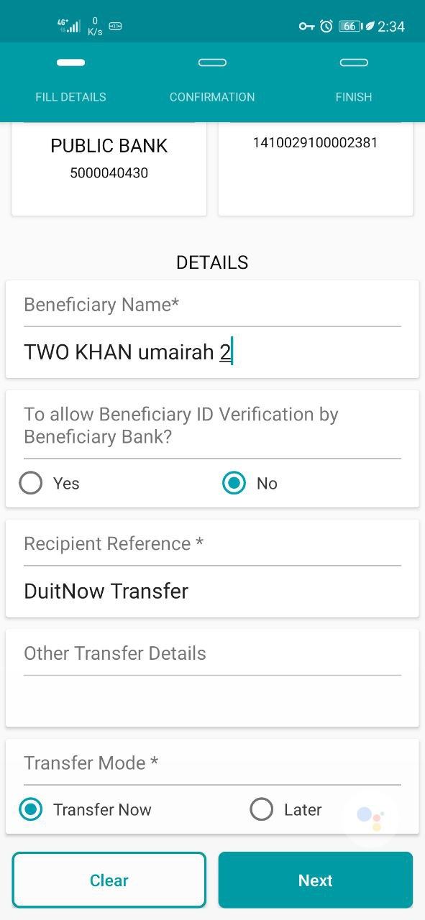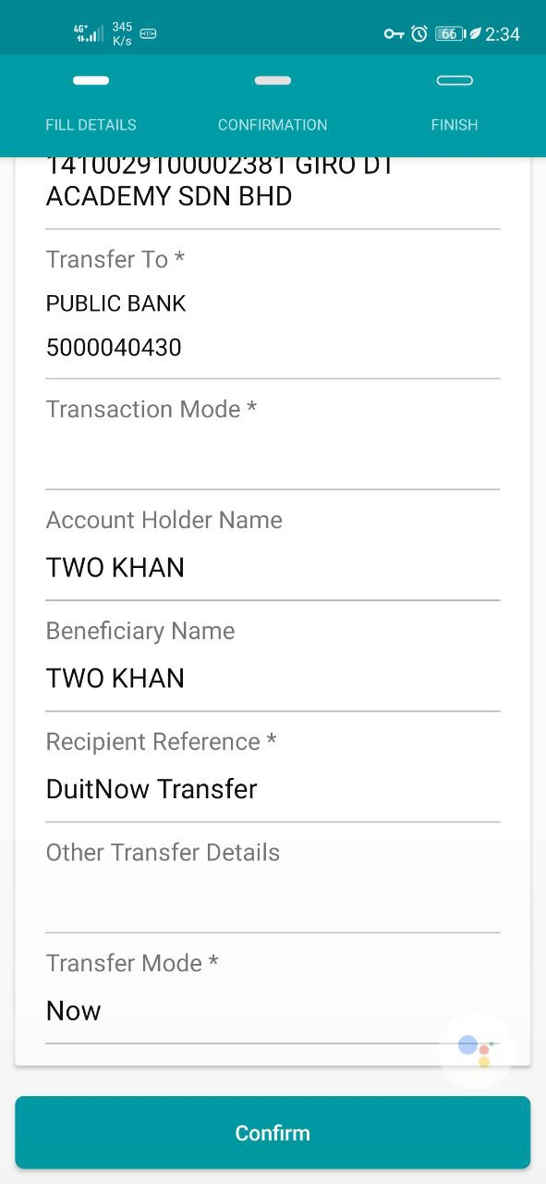  Step 7 & 8:  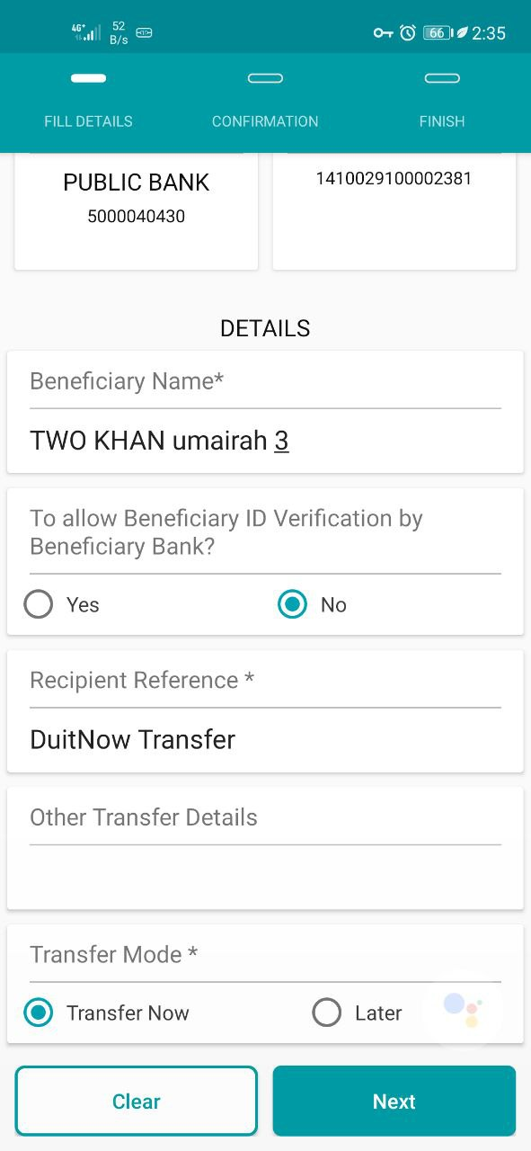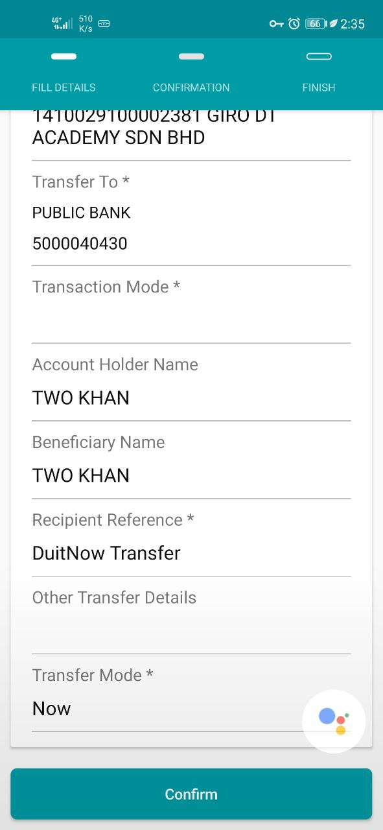  Step 9 & 10:  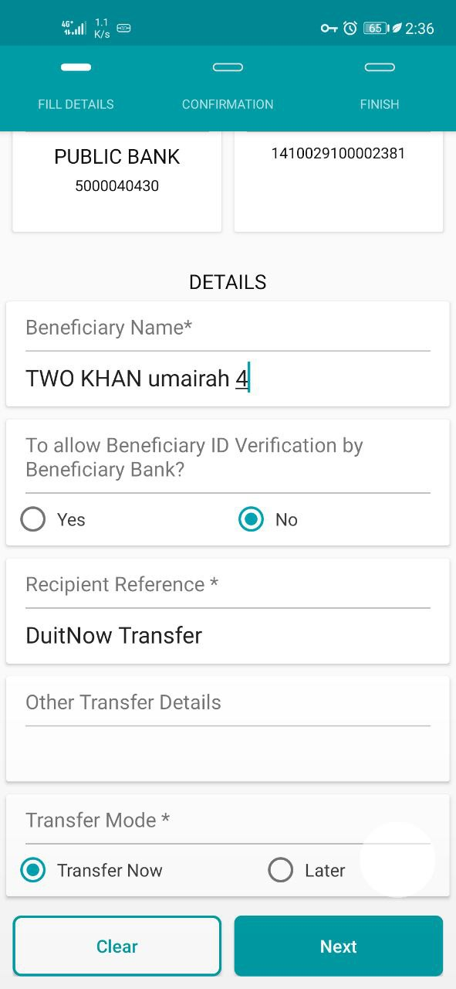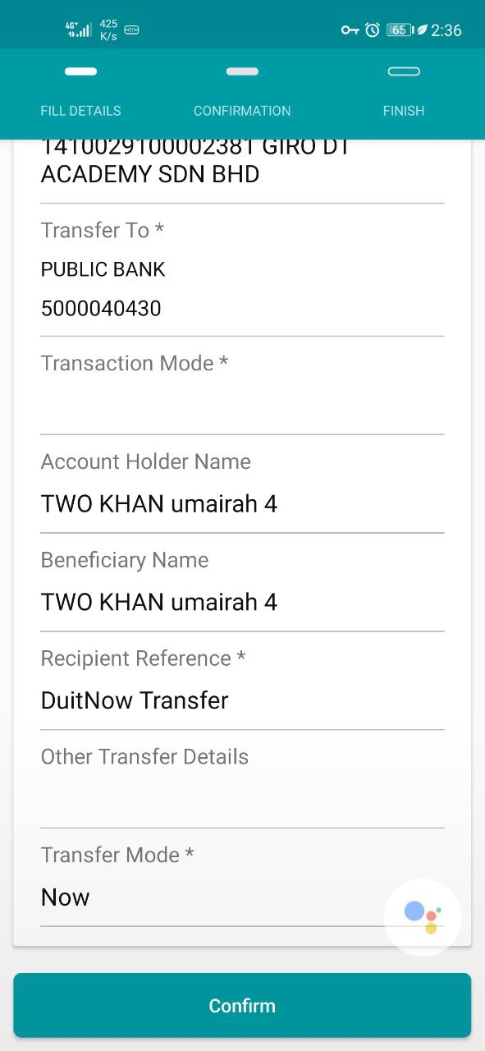  Step 11:  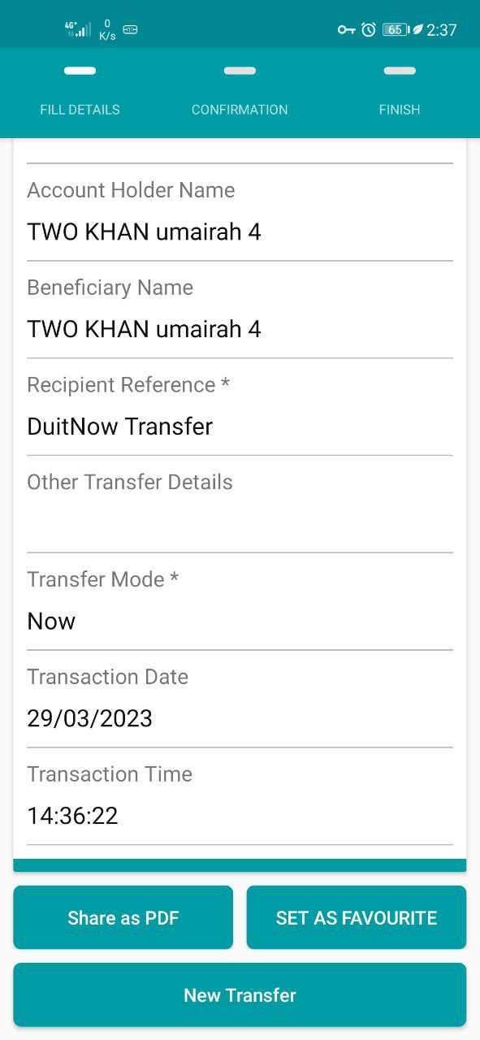  Step 12 & 13:  