SCPID#6624
Test Title: |  | Obsolete Browser
Test Description: |  | Request to parameterize browser version in Config file (CDB & IBAM) for below browsers:  1. Google Chrome  2. Internet Explorer-provided  3. Mozilla Firefox  4. Microsoft Edge  5. Opera  6. Safari
Test Functionality: |  | To test the ability to access IBAM and BSNeBiz using different web browsers.
Test Procedure: |  | Test steps:  - Access IBAM and BSNeBiz using Microsoft Internet Explorer  - Expected result, get message 'This website is best viewed with Microsoft Edge, Google Chrome, Mozilla Firefox ® browser software.  - Access IBAM and BSNeBiz using other than Microsoft Internet Explorer. Like Google Chrome, Mozilla Firefox, Safari or Opera  - Only browser version greater and equal to version set in app config can access and login IBAM and BSNeBiz
Response Message:
Test Result: | Pass: Fail: |  | Tested by: | Nor Athirah Umairah (31/03/2022)
Reason for Failure:
Remarks: |  | - Access IBAM and BSNeBiz using Microsoft Internet Explorer.  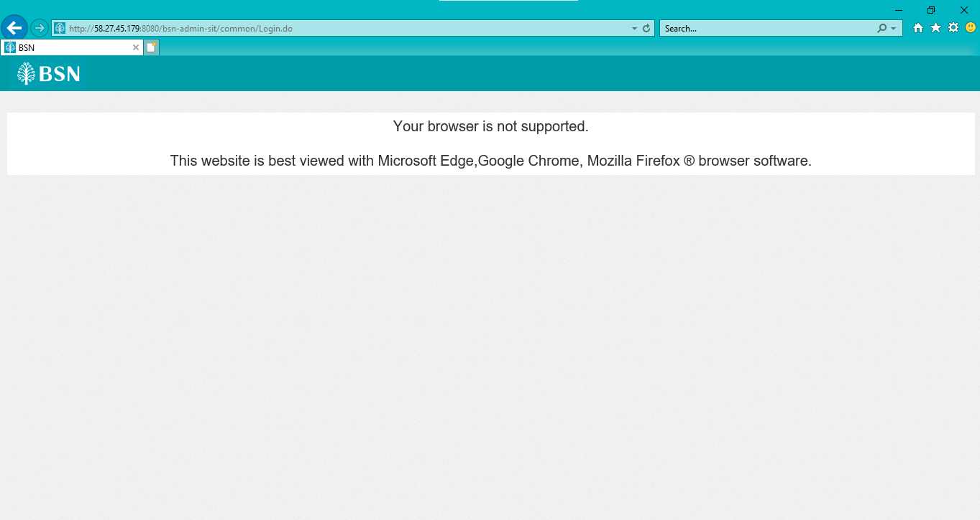  Figure 1: IBAM  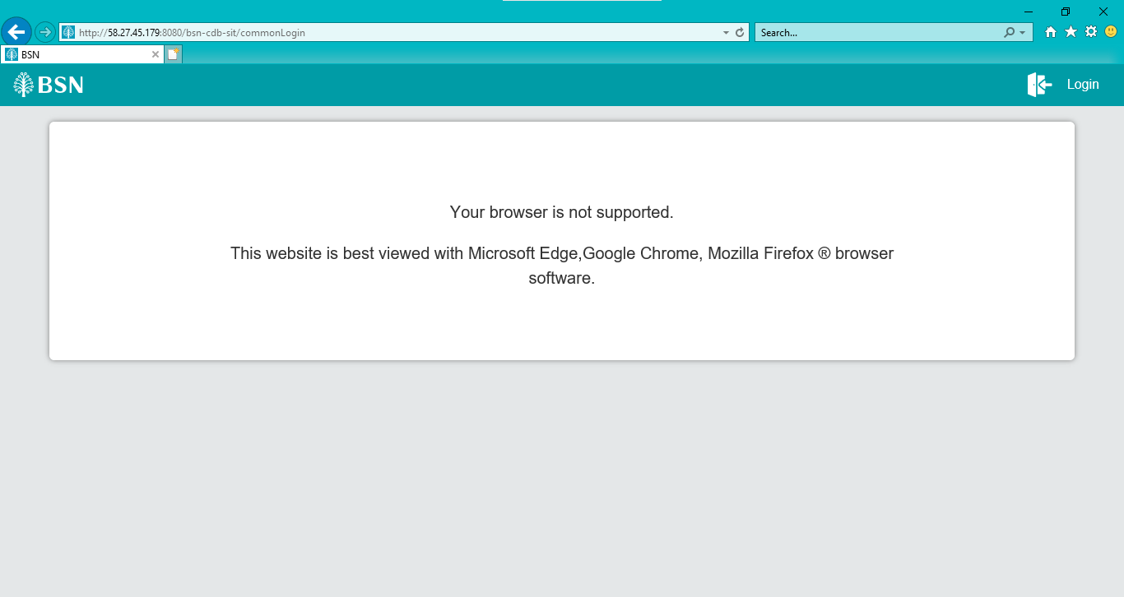  Figure 2: BSNeBiz  - Access IBAM and BSNeBiz using Microsoft Edge  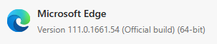  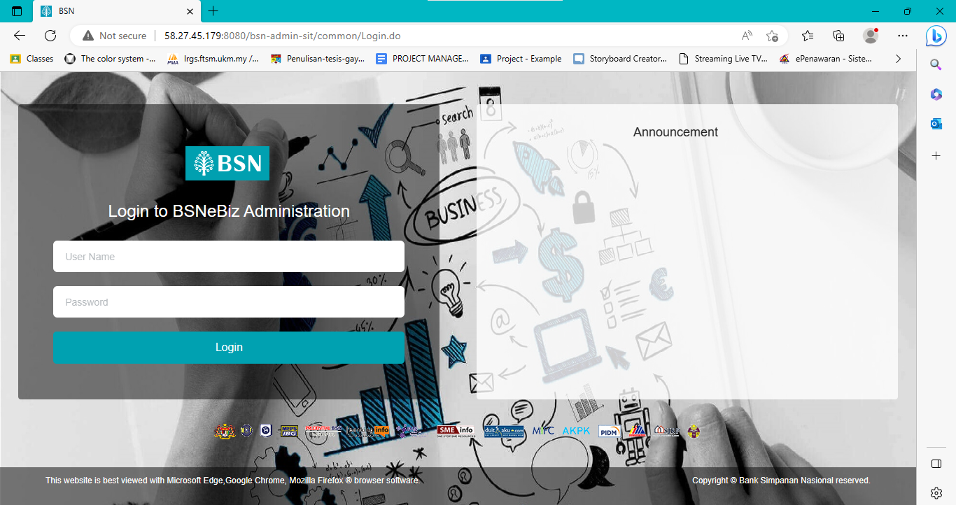  Figure 3: IBAM  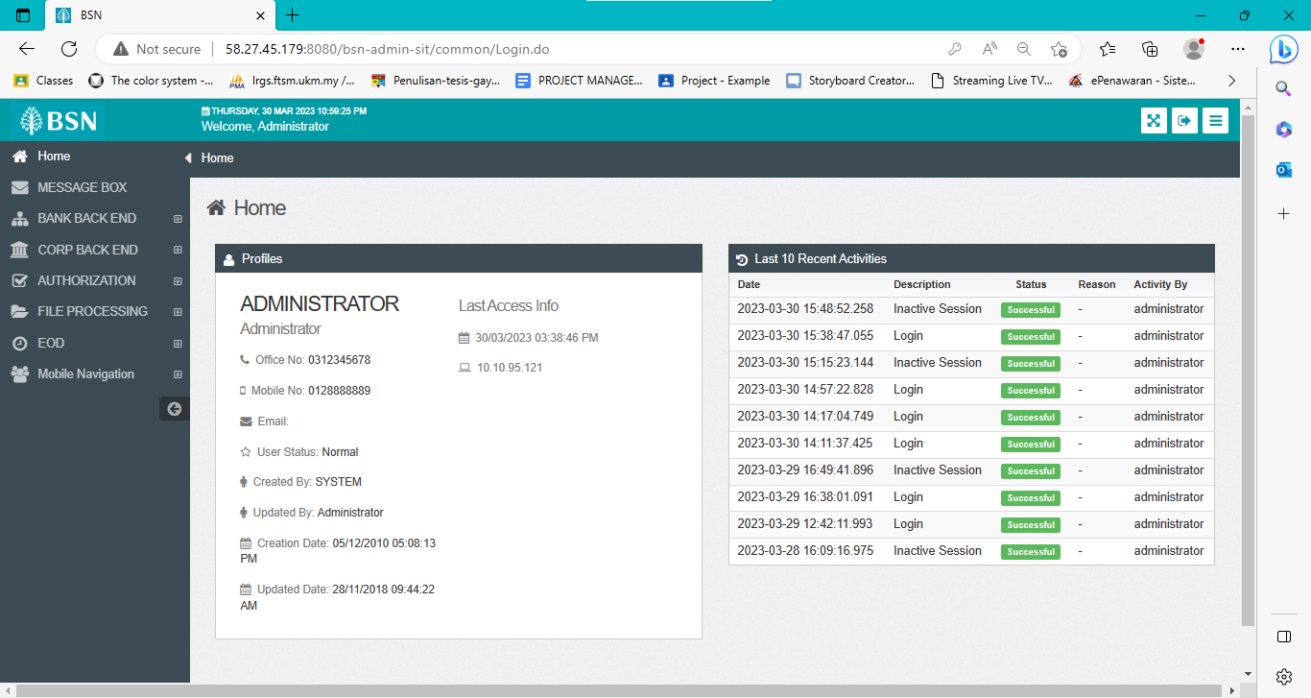  Figure 4: IBAM (Homepage)  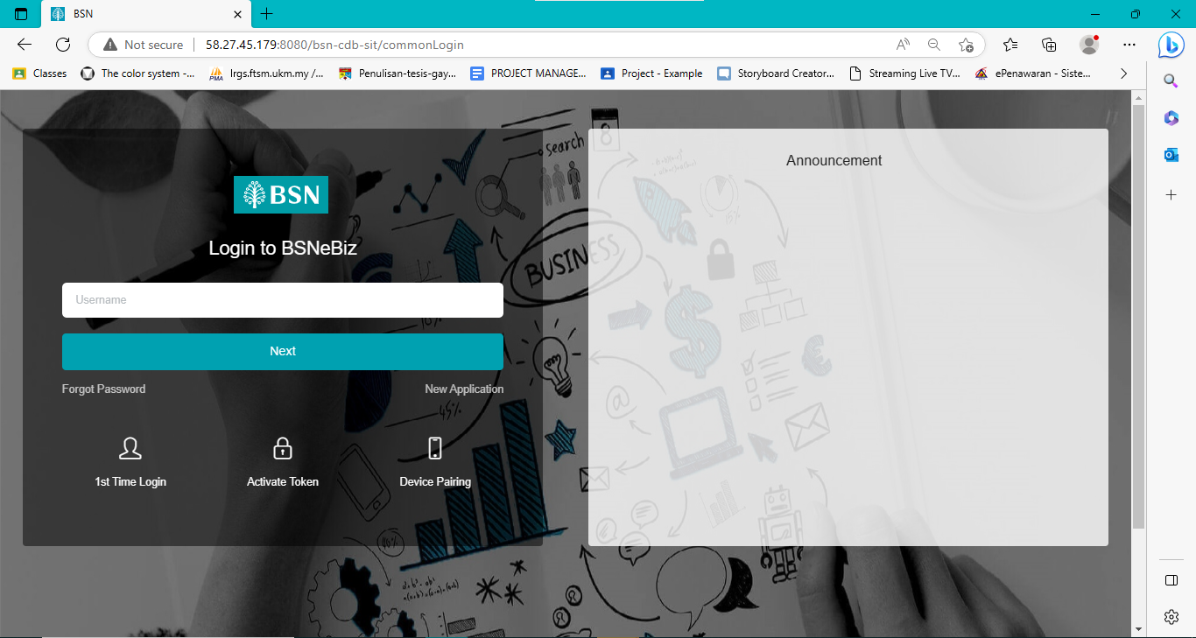  Figure 5: BSNeBiz (Login)  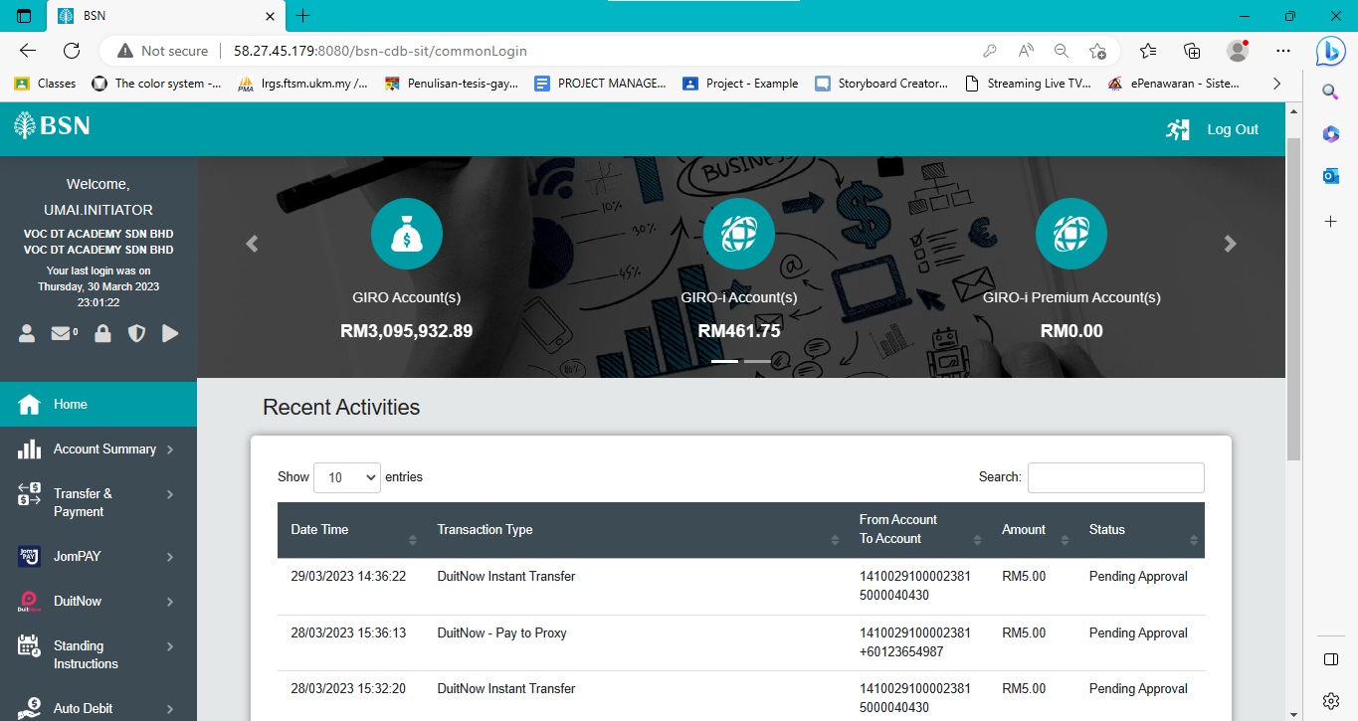  Figure 6: BSNeBiz (Homepage)  - Access IBAM and BSNeBiz using Chrome 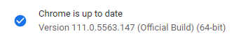  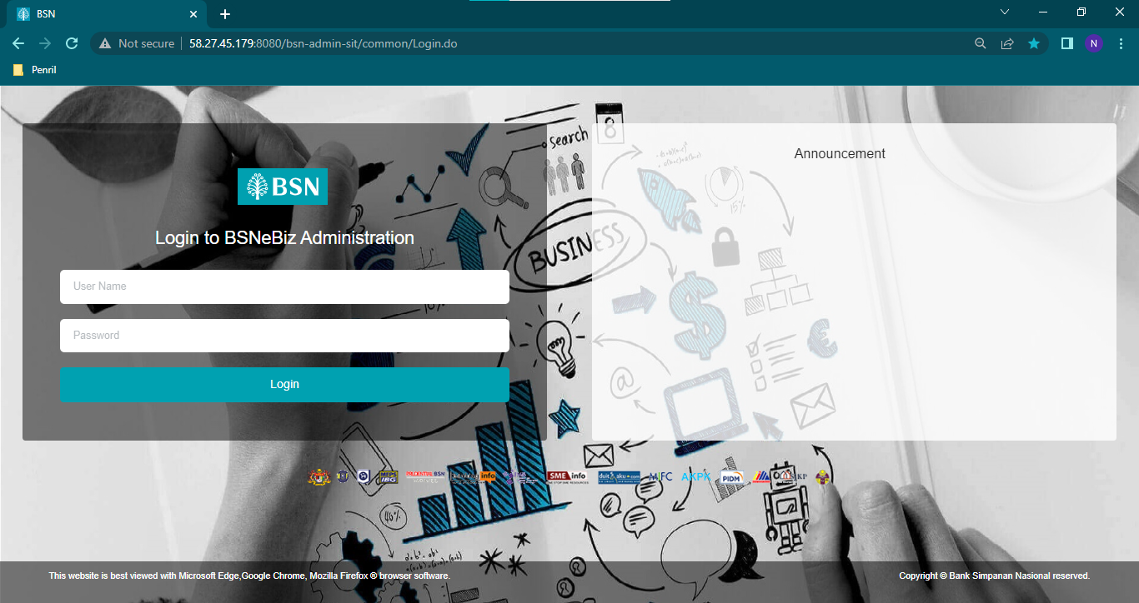  Figure 7: IBAM  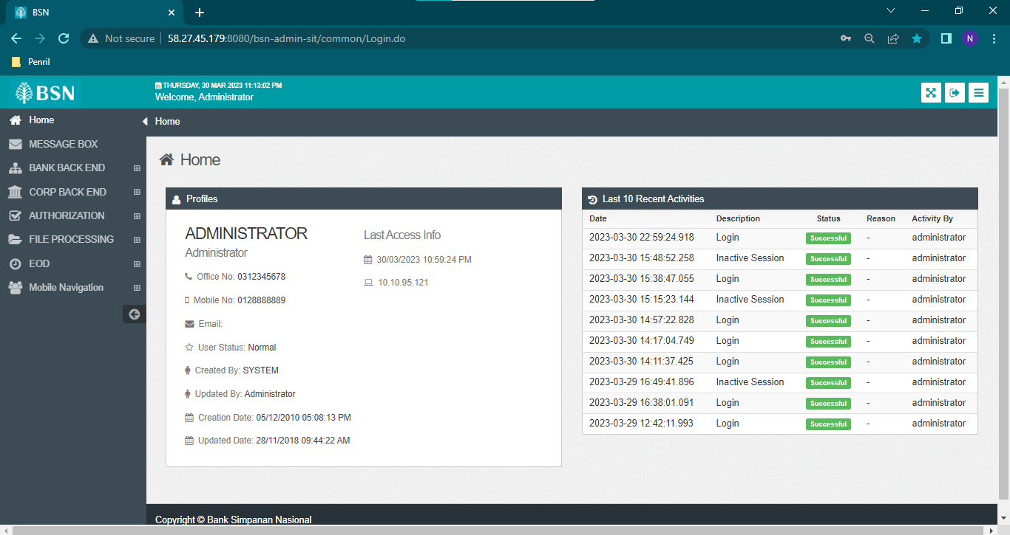  Figure 8: IBAM (Homepage)  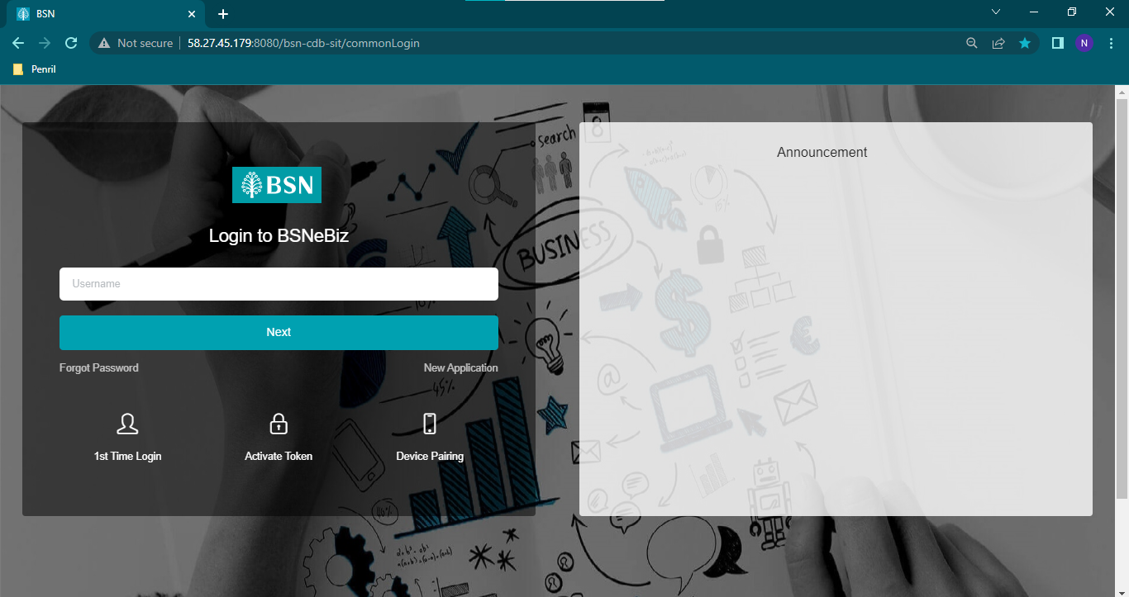  Figure 9: BSNeBiz (Login)  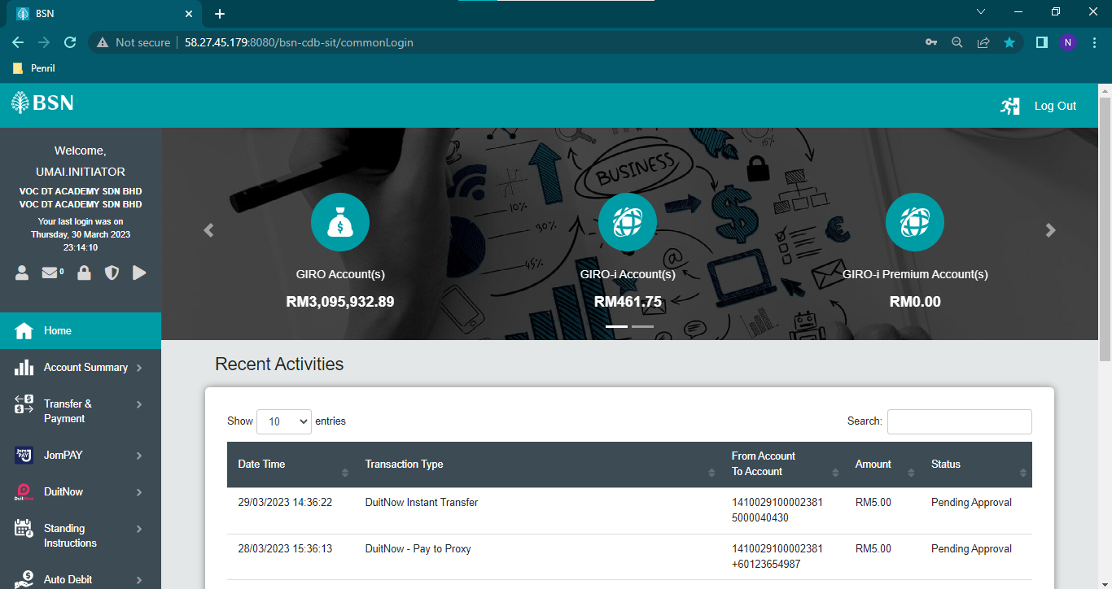  Figure 10: BSNeBiz (Homepage)  Min version:  chrome.version=52  edg.version=25  firefox.version=40  safari.version=8  opera.version=15  - Access IBAM and BSNeBiz using Chrome (Old Version)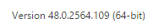  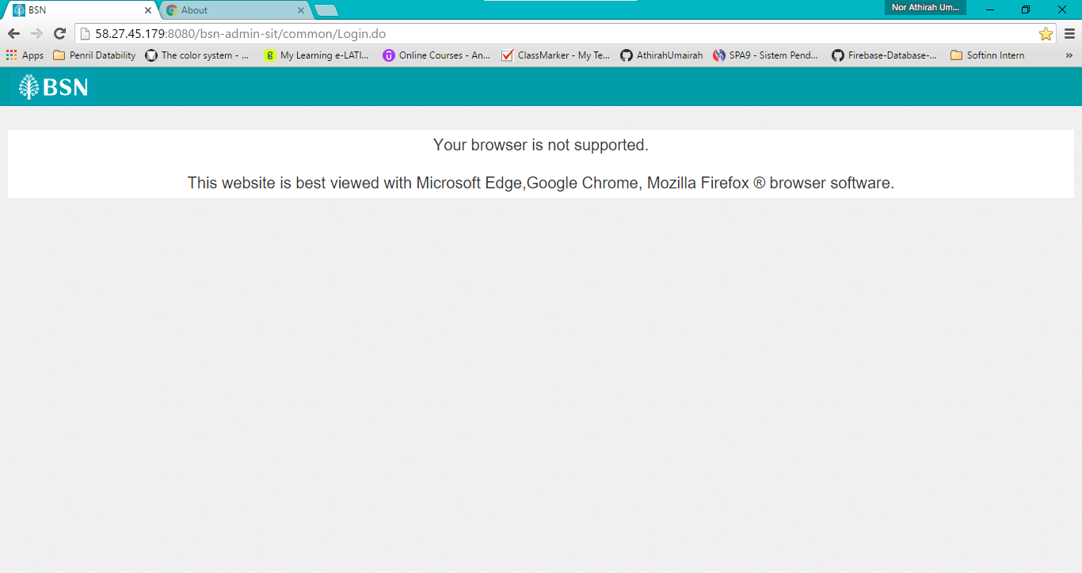  Figure 11: IBAM  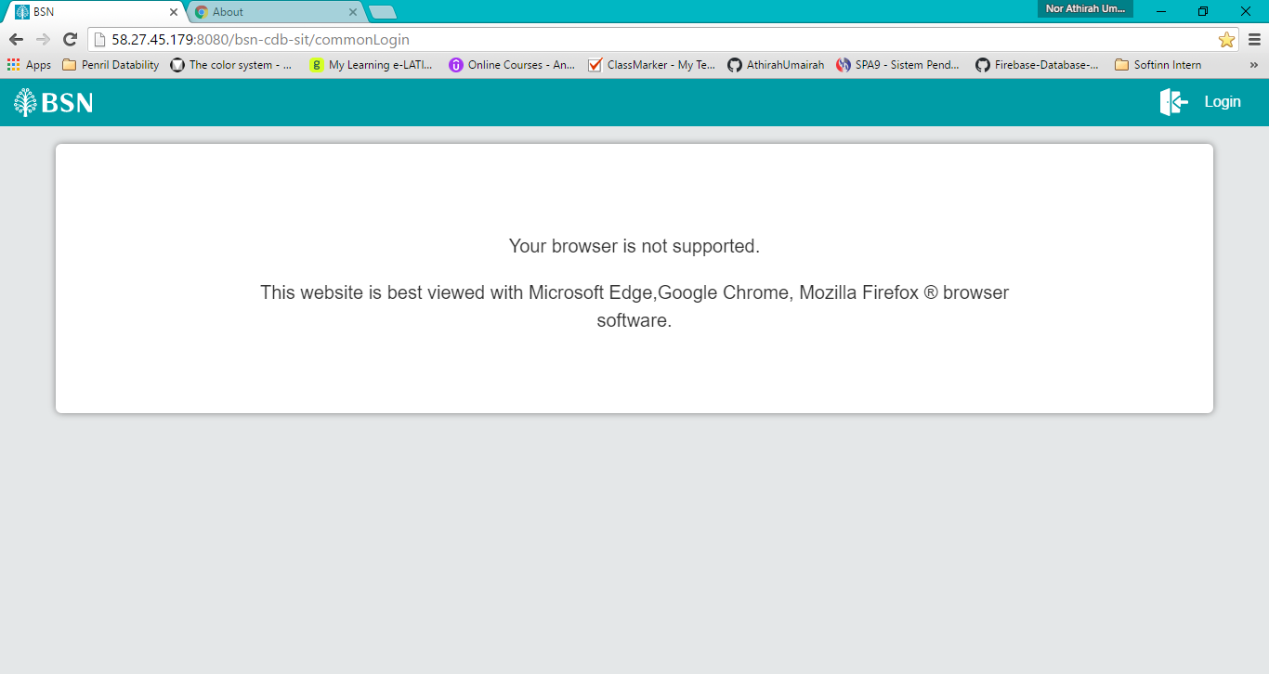  Figure 12: BSNeBiz

