SCPID#6632
Test Title: |  | IBAM Message Box
Test Description: |  | Issue: Current maximum characters/digits for Message Box content is 2000 char  Solution: New maximum characters/digits is set to 5000
Test Functionality: |  | To test on sending a new message maximum to 5000 characters/digits at IBAM Message Box module
Test Procedure: |  | Test steps:  - Access to IBAM Message Box and Send New Notification  - Input message maximum 5000 character/digits  - Expected result, if less than 5000 char, success to send new message else error message popup.
Response Message:
Test Result: | Pass: Fail: |  | Tested by: | Nor Athirah Umairah (06/04/2023)
Reason for Failure:
Remarks: |  | - Input message greater than 5000 character/digits.  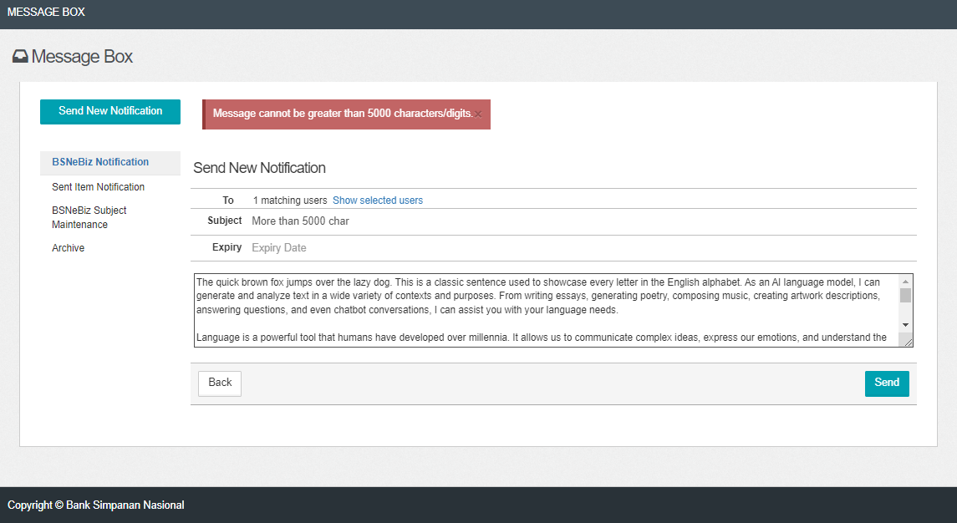  Figure 1: IBAM Message Box  - Input message less than 5000 character/digits.  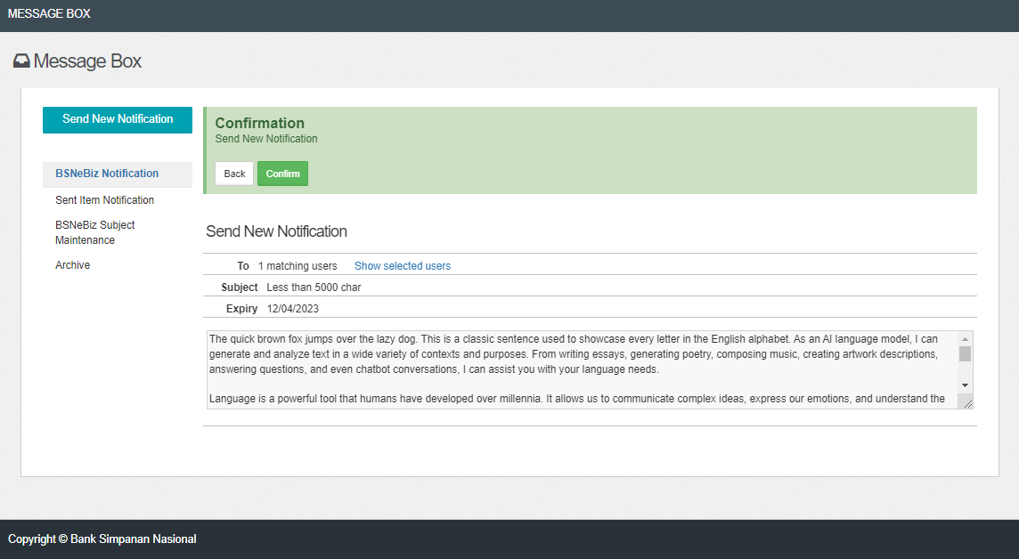  Figure 2: IBAM Message Box (Confirm)  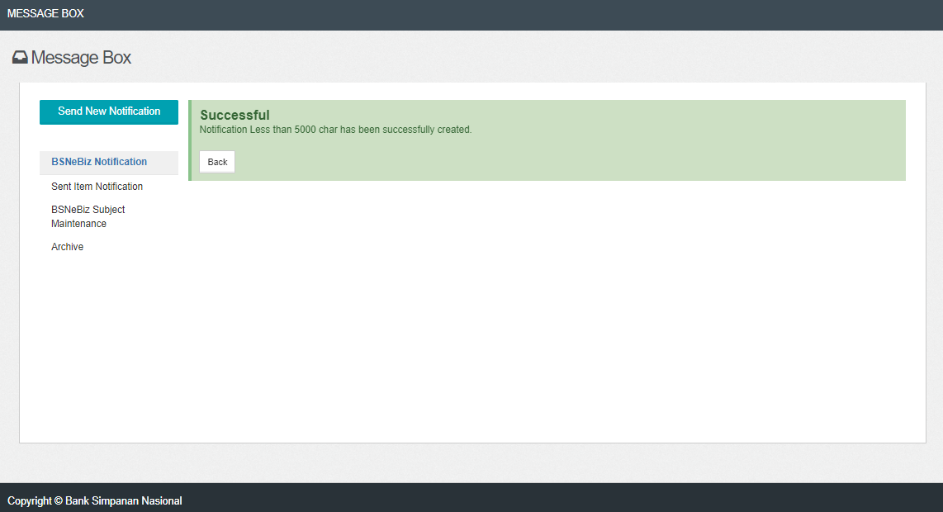  Figure 3: IBAM Message Box (Result)  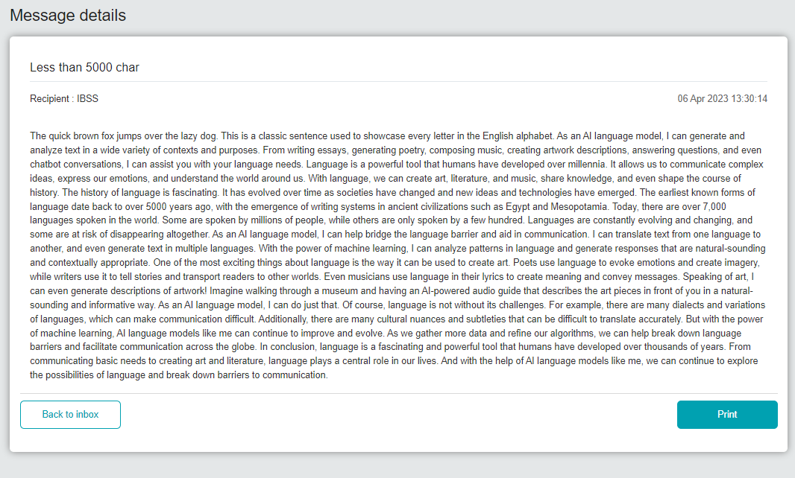  Figure 4: BSNeBiz Message Inbox

