First Time Login for User Audit 5

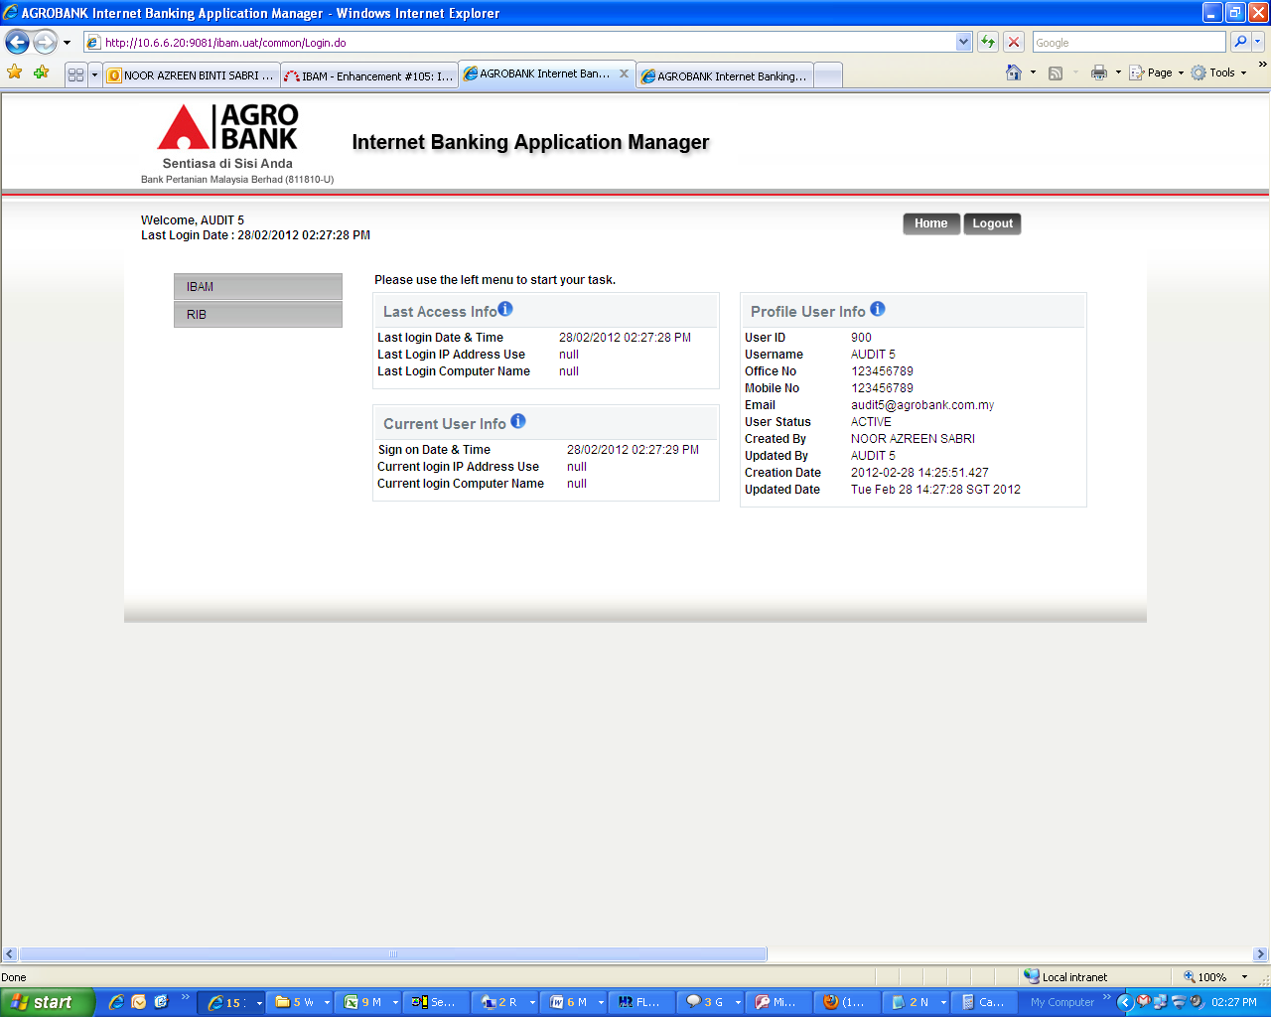

Upon 1st Time Login after Force Change Password.

* Last Access Info should be null for last login date and time and IP Address
* Current Access Info shall capture the IP Address

2nd Time Login for User Audit 5

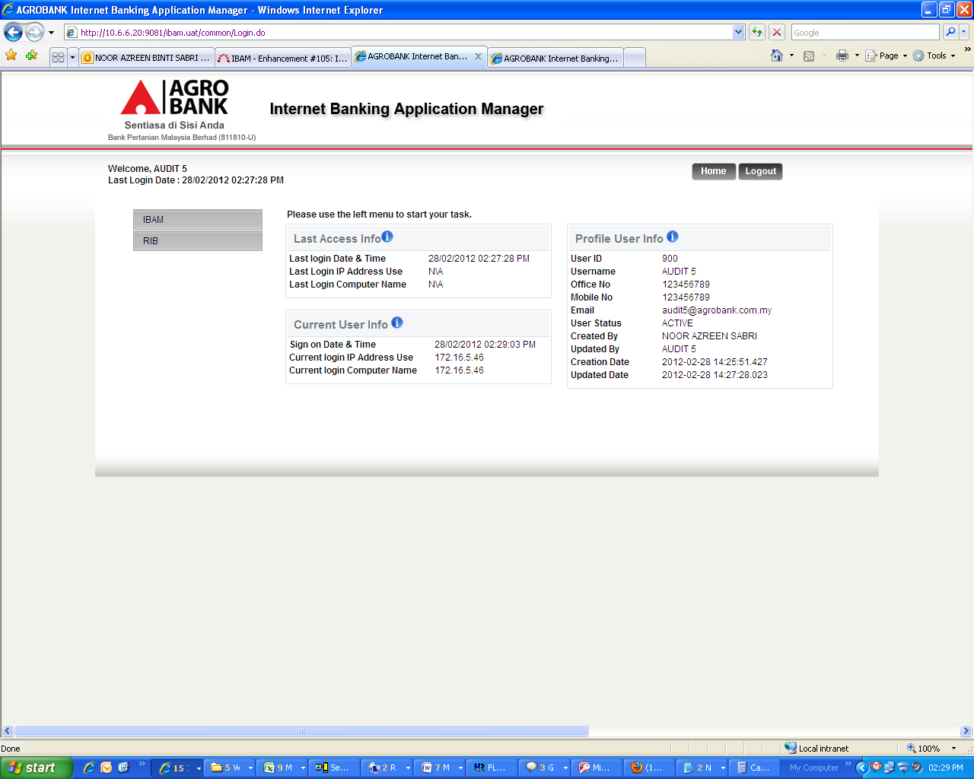

Upon 2nd Time Login:

* Last Access Info should capture 1st time login date/time and IP Address (which is the data in current info column during 1st time login)
* Current Access Info is correct.