# Introduction

This document describe the features, process flow and screen design of transactional and registration modules of Retail Internet Banking System respectively.

## Objective

The objective of this document is a basic step by step user guide for RIB which is mainly used for internal as a reference.

# Login

## How to Login IBAM Agro Bank URL

1. Go to this URL to access to IBAM Agro : <http://staging.penril.net/agro-ibam.sit/common/Login.do>
2. To access the system, you need to login before can use system.You can follow the following steps to login.

Default Super Admin (User)login information is as below:

**User ID**: Administrator

**Password**: Mss@dm1n

1. Key in the Username and Password Click Login button

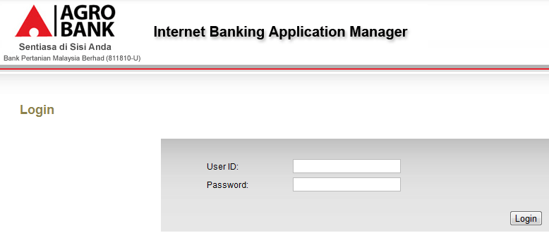

**Figure 2.1 login screen**

1. You shall successfully go to the main page of AGRO BANK

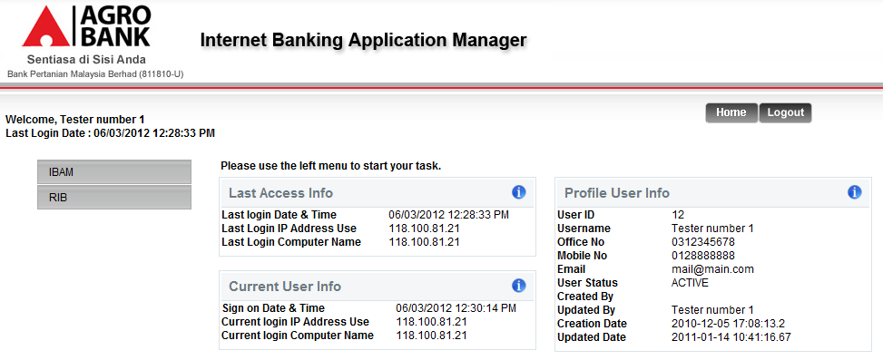

**Figure 2.2 main page**

1. Choose IBAM navigation to select Message Box.

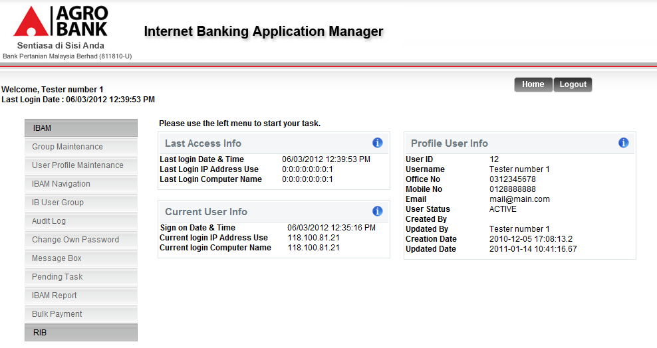

**Figure 2.3 main page**

# Message Box

**3.1 Secure Mailbox**

# This feature shall allow administrator to details about the Secure Mailbox.

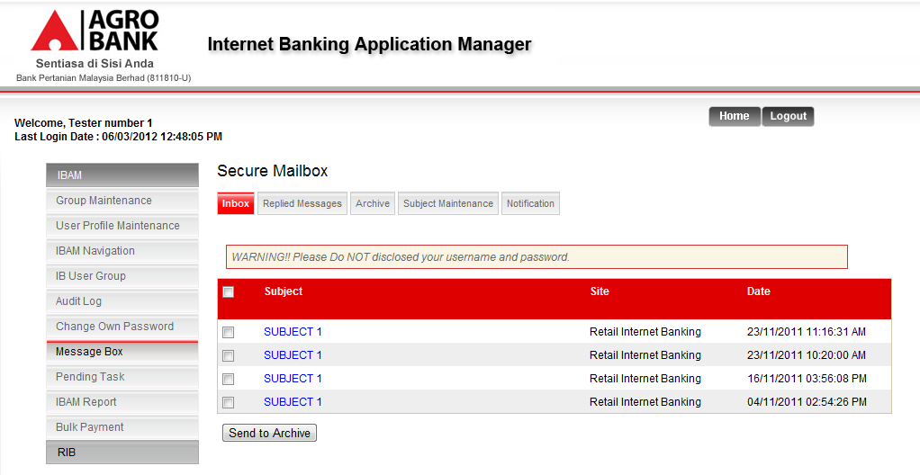

**Figure 3.1.1 Message Box details page**

**3.2 How to see message Inbox**

1. Choose Inbox navigation in Secure Mailbox. IBAM user can see this page.

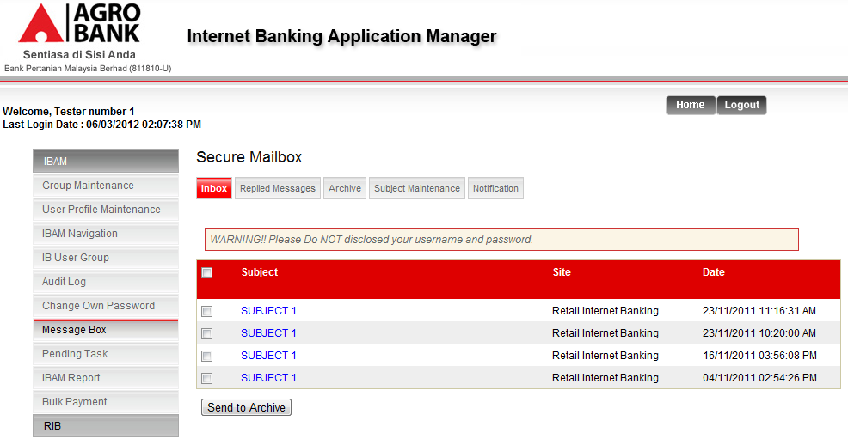 **Figure 3.2.1 Secure Mailbox page**

3.2 Choose any Subject link and go to the message Detail

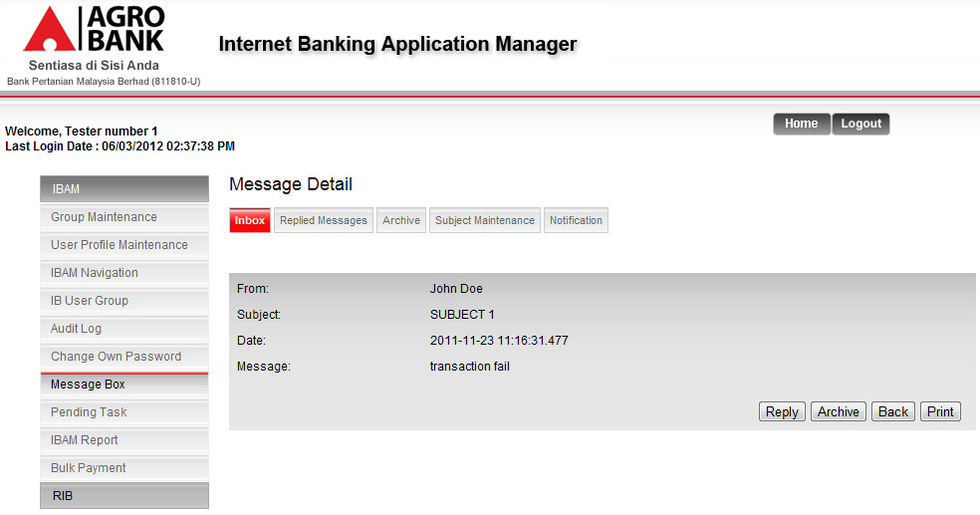

**Figure 3.2.2 Message Detail page**

**3.2 How to reply the message**

Choose the Reply button and go to the reply mail page .

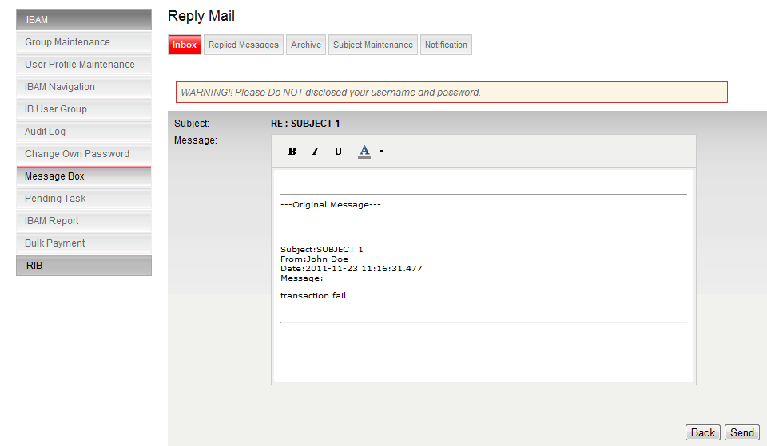

**Figure 3.2.3 Reply message page**

**3.3How to see the Replied Messages**

Choose the Replied messages navigation in secure Mailbox and go to the replied messages page.

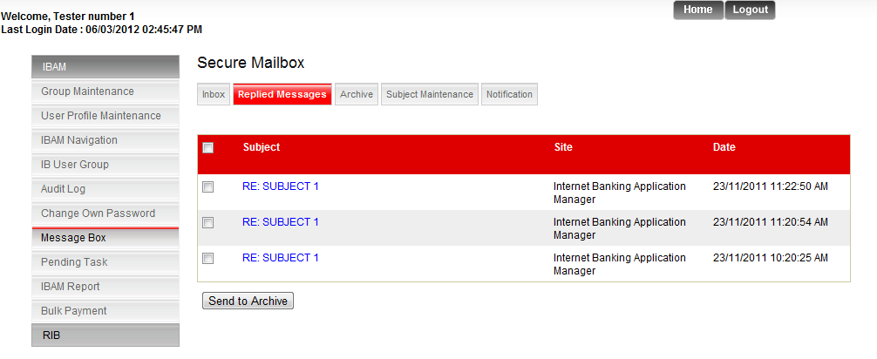

**Figure 3.3.1 Replied message page**

**3.4 How to search Archive**

Choose the Archive navigation in Secure Mailbox and go to search by page.

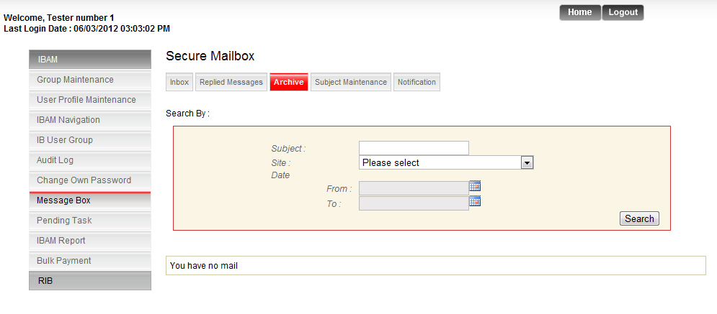

**Figure 3.4.1 Archive page**

**To search the Archive user can write subject and select the site and choose the Date .and click the Search button.**

**There is a list of search archive.**

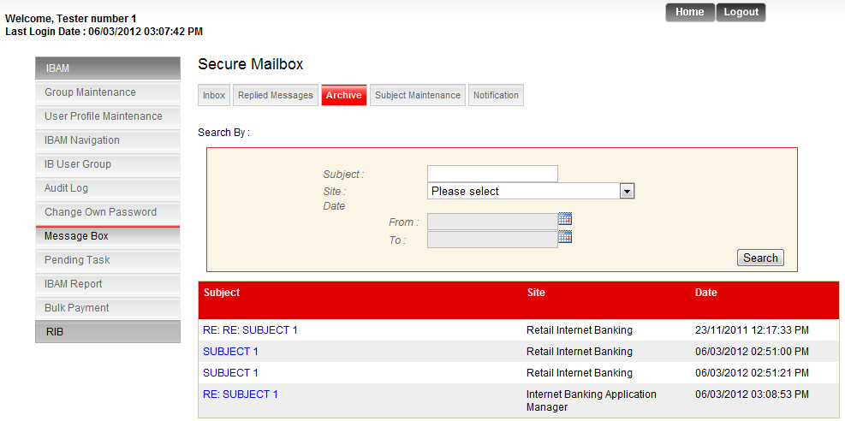

**Figure 3.4.2 Archive page**

**By choosing the any hyperlink user can see all archive details.**

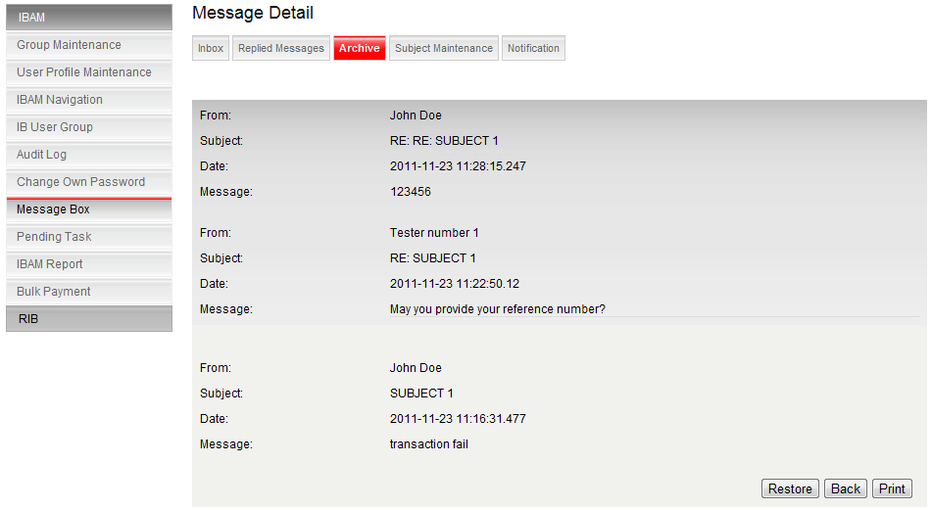

**Figure 3.4.3 Archive page details**

**In this page user is able to Restore and print details or Back to pervious page .**

**3.5 How to see the category**

Select the Subject Maintenance navigation and go to the category page.

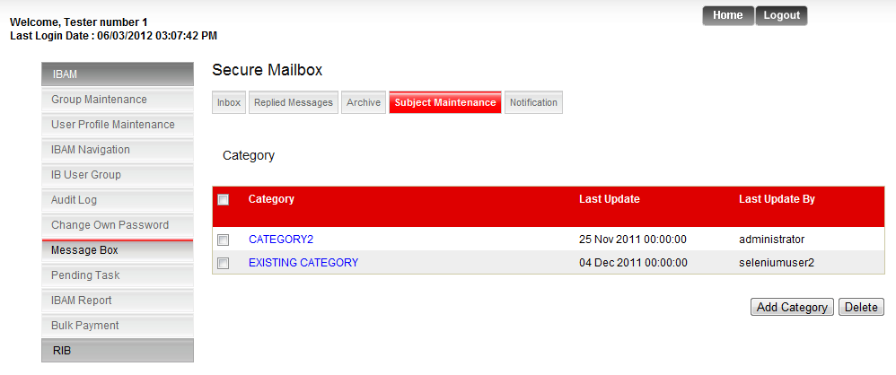

**Figure 3.5.1 Archive page details**

**3.5.1How to add the category**

Click the add category and go to the Add Category Page .Use can write the category and click the add button to add the category.

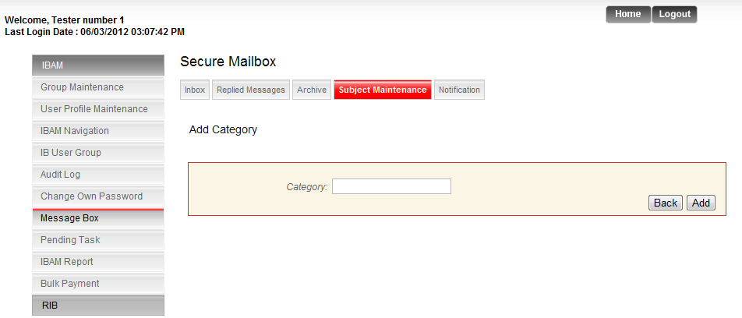

**Figure 3.5.1 .1Archive page details**

**How to Edit the category**

Choose any category hyperlink and go to category Detail page.

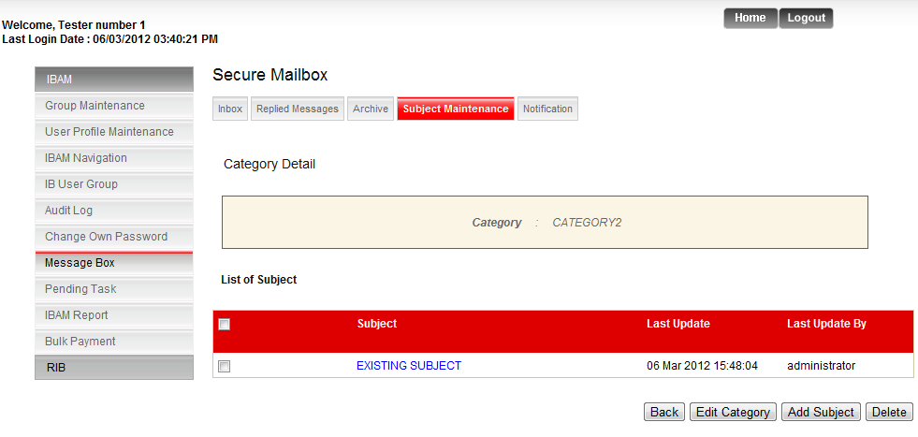

In the step user can edit category , Add Subject , and Delete , and also can back to the pervious page .

If user select Edit Category , can go to the edit category page.

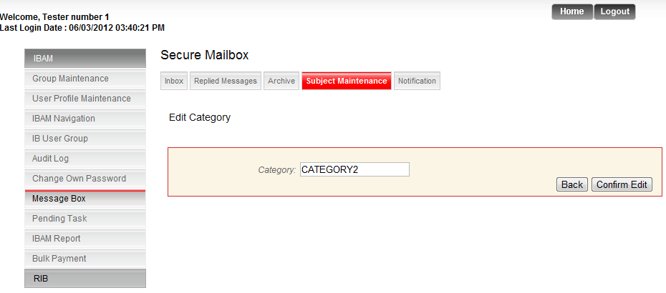

1. Write the category
2. Select Confirm Edit Button. And go to the result page.

