SCPID#6709
Test Title: |  | Credit Card error
Test Description: |  | Issue:  Currently credit card numbers are not available in BSNeBiz.  Finding:  Data power changed credit card host parameter. Thus BSNeBiz unable to generate credit card numbers list.  During UAT, the parameter name is <LastPymtDt></LastPymtDt> but now is <LastPymtDt/>  Solution:  Update the ESB code to support the actual parameter name. For example <LastPymtDt></LastPymtDt> and <LastPymtDt/> is considered the same.
Test Functionality: |  | To test on Credit Card module
Test Procedure: |  | Test steps:  - Access IBAM>BBE>Org Setup>Services and charges, register a credit card number. Can ask JTM to provide.  - Access IBAM>BBE>Org Setup>Account Management, credit card number(s) should be available  - Access IBAM>BBE>Org Setup>User Management, add credit card number(s) to a user  - Access BSNeBiz>Account Summary, credit card(2) balance should be available  - Access BSNeBiz>Account Summary>Pay card and proceed to make payment  - Expected result, credit card list, details, balance and payment should works
Response Message:
Test Result: | Pass: Fail: |  | Tested by: | Nor Athirah Umairah (26/06/2023)
Reason for Failure:
Remarks: |  | 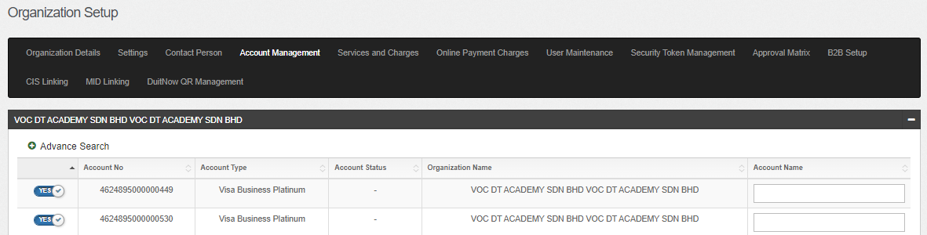  Figure 1: IBAM > Org Setup > Account Management (Credit Card)  Figure 1: IBAM > Org Setup > Account Management (Credit Card)  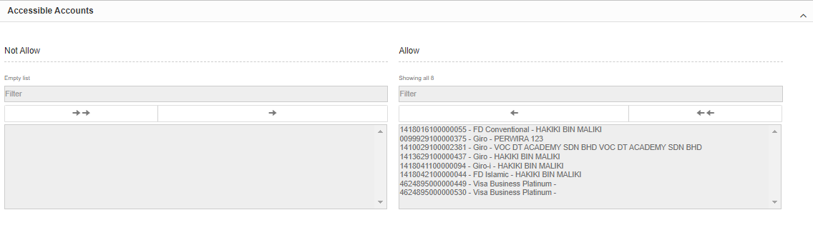  Figure 2: IBAM > Org Setup > User Maintenance  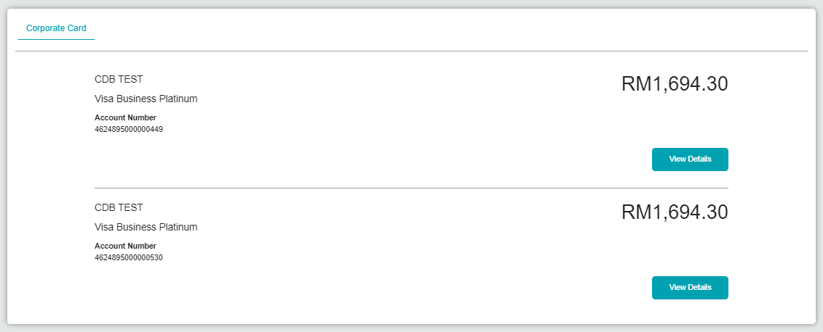  Figure 3: BSNeBiz > Account Summary  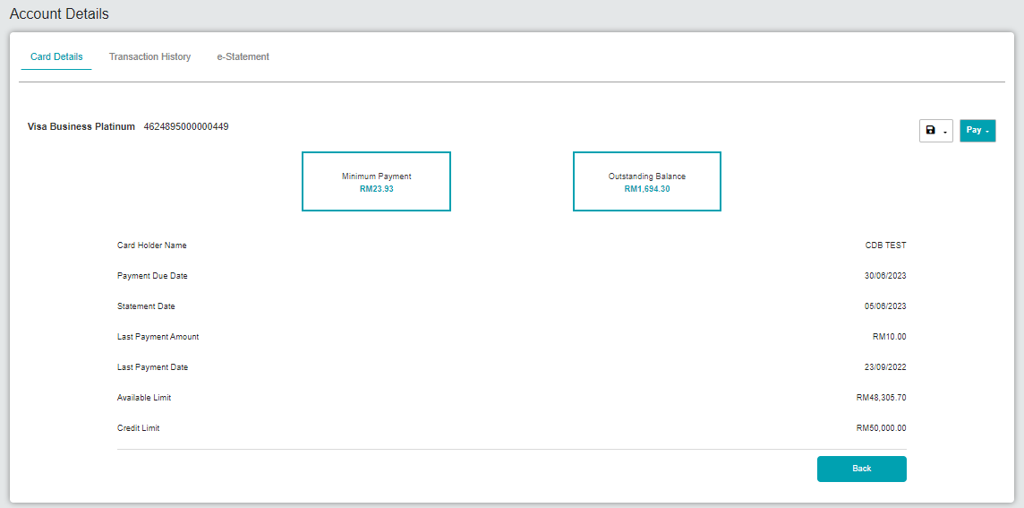  Figure 4: BSNeBiz > Account Summary > Account Details  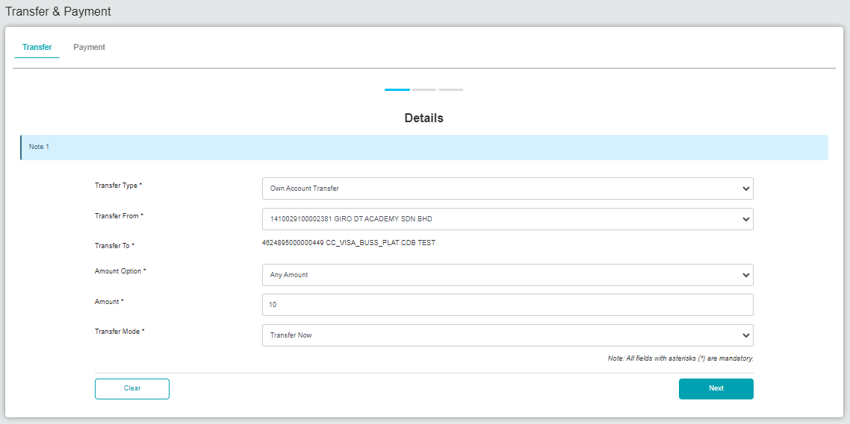  Figure 5: BSNeBiz > Pay Card (Details)  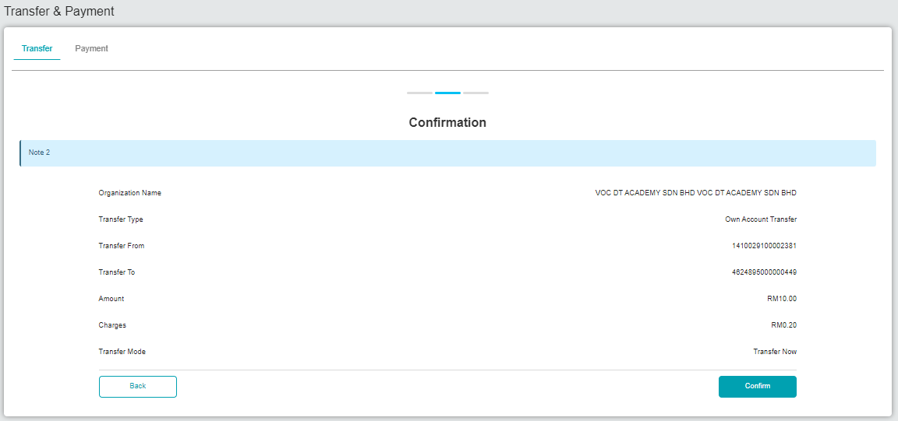  Figure 6: BSNeBiz > Pay Card (Confirmation)  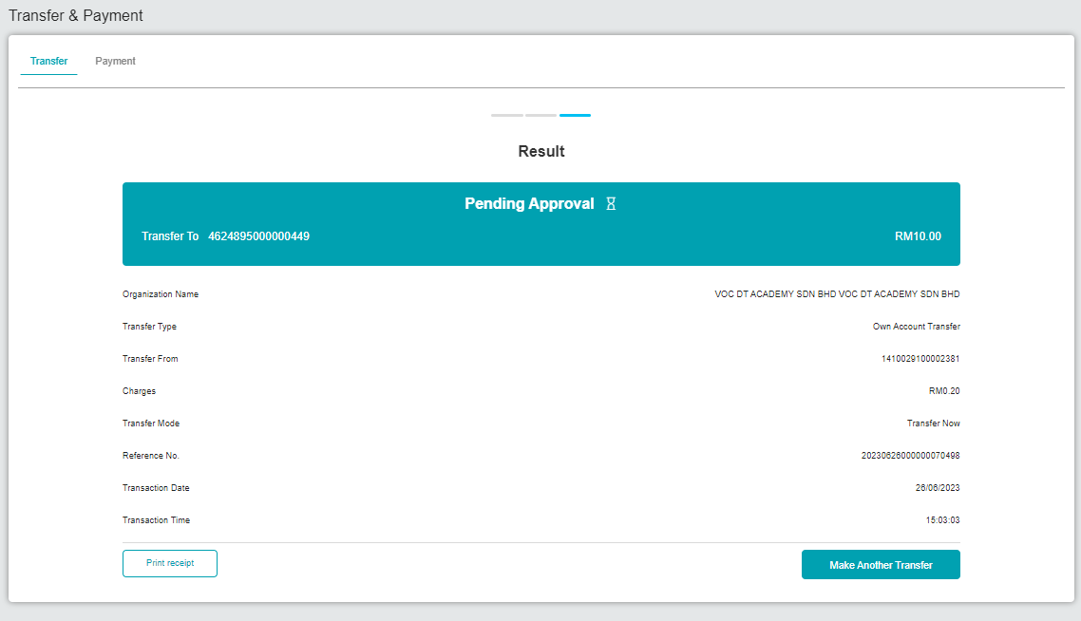  Figure 7: BSNeBiz > Pay Card (Result)  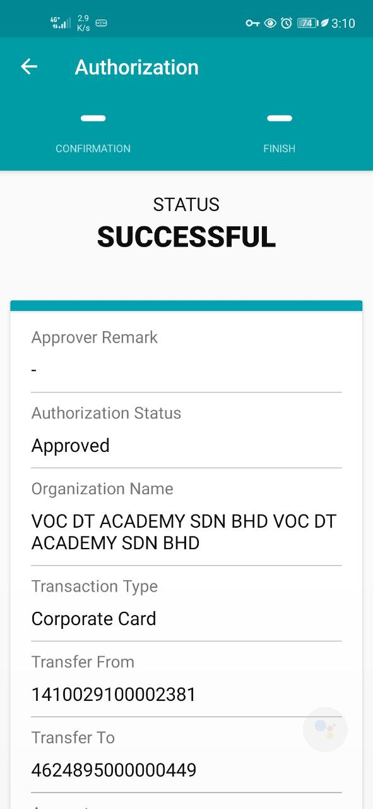  Figure 8: BSNeBiz > Approver (Result)  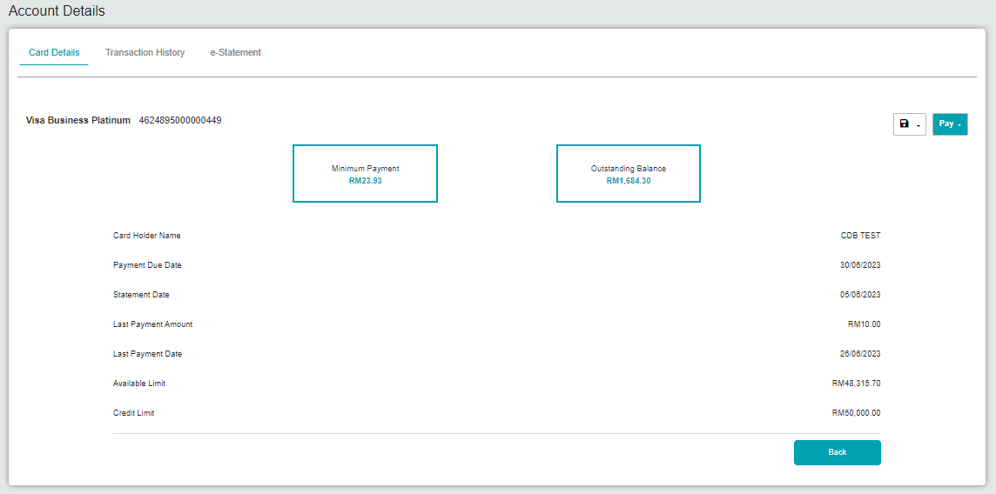  Figure 9: BSNeBiz > Account Summary > Account Details

