DuitNow QR (Error Logs – 31/5/2023)
Item | Test | Remarks
1. | Onboarding Merchant  - Merchant Category  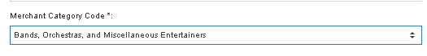  b)  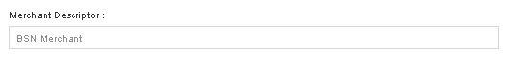  c)  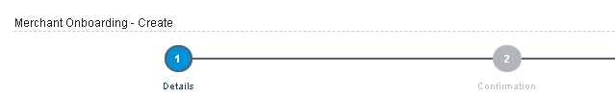  d) Authorization by Checker  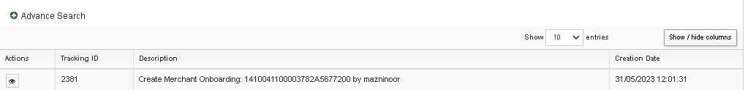  e) email notification  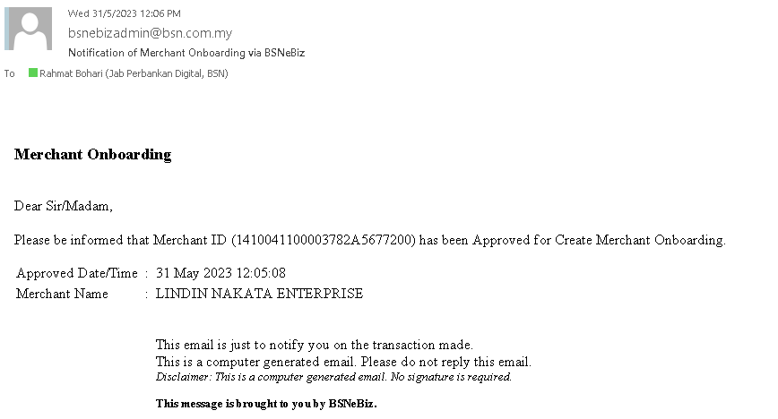  f) QR – pdf file download  g)  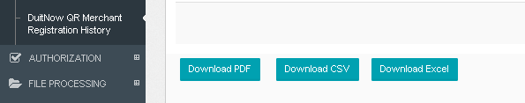  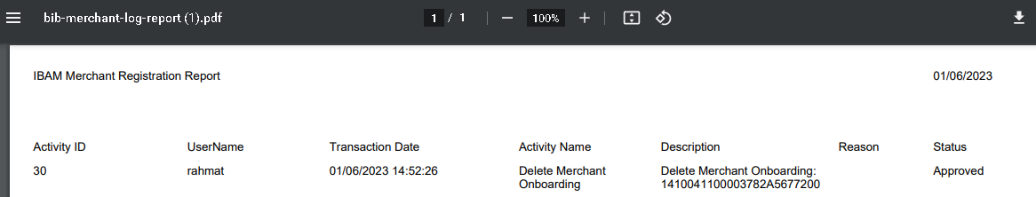  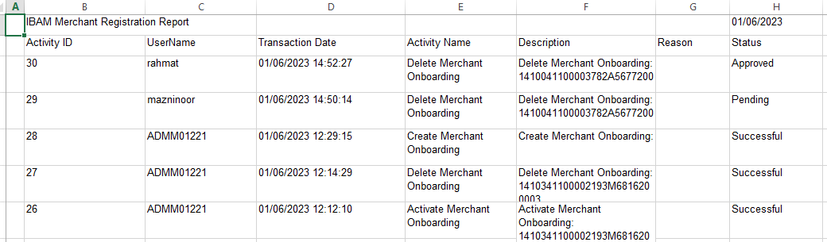 | Please justify what is this?  Change to BSN Merchant QR  Change to BSN Merchant QR Onboarding –Create/Add  Change to Create Merchant QR Onboarding  Action :  - to display merchant account number  - Email Title change to Notification of Merchant QR via BSNeBiz  - To remove:  - Email body content to remove Merchant Onboarding wording  - This email is just to notify you on the transaction made.  Naming convention:  Merchant name DuitNow QR  Example:  Lindin Nakata DuitNow QR  - Dowload:  - PDF okay  - CSV Not Okay  - Excel okay  - Pdf/csv/excel file naming convention to be Merchant QR Logs Report  - Pdf/csv/excel name in report to be Merchant QR Logs Report  - To refine alignment in excel/pdf file report.

DuitNow QR (Error Logs – 2/6/2023)
Item | Test | Remarks
1. | CDB – Corporate Administrator  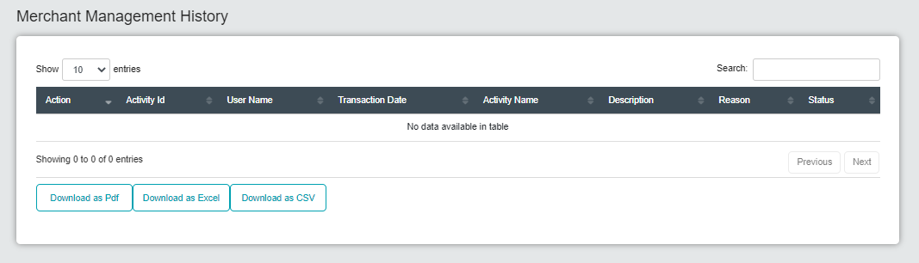  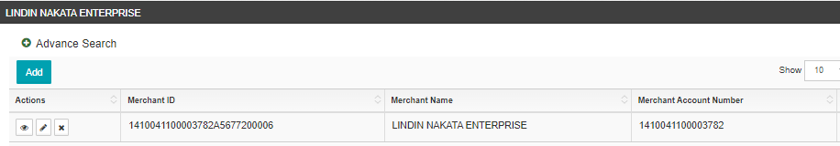 | No history available to download for Lindin Nakata
 | 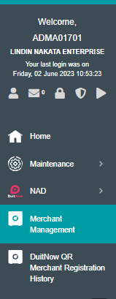 | Change name:  Merchant Management to DuitNow QR Merchant Management
Create New Merchant QR
When select Merchant State – droplist to display according to state selected not all in Malaysia

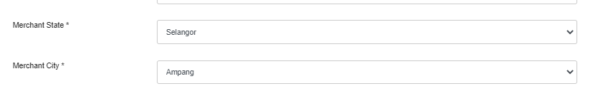

 | 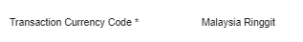 | To hide
 | 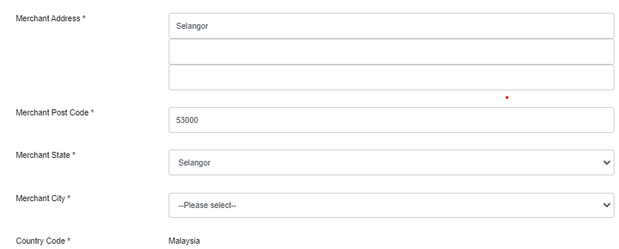 | - To remove word merchant for address info  - Rearrange (CDB & IBAM)  - Address  - Postcode  - City  - State  - Country (remove code)  Noted :  Once select city system to auto default postcode & state
 | 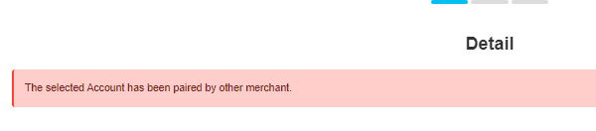 | Is this as expected?
 | 1 merchant already created..but when Create another new merchant error display  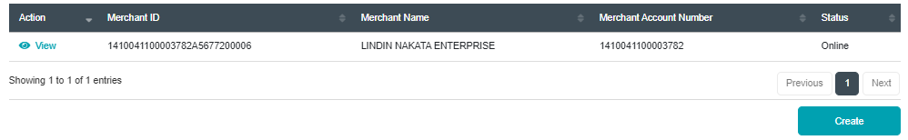  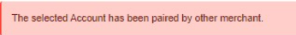 | System should allow add merchant

DuitNow QR (Error Logs – 6/6/2023)
Item | Test | Remarks
1. | CDB – Corporate Administrator  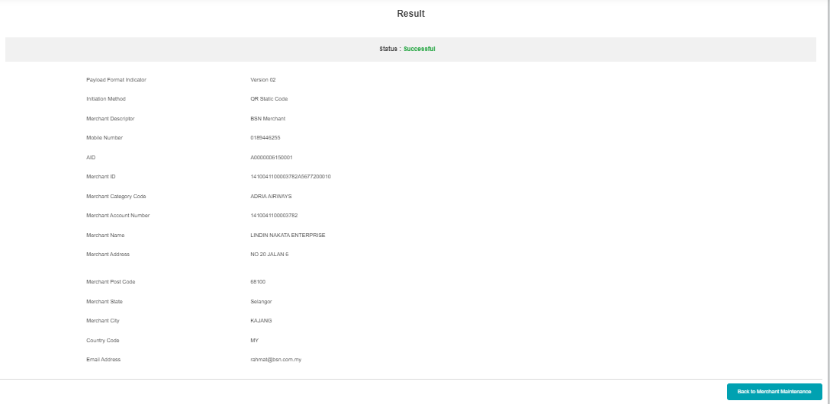 | Upon successfully registered merchant the system should prompt QR screen to download & print NOT back to Merchant Management  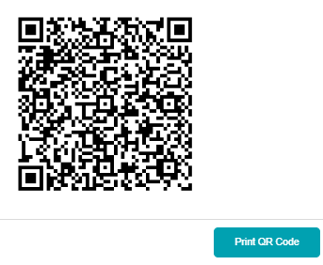
2. | Mobile Apps  DuitNow QR Pay | User able to scan without login to apps.  MUST require to login using passcode before scan

DuitNow QR (Error Logs – 7/6/2023)
Item | Test | Remarks
1. | Mobile Apps:  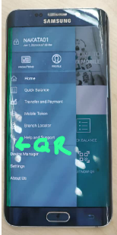 | No DuitNow QR navigation
2. | Mobile Apps  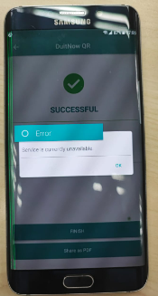 | Error to generate receipt
3. | Mobile Apps | DuitNow QR received function to be available for w/flow user
4. | SOW08.2: To add New Module – DuitNow QR (Receive) in BSNeBiz (Mobile – iOS and Android)  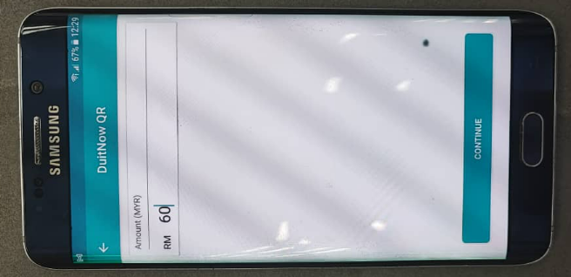 | - Merchant enter amount to receive  - Customer scan to pay but the amount entered by merchant does not display.  - Customer need to enter again the amount

DuitNow QR (Error Logs – 9/6/2023)
Item | Test | Remarks
1. | DuitNow QR Management  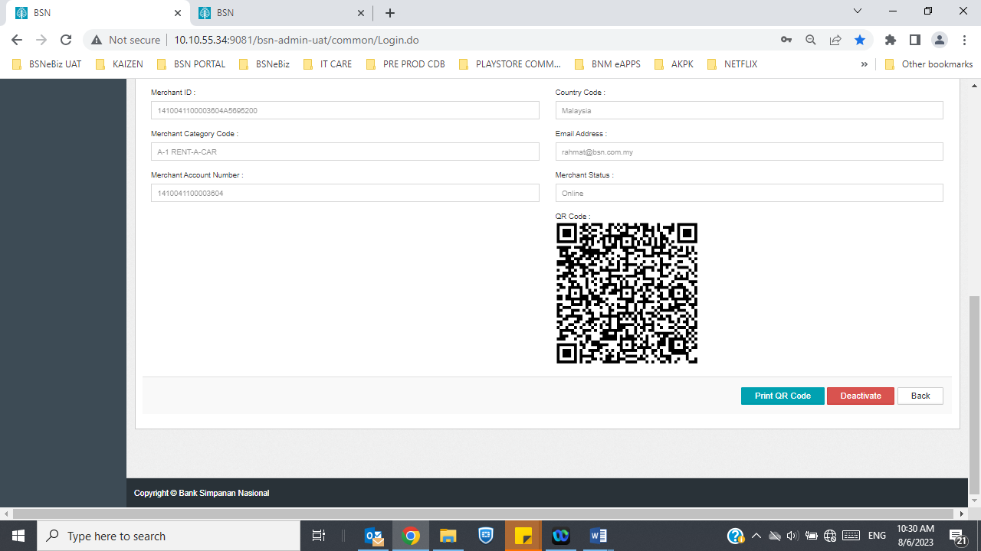 | QR to be in color
2. | IBAM - Org Setup – DuitNow QR Merchant Management  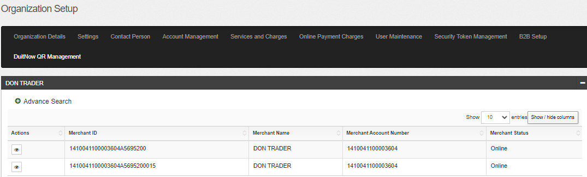 | To display date of onboarding
3. | IBAM – DuitNow QR Merchant Registration History  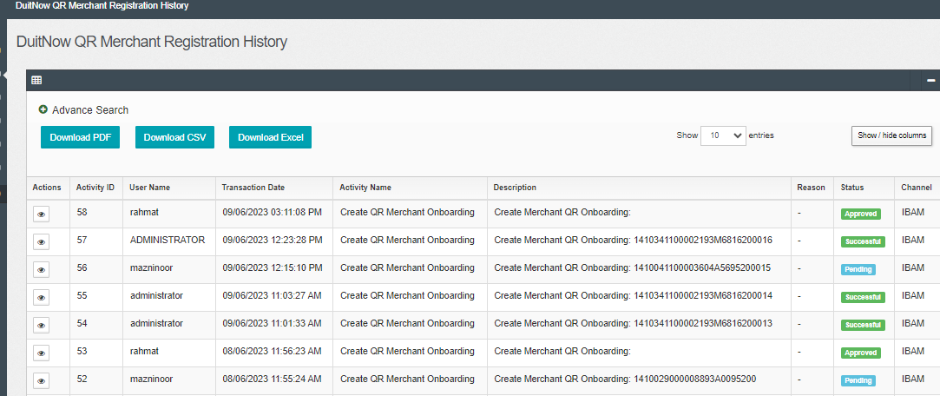 | - To add new column  - Merchant Name  - Merchant ID  - Merchant Acc. No  - Org Code  - Same information available in pdf,csv & excel
 | IBAM – BSNeBiz Report  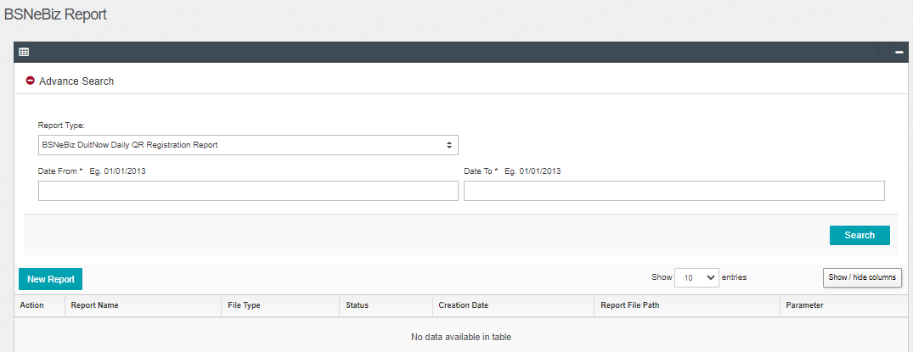 | Report – Not Available
 | Mobile apps  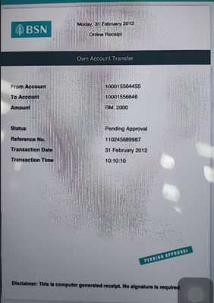 | - Date & time generate in receipt does not sync with system date  - Status must be SUCCESS not PENDING APPROVAL  - Title must be correct not Own Account Transfer
 | IBAM/CDB  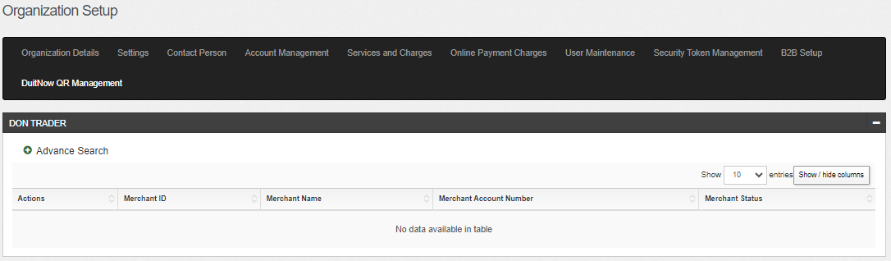 | System must block QR after merchant has been deleted from IBAM/CDB.  If scan – to prompt error  Not allow for inquiry & payment

DuitNow QR (Error Logs – 30/6/2023)
Item | Test | Remarks
1. | Mobile Apps:  Android ios  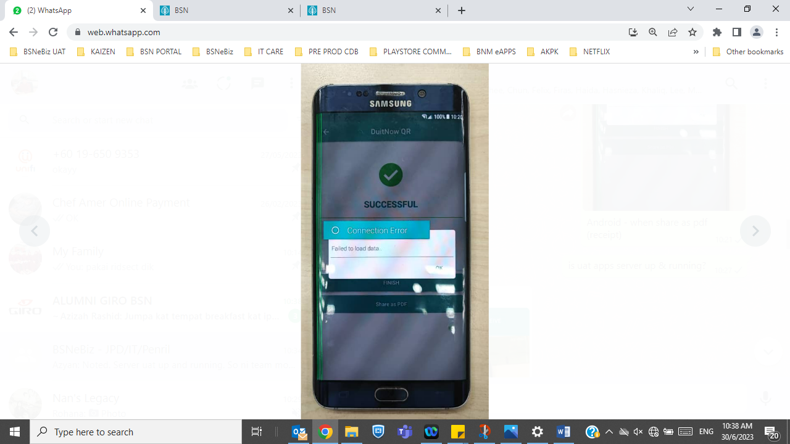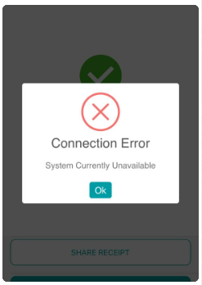 | When share pdf receipt  Ios – done 30/6  Android – yet to fix
2. | Ios  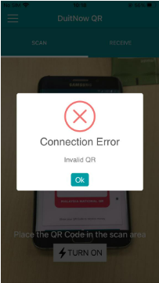 | When scan & pay to BSN QR  Done – 3/6
3. | Android  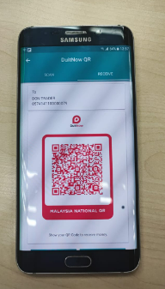 | Amount button does not display within screen
4. | Receive payment  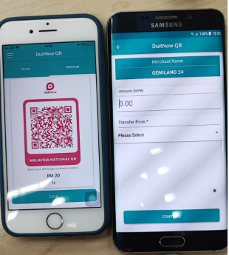 | Ios – received & enter amount to recive  Android – when scan amount does not display  Please check vise versa

