SCPID#6687
Test Title: |  | Status Pending Validate for File size more than 3MB
Test Description: |  | Issue:  Current process in CDB for file upload (more than 3MB); status in File Processing is 'Pending Processing' when file is not completely loaded in DB  Solution:  Update status file to 'Pending Validate' when file is loaded in server. Once complete load in DB, status change to 'Pending Processing'.
Test Functionality: |  | To test on file upload with file size more than 3MB
Test Procedure: |  | Test steps:  - Upload file greater than 3MB  - Run Batch Processing program  - Simulate Batch Processing crash before loads data in details table  (Only can test in local env)  i. Set loading time  ii. Stop server running Batch Processing program  iii. Make sure the File status still Pending Validated.
Response Message:
Test Result: | Pass: Fail: |  | Tested by: | Nor Athirah Umairah (27/06/2023-03/07/2023)
Reason for Failure:
Remarks: |  | 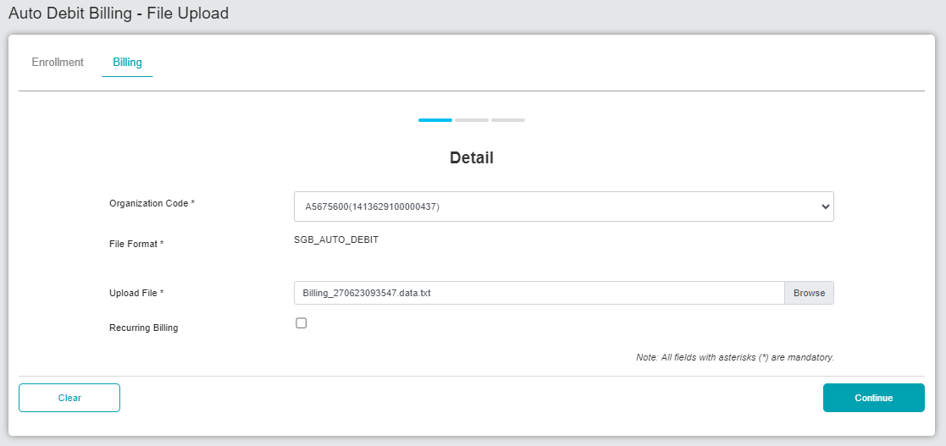  Figure 1: File Upload (Detail)  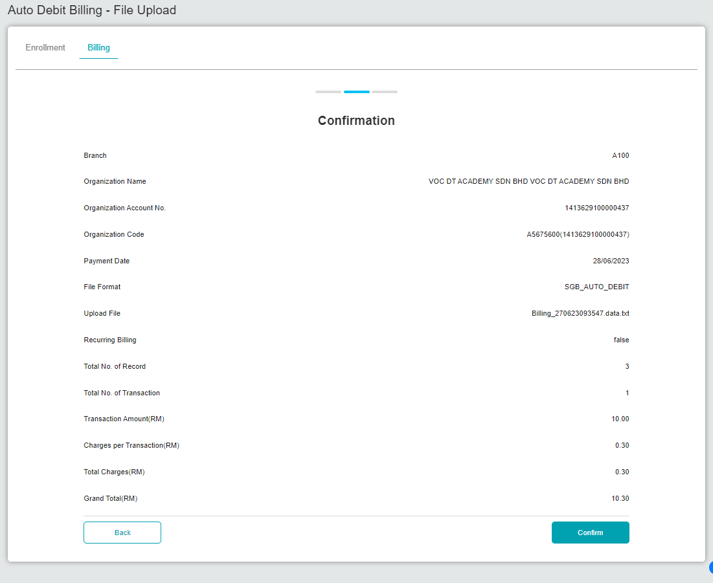  Figure 2: File Upload (Confirmation)  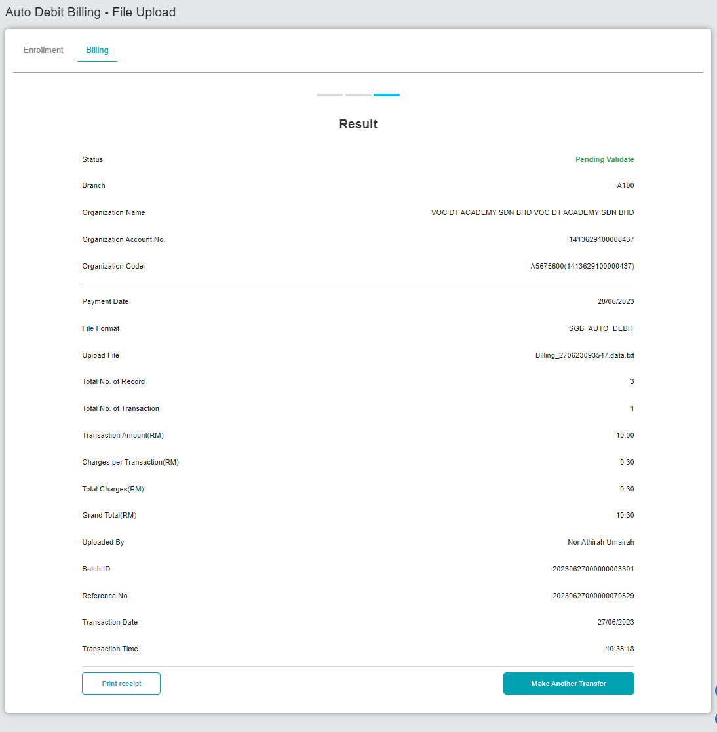  Figure 3: File Upload (Result)  Steps 2&3: Successful stimulate crash by Hasnieza in local environment.

