FPX CMS Error

1. TXN008 =Insufficient fund (expected transaction code is 51 to Paynet). Instead the page just remain at transaction page and when click cancel, rejected transaction code is 1F.

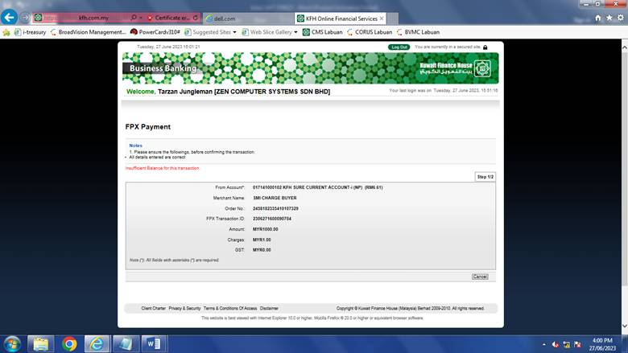

1. TXN009 =To check on the page timeout error code, expected to return transaction code 1D to payNet. When testing, it appear as error.

