Video: <https://drive.google.com/file/d/131dTRpVEipbOMIZDuUvQa0WjLVkoOsPu/view?usp=drivesdk>

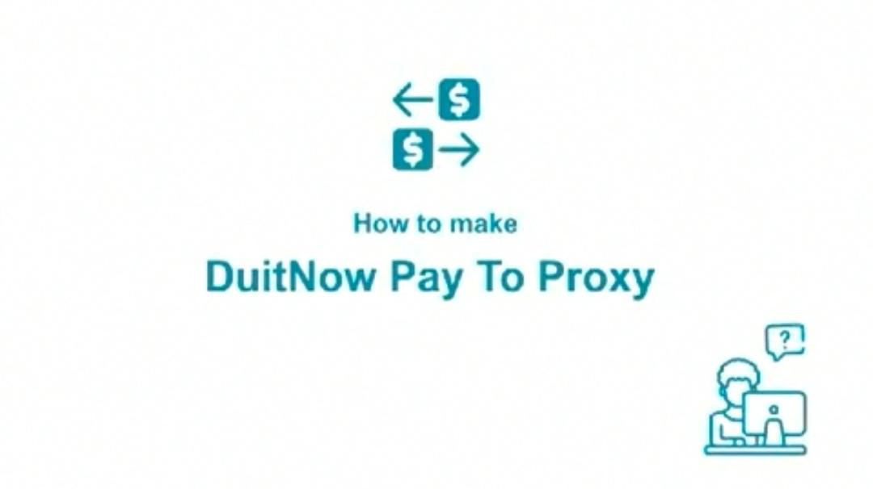

* Logo: Duitnow
* Title: How to transfer funds with DuitNow (Pay To Proxy)

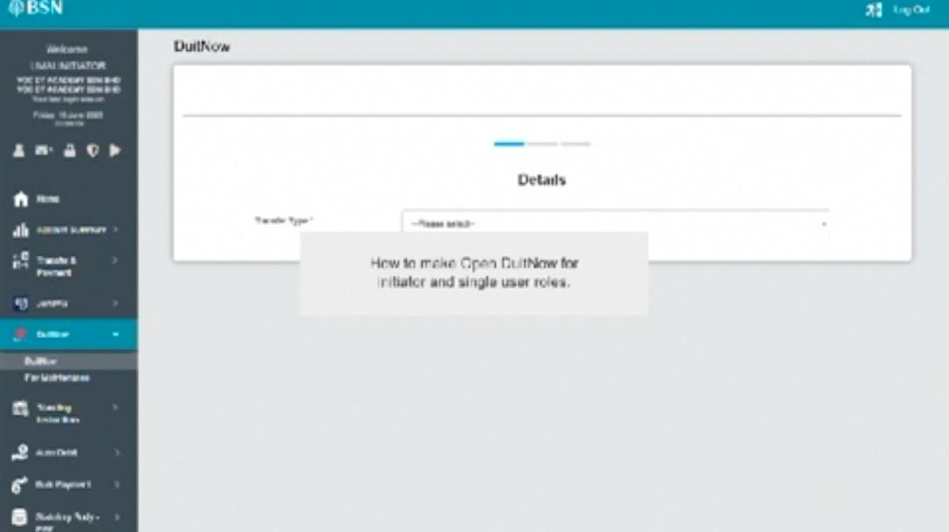

* Dim background
* Text: How to transfer funds with DuitNow for initiator and single user

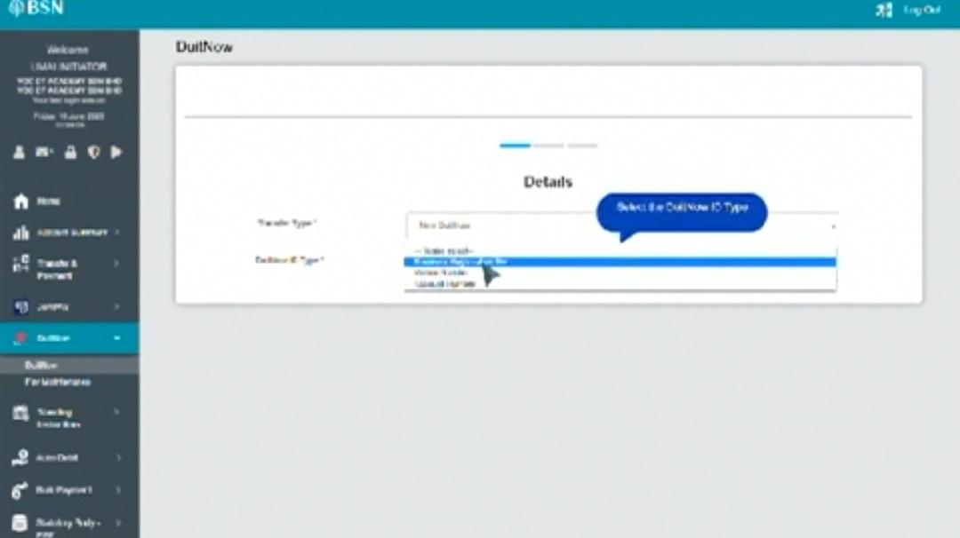

* Align the text to centre

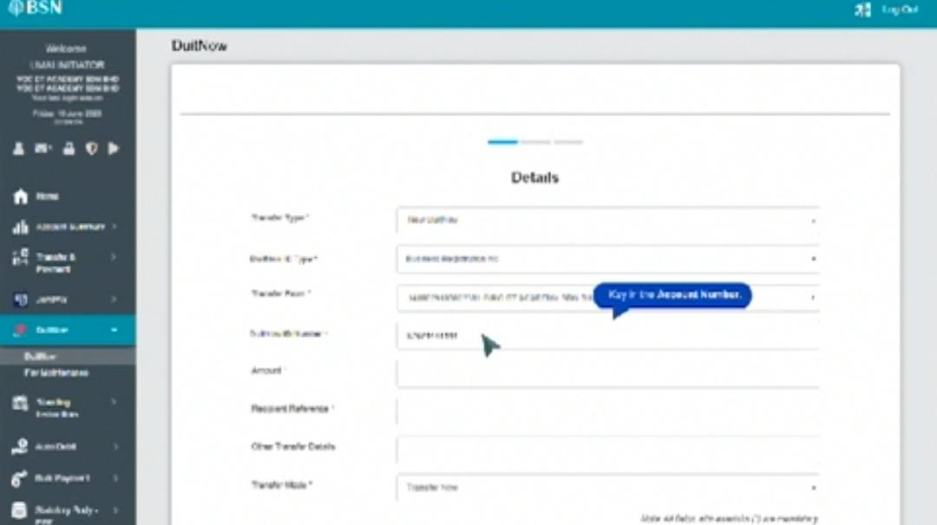

* Text: Fill in the DuitNow ID Number

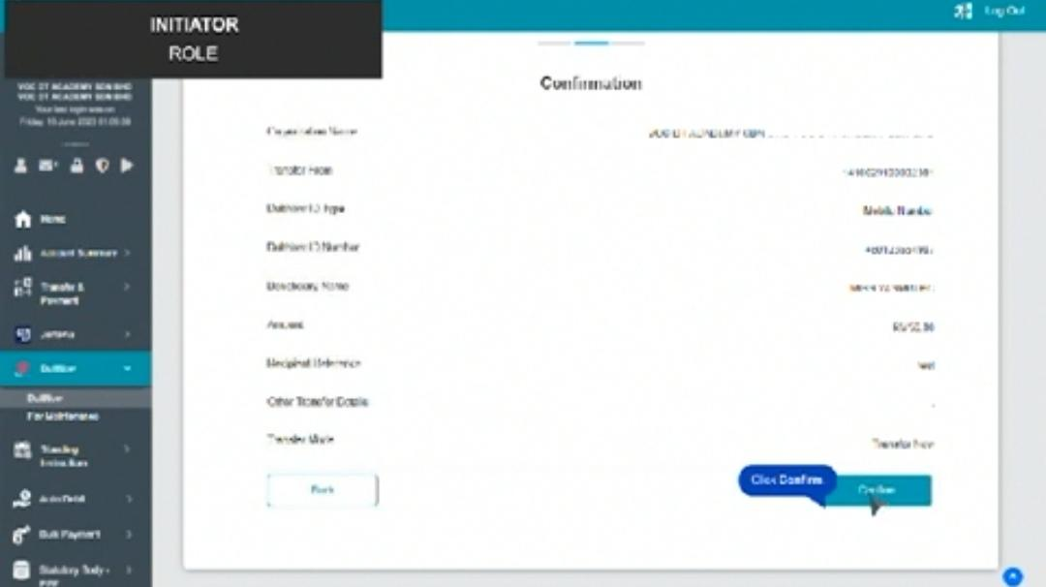

* Position the dialog box

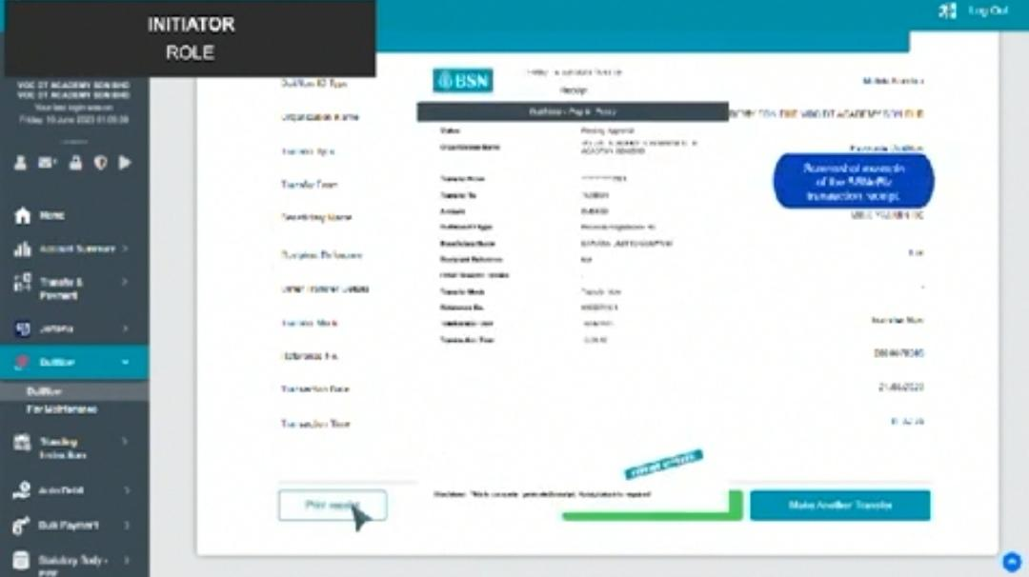

* Dim background

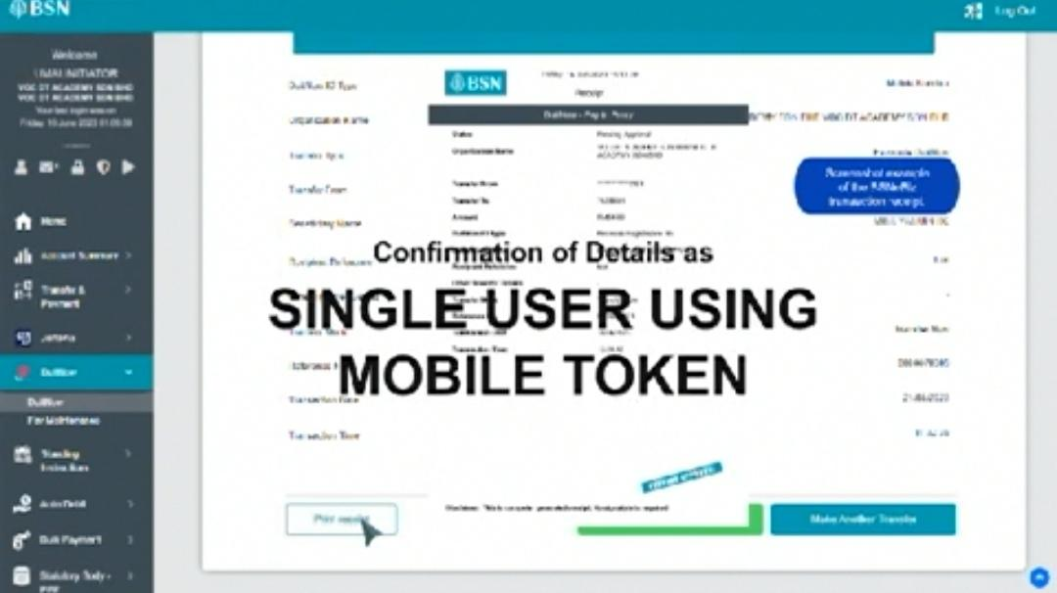

* Adjust the keyframes

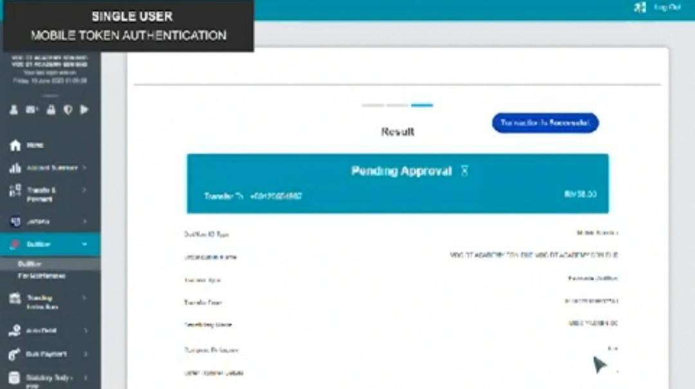

* Single user should be Successful not Pending Approval

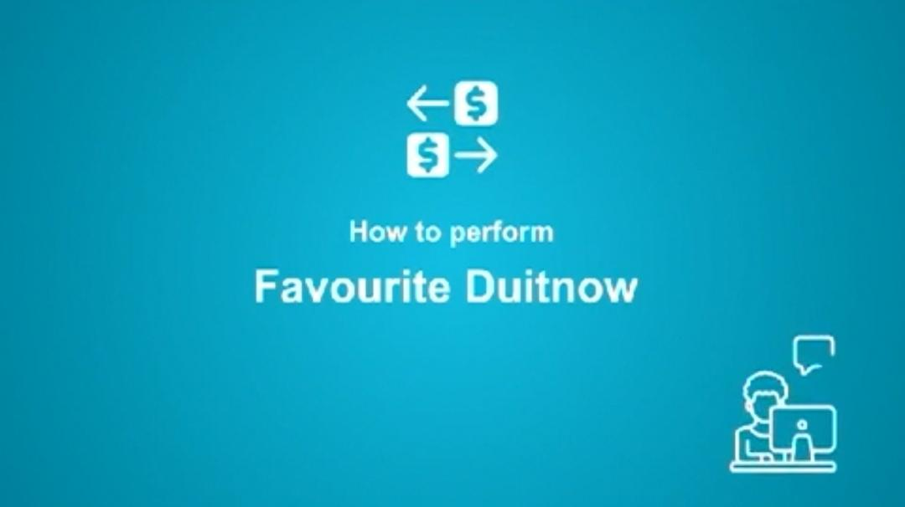

* Standardize the design (white background)
* Logo: Duitnow

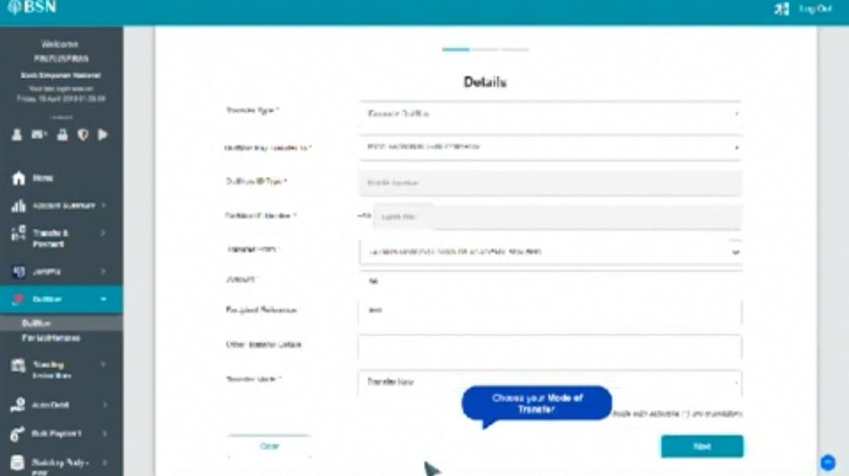

* Position dialog box

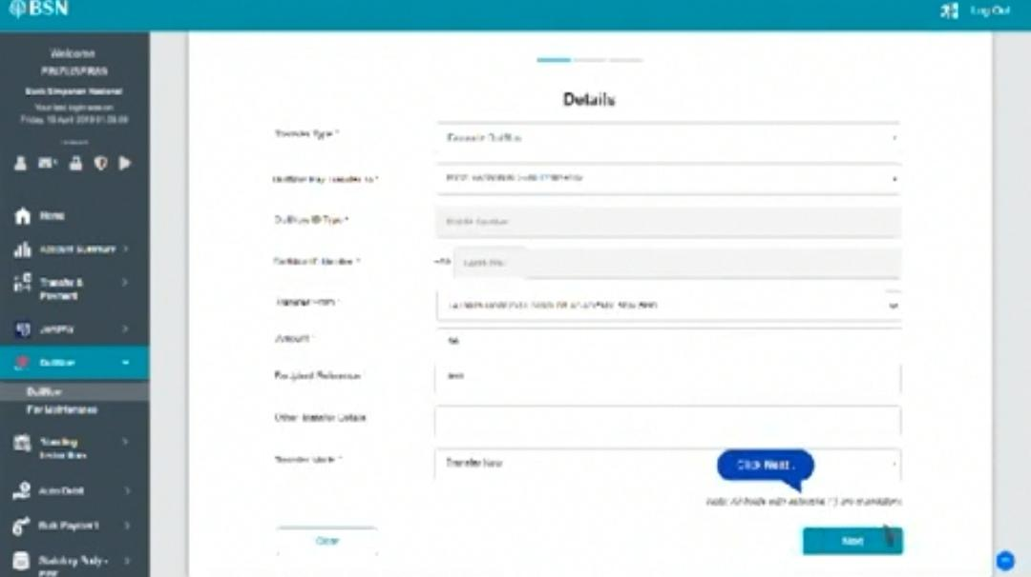

* Position dialog box

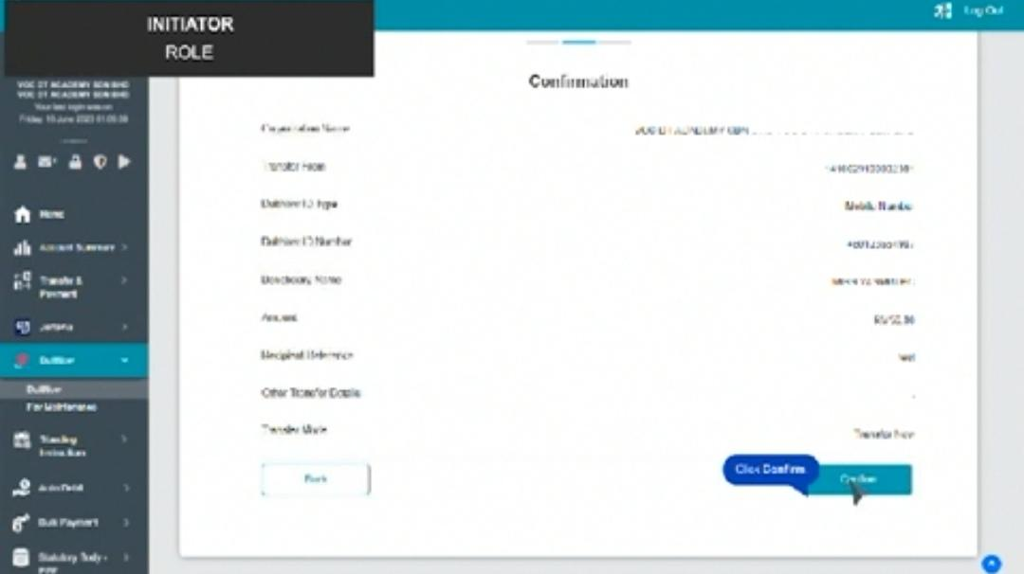

* Position dialog box

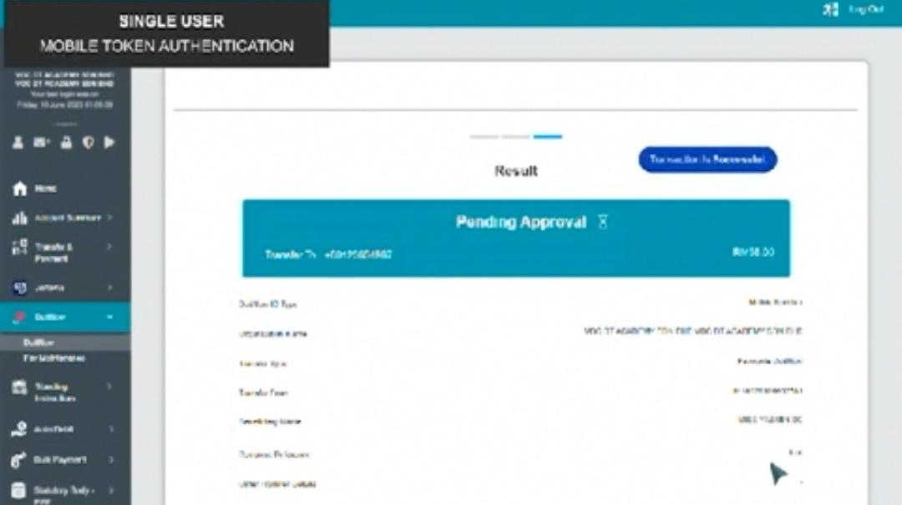

* Successful

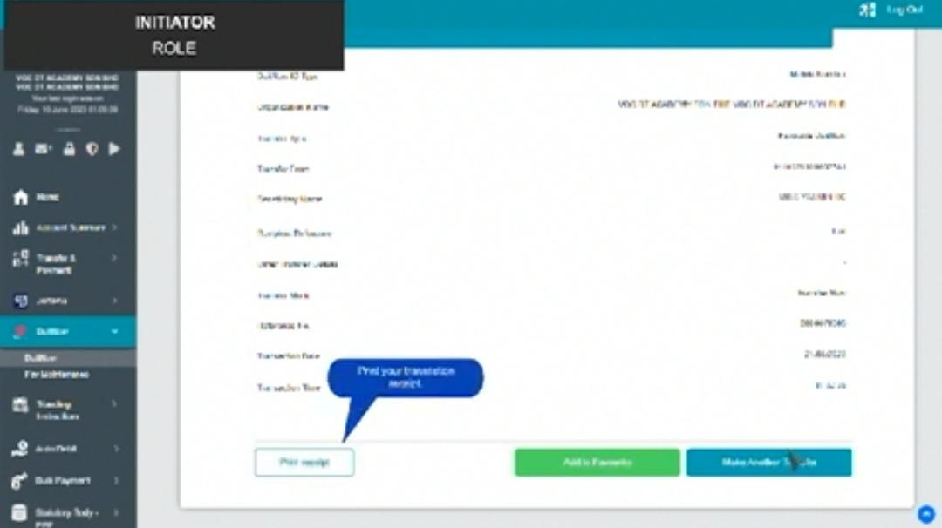

* Standardize the design for dialog box

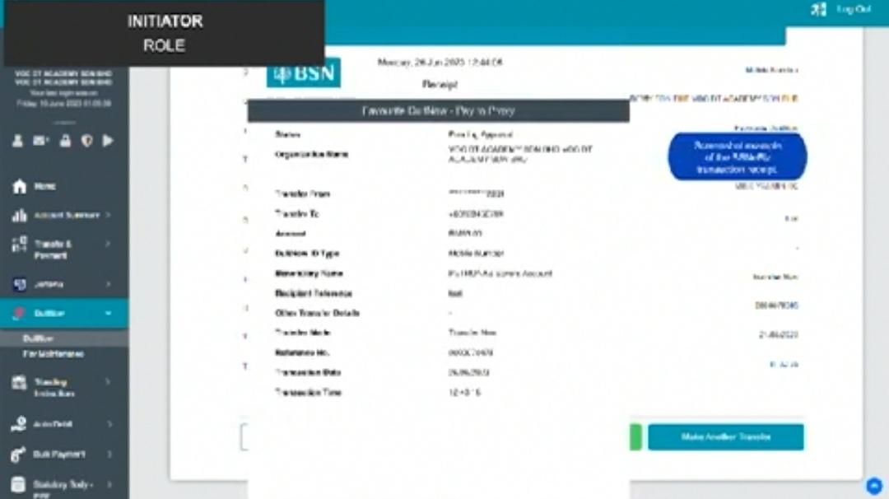

* Dim background



* Remove the closing scene. Can use white colour with simple transitions

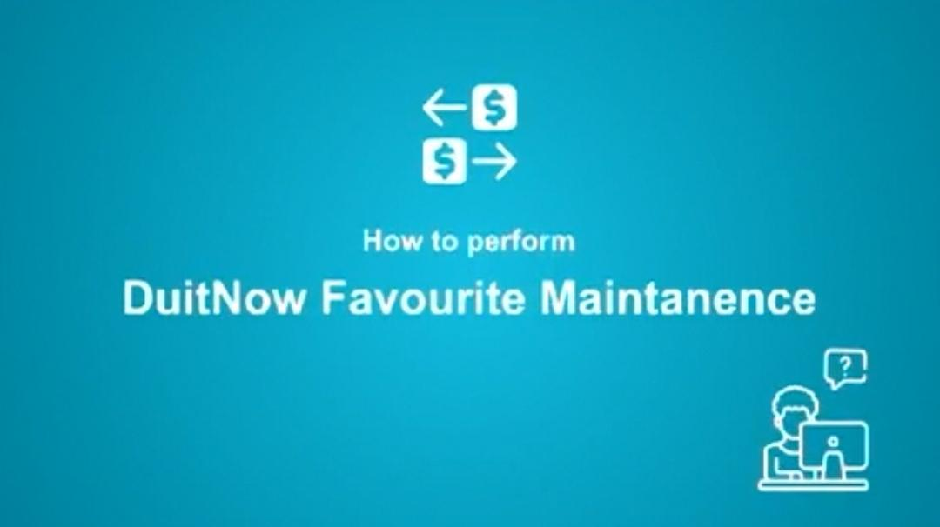

* Standardize the design (white background)
* Logo: Duitnow

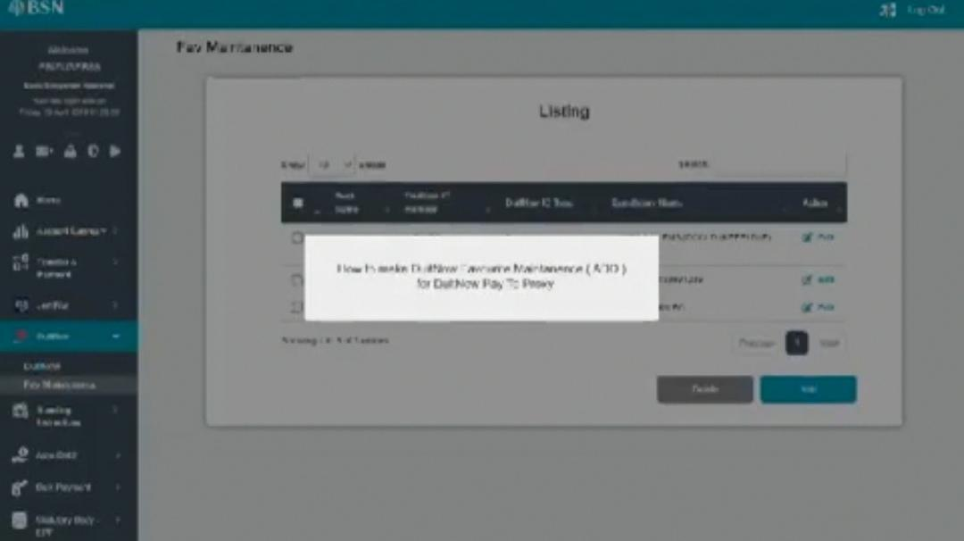

* How to add favourite DuitNow ID

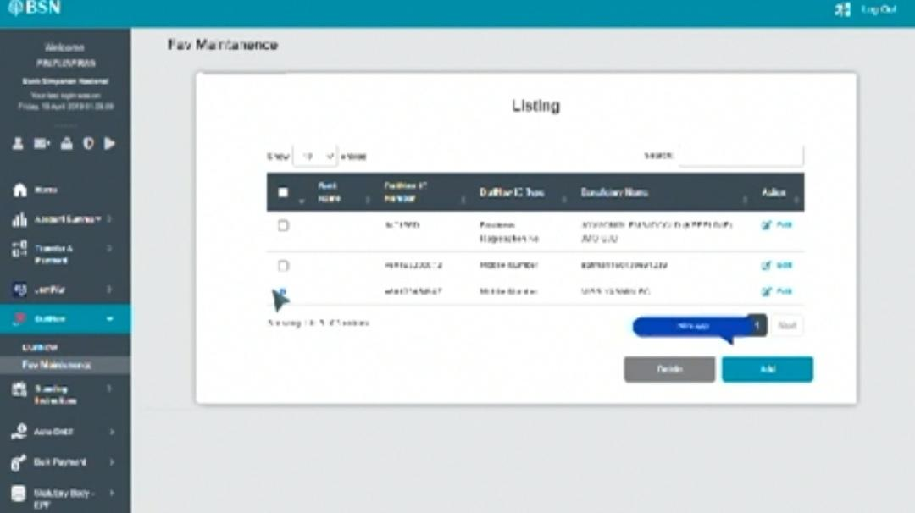

* No need to select checkbox
* Fit text with dialog box

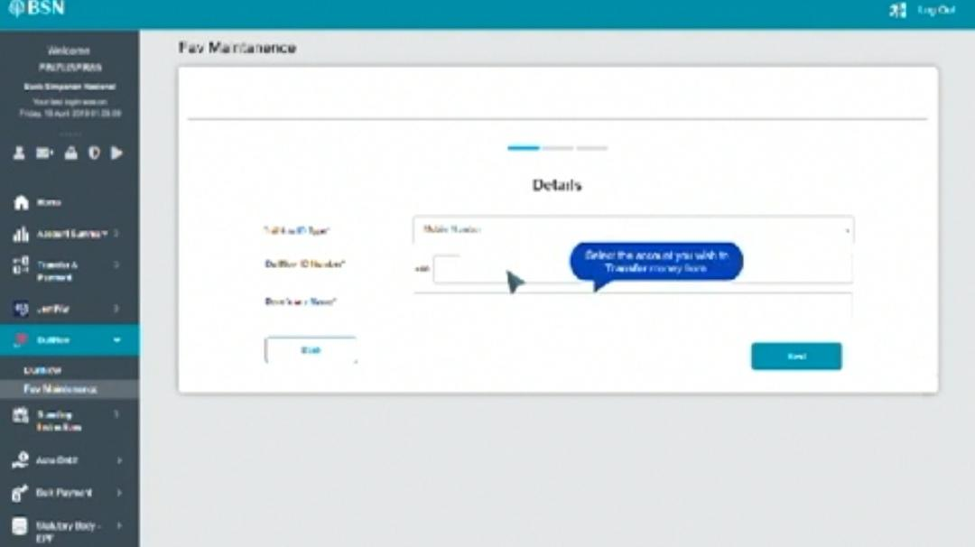

* Adjust the transition

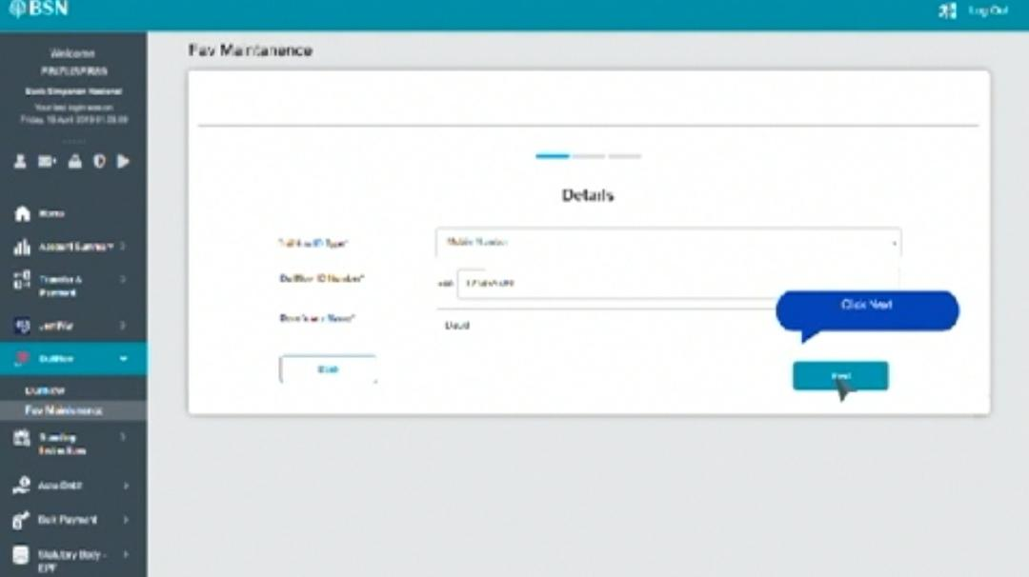

* Fit text with dialog box and adjust the position

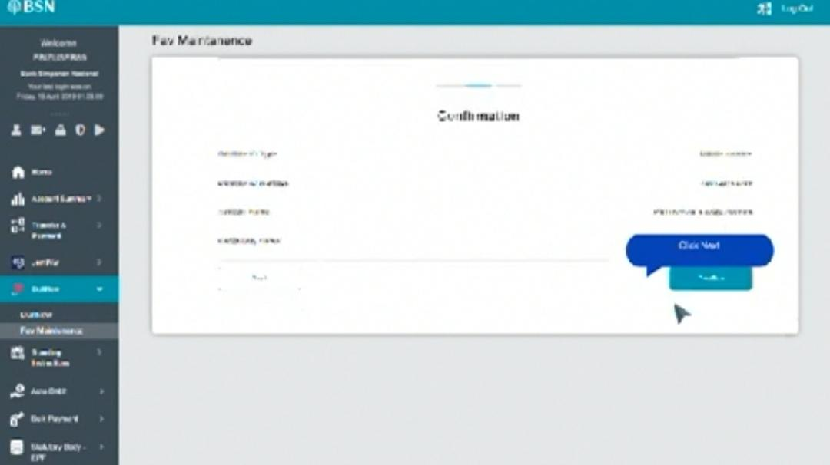

* Fit text with dialog box and adjust the position

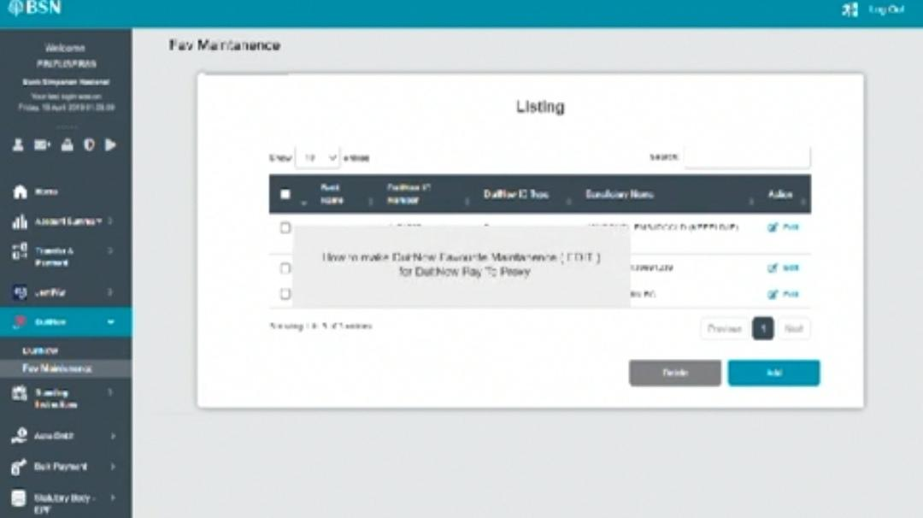

* Dim background
* How to edit favourite DuitNow ID

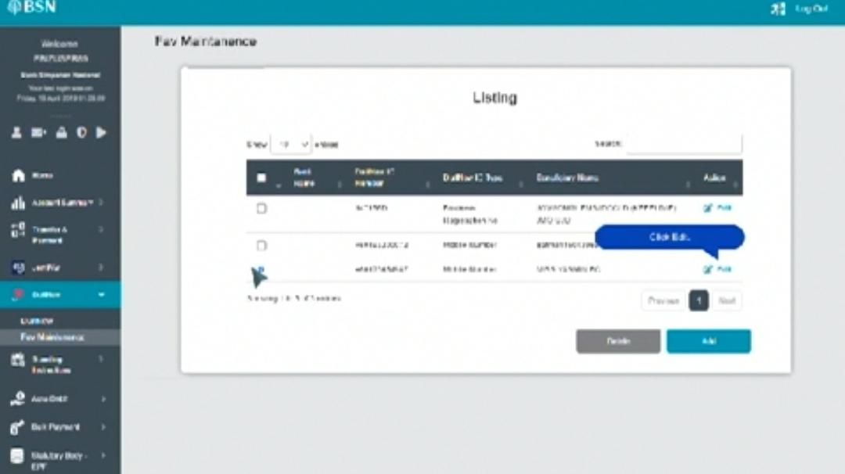

* No need to select checkbox
* Fit text with dialog box

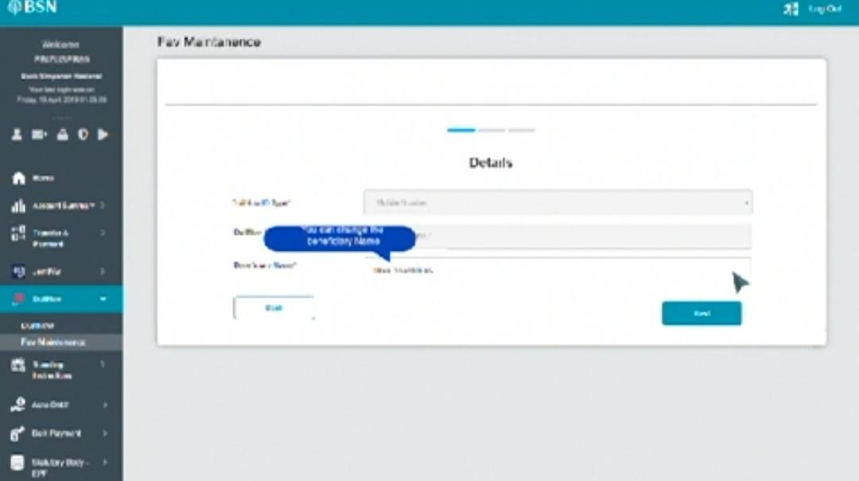

* Fit text with dialog box

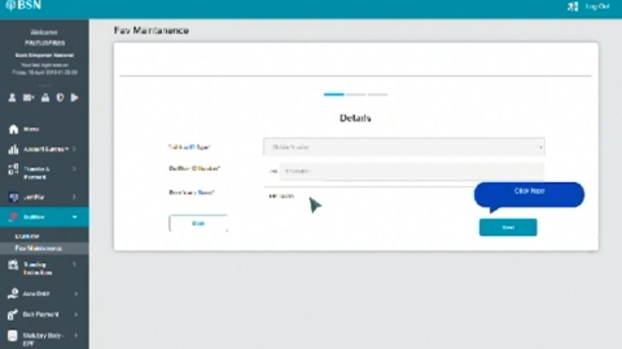

* Fit text with dialog box

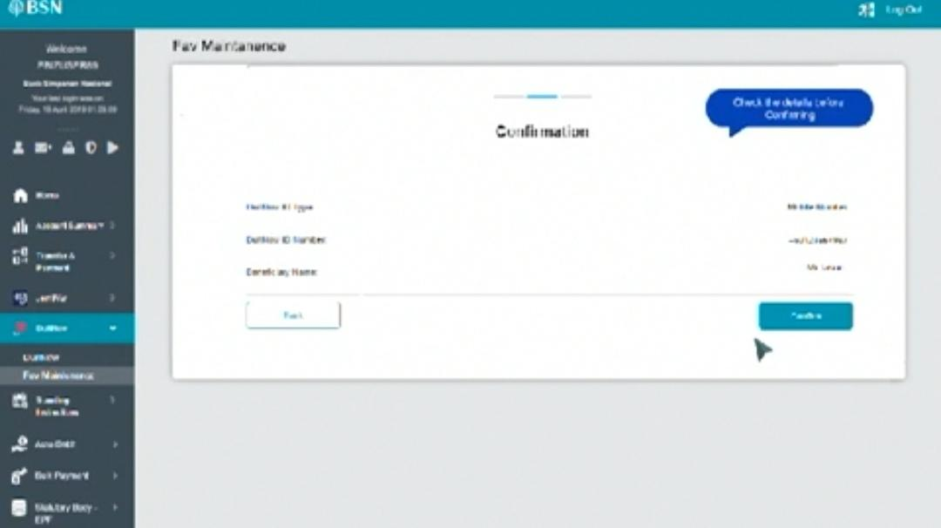

* Use round rectangle not dialog box (standardize with others)

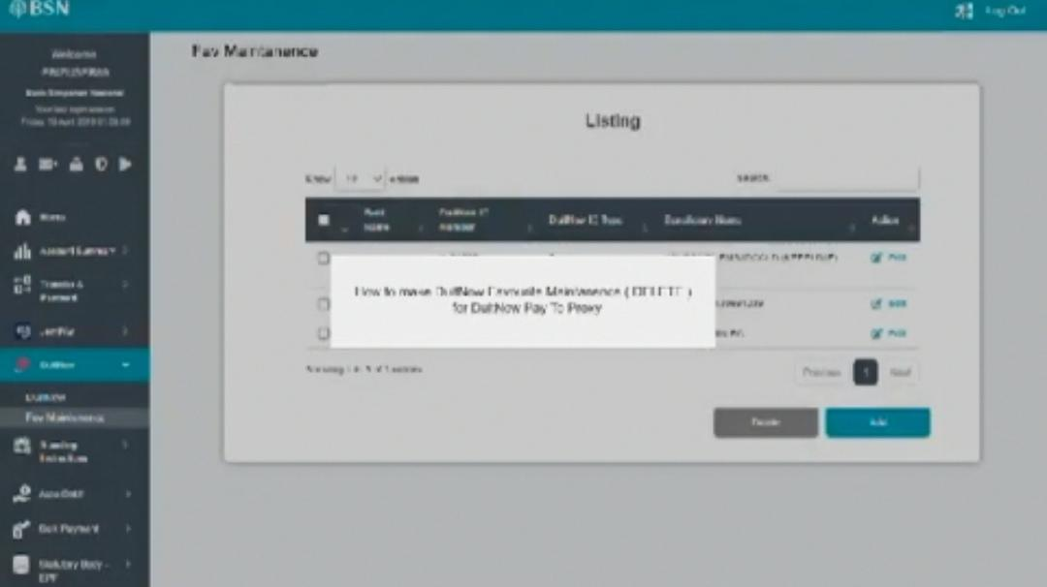

* How to delete favourite DuitNow ID

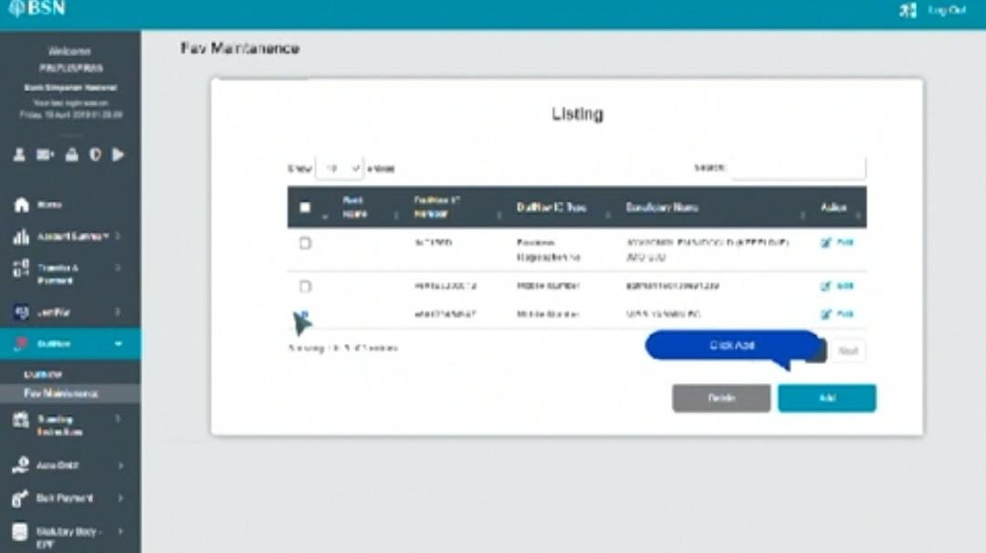

* Adjust the transition to select checkbox and put dialog "Select DuitNow ID"
* Fit text with dialog box

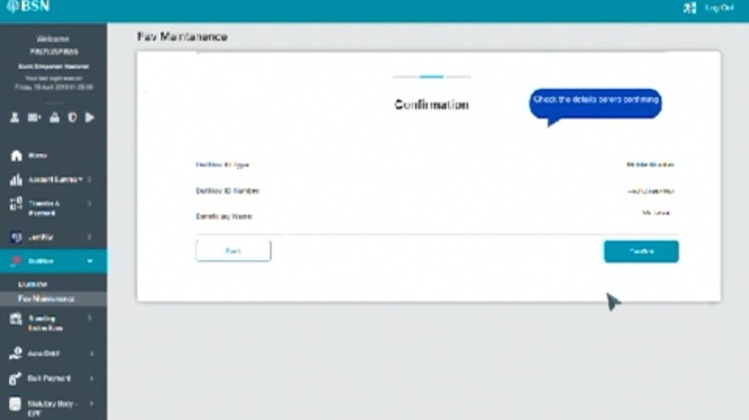

* Use round rectangle not dialog box (standardize with others)

Video (NAD): <https://drive.google.com/file/d/1Kf9QUBVkbij2R9w4lHADTjYP9KweSj5K/view?usp=drivesdk>

\*readjust keyframes to avoid time delay

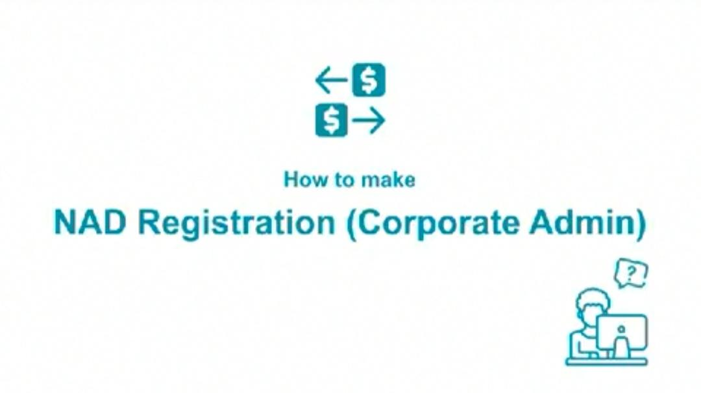

* Change logo

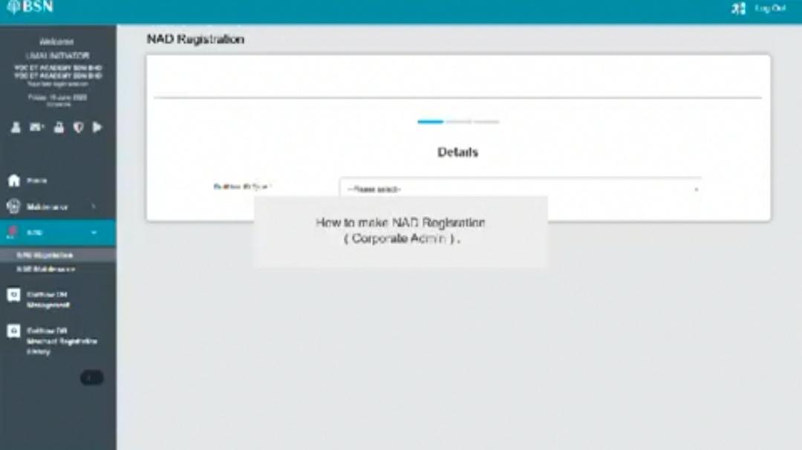

* Dim background

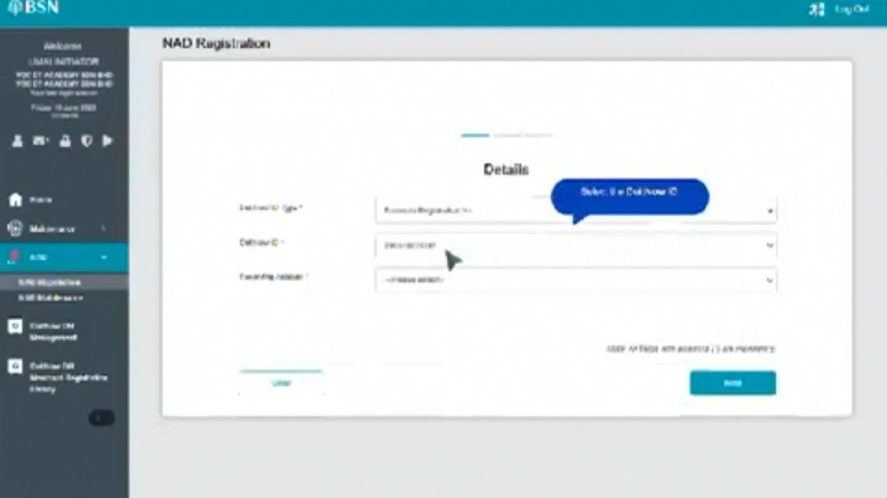

* Adjust the keyframes

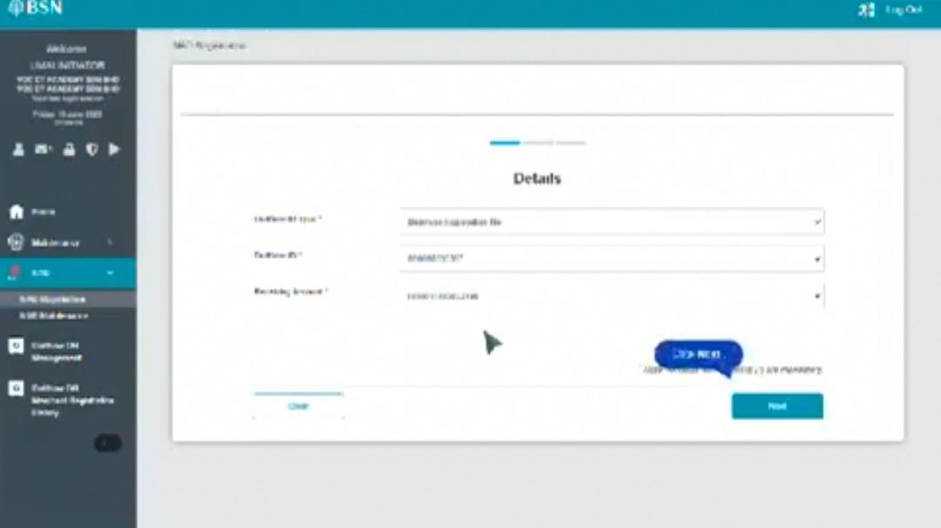

* Title "NAD Registration" not same as previous screne

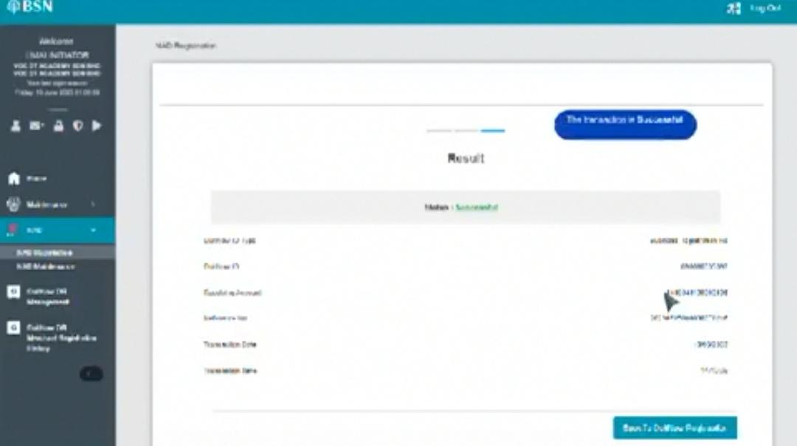

* Fit text with box

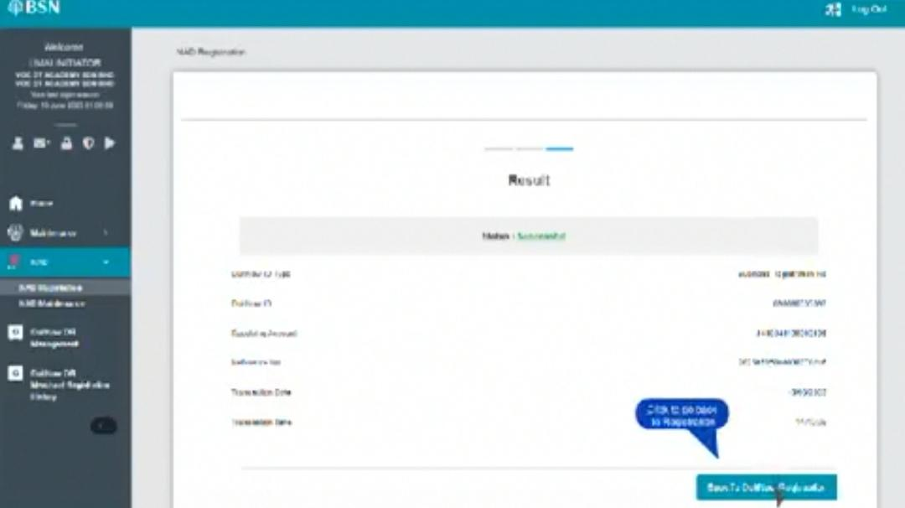

* Standardize dialog box design



* Remove the closing scene

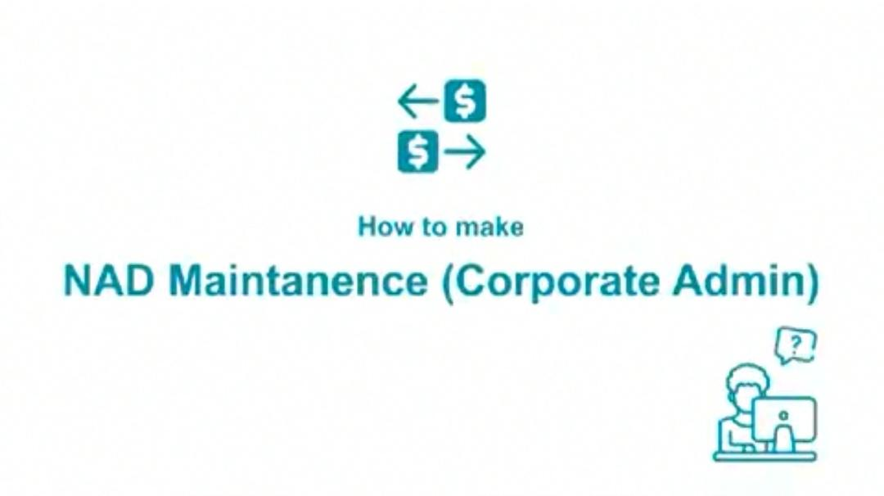

* Logo
* How to perform NAD Maintenance

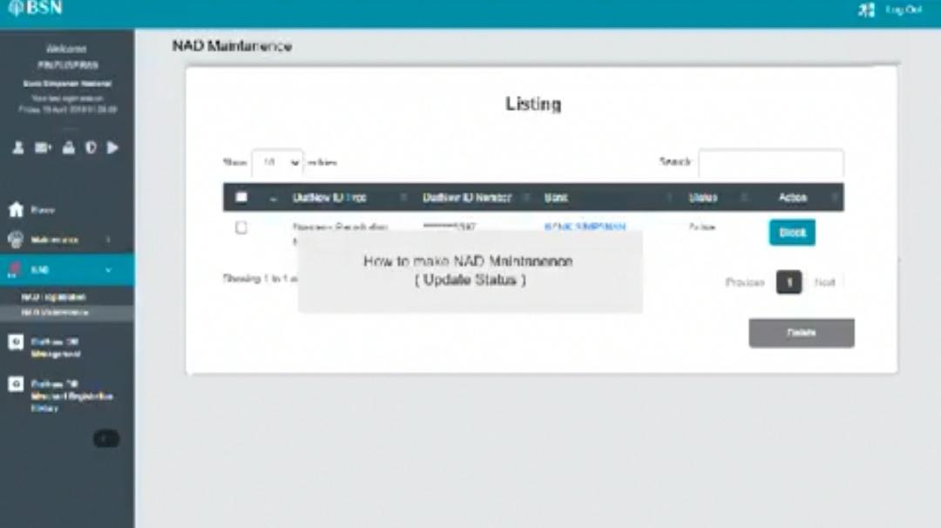

* Dim background
* How to update DuitNow ID status
* Can add notes: block for active, unblock for suspended

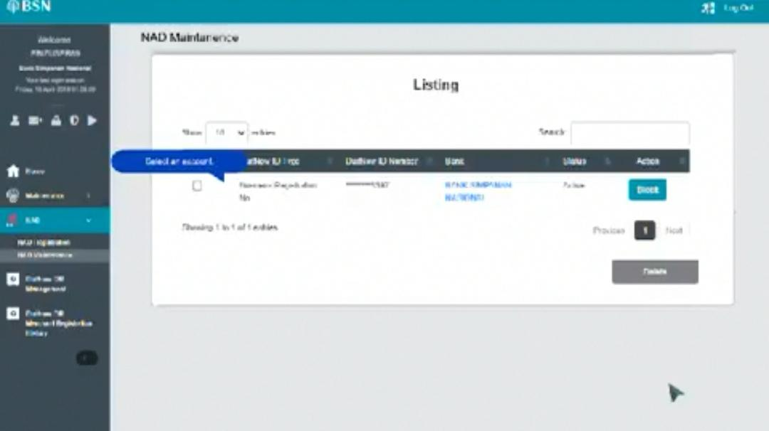

* Position dialog box and fit with text
* Block/unblock no need to select checkbox

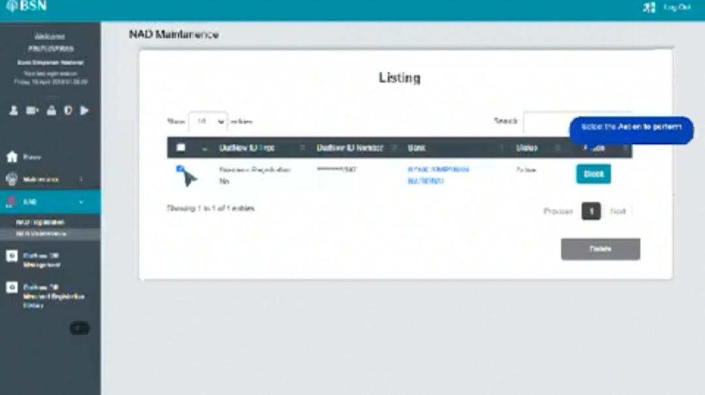

* Fit text with dialog box

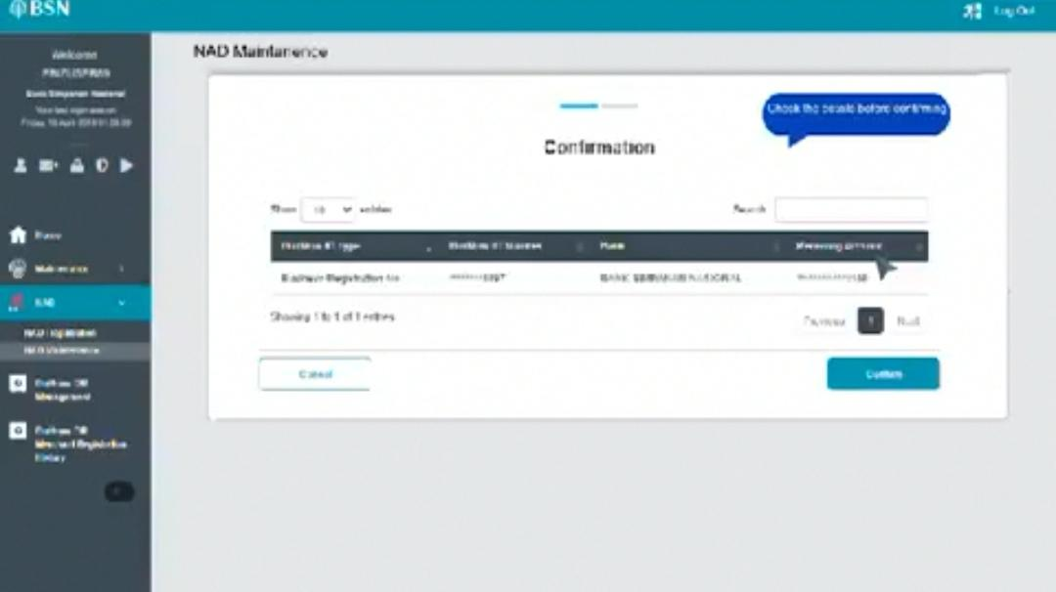

* User round rectangle not dialog box

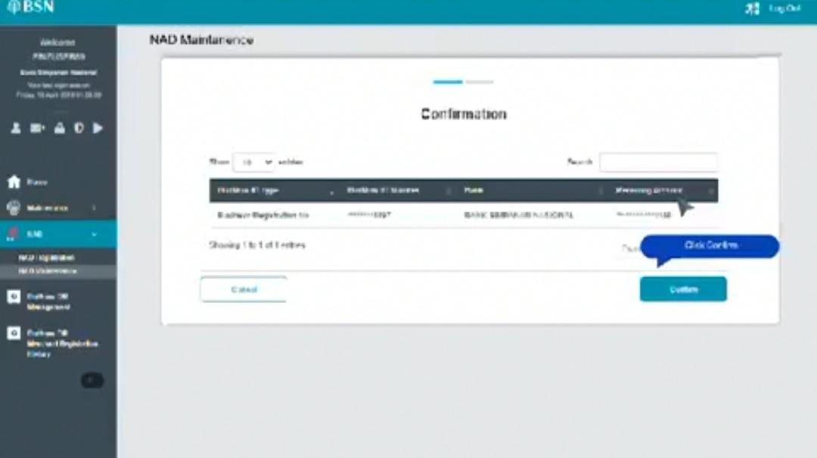

* Fit text with dialog box

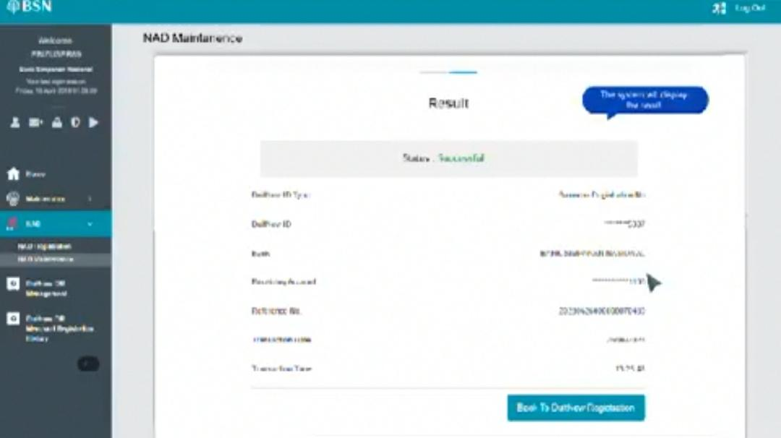

* Use round rectangle not dialog box

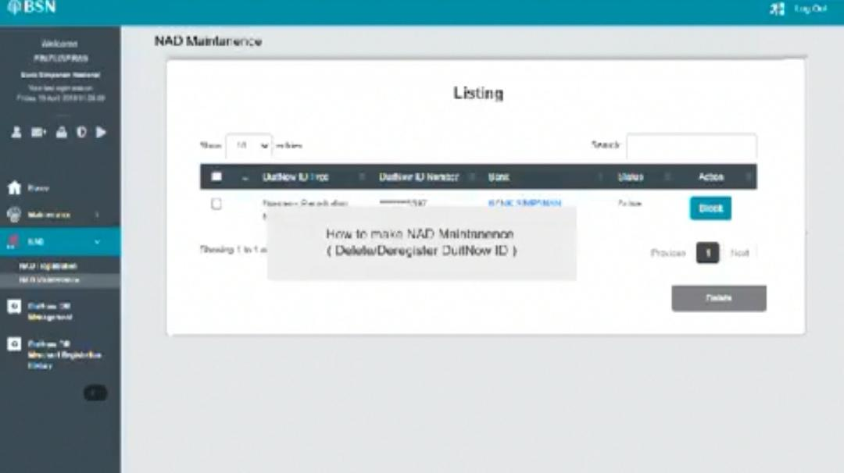

* Dim background
* How to delete DuitNow ID



* Position dialog box and fit with text

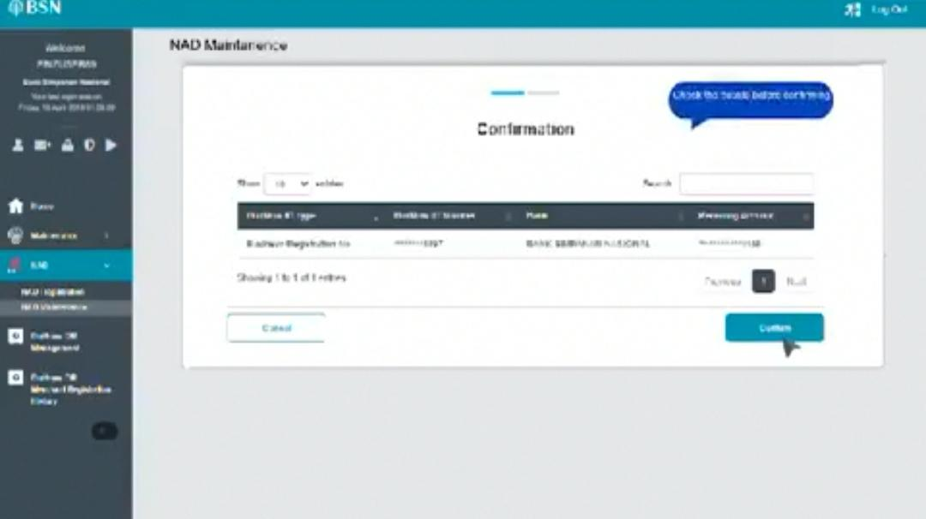

* Use round rectangle not dialog box

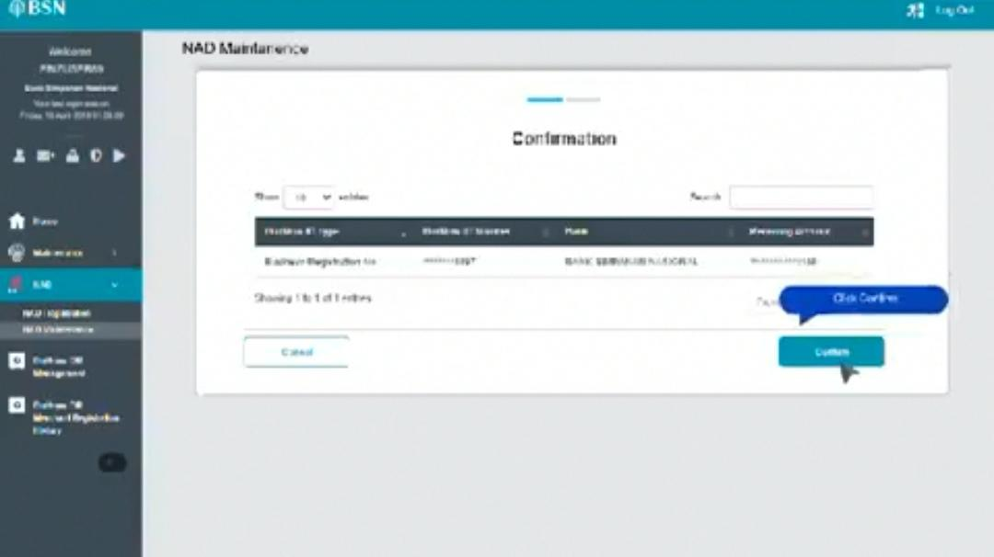

* Fit text with dialog box

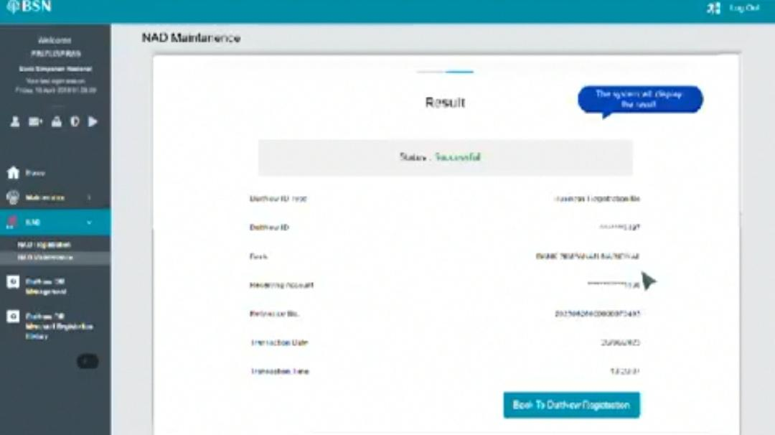

* Use round rectangle

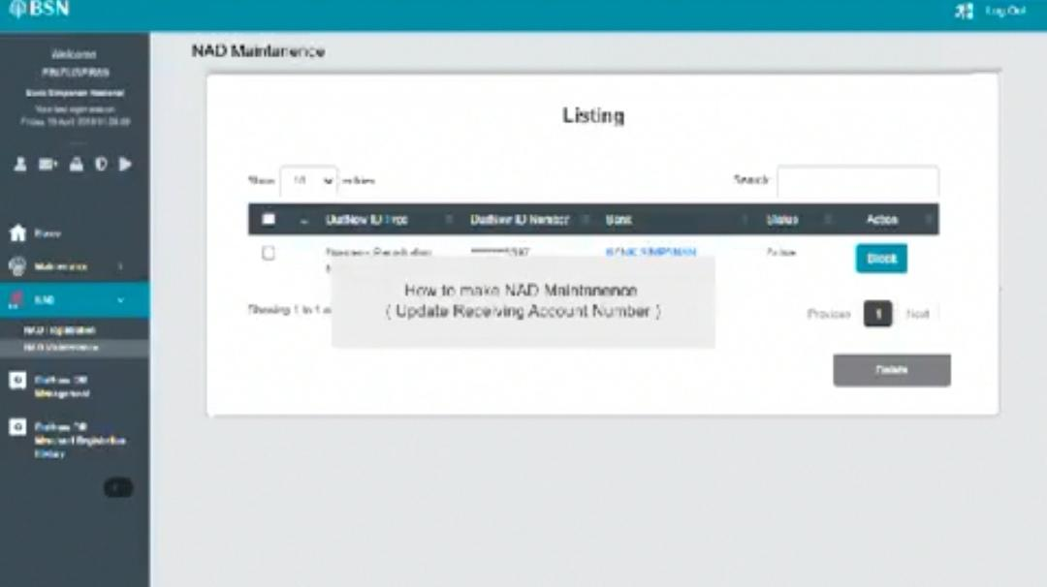

* Dim background
* How to update receiving account number or
* How to update/switch receiving account number
* Can add notes: the difference between update account number and switch account

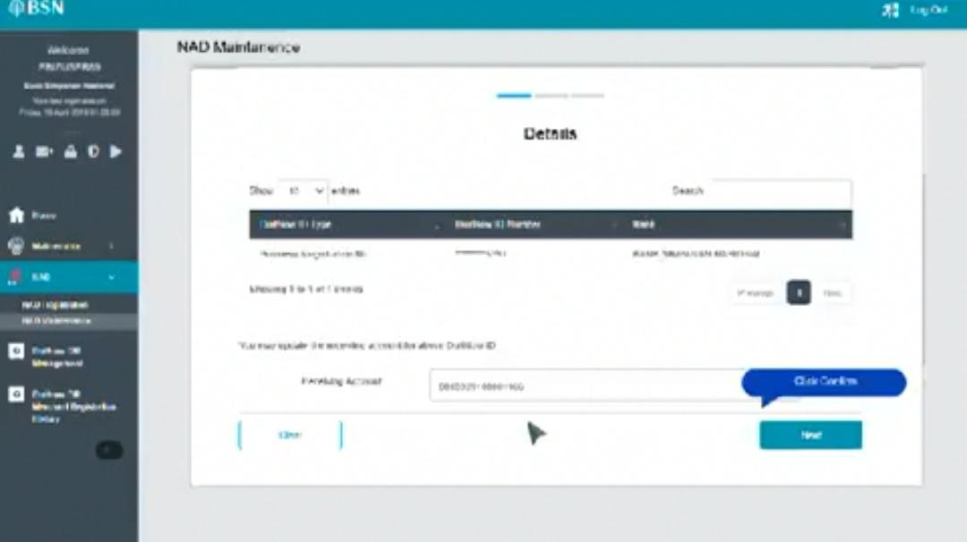

* Fit text with dialog box

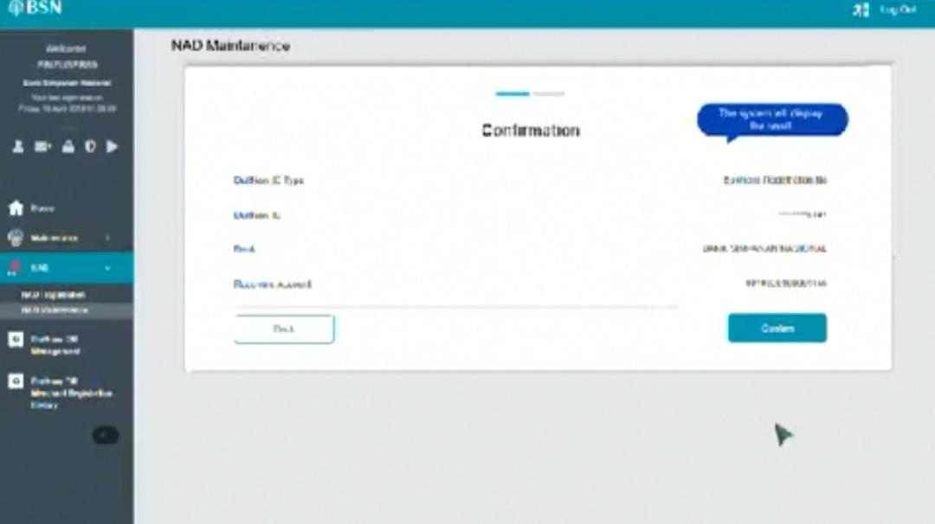

* Use round rectangle

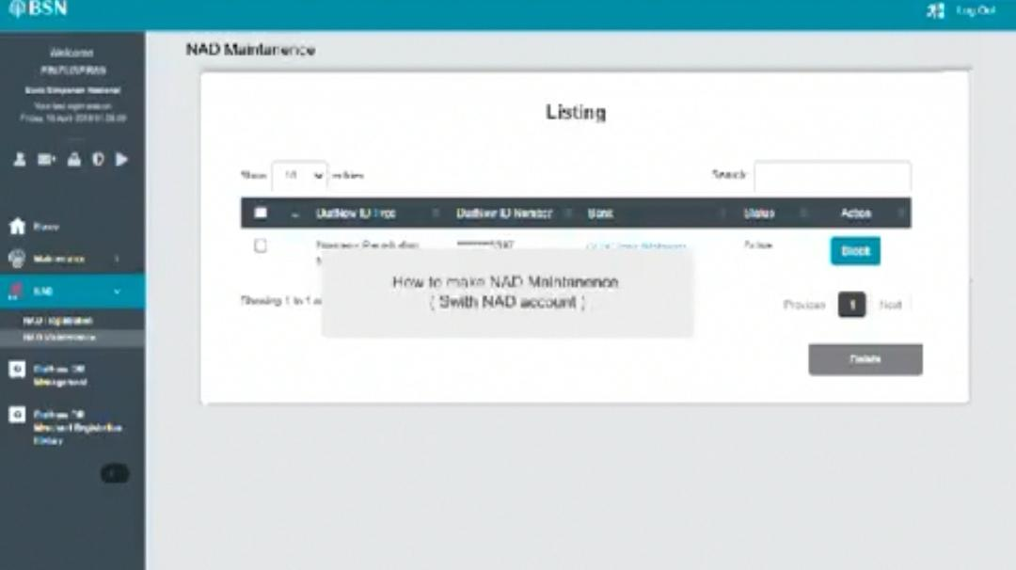

* Dim background
* How to switch NAD account

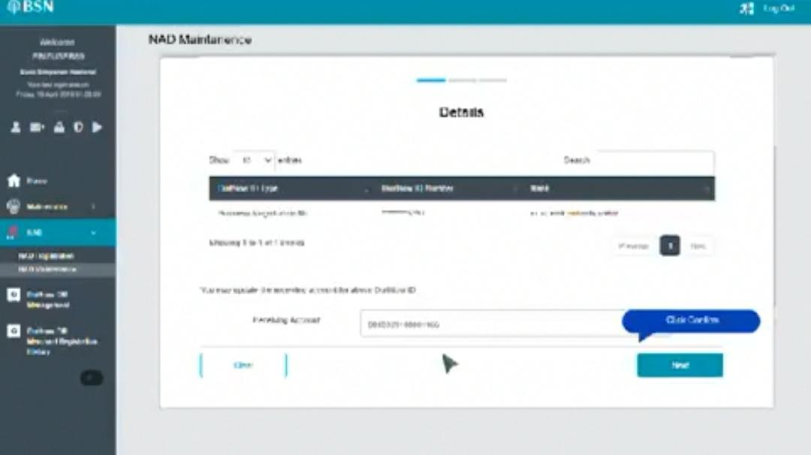

* Fit text with dialog box

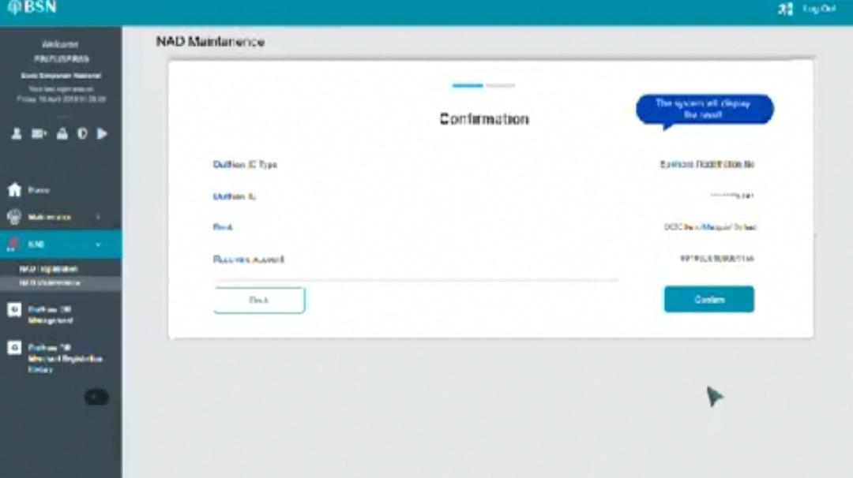

* Use round rectangle