Internal Testing – Error Result

## SOW01.1: To enhance on existing BSNeBiz - New Application Form

|  |  |
| --- | --- |
| Description/ Error | Currently: ZAKAT field will be display when user checked on Auto Debit or Bulk Payment.  Previously: ZAKAT is under Statutory Body  * to be confirm with En Rahmat (umai) |
| Suggestion to be fixed | Spacebar between Statutory Body and “i” icon. |

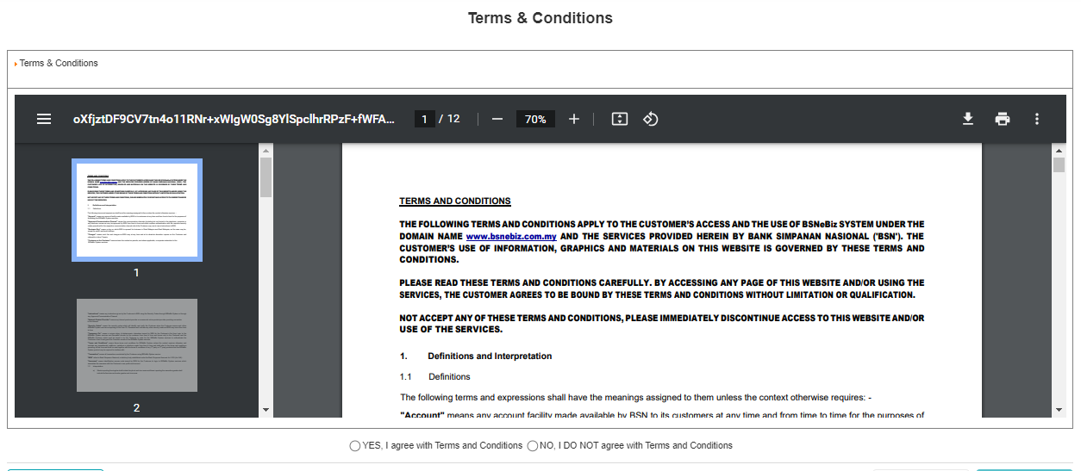

|  |  |
| --- | --- |
| Description/ Error | Is this the latest T&C? |

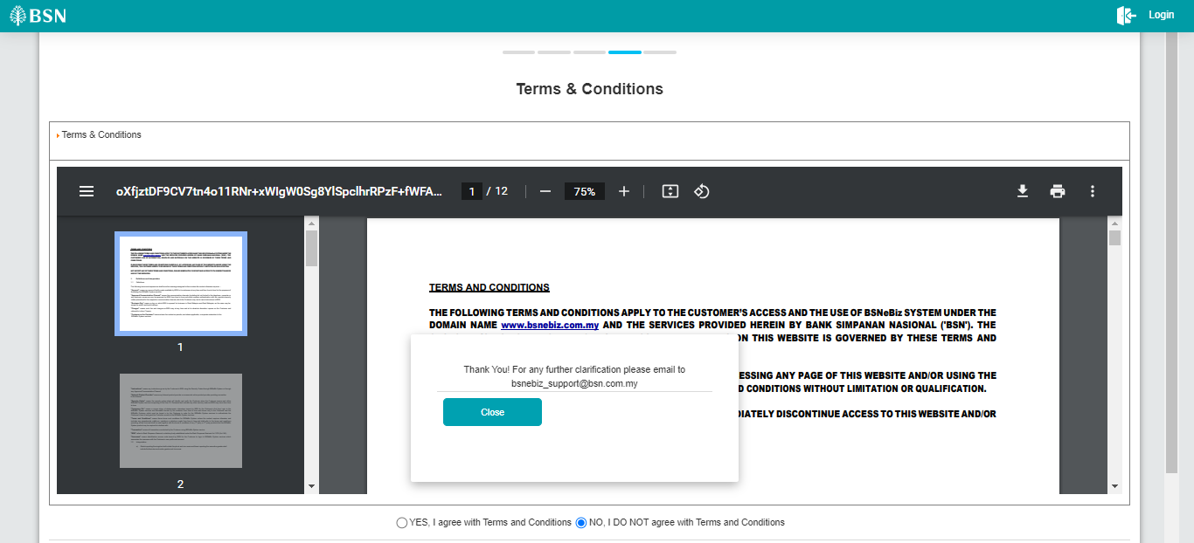

|  |  |
| --- | --- |
| Description/ Error | Scrollbar at pop up screen not at main screen. |
| Suggestion to be fixed | Should be scrollbar at main screen. Pop up screen static. |

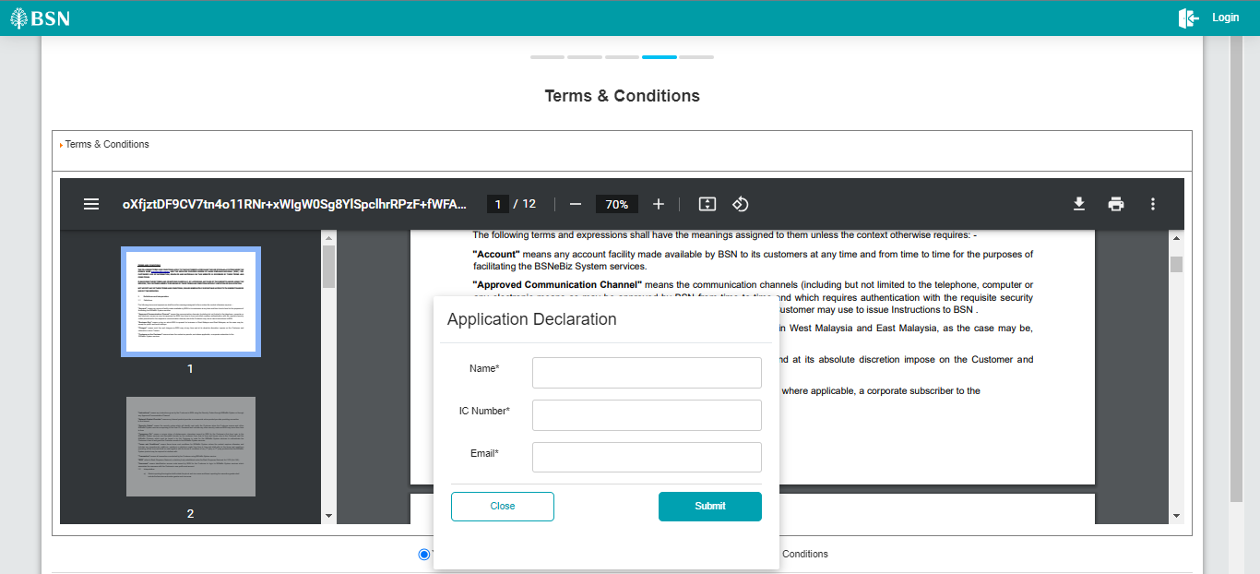

|  |  |
| --- | --- |
| Description/ Error | 1. Scrollbar at pop up screen not at main screen. 2. Able to submit application declaration many times. 3. No error message if leave empty in mandatory field. 4. Unable to display back application declaration if click “close” because system still checked on “Yes,…” |
| Suggestion to be fixed | 1. Should be scrollbar at main screen. Pop up screen (Application Declaration) static. 2. System checked on “Yes,…” and disable button after submit application declaration. 3. Display error message. Ex: “*Name is required.*” 4. System unchecked the radio button. Suggest to use “Back” instead of “Close”. Close already used in “NO, I DO NOT…” that directly to login page. |

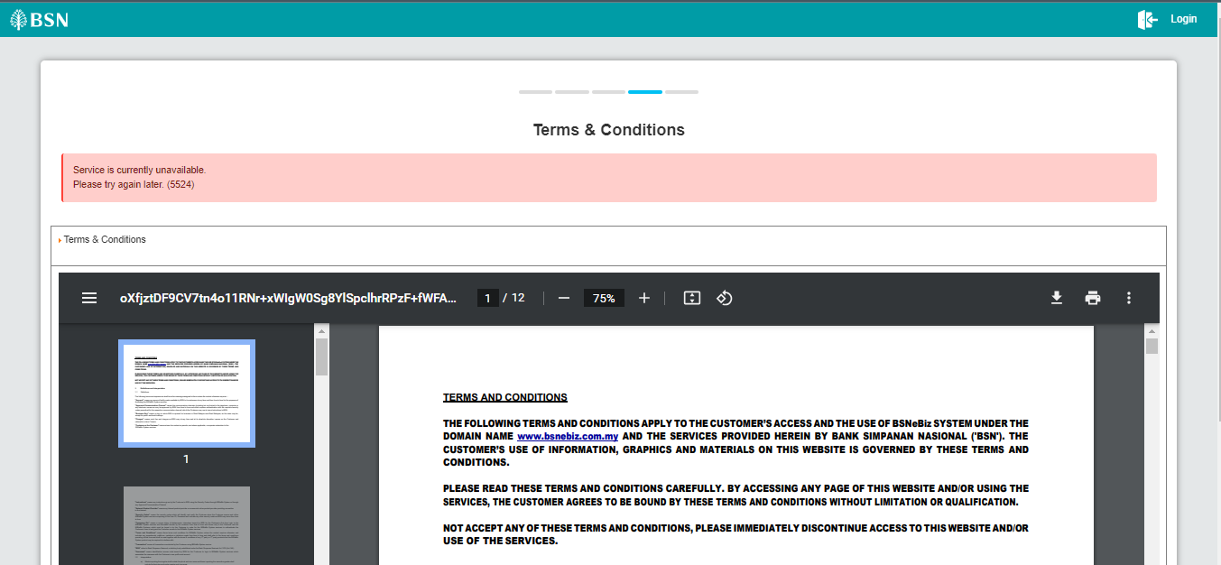

|  |  |
| --- | --- |
| Description/ Error | Display error message after “Submit” on application declaration. |

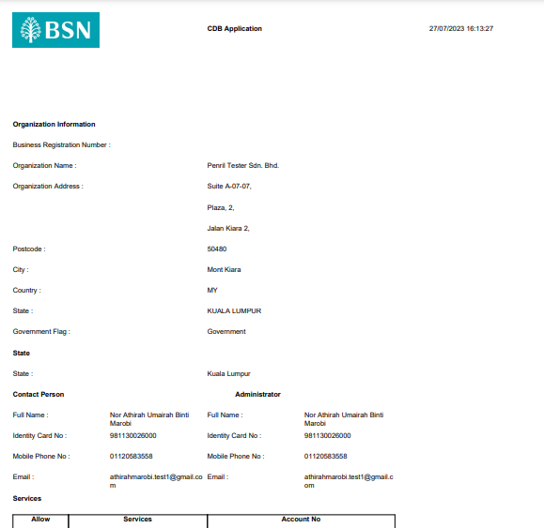

|  |  |
| --- | --- |
| Description/ Error | 1. Layout (maybe need to verify by BSN later) 2. Information in Application Declaration empty |

|  |  |
| --- | --- |
| Description/ Error | Email not display |



|  |  |
| --- | --- |
| Description/ Error | Display this error when click on “Save and Download”.  First testing – ok can download  Second testing – Error |

## SOW01.2: To replace “Terms and Conditions” navigation with “Fee & Charges” at BSNeBiz Login Page

|  |  |
| --- | --- |
| Description/ Error | Fee & Charges document still pending JPD to provide. |

## SOW01.3: To enhance on existing BSNeBiz - First Time Login (FTL)

|  |  |
| --- | --- |
| Description/ Error | Need to add “eye” icon on new password and confirm new password. |

|  |  |
| --- | --- |
| Description/ Error | Incorrect message display |

|  |  |
| --- | --- |
| Description/ Error | Incorrect message display |