Video: <https://drive.google.com/file/d/16A6k_5SEQgVXMLdunbG5tJC3m-OkeKNQ/view?usp=drivesdk>

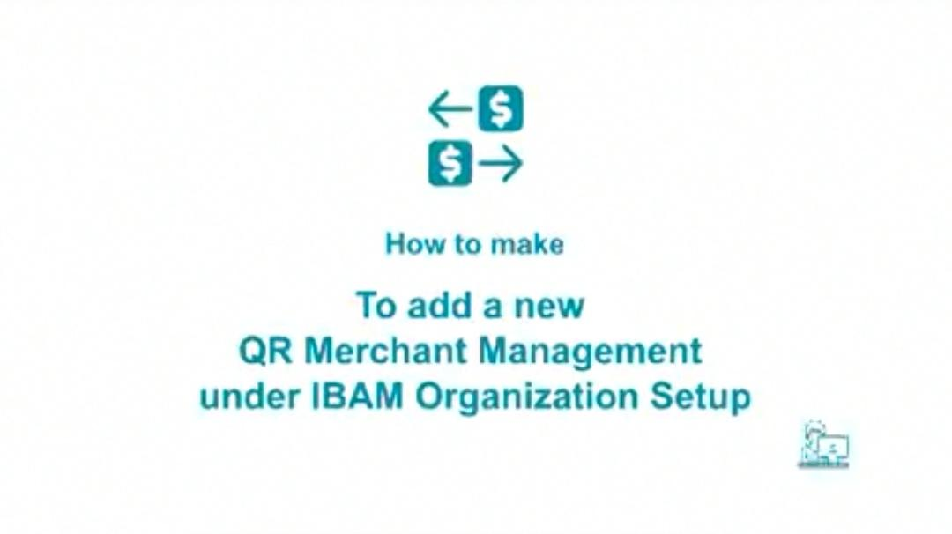

Change title and logo. DuitNow QR Merchant Management in IBAM

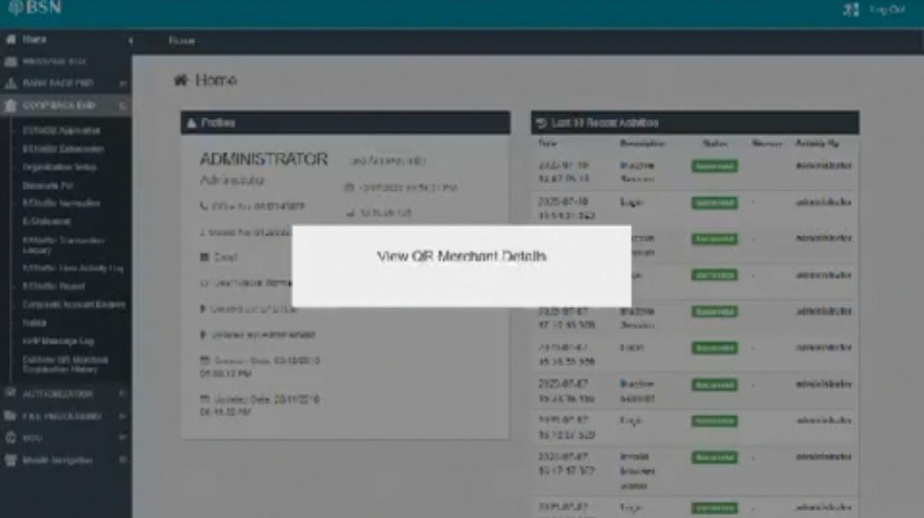

How to view DuitNow QR merchant details

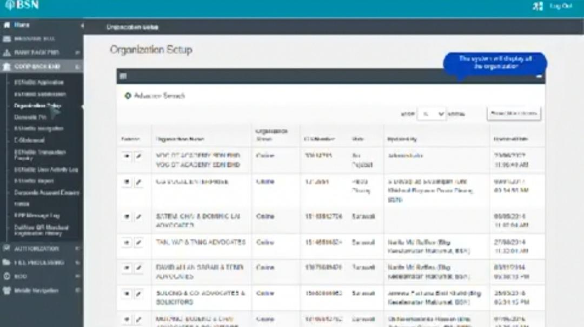

For statement/notes, suggest to use round rectangle. Dialog box for action/instruction.

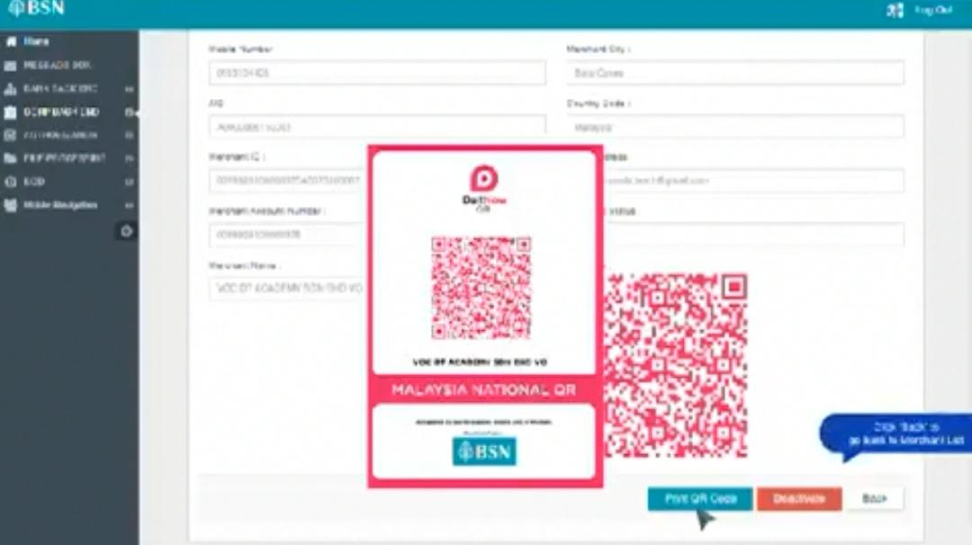

Dim background. Can enlarge image.

* Suggest to combine showing steps for activate/deactivate and add an explanation.
* New requirement: Only 1 merchant allow to be online. If add new merchant, will auto offline if have other merchant online.

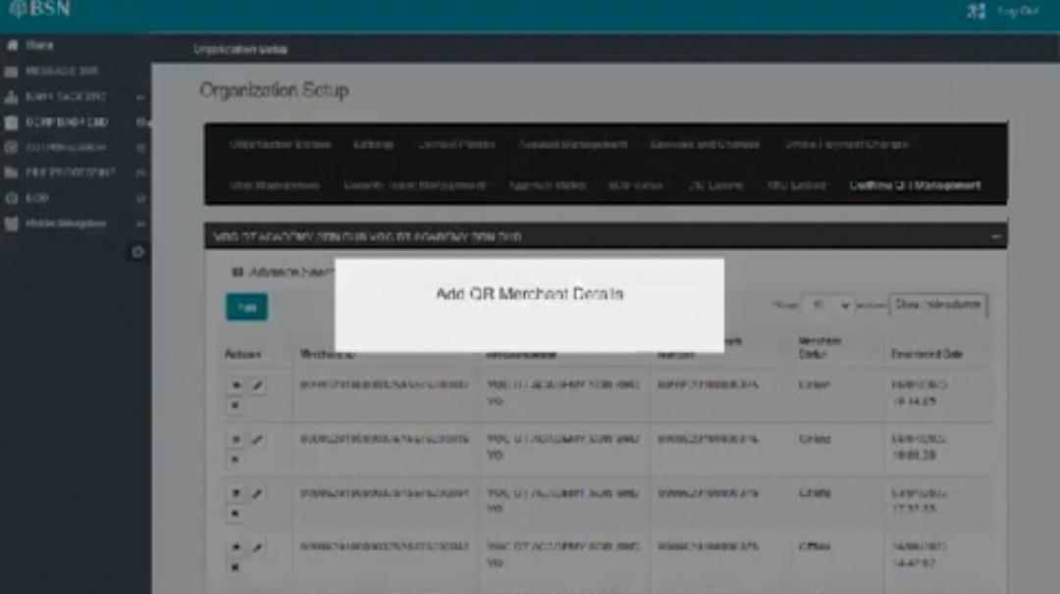

How to add new DuitNow QR merchant

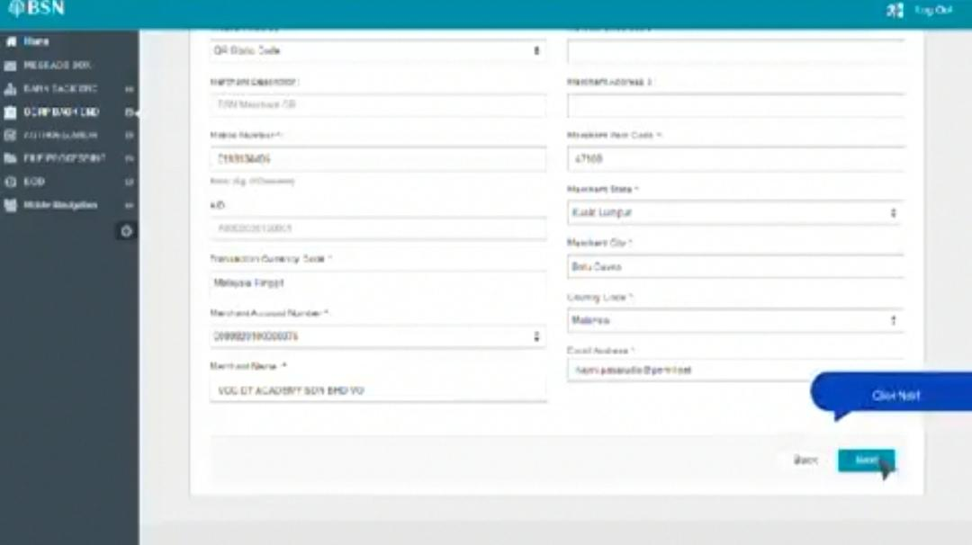

Position dialog box out of frame. Fit text.

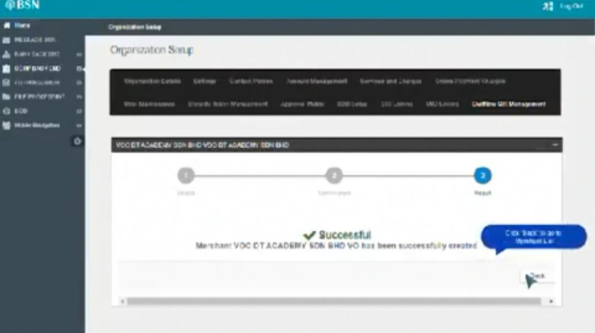

Position dialog box.

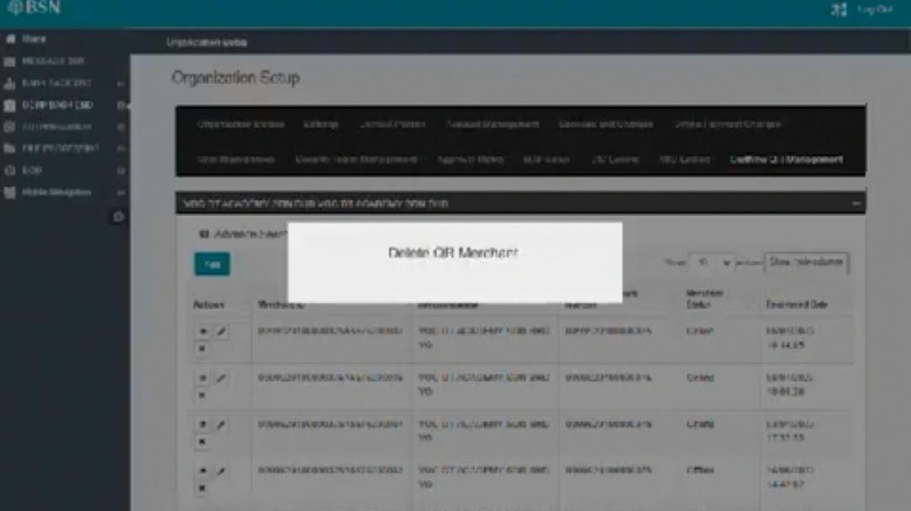

How to delete DuitNow QR merchant

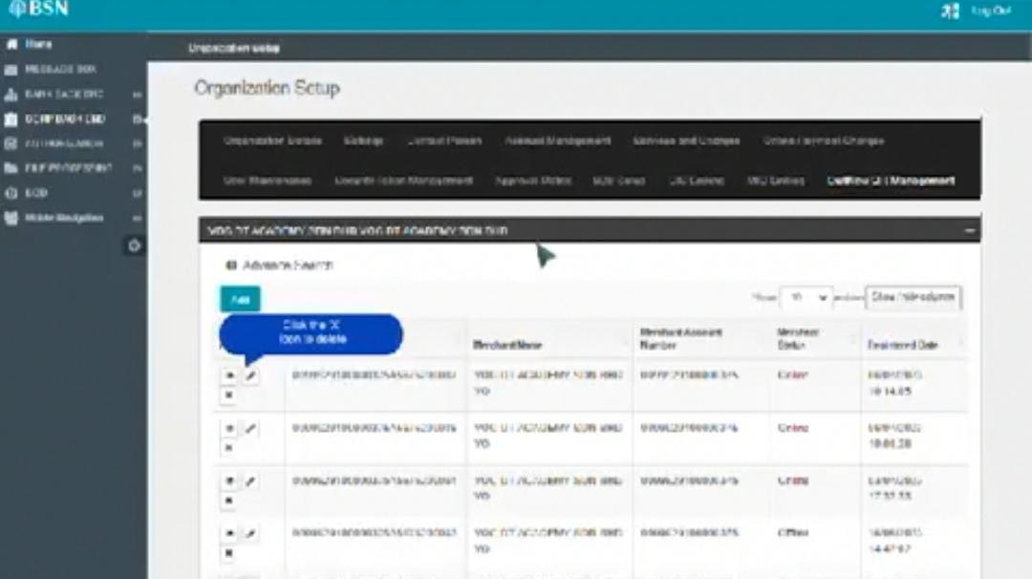

Position dialog box

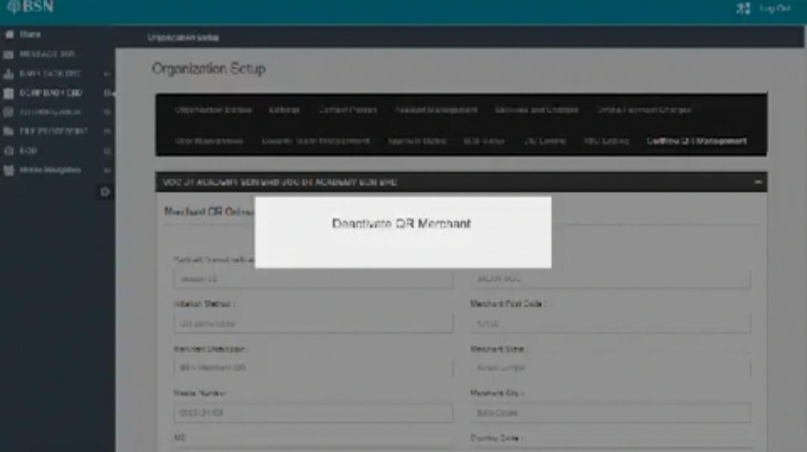

How to deactivate DuitNow QR merchant

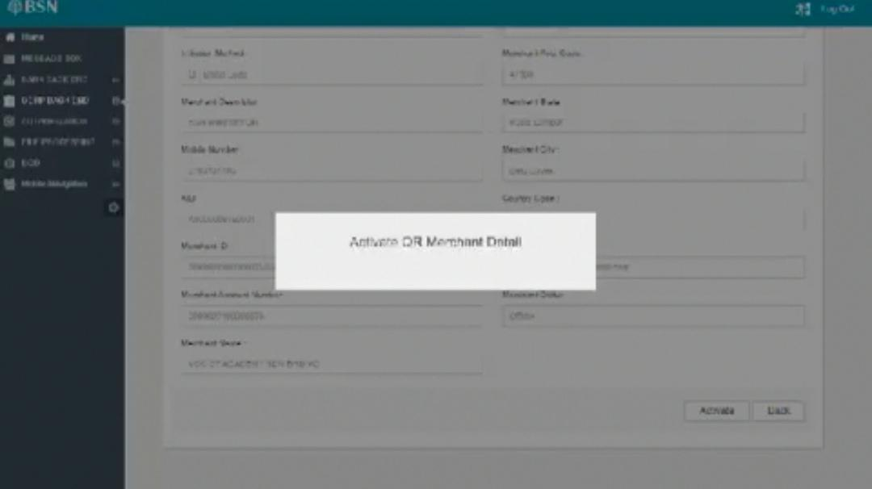

How to activate DuitNow QR merchant



Can be removed. Main opening only.

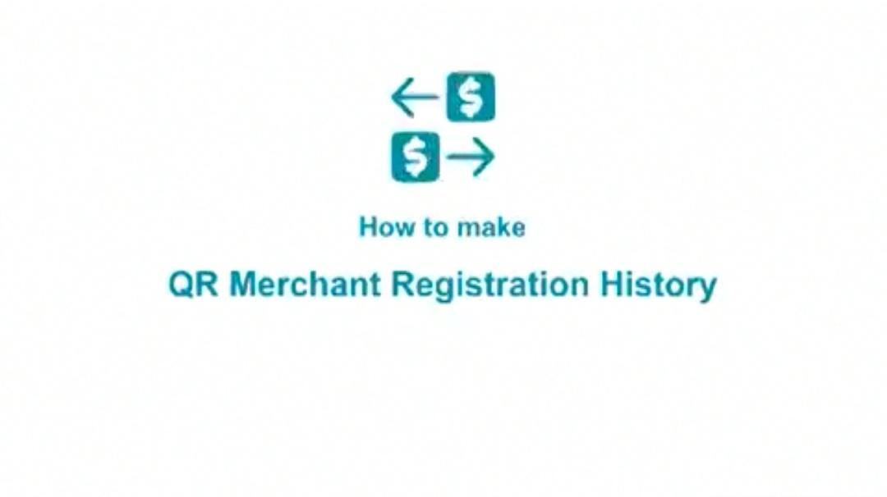

Change title. DuitNow QR Merchant Registration History in IBAM

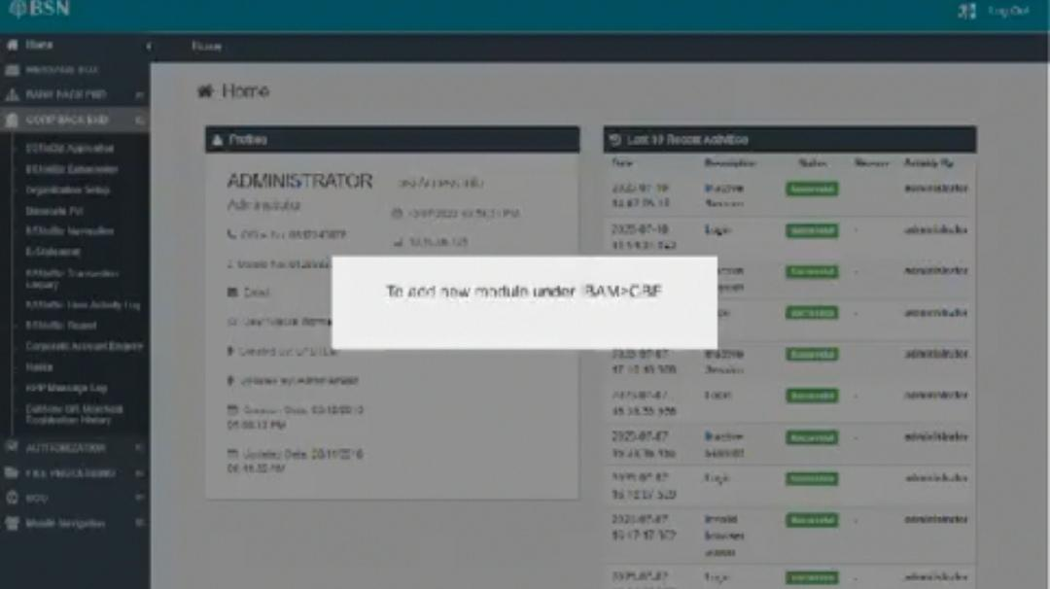

How to view DuitNow QR Merchant Registration History in IBAM

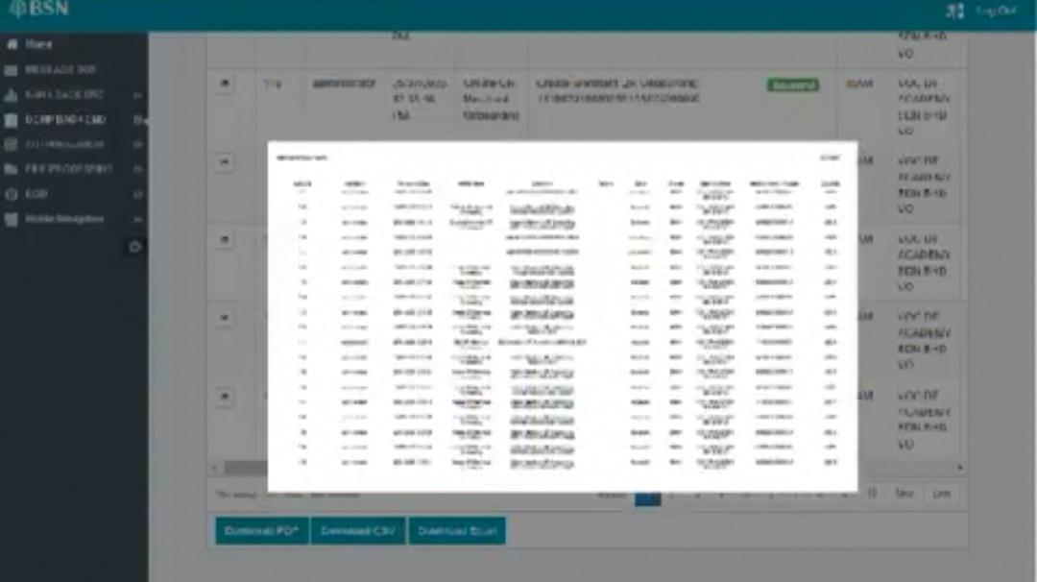

No need to display. Can only explain that user able to download in PDF, CSV, Excel file.

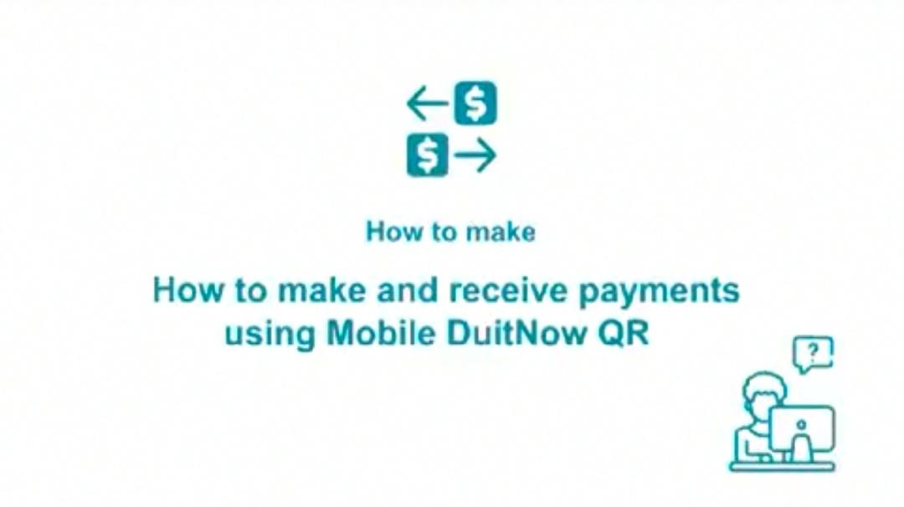

Incorrect title.

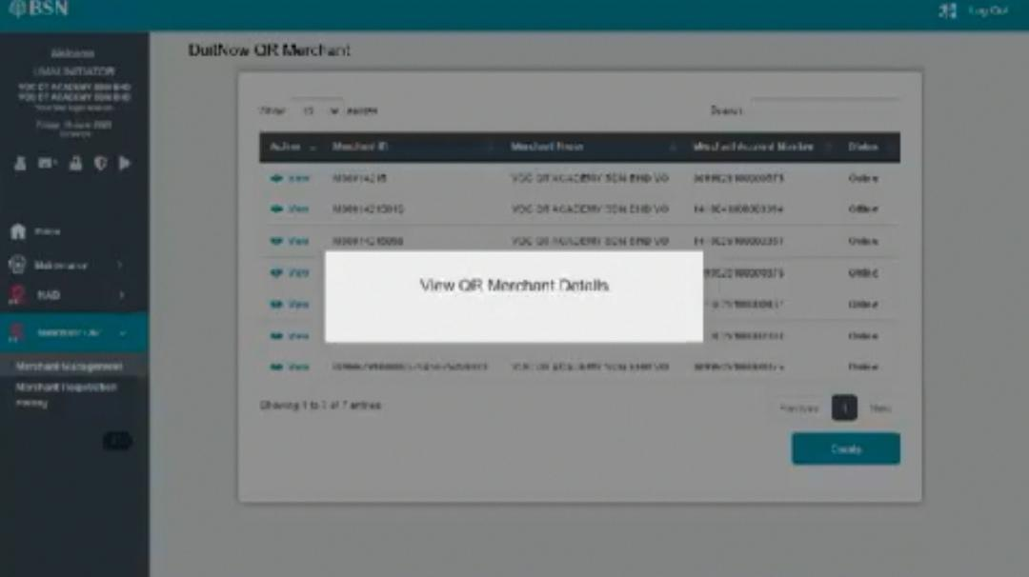

How to view DuitNow QR merchant details

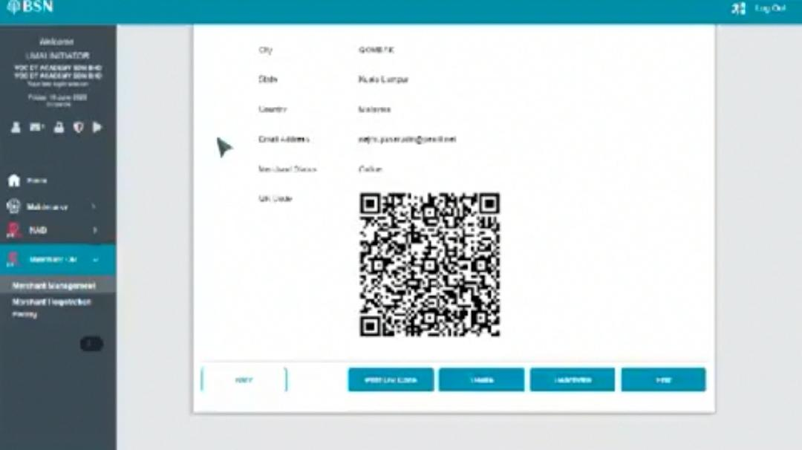

Use latest screen with magenta qr.

* Suggest to combine showing steps or add an explanation for edit, delete, activate/deactivate button

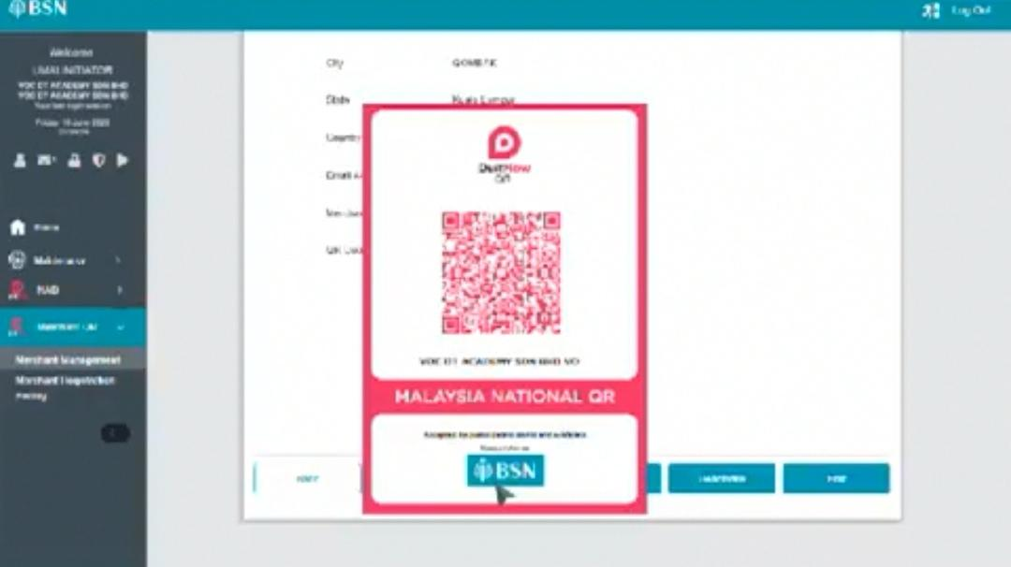

Dim background

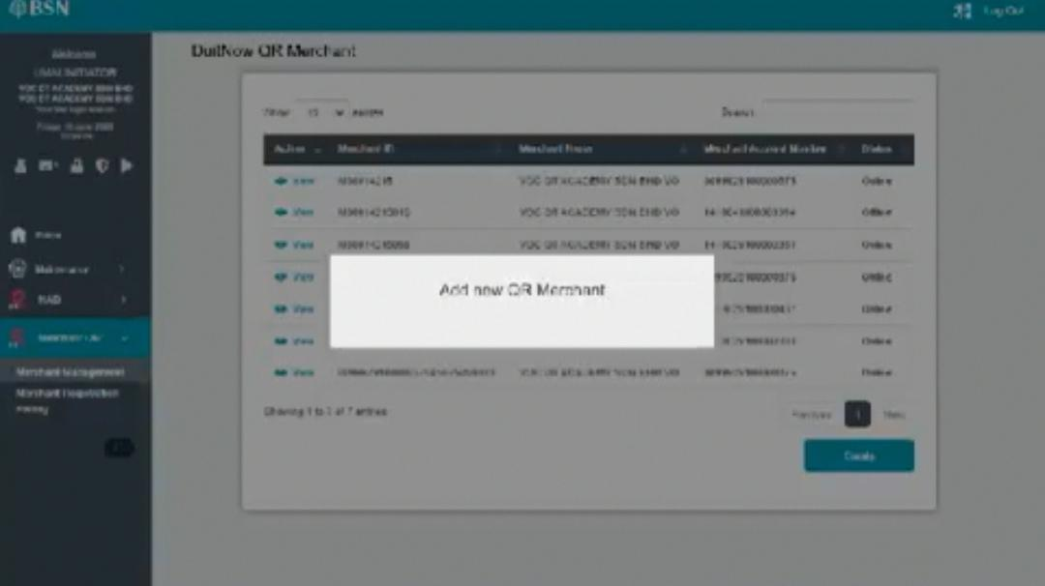

How to add new DuitNow QR merchant

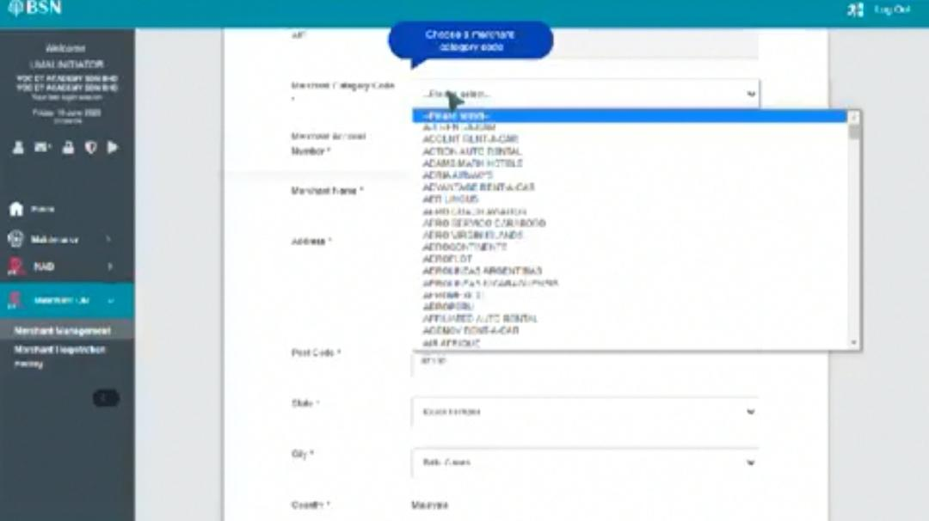

Use latest interface without merchant category code.

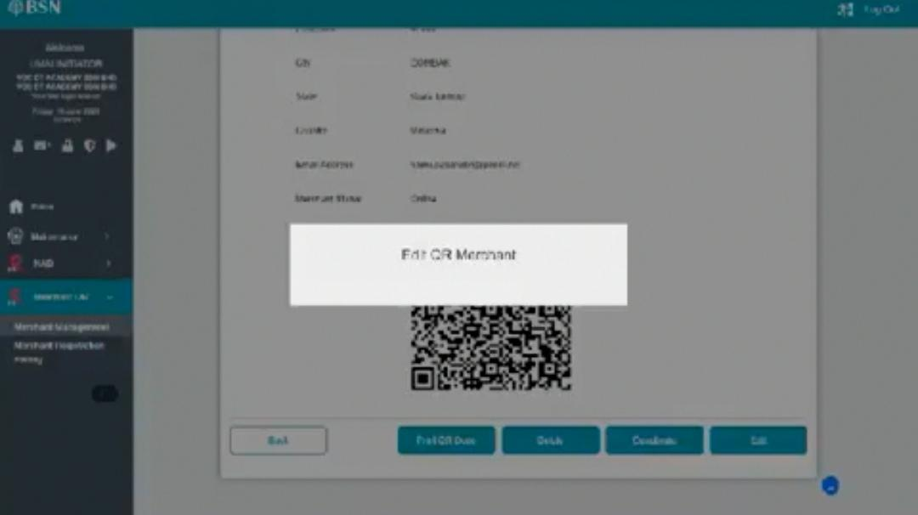

How to edit DuitNow QR merchant

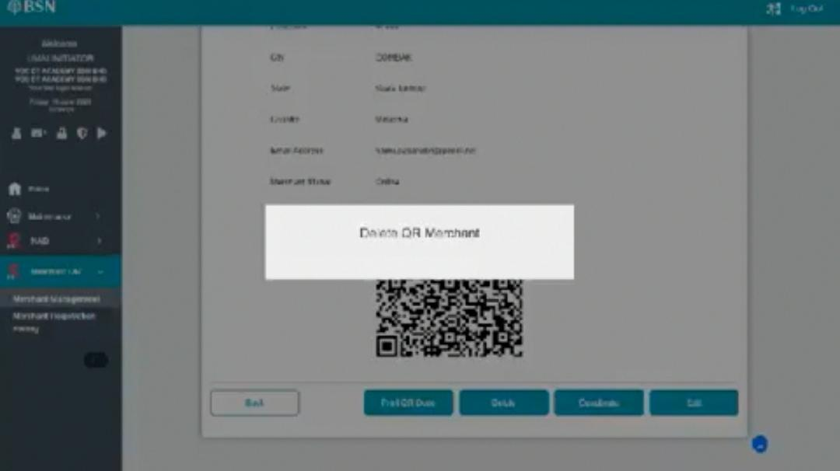

How to delete DuitNow QR merchant

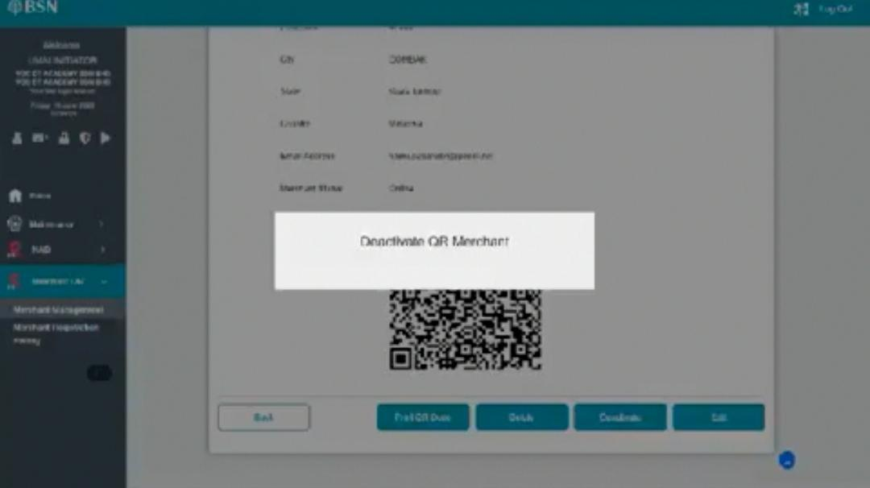

How to deactivate DuitNow QR merchant

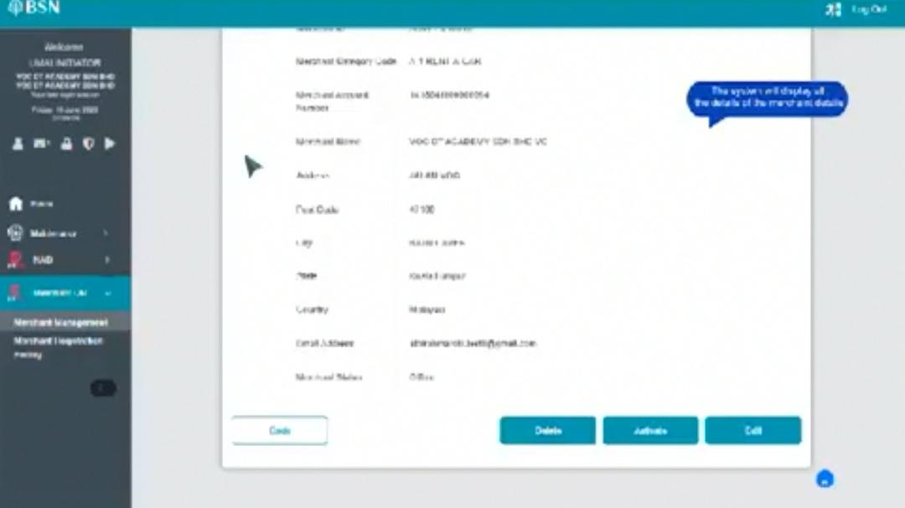

Use round rectangle. Adjust scrolling keyframes to avoid time delay

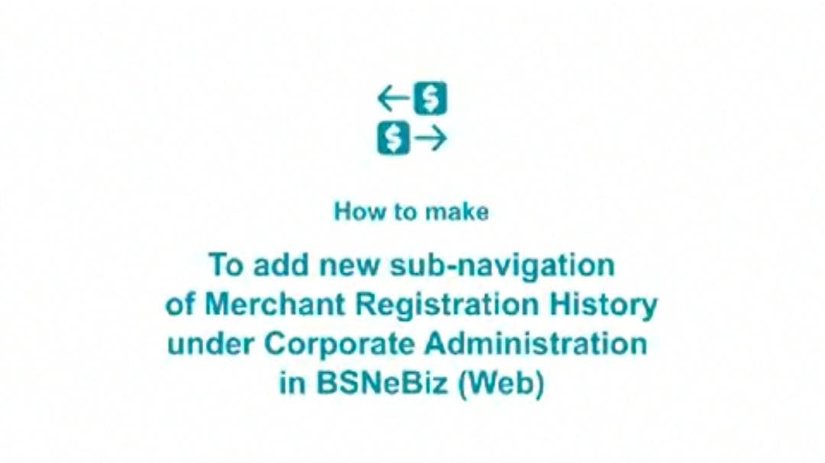

Incorrect title

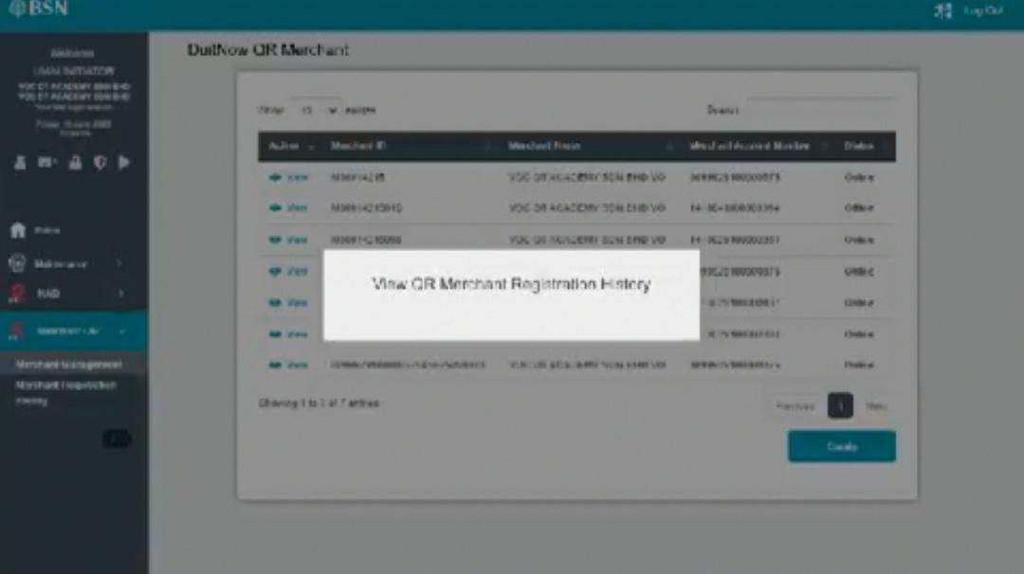

How to view DuitNow QR merchant registration history

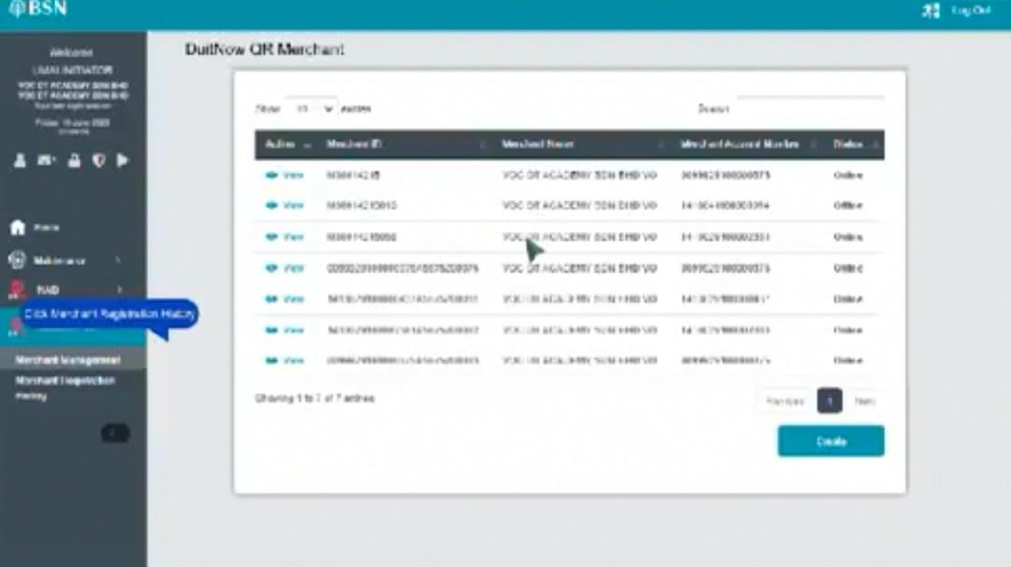

Position dialog box

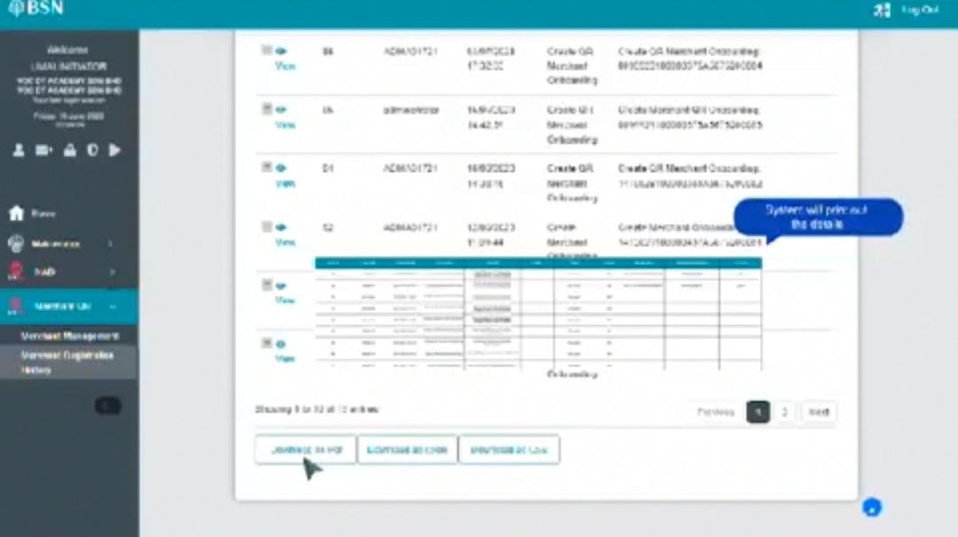

No need to display the file. Can only explain that user able to download in PDF, CSV, Excel file