Video: <https://drive.google.com/file/d/1nrn82aO4ukS8SJpHRoEqeStEFmJ4ZLWR/view?usp=drive_link>

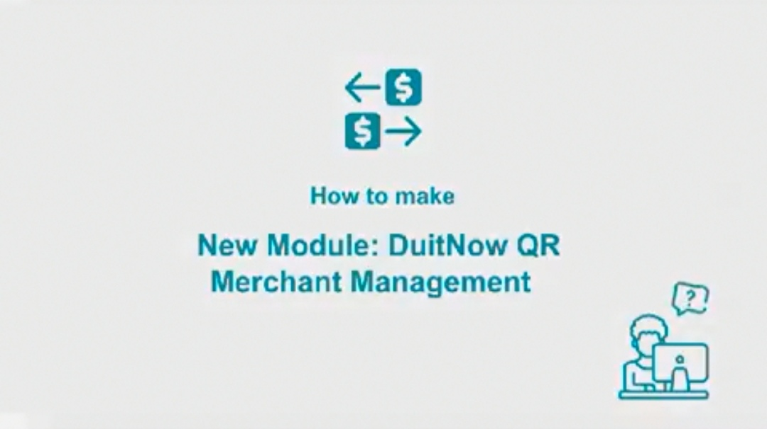

* Image: Duitnow logo
* Title: How to make and receive payments using Mobile DuitNow QR

\*add new scene: to add extra note to explain function of DuitNow QR (able to scan-make payment, receive payment, share qr)

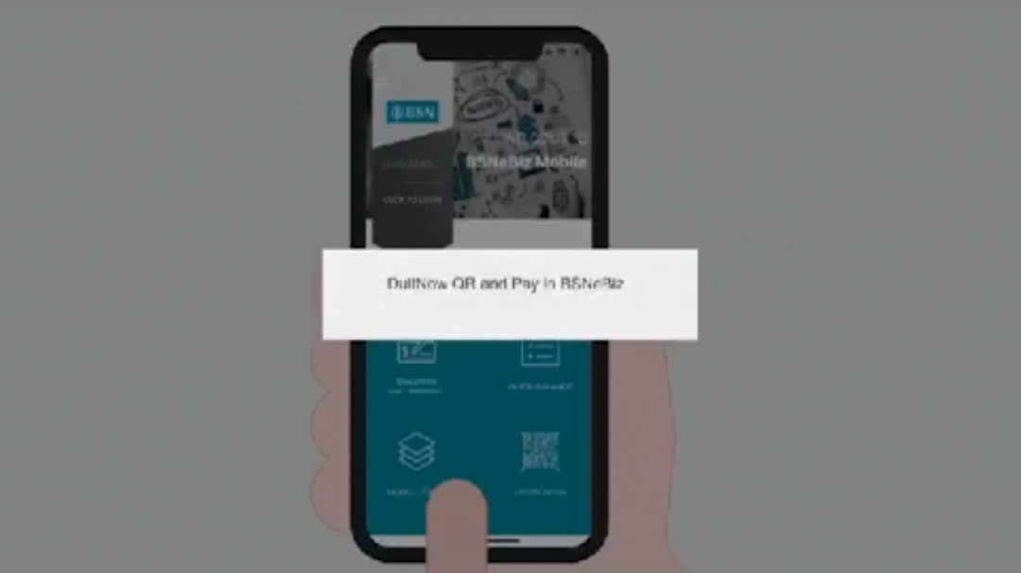

* Align the text to centre
* Use latest interface (DuitNow logo)
* Text: How to make payments with DuitNow QR

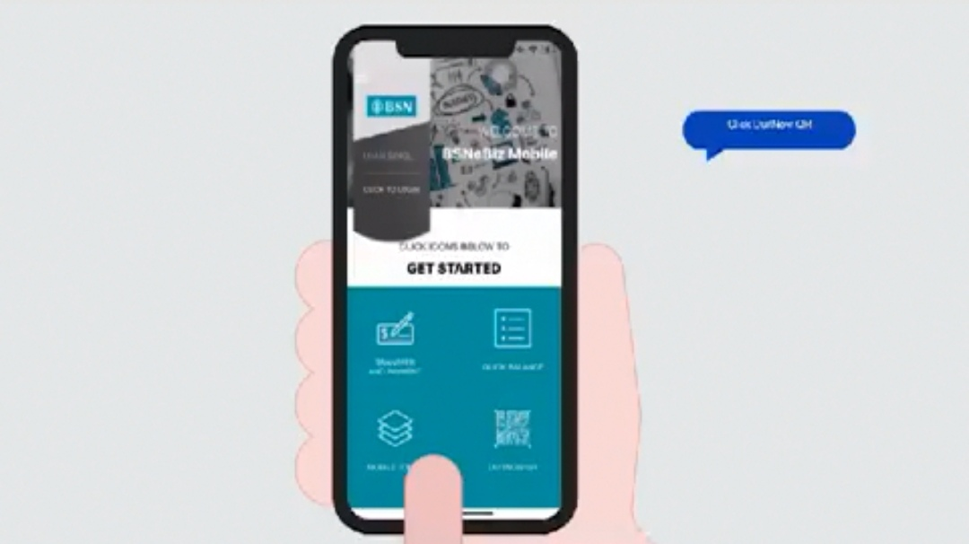

* Align the text to centre
* Use latest interface (DuitNow logo)

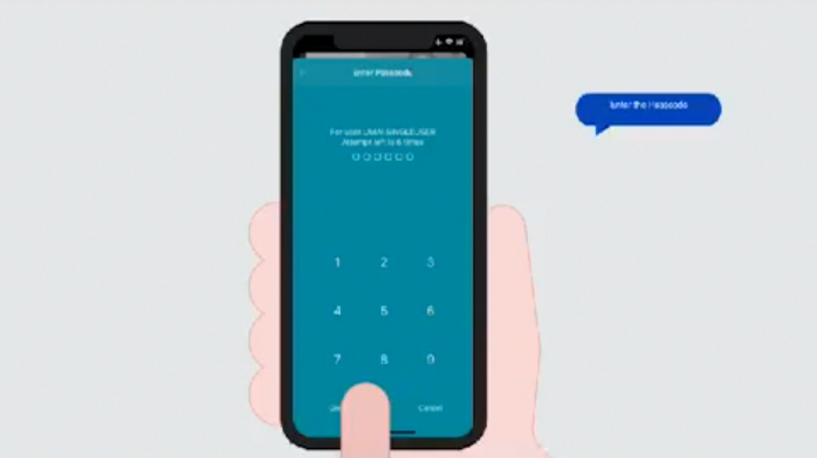

* Align the text to centre
* Resize image fit to frame
* Dot transition align with finger tap

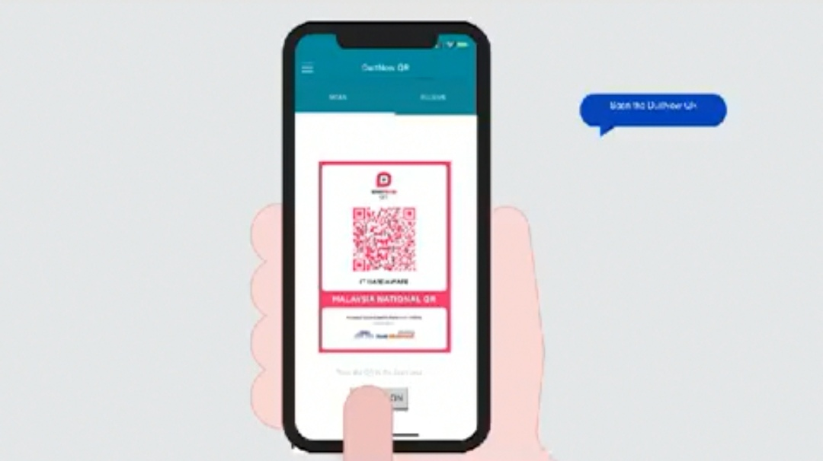

* Align the text to centre
* Show camera scanning
* DuitNow QR image on backward the phone

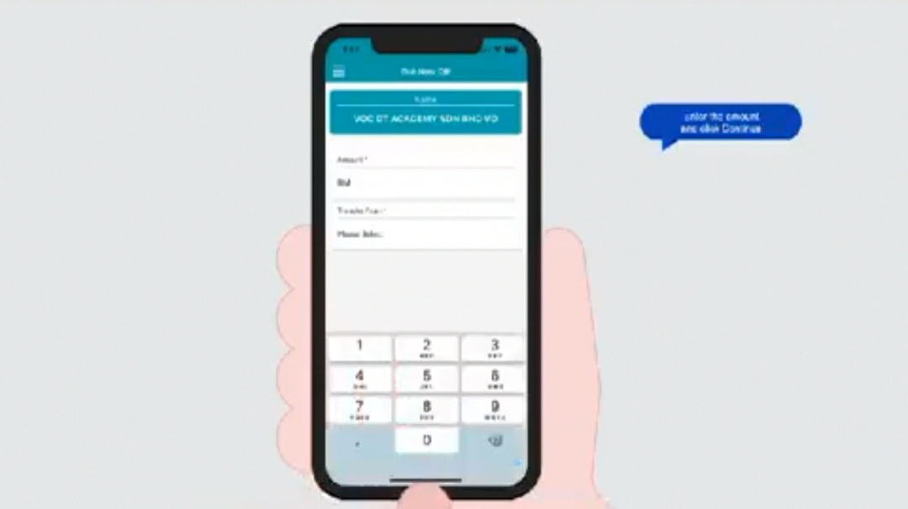

* Text transition align with finger tap
* After confirm, show the result screen

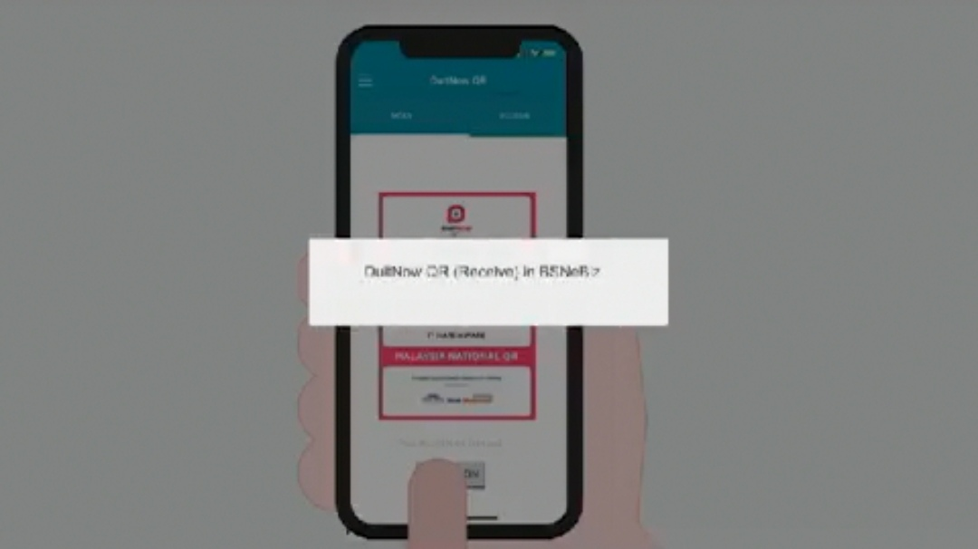

* Repeat step from homepage
* Text: How to receive payment with DuitNow QR

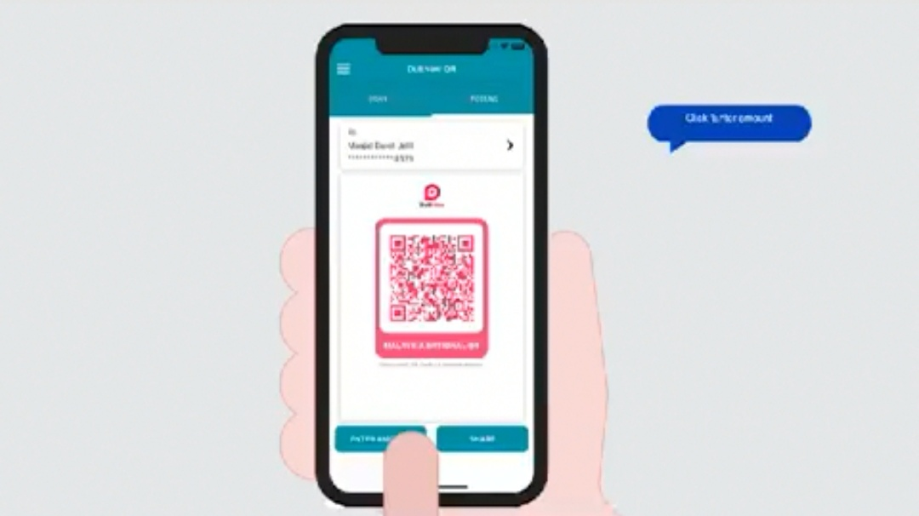

* Align the text to centre
* Add note: Select enter amount to input specific amount for receive payment. Select share to share qr code via other apps.

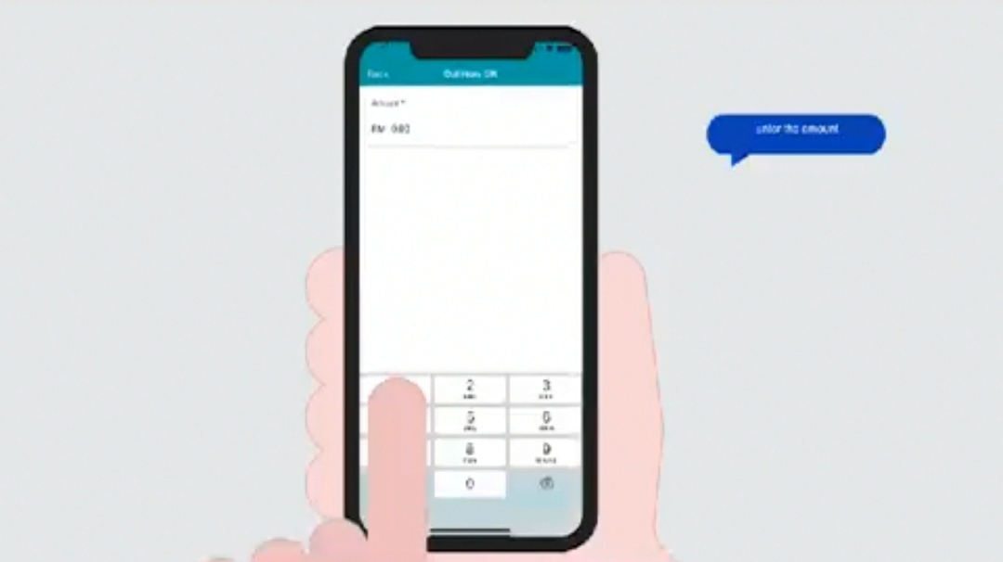

* Align the text to centre
* Text transition align with finger tap

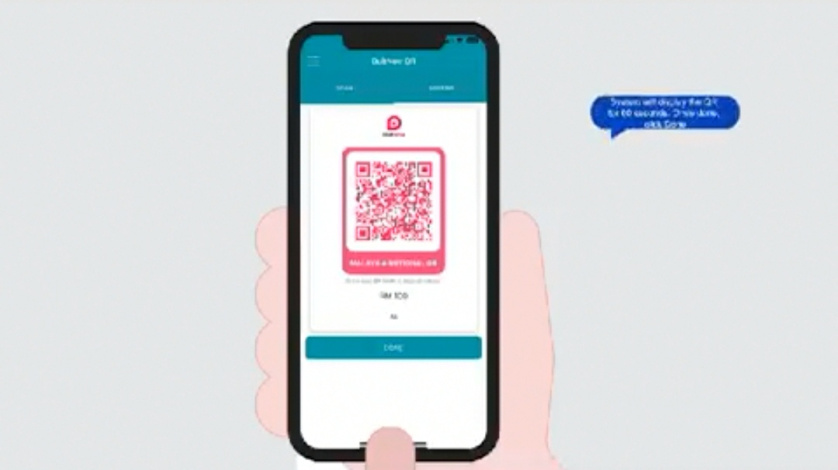

* Resize dialog box fit with text
* Tap done

\*add ending/closing sceen standardize with other previous videos