APPENDIX A

SCOPE OF WORK

DuitNow - Request To Pay
SOW | TASK | EFFORT
 |  | (Man Days)
01: DN – REQUEST TO PAY (RTP)
Remain the current structure of the Internet Banking workflow and processes, including interfaces and connections to existing third party systems.
BSNeBiz (Web)
SOW01.1 | i. DuitNow Request To Pay Module | 60 | 110
 | a) Request Payment - single (5)
 | - Request screen (Customer to insert details of request)
 | - Request to Account Number and Proxy
 | - New and Favourite request
 | b) Request Payment – Bulk (10)
 | - File upload
 | - Data Entry
 | - Bulk History
 | c) Manage Pending RTP (13)
 | - Incoming and outgoing list
 | - Action. (Include Approve, Reject, Forward and Block)
 | d) RTP History (5)
 | - List of previous transaction (exclude pending status)
 | - Allow customer to download (excel & PDF)
 | - Incoming and Outgoing
 | e) RTP Block Maintenance (3)
 | - Retrieve blocked list from DB
 | - View and unblock on the account number, proxy ID.
 | (Mobile number and Business Registration Number)
 | f) RTP Favourite Maintenance (3)
 | - Account
 | - Proxy ID
 | ii. Authorization | 30
 | Update Authorization (Verifier & Approver) module in BSNeBiz (Web) for DN – RTP
 | Cover for all action:
 | Single - New Request, Approve (Pay), Reject (Pay), Forward (Pay), Block (Pay) and Unblock.
 | Bulk - New Request
 | - Verifier
 | - Approver
 | iii. Enhancement on other related modules at BSNeBiz (Web) (13) | 20
 | a) Host Transaction History
 | Penril assumes that Host will provide different Transaction Code for any transaction related to DN RTP and the transaction description will be customised for RTP payment purpose.
 | b) BSNeBiz Transaction History
 | i. This consists of successful RTP Request
 | ii. This consists of successful RTP Update
 | iii. Block & Unblock
BSNeBiz (Mobile)
SOW01.2 | i. DuitNow Request Module (Android & IOS) | 60 | 130
 | a) Request Payment
 | - Request screen (Customer to insert details of request)
 | - Request to Account Number and Proxy
 | - New and Favourite request
 | b) Manage Pending Request
 | - Incoming and outgoing list
 | - Action. (Include Approve, Reject, Forward and Block)
 | c) Request History
 | - List of previous transaction (exclude pending status)
 | - Allow customer to download (excel & PDF)
 | - Incoming and Outgoing
 | d) RTP Block Maintenance
 | - Retrieve blocked list from DB
 | - View and unblock on the account number, proxy ID.
 | - (Mobile number and Business Registration Number)
 | ii. Authorization | 30
 | Update Authorization (Verifier & Approver) module in BSNeBiz (Mobile) for DN – RTP
 | Cover for all action:
 | New Request, Approve (Pay), Reject (Pay), Forward (Pay), Block (Pay) and Unblock.
 | - Verifier
 | - Approver
 | iii. Push Notification (20) | 20
 | To receive notification of new RTP request
 | - Cover for Android & IOS
 | - Message of incoming notification
 | - Push Notification – to approve
 | iv. Enhancement on other related modules at BSNeBiz (Mobile) (13) | 20
 | a) Host Transaction History
 | b) BSNeBiz Transaction History
Internet Banking Application Manager (IBAM)
SOW01.3 | i. New feature at IBAM | 15 | 30
 | a) DuitNow Request Maintenance – Under Service Info
- Add new field - Enable / Disable Forward Feature (Response
P2P|B2C)
- Add new field - Validity Period of Outgoing DuitNow Request
(Custom Expiration Setup)
 | b) Report
 | - Sent DuitNow Request Report
 | - Received DuitNow Request Report
 | ii. Enhancement on other related modules at IBAM | 15
 | a) IBAM > CBE
 | (Organization Setup; BSNeBiz Navigation; BSNeBiz Transaction Enquiry; User Activity Log; BSNeBiz Report; RPP Message Log)
 | b) IBAM > BBE
 | (Content - Service Info; File Format)
Integration / Database
SOW01.4 | i. BSNeBiz Web Integration | 50 | 110
 | a) New integration to Paynet (30)
 | - RTP outgoing
 | - Retrieve transaction info
 | - Manage Pending
 | o Approve
 | o Reject
 | o Forward
 | b) New Webservice for Paynet to call
 | - RTP incoming and forward
 | - Approve (Update Status)
 | - Reject (Update Status)
SOW01.5 | i. BSNeBIz Mobile Integration | 30
 | a) To create restful for integration with Paynet
 | i. Request Payment
 | ii. Manage Pending
 | iii. RTP History
 | iv. Block Maintenance
 | v. Authorization
SOW01.6 | i. Enhancement at Batch Program and Database | 30
 | a) To create Batch for
 | - Outgoing Request (Bulk Request)
 | - DuitNow Request Expiration
 | b) To add new table at Data Base
 | SIT | 20 | 20
DN - RTP: Total Development (Man Days) |  | 400

DuitNow - Consent (Auto Debit)
SOW | TASK | EFFORT
 |  | (Man Days)
02: DN – CONSENT (Auto Debit)
Remain the current structure of the Internet Banking workflow and processes, including interfaces and connections to existing third party systems.
BSNeBiz (Web)
SOW02.1 | i. DuitNow Auto Debit Consent (Registration) | 40 | 108
 | a) DuitNow Customer Consent (BSN as Merchant)
 | To request and manage consent from customer
 | - Register
 | - Approve
 | - Reject
 | b) DuitNow Self Consent (BSN as Customer)
 | To give and manage consent given to others
 | - Register
 | - Approve
 | - Reject
 | - Pause
 | - Block
 | - Cancel
 | - Switch Bank
 | - Switch Account
 | ii. DuitNow Real Time Debit | 45
 | a) DuitNow Customer Auto Debit
 | - To send and manage customer's Auto Debit
 | b) DuitNow Self Auto Debit
 | - To manage Auto Debit sent by others
 | c) RTP with Auto Debit Registration offer
 | - Once RTP successful, offer to do give consent similar to item i(b)
 | iii. Authorization | 8
 | Update Authorization (Verifier & Approver) module in BSNeBiz (Web) for incoming DuitNow consent
 | - To have approver role for Real Time Debit transaction
 | iv. Enhancement on other related modules at BSNeBiz (Web) | 15
 | a) Host Transaction History
 | Penril assumes that Host will provide different TC for any transaction related to Consent Management such as:
 | i. Auto Debit after recurring transaction completed.
ii. Penril assumed that the transaction description will be customised
for Auto Debit payment purpose.
 | b) BSNeBiz Transaction History
 | i. This consists of successful Auto Debit Registration
ii. This consists of successful Auto Debit Update (Switch Bank &
Switch Account, Pause, Enable, Cancel/Remove)
 | iii. Block & Unblock
 | iv. Reject
BSNeBiz (Mobile)
SOW02.2 | i. Authorization | 10 | 20
 | Update Authorization (Verifier & Approver) module in BSNeBiz (Mobile) for incoming DuitNow consent.
 | ii. Push Notification | 10
 | - Cover for Android & IOS
 | - Message of incoming notification
 | - Push Notification – to approve
Internet Banking Application Manager (IBAM)
SOW02.3 | i. New feature at IBAM | 20 | 27
 | a) DuitNow Consent Maintenance
 | - Min and Max of Consent Auto Debit amount
 | - Suspended Merchant Maintenance (Suspend Merchant by Bank)
 | - Auto Debit validity period maintenance
 | b) Report
- Consent Auto Debit Register Report (Incoming, Outgoing and
Redirect)
 | - eConsent Auto Debit Report
 | ii. Enhancement on other related modules at IBAM | 7
 | a) IBAM > CBE
 | (Organization Setup; BSNeBiz Navigation; BSNeBiz Transaction Enquiry; User Activity Log; BSNeBiz Report; RPP Message Log)
 | b) IBAM > BBE
 | (Content - Service Info; File Format)
Integration / Database
SOW02.4 | i. BSNeBiz Web Integration | 45 | 88
 | a) New integration to Paynet
 | - Consent request
 | - Approve consent
 | - Reject consent
 | - Cancel active consent
 | - Auto Debit transaction
 | b) New Webservice for Paynet to call
 | - Consent Maintenance
 | - Approve (Update Status)
 | - Reject (Update status)
 | - Cancel (Update Status)
 | - Consent incoming
 | - Real Time Debit – To confirm
SOW02.5 | i. BSNeBIz Mobile Integration | 20
 | a) To create restful for integration with backend service
 | - Register eConsent
 | - Manage Pending
 | - Manage active eConsent
 | - Block Maintenance
 | - Autorization
 | - Real-Time debit
SOW02.6 | i. Enhancement at Batch Program and Database | 23
 | a) To create Batch for
 | - Outgoing Request
 | - Expired consent
 | b) To add new table at Data Base
 | SIT | 20 | 20
DN - Consent (Auto Debit): Total Development (Man Days) |  | 263

DuitNow Online Banking (DOB)
SOW | TASK | EFFORT
 |  | (Man Days)
03: DuitNow Online Banking
New creation of DuitNow Online Banking interface, remain the current structure of the internet Banking workflow and process.
Integration
SOW03.1 | i. DOB – BSNeBiz Integration | 40 | 75
 | a) To integrate with DuitNow Online Banking web service
 | - Inquiry Bank List
 | - Inquiry Account
 | - Payment
 | - Page Status update (Send to Paynet)
 | - Cancel Transaction
SOW03.2 | i. DOB– BSNeBiz Mobile | 35
 | a) To create restful for :
 | - Authorization for Payment
 | - Push Approval
BSNeBiz (Website)
SOW03.3 | i. Web redirect interface | 60 | 80
 | a) Key verification
 | b) To develop new portal
 | - Login Screen
 | - Details Screen
 | - Confirm Screen
 | - Result Screen
 | - Receipt
 | c) Redirect back to merchant screen
 | ii. Authorization | 10
a) Update Authorization (Verifier & Approver) module in BSNeBiz (Web)
for DuitNow Online Banking approval
 | iii. Enhancement on other related modules at BSNeBiz (Mobile) | 10
 | a) BSNeBiz Transaction History
BSNeBiz (Mobile)
SOW03.4 | i. Authorization | 10 | 35
a) Update Authorization (Verifier & Approver) module in BSNeBiz (Mobile)
for DuitNow Online Banking approval
 | ii. Enhancement on other related modules at BSNeBiz (Mobile) | 10
 | a) BSNeBiz Transaction History
 | iii. Push Notification | 15
 | a) To receive notification of new DOB request
 | - Cover for Android & IOS
 | - Message of incoming notification
 | - Push Notification – to approve
Internet Banking Application Manager (IBAM)
SOW03.5 | i. Enhancement on existing module at IBAM | 15 | 15
 | a) IBAM > CBE
 | - BSNeBiz Transaction Enquiry;
 | - User Activity Log;
 | - BSNeBiz Report – New Report
 | SIT | 20 | 20
DN - DOB: Total Development (Man Days) |  | 225

Professional Services
SOW | TASK | EFFORT
 |  | (Man Days)
Professional Services
1 | To conduct Planning & Design services inclusive of Requirement Gathering and preparation and delivery of the following Documentations: | 35
 | a) FSD Compilation
 | b) TSD Compilation
 | c) User Guide and Training Material
 | d) Demo
2 | To perform the following support | 45
 | a) UAT support
 | b) Pentest Support
 | c) Go live support
3 | Performance Test | 30
Professional Services (Man Days) |  | 110
TOTAL MANDAYS |  | 998

Development Assumptions:
DuitNow- RTP
- Request to Pay is an overlay servive for Retails Payments Platform (RPP). Payee will be the initiation party. Payee can send request to ask payment from Payer.
- Request to pay (in Biz) covers business models as below :
- Business to Consumer (B2C)
- Businiess to Business (B2B)
- e/m- commerce
- DuitNow Request To Pay consisting of TWO Transaction type :
  - DuitNow Request
  - DuitNow Response
- Decouple requirement does not require immediate attention (longer expiry period).
- RTP module allow payment request in a bulk, instead of creating the payment request to their customer one by one, they can choose to upload the file contains the request they would like to send out via Crediting Agent.

DuitNow - CONSENT (AUTO DEBIT)
- Consent AutoDebit allow Biller to request and obtain on-demand or periodic charges consent from their customers.
- Biller can initiate the Real Time Direct Debit instruction based on the consent they obtained.
- Consent Management allow Biller and Customer to manage the registered consent. Biller can view, update or terminate the consent based on request from customers.
- Consent AutoDebit registration can be done via 2 types of methods (involved biz) :
        - Consent AutoDebit Registration via Debiting Agent
Retail customer will initiate consent registration and Merchant / Biller will approve / reject.
        - Consent Registration via Crediting Agent
Merchant / Biller send consent request to customer and customer will approve / reject.

DuitNow Online Banking (DOB)
- DuitNow Online Banking / Wallet is a real time online payment service which enables Payers to transact securely using their Internet Banking and Mobile Banking. This service supports the real-time switching and routing of payment transactions between the Merchant and Debiting Participant.
- The Parties involved in the DuitNow Onlone Banking / Wallet Service are :
              - Payer
Individual, companies, body corporate, businesses, government agencies, statutory bodies, societies and other Customers that initiates Payment to Merchant via DuitNow Online Banking.
  - Merchant
Businesses that registered with the Companies of Malaysia, sole proprietor and partnership, government agencies, statutory bodies, societies, and other entities that receive funds from Payer using DuitNow Online Banking / Wallet. Merchant shall establish an acquiring relationship with any Crediting Participant in order to use DuitNow Online Banking/Wallets Services.

APPENDIX B

FLOW DIAGRAM

Request To Pay (RTP) Flow Diagram

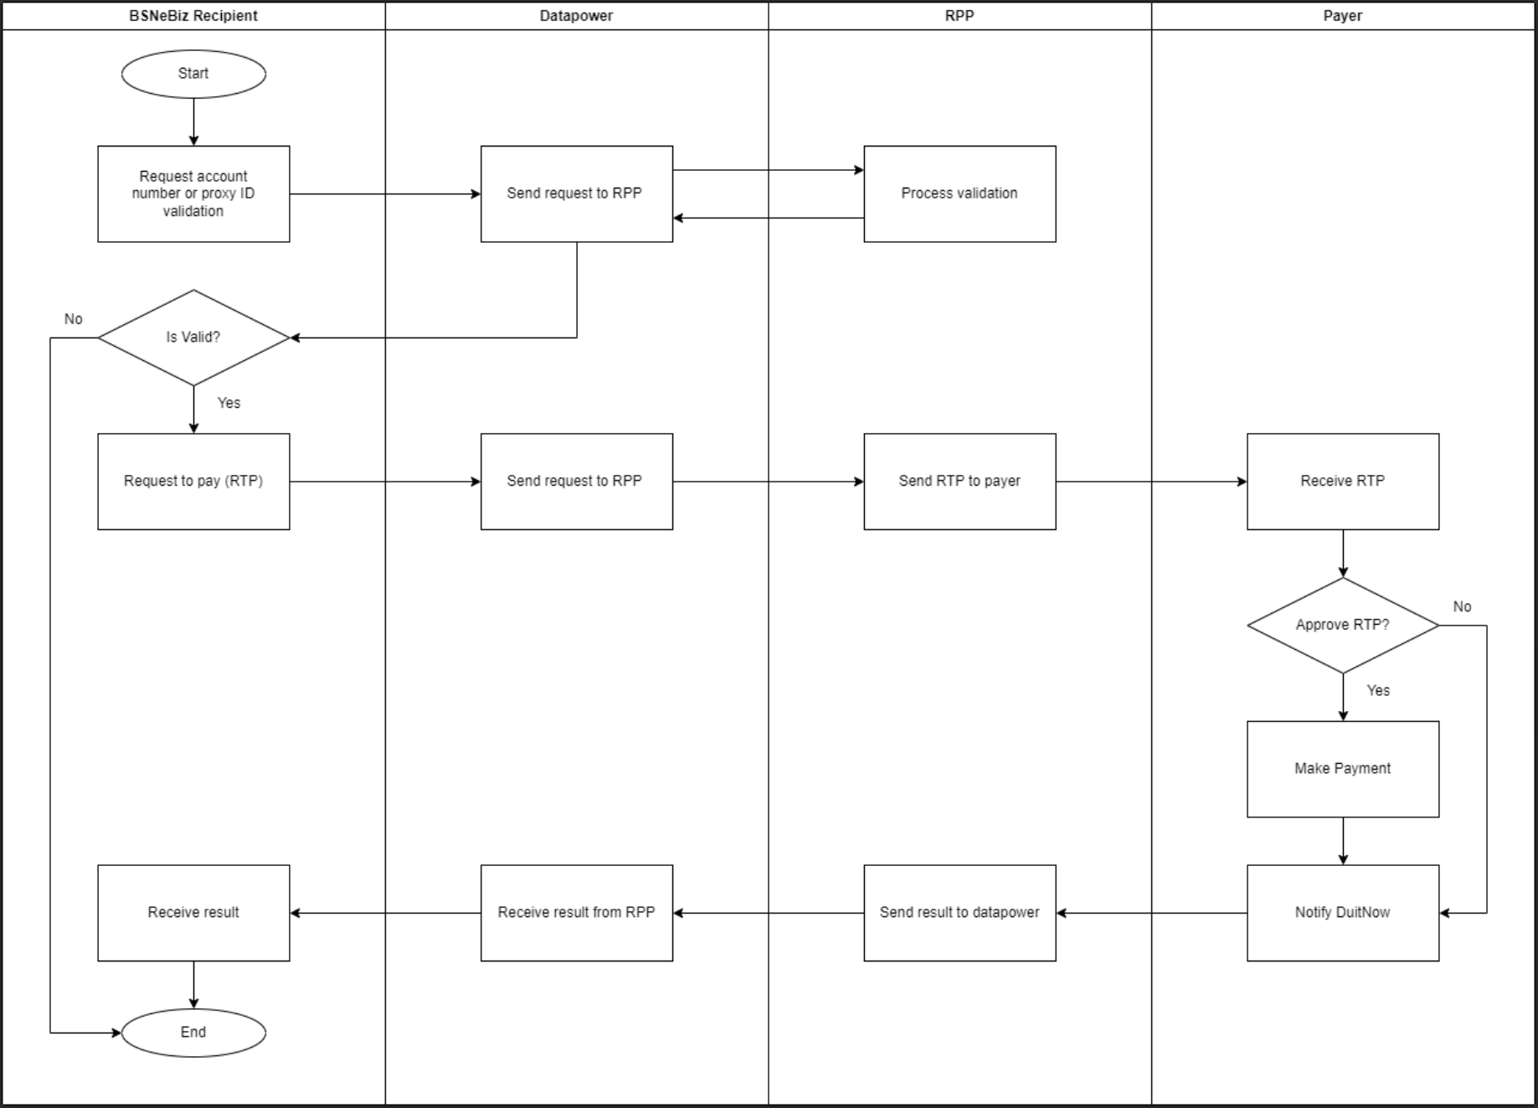
Figure 1 : BSNeBiz - Outgoing

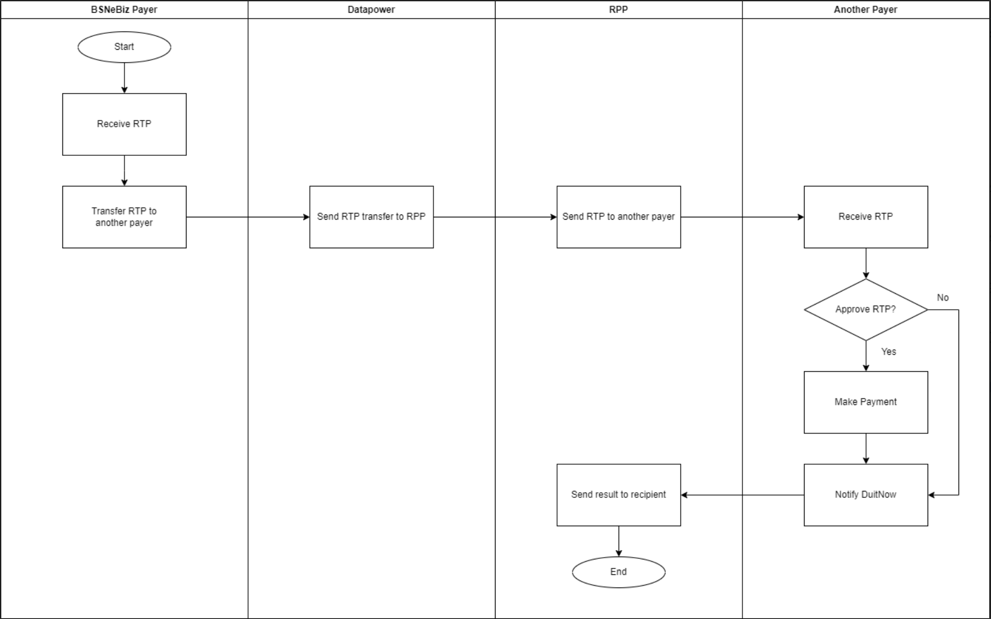
Figure 2 : BSNeBiz - Incoming

eConsent AutoDebit Flow

Successful End To End Flow

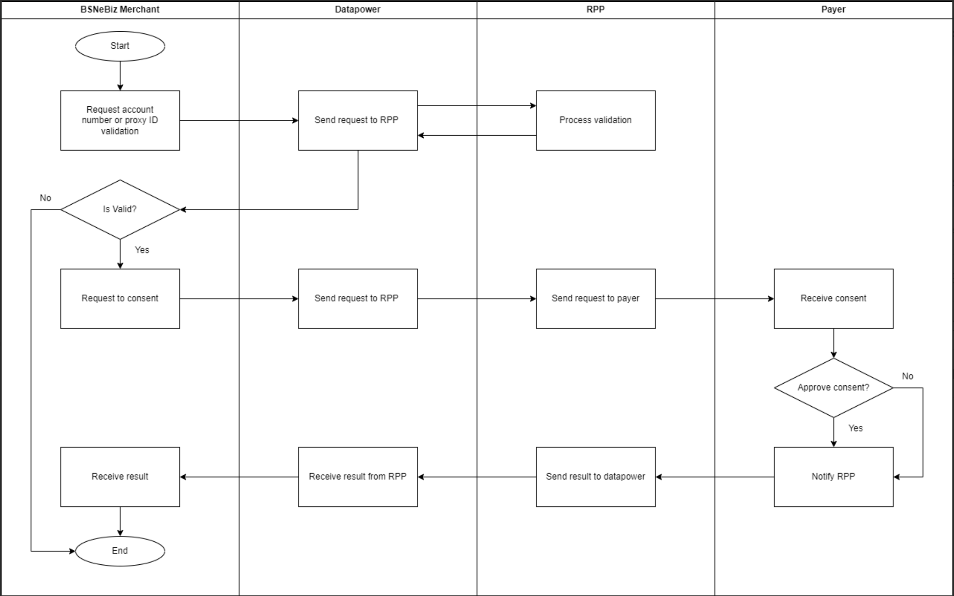
Figure 3 : Consent Register Request

Figure 4 : Auto Debit Process – File

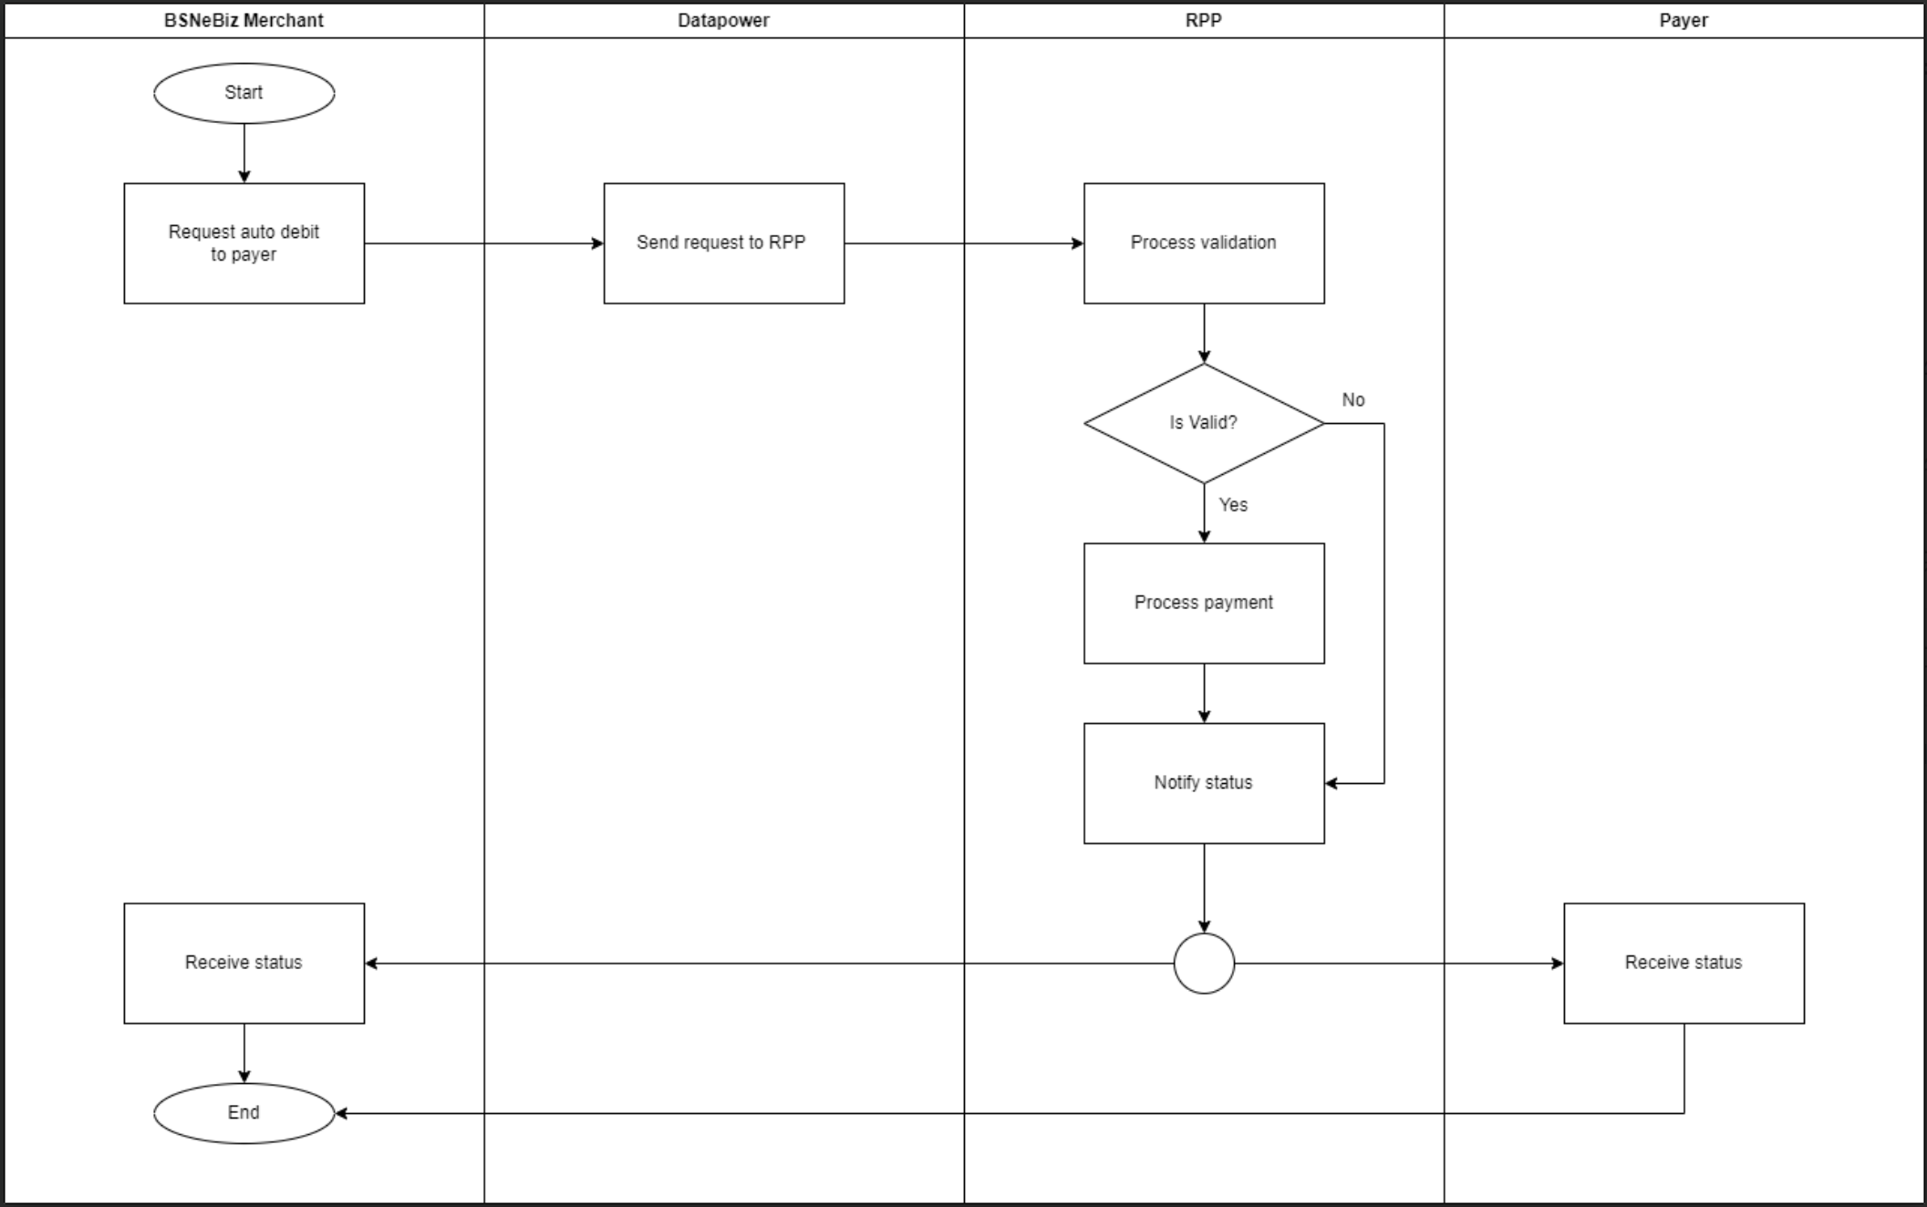
Figure 5 : Auto Debit Process – Individual

DuitNow Online Banking Flow Diagram

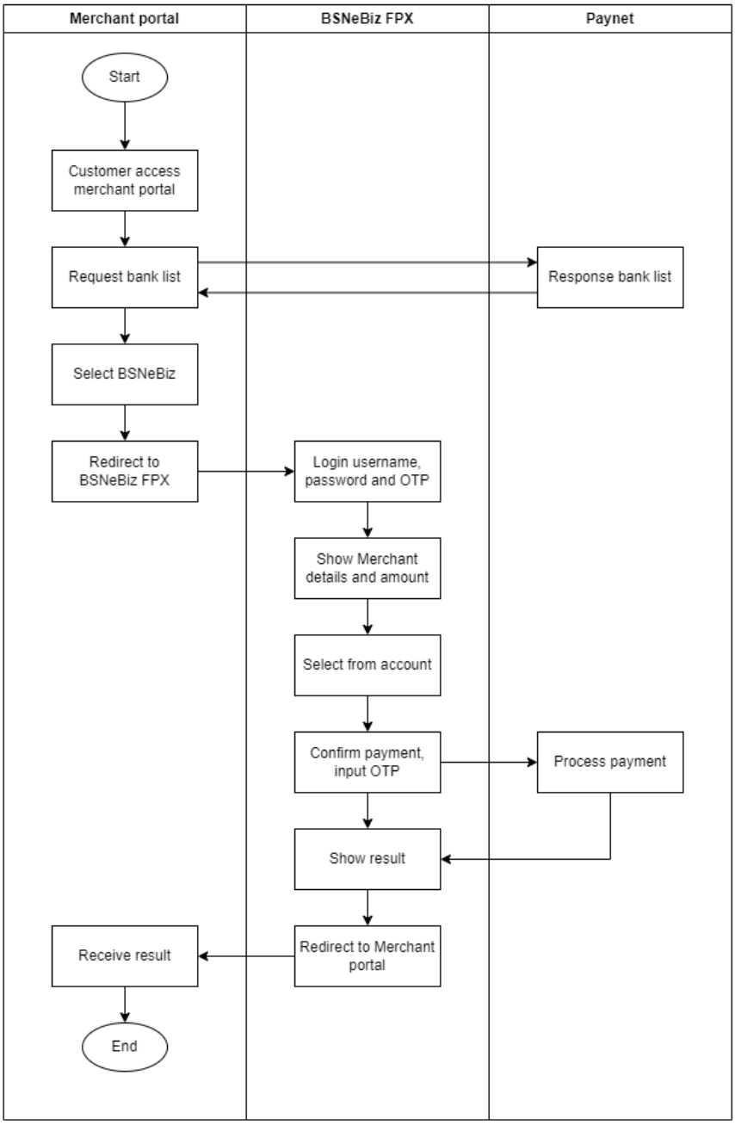
Figure 6 : Single User perform transaction

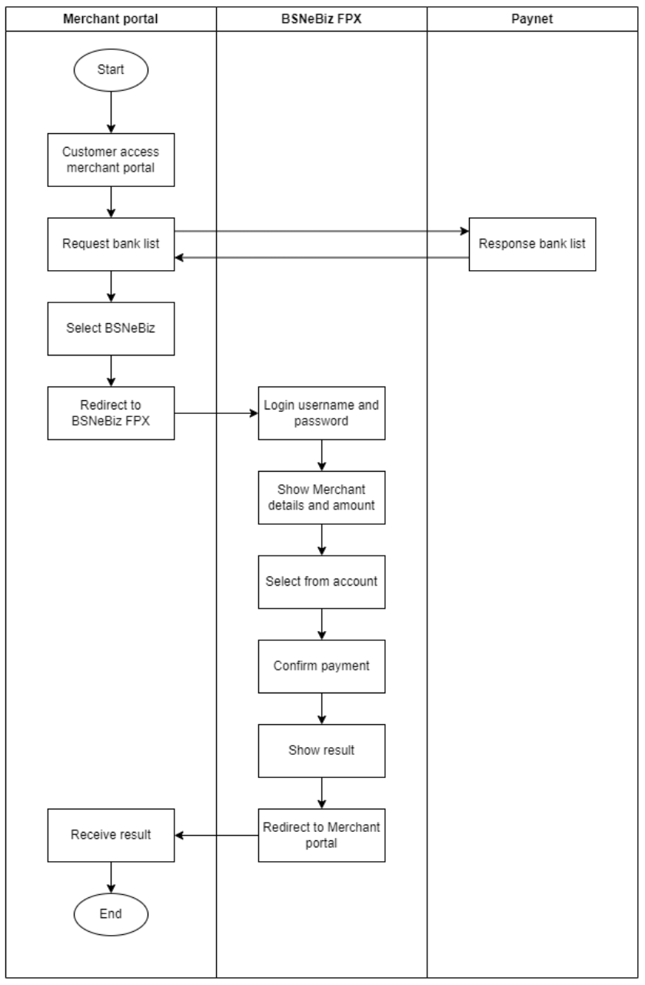
Figure 7: Initiator (Company with workflow) perform transaction

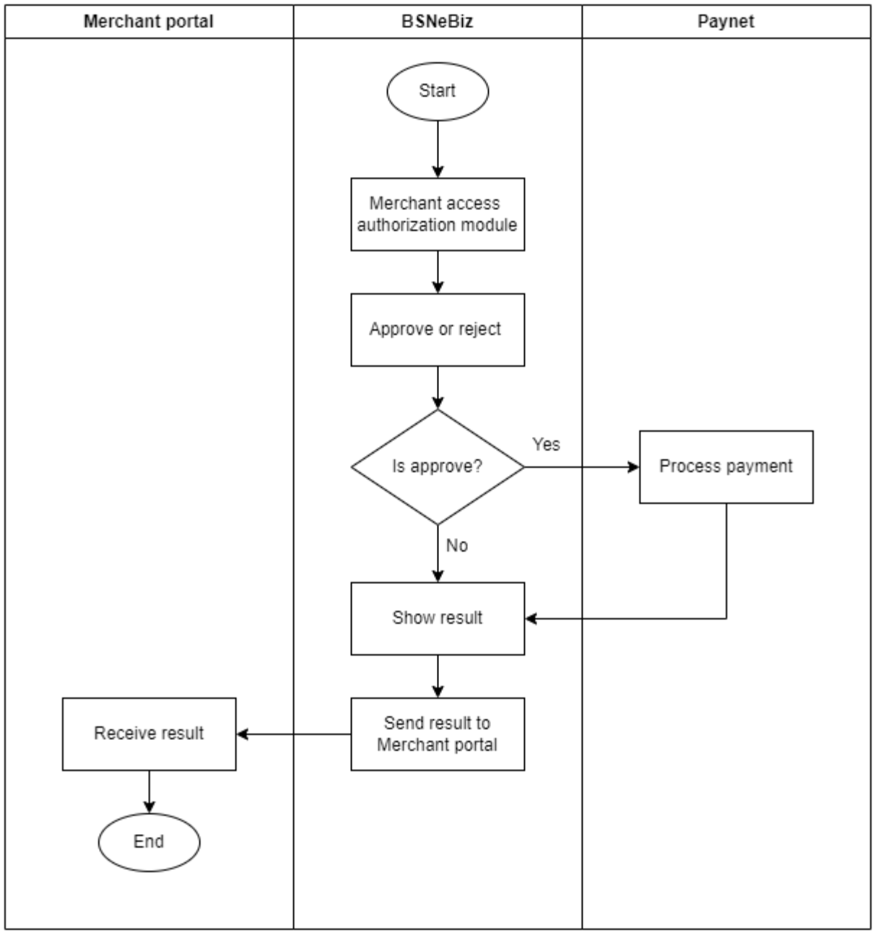
Figure 7: Approver authorize the request

Sample screen for DuitNow Online Banking (DOB)

Single User / Initiator
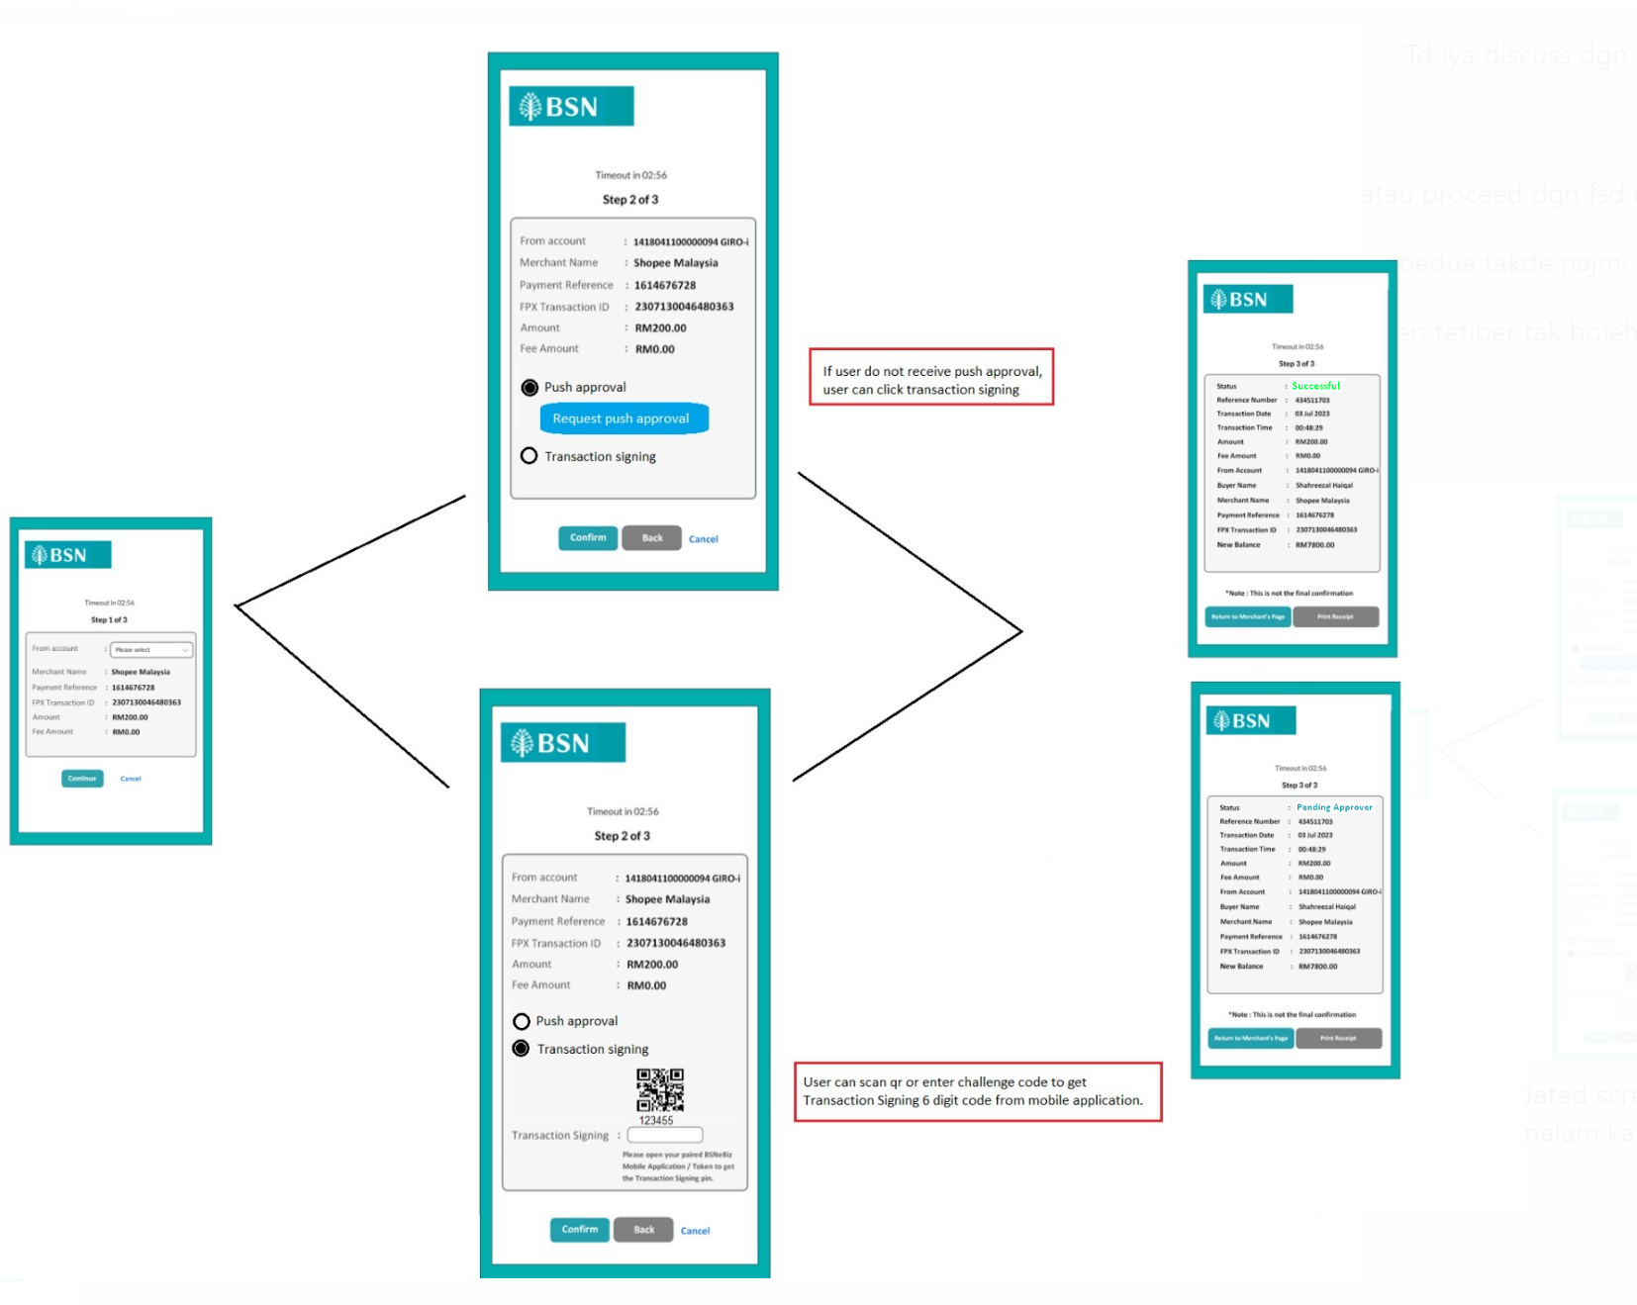

After clicking “Return to Merchant” system will logout the user. User need to click “Return to Merchant Page” again to return back to merchant screen.

