|  |
| --- |
|  |
| **Corporate Digital Banking**  **BSNeBiz Fraud Management System** |
| Business Requirement and Functional Document |
|  |
| ***(PENRIL/BSN/BRFD_CDB(CR)0XX – [CR23002])***  ***Revision: 00*** |
| **XXth July 2023**  Prepared By:    **Penril Datability (M) Sdn Bhd (816792-X)**  Suite A-07-07 Plaza Mon’t Kiara  No. 2, Jalan Kiara, Mon’t Kiara  50480 Kuala Lumpur, Malaysia  Tel: (603) 6201 2622Fax: (603) 6201 7622 |

# Document Amendment Log

| **Rev. No** | **Date Update** | **Description of Change** | **Update By**  **<Name, Dept>** | **Review By**  **<Name, dept>** |
| --- | --- | --- | --- | --- |
| 00 | XX/07/23 | Initial Release | Athirah Umairah  Quality Engineer | Norhaidah Dasuki  Senior Manager |

# Table of Content

Document Amendment Log 2

Table of Content 3

Business Requirement & Functional Acceptance 5

**Section A: Introduction** 6

1 Introduction 6

1.1 Objective 6

1.2 Assumptions 7

1.3 Scope of Works 8

1.4 FHP Rules Flow 9

1.5 FHP covers process 11

1.6 Rule Decision Mapping for BSNeBiz 13

1.7 Functional Overview 14

**Section B: BSNeBiz Web Application** 16

2 SOW01: Development and Integration of BSNeBiz Web and Mobile 16

2.1 SOW01.1: To develop and integrate with FHP and Predator 16

2.1.1 SOW01.1a: BSNeBiz (Web Session) 16

2.1.2 SOW01.1b: BSNeBiz (Monetary) 20

2.1.3 SOW01.1c: BSNeBiz (Non-Monetary) 24

**Section C: BSNeBiz Web Application** 26

3 SOW01: Enhancement at BSNeBiz Web Application 26

3.1 SOW01.1: To apply FPH and Predator plugin / code to every module include monetary and non-monetary based on FHP Rule Flow 26

3.2 SOW01.2: To implement the security question to every module if triggered FHP and Predator rule 32

3.2.1 Process Flow 32

3.2.2 Screen Flow 32

**Section D: BSNeBiz Mobile Application** 35

4 SOW02: Enhancement at BSNeBiz Mobile App 35

4.1 SOW02.1: To apply FPH and Predator plugin / code to every module include monetary and non-monetary based on FHP Rule Flow 35

4.2 SOW02.2: To implement the security question to every module if triggered FHP and Predator rule 38

4.2.1 Process Flow 38

4.2.2 Screen Flow 38

**Section D: Internet Banking Administration Module (IBAM)** 42

5 SOW03: Enhancement at IBAM 42

5.1 SOW03.1: To create new module at IBAM 42

5.1.1 Process Flow 42

5.1.2 Screen Flow 42

**Section E: Appendix** 47

E1: Traceability Matrix 47

E2: Related Item for Development 47

# Business Requirement & Functional Acceptance

I/We hereby verify that this Business Requirement & Functional consist of all the requirements requested by BANK SIMPANAN NASIONAL. The implemented system will fulfill ONLY this requirement.

I/We also hereby AGREE that this satisfies our entire requirement for **BSNeBiz Fraud Management System.**

Any future changes to this agreed scope would be treated as an enhancement to the system. Any future changes to the project timeline will be subjected to the final approval of the project steering committee.

**BANK SIMPANAN NASIONAL:**

|  |  |  |  |
| --- | --- | --- | --- |
| **Approved by** | **Role** | **Signature** | **Date** |
|  |  |  |  |
|  |  |  |  |
|  |  |  |  |
|  |  |  |  |
|  |  |  |  |
|  |  |  |  |
|  |  |  |  |

**Penril Datability (M) Sdn. Bhd.:**

|  |  |  |  |
| --- | --- | --- | --- |
| **Approved by** | **Role** | **Signature** | **Date** |
| Norhaidah Bt Md Dasuki | Senior Manager, Profesional Service |  |  |
| Najmi Bin Pasarudin | Senior Software Engineer |  |  |
|  |  |  |  |

**Section A: Introduction**

# Introduction

This document served as the business requirement and system specification of implementing **Fraud Management System** in BSNeBiz, which is customer able to make new application and digital signing via online.

This document shall explain all the features and functionalities, which is elaborating with screen captures, process flow, descriptions, input fields specifications and error messages. All screen designs provided in this document are samples and only illustration purpose for easy understanding. The screen designs are not final.

## Objective

The objective of this document is to capture user requirements of transactional and administration modules of implementing BSNeBiz Fraud Management System. This document will facilitate development and implementation of the mentioned modules of Internet Banking System for BSNeBiz.

The base line features description and screen designs will become a reference blueprint for the development team to develop the transactional and administration module. Hence, it is crucial that all stakeholders need to ensure the correctness and adequacy of the requirements captured in this document.

All stakeholders involved are expected to review and sign off this document before the development starts. By signing the document, the stakeholder has endorsed the correctness and accuracy and adequacy of the requirements documented in this document.

## Assumptions

1. BSNeBiz Web Application
   1. FPH and Predator plugin / code will be applied to every module including monetary and non-monetary based on FHP Rule Flow.
   2. The security question will be implemented to every module if triggered FHP and Predator rule.
2. BSNeBiz Mobile Application
   1. FPH and Predator plugin / code will be applied to every module including monetary and non-monetary based on FHP Rule Flow.
   2. The security question will be implemented to every module if triggered FHP and Predator rule.
3. IBAM
   1. To create new module at IBAM level that allow Bank Admin to maintain the Fraud Management Process

• Bypass FPH and Predator

1. Any other payment and transfer services which are not mentioned in SOW item 1.3 below will be treated as Change of Requirement.

## Scope of Works



|  |  |  |  |
| --- | --- | --- | --- |
| System | Modules | Features | Description |
| IBAM | Fraud Management | Field | Create new module at IBAM level that allow Bank Admin to maintain the Fraud Management Process  • Bypass FPH and Predator |
| BSNeBiz  (Web) | Monetary and Non-Monetary | FHP & Predator | Apply FPH and Predator plugin / code to every module including monetary and non-monetary based on FHP Rule Flow.  Implement the security question to every module if triggered FHP and Predator rule. |
| BSNeBiz  (Mobile) | Monetary and Non-Monetary | FHP & Predator | Apply FPH and Predator plugin / code to every module including monetary and non-monetary based on FHP Rule Flow.  Implement the security question to every module if triggered FHP and Predator rule. |

Table 1: BSNeBiz Fraud Management System – Impact Module

## FHP Rules Flow

1. FHP tracking code at BSN website/mobile apps sends collected data to FHP Cloud
2. FHP rules setup at FHP Cloud – via FHP Admin Panel

* FHP rules will be sent to Predator via Push API if it is enabled and configured to sent through API

3. FHP alert messages received at Predator side

* Any Predator rules to be created for these FHP rules?

Possible options:

* To create a Predator rule based on certain types of FHP rules Strong action = Block related transactions if these FHP rules triggered e.g. if type_id = 4 (multiple accounts within same FHP session) AND current count >=10 (More than 10 distinct users in the same FHP session), then: To Block related transactions
* To create a Predator rule based on session score (i.e. device_score) e.g. if device_score >= 70, then: To Step up related transactions
* To create a Predator rule based on types of FHP rules + session score e.g. if type_id = 111 (First time login of current user in this new device) AND device_score = 100, then: To Block related transactions
* To keep FHP rules as data enrichment only. To use these rules for investigation and analysis purpose (i.e. Not mapped to a specific Predator rule)

1. BSN system received Predator messages (which contain FHP rules)

* To Step up / Hold / Approve / Reject transactions based on Predator message’s `Rule Decision`

## FHP covers process

**‘Outside a FHP Login Session’**

`Outside a Login Session` is defined as any pages where the user can browse without specifying a valid user credentials.

As FHP alerts generated at `Outside a Login Session` pages cannot be attributed to any `user_id`. When these alerts are sent to Predator, they will persist under default `user_id` = “NA”.

Example of FHP alerts which can be generated `Outside a Login Session`

* Bot / automation usage
* Tor browser usage
* VM (Virtual Machine) usage
* VPN usage
* Activity from a blacklisted `device_id`
* Activity from a blacklisted IP country

**‘Inside a Login Session’**

`Inside a Login Session` is defined as any pages which only accessible by a user who successfully logged in using a valid user credentials (including the usage of temporary password).

Example of FHP alerts which can only be generated `Inside a Login Session`

* An existing user is successfully login from a new device, for the very first time. It indicates an Account Takeover (ATO) risk
* A successful login by a blacklisted user
* A user who successfully login from a blacklisted `device_id`
* A shared device usage by multiple users

## Rule Decision Mapping for BSNeBiz

Predator will process this transaction and return a Rule Decision to BSNeBiz.

Note: OK means no rules were triggered

## Functional Overview

The following diagram shows a high-level overview of how Predator does transaction Fraud checking.

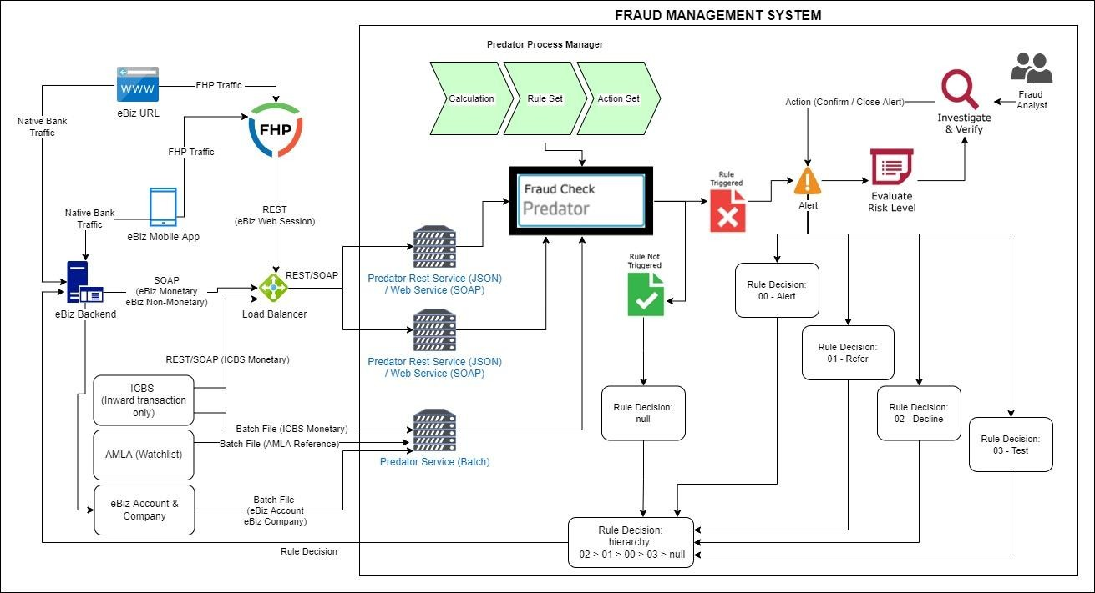

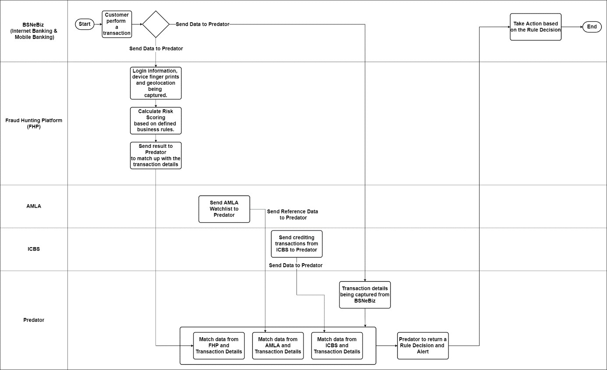

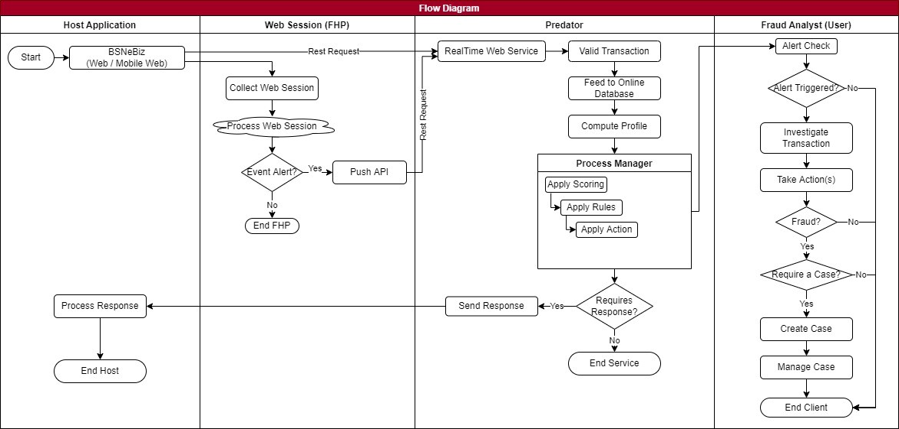

**Section B:** **BSNeBiz Web Application**

# SOW01: Development and Integration of BSNeBiz Web and Mobile

## SOW01.1: To develop and integrate with FHP and Predator

### 2.1.1 SOW01.1a: BSNeBiz (Web Session)

| Function ID | SOW01.1a | | |
| --- | --- | --- | --- |
| Module Name | BSNeBiz (Web Session) | Path | BSNeBiz |
| Description | All user session activity recorded by Fraud Hunting Platform (FHP) to be sent to Predator as a web session transaction. Data to be fed in real-time. | | |

Below is the layout regarding the channel’s configuration which the Predator Web Service will be expecting data for this channel to be sent in.

|  |  |  |  |  |  |  |  |  |  |
| --- | --- | --- | --- | --- | --- | --- | --- | --- | --- |
| No | Field Name | Display Name | Data Type | Allow NULL | Group By | Lookup Tables | Reference Tables | Payload Key Name | Property Fields |
| 1. | Transaction_Serial_ No | Transaction Serial No | BIGINT NOT NULL | Y | N |  |  | Transaction_Serial_No |  |
| 2. | fhp_alert_uuid | FHP Alert UUID | NVARCHAR (50) | N | N |  |  | fhp_alert_uuid |  |
| 3. | customer_id | FHP Customer ID | INT | N | N |  |  | customer_id |  |
| 4. | type_id | Alert Type Code | INT | N | N |  |  | type_id |  |
| 5. | type_title | Alert Title | NVARCHAR (100) | N | N |  |  | type_title |  |
| 6. | risk_level | Event Risk Level | NVARCHAR (10) | Y | N |  |  | risk_level |  |
| 7. | Transaction_Datetime | Event Time | datetime | N | N |  |  | time |  |
| 8. | Ip | IP Address | NVARCHAR (50) | Y | N |  |  | ip |  |
| 9. | ip_country | IP Country | NVARCHAR (2) | Y | N |  |  | ip_country |  |
| 10. | ip_city | IP City | NVARCHAR (50) | Y | N |  |  | ip_city |  |
| 11. | ip_isp | IP Internet Service Provider | NVARCHAR (50) | Y | N |  |  | ip_isp |  |
| 12. | device_id | Device ID | NVARCHAR (50) | Y | N |  |  | device_id |  |
| 13. | user_id | User ID | NVARCHAR (50) | N | Y |  |  | user_id | UUID |
| 14. | score_alert | Event Risk Score | INT | Y | N |  |  | score_alert |  |
| 15. | score_device | Device Risk Score | INT | Y | N |  |  | score_device |  |
| 16. | fhp_session_id | FHP Session ID | NVARCHAR (50) | Y | N |  |  | fhp_session_id |  |
| 17. | customer_session_id | Customer Session ID | NVARCHAR (50) | Y | N |  |  | customer_session_id |  |
| 18. | device_platform | Device Platform | NVARCHAR (30) | Y | N |  |  | device_platform |  |
| 19. | device_browser | Device Browser | NVARCHAR (30) | Y | N |  |  | device_browser |  |
| 20. | device_mobile | Device Mobile | NVARCHAR (3) | Y | N |  |  | device_mobile |  |
| 21. | device_hash | Device Hash | NVARCHAR (50) | Y | N |  |  | device_hash |  |
| 22. | user_agent | Browser User Agent | NVARCHAR (200) | Y | N |  |  | user_agent |  |
| 23. | Referrer | URL Referrer | NVARCHAR (200) | Y | N |  |  | referrer |  |
| 24. | Channel | Channel | NVARCHAR (10) | N | N |  |  | channel |  |
| 25. | fhp_app_version | FHP App Version | NVARCHAR (10) | Y | N |  |  | fhp_app_version |  |
| 26. | global_id | Global ID | NVARCHAR (50) | Y | N |  |  | global_id |  |
| 27. | cloud_id | Cloud ID | NVARCHAR (50) | Y | N |  |  | cloud_id |  |
| 28. | phone_manufacturer  _model | Android Manufacturer Model | NVARCHAR (50) | Y | N |  |  | phone_manufacturer_ model |  |
| 29. | phone_brand | Android Phone Brand | NVARCHAR (20) | Y | N |  |  | phone_brand |  |
| 30. | data_count | Data.Count | INT | Y | N |  |  | data_count |  |
| 31. | data_logins | Data.Logins | NVARCHAR (200) | Y | N |  |  | data_logins |  |
| 32. | data_attempt_counter | Data.Attempt Counter | INT | Y | N |  |  | data_attempt_counter |  |
| 33. | data_different_login_counter | Data.Different Login Counter | INT | Y | N |  |  | data_different_login_c ounter |  |
| 34. | data_first_app_pack age | Data.FirstApp Package | NVARCHAR (50) | Y | N |  |  | data_first_app_package |  |

2.1.2 SOW01.1b: BSNeBiz (Monetary)

| Function ID | SOW01.1b | | |
| --- | --- | --- | --- |
| Module Name | BSNeBiz (Monetary) | Path | BSNeBiz |
| Description | All banking transactions stemming from internet activities involving financial transactions. Data to be fed in real-time. | | |

Below is the layout regarding the channel’s configuration which the Predator Web Service will be expecting data for this channel to be sent in.

|  |  |  |  |  |  |  |  |  |  |  |
| --- | --- | --- | --- | --- | --- | --- | --- | --- | --- | --- |
| No | Field Name | Display Name | Data Type | Allow NULL | Group By | Lookup Tables | Reference Tables | Payload Key Name | BSNeBiz Source | Property Fields |
| 1. | Transaction_Datetime | Transaction Datetime | DATETIME NOT NULL | N | N |  |  | Transaction_D atetime | EFFECT IVE_DATE |  |
| 2. | TransactionId | Transaction ID | NVARCHAR  (50) | N | N |  |  | TransactionId | TRNX_ID |  |
| 3. | Source* | Source | NVARCHAR  (10) | Y | N |  |  | Source |  |  |
| 4. | AccountNo | Account Number | NVARCHAR (25) | N | N |  | BSNeBiz  Account Info.Account_No | AccountNo | FROM_  ACCOUNT_NO | Account No |
| 5. | AccountType | Account Type | NVARCHAR  (100) | N | N | BSNeBiz  Account Type |  | AccountType |  |  |
| 6. | ToAccountName | To Account  Name | NVARCHAR  (140) | Y | N |  |  | ToAccountName |  |  |
| 7. | ToAccountNo | To Account Number | NVARCHAR (25) | N | N |  |  | AccountNo | TO_AC COUNT  _NO | ToAcco untNo |
| 8. | ToAccountType | To Account  Type | NVARCHAR  (100) | N | N | BSNeBiz  Account Type |  | AccountType |  |  |
| 9. | Amount | Amount | DECIMAL (19,2) | N | N |  |  | Amount | AMOUN T | Transaction  Amount |
| 10. | PaymentDetail | Payment Detail | NVARCHAR  (140) | Y | N |  |  | PaymentDetail | DETAILS |  |
| 11. | RecipientReference | Recipient  Reference | NVARCHAR  (140) | Y | N |  |  | RecipientReference |  |  |
| 12. | TransactionC ode | Transaction Code | NVARCHAR (50) | N | N | BSNeBiz Transaction Code |  | TransactionCo de | TRNX_ CODE |  |
| 13. | BillerName | Biller Name | NVARCHAR  (100) | Y | N |  |  | BillerName | BILLER  _NAME |  |
| 14. | BillAccountNo | Bill Account No | NVARCHAR (50) | Y | N |  |  | BillAccountNo | BILLER  _ACCO UNT_N O |  |
| 15. | BillerCode | Biller Code | NVARCHAR  (10) | Y | N |  |  | BillerCode | BILLER  _CODE |  |
| 16. | BillerReferrence1 | Biller  Referrence1 | NVARCHAR  (50) | Y | N |  |  | BillerReferrence1 | REF1 |  |
| 17. | BillerReferre  nce2 | Biller  Referrence2 | NVARCHAR  (50) | Y | N |  |  | BillerReferrence2 | REF2 |  |
| 18. | BeneficierName | Beneficier Name | NVARCHAR (140) | Y | N |  |  | BeneficierName | BENEFI CIARY_  NAME |  |
| 19. | BeneficierResidencyStatus | Beneficier Residency  Status | NVARCHAR (20) | Y | N |  |  | BeneficierResidencyStatus |  |  |
| 20. | BeneficerNationality | BeneficerNationality | NVARCHAR  (35) | Y | N |  |  | BeneficerNationality |  |  |
| 21. | BeneficierBankName | Beneficier Bank  Name | NVARCHAR  (140) | Y | N |  |  | BeneficierBank Name |  |  |
| 22. | Status | Status | NVARCHAR (20) | N | N |  |  | Status | TRNX_ STATUS STATU S |  |
| 23. | UUID | UUID | NVARCHAR (50) | N | Y |  | BSNeBizAccount Info.UUID | UUID |  | UUID |
| 24. | CSID | Customer  Session ID | NVARCHAR  (50) | N | N |  |  | CSID |  |  |
| 25. | accAvailBal | Available  Balance | DECIMAL  (19,2) | N | N |  |  | accAvailBal |  |  |
| 26. | CurrencyCode | Currency Code | NVARCHAR (3) | N | N |  |  | CurrencyCode | FROM_ CURRE NCY  TO_CU RRENC  Y |  |
| 27. | Channel | Channel | NVARCHAR  (3) | Y | N |  |  | Channel | CHANN  EL |  |
| 28. | WorkflowStatus | Workflow Status | NVARCHAR (3) | N | N | BSNeBiz WorkflowStatus |  | WorkflowStatus |  |  |
| 29. | CompanyCode | Company Code | NVARCHAR (50) | N | N |  | BSNeBiz  Company.COMP ANY_ID | CompanyCode |  |  |
| 30. | IPAddress | IP Address | NVARCHAR  (50) | N | N |  |  | IPAddress | HOST_I  P |  |

### 2.1.3 SOW01.1c: BSNeBiz (Non-Monetary)

| Function ID | SOW01.1c | | |
| --- | --- | --- | --- |
| Module Name | BSNeBiz (Non-Monetary) | Path | BSNeBiz |
| Description | Non-monetary transactions from the Internet Banking and Mobile Banking such as customer change of limit and password. | | |

Below is the layout regarding the channel’s configuration which the Predator Web Service will be expecting data for this channel to be sent in.

|  |  |  |  |  |  |  |  |  |  |  |
| --- | --- | --- | --- | --- | --- | --- | --- | --- | --- | --- |
| No | Field Name | Display Name | Data Type | Allow NULL | Group By | Lookup Tables | Reference Tables | Payload Key Name | BSNeBi  z Source | Property Fields |
| 1. | Transaction_Datetime | Transaction  Datetime | DATETIME  NOT NULL | N | N |  |  | Transaction_D  atetime | TRNX_DATE |  |
| 2. | Transaction  Id | Transaction ID | NVARCHAR  (50) | N | N |  |  | TransactionId | TRNX_ID |  |
| 3. | Source* | Source | NVARCHAR  (10) | Y | N |  |  | Source |  |  |
| 4. | AccountNo | Account  Number | NVARCHAR  (25) | Y | N |  |  | AccountNo |  | Account  No |
| 5. | AccountType | Account Type | NVARCHAR  (100) | N | N | BSNeBiz  Account Type |  | AccountType |  |  |
| 6. | UUID | UUID | NVARCHAR (50) | N | Y |  | BSNeBizAccount Info.UUID | UUID |  |  |
| 7. | CSID | Customer  Session ID | NVARCHAR  (50) | N | N |  |  | CSID |  | ToAccountNo |
| 8. | Transaction Code | Transaction Code | NVARCHAR (50) | N | N | BSNeBiz Transaction Code |  | TransactionCo de |  |  |
| 9. | Status | Status | NVARCHAR  (20) | N | N |  |  | Status | STATUS |  |
| 10. | Channel | Channel | NVARCHAR  (3) | Y | N |  |  | Channel | CHANNEL |  |
| 11. | WorkflowSt atus | Workflow Status | NVARCHAR (3) | N | N | BSNeBiz WorkflowStatus |  | WorkflowStatus | SINGLE_USER |  |
| 12. | DigitalTokenDeviceUDID | Digital token device UDID | NVARCHAR (100) | Y | N |  |  | DigitalTokenDeviceUDID |  |  |
| 13. | CompanyC ode | Company Code | NVARCHAR (50) | N | N |  | BSNeBiz Company.COM  PANY_ID | CompanyCode |  |  |
| 14. | IPAddress | IP Address | NVARCHAR  (50) | N | N |  |  | IPAddress | REMOTE_IP |  |

**Section C: BSNeBiz Web Application**

# SOW01: Enhancement at BSNeBiz Web Application

## SOW01.1: To apply FPH and Predator plugin / code to every module include monetary and non-monetary based on FHP Rule Flow

| Function ID | SOW01.1 | | |
| --- | --- | --- | --- |
| Module Name | Monetary and Non-Monetary | Path | BSNeBiz |
| Description | FHP and Predator will apply to every module for monetary and non-monetary transaction based on transaction code in BSNeBiz in table below. | | |

|  |  |  |  |
| --- | --- | --- | --- |
| No | Value | Description | Type |
|  | BFUNOWN | FUND TRANSFER OWN | Monetary |
|  | BFUNLOAN | FUND TRANSFER LOAN | Monetary |
|  | BFUNFRA | FUND TRANSFER INTRABANK FAV | Monetary |
|  | BFUNORA | FUND TRANSFER INTRABANK NEW | Monetary |
|  | BFUNFER | FUND TRANSFER INTERBANK FAV | Monetary |
|  | BFUNOER | FUND TRANSFER INTERBANK NEW | Monetary |
|  | BFUNFRR | FUND TRANSFER FAV RENTAS | Monetary |
|  | BFUNORR | FUND TRANSFER NEW RENTAS | Monetary |
|  | BFUNCARD | FUND TRANSFER CORP CARD | Monetary |
|  | BFUNOEDUITN OW | FUND TRANSFER DUITNOW NEW | Monetary |
|  | BFUNFEDUITN OW | FUND TRANSFER DUITNOW FAV | Monetary |
|  | BFUNTD | FUND TRANSFER TERM DEPOSIT | Monetary |
|  | BBILLOPEN | BILL PAYMENT NEW PAYMENT | Monetary |
|  | BBILLFAV | BILL PAYMENT FAV PAYMENT | Monetary |
|  | BNBPSOPEN | JOMPAY NEW PAYMENT | Monetary |
|  | BNBPSYFAV | JOMPAY FAV PAYMENT | Monetary |
|  | BADENLFU | AUTO_DEBIT_ENROLLMENT_FILE_UPLOAD | Non-Monetary |
|  | BADENLDE | AUTO_DEBIT_ENROLLMENT_DATA_ENTRY | Non-Monetary |
|  | BADBILFU | AUTO_DEBIT_BILLING_FILE_UPLOAD | Monetary |
|  | BADBILDE | AUTO_DEBIT_BILLING_DATA_ENTRY | Monetary |
|  | BAUCRFU | AUTO_CREDIT_FILE_UPLOAD | Monetary |
|  | BAUCRDE | AUTO_CREDIT_DATA_ENTRY | Monetary |
|  | BAUCRWOACF U | AUTO_CREDIT_WO_ACCT_FILE_UPLOAD | Monetary |
|  | BAUCRWOACP A | AUTO_CREDIT_WO_ACCT_PAYMENT_APPROVED | Monetary |
|  | BPRUBSNFU | PRU_BSN_FILE_UPLOAD | Monetary |
|  | BKWSPFU | STATUTORY_KWSP_FILE_UPLOAD | Monetary |
|  | BKWSPDE | STATUTORY_KWSP_DATA_ENTRY | Monetary |
|  | BKWSPOP | STATUTORY_KWSP_OTHER_PAYMENT | Monetary |
|  | BSOCSOFU | STATUTORY SOCSO FILE UPLOAD | Monetary |
|  | BSOCSODE | STATUTORY SOCSO DATA ENTRY | Monetary |
|  | BZAKATDE | STATUTORY ZAKAT DATA ENTRY | Monetary |
|  | BZAKATFU | STATUTORY ZAKAT FILE UPLOAD | Monetary |
|  | BLHDNFU | STATUTORY_LHDN_FILE_UPLOAD | Monetary |
|  | BLHDNDE | STATUTORY_LHDN_DATA_ENTRY | Monetary |
|  | BSWEEPFUND TF | SWEEPING ACCOUNT TRANSFER | Monetary |
|  | BACCLOGIN | ACCESS_LOGIN | Non-Monetary |
|  | BACCLOGOUT | ACCESS_LOGOUT | Non-Monetary |
|  | BACCFPA | ACCESS_RESET_PASSWORD | Non-Monetary |
|  | BASPSS | ACCESS_RESET_SECURE_PASS | Non-Monetary |
|  | BACCREG | ACCESS_FT_LOGIN | Non-Monetary |
|  | BACCTAC | ACCESS_FT_TAC | Non-Monetary |
|  | BDEVICEPAIRI NG | ACCESS_DEVICE_PAIRING | Non-Monetary |
|  | BREGISTRATI ON | ACCESS_REGISTRATION | Non-Monetary |
|  | BMIGRATEDLO GIN | ACCESS_MIGRATED_LOGIN | Non-Monetary |
|  | BENQSUM | ACCOUNT_ENQUIRY_SUMMARY | Non-Monetary |
|  | BNOADET | NORMAL_ACC_DETAILS | Non-Monetary |
|  | BLNADET | LOAN_ACC_DETAILS | Non-Monetary |
|  | BESTMNT | E_STATEMENT | Non-Monetary |
|  | BTRANSHIST | TRANSACTION_HISTORY | Non-Monetary |
|  | BONLINEHIST | ONLINE_TRANSACTION_HISTORY | Non-Monetary |
|  | BACCVALIDATI ON | ACCOUNT_VALIDATION | Non-Monetary |
|  | BCASHLINEIN OTICE | CASHLINE_I_NOTICE | Non-Monetary |
|  | BFUNMRA | FUND_TRANSFER_INTRA_MAINT | Non-Monetary |
|  | BFUNMRAADD | FUND_TRANSFER_INTRA_ADD | Non-Monetary |
|  | BFUNMRAEDIT | FUND_TRANSFER_INTRA_EDIT | Non-Monetary |
|  | BFUNMRADEL | FUND_TRANSFER_INTRA_DELETE | Non-Monetary |
|  | BFUNMER | FUND_TRANSFER_INTER_MAINT | Non-Monetary |
|  | BFUNMERADD | FUND_TRANSFER_INTER_ADD | Non-Monetary |
|  | BFUNMEREDIT | FUND_TRANSFER_INTER_EDIT | Non-Monetary |
|  | BFUNMERDEL | FUND_TRANSFER_INTER_DELETE | Non-Monetary |
|  | BBILLFAVMAIN T | BILL PAYMENT FAV PAYEE | Non-Monetary |
|  | BBPFAVPAYAD | BILL PAYMENT FAV PAYEE ADD | Non-Monetary |
|  | BBPFAVPAYDE | BILL PAYMENT FAV PAYEE DEL | Non-Monetary |
|  | BBPFAVPAYED | BILL PAYMENT FAV PAYEE EDIT | Non-Monetary |
|  | BJOMPAYFAV MAINT | JOMPAY FAV BILLER | Non-Monetary |
|  | BBPFAVBILLAD | JOMPAY FAV BILLER ADD | Non-Monetary |
|  | BBPFAVBILLDE | JOMPAY FAV BILLER DEL | Non-Monetary |
|  | BBPFAVBILLED | JOMPAY FAV BILLER EDIT | Non-Monetary |
|  | BSWPACCM | SWEEPING_ACCOUNT_MAIN | Non-Monetary |
|  | BSWPACCMN | SWEEPING_ACCOUNT_MAINT_NEW | Non-Monetary |
|  | BSWPACCH | SWEEPING_ACCOUNT_HISTORY | Non-Monetary |
|  | BSWEEPFUND | SWEEPING_ACCOUNT | Non-Monetary |
|  | BSWEEPFUND A | SWEEPING_ACCOUNT_ADD | Non-Monetary |
|  | BSWEEPFUND ACT | SWEEPING_ACCOUNT_ACTIVATE | Non-Monetary |
|  | BSWEEPFUND DACT | SWEEPING_ACCOUNT_DEACTIVATE | Non-Monetary |
|  | BSWEEPFUND D | SWEEPING_ACCOUNT_DELETE | Non-Monetary |
|  | BSWPACCMCP A | SWEEPING_ACCOUNT_MAIN_CREATE_PAYMENT_A CCT | Non-Monetary |
|  | BSWPACCMST OP | SWEEPING_ACCOUNT_MAIN_STOP_PAYMENT_ACC T | Non-Monetary |
|  | BSWPACCMAC T | SWEEPING_ACCOUNT_MAIN_ACTICE_PAYMENT_A CCT | Non-Monetary |
|  | BSWPACCMEP A | SWEEPING_ACCOUNT_MAIN_EDIT_PAYMENT_ACCT | Non-Monetary |
|  | BADENLHL | AUTO_DEBIT_ENROLLMENT_HISTORY_LISTING | Non-Monetary |
|  | BAUDBENCF | AUTO_DEBIT_ENROLLMENT_CANCEL_FILE | Non-Monetary |
|  | BADBILHL | AUTO_DEBIT_BILLING_HISTORY_LISTING | Non-Monetary |
|  | BAUDBBILCF | AUTO_DEBIT_BILLING_CANCEL_FILE | Non-Monetary |
|  | BAUCRHL | AUTO_CREDIT_HISTORY_LISTING | Non-Monetary |
|  | BAUCRCF | AUTO_CREDIT_CANCEL_FILE | Non-Monetary |
|  | BAUCRWIN | AUTO_CREDIT_WINDOW | Non-Monetary |
|  | BKWSPTEST | STATUTORY_KWSP_TEST_DATA_ENTRY | Non-Monetary |
|  | BKWSPHL | STATUTORY_KWSP_HISTORY_LISTING | Non-Monetary |
|  | BKWSPCF | STATUTORY_KWSP_CANCEL_FILE | Non-Monetary |
|  | BLHDNHL | STATUTORY_LHDN_HISTORY_LISTING | Non-Monetary |
|  | BLHDNCF | STATUTORY_LHDN_CANCEL_FILE | Non-Monetary |

## SOW01.2: To implement the security question to every module if triggered FHP and Predator rule

| Function ID | SOW01.2 | | |
| --- | --- | --- | --- |
| Module Name | BSNeBiz Web | Path | BSNeBiz |
| Description | To implement the security question to every module if triggered FHP and Predator rule | | |

### 3.2.1 Process Flow

Diagram 1: Process Flow

### Screen Flow

***Step 1:***

1. Users perform a transaction in BSNeBiz web.
2. If fraud triggered an alert, the system will display security question.
3. User inputs answer for the requested security question.

Figure 2: Fraud Alert – Security Question screen

**Display Specification:**

| **No** | **Field** | **Field Type** | **Description** |
| --- | --- | --- | --- |
|  | FHP | Text | FHP status. |
|  | Predator | Text | Predator status. |

Table 3: Fraud Alert - Security Question Display Specification

**Input Specification:**

| **No** | **Field** | **Field Type** | **Rule** | **Description** | **Required** |
| --- | --- | --- | --- | --- | --- |
|  | Answer | Text Box | Alphanumeric | Input answer for security question | Yes |
|  | Confirm Answer | Text Box | Alphanumeric | Input confirm answer for security question | Yes |

Table 4: Fraud Alert – Security Question Input Specification

**Action:**

| **No** | **Action** | **Type** | **Description** |
| --- | --- | --- | --- |
|  | Submit | Button | Contains an action to submit the data and system will process response. |

Table 5: Fraud Alert - Security Question Action

**List of available messages for the screen:**

|  |  |  |
| --- | --- | --- |
| No | Event | Error Description in English |
|  | Answer not inserted | Answer is required. |
|  | Confirm Answer not inserted | Confirm Answer is required. |

Table 6: Fraud Alert - Security Question Error Message

***Step 2:***

1. BSNeBiz System will process response for the rule decision.
2. If users input correct answer or no fraud rule triggered or fraud rule triggered approved, user able to proceed with the transaction.
3. Else, if users input wrong answer or fraud rule triggered rejected, system will display an error message.

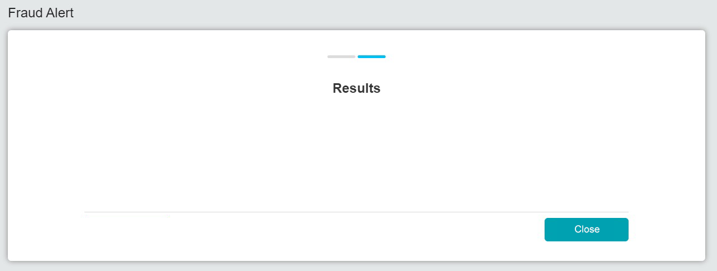

**Error Message**

Figure 7: Fraud Alert – Error Message screen

**Display Specification:**

| **No** | **Field** | **Field Type** | **Description** |
| --- | --- | --- | --- |
|  | Error Message | Text, symbol | To display error message of process response. |

Table 8: Fraud Alert – Error Message Display Specification

**Action:**

| **No** | **Action** | **Type** | **Description** |
| --- | --- | --- | --- |
|  | Close | Button | Contains an action to close screen and go to main page. |

Table 9: Fraud Alert – Error Message Action

**Section D: BSNeBiz Mobile Application**

# SOW02: Enhancement at BSNeBiz Mobile App

## SOW02.1: To apply FPH and Predator plugin / code to every module include monetary and non-monetary based on FHP Rule Flow

| Function ID | SOW01.1 | | |
| --- | --- | --- | --- |
| Module Name | Monetary and Non-Monetary | Path | BSNeBiz Mobile |
| Description | FHP and Predator will apply to every module for monetary and non-monetary transaction based on transaction code in BSNeBiz in table below. | | |

|  |  |  |  |
| --- | --- | --- | --- |
| No | Value | Description | Type |
|  | BFUNOWN | FUND TRANSFER OWN | Monetary |
|  | BFUNLOAN | FUND TRANSFER LOAN | Monetary |
|  | BFUNFRA | FUND TRANSFER INTRABANK FAV | Monetary |
|  | BFUNORA | FUND TRANSFER INTRABANK NEW | Monetary |
|  | BFUNFER | FUND TRANSFER INTERBANK FAV | Monetary |
|  | BFUNOER | FUND TRANSFER INTERBANK NEW | Monetary |
|  | BFUNFRR | FUND TRANSFER FAV RENTAS | Monetary |
|  | BFUNORR | FUND TRANSFER NEW RENTAS | Monetary |
|  | BFUNCARD | FUND TRANSFER CORP CARD | Monetary |
|  | BFUNOEDUITN OW | FUND TRANSFER DUITNOW NEW | Monetary |
|  | BFUNFEDUITN OW | FUND TRANSFER DUITNOW FAV | Monetary |
|  | BFUNTD | FUND TRANSFER TERM DEPOSIT | Monetary |
|  | BBILLOPEN | BILL PAYMENT NEW PAYMENT | Monetary |
|  | BBILLFAV | BILL PAYMENT FAV PAYMENT | Monetary |
|  | BNBPSOPEN | JOMPAY NEW PAYMENT | Monetary |
|  | BNBPSYFAV | JOMPAY FAV PAYMENT | Monetary |
|  | BACCLOGIN | ACCESS_LOGIN | Non-Monetary |
|  | BACCLOGOUT | ACCESS_LOGOUT | Non-Monetary |
|  | BACCFPA | ACCESS_RESET_PASSWORD | Non-Monetary |
|  | BASPSS | ACCESS_RESET_SECURE_PASS | Non-Monetary |
|  | BACCREG | ACCESS_FT_LOGIN | Non-Monetary |
|  | BACCTAC | ACCESS_FT_TAC | Non-Monetary |
|  | BDEVICEPAIRI NG | ACCESS_DEVICE_PAIRING | Non-Monetary |
|  | BMIGRATEDLO GIN | ACCESS_MIGRATED_LOGIN | Non-Monetary |
|  | BENQSUM | ACCOUNT_ENQUIRY_SUMMARY | Non-Monetary |
|  | BNOADET | NORMAL_ACC_DETAILS | Non-Monetary |
|  | BLNADET | LOAN_ACC_DETAILS | Non-Monetary |
|  | BESTMNT | E_STATEMENT | Non-Monetary |
|  | BTRANSHIST | TRANSACTION_HISTORY | Non-Monetary |
|  | BONLINEHIST | ONLINE_TRANSACTION_HISTORY | Non-Monetary |
|  | BACCVALIDATI ON | ACCOUNT_VALIDATION | Non-Monetary |
|  | BCASHLINEIN OTICE | CASHLINE_I_NOTICE | Non-Monetary |
|  | BFUNMRA | FUND_TRANSFER_INTRA_MAINT | Non-Monetary |
|  | BFUNMRAADD | FUND_TRANSFER_INTRA_ADD | Non-Monetary |
|  | BFUNMRAEDIT | FUND_TRANSFER_INTRA_EDIT | Non-Monetary |
|  | BFUNMRADEL | FUND_TRANSFER_INTRA_DELETE | Non-Monetary |
|  | BFUNMER | FUND_TRANSFER_INTER_MAINT | Non-Monetary |
|  | BFUNMERADD | FUND_TRANSFER_INTER_ADD | Non-Monetary |
|  | BFUNMEREDIT | FUND_TRANSFER_INTER_EDIT | Non-Monetary |
|  | BFUNMERDEL | FUND_TRANSFER_INTER_DELETE | Non-Monetary |
|  | BBILLFAVMAIN T | BILL PAYMENT FAV PAYEE | Non-Monetary |
|  | BBPFAVPAYAD | BILL PAYMENT FAV PAYEE ADD | Non-Monetary |
|  | BBPFAVPAYDE | BILL PAYMENT FAV PAYEE DEL | Non-Monetary |
|  | BBPFAVPAYED | BILL PAYMENT FAV PAYEE EDIT | Non-Monetary |
|  | BJOMPAYFAV MAINT | JOMPAY FAV BILLER | Non-Monetary |
|  | BBPFAVBILLAD | JOMPAY FAV BILLER ADD | Non-Monetary |
|  | BBPFAVBILLDE | JOMPAY FAV BILLER DEL | Non-Monetary |
|  | BBPFAVBILLED | JOMPAY FAV BILLER EDIT | Non-Monetary |

## SOW02.2: To implement the security question to every module if triggered FHP and Predator rule

| Function ID | SOW02.2 | | |
| --- | --- | --- | --- |
| Module Name | BSNeBiz Mobile | Path | BSNeBiz |
| Description | To implement the security question to every module if triggered FHP and Predator rule | | |

### Process Flow

Diagram 2: Process Flow

### Screen Flow

***Step 1:***

1. Users perform a transaction in BSNeBiz Mobile.
2. If fraud triggered an alert, the system will display security question.
3. User inputs answer for the requested security question.

Submit

**Security Question**

Figure 10: Fraud Alert – Security Question screen

**Display Specification:**

| **No** | **Field** | **Field Type** | **Description** |
| --- | --- | --- | --- |
|  | FHP | Text | FHP status. |
|  | Predator | Text | Predator status. |

Table 11: Fraud Alert - Security Question Display Specification

**Input Specification:**

| **No** | **Field** | **Field Type** | **Rule** | **Description** | **Required** |
| --- | --- | --- | --- | --- | --- |
|  | Answer | Text Box | Alphanumeric | Input answer for security question | Yes |
|  | Confirm Answer | Text Box | Alphanumeric | Input confirm answer for security question | Yes |

Table 12: Fraud Alert – Security Question Input Specification

**Action:**

| **No** | **Action** | **Type** | **Description** |
| --- | --- | --- | --- |
|  | Submit | Button | Contains an action to submit the data and system will process response. |

Table 13: Fraud Alert - Security Question Action

**List of available messages for the screen:**

|  |  |  |
| --- | --- | --- |
| No | Event | Error Description in English |
|  | Answer not inserted | Answer is required. |
|  | Confirm Answer not inserted | Confirm Answer is required. |

Table 14: Fraud Alert - Security Question Error Message

***Step 2:***

1. BSNeBiz System will process response for the rule decision.
2. If users input correct answer or no fraud rule triggered or fraud rule triggered approved, user able to proceed with the transaction.
3. Else, if users input wrong answer or fraud rule triggered rejected, system will display an error message.

**Error Message**

Close

Figure 15: Fraud Alert – Error Message screen

**Display Specification:**

| **No** | **Field** | **Field Type** | **Description** |
| --- | --- | --- | --- |
|  | Error Message | Text, symbol | To display error message of process response. |

Table 16: Fraud Alert – Error Message Display Specification

**Action:**

| **No** | **Action** | **Type** | **Description** |
| --- | --- | --- | --- |
|  | Close | Button | Contains an action to close screen and go to main page. |

Table 17: Fraud Alert – Error Message Action

**Section D: Internet Banking Administration Module (IBAM)**

# SOW03: Enhancement at IBAM

## SOW03.1: To create new module at IBAM

|  |  |  |  |
| --- | --- | --- | --- |
| Function ID | SOW03.1 | | |
| Module Name | BSNeBiz Fraud Management | Path | IBAM > BBE > BSNeBiz Fraud Management |
| Description | To create new module at IBAM level that allow Bank Admin to maintain the Fraud Management Process  • Bypass FPH and Predator | | |

### 5.1.1 Process Flow

Diagram 3: BSNeBiz Fraud Management Process Flow

### 5.1.2 Screen Flow

***Step 1:***

1. BBE Admin accesses the Fraud Management page.
2. BBE Admin click on “Edit” button.

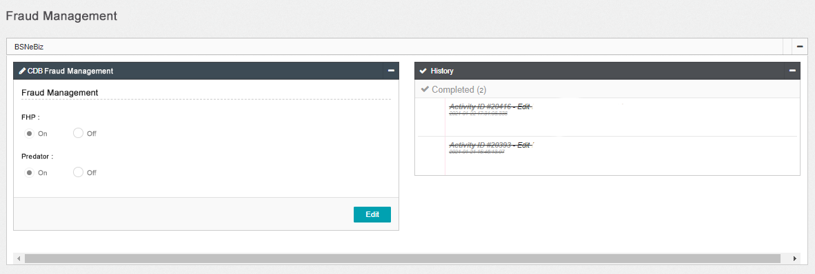

Figure 18: Fraud Management page

**Display Specification:**

| **No** | **Field** | **Field Type** | **Description** |
| --- | --- | --- | --- |
|  | FHP | Text | FHP status. |
|  | Predator | Text | Predator status. |

Table 19: Fraud Management Display Specification

**Action:**

| **No** | **Action** | **Field Type** | **Description** |
| --- | --- | --- | --- |
|  | Edit | Button | Contains an action to go to the edit screen. |

Table 20: Fraud Management Action

***Step 2:***

1. BBE Admin able to on/off FHP and Predator and clicks on the “Next” button.

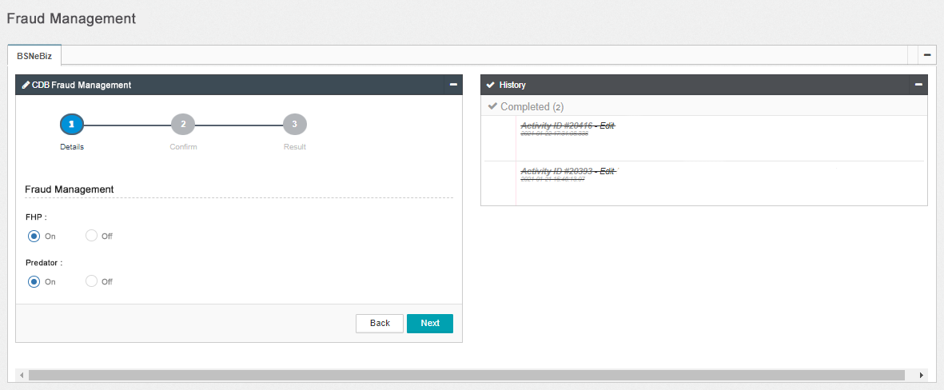

Figure 21: Fraud Management – Details screen

**Input Specification:**

| **No** | **Field** | **Field Type** | **Rule** | **Description** | **Required** |
| --- | --- | --- | --- | --- | --- |
|  | FHP | Radio Button | On or Off | Allow to on/off fraud alert | Yes |
|  | Predator | Radio Button | On or Off | Allow to on/off predator alert | Yes |

Table 22: Fraud Management – Details Input Specification

**Action:**

| **No** | **Action** | **Type** | **Description** |
| --- | --- | --- | --- |
|  | Back | Button | Contain an action to go to previous page |
|  | Next | Button | Contains an action to save the data and go to next page. |

Table 23: Fraud Management - Details Action

***Step 3:***

1. BBE Admin review the details and click on “Confirm” button.

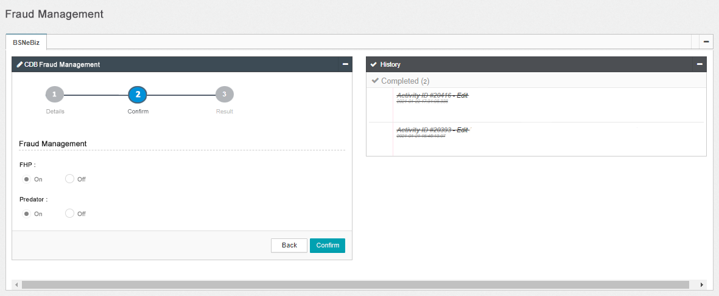

Figure 24: Fraud Management – Confirm screen

**Display Specification:**

| **No** | **Field** | **Field Type** | **Description** |
| --- | --- | --- | --- |
|  | FHP | Text | FHP status. |
|  | Predator | Text | Predator status. |

Table 25: Fraud Management - Confirm Display Specification

**Action:**

| **No** | **Action** | **Type** | **Description** |
| --- | --- | --- | --- |
|  | Back | Button | Contain the action to action to forward back to the previous screen |
|  | Confirm | Button | Forward the action to save the fields edited and go to Result screen |

Table 26: Fraud Management - Confirm Action

***Step 4:***

1. IBAM System validates save the data to IB Database and displays result page.
2. IBAM shows Successful message and pending for Authorization approval process (if customer BBE module maker checker permission set as ‘Enable’).

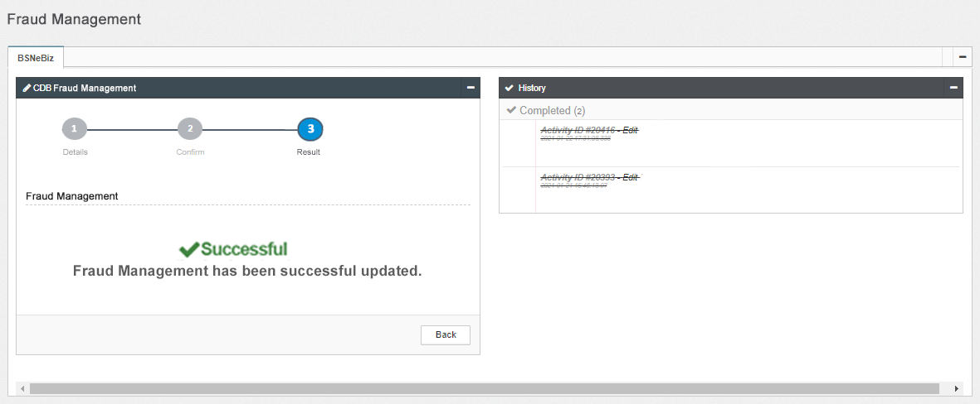

Figure 1: Fraud Management – Result screen

**Display Specification:**

| **No** | **Field** | **Format** | **Description** |
| --- | --- | --- | --- |
|  | Result Message | Text, symbol | To display result status and message. |

Table 27: Fraud Management – Result Display Specification

**Action:**

| **No** | **Action** | **Type** | **Description** |
| --- | --- | --- | --- |
|  | Back | Button | Contain an action to go to previous page |

Table 28: Fraud Management – Result Action

**Section E: Appendix**

# E1: Traceability Matrix

**Version Control**

|  |  |  |  |
| --- | --- | --- | --- |
| **No** | **BRFD Version** | **CR Version** | **CR Date** |
| 1 | ver.00 | CR-23002 ver.01.1 | 19/05/2023 |

**CR vs BRFD**

|  |  |  |
| --- | --- | --- |
| **No** | **CR SOW ID** | **BRFD ID** |
|  | SOW01 | 2.1 (2.1.1 – 2.1.2) |
|  | SOW01 (I) | 3.1 |
|  | SOW01 (II) | 3.2 |
|  | SOW02 (I) | 4.1 |
|  | SOW02 (II) | 4.2 |
|  | SOW03 (I) | 5.1 |

# E2: Related Item for Development

|  |  |
| --- | --- |
| **CR SOW ID** | **Item** |
| SOW04 | Enhancement at Batch Program and Database   1. To send batch file contains of company details to FPH and predator daily. |