DuitNow QR (Error Logs – 3/8/2023)
Item | Test | Remarks
1. | Mobile apps function : Receive  When share QR the format not standard for iOS & android  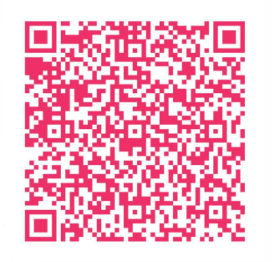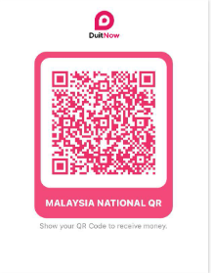 | Should contain merchant name with proper QR logo sample:  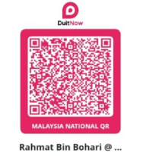
2. | Favorite account unable to proceed with DuitNow  Not in droplist for ios | To fix
3. | Receipt generate error – Folder failed to create  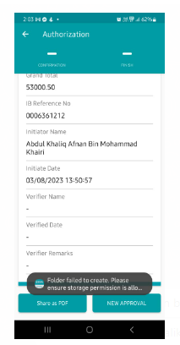 | To Fix

