DuitNow QR (Error Logs – 4/7/2023)
Item | Test | Remarks
1. | CDB :  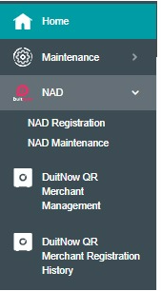 | To follow same as DuitNow NAD.  DuitNow (Logo) – Merchant QR (TITLE)  - Merchant Management  - Merchant Registration History  