DuitNow QR (Error Logs – 30/6/2023)
Item | Test | Remarks
1. | Mobile Apps:  Android ios  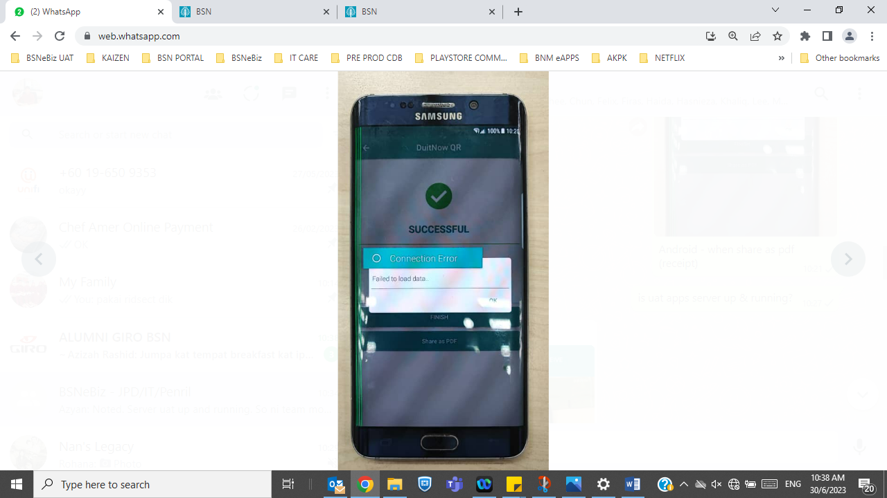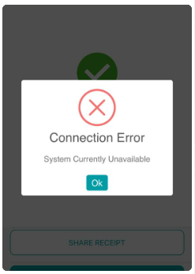 | When share pdf receipt  Ios – done 30/6  Android – yet to fix
2. | Ios  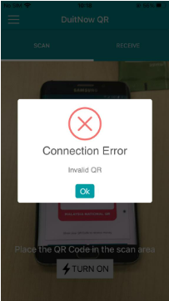 | When scan & pay to BSN QR  Done – 3/6
3. | Android  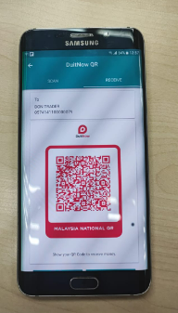 | Amount button does not display within screen
4. | Receive payment  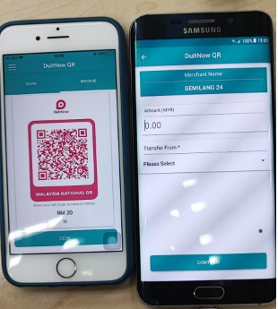 | Ios – received & enter amount to recive  Android – when scan amount does not display  Please check vise versa

