SCPID#6757
Test Title: |  | Tool and Guide - Remove Demo video
Test Description: |  | Issue: Remove demo video at Tool and Guide. Service Info BDEMOMNT should offline demo video only.  Finding: There is logic error when need to online demo video service also in order to display tools and guide.  Solution: Fix the logic error condition.
Test Functionality: |  | To test online/offline BDEMOMNT and BDOWNLOAD
Test Procedure: |  | Test steps:  IBAM > BBE > Content > Service Info  BDEMOMNT = Demo Maintenance  BDOWNLOAD = Tool and Guide  Situation 1  - Online service BDEMOMNT.  - Offline service BDOWNLOAD.  - Login CDB > select Tools and Guide.  - Expected result: Only display Demo Video.  - Logout.  Situation 2  - Offline service BDEMOMNT.  - Online service BDOWNLOAD.  - Login CDB > select Tools and Guide.  - Expected result: Only display Tools and Guide.  - Logout.  Situation 3  - Online service BDEMOMNT.  - Online service BDOWNLOAD.  - Login CDB > select Tools and Guide.  - Expected result: Display Demo Video, Tools and Guide.  - Logout.  Situation 4  - Offline service BDEMOMNT.  - Offline service BDOWNLOAD.  - Login CDB > select Tools and Guide.  - Expected result: Both do not display and throw offline message.  - Logout.
Response Message:
Test Result: | Pass: Fail: |  | Tested by: | Nor Athirah Umairah (15/08/2023)
Reason for Failure:
Remarks: |  | Situation 1: Online service BDEMOMNT, Offline service BDOWNLOAD  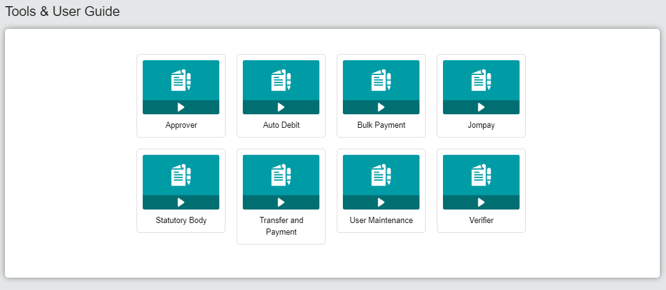  Situation 2: Offline service BDEMOMNT, Online service BDOWNLOAD  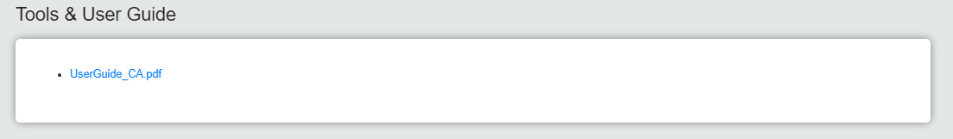  Situation 3: Online service BDEMOMNT, Online service BDOWNLOAD  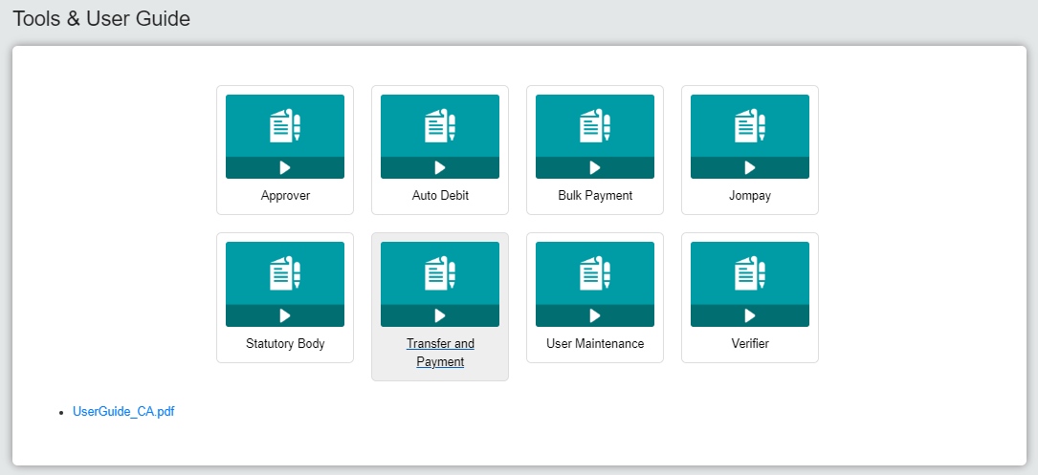  Situation 4: Offline service BDEMOMNT, Offline service BDOWNLOAD  