SCPID#6759
Test Title: |  | FAILED TO APPROVE BY SUPERVISOR
Test Description: |  | This issue can happen if:  1. maker 1 edit contact A, pending approval  2. root admin edit contact A, direct save to database  3. checker approve and got error because conflict with step 2  Finding: Null exception error  Solution: Handling the null exception
Test Functionality: |  | To test approval for Edit Organization Contact Person
Test Procedure: |  | Test steps:  Situation 1  - Login as maker, organization setup > edit Contact Person.  - Login as checker, approve the maker's activity.  - Expected result: Successfully approved.  Situation 2  - Login as maker, organization setup > edit Contact Person.  - Login as checker, reject the maker's activity.  - Expected result: Successfully rejected.  Situation 3  - Login as maker, organization setup > edit Contact Person.  - Login as admin, organization setup > edit Contact Person.  - Expected result: System throw error message "Pending for Approval".
Response Message:
Test Result: | Pass: Fail: |  | Tested by: | Nor Athirah Umairah (16/08/2023)
Reason for Failure:

Remarks: | Situation 1  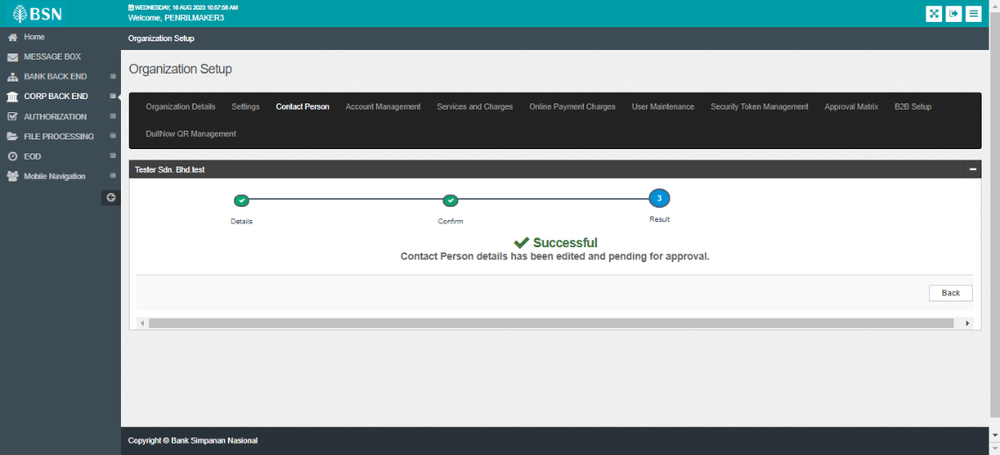  Figure 1: Maker Edit Contact Person  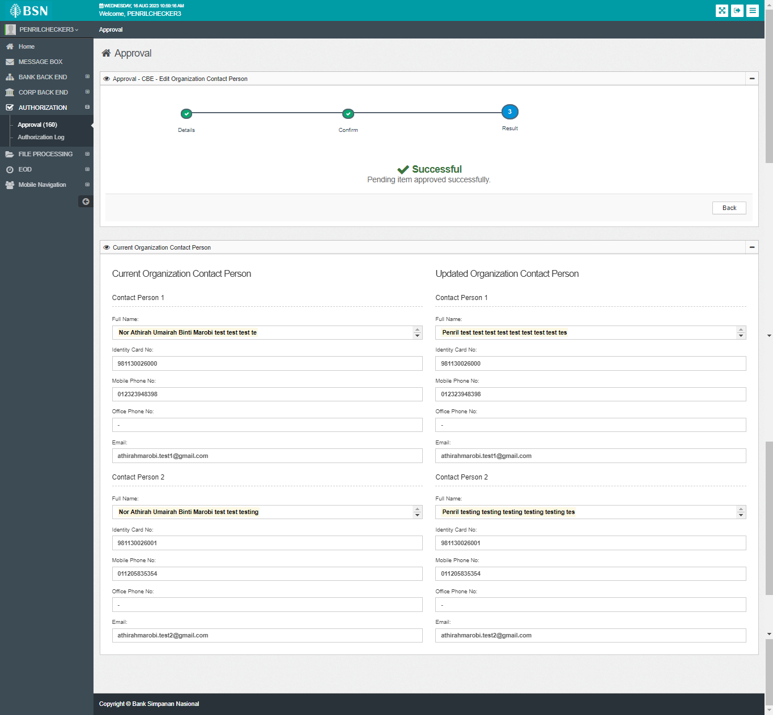  Figure 2: Checker approval - approved  Situation 2  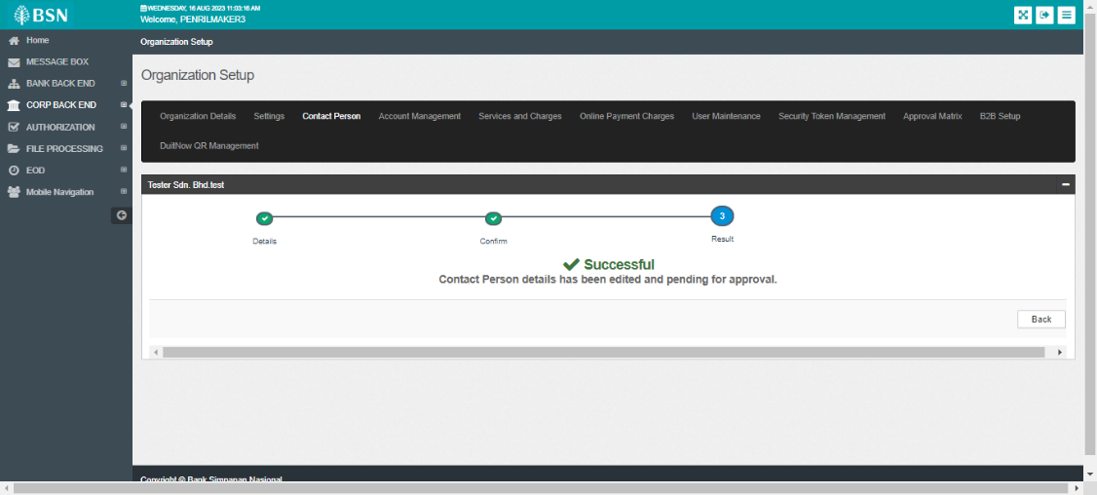  Figure 3: Maker Edit Contact Person  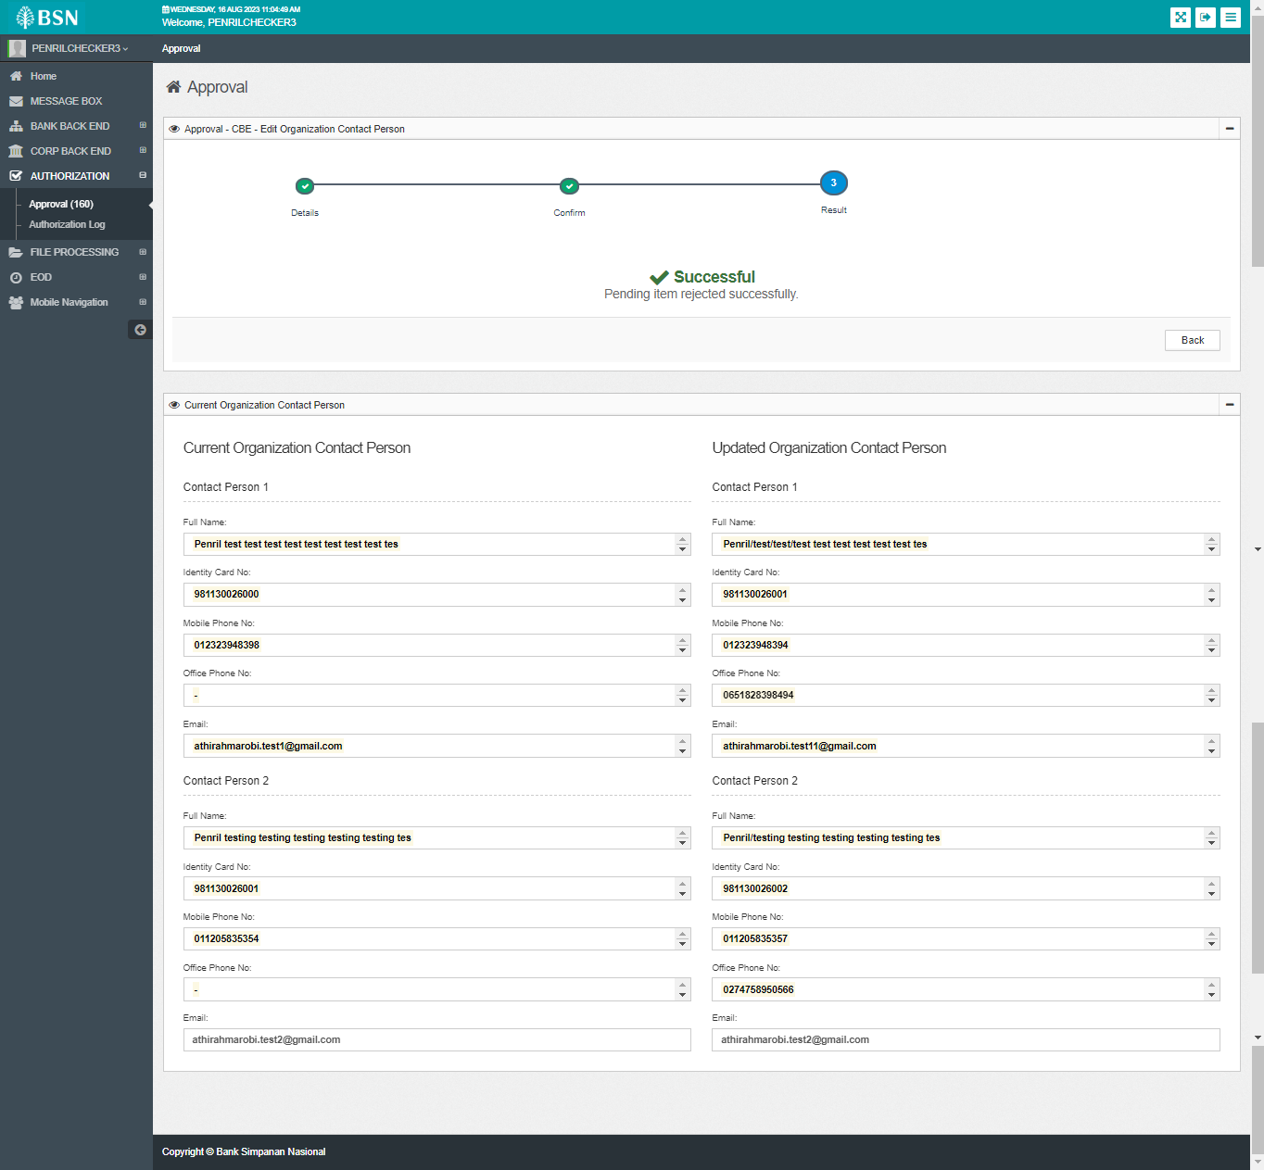  Figure 4: Checker approval - rejected  Situation 3  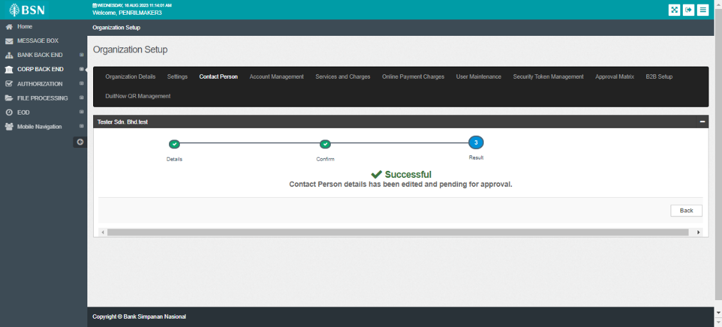  Figure 5: Maker Edit Contact Person  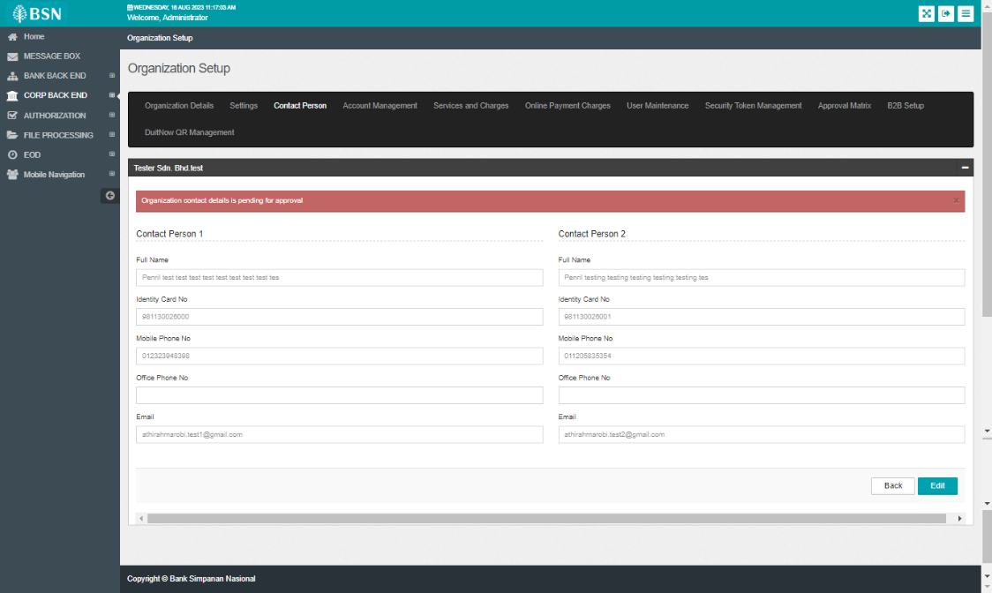  Figure 6: Admin Edit Contact Person

