SCPID#6761
Test Title: |  | EOD AutoCredit Failed to Process
Test Description: |  | Issue: EOD failed to process on of the orgcode due to duplication on the services registered.  Finding: EOD program failed because of duplicate service code.  Solution: Update getServiceCode query remove uniqe criteria replace with list, only get first list value.
Test Functionality: |  | To test on bulk payment EOD processing file.
Test Procedure: |  | Test steps:  - Perform upload/data entry bulk payment auto credit/auto debit.  - Ask developer to update db table BibAccountServices, set duplicate orgId and allowServices(AC/AD/SK)  - Run EOD Processing.  - Expected result: File should be successfully processed.
Response Message:
Test Result: | Pass: Fail: |  | Tested by: | Nor Athirah Umairah (22/08/2023-23/08/2023)
Reason for Failure:
Remarks: |  | 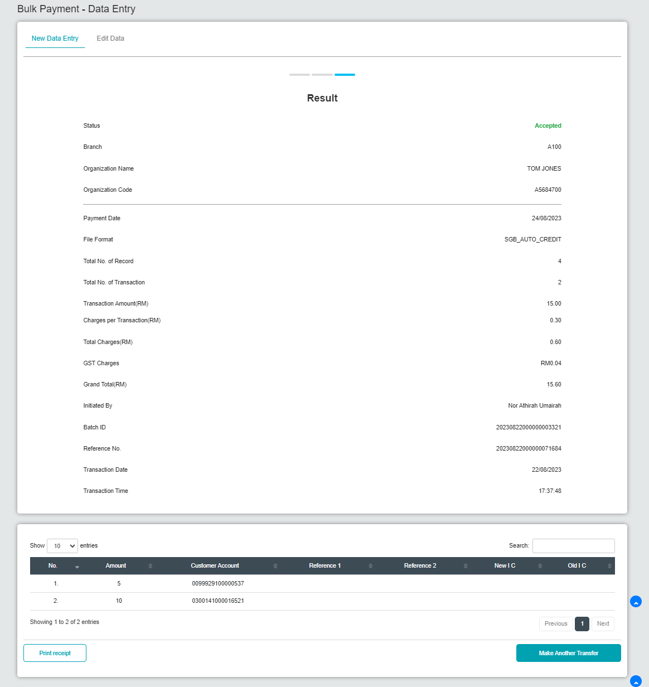  Figure 1: Bulk Payment - Data Entry (Step 1)  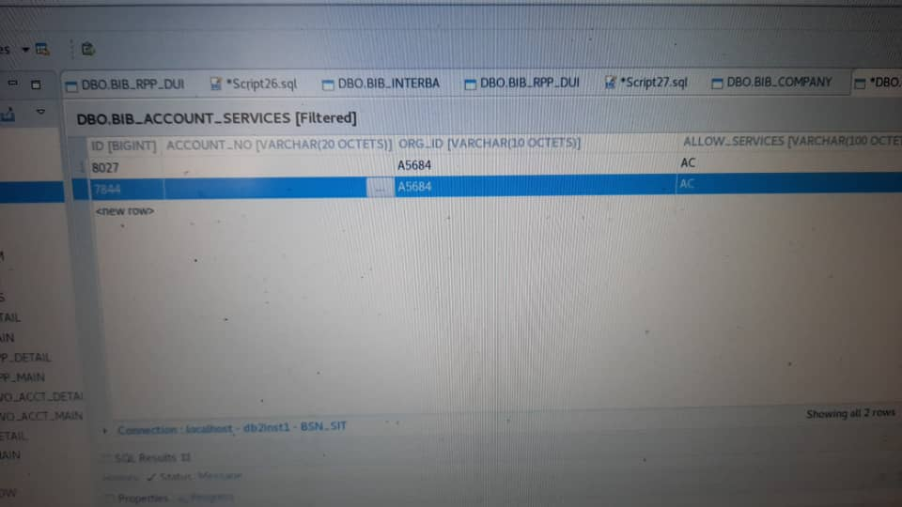  Figure 2: BibAccountServices (Step 2)  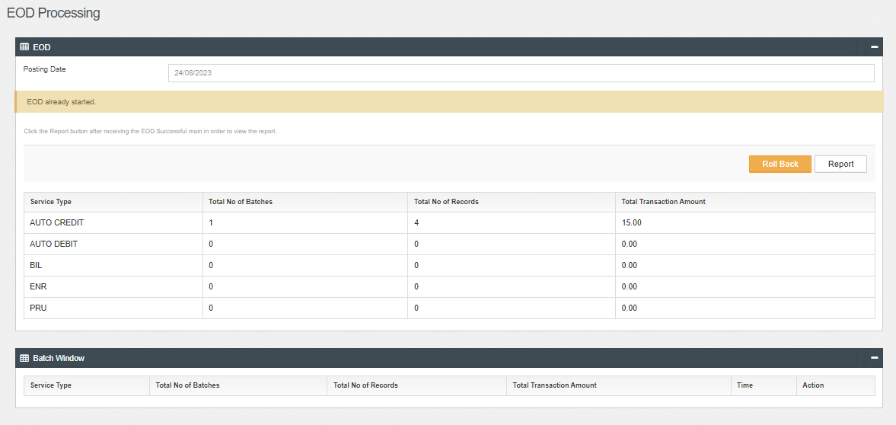  Figure 3: EOD Processing (Step 3)  Result: File successfully processed.  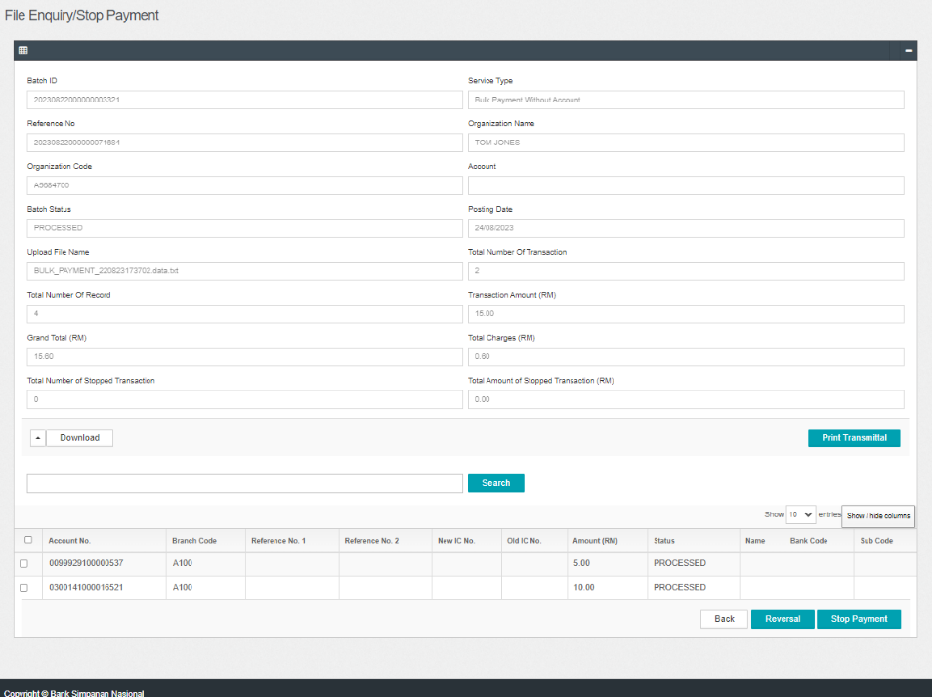  Figure 4: File Enquiry

