|  |  |  |  |  |
| --- | --- | --- | --- | --- |
| FUNC_3.1 | TC-005 | 1. Insert the invalid CIS Number / Account Number 2. Click on "Validate" button | System will display error message:  1. CIS Number/Account Number is invalid. | Search By Account Number but error message CIS Number is invalid |

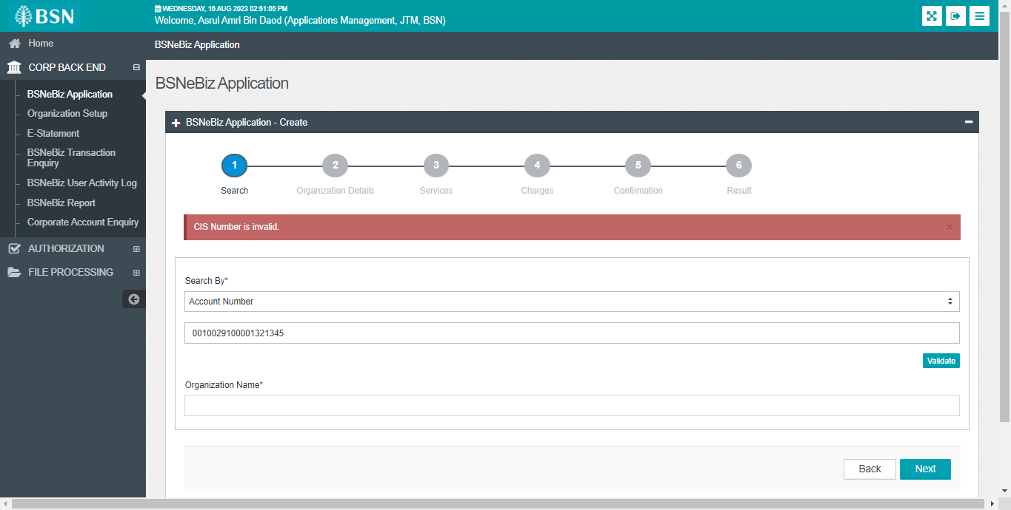

2.

|  |  |  |  |  |
| --- | --- | --- | --- | --- |
| FUNC_3.1 | TC-006 | 1. Leave empty at CIS Number / Account Number 2. Click on "Next" button | System will display error message:  1. CIS Number/Account Number is required. | No error message validate empty field for both CIS and account number |

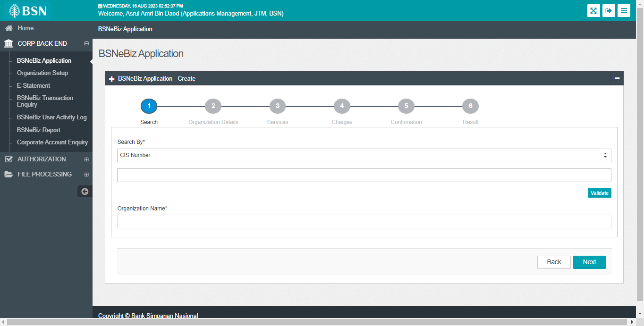

3.

a. Change main title CDB Application to BSNeBiz Application and Increase font size.

b. Under Services section, use Yes & No for Allow column. Replace null to empty char for other’s column

