Module | BSNeBiz – New Application Process
Error Logs | 17/8/2023
Test Date | 17/8/2023

Item | Subject | Remarks
1 | CDB – Organization Application  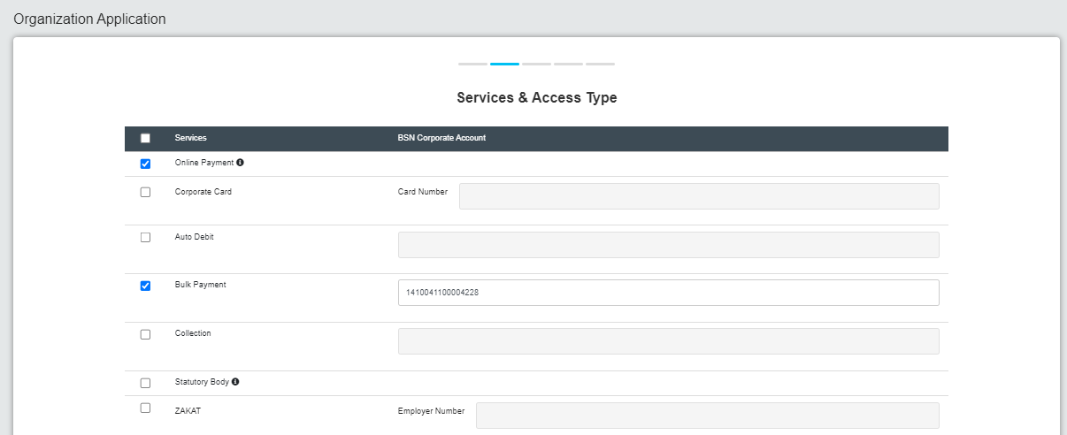 | To rearrange the Service:  BATCH PROCESS  Bulk Payment  Auto Debit  ONLINE PAYMENT  DuitNow  Intrabank (BSN to BSN)  Interbank (IBG)  RENTAS  STATUTORY BODY  LHDN  EPF  SOCSO  Corporate Card  Notes:  Auto default tick for Bulk Payment,Auto Debit & Online payment  If RENTAS selected by default in IBAM setting is YES
2 | 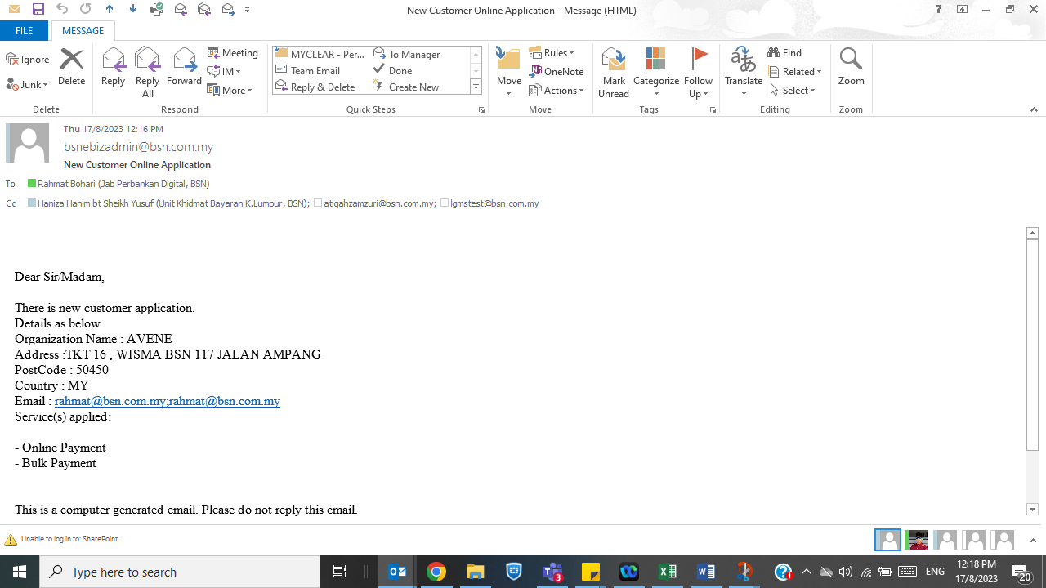 | Can we include the info of person perform declaration in the emel content?
3. | Email - Username  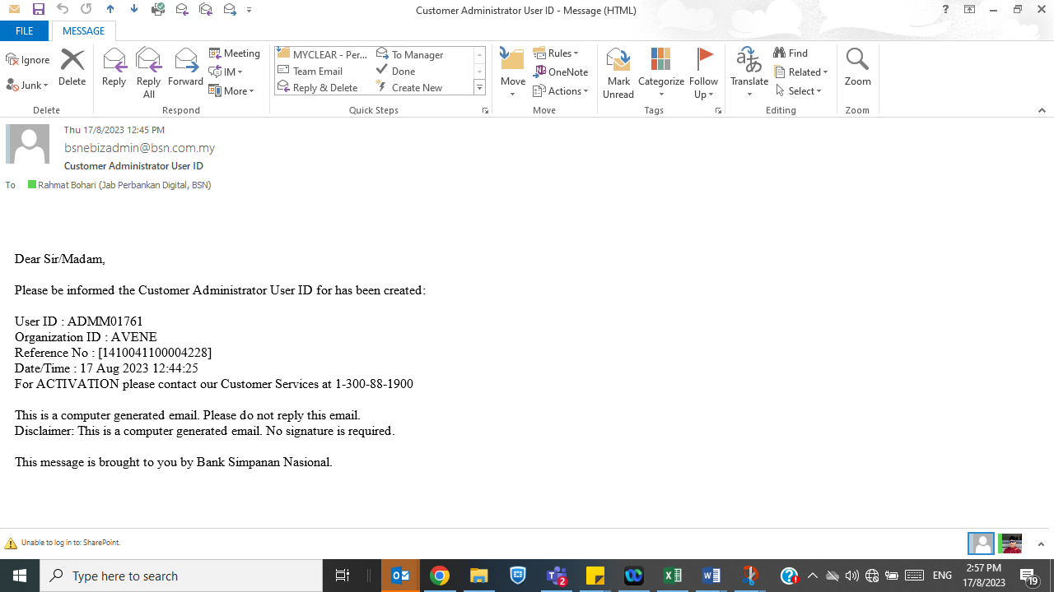 | Body content to update:  Dear Sir/Madam,  Please be informed the Customer Administrator User ID for has been created:  User ID : ADMM01761  Organization ID : AVENE  Reference No : [1410041100004228]  Date/Time : 17 Aug 2023 12:44:25  For ACTIVATION please contact our Customer Services at 1-300-88-1900  For enquiry please email to bsnebiz_support@bsn.com.my  This is a computer generated email. Please do not reply this email.  Disclaimer: This is a computer generated email. No signature is required.  This message is brought to you by Bank Simpanan Nasional.
 | Email – Temporary Password  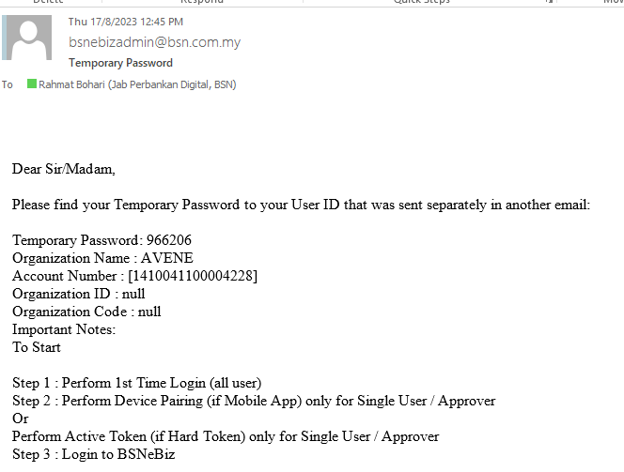 | Dear Sir/Madam,  Please find your Temporary Password to your User ID that was sent separately in another email:  Temporary Password: 966206  Organization Name : AVENE  Account Number : [1410041100004228]  Organization ID : null ????  Organization Code : null ????  Important Notes:  To Start  Step 1 :  - Perform 1st Time Login (all user) via BSNeBiz web at https://www.bsnebiz.com.my/bsn-cdb/commonLogin  Step 2 :  Perform Device Pairing (if Mobile App) for Single User / Approver via BSNeBiz web & mobile apps  Step 3 : Login to BSNeBiz web
 | IBAM – ORGANIZATION INFORMATION  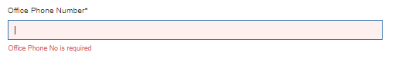 | Office Phone Number  Not mandatory
 | IBAM – ORG SETUP – SETTING  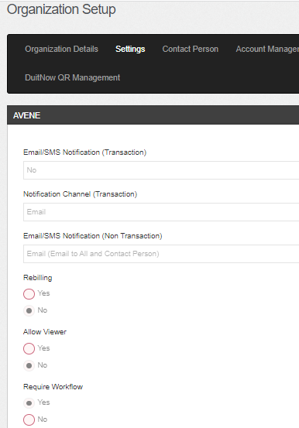 | Require Workflow does not default to customer application
 | IBAM – ORG SETUP – CONTACT PERSON  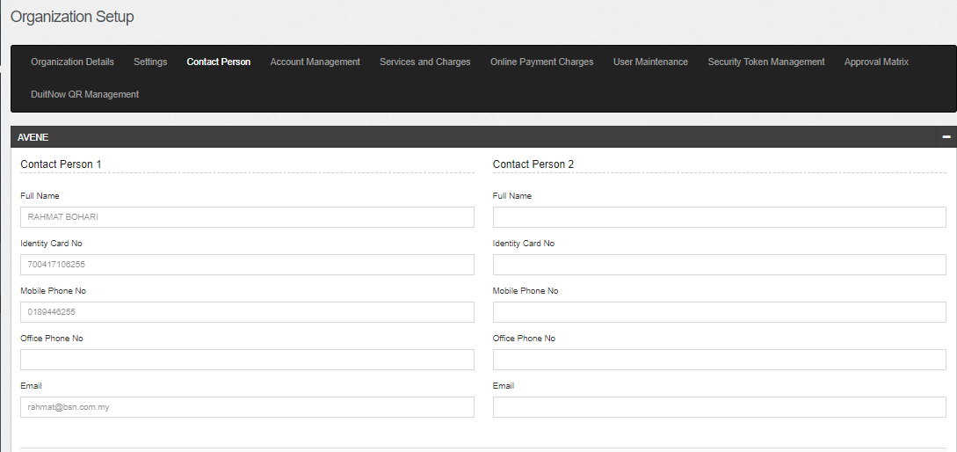 | To remove Contact Person 2

