Module | BSNeBiz – New Application Process
Error Logs | 05/09/2023
Test Date | 01/09/2023 – 05/09/2023

Item | Subject | Remarks
1. | CDB  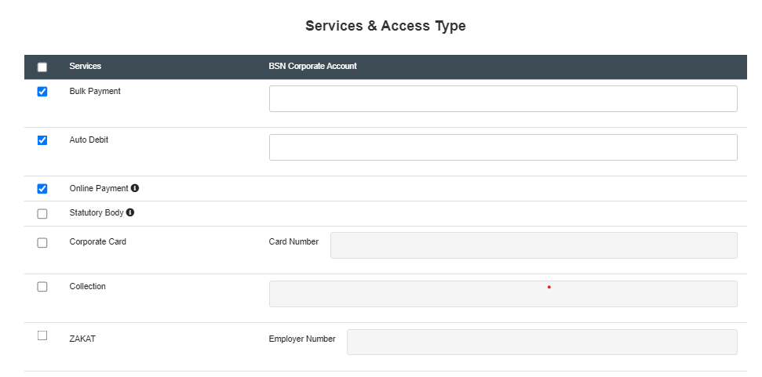 | Mandatory field for account number / employer number
2. | IBAM  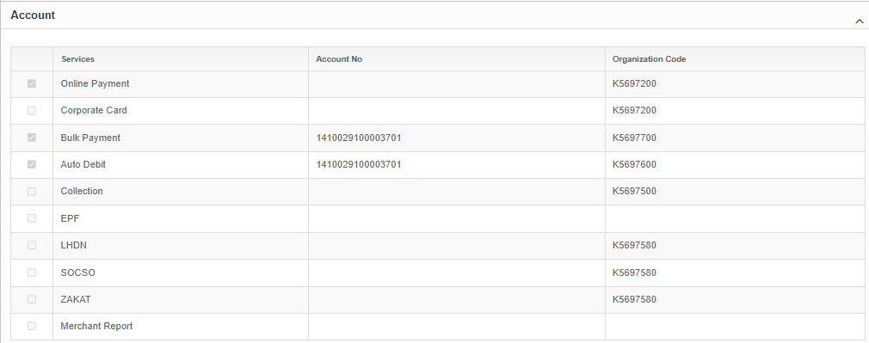 | After generate ID  System generate the org code for services not selected.
3. | IBAM  Organization and Information  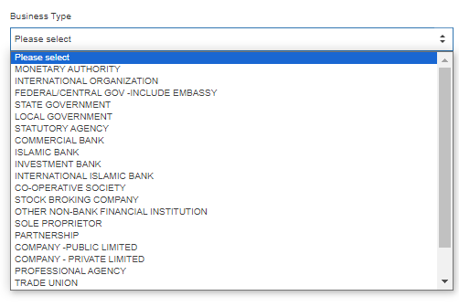  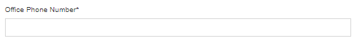 | Business type to mandatory  To remove - *
4. | Application Form (pdf)  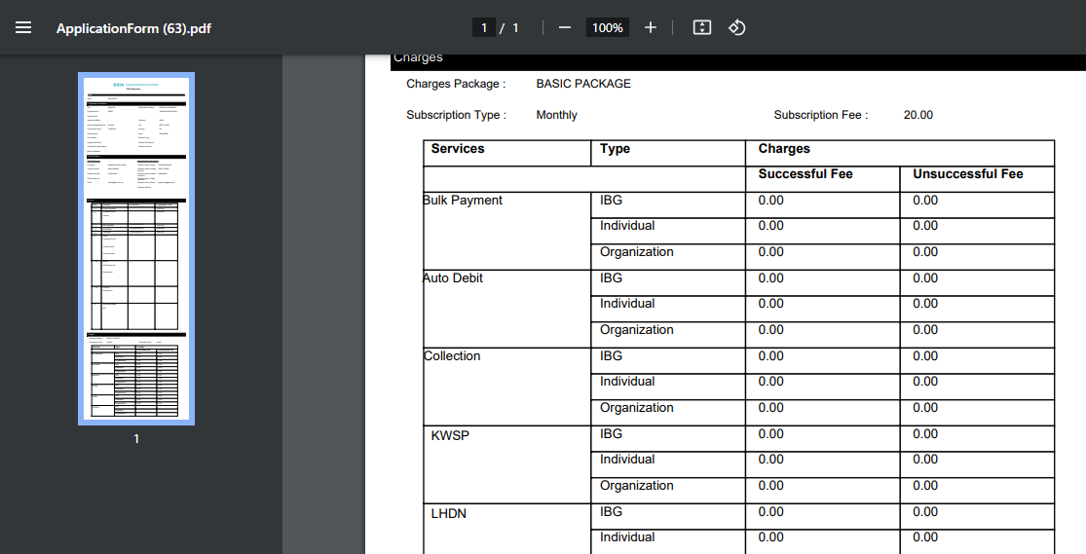 | To have proper alignment  - Font not standardize.  - To follow same font type & bold as Services/Type/Charges  - Alignment to center  - Successful Fee & Unsuccessful Fee detail to center alignment
5. | IBAM | Approver Authorization Log  State should be Selangor not Ibu Pejabat

