Module | BSNeBiz – New Application Process
Error Logs | 28/8/2023
Test Date | 28/8/2023

Item | Subject | Remarks
1. | CDB  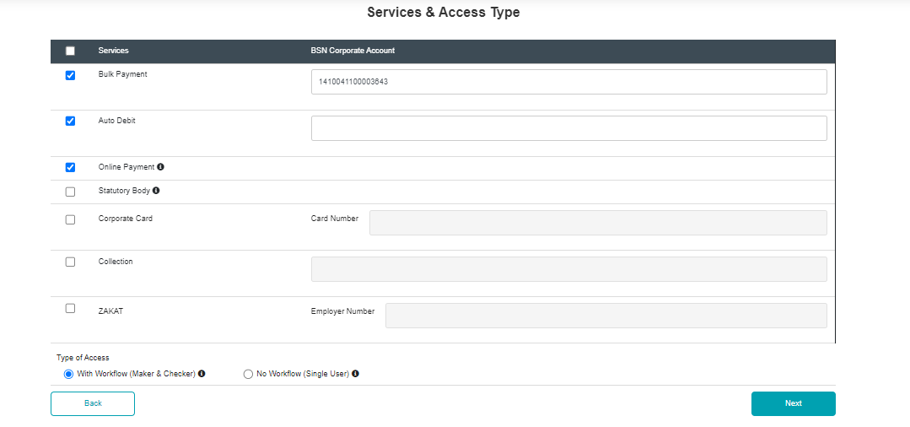 | - Online Payment to have account number box  - To add DuitNow QR Merchant Registration  Tak sempat, hold dulu.
2 | CDB  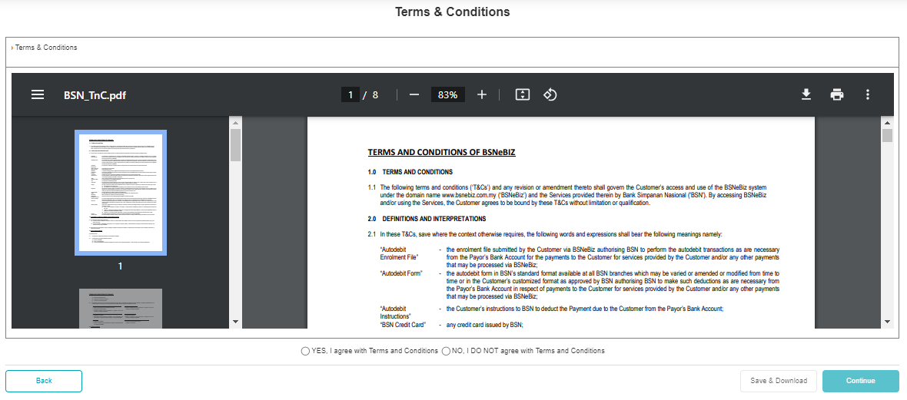 | - Font to be in black  - Disable download & print function  Check whether can hide or not. If not just leave it first.
3. | CDB  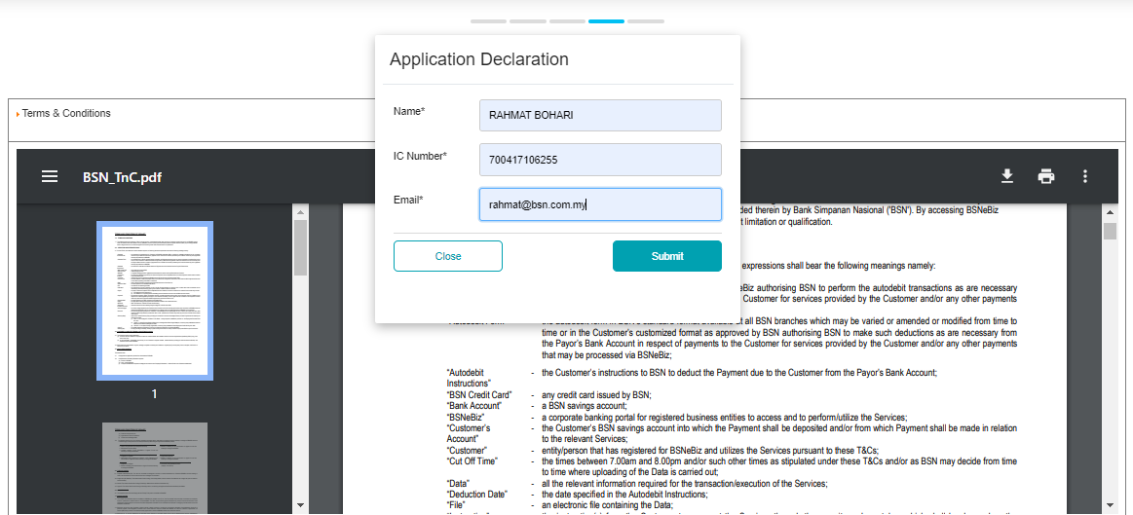 | - To in Application Declaration box:  DECLARATION  This application is made on behalf of (Company name) and I have informed my organisation regarding my application
4 | CDB  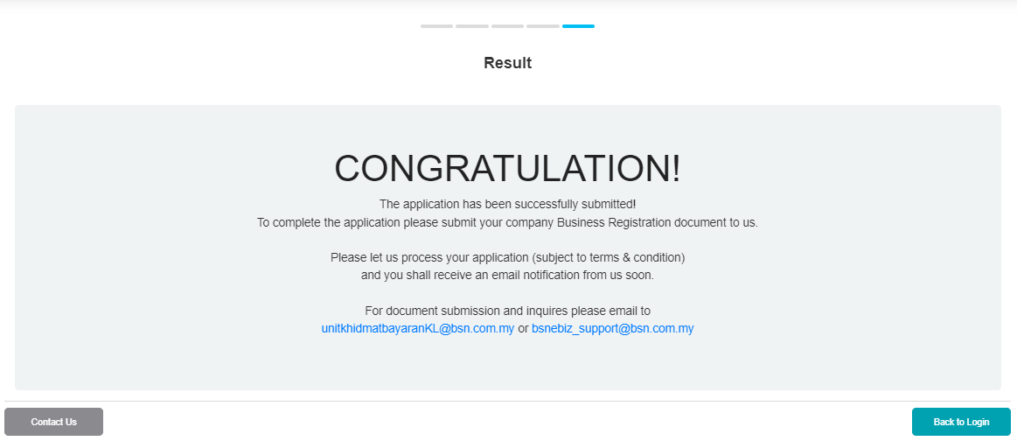 | - To reword:  The application has been successfully submitted and received!  We shall contact you soon for further clarification to proceed with the application (subject to terms and condition)  For document submission and inquiries please email to:  UKB Negeri & bsnebiz_support@bsn.com.my
5. | CDB  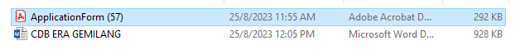 | - Application form naming convention : <companyname><application form>
6. | IBAM  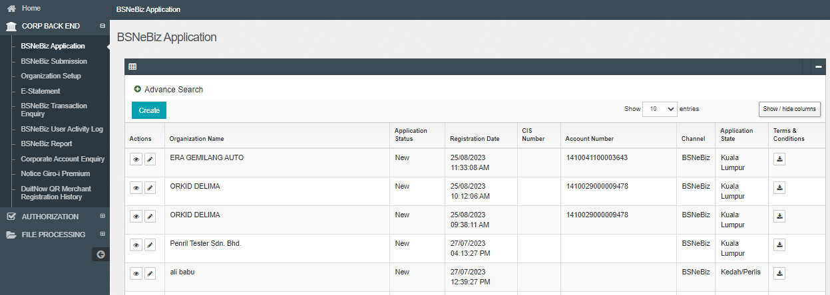 | - Detail BSNeBiz application box.  Alignment should be centre
7. | IBAM – Create : Did not submit but display in new application | - The applicant did not submit or complete the application process however it capture in IBAM new application. No function to delete.  If the application did nor complete system should not capture the application other wise system should have DELETE button (with no cost)  Report as production issue.  Check with najmi/chee ping behaviour existing.

