SCPID#6782
Test Title: |  | Unable approve Edit Organization Profile
Test Description: |  | Issue: Unable to approve Edit Organization Profile  Finding: Because BibCompany (company profile details) join table with BibAccount and BibApprovalMatrix,  if any update at BibAccount and BibApprovalMatrix will affect BibCompany approval.  Scenario:  - Maker edit Organization Details and pending approval  - Maker edit Account Management and pending approval  - Checker approve Account Management and successful  - Checker approve Organization Details and will get error db missing row  Solution: At Edit Organization Details approval, update only BibCompany Organization Details data
Test Functionality: |  | To test on edit organization setup for maker and checker.
Test Procedure: |  | Test steps:  - Access IBAM as maker  - Access CBE>Org Setup>Select Company>Account Management and edit selected account  - Access CBE>Org Setup>Select Company>Organization Details and edit  - Access IBAM as checker  - Access Authorization>Approval  - Approve Company Account Management  - Approve Company Organization Details  - Expected result, both approval success and changes is reflected in Org Setup Account and Organization Details
Response Message:
Test Result: | Pass: Fail: |  | Tested by: | Nor Athirah Umairah (08/09/2023)
Reason for Failure:
Remarks: |  | Access IBAM as maker  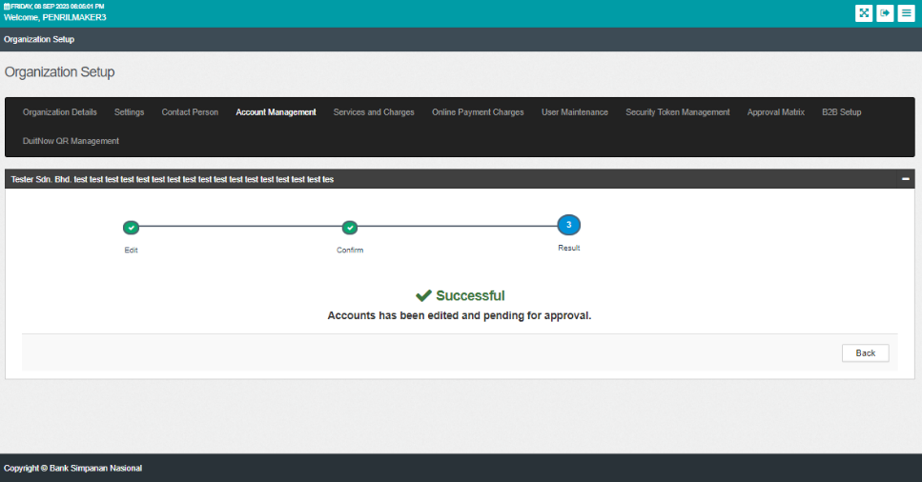  Figure 1: Edit Account Management (Result)  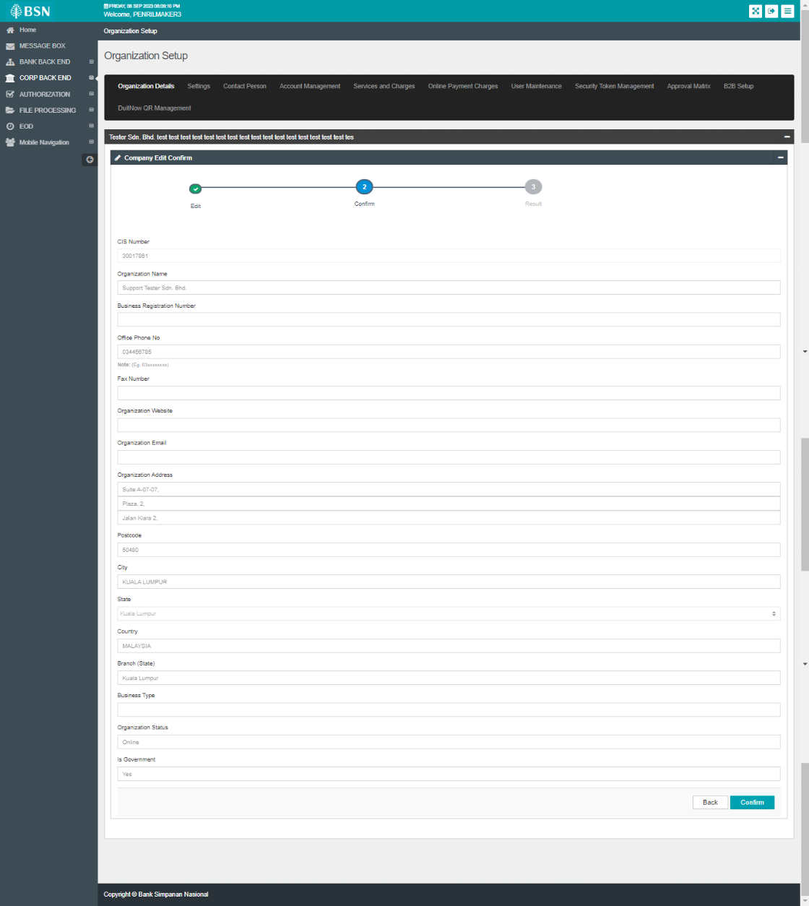  Figure 2: Edit Organization Details (Confirm)  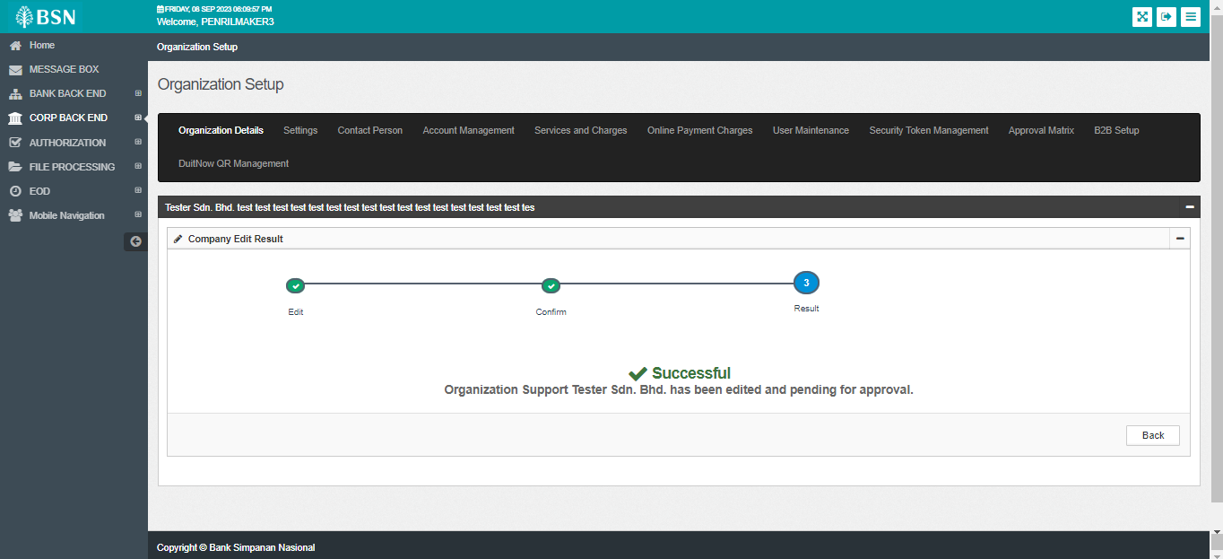  Figure 3: Edit Organization Details (Result)  Access IBAM as checker  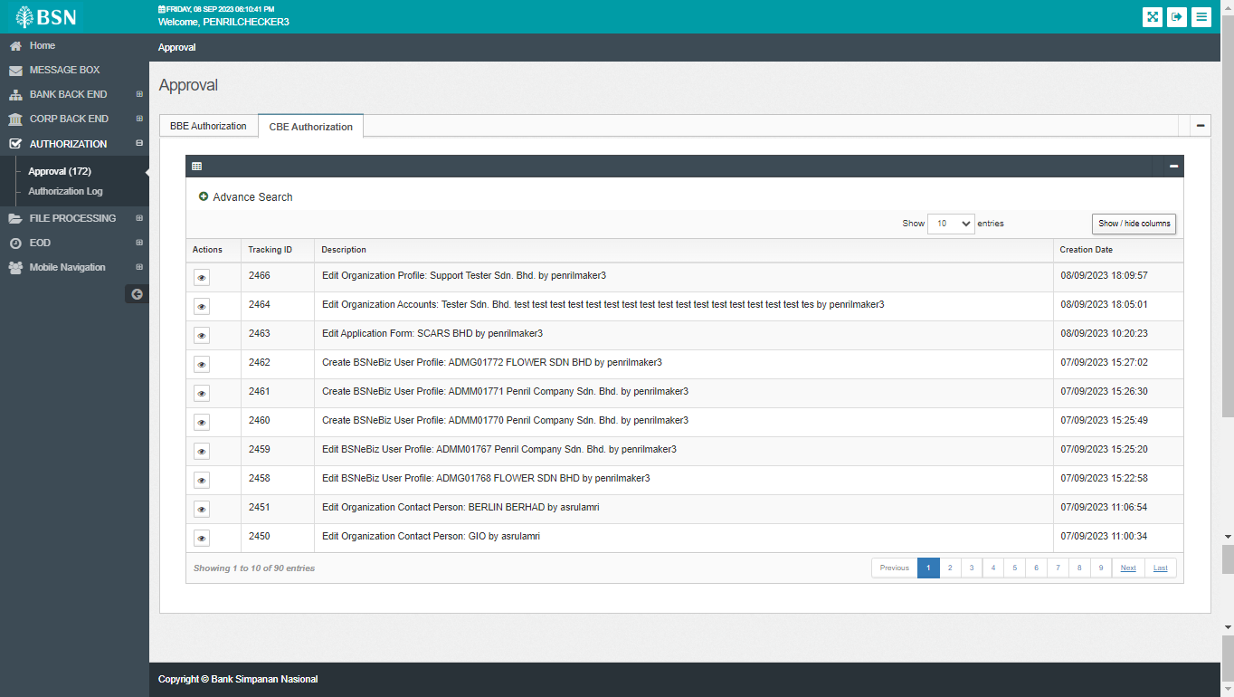  Figure 4: Authorization > Approval  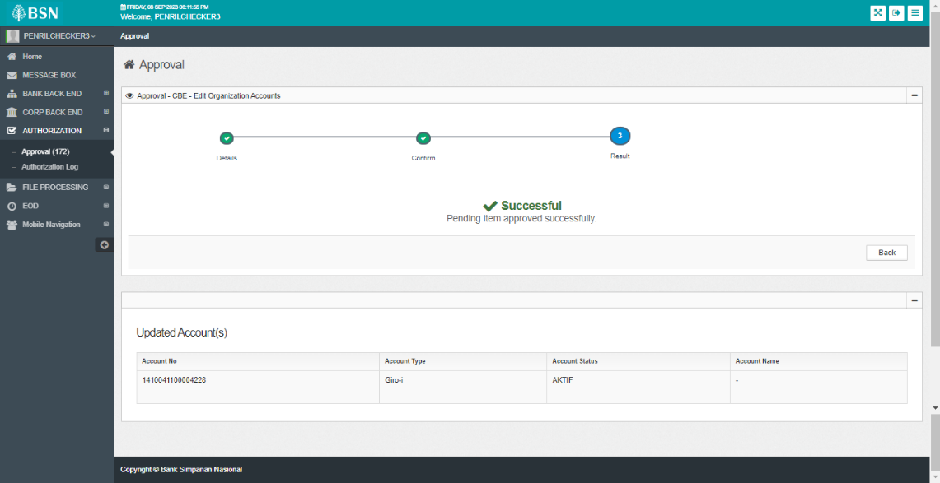  Figure 5: Approval – Edit Organization Accounts (Result)  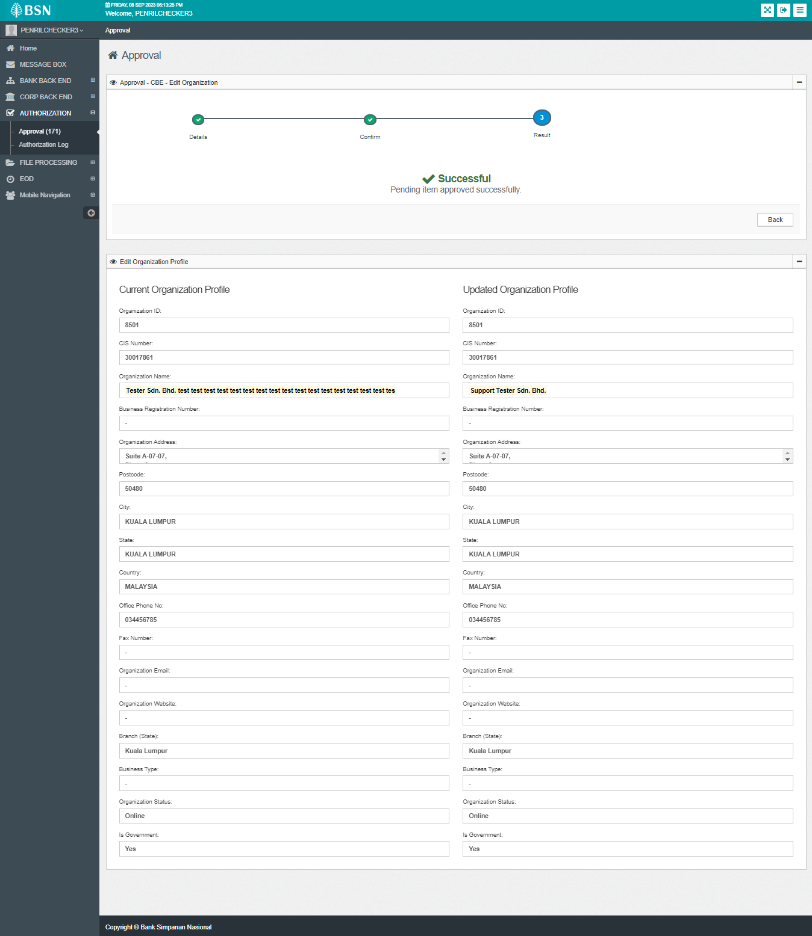  Figure 6: Approval – Edit Organization Details (Result)

