SCPID#6784
Test Title: |  | NAD Registration
Test Description: |  | Current BREG format allows alphanumeric and - symbol only.  Finding: RPP Web Service request only validate BREG alphanumeric  Solution: Handle backend send request BREG value to RPP Web Service replace symbol - with no space  Please test BREG with special character (DuitNow trnx - web and mobile)  i. NAD Registration  ii. NAD Maintenance  iii. DuitNow New and Fav Transfer  iv. DuitNow Fav Maintenance
Test Functionality: |  | To test on NAD Registration and DuitNow transaction using business registration with special character (-).
Test Procedure: |  | Test steps:  Perform transaction in web and mobile using business registration with special character.  - NAD Registration  - NAD Maintenance  - DuitNow New and Fav Transfer  - DuitNow Fav Maintenance
Response Message:
Test Result: | Pass: Fail: |  | Tested by: | Nor Athirah Umairah (14/09/2023)
Reason for Failure:
Remarks: |  | 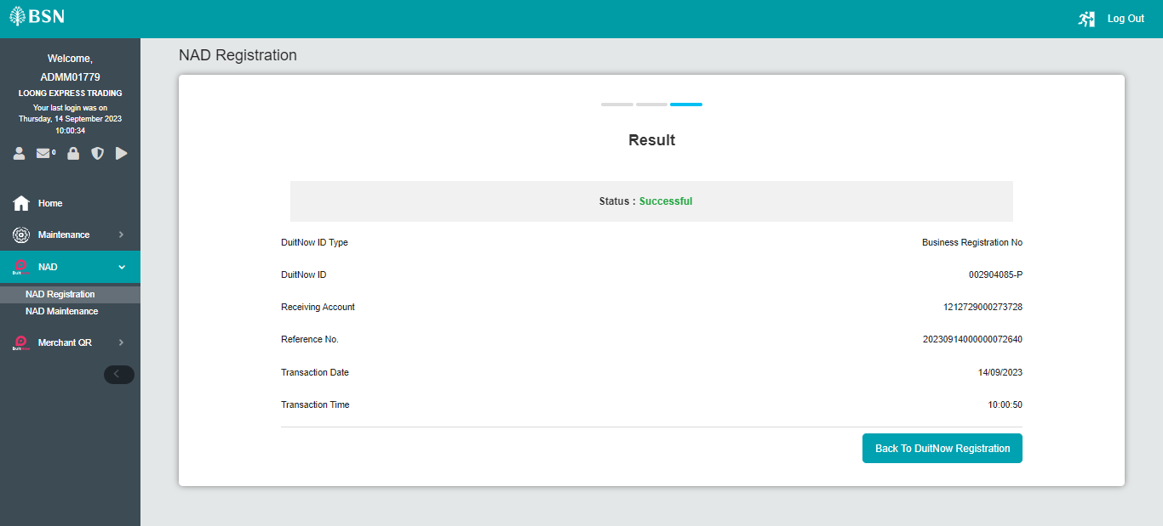  Figure 1: NAD Registration (Result)  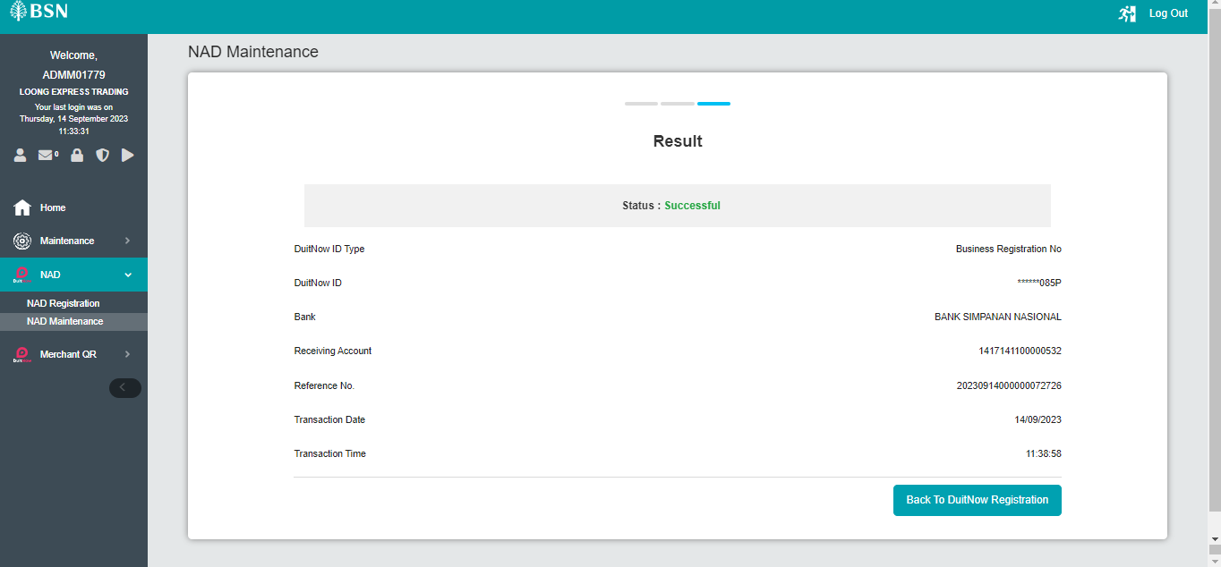  Figure 2: NAD Maintenance - Edit (Result)  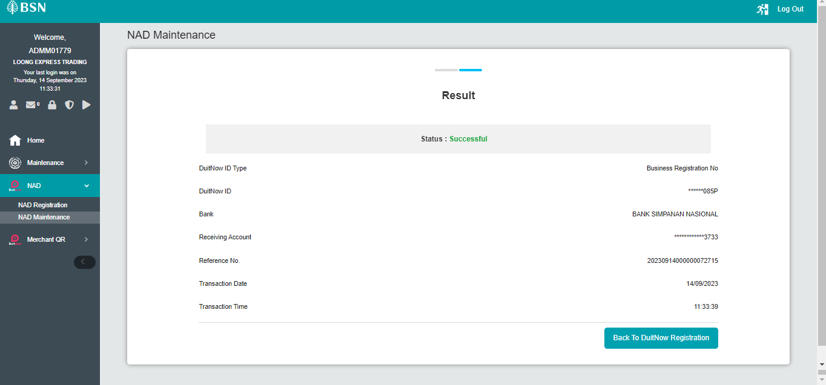  Figure 3: NAD Maintenance - Block (Result)  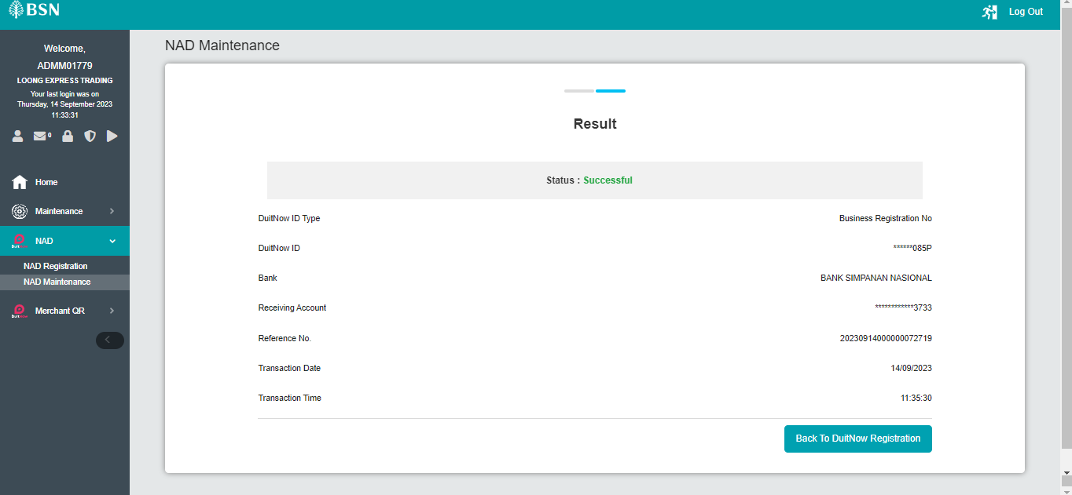  Figure 4: NAD Maintenance – Activate (Result)  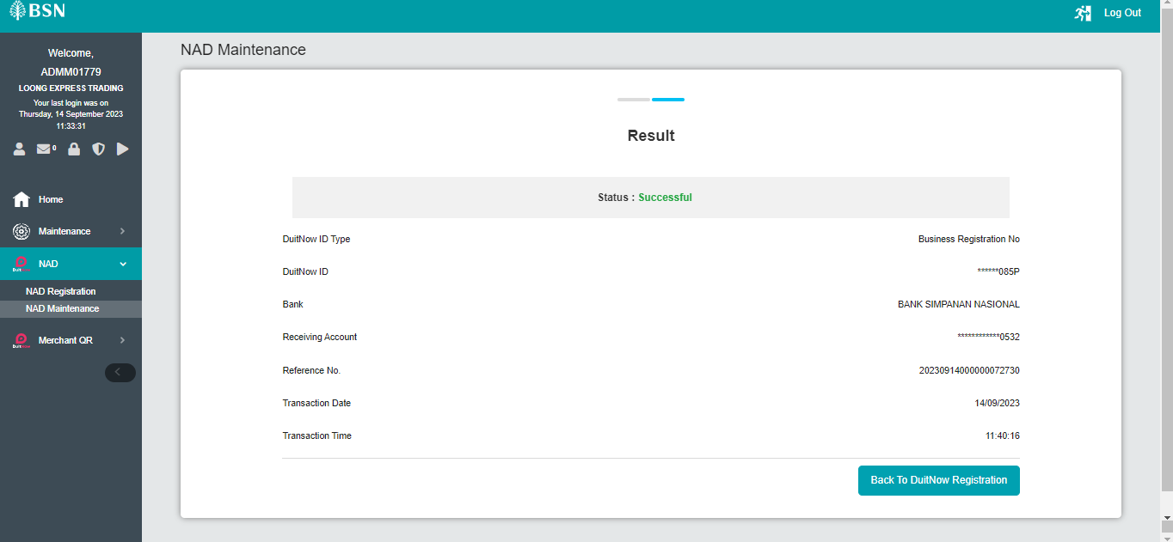  Figure 5: NAD Maintenance - Delete (Result)  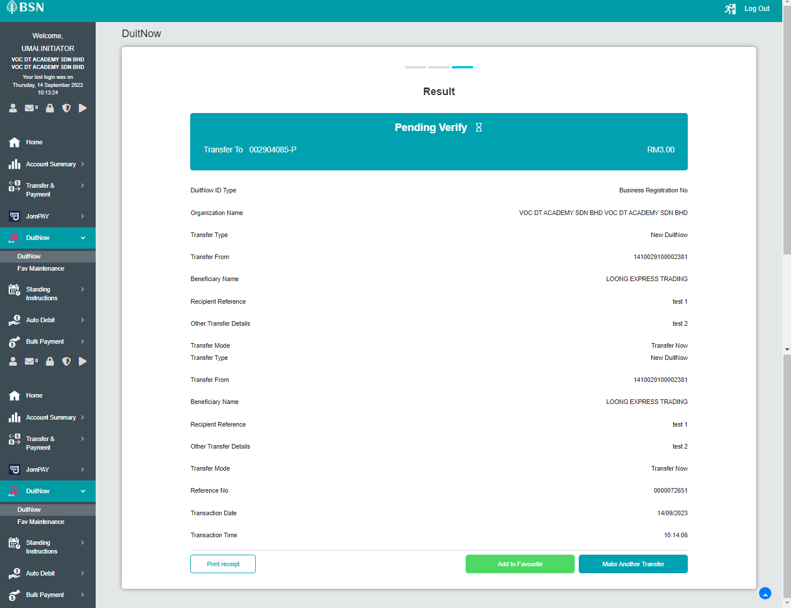  Figure 6: New DuitNow (Result)  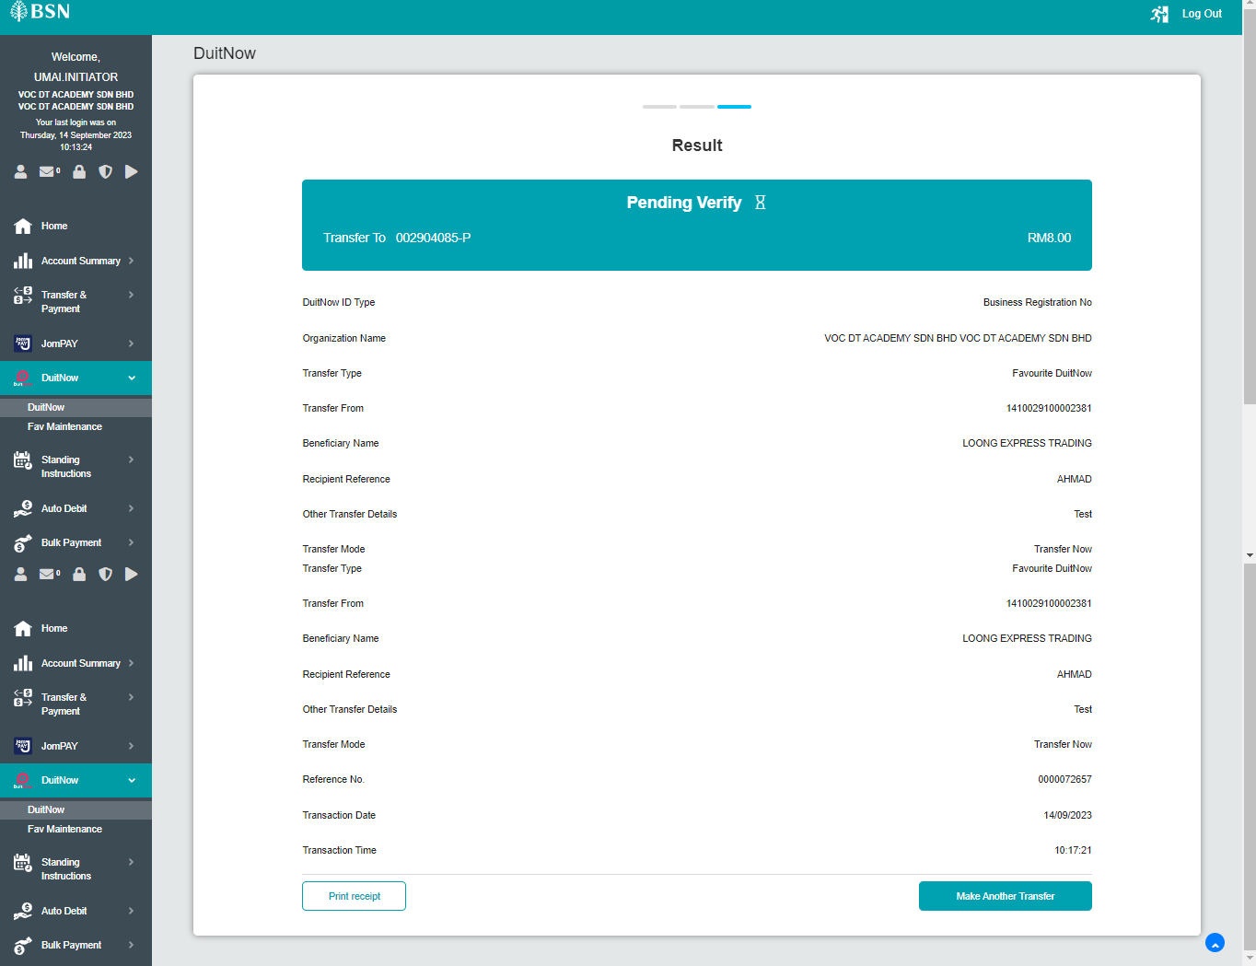  Figure 7: Fav DuitNow (Result)  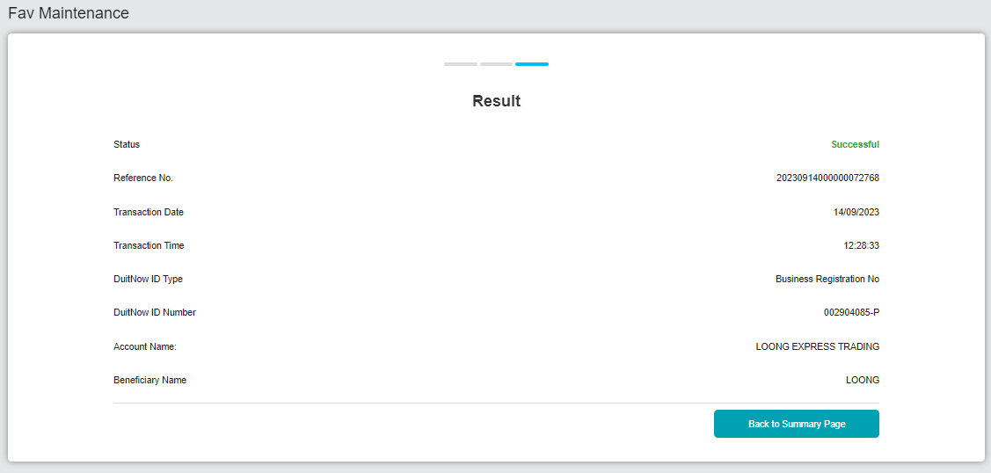  Figure 8: DuitNow Fav Maintenance - Add (Result)  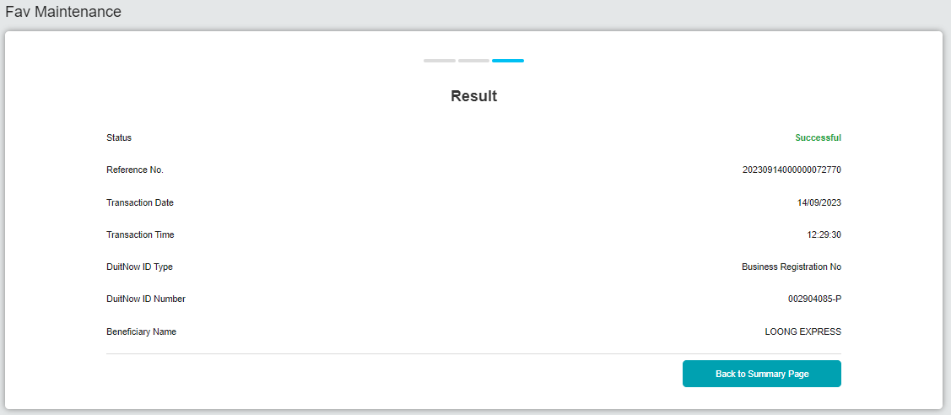  Figure 9: DuitNow Fav Maintenance - Edit (Result)  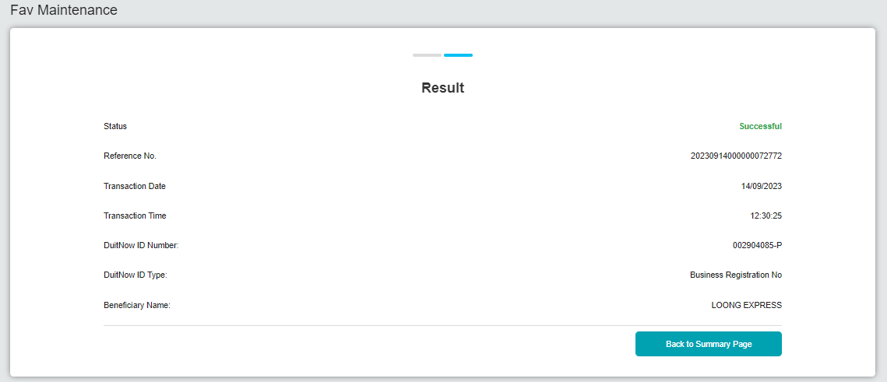  Figure 10: DuitNow Fav Maintenance - Delete (Result)  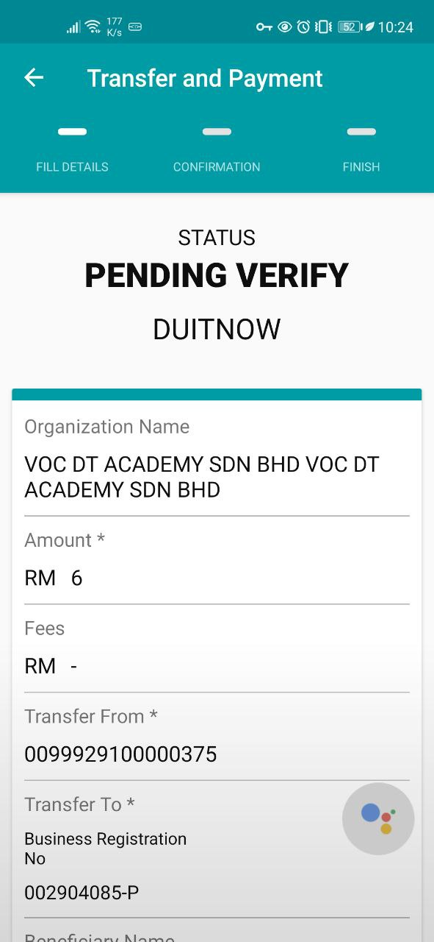  Figure 11: New DuitNow - Mobile (Result)  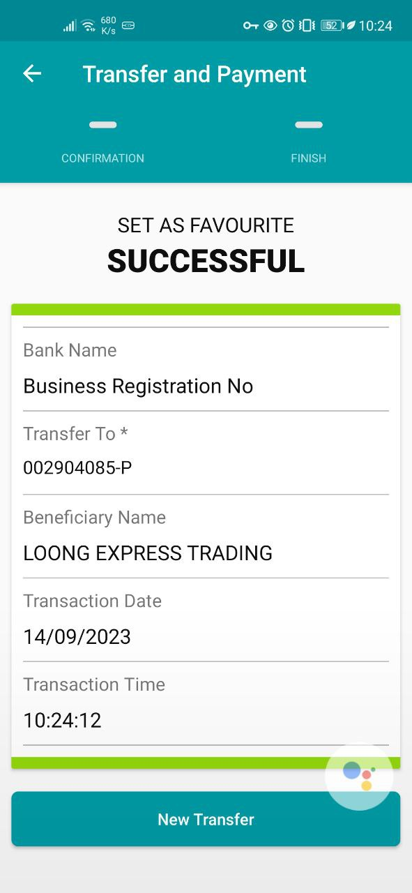  Figure 12: DuitNow Add as Fav - Mobile (Result)  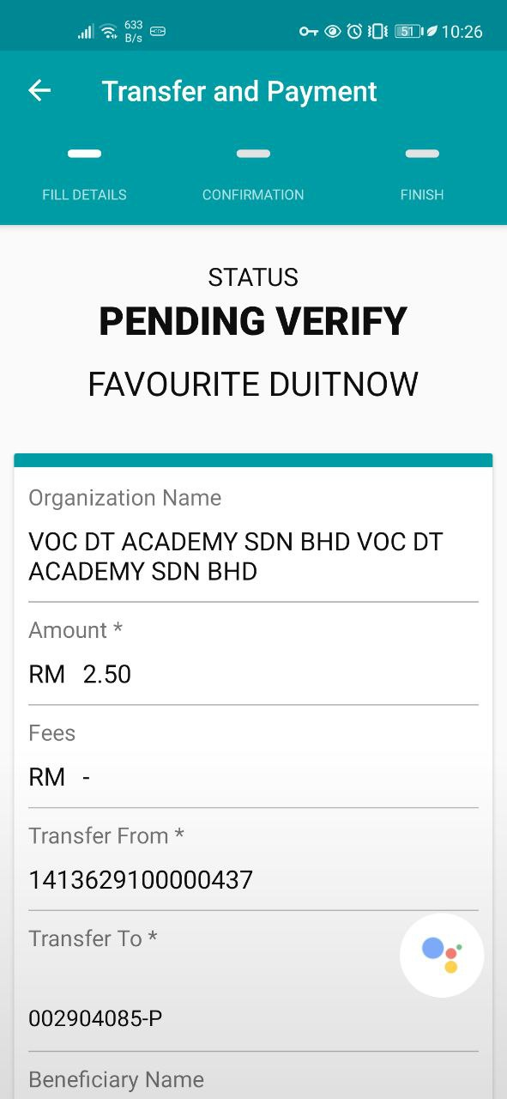  Figure 13: Fav DuitNow - Mobile (Result)

