

**Corporate Digital Banking**

UAT/Staging Performance Test Report

**Enhancement of New Application for BSNeBiz**

**(PENRIL/BSN-PERF-TEST/BSNeBiz/01)**

**Version 1.0**

**29rd August 2023**

Prepared By:

**PenrilDatability (M) Sdn Bhd (816792-X)**

Suite A-07-07 Plaza Mon’t Kiara No. 2, Jalan Kiara, Mon’t Kiara 50480 Kuala Lumpur, Malaysia

Tel: (603) 6201 2622Fax: (603) 6201 7622

Performance Testing Acceptance

I/We hereby verify that this Performance Testing Acceptance Document consists of all the information requested by Bank Simpanan Nasional.

I/We also hereby AGREE that this satisfies our entire performance test result for **DB Tech Refresh (MSSQL 2019) in UAT environment.**

**Bank Simpanan Nasional:**

|  |  |  |  |
| --- | --- | --- | --- |
| **Approved by** | **Role** | **Signature** | **Date** |
|  |  |  |  |
|  |  |  |  |
|  |  |  |  |
|  |  |  |  |
|  |  |  |  |
|  |  |  |  |
|  |  |  |  |
|  |  |  |  |
|  |  |  |  |
|  |  |  |  |
|  |  |  |  |

**Penril Datability (M) Sdn. Bhd.:**

|  |  |  |  |
| --- | --- | --- | --- |
| **Approved by** | **Role** | **Signature** | **Date** |
|  |  |  |  |

**Document Management**

|  |  |  |  |  |
| --- | --- | --- | --- | --- |
| **Rev. No** | **Date Update** | **Description of Change** | **Updated By** | **Reviewed By** |
|  |  |  |  |  |
|  |  |  |  |  |
|  |  |  |  |  |

**Table of Contents**

Chapter 1 - Introduction 5

1. Background 5

2. Purpose 5

Chapter 2 – Content 6

1. Execution Strategy 6

1.1 Type of testing: Load Testing 6

1.2 Methods of Testing 6

1.3 Process of testing 7

A. BSNeBIZ Login 7

B. BSNeBIZ New Application Form 7

1.4 Tools: Apache JMeter 5.1.1 r1855137 14

2. Business processes involved 14

Process Flow 14

3. Performance Test Environment 14

4. Test Scenario & Test Result with Explanation in Layman Terms 14

# Chapter 1 - Introduction

## Background

Bank implements the BNM OTP. However, the bank requested Penril to perform a performance report at Internet Banking and API Gateway.

## Purpose

Bank needs to ensure that by implementing BNM OTP and integrating IB to this new system will not cause major performance degradation.

Thus, this document describes the Performance Test Result before and after IB integration to BNM OTP in the UAT environment.

# Chapter 2 – Content

## Execution Strategy

### Type of testing: Load Testing

A load test is a planned test to perform a specified number of requests to a system in order to test the query to DB under specific levels of simultaneous requests. A load test ensures that IB is capable of handling an expected volume of traffic, and therefore is sometimes referred to as volume testing.

The goal of this load test is to prove that with new integration to BNM OTP, it can handle the expected volume with minimal to acceptable performance degradation. In this test scenario, we simulated the maximum number of requests with the goal of less than 1% of errors.

### Methods of Testing

Penril conducted load testing to the selected menu mentioned in Chapter 1 - 2 Purpose - Module to Test. One of the test scenarios will be Login, because this is considered one of modules that perform heavy query to database and highest number of touch points to BNM. Below is the list of detailed test modules in BSNeBiz:

|  |  |  |  |
| --- | --- | --- | --- |
| **System** | **Function** | **Module** | **Test Case** |
| **BSNeBIZ** | Login | Login – Access (ibPortalAccess.do) | [TS-CDB-LOGIN-1] |
| New Application | New Application Page – Step 1  (ibNewApplicationFormStep1.action) | [TS-CDB-FORM-1] |
| New Application Organization and Information Form Page – Step 2  (ibNewApplicationFormStep2.action) | [TS-CDB-FORM-2] |
| New Application Services and Access Type Form Page – Step 3  (ibNewApplicationFormStep3.action) | [TS-CDB-FORM-3] |
| New Application Confirmation Form Page – Step 4  (ibNewApplicationFormStep4.action) | [TS-CDB-FORM-4] |
| New Application Declaration Form Page – Step 5  (ibNewApplicationFormModal.action) | [TS-CDB-FORM-5] |
| New Application Save and Download Declaration Pdf Page – Step 6  (RegistrationSummaryPdfDownload.action) | [TS-CDB-FORM-6] |
| New Application Result Page – Step 7  (ibNewApplicationFormStep7.action) | [TS-CDB-FORM-7] |

|  |
| --- |
| **Important Notes:**  **This performance test case does not reflect the actual performance in the production environment. Bank need to provide the ratio between staging vs. production environment.** |

### Process of testing

Refer below items for the detailed process:

### BSNeBIZ Login

* 1. **[TS-CDB-LOGIN 1] - Login - Access (ibPortalAccess.do)**

This test scenario simulates concurrent users opening the home page of BSNeBIZ. In this stage, the IB connects to:

1. **IB DB Schema**

The IB fetches:

* Service Info. Service Info contains some notes or announcements.
* Site Navigation. System loads the site navigation from IB DB, so the BSNeBIZ home page can be shown properly to customers.

1. **FMS**

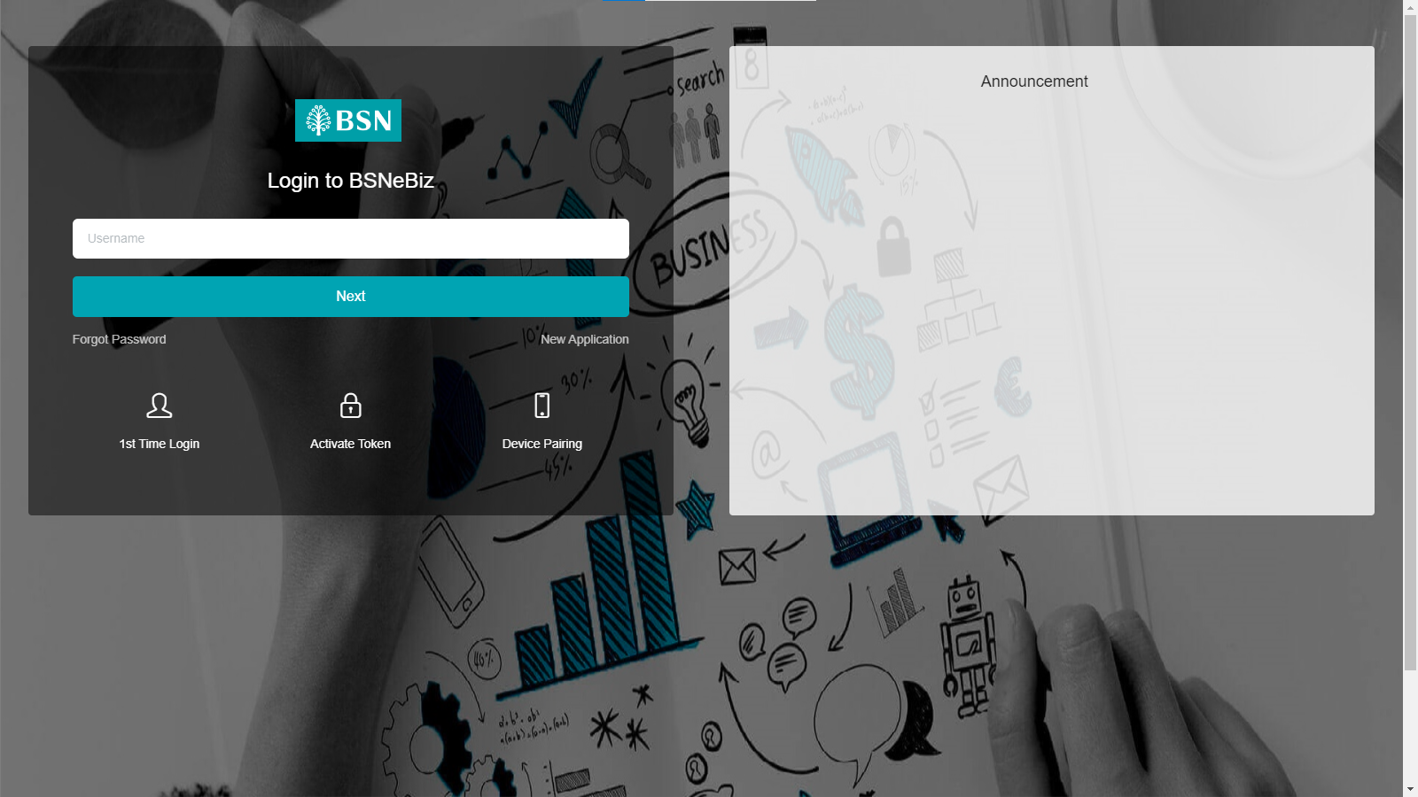

### BSNeBIZ New Application Form

This test scenario simulates concurrent users making a new application service. This test case depends on below test case to be executed:

[TS-CDB-LOGIN-1] – Login – Access (ibPortalAccess.do)

1. **[TS-CDB-FORM-1] - New Application Page – Step 1 (ibNewApplicationFormStep1.action)**

In this stage, the IB connects to:

1. **IB DB Schema**

The IB fetches:

- Service Info. Service Info contains some notes or announcements.

- Site Navigation. System loads the site navigation from IB DB, so the BSNeBIZ home page can be shown properly to customers.



1. **[TS-CDB-FORM-2] - New Application Organization and Information Form Page – Step 2 (ibNewApplicationFormStep2.action)**

In this stage, the IB connects to Organization and Information form page:

* 1. **IB DB Schema**

The IB fetches:

- Service Info. Service Info contains some notes or announcements.

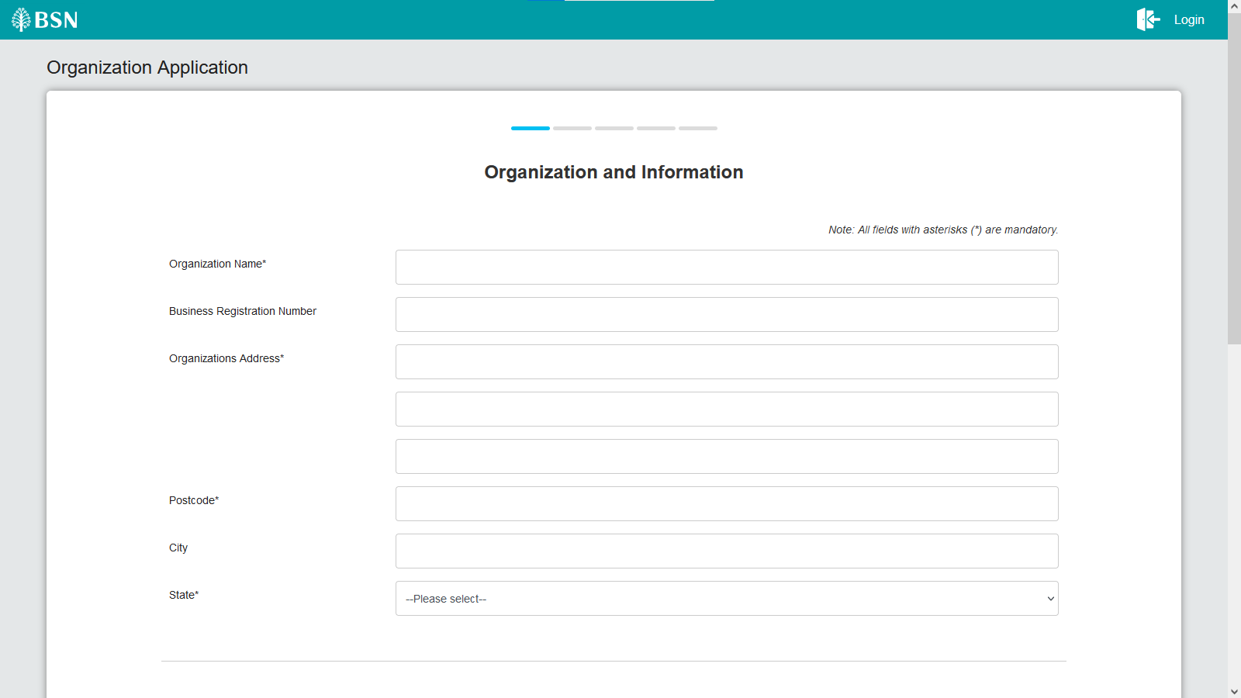

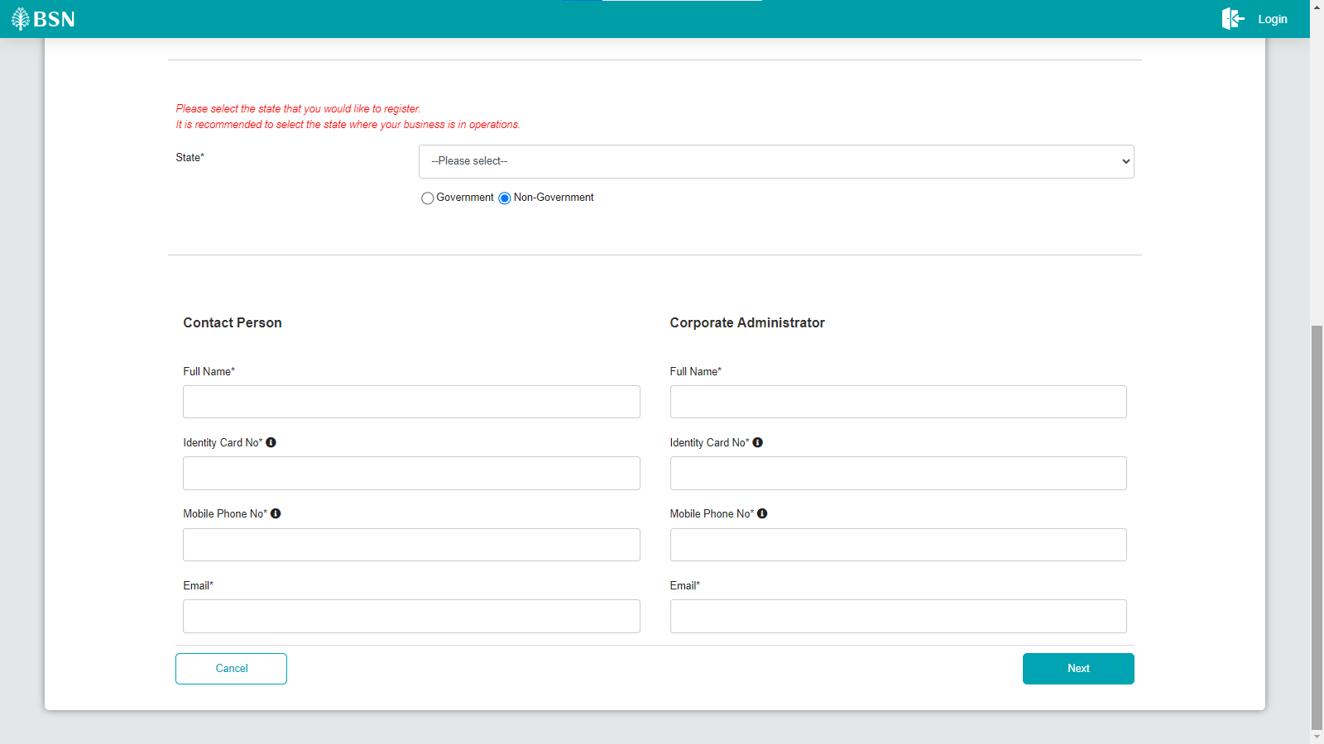

1. **[S-CDB-FORM-3] - New Application Services and Access Type Form Page – Step 3 (ibNewApplicationFormStep3.action)**

In this stage, the IB connects to Services and Access Form page:

* 1. **IB DB Schema**

The IB fetches:

- Service Info. Service Info contains some notes or announcements.

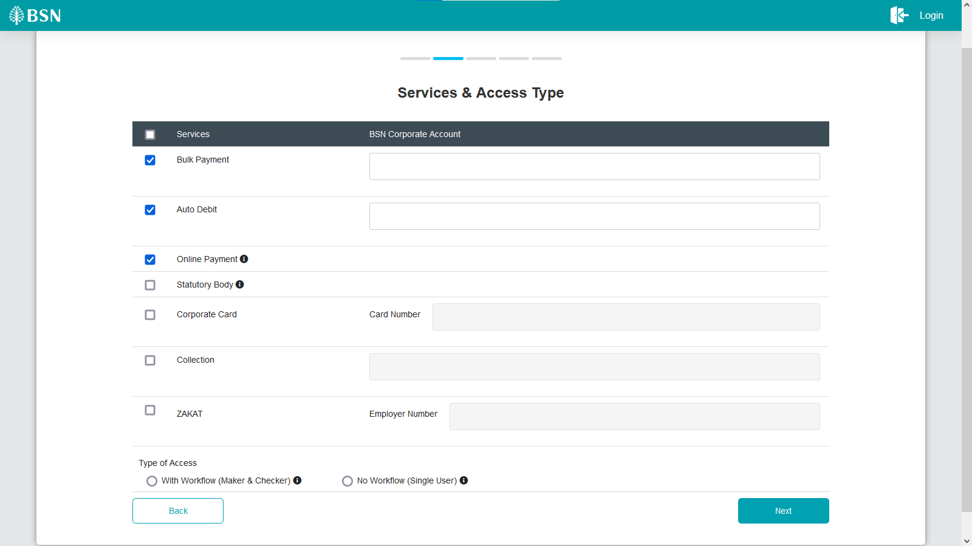

1. **[S-CDB-FORM-4] - New Application Confirmation Form Page – Step 4 (ibNewApplicationFormStep4.action)**

In this stage, the IB navigate to Confirmation page:

* 1. **IB DB Schema**

The IB fetches:

- Service Info. Service Info contains some notes or announcements.

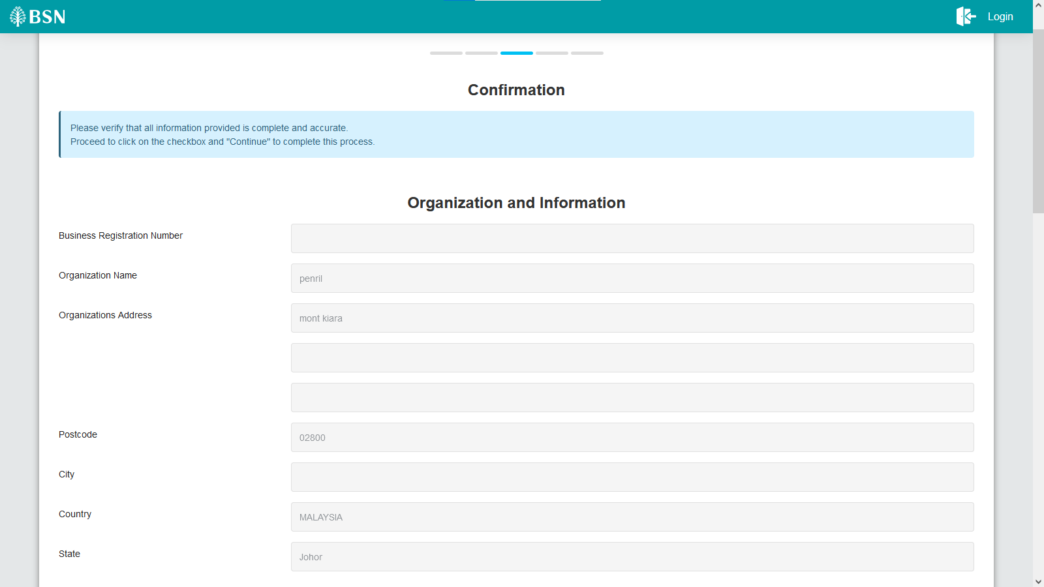

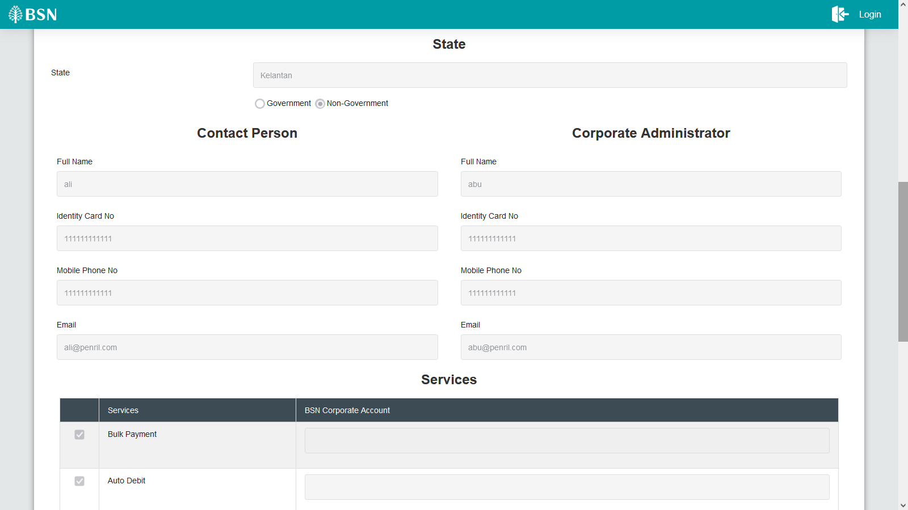

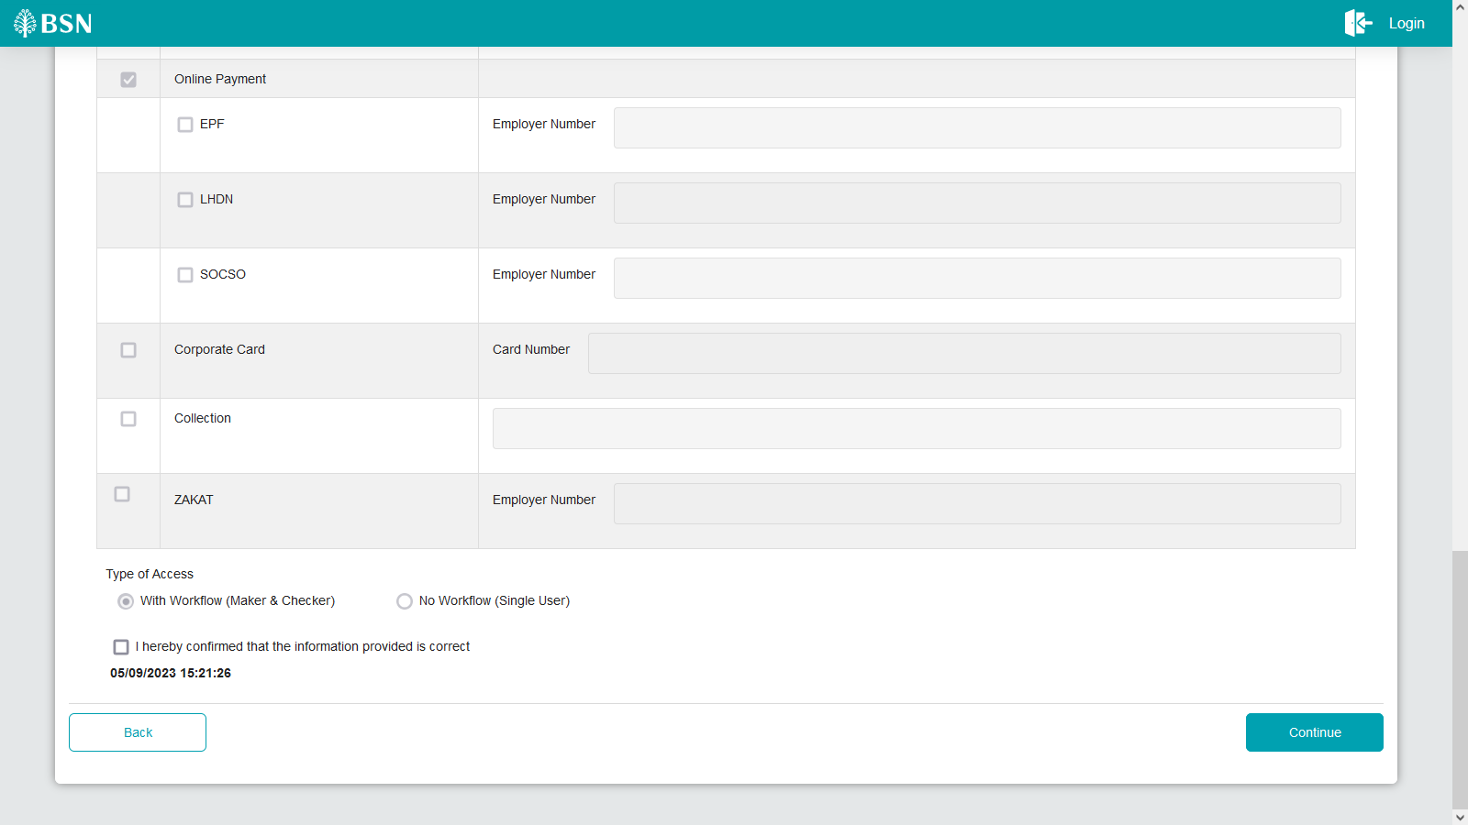

1. **[TS-CDB-FORM-5] - New Application Declaration Form Page – Step 5 (ibNewApplicationFormModal.action)**

In this stage, the IB connects to Declaration page:

* 1. **IB DB Schema**

The IB fetches:

- Service Info. Service Info contains some notes or announcements.

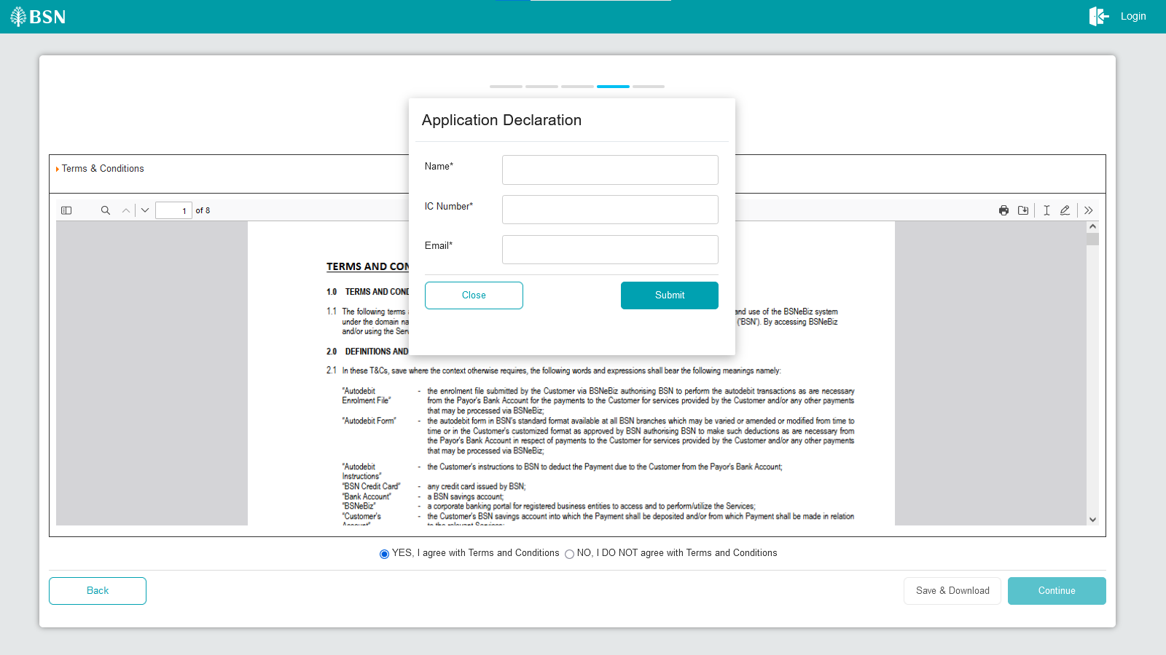

1. **[TS-CDB-FORM-6] - New Application Save and Download Declaration Pdf Page – Step 6 (RegistrationSummaryPdfDownload.action)**

In this stage, the IB connects to Services and Access Form page:

* 1. **IB DB Schema**

The IB fetches:

- Service Info. Service Info contains some notes or announcements.

- To grab Registration Summary in PDF format.

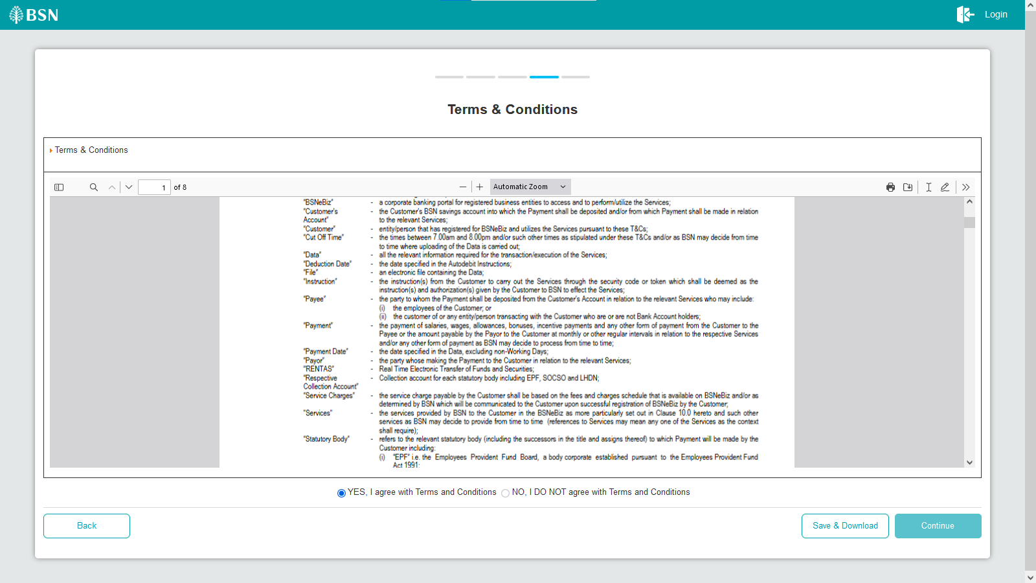

1. **[TS-CDB-FORM-7] - New Application Result Page – Step 7 (ibNewApplicationFormStep7.action)**

In this stage, the IB connects to Result page:

* 1. **IB DB Schema**

The IB fetches:

- Service Info. Service Info contains some notes or announcements.

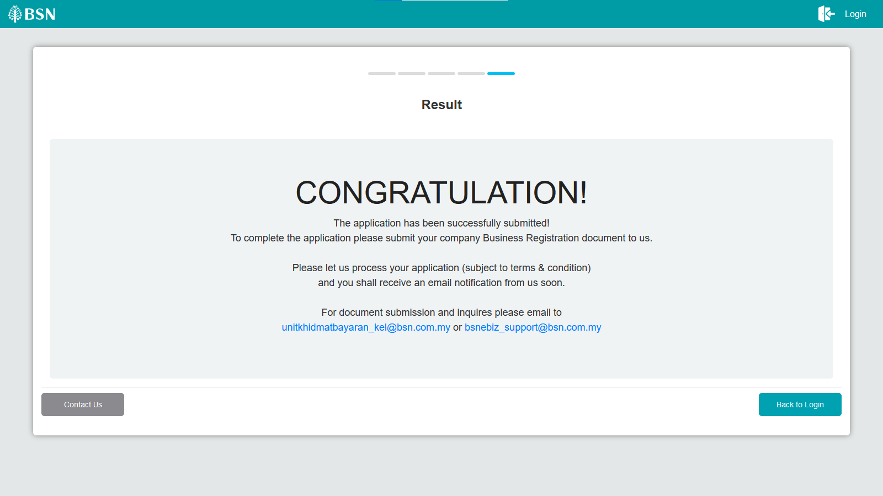

### Tools: Apache JMeter 5.1.1 r1855137

Apache JMeter is pure Java open-source software with the purpose of load testing functional behaviour and measuring performance of web applications. This app is chosen because it is platform independent, easy to install and provides better visualization on test results.

## Business processes involved

### Process Flow

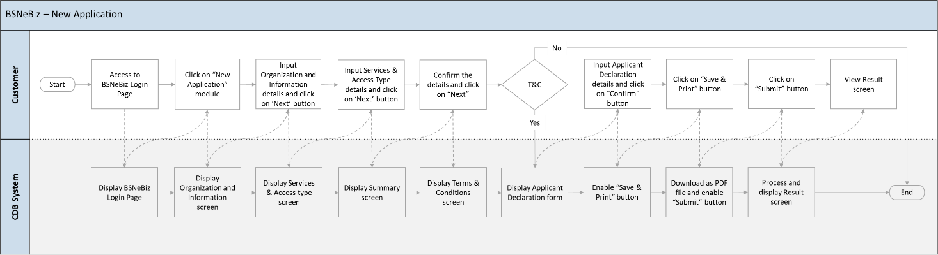

This is a simplified flow diagram of load test scenarios representing Internet Banking Customers performing login and new application process.

## Performance Test Environment

|  |  |  |
| --- | --- | --- |
| Test Region | : | SIT Environment |
| Instance Testing | : | BSNeBIZ – SIT Environment  Web : <http://58.27.45.179:8080/bsn-cdb-sit/commonLogin> |
| Apache JMeter | : | Version 5.6.2 |
| Java Version | : | JDK 1.8 |

## Test Scenario & Test Result with Explanation in Layman Terms

|  |
| --- |
| **Testing Objective:**  Bank would like to establish baseline (no. of concurrent users) of:   1. BSNeBIZ Login 2. BSNeBIZ New Application |

|  |
| --- |
| **A. BSNeBIZ Login** |
| To simulate the maximum number of requests to perform BSNeBIZ login with goal of:   * Error < 1%. * Criteria of throughput (second / request) & TPS for each flow:   + ibPortalAccess.do <5 second or >0.2 TPS     - This step is to load the page of IB |
| I. **Perform login service for 50 concurrent users** |
| **JMeter Execution Date: 11/09/2023**   * **Test Criteria**   + Perform transaction for 50 concurrent users for 1 loop * **Summary of Testing**   The performance test result has passed/ not passed the test against the benchmarks that have been set above (such as number of concurrent users, error percentage, and throughput).   * **Declaration** * **RegistrationSummaryPdfDownload.action** caused error because of the interceptor token cannot capture and modify the HTTP request and responses. As token only allow one click per action, token interceptor cannot be applied at **RegistrationSummaryPdfDownload.action** while Save and Download button can be click multiple time per action. Therefore, **RegistrationSummaryPdfDownload.action** have error in test result. * **Test Result**   o The JMeter result shows that the system can support 50 concurrent users to perform transactions with 12.5% error. It takes 81 seconds to complete the transaction process for all users.   * **Throughput (min/request)**   The system is capable of completing a http request within 37.8 s (fastest) and 37.6 s (slowest).   * **TPS (Transaction per Second)**   The system is capable of performing 1.596 TPS (fastest) and 1.587 TPS (slowest).   * The reasonable ramp-up period without any error is 60 seconds for 50 users.     *Image 1: JMeter Test Result – 50 BSNeBIZ users login service* |

|  |
| --- |
| **B. BSNeBIZ New Application** |
| To simulate the maximum number of requests to perform BSNeBIZ New Application with goal of:   * Error < 1%. * Criteria of throughput (second / request) & TPS for each flow:   + ibNewApplicationFormStep1.action <5 second or >0.2 TPS     - This step is to load the page of IB   + ibNewApplicationFormStep2.action <5 second or >0.2 TPS     - To load the Organization and Information form page   + ibNewApplicationFormStep3.action <5 second or >0.2 TPS     - To load the Services and Access type form page   + ibNewApplicationFormStep4.action <5 second or >0.2 TPS     - To load the Confirmation page   + ibNewApplicationFormModal.action <5 second or >0.2 TPS     - To load the Application Declaration form page   + RegistrationSummaryPdfDownload.action <5 second or >0.2 TPS     - To load the Registration Summary page in PDF format     - To save and download the Registration Summary page in PDF format   + ibNewApplicationFormStep5.action <5 second or >0.2 TPS     - To load the Result page |
| I. **Perform login service for 50 concurrent users** |
| **-Jmeter Execution Date: 11/09/2023**   * **Test Criteria**   + Perform transaction for 50 concurrent users for 1 loop * **Summary of Testing**   The performance test result has passed/ not passed the test against the benchmarks that have been set above (such as number of concurrent users, error percentage, and throughput).   * **Declaration** * **RegistrationSummaryPdfDownload.action** caused error because of the interceptor token cannot capture and modify the HTTP request and responses. As token only allow one click per action, token interceptor cannot be applied at **RegistrationSummaryPdfDownload.action** while Save and Download button can be click multiple time per action. Therefore, **RegistrationSummaryPdfDownload.action** have error in test result. * **Test Result**   o The JMeter result shows that the system can support 50 concurrent users to perform transactions with 12.5% error. It takes 81 seconds to complete the transaction process for all users.   * **Throughput (min/request)**   The system is capable of completing a http request within 37.8 s (fastest) and 37.6 s (slowest).   * **TPS (Transaction per Second)**   The system is capable of performing 1.596 TPS (fastest) and 1.587 TPS (slowest).   * The reasonable ramp-up period without any error is 60 seconds for 50 users.     *Image 1: JMeter Test Result - 50 BSNeBIZ users new application* |