SCPID#6783
Test Title: |  | DuitNow QR Merchant Registration History
Test Description: |  | - To allow Merchant Registration History to Display Status & allow to download report for merchant with status:  - Online  - Offline  - Merchant Registration History name to become DuitNow QR Merchant Registration History
Test Functionality: |  | To test on DuitNow QR Merchant Registration History and download report for status online and offline.
Test Procedure: |  | Test steps (1):  - Access to IBAM  - Click on CBE > DuitNow QR Merchant Registration History  - Able to filter and view and download report with merchant status online and offline  Test steps (2):  - Access to BBE > IBAM Navigation  - Click edit on Merchant Registration History and rename
Response Message:
Test Result: | Pass: Fail: |  | Tested by: | Nor Athirah Umairah (18/09/2023)
Reason for Failure:
Remarks: |  | 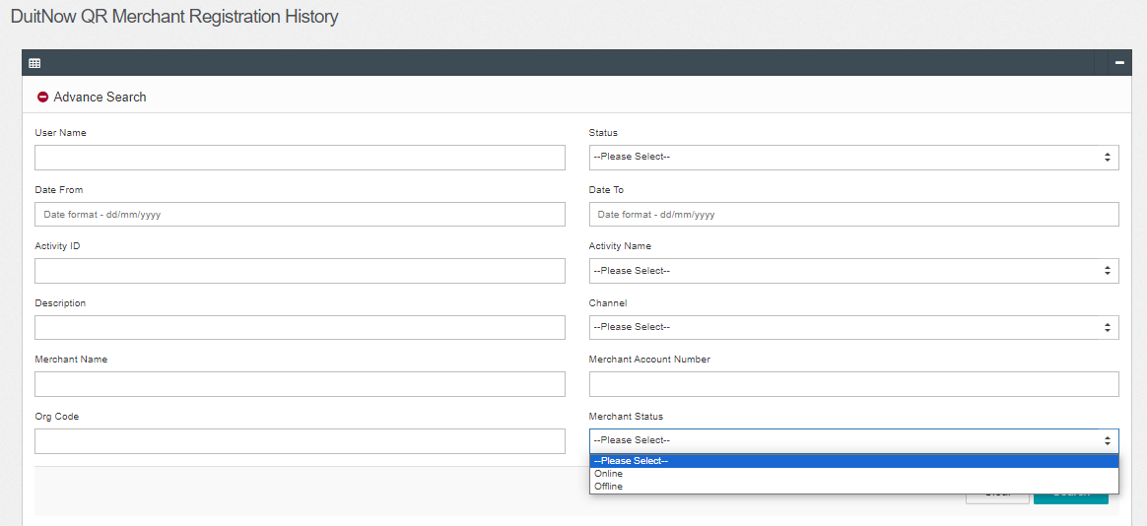  Figure 1: IBAM > DuitNow QR Merchant Registration History (Advance Seacrh)  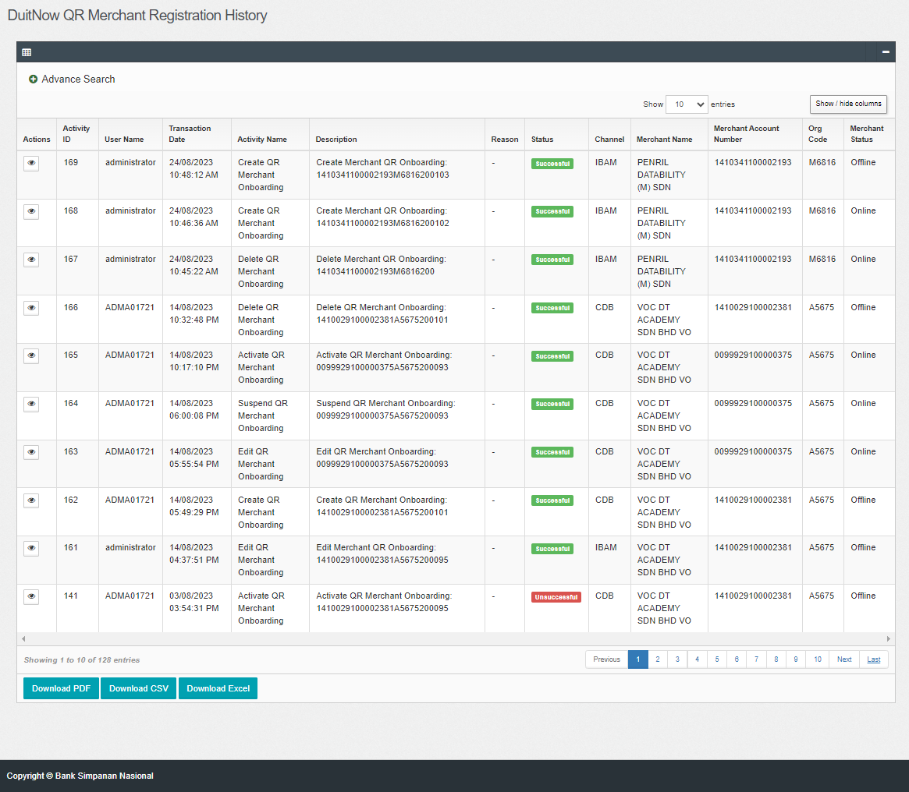  Figure 2: IBAM > DuitNow QR Merchant Registration History  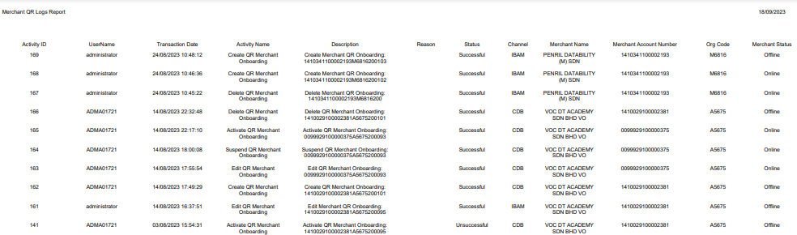  Figure 3: DuitNow QR Merchant Registration History (PDF)  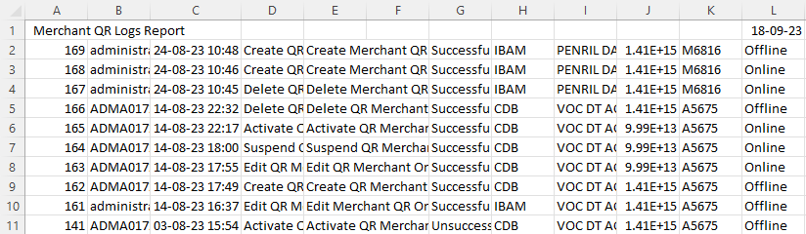  Figure 4: DuitNow QR Merchant Registration History (CVS)  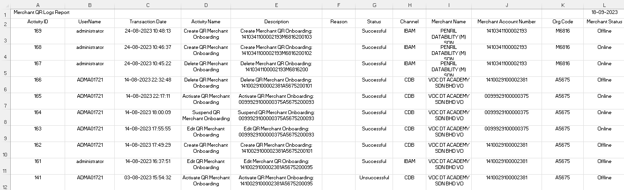  Figure 5: DuitNow QR Merchant Registration History (Excel)  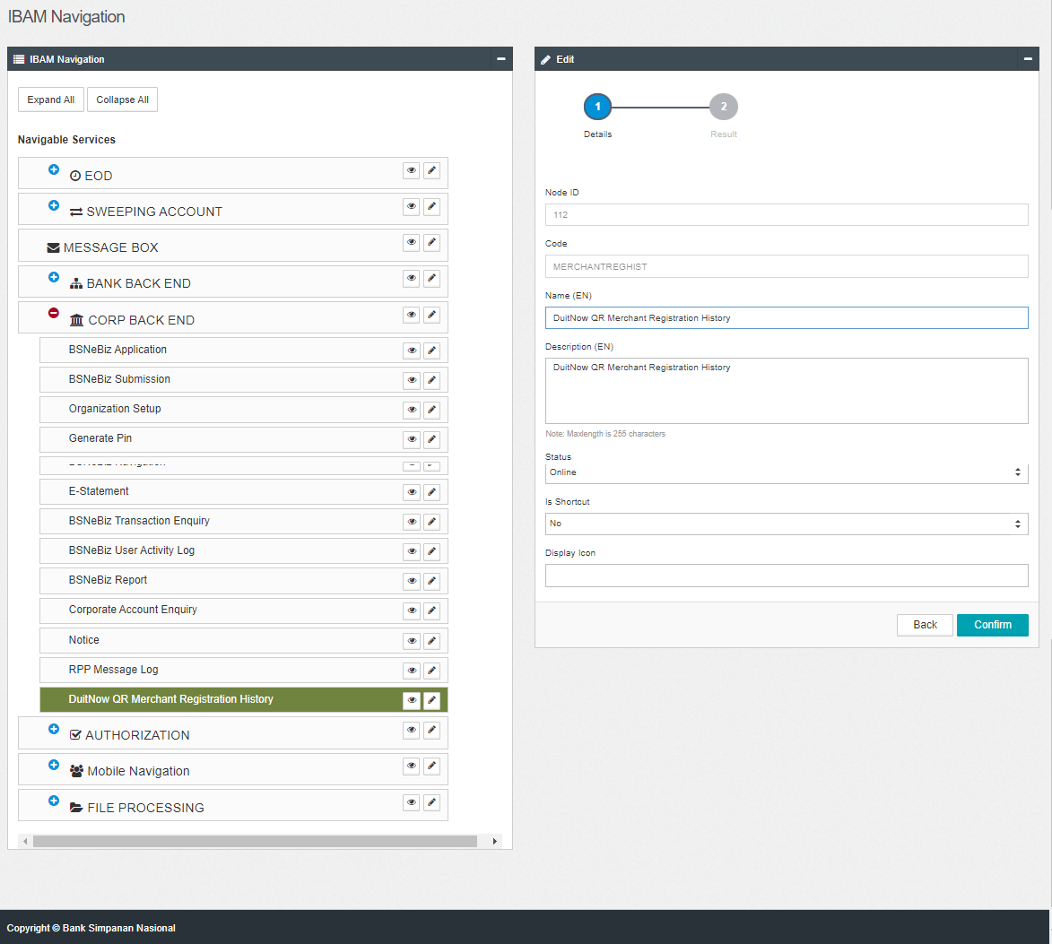  Figure 6: BBE > IBAM Navigation > DuitNow QR Merchant Registration History

