SCPID#6800
Test Title: |  | DuitNow QR Does Not Record The Charges to Database
Test Description: |  | Issue: Charges that being charged for any transaction above RM5,000.00 using DuitNow QR is not reflected in the BSNeBiz Transaction History.  Finding: The charges already successfully reached ICBS but due to bug code, the amount does not recorded to database.
Test Functionality: |  | To test on Transaction Charges display on BSNeBiz Transaction History for DuitNow QR.
Test Procedure: |  | Test steps:  - Ensure service has setup tier charges or any fee  - Access mobile app DuitNow QR  - Enter amount that has fee  - Complete the transaction  - Access BSNeBiz Transaction History  - Expected result, the column charges should have value
Response Message:
Test Result: | Pass: Fail: |  | Tested by: | Nor Athirah Umairah (02/10/2023)
Reason for Failure:
Remarks: |  | *set amount to 10.00 for testing purposed due to insufficient account balance  Figure 1: IBAM > BBE > Content > Tier Charges  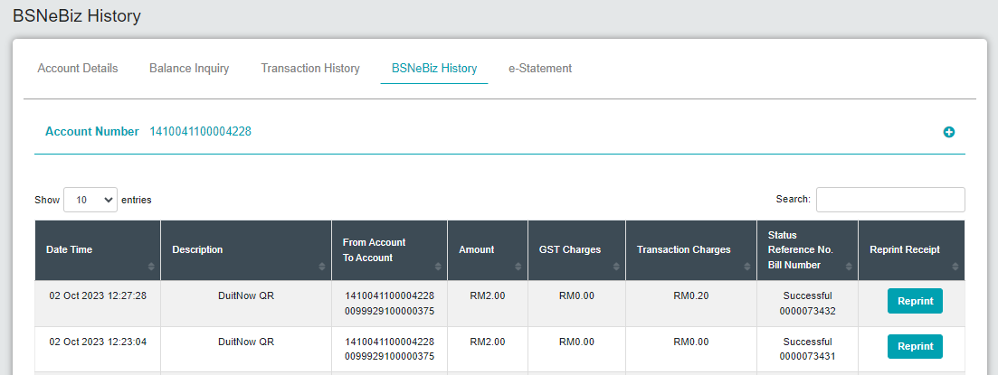  Figure 2: CDB > BSNeBiz History  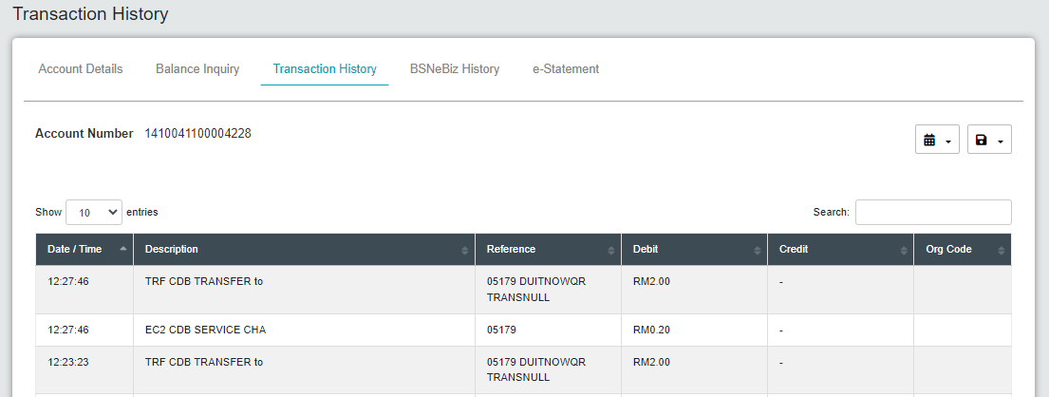  Figure 3: CDB > Transaction History

