Test Title: |  | New creation for CA
Test Description: |  | To apply same process as new application (generate temporary password) for creation additional new CA
Test Functionality:
Test Procedure: |  | Test steps:  - Access to IBAM>Organization Setup>User Maintenance  - Create New Corporate Administrator  - Expected result, system auto generate temporary password after CA successfully created
Response Message:
Test Result: | Pass: Fail: |  | Tested by: | Nor Athirah Umairah (09/10/2023)
Reason for Failure:
Remarks: |  | 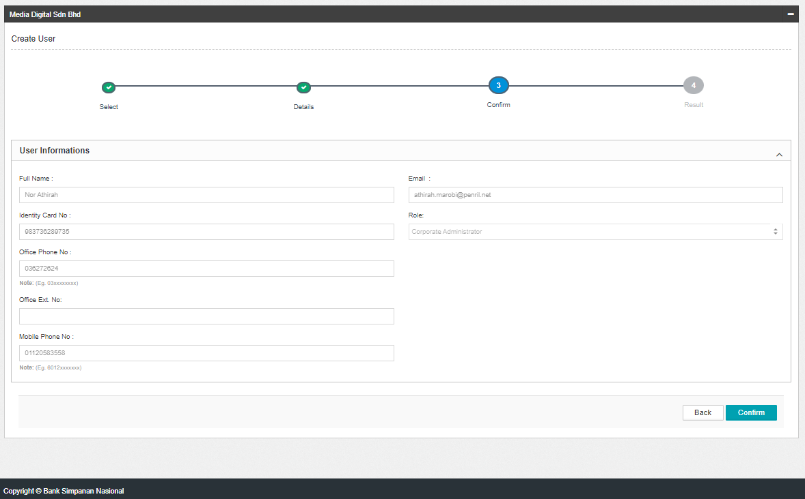  Figure 1: IBAM>Organization Setup>User Maintenance (Confirm)  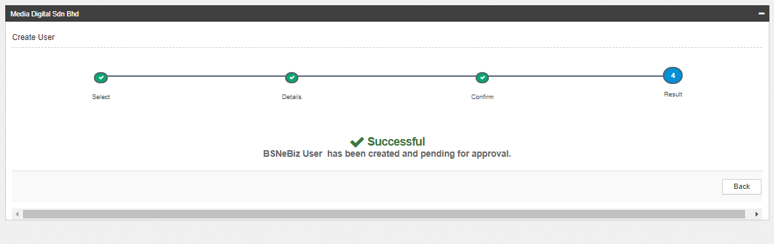  Figure 2: IBAM>Organization Setup>User Maintenance (Result)  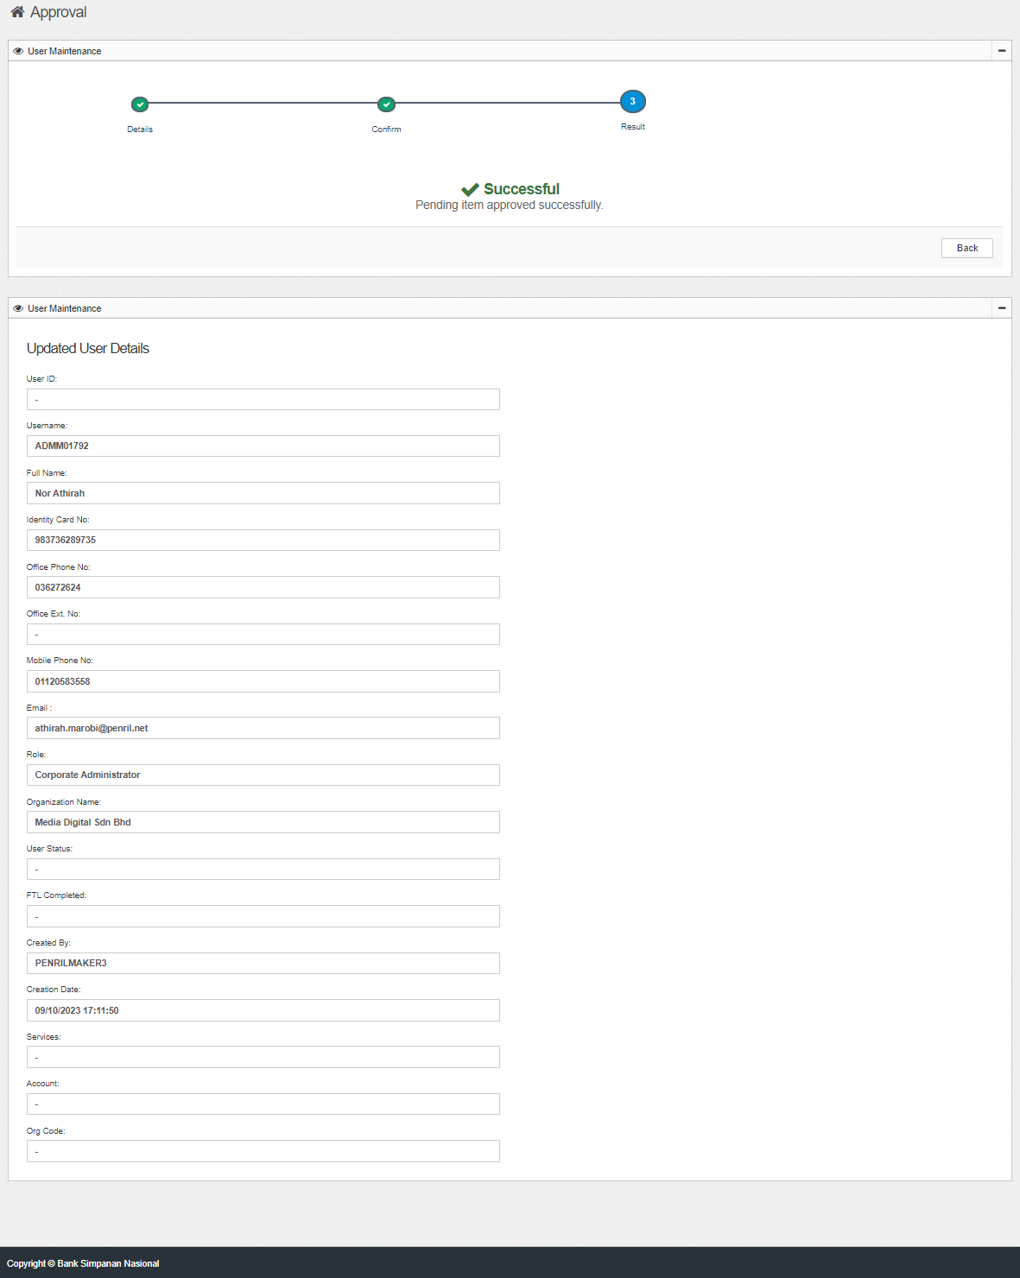  Figure 3: IBAM>Approval (Result)  Figure 4: Email  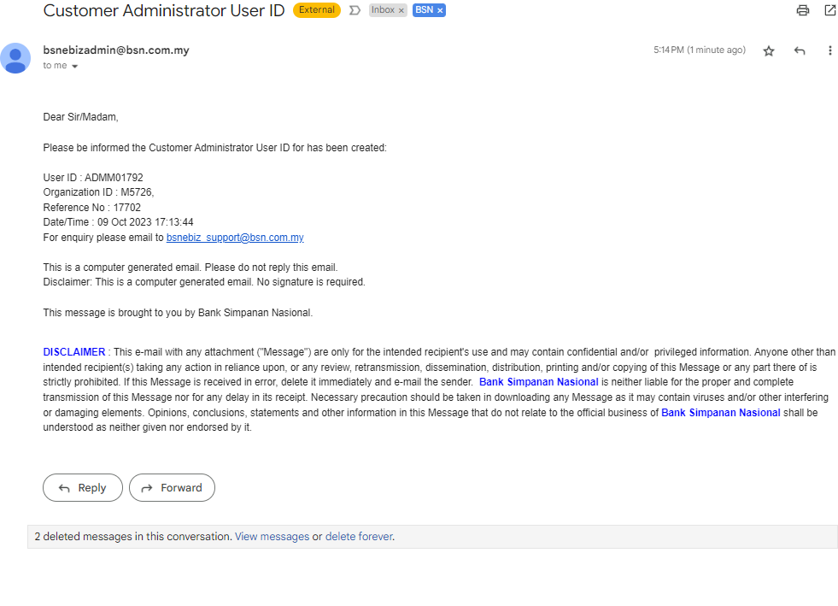  Figure 5: Email Content (User ID)  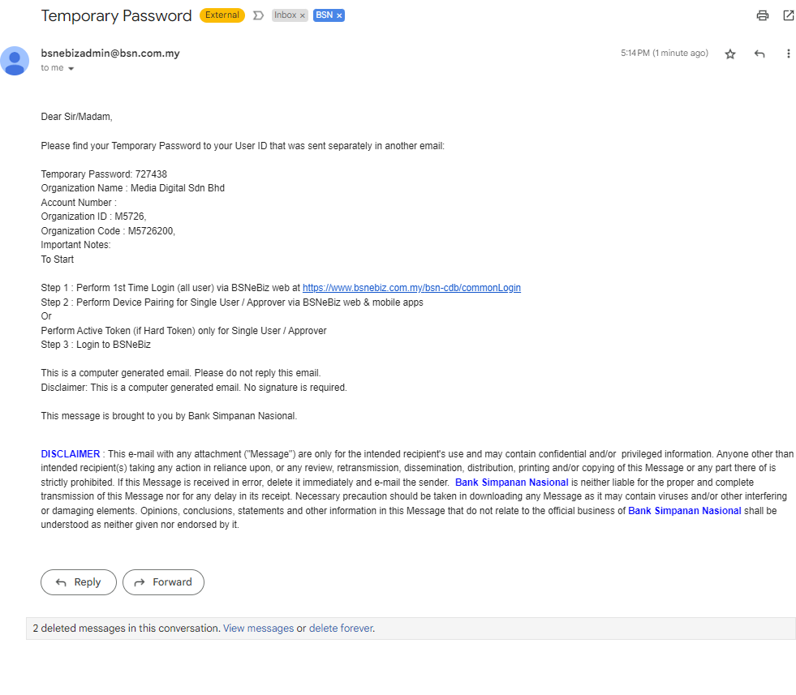  Figure 6: Email Content (Temporary Password)

