Test Title: |  | To hide LHDN module in CDB and IBAM
Test Description: |  | CDB  - New Application (Services & Access Type)  - PDF Application Form  IBAM  - BSNeBiz Application  - Organization Setup
Test Functionality:
Test Procedure:
Response Message:
Test Result: | Pass: Fail: |  | Tested by: | Nor Athirah Umairah (11/10/2023)
Reason for Failure:
Remarks: |  | 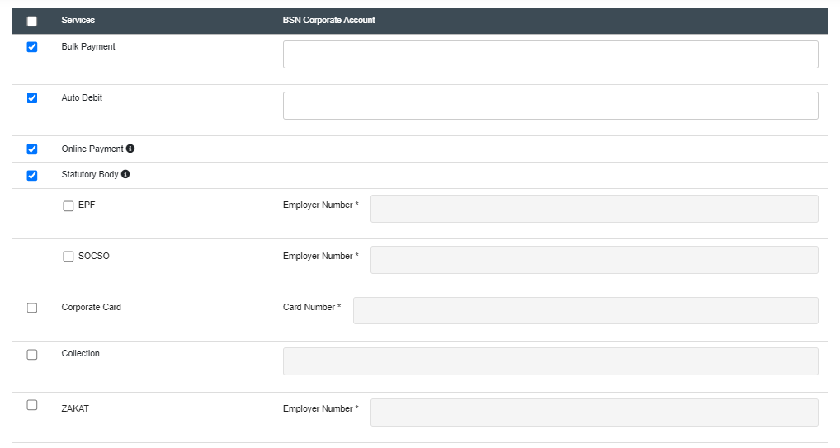  Figure 1: BSNeBiz Application>Services & Access Type  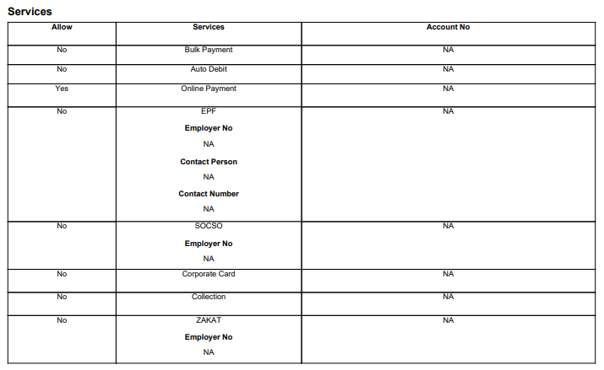  Figure 1: BSNeBiz Application>Application Form (PDF)  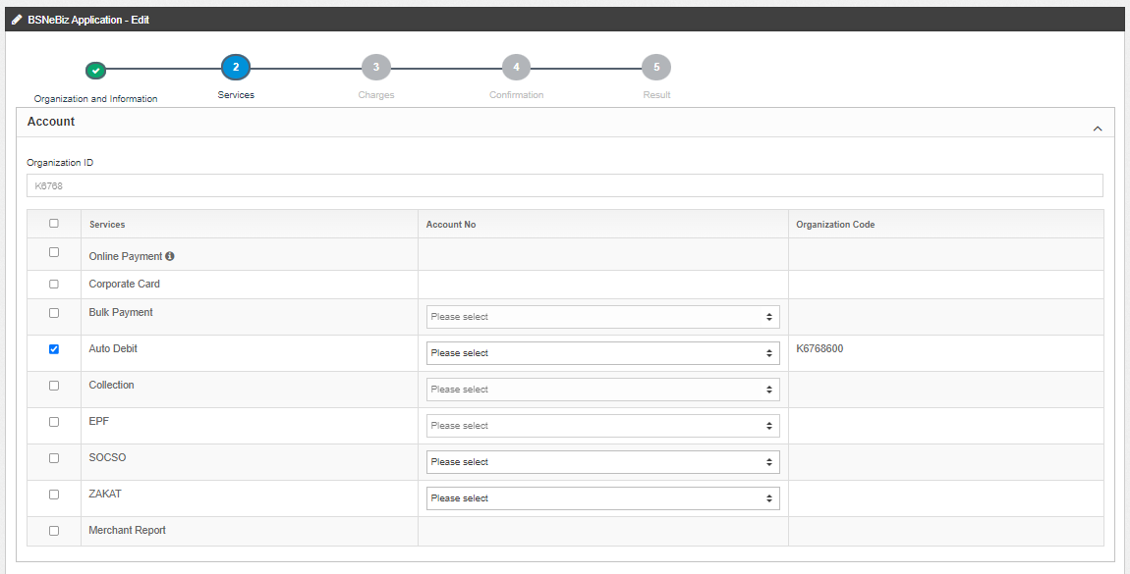  Figure 1: IBAM>BSNeBiz Application>Edit (Services)  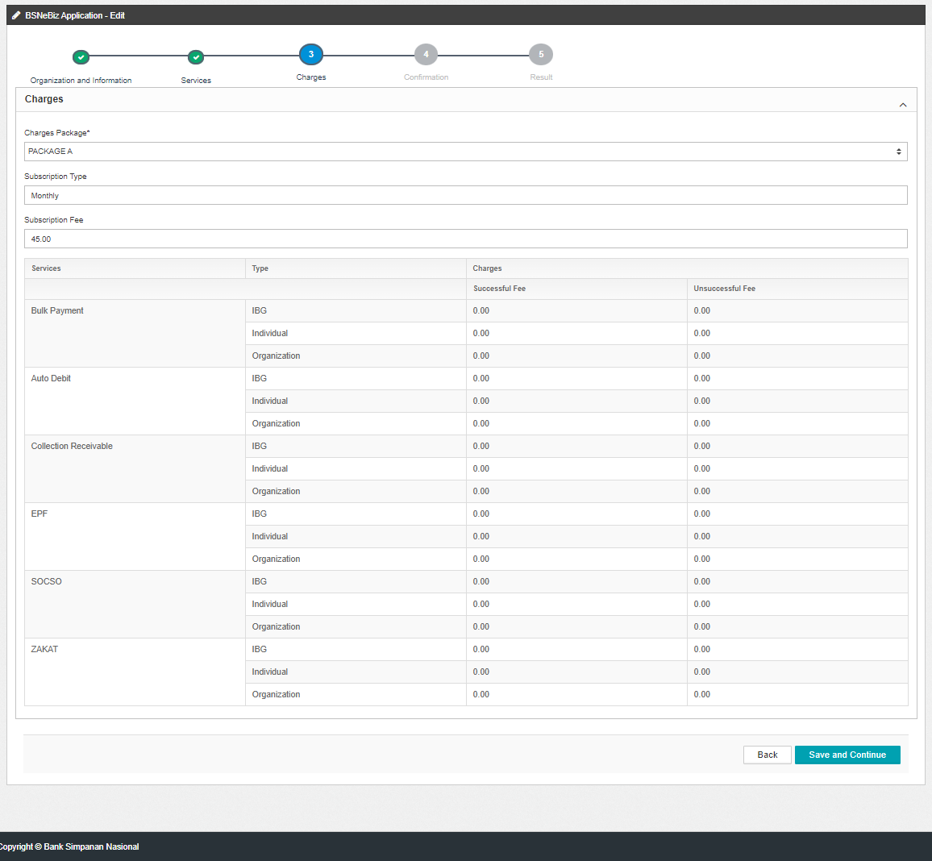  Figure 1: IBAM>BSNeBiz Application>Edit (Charges)  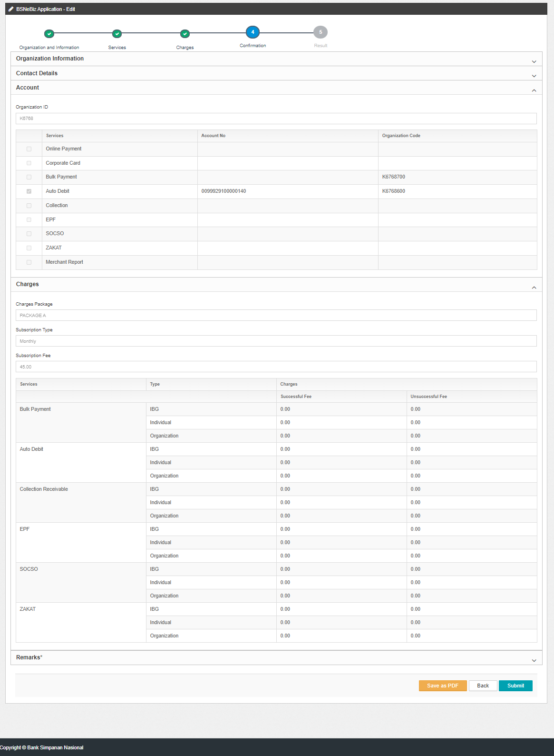  Figure 1: IBAM>BSNeBiz Application>Edit (Confirmation)  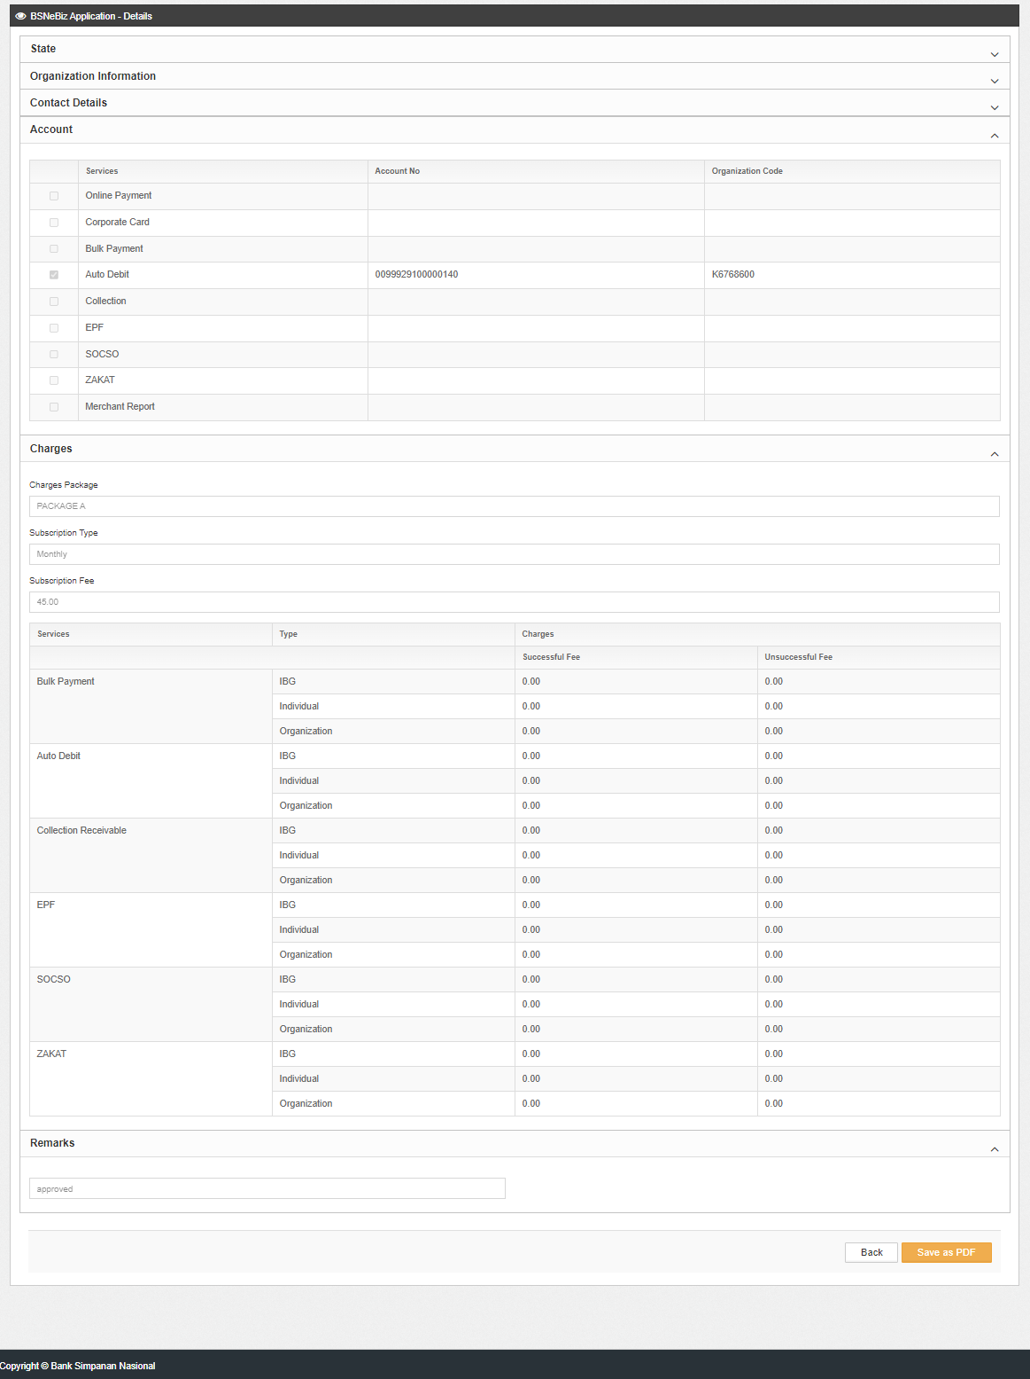  Figure 1: IBAM>BSNeBiz Application>Details  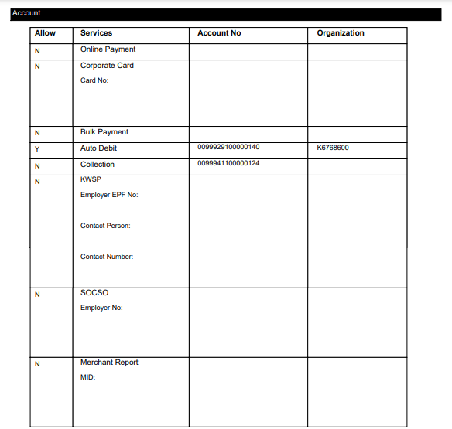  Figure 1: IBAM>BSNeBiz Application>PDF (Account)  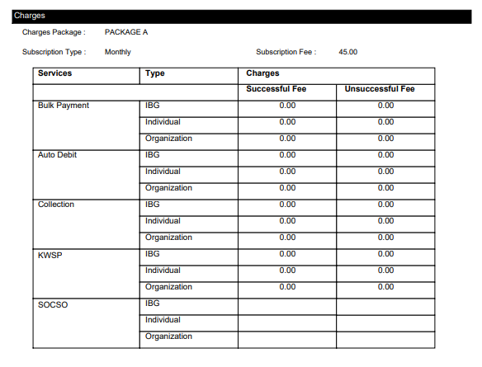  Figure 1: IBAM>BSNeBiz Application>PDF (Charges)  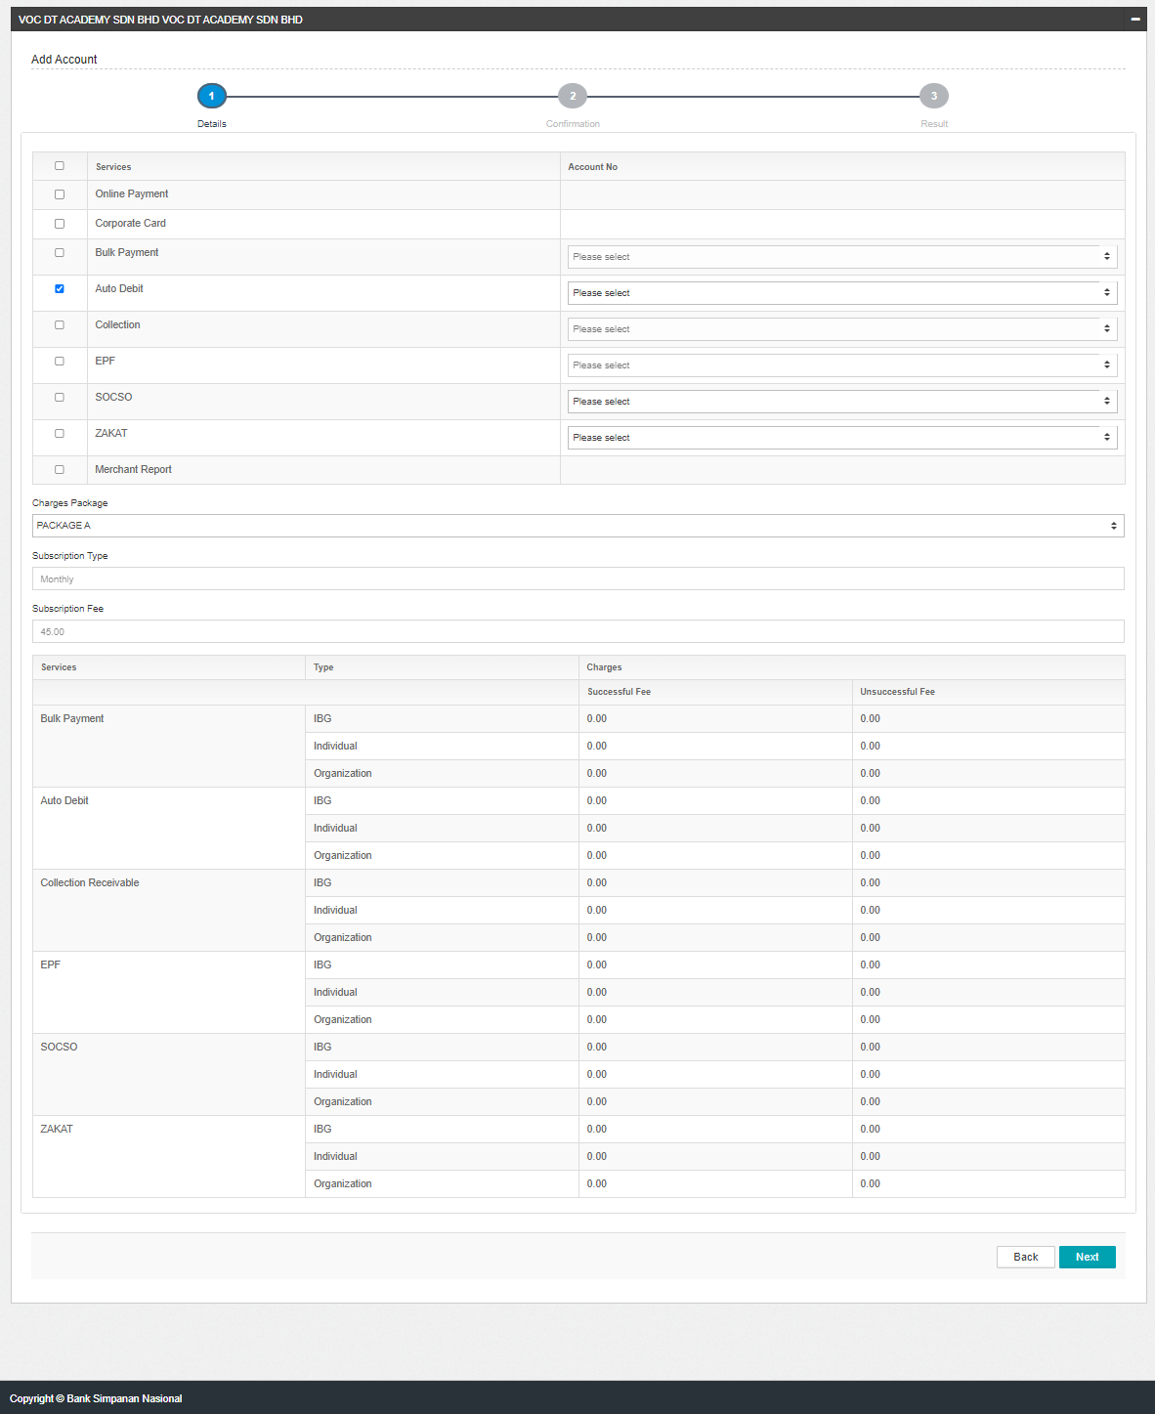  Figure 1: IBAM>Organization Setup>Services&Charges (Add)  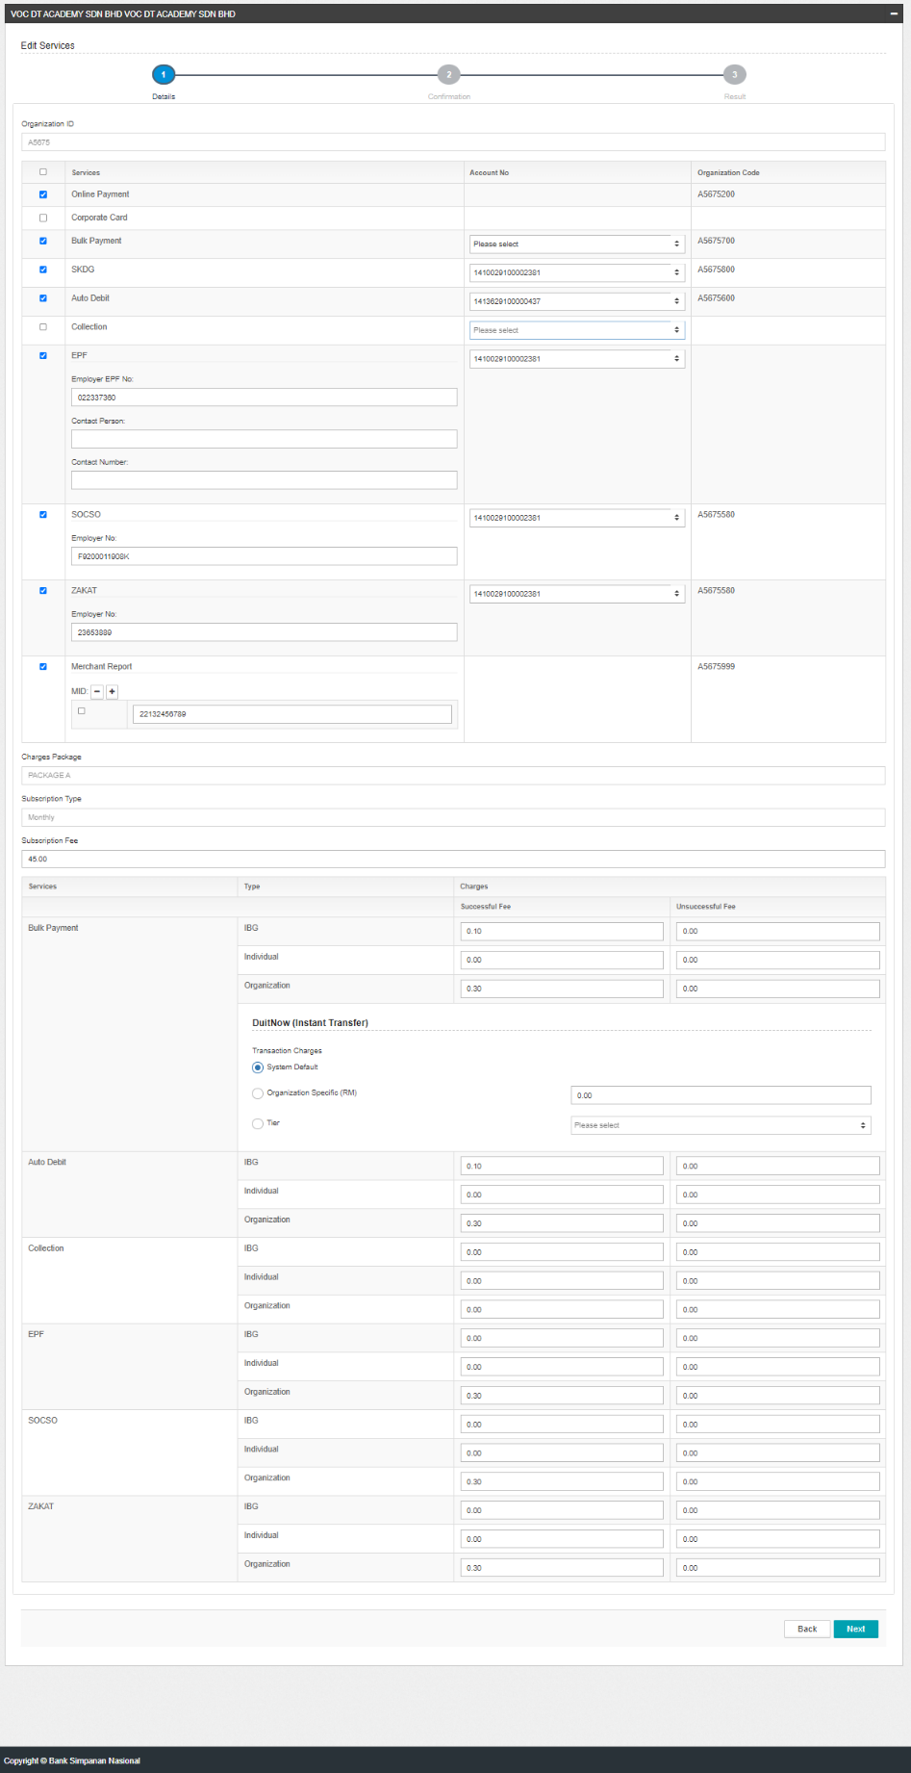  Figure 1: IBAM>Organization Setup>Services&Charges (Edit)

