SCPID#6809
Test Title: |  | RENTAS Issue
Test Description: |  | Issue:  Company RENTAS setting is disabled at IBAM>Org Setup but can do RENTAS transaction  Finding:  RENTAS setting is not working at bsn-cdb and bsn-restful
Test Functionality: |  | To test on RENTAS transaction based on company RENTAS setting in IBAM.
Test Procedure: |  | Test steps Web/Mobile 1:  - Enables IBAM>Org Setup RENTAS setting  - Access BSNeBiz CDB>Payment Transfer>RENTAS  - Expected result, can do RENTAS transaction  Test steps Web/Mobile 2:  - Disables IBAM>Org Setup RENTAS setting  - Access BSNeBiz CDB>Payment Transfer  - Expected result, cannot select RENTAS transaction  Test steps Web/Mobile 3:  - Enables IBAM>Org Setup RENTAS setting  - Access BSNeBiz CDB>Payment Transfer>RENTAS  - Before click Next, Disables IBAM>Org Setup RENTAS setting  - Expected result, get error message RENTAS not registered  Mobile APK/IPA (SIT):  Penril iOS https://testflight.apple.com/join/D2HQqZxx  Android https://drive.google.com/file/d/1pNM-tEqEfj-QBOqsKWL_GZYm5JSFIol_/view?usp=drive_link  BSN iOS https://testflight.apple.com/join/D69PNezx  Android https://drive.google.com/file/d/17xKzzguslSHGmy2G8izS5NvHrZ01xQ-A/view?usp=drive_link
Response Message:
Test Result: | Pass: Fail: |  | Tested by: | Nor Athirah Umairah (09/10/2023-12/10/2023)
Reason for Failure:
Remarks: |  | Test steps Web/Mobile 1:  Enables IBAM>Org Setup RENTAS setting  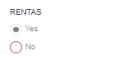  Result: Success to perform RENTAS transaction.  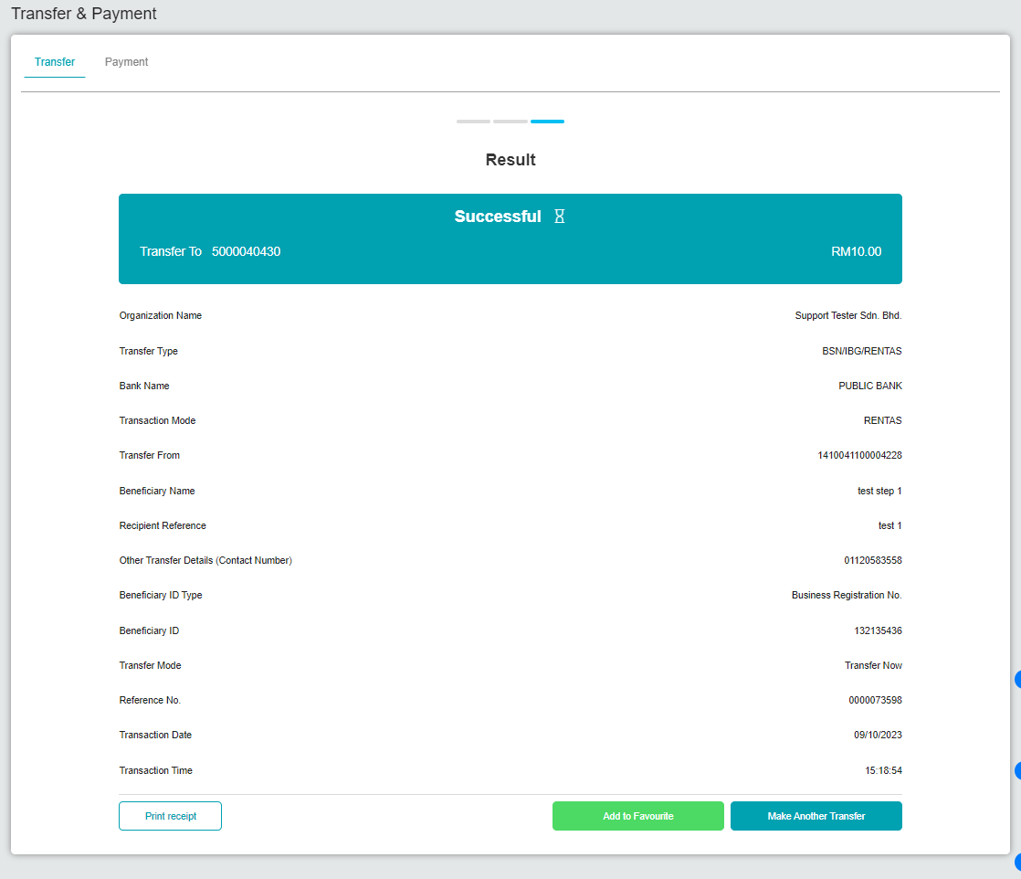  Figure 1: CDB > Transfer & Payment (Result)  Test steps Web/Mobile 2:  Disables IBAM>Org Setup RENTAS setting  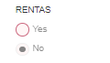  Result: Unable to select RENTAS transaction.  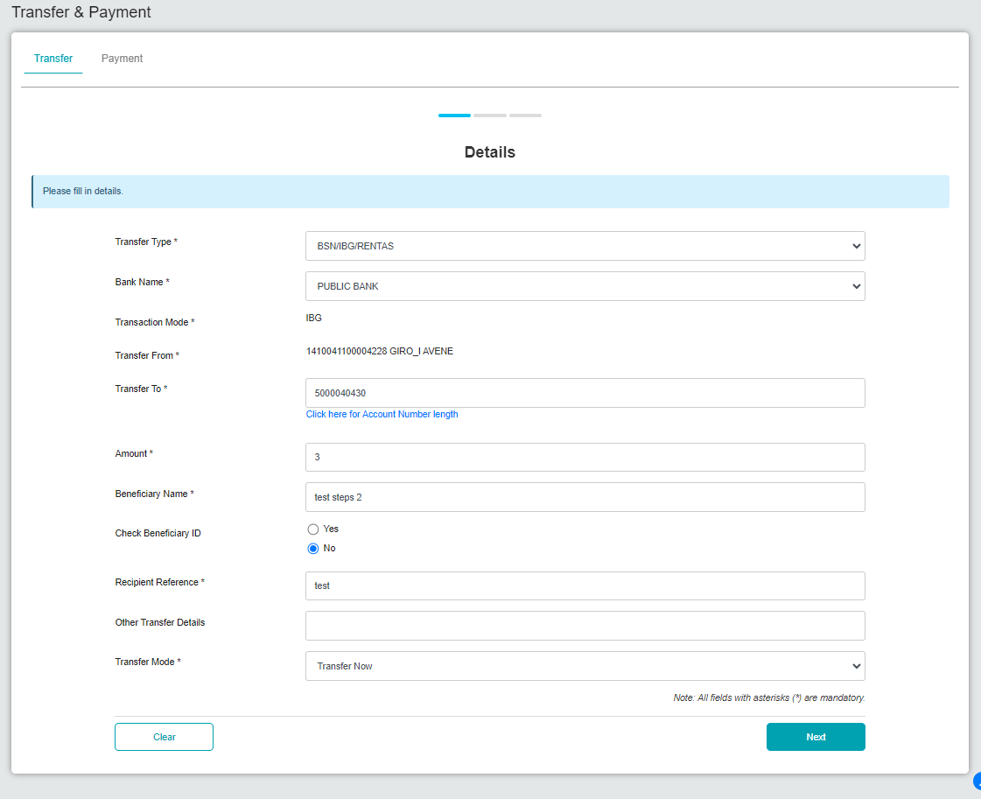  Figure 2: CDB > Transfer & Payment (Details)  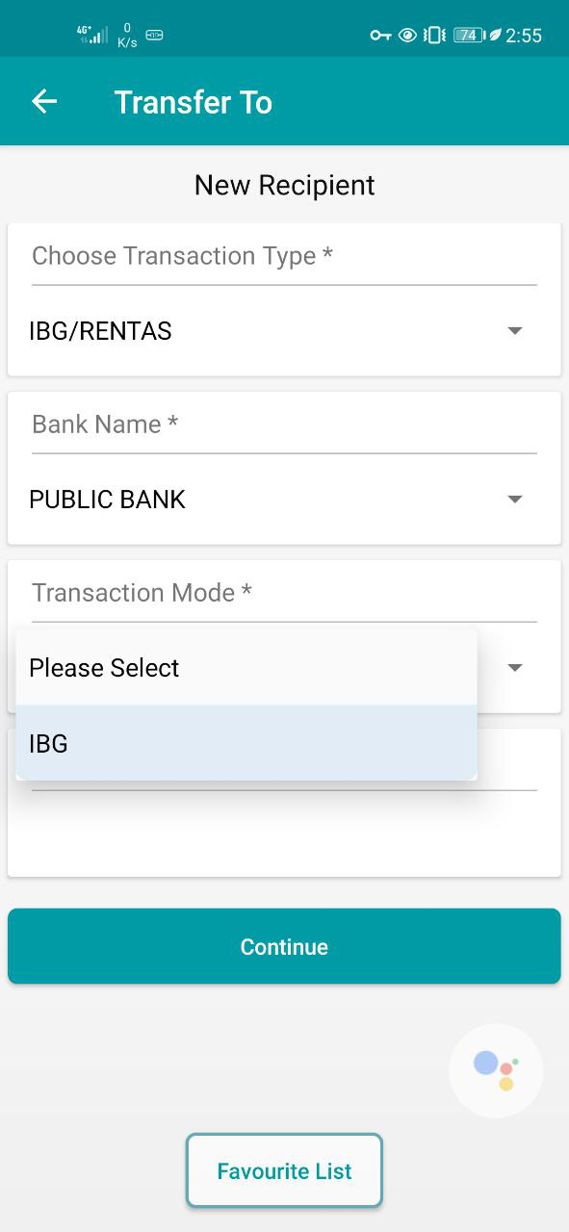  Figure 3: Mobile > Transfer & Payment  Disable RENTAS and input max amount for IBG:  System will prompt error message exceed max IBG limit when click Next  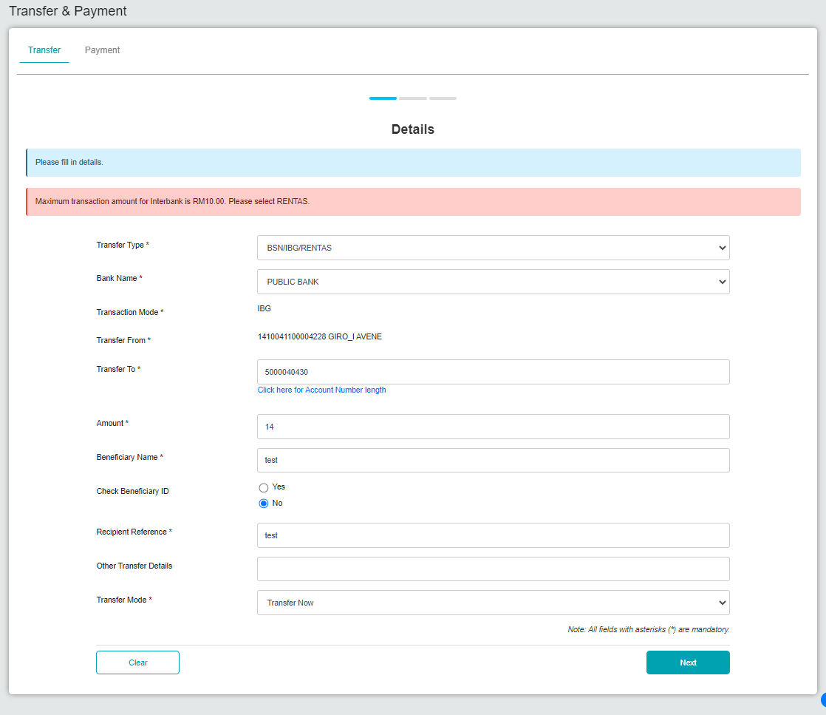  Figure 4: CDB > Transfer & Payment (Details)  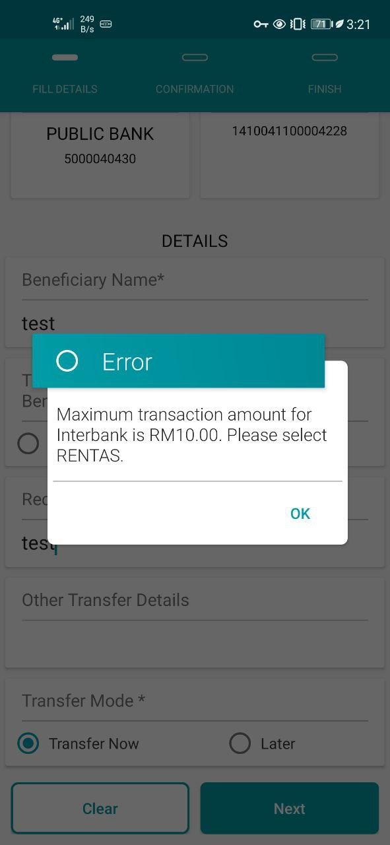  Figure 5: Mobile > Transfer & Payment  Test steps Web/Mobile 3:  Enables IBAM>Org Setup RENTAS setting  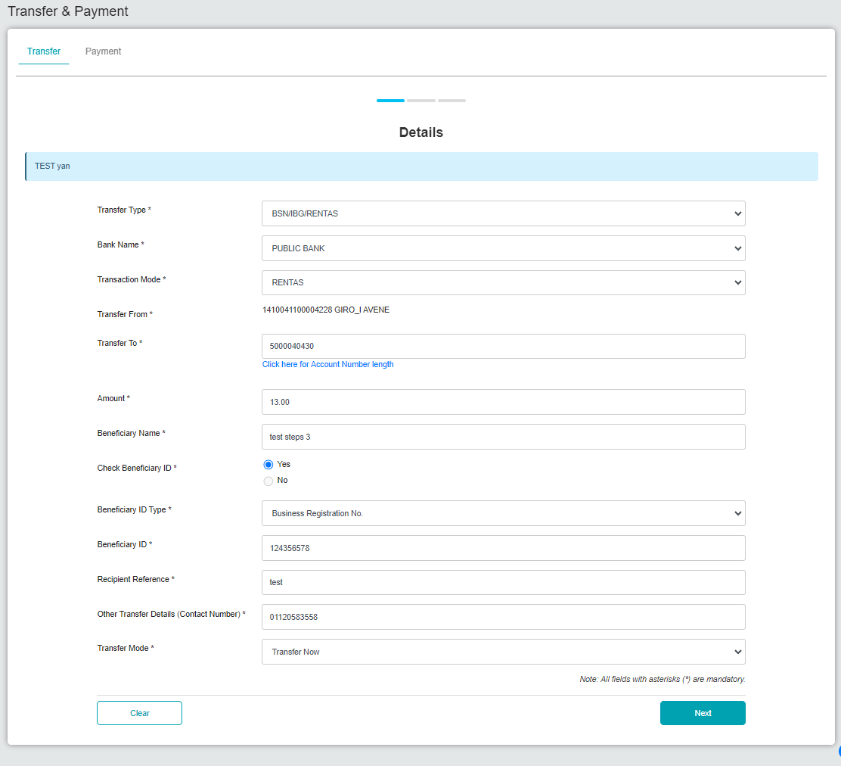  Figure 6: CDB > Transfer & Payment (Details)  Disable IBAM>Org Setup RENTAS setting before click Next in CDB  Result: Error message displayed.  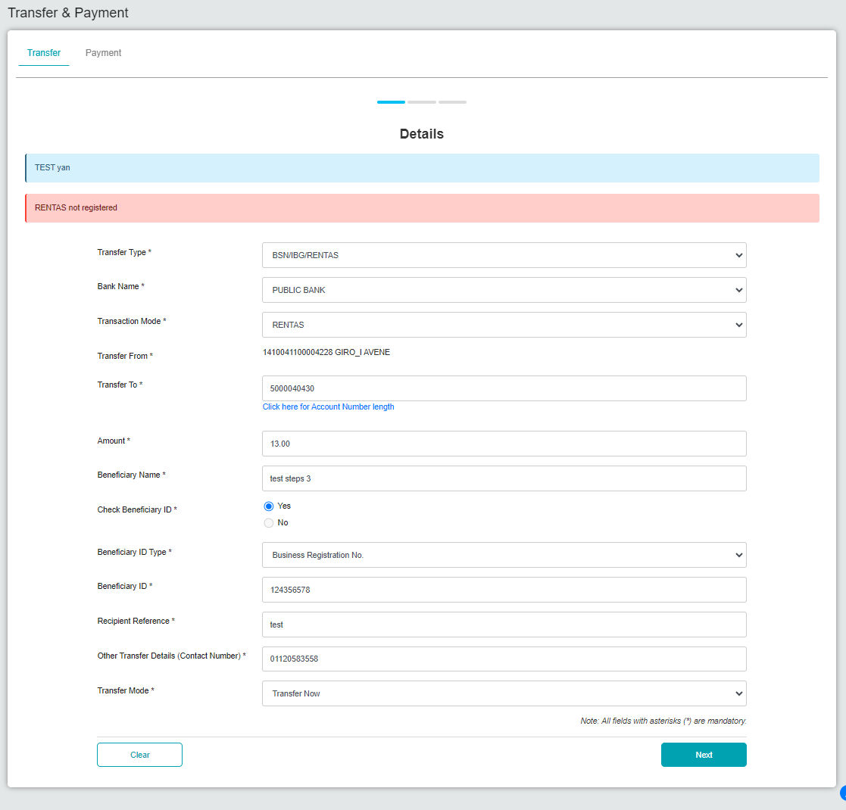  Figure 7: CDB > Transfer & Payment (Details)  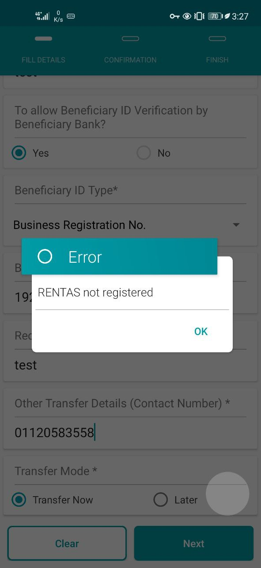  Figure 8: Mobile > Transfer & Payment (Details)

