FUNC 3.1 TC-011

Transfer from Account No missing at result page (Transfer Favorite)

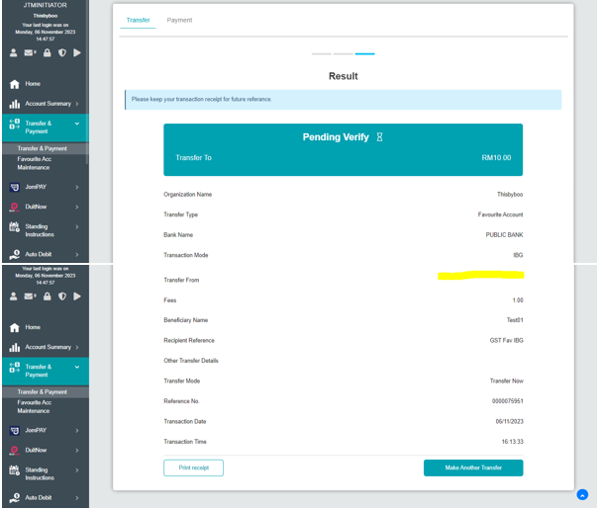

FUNC3.2 TC-002

Jompay transacton error

