SCPID#6829
Test Title: |  | No Reversal Occurred Due To No Response Return
Test Description: |  | Finding: There is no reversal occured if the host response return empty because  cdb handle reversal based on return response error code. Current set responseCode 999(integration error) when no response return.  Solution: Check response empty/null(integration error) BDS21800-PINDAHAN web service and throw error message "Host Connection Timeout".
Test Functionality: |  | To test transaction for own account, DuitNow, QR and 3rd Party.
Test Procedure: |  | Test Steps:  1. Perform own transfer, DuitNow proxy, QR, and 3rd party transfer.  2. Single user/Approver approved - Expected result throw error message "Host Connection Timeout".  *Set mockup data for testing empty response for BDS21800-PINDAHAN in AppConfig table.
Response Message:
Test Result: | Pass: Fail: |  | Tested by: | Nor Athirah Umairah (10/11/2023)
Reason for Failure:
Remarks: |  | 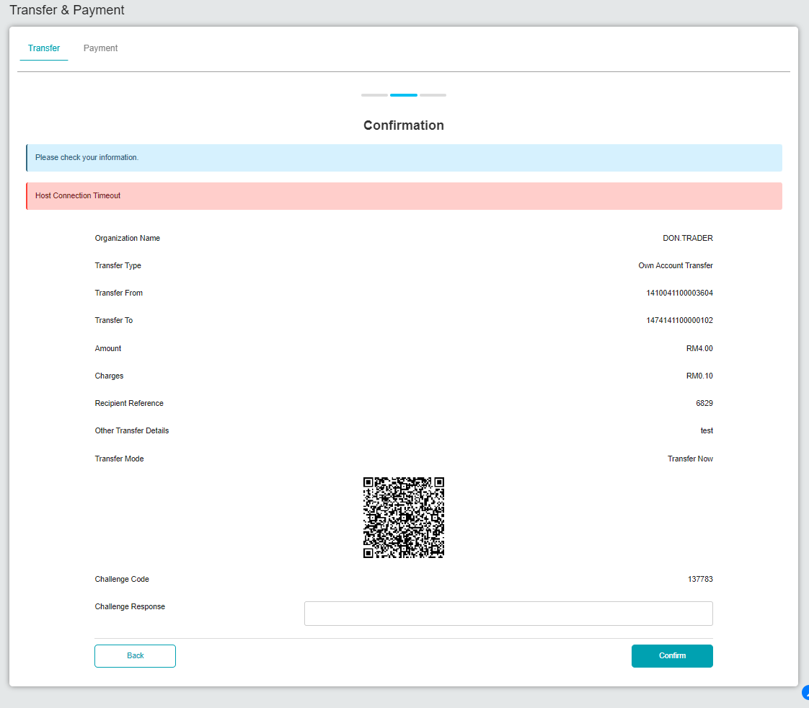  Figure 1: Own Account Transfer (Single User)  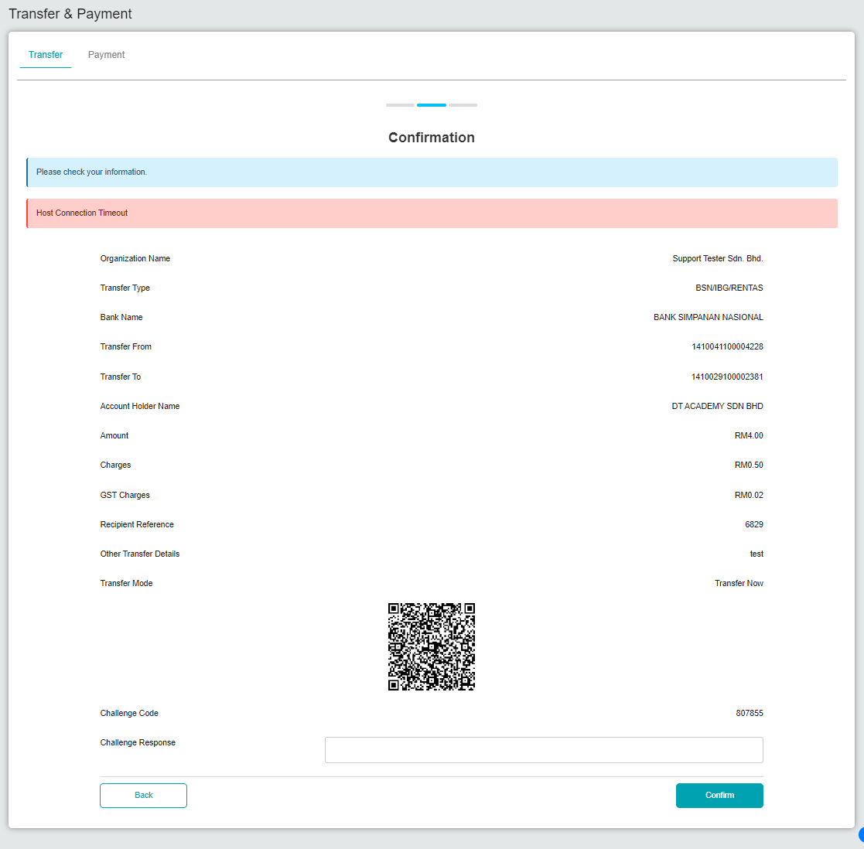  Figure 2: 3rd Party Transfer (Single User)  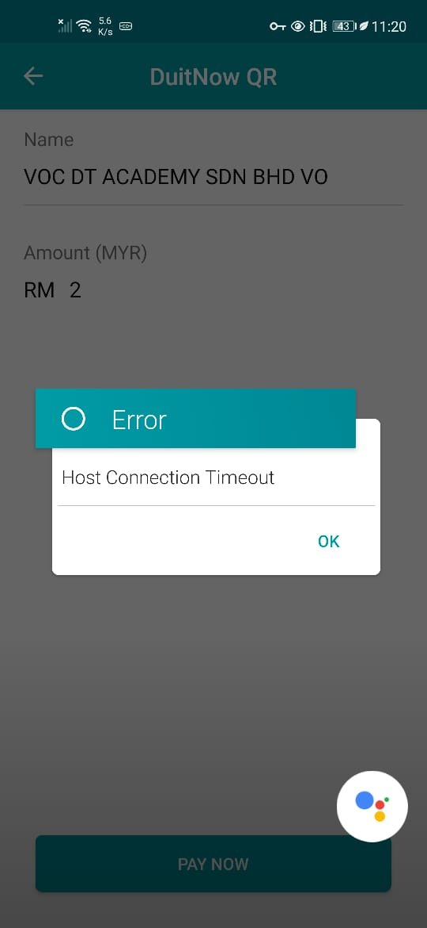  Figure 3: DuitNow QR (Single User)  *Unable to test for DuitNow proxy due to RPP Host Error.  * Approver failed to approver due to ICBS error.  