Section A: Scope of Work Summary

**Business Requirements:**

To relocate the below Norton Secured logo to a more suitable position. It does not look professional at its current location as I recently added the Notice of Discontinuation of Rentas Services

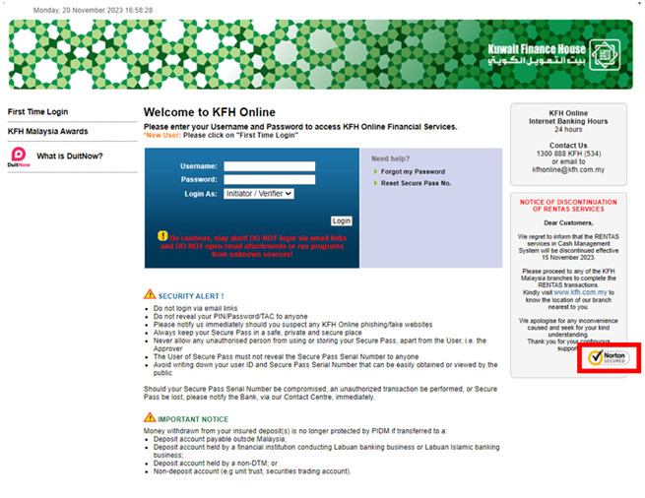

**Scope of Changes:**

* Amend JS code for login page to align the Norton Secured Logo

**Impacted System:**

* CMS web browser