SCPID#6847
Test Title: |  | Hide T&C For Companies Registered Before 28/10/2023
Test Description: |  | To hide T&C for companies registered before 28/10/2023 as per request by user. This due to deployment for enhancement of New Application Form.
Test Functionality: |  | To ensure T&C download icon for company register before 28/10/2023 not displayed.
Test Procedure: |  | Test Steps:  - Access to IBAM>CBE>BSNeBiz Application  - Expected result, no T&C download icon for company register before 28/10/2023.  - Access to IBAM>CBE>Organization Setup  - Expected result, no T&C download icon for company register before 28/10/2023.
Response Message:
Test Result: | Pass: Fail: |  | Tested by: | Nor Athirah Umairah (23/11/2023)
Reason for Failure:
Remarks: |  | 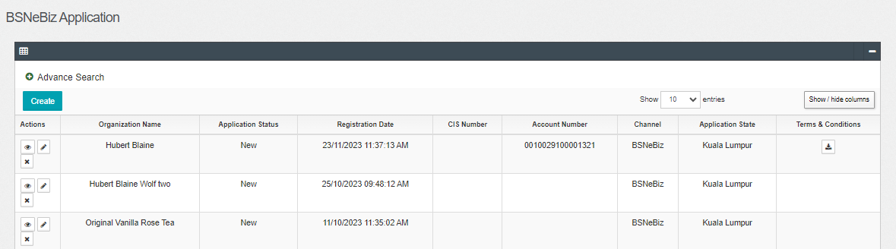  Figure 1: BSNeBiz Application  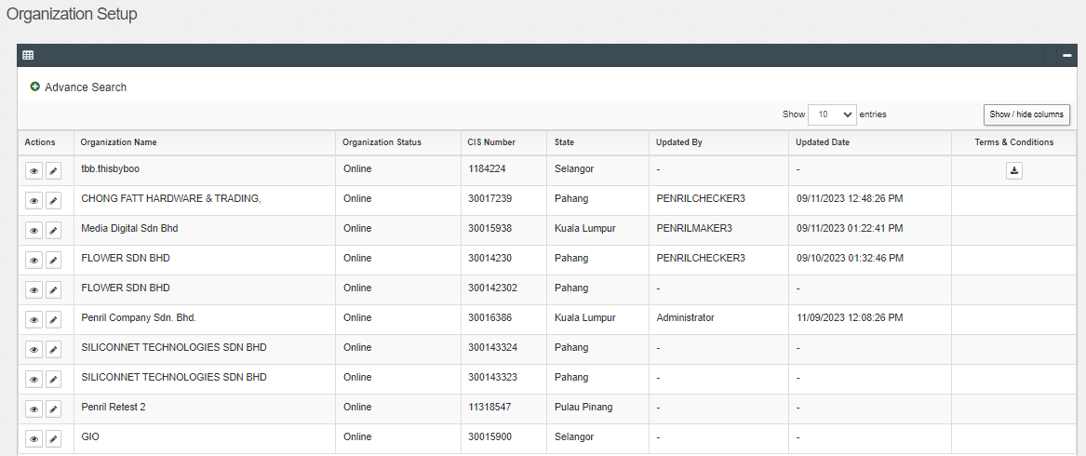  Figure 2: Organization Setup

