SCPID#6854
Test Title: |  | Add Merchant QR Monthly Report to IBAM
Test Description: |  | Add Merchant QR Monthly Report to IBAM based on “QR-Appendix5-QR Merchant Reg Report.pdf”
Test Functionality: |  | Test downloading Merchant QR Monthly Report in IBAM
Test Procedure: |  | Test Steps:  - Access to IBAM>DuitNow QR Merchant Registration History  - Select month. If no month is selected, system default to last month  - Click on “Download Paynet Report”
Response Message:
Test Result: | Pass: Fail: |  | Tested by: | Nor Athirah Umairah (24/11/2023)
Reason for Failure:
Remarks: |  | 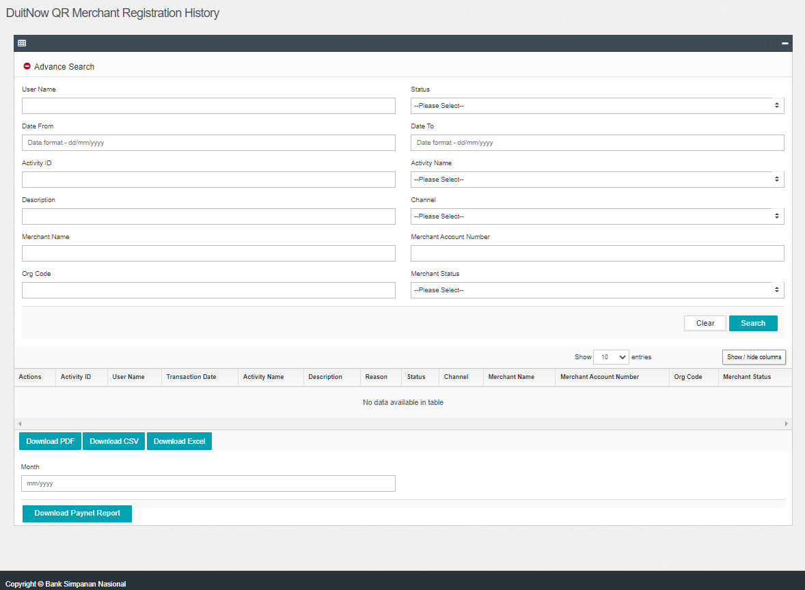  Figure 1: DuitNow QR Merchant Registration History  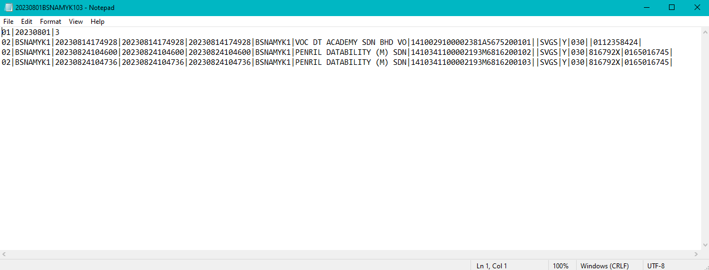  Figure 2: Paynet Report

