|  |
| --- |
|  |
| **Internet Banking Administration Module**  **Corporate Back End**  (Organization Setup) |
| Business Requirement and Functional Document |
|  |
| ***(PENRIL/BSN/BRFD_IBAM002)***  ***Revision: 04*** |
| **11th March, 2019**  Prepared By:    **PenrilDatability (M) SdnBhd (816792-X)**  Suite A-07-07 Plaza Mon’t Kiara  No. 2, Jalan Kiara, Mon’t Kiara  50480 Kuala Lumpur, Malaysia  Tel: (603) 6201 2622Fax: (603) 6201 7622 |

# Document Administration

| **Ver.**  **No** | **Date Updated** | **Description of Change** | **Updated By**  **<Name, Dept>** | **Reviewed By**  **<Name, Dept>** | **Approved By <Name, Dept>** |
| --- | --- | --- | --- | --- | --- |
| 00 | 02/08/2017 | Initial Release | Erni Suhaireen  Software Support | Siti Norahayu Mohd Desa  Business Analyst | Tan Lee Yong  Project Manager |
| 01 | 20/07/2018 | Updated based on new requirement | Athira Rahim  Professional Support | Nurul Akmal  Software Support | Norhaidah Dasuki  Senior Manager |
| 02 | 25/09/2018 | Add on Settings Tab & Charges Package | Siti Norahayu Mohd Desa  Business Analyst | Erni Suhaireen  Software Support | Tan Lee Yong  Project Manager |
| 03 | 23/10/2018 | Add on Email and SMS on Generate Pin | Athira Rahim  Software Support | Siti Norahayu Mohd Desa  Business Analyst | Tan Lee Yong  Project Manager |
| 04 | 11/03/2019 | Updated based on current system | Erni Suhaireen  Software Support | Siti Norahayu Mohd Desa  Business Analyst | Tan Lee Yong  Project Manager |
| 05 | 28/11/2023 | Updated based on current system | Nurin Sabrina Azauddin  Quality Engineer |  |  |
|  |  |  |  |  |  |

# Table of Content

Document Administration 2

Table of Content 3

Section A: Introduction 5

1.1 Objective 5

1.2 IBAM Introduction 6

1.3 IBAM Page Flow Overview 7

1.3.1 Corporate Back End Overview 8

Section B: Corporate Back End (CBE) 9

2.1 Organization Setup 9

2.1.1 View Organization Details 9

2.1.2 Edit Organization Details 14

2.2 Settings 23

2.2.1 View & Edit Settings Details 23

2.3 Contact Person 32

2.3.1 View & Edit Contact Person 32

2.4 Account Management 39

2.4.1 View & Edit Account List 39

2.5 Services & Charges 45

2.5.1 View & Edit Account and Services 45

1.0.1 Create Account & Services 55

2.5 User Maintenance 65

2.5.1 Create Organization User 65

2.5.2 Edit Organization User 75

2.5.3 Delete Organization User 82

2.5.4 Block Organization User 87

2.5.5 Activate Organization User 94

2.5.6 Unlock Organization User 98

2.5.7 Re-send Password 103

2.6 Security Token Management 108

2.6.1 Add Security Token 108

2.6.2 View & Update Security Token Details 112

2.6.3 Delete Security Token 117

2.7 Approval Matrix 120

2.7.1 View & Edit Approval Matrix 120

2.8 Online Payment Charges 128

2.8.1 View & Edit Charges 128

2.9 CIS Linking 135

2.9.1 To Allow CIS Linking 135

2.9.2 Add CIS Number 140

2.9.3 Delete CIS Number 144

Appendix 1: Glossary 148

Appendix 2: System Security Requirements 149

Appendix 3: CDB and IBAM User Status 150

Appendix 4: Acceptable Characters for Validation 151

# Section A: Introduction

This document serves as the business requirement and system specification for adding/creating new function on the Internet Banking Application Management (IBAM).

This document shall explain all the features and functionalities which will be elaborated with screen captures, process flow, descriptions, input fields specifications and error messages. All screen designs provided in this document are samples that are for illustration purposes for easy understanding only. The screen designs are not final.

# Objective

The objective of this document is to capture the user requirements of transactional and UKB transactions modules for implementing the Corporate Back End. This document will facilitate development and implementation of the mentioned modules for IBAM.

The base line features description and screen designs will be the blueprint for the development and testing team. Hence, it is crucial that all stakeholders ensure the correctness and adequacy of the requirements being captured.

All stakeholders involved are expected to review and sign off this document before the commencement of this development. By signing off this document, the stakeholder has endorsed the correctness, accuracy and adequacy of the documented requirements.

# IBAM Introduction

There are two major functionalities in IBAM, which are Bank Back End and Corporate Back End.

**Bank Back End**

Bank Back End (BBE) is for IBAM administrator to manage IBAM application itself. Below are the available services in BBE Modules:-

* Admin Group Manager
* Admin User Manager
* IBAM Navigation
* Content
* Audit Trail
* Report
* Password Policy
* Token Upload
* Token Listing
* Maker Checker Maintenance

**Corporate Back End (CBE)**

Corporate Back End allows IBAM administrator which is for Business and Operation department to manage Corporate Digital Banking application. Following are the available services in CBE Modules:-

* CDB Application
* CDB Submission
* Organization Setup
* Generate Pin
* CDB Navigation
* E-Statement
* CDB Transaction Enquiry
* CDB User Activity Log
* CDB Report
* Corporate Account Enquiry

Beside from that, there is also other services/module in the IBAM system as follows:-

* Message Box
* File Processing
* EOD
* Authorizations

# IBAM Page Flow Overview

Below diagram shows the overall view of the IBAM application modules breakdown. The detail of each function will be described in this document later.

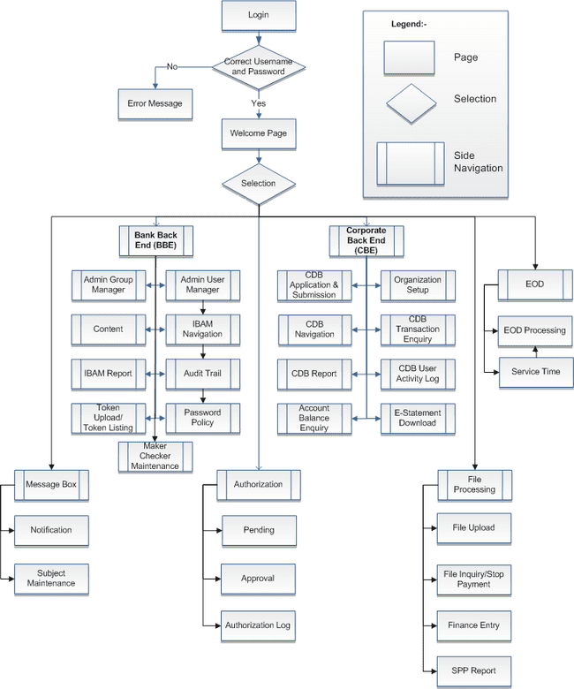

Diagram 1: Overall IBAM Modules Breakdown

# Corporate Back End Overview

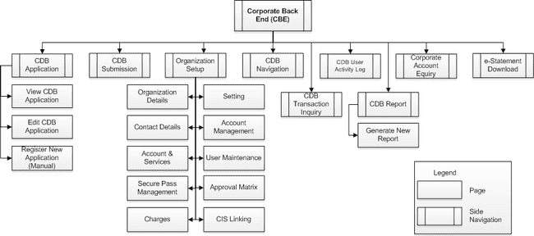Diagram 2: Corporate Back END (CBE) Modules Breakdown

# Section B: Corporate Back End (CBE)

# Organization Setup

In this document, we will focus main sub-module or functionalities of Organization Setup that allow IBAM CBE UKB to manage the setup of organization to access CDB.

### View Organization Details

This feature allows CBE UKB to search for an organization. The search criteria are Organization Name, CIS No, Business Registration Number, Organization Status, State or Org Code.

#### Process Flow



Diagram 3: Organization Enquiry Flow Diagram

#### Screen Flow

***Step 1:***

1. CBE UKB accesses to IBAM – Corporate Back End module and click on Organization Setup Navigation.
2. IBAM system display the Organization Setup Advance Search Function screen.

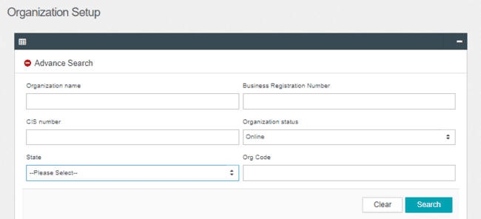

Figure 1: Organization Setup – Advance Search Function Screen

**Input Specification:**

| **No** | **Field** | **Format** | **Description** |
| --- | --- | --- | --- |
|  | Organization Name | Alpha, Numeric, or Alphanumeric | Contain the Organization Name |
|  | Business Registration Number | Numeric | Contain Business Reg. No |
|  | CIS Number | Numeric | Contain CIS number |
|  | Organization Status | Dropdown | Contain Organization Status |
|  | State | Dropdown | Contain State |
|  | Org Code | Alpha, Numeric or Alphanumeric | Contain Organization ID |

Table 1: Organization Setup - Input Specification

**Action:**

| **No** | **Action** | **Field Type** | **Description** |
| --- | --- | --- | --- |
|  | Search | Button | Contains an action to display the search result screen. |
|  | Clear | Button | Contains an action to clear up the entered fields. |

Table 2: Organization Setup– Advanced Search Function Action

***Step 2:***

1. CBE UKB click on “**Search”** button to view all list of Organization or using “Advanced Search” function based on criteria of Organization Name, Business Registration Number, CIS Number, Organization Status, State, Org Code and/or any combination of filters.
2. IBAM system list out the search result in the table format below the Advance Search function.
3. CBE UKB clicks on “**Eye**” icon on the view the Application form details.

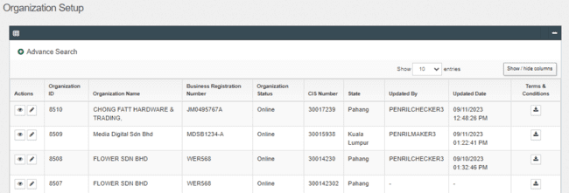

Figure 2: Organization Setup - Search Result Screen

**Display Specification:**

| **No** | **Field** | **Field Type** | **Description** |
| --- | --- | --- | --- |
|  | Organization ID | Numeric | ID of an Organization. |
|  | Organization Name | Text, Hyperlink | The name of an Organization. |
|  | Business Registration Number | Alphanumeric | Display the Organization Registration Number. |
|  | Organization Status | Text | Define the availability of the existing Organization whether it is online or offline. |
|  | CIS Number | Numeric | Common ID Number. The unique personal identifier for an Organization. |
|  | State | Text | Display the state of the Organization. |
|  | Updated By | Text | Show who updated the Organization. |
|  | Updated Date | DD/MM/YYYY HH:MM:SS | Shows the date and time when a particular UKB was updated. |

Table 3: Organization Setup –Search Result Display Field

**Action:**

| **No** | **Action** | **Field Type** | **Description** |
| --- | --- | --- | --- |
|  | “eye” icon | Button | Contains an action to display the details of the Organization. |
|  | Next/Previous | Button | Contains an action to display the next or previous page. |
|  | Terms & Condition | Button | Contains an action to display the Terms & Conditions of the Organization. |

Table 4: Organization Setup – Search Result Action

***Step 3:***

1. IBAM system shows the selected Organization details
2. CBE UKB can also view others Organization information based on the tabs (Settings, Contact Person, Account Management, Services & Charges, Online Payment Charges, User Maintenance, Security Token Management, B2B Setup, DuitNow QR Management).

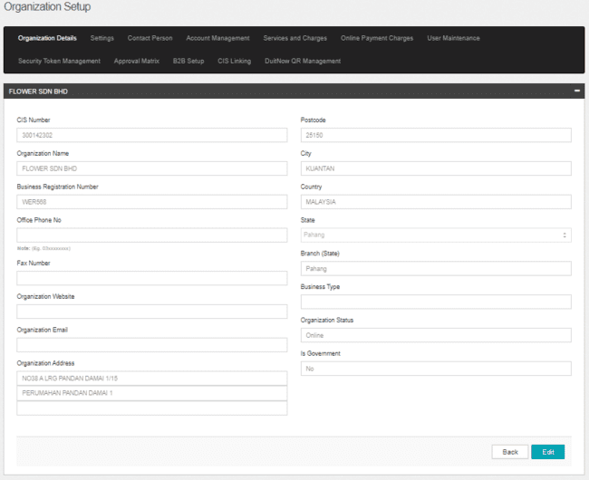

Figure 3: Organization Setup - Organization Details Screen

**Display Specification:**

| **No** | **Field** | **Field Type** | **Description** |
| --- | --- | --- | --- |
|  | CIS Number | Text | Common ID Number. The unique personal identifier for an Organization. |
|  | Organization Name | Text | The name of an Organization. |
|  | Business Registration Number | Text | An unique combination of numbers. This number is important to the business because it is company identity is going to be known by. |
|  | Office Phone Number | Text | The Organization office phone number. |
|  | Fax Number | Text | The Organization office fax number. |
|  | Organization Website | Text | The Organization website. |
|  | Organization Email | Text | The Organization email address. |
|  | Organization Address | Text | The address of an Organization (No/Street Name). |
|  | Postcode | Text | Display the postcode of the Organization city located. |
|  | City | Text | Display the city of the Organization located. |
|  | Country | Text | Display the country of the Organization located. |
|  | State | Text | Display the state of the Organization located. |
|  | Branch (State) | Text | Display the branch of the Organization located. |
|  | Business Type | Dropdown | Type of Business field of Organization. |
|  | Organization Status | Text | Define the availability of the existing Organization whether it is online or offline. |
|  | Is Government |  | Define the government sector of the Organization whether it is yes or no. |

Table 5: Organization Details Display Field

**Action:**

| **No** | **Action** | **Field Type** | **Description** |
| --- | --- | --- | --- |
|  | Edit | Button | Contains an action to edit details page. |
|  | Back | Button | Contains an action to go back to previous page. |

Table 6: Application Details Action

### Edit Organization Details

This feature allows CBEUKB to edit an Organization’s information.

#### Process Flow



Diagram 4: Organization Setup Flow Diagram

#### Screen Flow

***Step 1:***

1. IBAM system shows the selected Organization details
2. UKB clicks on the **“Pencil”** icon to edit the Organization information

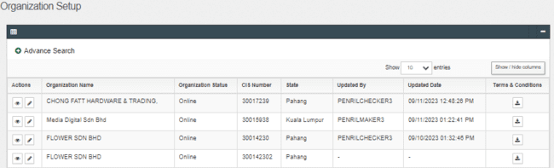 Figure 4: Organization Setup - Organization Edit Details Screen

**Action:**

| **No** | **Action** | **Type** | **Description** |
| --- | --- | --- | --- |
|  | ‘Pencil’ icon | Button | Contain an action to display the Organization Setup – Edit Page |

Table 7: Organization Setup Action

***Step 2:***

1. IBAM shows the Organization details editing screen. UKB keys in the fields that wants to be changed.
2. UKB clicks the **Next** button. IBAM will shows the Confirm Page.

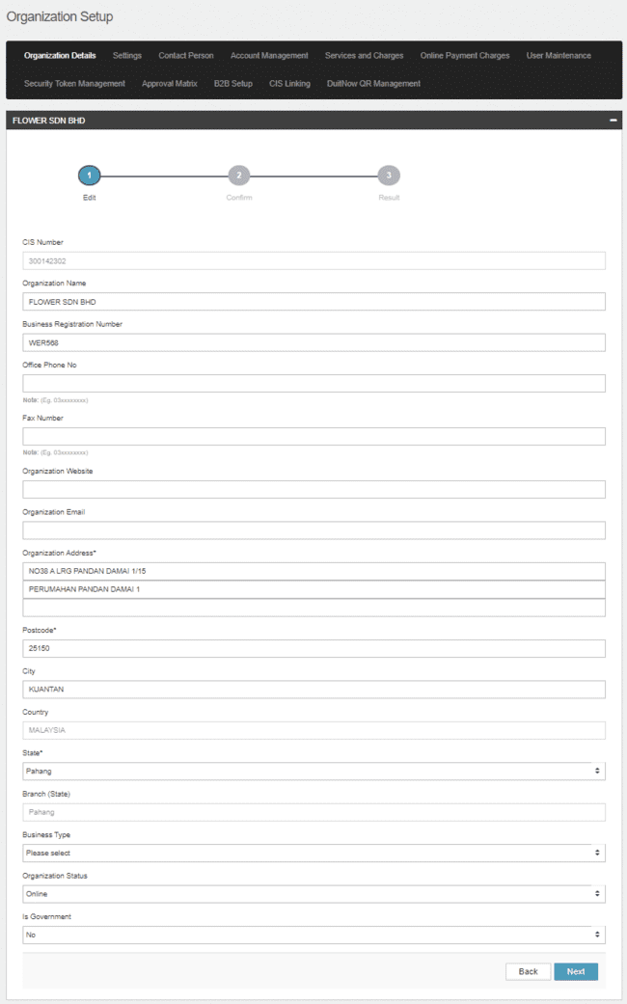

Figure 5: Organization Setup - Organization Edit Details Screen

**Display Fields:**

|  |  |  |  |
| --- | --- | --- | --- |
| **No** | **Field** | **Format** | **Description** |
|  | CIS Number | Text | The CIS number of the Organization |
|  | Country | Text | The country of the organization located |
|  | Branch (State) | Text | Display the branch of the Organization located |

Table 8: Organization Details – Edit Details Screen Display Field

**Input Specification:**

| **No** | **Field** | **Field Type** | **Rule** | **Description** | **REQUIRED** |
| --- | --- | --- | --- | --- | --- |
|  | Organization Name | Text | Max length:100 | The Organization name | YES |
|  | Business Registration Number | Text | Max length:19  Alpha, numeric, and/or | The Organization Business Registration Number | YES |
|  | Office Phone No. | Text | Match length:10 numeric | The office number phone | YES |
|  | Fax Number | Text | Match length:10 numeric | The Organization fax number | NO |
|  | Organization Website | Text | Match length:128 | The organization website | NO |
|  | Organization Email | Text | Max length:64  Alpha, numeric, and/or Text combination as long contain this format: <value>@<value>.<value> | The Organization email address | YES |
|  | Organization Address | Text | Match length: 64 for every line | Type of customer for the Organization | YES |
|  | Postcode | Text | Match length:5  numeric | The postcode of the Organization located | YES |
|  | City | Text | Match length: 50  Alphanumeric | The city of the Organization located | NO |
|  | State | Dropdown list | N/A | The state of the Organization located | YES |
|  | Business Type | Dropdown list | N/A | The organization business type | NO |
|  | Organization Status | Dropdown list | N/A | Online / Offline status for CDB access | YES |
|  | Is Goverment | Dropdown list | N/A | No / Yes status for Government sector | YES |

Table 9: Organization Setup – Edit Details Input Specification

**Action:**

| **No** | **Action** | **Type** | **Description** |
| --- | --- | --- | --- |
|  | Back | Button | Contain the action to forward back the page to “Organization Details” |
|  | Next | Button | * Contains the action to do field validation according to requirement mentioned in specification table, also checks for empty and duplicate fields. * Forward the action to display the confirmation page. |

Table 10: Organization Setup – Edit Action

**List of available messages for the screen:**

| **No.** | **Event** | **Error Description in English** |
| --- | --- | --- |
|  | Did not fill in the required field. | Organization Name is required  Business Registration Number is required  Office Phone No is required  Organization Email is required  Organization Address is required  Postcode is required  City is required  State is required |
|  | Fill in the below fields with special characters   * Office Phone Number * Fax Number * Organization Website * Organization Email * Postcode | Please enter a valid number  Please enter a valid email address  Please enter a valid number |
|  | Fill in Office Phone No. & Fax Number with less than 9 digit | Please enter at least 9 characters. |

Table 11: Organization Setup – Edit Error Message

***Step 3:***

1. IBAM display the Organization Setup – Edit Confirmation Screen

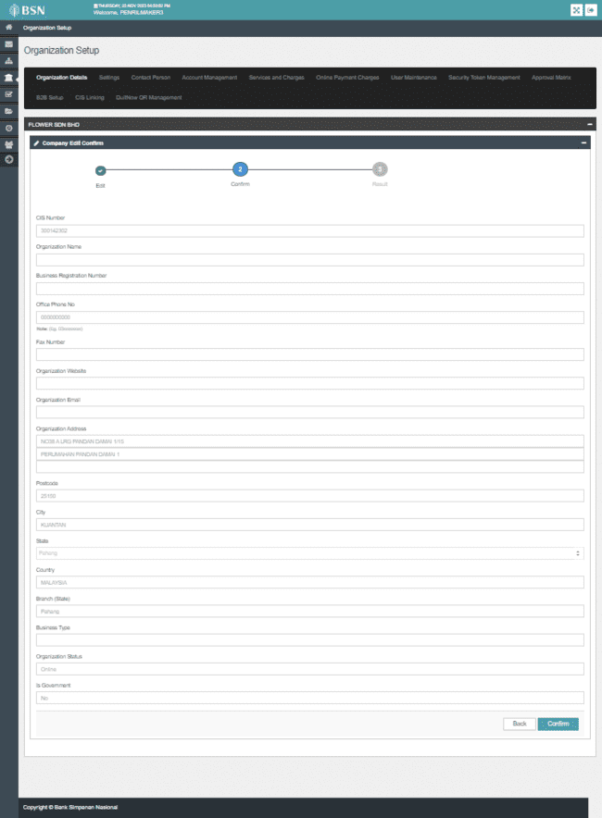

Figure 6: Organization Details – Edit Details Confirmation Screen

**Display Fields:**

|  |  |  |  |
| --- | --- | --- | --- |
| **No** | **Field** | **Format** | **Description** |
|  | CIS Number | Text | Display the CIS number of the Organization |
|  | Organization Name | Text | Display the Organization name |
|  | Business Registration No. | Text | Display the Registered Business No. |
|  | Office Phone No | Text | Display the organization office phone no |
|  | Fax Number | Text | Display the organization fax number |
|  | Organization Website | Text | Display the organization website |
|  | Organization Email | Text | Display the organization email |
|  | Organization Address | Text | Display the organization address |
|  | Postcode | Text | Display the postcode of the organization city located |
|  | City | Text | Display the city of the organization located |
|  | State | Text | Display the state of the organization located |
|  | Country | Text | Display the country code of the organization located |
|  | Branch (State) | Text | Display the Organization home branch name |
|  | Business Type | Text | Display the type of Business field of Organization |
|  | Organization Status | Text | Display the availability of the existing Organization whether it is online or offline. |
|  | Is Government | Text | Display the Government sector of the existing Organization whether it is yes or no |

Table 12: Organization Details – Edit Details Screen Display Field

**Action:**

| **No** | **Action** | **Type** | **Description** |
| --- | --- | --- | --- |
|  | Back | Button | Contain the action to forward back the page to “Organization Setup – Edit” |
|  | Confirm | Button | * Contains the action to do field validation according to requirement mentioned in specification table, also checks for empty and duplicate fields. * Forward the action to save the fields edited in “edit Organization back to database” |

Table 13: Organization Details – Edit Details Confirmation Action

***Step 4:***

1. IBAM System validates and save the changes to IB Database and displays result page.
2. IBAM shows Successful message and pending for Authorization approval process.

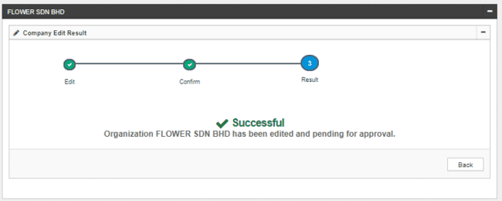

Figure **7**: Organization Details - Edit Details Result Screen

If Customer Organization Details Module Maker Checker Permission set as ‘Disable’

1. IBAM saves the update information and display the successful result page.
2. IBAM shows Successful message and will shows update information without any approval process.

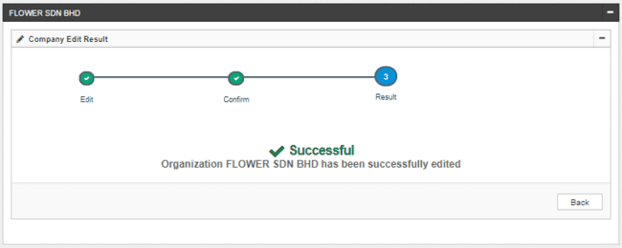

Figure 8: Organization Details – Edit Result with disable Checker Maker Permission Screen

**Display Fields:**

|  |  |  |  |
| --- | --- | --- | --- |
| **No** | **Field** | **Format** | **Description** |
|  | Result Step | Alphanumeric | To display result step |
|  | Status | Alpha numeric | To display result status. |
|  | Result Message | Alpha numeric | To display result message. |

Table 14: Organization Setup – Edit Result Display Field

**Action:**

|  |  |  |  |
| --- | --- | --- | --- |
| **No** | **Action** | **Type** | **Description** |
|  | Back | Button | Contains an action to Organization Setup main page |

Table 15: Organization Setup – Edit Result Action

# Settings

### View & Edit Settings Details

This feature allows IBAM UKB to view and Edit for Company Setting.

#### Process Flows



Diagram 5: Company Setting Flow Diagram

#### Screen Flows

***Step 1:***

1. UKB clicks on the **Settings** tab.
2. IBAM system shows setting details assigned to Organization.
3. IBAM UKB view Setting details

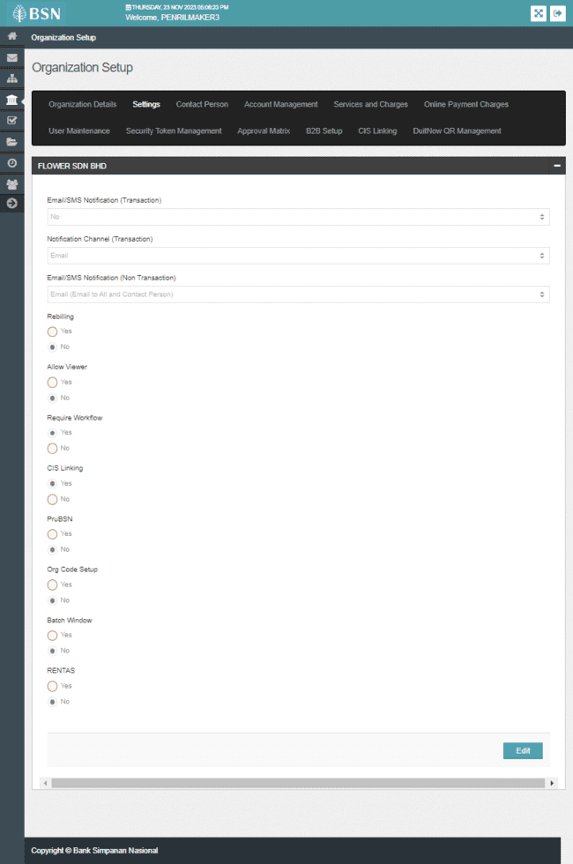

Figure 9: Settings Screen

Display Specification

| **No** | **Field** | **Format** | **Description** |
| --- | --- | --- | --- |
|  | Email/SMS Notification | Dropdown | Role that will received Email Notification.   * Send to all * Authorizer only * Initiator only * Contact Person Only * No |
|  | Notification Channel (Transaction) | Dropdown | Display the Organization Notification Channel.   * Email * SMS * Email and SMS |
|  | Email / SMS Notification (Non Transaction) | Dropdown | Display Email and SMS Notification receiver and channel for non-transaction   * Email (Email to All and Contact Person) * SMS (SMS to Contact Person Only) * Email and SMS (SMS to Contact Person and Email to All) * Email (Email to Contact Person Only) * Email and SMS (Email and SMS to Contact Person Only) * Email and SMS (Email and SMS to Contact Person and to all) |
|  | Rebilling | Radio Button | An indicator to enable/disable rebilling dropdown in the CDB   * Yes * No |
|  | Allow Viewer | Radio Button | An indicator for selected Organization to allow viewer or not   * Yes * No |
|  | Require Workflow | Radio Button | An indicator for selected Organization to require workflow or not   * Yes * No |
|  | CIS Linking | Radio Button | An indicator for selected Organization to have CIS Linking or not   * Yes * No |
|  | PruBSN | Radio Button | An indicator for selected Organization to have insurance PRUBSN or not   * Yes * No |
|  | Org Code Setup | Radio Button | An indicator for selected Organization to have Org Code Setup or not   * Yes * No |
|  | Batch Window | Radio Button | An indicator for selected Organization to have Batch Window or not   * Yes * No |
|  | RENTAS | Radio Button | An indicator for selected Organization to have RENTAS or not   * Yes * No |

Table 16: Settings Display Specification

***Step 2:***

1. UKB clicks on “**Edit**” button to display Edit Setting screen.

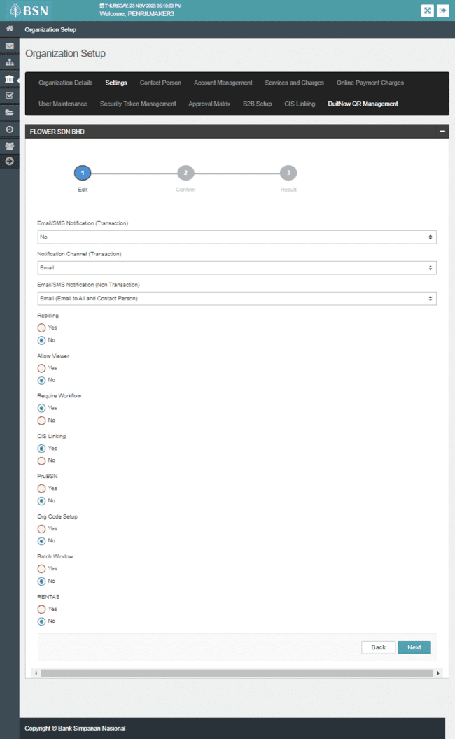

Figure 10: Edit Setting Screen

Input Specification

| **No** | **Field** | **Format** | **Rule** | **Description** |
| --- | --- | --- | --- | --- |
|  | Email/SMS Notification | Dropdown | N/A | Role that will received Email Notification.   * Send to all * Authorizer only * Initiator only * Contact Person Only * No |
|  | Notification Channel (Transaction) | Dropdown | N/A | An indicator to define the Organization Notification Channel.   * Email * SMS * Email and SMS |
|  | Email / SMS Notification (Non Transaction) | Dropdown | N/A | Display Email and SMS Notification receiver and channel for non-transaction   * Email (Email to All and Contact Person) * SMS (SMS to Contact Person Only) * Email and SMS (SMS to Contact Person and Email to All) * Email (Email to Contact Person Only) * Email and SMS (Email and SMS to Contact Person Only) * Email and SMS (Email and SMS to Contact Person and to all) |
|  | Rebilling | Radio Button | N/A | An indicator to enable/disable rebilling dropdown in the CDB   * Yes * No |
|  | Allow Viewer | Radio Button | N/A | An indicator for selected Organization to allow viewer or not   * Yes * No |
|  | Require Workflow | Radio Button | N/A | An indicator for selected Organization to require workflow or not   * Yes * No |
|  | CIS Linking | Radio Button | N/A | An indicator for selected Organization to have CIS Linking or not   * Yes * No |
|  | PruBSN | Radio Button | N/A | An indicator for selected Organization to have insurance PRUBSN or not   * Yes * No |
|  | Org Code Setup | Radio Button | N/A | An indicator for selected Organization to have Org Code Setup or not   * Yes * No |
|  | Batch Window | Radio Button | N/A | An indicator for selected Organization to have Batch Window or not   * Yes * No |
|  | RENTAS | Radio Button | N/A | An indicator for selected Organization to have RENTAS or not   * Yes * No |

Table 17: Edit Settings Input Specification

**Action:**

| **No** | **Action** | **Type** | **Description** |
| --- | --- | --- | --- |
|  | Next | Button | Contain the action to display Edit Setting Confirmation screen. |
|  | Back | Button | Contain action to display back on details page |

Table 18: Edit Setting Action

***Step 3:***

1. IBAM display the Edit Setting Confirmation screen.
2. UKB clicks on “**Confirm**” button to confirm the changes.

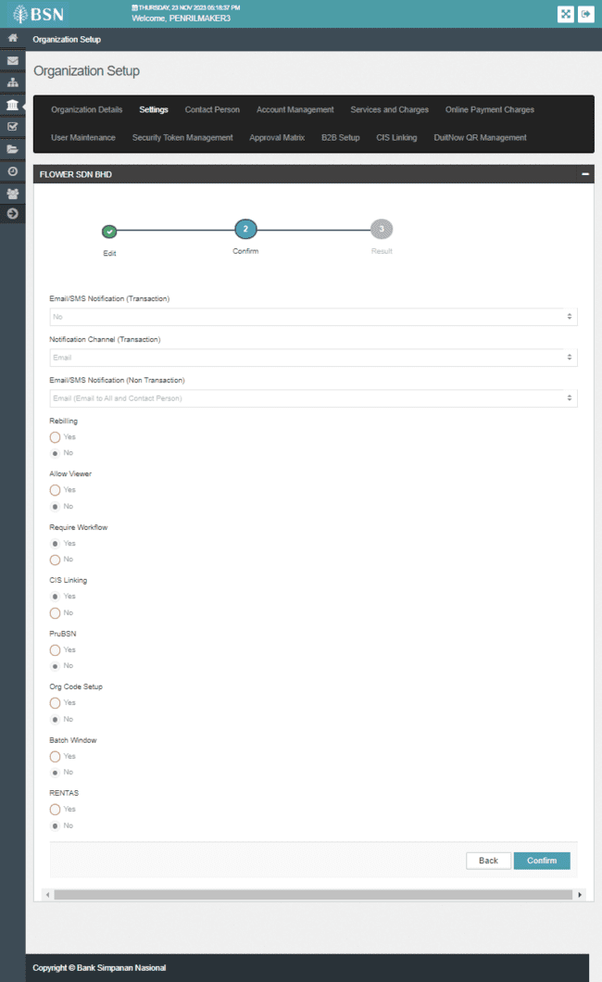

Figure 11: Edit Setting Confirmation Screen

**Action:**

| **No** | **Action** | **Type** | **Description** |
| --- | --- | --- | --- |
|  | Confirm | Button | Contain the action to display Edit Setting - Result page |
|  | Back | Button | Contain the action to display back on Edit Setting Page |

Table 19: Edit Setting Confirmation Action

***Step 4:***

1. IBAM System validates and save the changes to IB Database and displays result page.
2. IBAM shows Successful message and pending for Authorization approval process.

If User Maintenance Module Maker Checker Permission set as ‘Disable’

1. IBAM saves the update information and display the successful result page.
2. IBAM shows Successful message and will shows update information without any approval process.

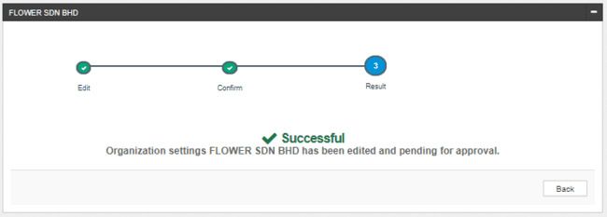

Figure 12: Edit Setting – Result Screen

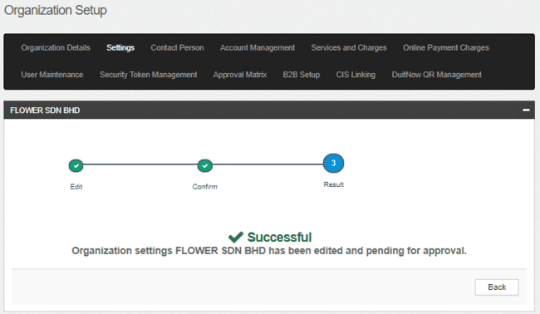

Figure 13: Edit Setting – Result Screen with disable Checker Maker Permission

**Display Fields:**

|  |  |  |  |
| --- | --- | --- | --- |
| **No** | **Field** | **Format** | **Description** |
|  | Result Step | Alphanumeric | To display result step |
|  | Status | Alpha numeric | To display result status. |
|  | Result Message | Alpha numeric | To display result message. |

Table 20: Setting – Result Screen Display Field

**Action:**

|  |  |  |  |
| --- | --- | --- | --- |
| **No** | **Action** | **Type** | **Description** |
|  | Back | Button | Contains an action to Organization Setup page |

Table 21: Setting – Result Action



# Contact Person

This feature allows CBE UKB to edit contact person of a registered Organization.

### View & Edit Contact Person

#### Process Flow



Diagram 6: View Organization’s Contact Person Process Flow Diagram

#### Screen Flow

***Step 1:***

1. UKB clicks on **Organization Setup** navigation at the left side of the screen.
2. UKB clicks on the **“Pencil”** icon button on the selected Organization.

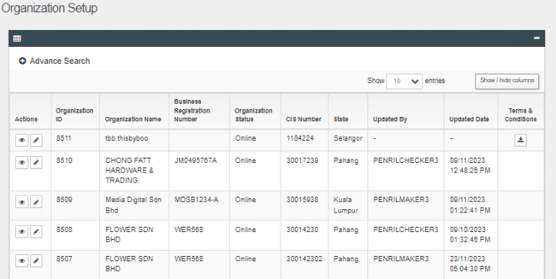

Figure 14: Organization Setup Screen

**Display Specification:**

| **No** | **Field** | **Field Type** | **Description** |
| --- | --- | --- | --- |
|  | Organization ID | Numeric | ID of an Organization |
|  | Organization Name | Text, | The name of an Organization |
|  | Business Registration Number | Alphanumeric | Display the Organization Registration Number |
|  | Organization Status | Text | Define the availability of the existing Organization whether it is online or offline. |
|  | CIS Number | Numeric | Common ID Number. The unique personal identifier for an Organization. |
|  | State | Text | Define the state of the organization. |
|  | Updated By | Text | Show who registered the Organization |
|  | Updated Date | DD/MM/YYYY HH:MM:SS | Shows the date and time when a particular UKB was registered. |

Table 22: Organization Setup –Search Result Display Field

**Action:**

| **No** | **Action** | **Type** | **Description** |
| --- | --- | --- | --- |
|  | “Pencil” icon | Button | Contain the action to display the selected Organization details |
|  | “Eye” icon | Button | Contain the action to display the selected Organization details |
|  | “Download” icon | Button | Contain the action to display the selected Organization terms & condition details. |

Table 23: Organization Setup Action

***Step 2:***

1. UKB go to **“Contact Person”** screen.
2. UKB click on **“Edit”** button.

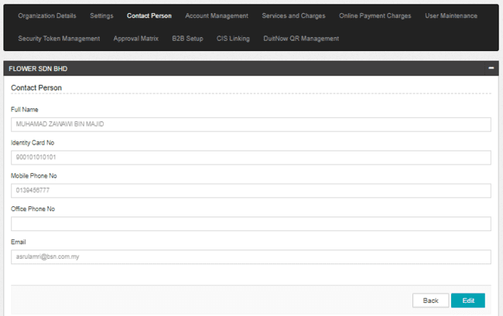

Figure 15: Contact Person Screen

**Display Specification:**

| **No** | **Field** | **Field Type** | **Description** |
| --- | --- | --- | --- |
|  | Full Name | Text | The contact person’s name |
|  | Identity Card No | Text | The contact person’s identity card number |
|  | Mobile Phone No. | Text | The contact person’s mobile phone number |
|  | Office Phone No. | Text | The contact person’s office phone number |
|  | Email | Text | The contact person’s email address |

Table 24: Contact Person – Display Specification

**Action:**

| **No** | **Action** | **Type** | **Description** |
| --- | --- | --- | --- |
|  | Edit | Button | Contain the action to display the Contact Person – Edit page. |
|  | Back | Button | Contain the action to display back on Organization Setup page. |

Table 25: Contact Person Screen Action

***Step 3:***

1. IBAM display the Contact Person – Edit page.

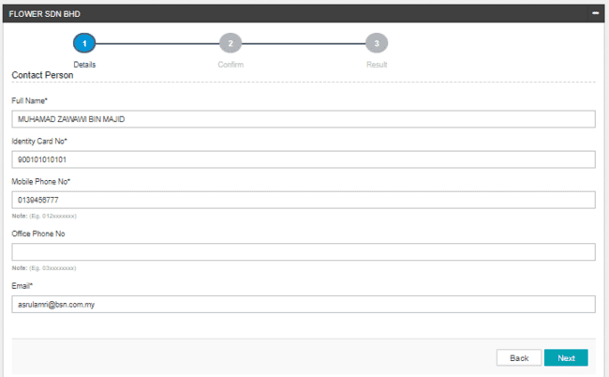

Figure 16: Contact Person – Edit Screen

**Input Specification:**

| **No** | **Field** | **Field Type** | **Validation Rule** | **Description** | **REQUIRED** |
| --- | --- | --- | --- | --- | --- |
|  | Full Name | Text | Max length :50 | The contact person’s name | YES |
|  | Identity Card No. | Text | Max Length:12  Numeric characters | The contact person’s identity card number | YES |
|  | Mobile Phone No. | Text | Max Length : 12  Numeric | The contact person’s mobile phone number | YES |
|  | Office Phone No. | Text | Max Length:13  Numeric | The contact person’s office phone number | NO |
|  | Email | Text | Max length:40  Alpha, numeric, and/or Text combination as long contain this format: <value>@<value>.<value> | The contact person’s email address | YES |

Table 26: Contact Person – Edit Screen Input Specification

**Action:**

| **No** | **Action** | **Type** | **Description** |
| --- | --- | --- | --- |
|  | Back | Button | Contain the action to do page backward from “Contact Person – Edit screen” to “Contact Person screen” |
|  | Next | Button | Contains an action to display the Contact Person – Confirmation page. |

Table 27: Contact Person – Edit Screen Action

**List of available messages for the screen:**

|  |  |  |
| --- | --- | --- |
| **No.** | **Event** | **Error Description in English** |
|  | Did not Fill in required Fields | Contact Person Name is required  Contact Person Identity Card No. is required  Contact Person Mobile No. is required.  Contact Person Email is required |
|  | Fill in below field with alphabet or special character:   * ID No * Mobile Phone No * Office Phone No | Please enter a valid number |
|  | Fill in Full Name with numeric and special characters except space @ . , / ( ) | Contact Person's Name cannot include numeric and special characters except space @ . , / ( ) |

Table 28: Contact Person – Edit Screen Error Message

***Step 4:***

1. IBAM display the Contact Person – Confirmation page.

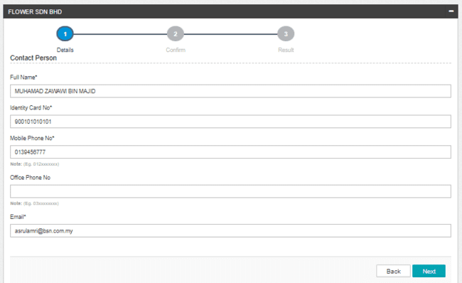

Figure 17: Contact Person – Confirmation Screen

**Action:**

| **No** | **Action** | **Type** | **Description** |
| --- | --- | --- | --- |
|  | Back | Button | Contain the action to do page backward from “Contact Person – Confirmation screen” to “Contact Person – Edit screen” |
|  | Confirm | Button | Contains an action to display the Contact Person – Result page. |

Table 29: Contact Person – Edit Screen Action

***Step 5:***

1. IBAM System validates and save the changes to IB Database and displays result page.
2. IBAM shows Successful message and pending for Authorization approval process.

If Contact Person Module Maker Checker Permission set as ‘Disable’

1. IBAM saves the update information and display the successful result page.
2. IBAM shows Successful message and will shows update information without any approval process.

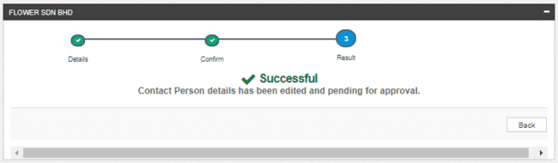

Figure 18: Contact Person – Result Screen

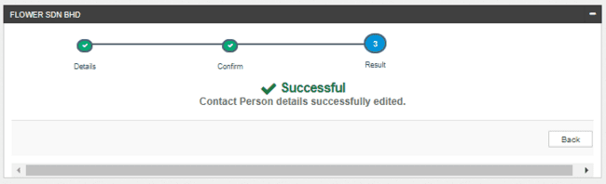

Figure 19: Contact Person – Result Screen with disable Checker Maker Permission

**Display Fields:**

|  |  |  |  |
| --- | --- | --- | --- |
| **No** | **Field** | **Format** | **Description** |
|  | Result Step | Alphanumeric | To display result step |
|  | Status | Alpha numeric | To display result status. |
|  | Result Message | Alpha numeric | To display result message. |

Table 30: Contact Person – Result Screen Display Field

**Action:**

|  |  |  |  |
| --- | --- | --- | --- |
| **No** | **Action** | **Type** | **Description** |
|  | Back | Button | Contains an action to Contact Person main page |

Table 31: Contact Person – Result Action

# Account Management

In this module, IBAM UKB can view and update the Organization’s account(s) for CDB accessibility.

### View & Edit Account List

This feature allows IBAM UKB (IBAM UKB ) to view Organization’s accounts list with IB accessible/inaccessible status

#### Process Flow



Diagram 7: Organization Account Management Process Flow Diagram

#### Screen Flow

***Step 1:***

1. UKB clicks on **Organization Setup** navigation at the left side of the screen.
2. UKB clicks on the **“Pencil”** icon button on the selected Organization.

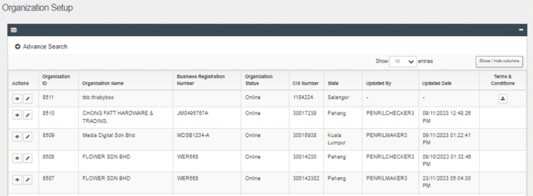

Figure 20: Organization Setup Screen

**Display Specification:**

| **No** | **Field** | **Field Type** | **Description** |
| --- | --- | --- | --- |
|  | Organization ID | Numeric | ID of an Organization |
|  | Organization Name | Text, Hyperlink | The name of an Organization |
|  | Business Registration Number | Alphanumeric | Display the Organization Registration Number |
|  | Organization Status | Text | Define the availability of the existing Organization whether it is online or offline. |
|  | CIS Number | Numeric | Common ID Number. The unique personal identifier for an Organization. |
|  | State | Text | Define the State of the organization. |
|  | Updated By | Text | Show who updated the Organization |
|  | Updated Date | DD/MM/YYYY HH:MM:SS | Shows the date and time when a particular UKB was updated. |

Table 32: Organization Setup –Search Result Display Field

**Action:**

| **No** | **Action** | **Type** | **Description** |
| --- | --- | --- | --- |
|  | “Pencil” icon | Button | Contain the action to display the selected Organization details |
|  | “Eye” icon | Button | Contain the action to display the selected Organization details |
|  | “Download” icon | Button | Contain the action to display the selected Organization terms & condition details |

Table 33: Organization Setup Action

***Step 2:***

1. UKB go to **“Account Management”** screen.
2. System displays Account Management screen.
3. UKB is allowed to edit the IB Accessible and input the Account Name.

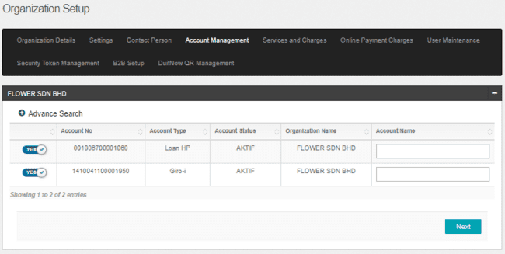

Figure 21: Account Management Screen

**Display Specification:**

| **No** | **Field** | **Field Type** | **Description** |
| --- | --- | --- | --- |
| 1. | Account No | Text | Displays the account number |
| 2. | Account Type | Text | Displays the type of account. |
| 3. | Account Status | Text | Displays the account status. |
| 4. | Organization Name | Text | Displays the Organization name. |

Table 34: Account Management Display Field

**Input Specification:**

| **No** | **Field** | **Field Type** | **Validation Rule** | **Description** | **REQUIRED** |
| --- | --- | --- | --- | --- | --- |
|  | Account Name | Text | Max length: 64 | Display the account name | YES |

Table 35: Account Management Input Specification

**Action:**

| **No** | **Action** | **Type** | **Description** |
| --- | --- | --- | --- |
|  | IB Accessible | Slide Checkbox | To enable or disable IB Accessible |
|  | Next | Button | Contain action to service editor |

Table 36: Account Management List Action

***Step 3:***

1. IBAM system displays the confirmation screen.
2. IBAM UKB click on “Confirm” button to proceed on changes, or click on “Back” button to cancel the action.

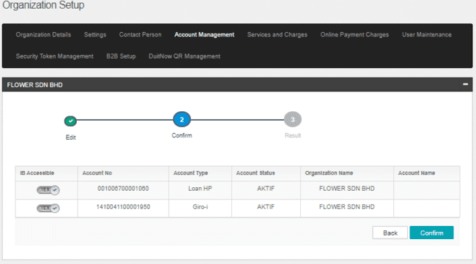

Organization 22: Account Management Confirmation Screen

**Action:**

| **No** | **Action** | **Type** | **Description** |
| --- | --- | --- | --- |
|  | Confirm | Button | Contain an action to save the changes made and display the result page |
|  | Back | Button | Contain an action to cancel the changes made and display back on previous page. |

Table 37: Account Management Confirmation Screen Action

***Step 4:***

1. IBAM System validates and save the changes to IB Database and displays result page.
2. IBAM shows Successful message and pending for Authorization approval process.

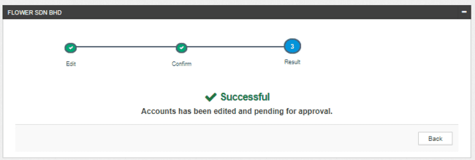

Figure 23: Contact Person – Result screen

If Account Management Module Maker Checker Permission set as ‘Disable’

1. IBAM saves the update information and display the successful result page.
2. IBAM shows Successful message and will shows update information without any approval process.

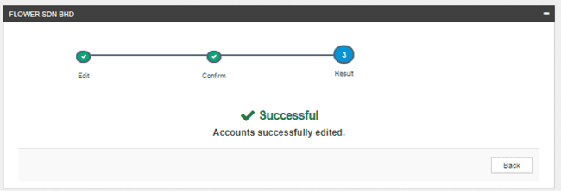

Figure 24: Contact Person – Result Screen with disable Checker Maker Permission

**Display Fields:**

|  |  |  |  |
| --- | --- | --- | --- |
| **No** | **Field** | **Format** | **Description** |
|  | Result Step | Alphanumeric | To display result step |
|  | Status | Alpha numeric | To display result status. |
|  | Result Message | Alpha numeric | To display result message. |

Table 38: Account Management – Result Screen Display Field

**Action:**

|  |  |  |  |
| --- | --- | --- | --- |
| **No** | **Action** | **Type** | **Description** |
|  | Back | Button | Contains an action to Account Management main page |

Table 39: Account Management – Result Action

# 2.5 Services & Charges

This feature allows CBE UKB to edit Services & Charges that have been created previously.

### 2.5.1 View & Edit Account and Services

This feature also allows IBAM UKB to setup charges for Organization per package or per Org ID for bulk payment services. Charges package can be created and maintain in BBE>Content> FEEMAINTENANCE.

#### 2.5.1.1 Process Flows



Diagram 8: Services & Charges Flow Diagram

#### Screen Flows

***Step 1:***

1. UKB clicks on the **Services & Charges** Tab Navigation.
2. IBAM system shows **Services & Charges** Advance Search function screen.
3. UKB keys in Account Number or Account Type or Org Code to search.
4. UKB clicks on the **Search** button to view the list of Account & Services or using Advance Search function based on criteria of Account Number, Account Type, Organization ID and / or any combination of filters.

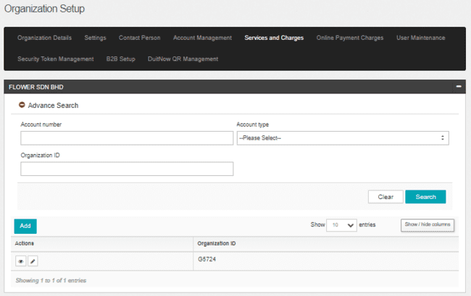

Figure 25: Account & Services Advance Search Screen

**Input Specification:**

| **No** | **Field** | **Field Type** | **Validation Rule** | **Description** | **REQUIRED** |
| --- | --- | --- | --- | --- | --- |
|  | Account Number | Text | Max Length: 20  numeric | Account number for the organization | O |
|  | Account Type | Dropdown list | N/A | Account Type for the organization | O |
|  | Organization ID | Text | Alphanumeric | Organization ID for the organization | O |

Table 40: Account & Services Advance Search Input Specification

**Action:**

| **No** | **Action** | **Type** | **Description** |
| --- | --- | --- | --- |
| 1 | Search | Button | Contain the action to list out the search result in the table format below the Advance Search Function. |
| 2 | Clear | Button | Contain action to clear up all the entered field |

Table 41: Account & Services Advance Search Action

***Step 2:***

1. IBAM system list out the search result in the table format below the Advance Search Function.
2. UKB clicks on “**Eye**” icon to display Account & Services Details.

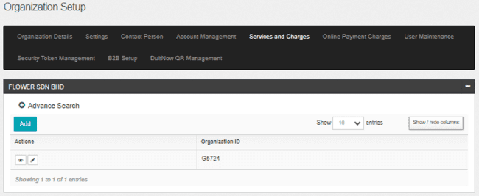

Figure 26: Account & Services Advance Search Screen

**Action:**

| **No** | **Action** | **Type** | **Description** |
| --- | --- | --- | --- |
| 1. | “Eye” icon | Button | Contain the action to display Account & Services Details screen. |
| 2. | “Pencil” icon | Button | Contain the action to display the selected Organization details |

Table 42: Account & Services Advance Search Screen Action

***Step 3:***

1. IBAM System display on Account & Services Details.
2. UKB click on **“Edit”**  button.

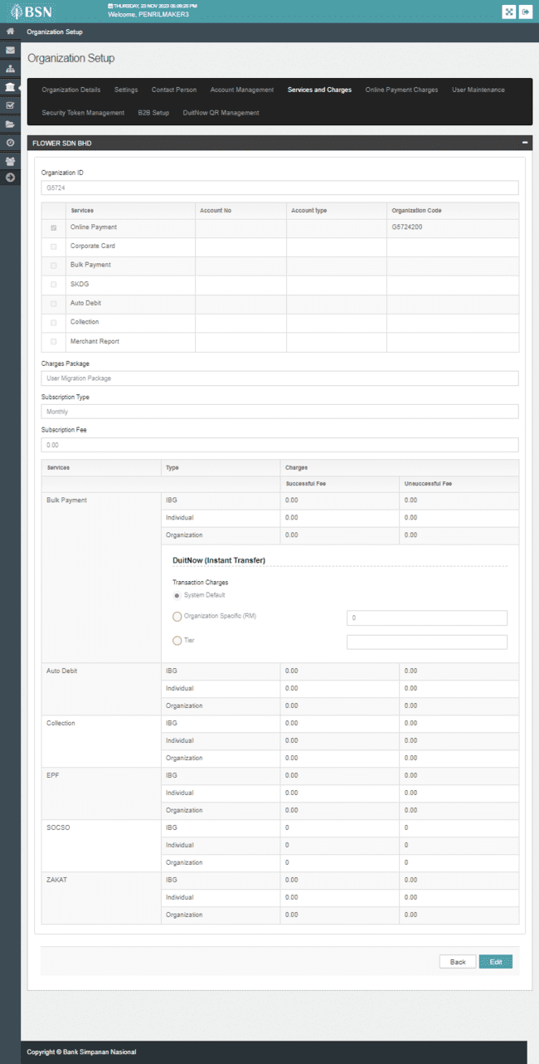

Figure 27: Account & Services – Details Screen

**Display Specification**

| No | Field | Format | Description |
| --- | --- | --- | --- |
|  | Organization ID | Text | Display the organization ID. |
|  | Services | Text | Display the available service. |
|  | Account No | Text | Display the account number. |
|  | Account Type | Text | Display the account type. |
|  | Organization Code | Text | Display the organization code for every service. |
| **Charges** | | | |
|  | Charges Package | Text | Display the charges package subscribed for the organization. |
|  | Subscription Type | Text | Display the subscription type for package. |
|  | Subscription Fees | Text | Display the subscription fees for the package. |
|  | Services | Text | Display the services that have charges. |
|  | Type | Text | Display the type of charges for the services:   * IBG * Individual * Organization * DuitNow (Instant Transfer) |
|  | Charges | Text | Display the successfully and unsuccessfully charges for every services. |

Table 43: Account & Services – Details Screen Display Specification

**Action:**

| **No** | **Action** | **Type** | **Description** |
| --- | --- | --- | --- |
| 1 | Back | Button | Contain the action to search all Account & Services page |
| 2 | Edit | Button | Contain the action to display the Edit Service Page |

Table 44: Account & Services Action

***Step 4:***

1. System display Edit Services screen.
2. Enter the changes.
3. Click on **Next** button.

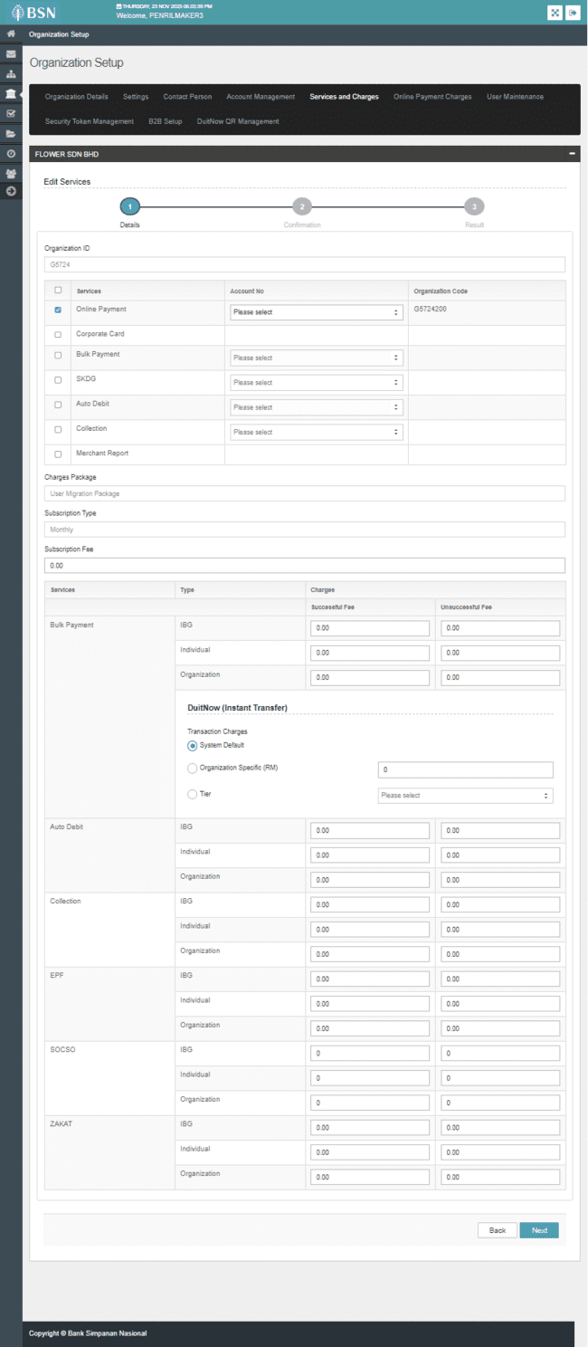

Figure 28: Edit Services Screen

**Input Specification:**

| **No** | **Field** | **Field Type** | **Rule** | **Description** | **Required** |
| --- | --- | --- | --- | --- | --- |
|  | Services | Check Box | N/A | To tick on the CDB services selected by Organization.   1. Online Payment 2. Corporate Card 3. Bulk Payment 4. SKDG 5. Auto Debit 6. Collection 7. Merchant Report | No |
|  | Account No | Dropdown list | N/A | Contains list of account for the services. | Yes for all services (except Bulk Payment) |
|  | Subscription Fees | Text | Max length (15,2)  Numeric | Subscription fees for the package. | No |
|  | Charges | Text | Max length (15,2)  Numeric | The successfully and unsuccessfully charges for every services. | No |

Table 45: Edit Services Input Specification

**Action:**

|  |  |  |  |
| --- | --- | --- | --- |
| **No** | **Action** | **Type** | **Description** |
|  | Next | Button | Contains an action to display Edit Services Confirmation screen. |
|  | Back | Button | Contain an action to display back on previous screen. |

Table 46: Edit Services Action

***Step 5:***

1. System display Edit Services Confirmation screen.
2. Click on **Confirm** button.

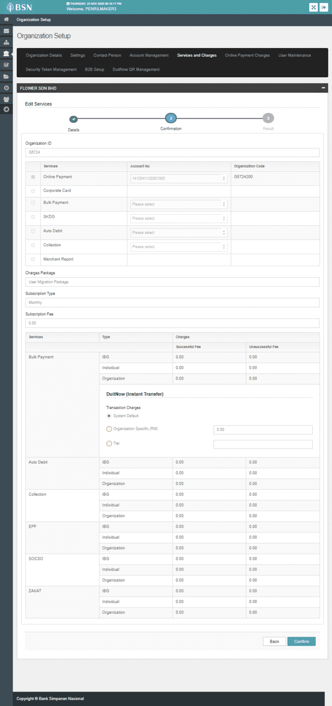

Figure 29: Edit Services Confirmation Screen

**Action:**

| **No** | **Action** | **Type** | **Description** |
| --- | --- | --- | --- |
|  | Confirm | Button | Contains an action to display Edit Services Result screen. |
|  | Back | Button | Contain an action to display back on previous page. |

Table 47: Edit Services Confirmation Action

***Step 6:***

1. IBAM System validates and save the changes to IB Database and displays result page.
2. IBAM shows Successful message and pending for Authorization approval process.

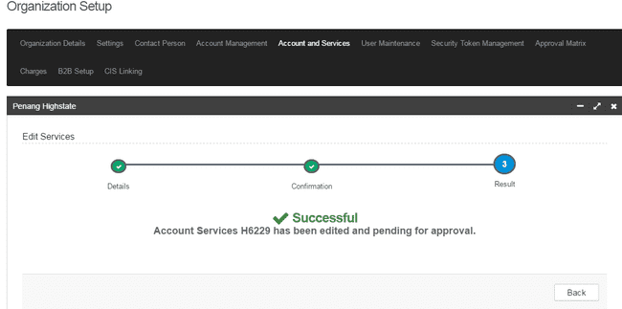

Figure 30: Edit Services Result Screen

If User Maintenance Module Maker Checker Permission set as ‘Disable’

1. IBAM saves the update information and display the successful result page.
2. IBAM shows Successful message and will shows update information without any approval process.

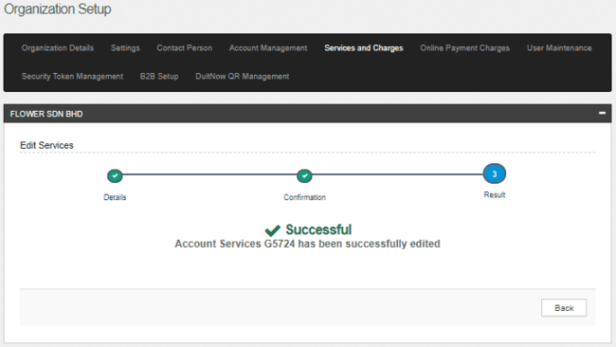

Figure 31: Edit Services Result Screen with disable Checker Maker Permission

**Display Fields:**

|  |  |  |  |
| --- | --- | --- | --- |
| **No** | **Field** | **Format** | **Description** |
|  | Result Step | Alphanumeric | To display result step |
|  | Status | Alpha numeric | To display result status. |
|  | Result Message | Alpha numeric | To display result message. |

**Action:**

|  |  |  |  |
| --- | --- | --- | --- |
| **No** | **Action** | **Type** | **Description** |
|  | Back | Button | Contains an action to display Account & Services main screen. |

### Create Account & Services

#### 2.5.2.1 Process Flows



Diagram 9: Create Account & Services Flow Diagram

#### Screen Flows

***Step 1:***

1. UKB clicks on the **Services and Charges** tab Navigation.
2. IBAM system shows **Services and Charges** search page.
3. UKB clicks on the “**Add”** button to add New Account & Service.

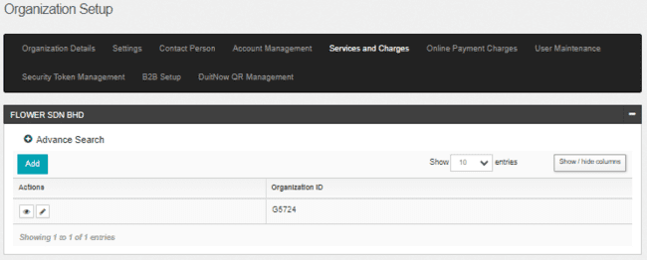

Figure 32: Account & Services Screen

**Action:**

| **No** | **Action** | **Type** | **Description** |
| --- | --- | --- | --- |
|  | Add | Button | Contains an action to add new account. |

Table 48: Account & Services Action

***Step 2:***

1. IBAM system show **Add Account - Details** page**.**
2. UKB tick on required services and select the Account Number.
3. UKB select on Charges Package.
4. UKB click on “Next” button to proceed to confirmation page.

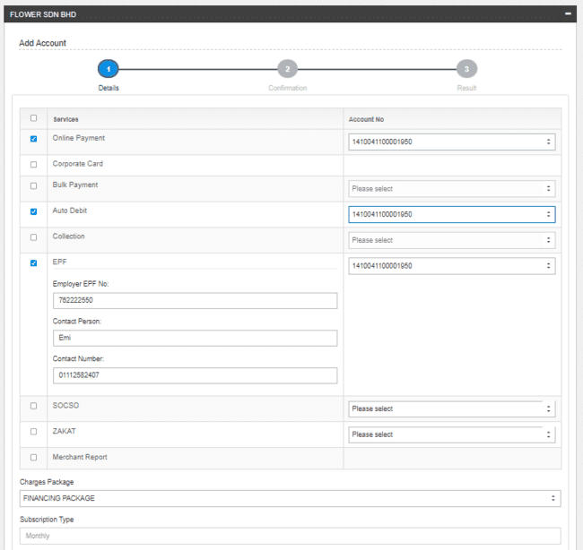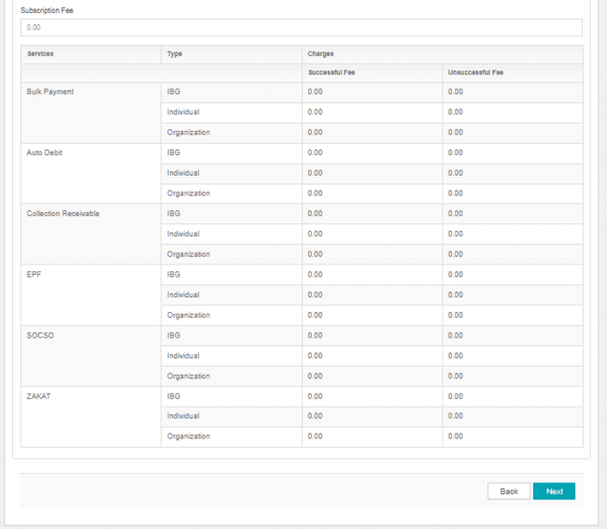

Figure 33: Add Account & Services Screen

**Input Specification:**

| **No** | **Field** | **Field Type** | **Rule** | **Description** | **Required** |
| --- | --- | --- | --- | --- | --- |
|  | Services | Check Box | N/A | To tick on the CDB services selected by Organization.   1. Online Payment 2. Corporate Card 3. Bulk Payment 4. Auto Debit 5. Collection 6. Statutory Body (Only available if select at least one service) 7. EPF (Only available if select Statutory Body) 8. SOCSO (Only available if select Statutory Body) 9. ZAKAT (Only available if select Statutory Body) 10. Merchant Report | Yes |
|  | Account No | Dropdown list | N/A | Contains list of account for the services. | Yes for all services (except Bulk Payment) |
|  | Employer EPF No | Text | Max Length:9  Numeric | Organization’s employer EPF number | No |
|  | Contact Person | Text | Max length:64  Alphabet & Symbol space @ - . / | Contact person name | No |
|  | Contact Number | Text | Max length:11  numeric | Contact person number | No |
|  | Charges Package | Dropdown List | N/A | Package for charges | Yes |

Table 49: Edit Services Input Specification

**Action:**

| **No** | **Action** | **Type** | **Description** |
| --- | --- | --- | --- |
|  | Next | Button | Contains an action to display Add Account & Services Confirmation screen. |
|  | Back | Button | Contain and action display back on previous page. |

Table 50: Add Account & Services Action

***Step 3:***

1. IBAM system display **Services and Charges** Confirmation Screen.
2. UKB click on “**Confirm**” button

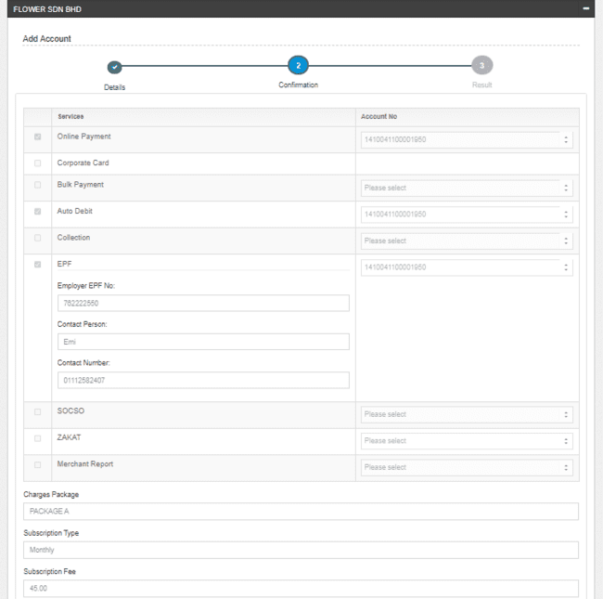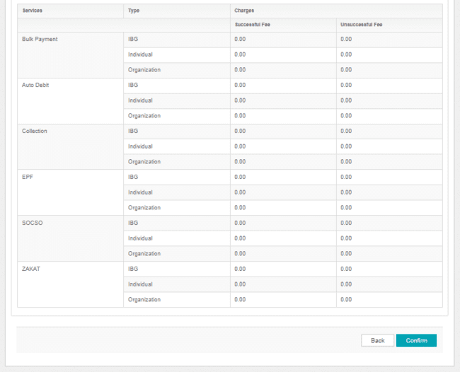

Figure 34: Add Account & Services Confirmation Screen

**Action:**

| **No** | **Action** | **Type** | **Description** |
| --- | --- | --- | --- |
|  | Confirm | Button | Contains an action to display Add Account & Services Result screen. |
|  | Back | Button | Contain an action to display back on previous page. |

Table 51: Add Account Confirmation Action

***Step 4:***

1. IBAM System validates and save the changes to IB Database and displays result page.
2. IBAM shows Successful message and pending for Authorization approval process.

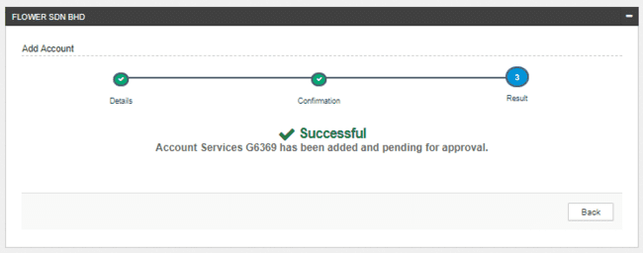

Figure 35: Add Account & Services

If User Maintenance Module Maker Checker Permission set as ‘Disable’

1. IBAM saves the update information and display the successful result page.
2. IBAM shows Successful message and will shows update information without any approval process.

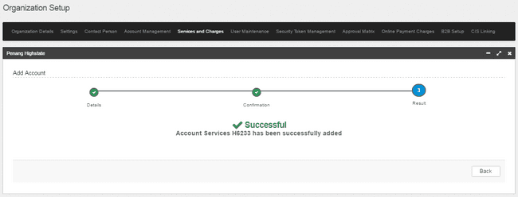

Figure 36: Add Account & Services with disable Checker Maker Permission

**Display Fields:**

|  |  |  |  |
| --- | --- | --- | --- |
| **No** | **Field** | **Format** | **Description** |
|  | Result Step | Alphanumeric | To display result step |
|  | Status | Alpha numeric | To display result status. |
|  | Result Message | Alpha numeric | To display result message. |

**Action:**

|  |  |  |  |
| --- | --- | --- | --- |
| **No** | **Action** | **Type** | **Description** |
|  | Back | Button | Contains an action to display Account & Services main screen. |

# User Maintenance

This feature allows IBAM UKB (IBAM UKB ) to view and edit CDB users (with role Corporate UKB (CA)) within a specific Organization.

### Create Organization User

This feature allows IBAM UKB (IBAM UKB ) to create CDB users (role Corporate Admin only) within a specific Organization.

#### Process Flow



Diagram 10: Create Organization User Process Flow Diagram

#### Screen Flow

***Step 1:***

1. UKB clicks on **Organization Setup** navigation at the left side of the screen.
2. UKB clicks on **“Pencil”** icon button on the selected Organization.

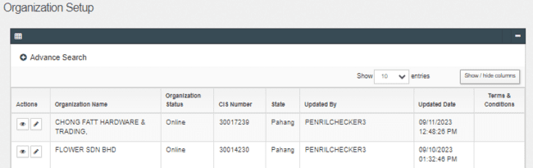Figure37: Organization Setup Screen

**Action:**

| **No** | **Action** | **Type** | **Description** |
| --- | --- | --- | --- |
|  | “Pencil” icon | Button | Contain the action to display the selected Organization details |
|  | “Eye” icon | Button | Contain the action to display the selected Organization details |

Table 52: Organization Setup Action

***Step 2:***

1. UKB clicks on the **User Maintenance** tab.
2. IBAM shows the list of registered user under that Organization
3. UKB clicks on the **“Create”**  button.

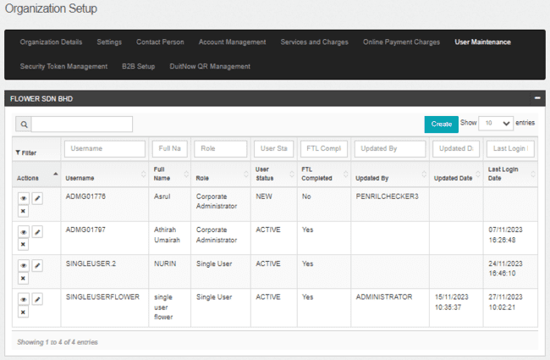

Figure 38: User Maintenance List Screen

**Action:**

| **No** | **Action** | **Type** | **Description** |
| --- | --- | --- | --- |
|  | “Create” | Button | Contain the action to display Create User page |

Table 53: User Maintenance Action

***Step 3:***

1. IBAM display the Create User - Select screen.
2. UKB User only allow to create Corporate Administrator.

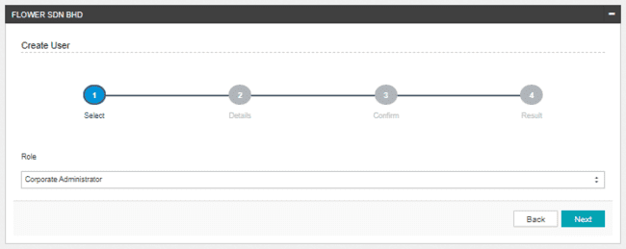Figure 39: Create User - Select Screen

**Input Specifications:**

| **No** | **Field** | **Field Type** | **Rule** | **Description** | **REQUIRED** |
| --- | --- | --- | --- | --- | --- |
|  | Role | Dropdown List | N/A | Only allow to create CA role | M |

Table 54: Create User - Select Screen Input Specification

**Action:**

|  |  |  |  |
| --- | --- | --- | --- |
| **No** | **Action** | **Type** | **Description** |
|  | Next | Button | Contains an action to display Create User – Details screen |
|  | Back | Button | Contain an action to display back on previous screen. |

Table 55: Create User - Select Screen Action

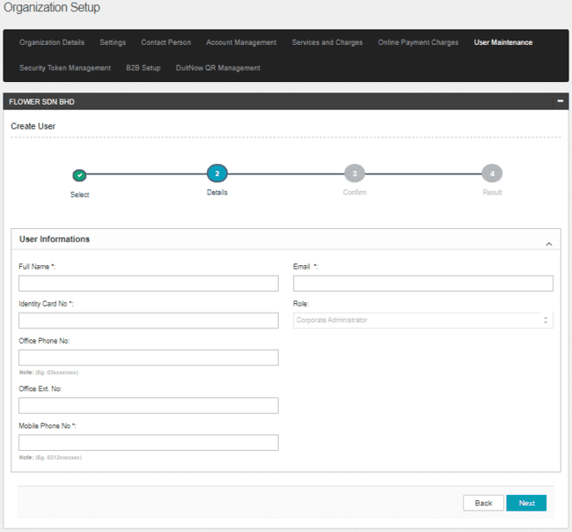

Figure 40: Create User – Details Screen

**Input Specifications:**

| **No** | **Field** | **Field Type** | **Rule** | **Description** | **REQUIRED** |
| --- | --- | --- | --- | --- | --- |
| 1. | Full Name | Text | Max length: 50  Alphanumeric with space @ - . / | User’s Full name | M |
|  | Identity Card No | Text | Max length: 20 Numeric | User Identity Card number | M |
|  | Office Phone No. | Text | Match length:13 Numeric | The user’s office phone number | M |
|  | Office Ext No | Text | Max length: 6 Numeric | The user’s phone extension no | O |
|  | Mobile No. | Text | Match length:13 Numeric | The user’s mobile number | M |
|  | Email | Text | Max length: 50  Alpha, numeric, and/or Text combination as long contain this format: <value>@<value>.<value> | The user’s email address | M |

Table 56: Create User – Details Screen Input Specification

**Display Fields:**

|  |  |  |  |
| --- | --- | --- | --- |
| **No** | **Field** | **Format** | **Description** |
|  | Role | Text | To display the role for the created user. |

Table 57: Create User – Details Screen Display Fields

**Action:**

| **No** | **Action** | **Type** | **Description** |
| --- | --- | --- | --- |
|  | Next | Button | Contain the action to display Create User - Confirm page |
|  | Back | Button | Contain the action to display back on previous screen. |

Table 58: Create User – Details Screen Action

***Step 4:***

1. IBAM display the Create User – Confirm page.

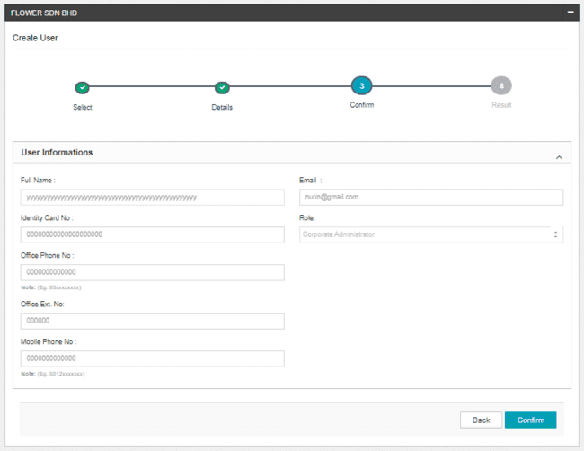

Figure 41: Create User– Confirm Screen

**Action:**

| **No** | **Action** | **Type** | **Description** |
| --- | --- | --- | --- |
|  | Confirm | Button | Contain the action to display Create User – Result page |
|  | Back | Button | Contain the action to display back on previous screen. |

Table 59: Create User– Confirm Screen Action

***Step 5:***

1. IBAM System validates and save the changes to IB Database and displays result page.
2. IBAM shows Successful message and pending for Authorization approval process.

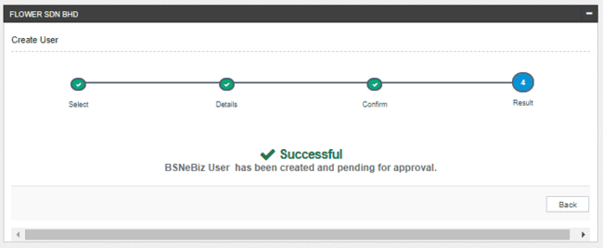

Figure 42: Edit User Details – Result screen

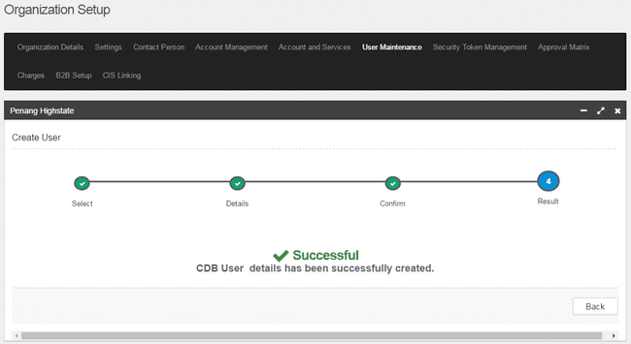

Figure43: Edit User Details – Result Screen with disable Checker Maker Permission

**Display Fields:**

|  |  |  |  |
| --- | --- | --- | --- |
| **No** | **Field** | **Format** | **Description** |
|  | Result Step | Alphanumeric | To display result step |
|  | Status | Alpha numeric | To display result status. |
|  | Result Message | Alpha numeric | To display result message. |

Table 60: Edit User Details – Result Screen Display Field

**Action:**

|  |  |  |  |
| --- | --- | --- | --- |
| **No** | **Action** | **Type** | **Description** |
|  | Back | Button | Contains an action to User Maintenance main page |

Table 61: Edit User Details – Result Screen Action

### Edit Organization User

This feature allows IBAM UKB (IBAM UKB ) to edit CDB users within a specific Organization.

#### Process Flow



Diagram 11: Edit Organization User Process Flow Diagram

#### Screen Flow

***Step 1:***

1. UKB clicks on **Organization Setup** navigation at the left side of the screen.
2. UKB clicks on **“Pencil”** icon button on the selected Organization.

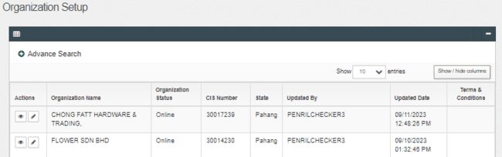Figure 44: Organization Setup Screen

**Action:**

| **No** | **Action** | **Type** | **Description** |
| --- | --- | --- | --- |
|  | “Pencil” icon | Button | Contain the action to edit the selected Organization details |
|  | “Eye” icon | Button | Contain the action to display the selected Organization details |

Table 62: Organization Setup Action

***Step 2:***

1. UKB clicks on the **User Maintenance** tab.
2. IBAM shows the list of registered user under that Organization
3. UKB clicks on the **“pencil’** icon button.

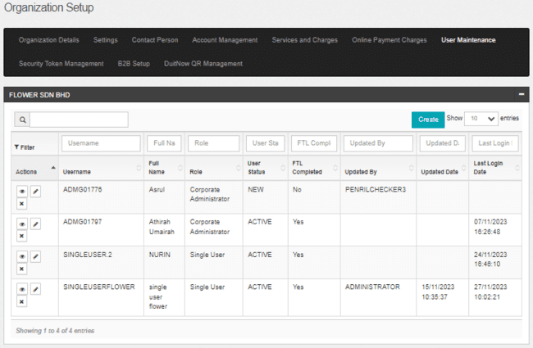

Figure 45: User Maintenance List Screen

**Action:**

| **No** | **Action** | **Type** | **Description** |
| --- | --- | --- | --- |
|  | “Pencil” icon | Button | Contain the action to display Edit User Details page |

Table 63: User Maintenance Action

***Step 3:***

1. IBAM display the Edit User Detail screen.
2. For Corporate User role, UKB User can choose either to edit in **User Information**, **Allow Service** or **Accessable Account**.
3. For Corporate UKB role, UKB User only can edit in **User Information**.

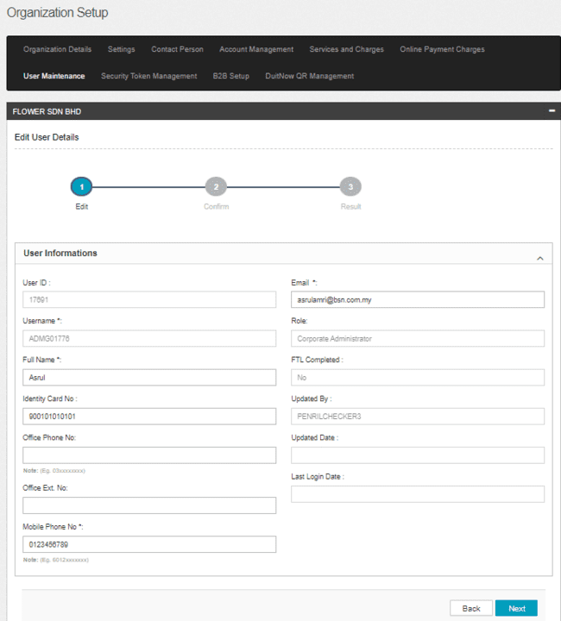

Figure 46: Edit User Details (User Information) Screen

**Display Fields:**

|  |  |  |  |
| --- | --- | --- | --- |
| **No** | **Field** | **Format** | **Description** |
|  | User ID | Text | Display the User ID for the selected user. |
|  | Username | Text | Display the Username for the selected user. |
|  | Role | Text | Display the role for the selected user. |
|  | FTL Completed | Text | Display the FTL status for the selected user. |
|  | Updated By | Text | Display the Username that updated the selected user. |
|  | Updated Date | Text | Display the Updated Date for the selected user. |
|  | Last Login Date | Text | Display the Last Login Date for the selected user. |

Table 64: Edit User Details Screen Display Field

**Input Specifications:**

| **No** | **Field** | **Field Type** | **Rule** | **Description** | **REQUIRED** |
| --- | --- | --- | --- | --- | --- |
|  | Full Name | Text | Max length: 64  Alphanumeric with Space | User’s Full name | M |
|  | Identity Card No | Text | Max length: 20 | User’s ID number | M |
|  | Office Phone No. | Text | Match length: 13  Numeric | The user’s office phone number | O |
|  | Office Ext. No | Text | Max length: 6 Numeric | The user’s phone extension no | O |
|  | Mobile Phone No. | Text | Match length: 13 Numeric | The user’s mobile number | M |
|  | Email Address | Text | Max length: 50  Alpha, numeric, and/or Text combination as long contain this format: <value>@<value>.<value> | The user’s email address | M |

Table 65: Edit User Details Screen Input Specification

**Action:**

| **No** | **Action** | **Type** | **Description** |
| --- | --- | --- | --- |
|  | Next | Button | Contain the action to display Edit User - Confirm page |
|  | Back | Button | Contain the action to display back on previous screen. |

Table 66: Edit User Details Action

***Step 4:***

1. IBAM display the Edit User – Confirm page.

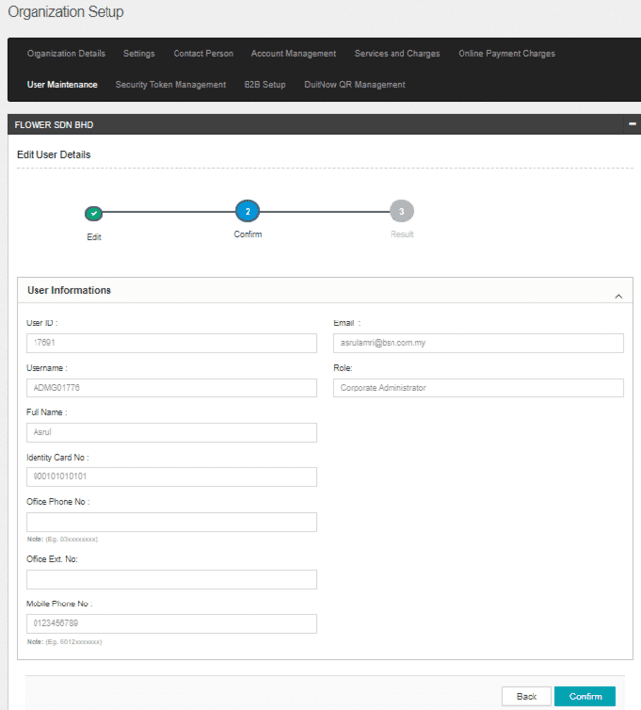

Figure 47: Edit User Details - Confirm Screen

**Action:**

| **No** | **Action** | **Type** | **Description** |
| --- | --- | --- | --- |
|  | Confirm | Button | Contain the action to display Edit User - Result page. |
|  | Back | Button | Contain the action to display back on previous screen. |

Table 67: Edit User Details Action

***Step 5:***

1. IBAM System validates and save the changes to IB Database and displays result page.
2. IBAM shows Successful message and pending for Authorization approval process.

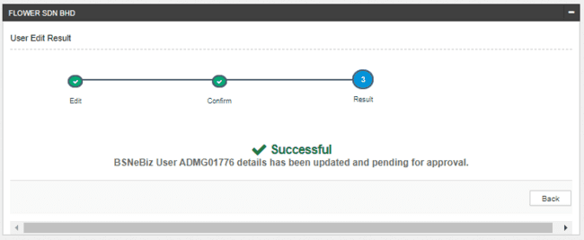

Figure 48 : Edit User - Result Screen

If User Maintenance Module Maker Checker Permission set as ‘Disable’

1. IBAM saves the update information and display the successful result page.
2. IBAM shows Successful message and will shows update information without any approval process.

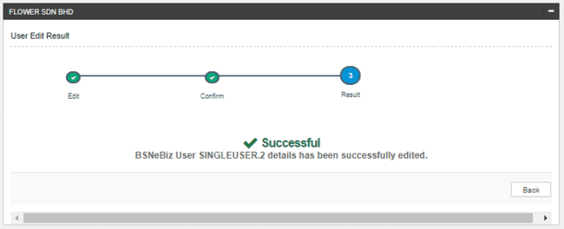

Figure 49 : Edit User - Result Screen with disable Checker-Maker Permission

**Display Fields:**

|  |  |  |  |
| --- | --- | --- | --- |
| **No** | **Field** | **Format** | **Description** |
|  | Result Step | Alphanumeric | To display result step |
|  | Status | Alpha numeric | To display result status. |
|  | Result Message | Alpha numeric | To display result message. |

Table 68: Edit User – Result Screen Display Field

**Action:**

|  |  |  |  |
| --- | --- | --- | --- |
| **No** | **Action** | **Type** | **Description** |
|  | Back | Button | Contains an action to User Maintenance main page |

Table 69: Edit User – Result Screen Action

### Delete Organization User

This feature allows IBAM UKB to delete CDB users within a specific Organization.

#### Process Flow

Diagram 12: Delete Organization User Process Flow Diagram

#### Screen Flow

***Step 1:***

1. UKB clicks on **“x”** button.

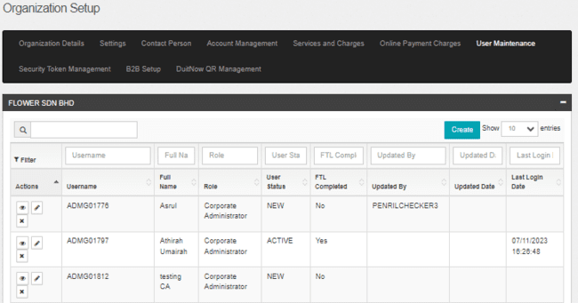

Figure 50 : User Maintenance Screen

**Action:**

| **No** | **Action** | **Type** | **Description** |
| --- | --- | --- | --- |
| 1. | “X” icon | Button | Contain the action to Delete User – Confirm page |

Table 70: Delete Organization User Confirmation Action

***Step 2:***

1. IBAM display Delete User confirmation page.
2. UKB clicks on **Confirm** button.

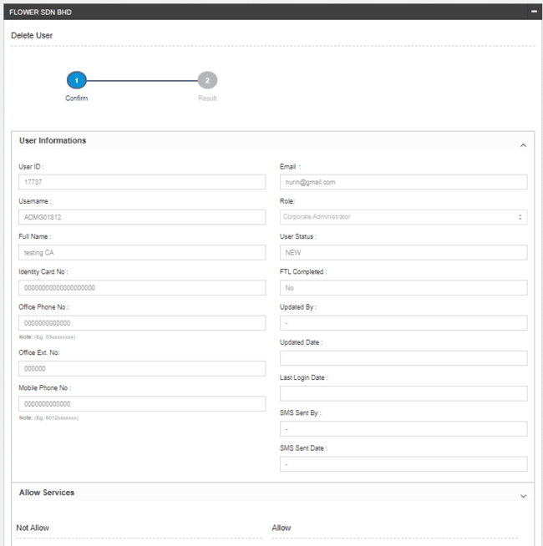

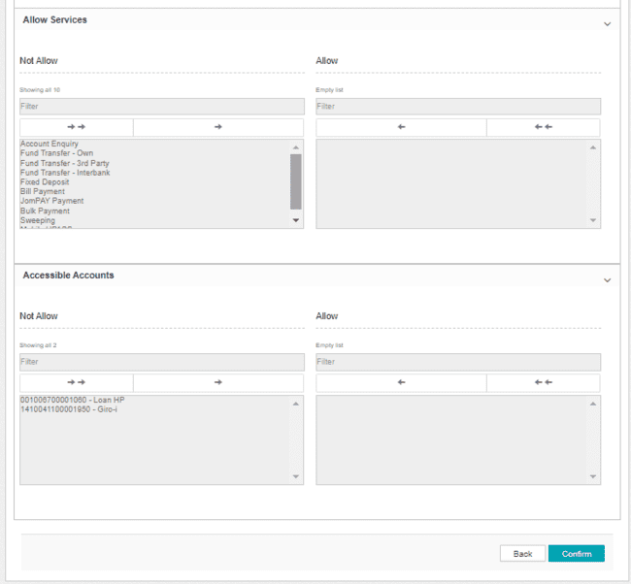

Figure 51 : Delete Organization User Confirmation Screen

**Action:**

| **No** | **Action** | **Type** | **Description** |
| --- | --- | --- | --- |
| 1. | Confirm | Button | Contain the action to Delete User – Result page. |
| 2. | Back | Button | Goes back to User Maintenance page. |

Table 71: Delete Organization User Confirmation Action

***Step 2:***

1. IBAM System validates and save the changes to IB Database and displays result page.
2. IBAM shows Successful message and pending for Authorization approval process.

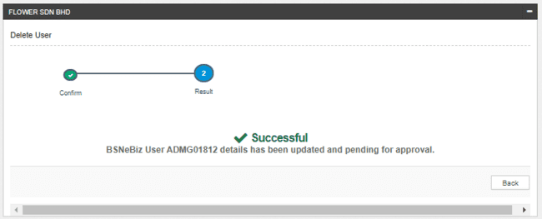

Figure 52 : Delete Organization User Result Screen

If User Maintenance Module Maker Checker Permission set as ‘Disable’

1. IBAM saves the update information and display the successful result page.
2. IBAM shows Successful message and will shows update information without any approval process.

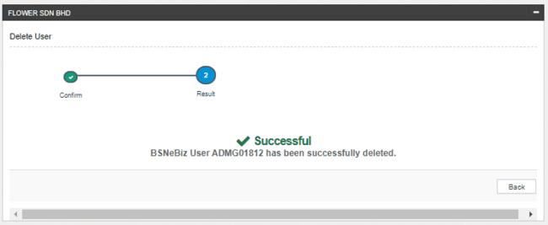

Figure 53 : Delete Organization User Result Screen with disable Checker-Maker Permission

**Display Fields:**

|  |  |  |  |
| --- | --- | --- | --- |
| **No** | **Field** | **Format** | **Description** |
|  | Result Step | Alphanumeric | To display result step |
|  | Status | Alpha numeric | To display result status. |
|  | Result Message | Alpha numeric | To display result message. |

Table 72: Delete User– Result Screen Display Field

**Action:**

|  |  |  |  |
| --- | --- | --- | --- |
| **No** | **Action** | **Type** | **Description** |
|  | Back | Button | Contains an action to User Maintenance main page |

Table 73: Delete User– Result Screen Action

### Block Organization User

This feature allows IBAM UKB to block CDB users within a specific Organization.

#### Process Flow

Diagram 13: Block Organization User Process Flow Diagram

#### Screen Flow

***Step 1:***

1. On User Maintenance page, user clicks on “**eye**” icon button.
2. IBAM system displays the User Details page.
3. UKB click on “**Block**” button.

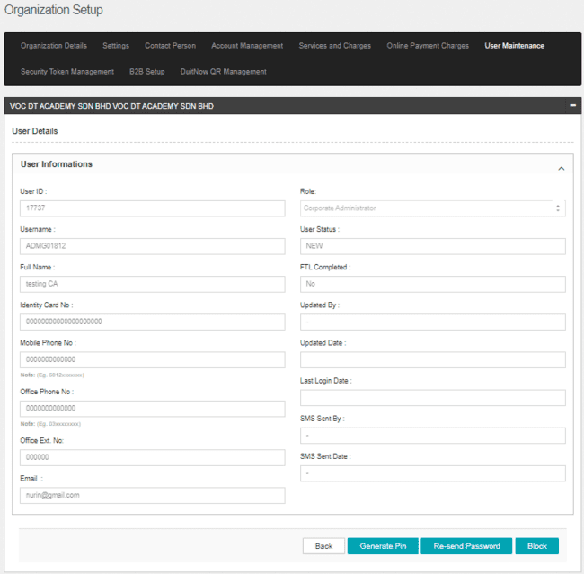

Figure 54 : User Details - Block Screen

**Action:**

| **No** | **Action** | **Type** | **Description** |
| --- | --- | --- | --- |
| 1. | Block | Button | Contain the action to display confirmation message pop up. |

Table 74: User Details – Block Action

***Step 2:***

1. IBAM display confirmation screen.

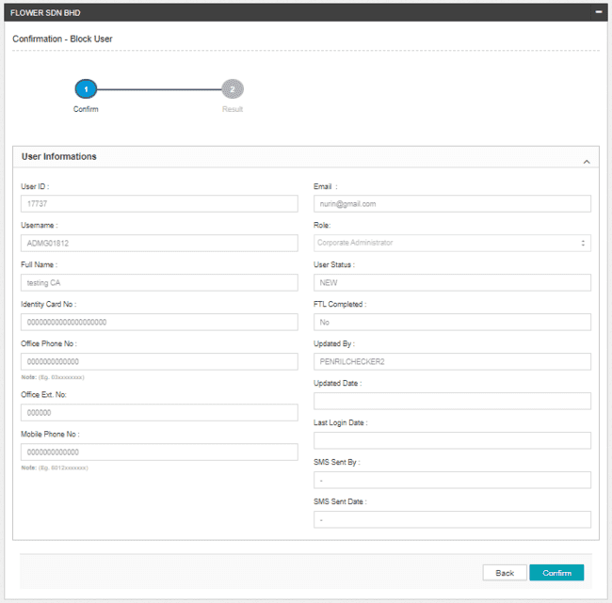

Figure 55: Block User Confirmation Pop up Screen

**Action:**

| **No** | **Action** | **Type** | **Description** |
| --- | --- | --- | --- |
| 1. | Confirm | Button | Contain the action to Block the Organization user and display the result screen. |
| 2. | Back | Button | Contain the action to display back to Organization user details page. |

Table 75: Block User Confirmation Screen Action

***Step 3:***

1. IBAM System validates and save the changes to IB Database and displays result page.
2. IBAM shows Successful message and pending for Authorization approval process.

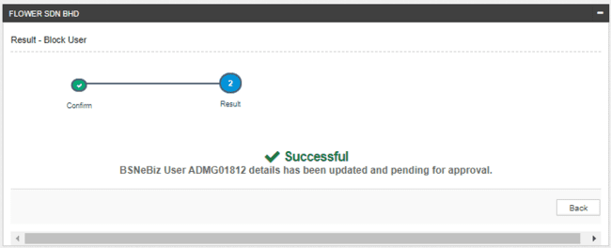

Figure 56: Block Organization – Result Screen

If User Maintenance Module Maker Checker Permission set as ‘Disable’

1. IBAM saves the update information and display the successful result page.
2. IBAM shows Successful message and will shows update information without any approval process.

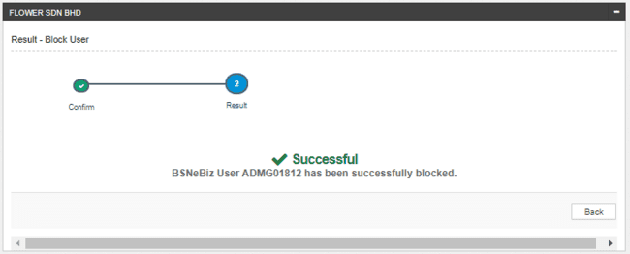

Figure 57: Block Organization – Result Screen with disable Checker Maker Permission

**Display Fields:**

|  |  |  |  |
| --- | --- | --- | --- |
| **No** | **Field** | **Format** | **Description** |
|  | Result Step | Alphanumeric | To display result step |
|  | Status | Alpha numeric | To display result status. |
|  | Result Message | Alpha numeric | To display result message. |

Table 76: Block User– Result Screen Display Field

**Action:**

|  |  |  |  |
| --- | --- | --- | --- |
| **No** | **Action** | **Type** | **Description** |
|  | Back | Button | Contains an action to User Maintenance main page |

Table 77: Block User– Result Screen Action

### Activate Organization User

This feature allows IBAM UKB to activate CDB users within a specific Organization. Active button only display for user with status:

* Blocked

#### Process Flow

Diagram 14: Activate Organization User Process Flow Diagram

#### Screen Flow

***Step 1:***

1. On User Maintenance page, user clicks on “eye” icon button.
2. IBAM system displays the User Details page.
3. UKB click on “Activate” button.

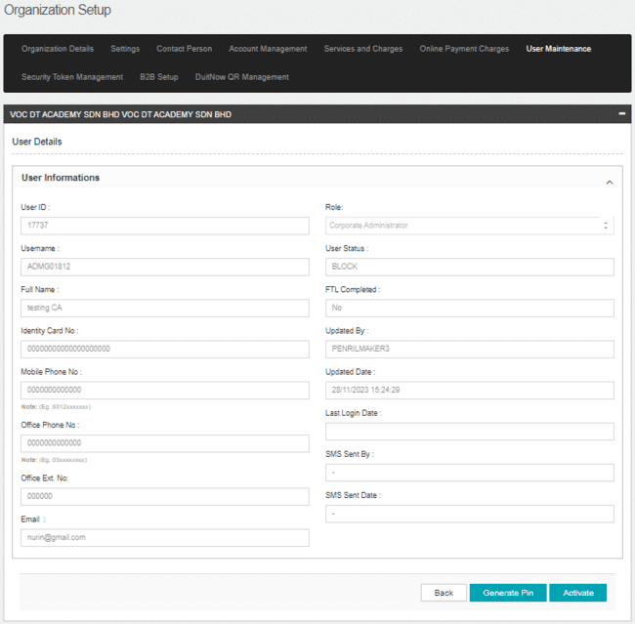Figure 58: User Details Screen

**Action:**

| **No** | **Action** | **Type** | **Description** |
| --- | --- | --- | --- |
| 1. | Activate | Button | Contain the action to display confirmation message pop up. |

Table 78: User Details Action

***Step 2:***

1. IBAM display confirmation screen

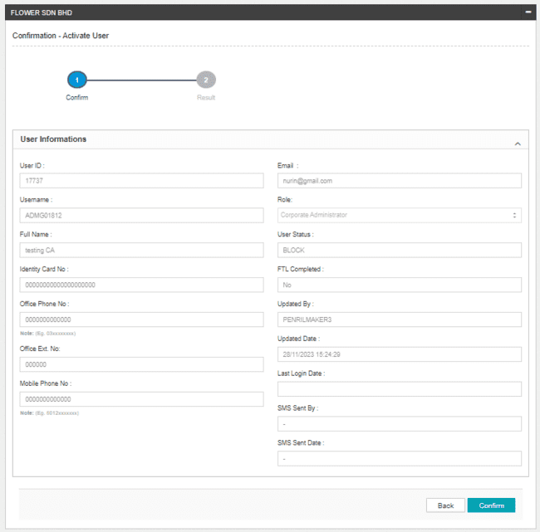

Figure59: Activate User Confirmation Pop up Screen

**Action:**

| **No** | **Action** | **Type** | **Description** |
| --- | --- | --- | --- |
| 1. | Confirm | Button | Contain the action to activate the Organization user. |
| 2. | Back | Button | Contain the action display back to Organization user details page. |

Table 79: Activate User Confirmation Screen Action

***Step 3:***

1. IBAM System validates and save the changes to IB Database and displays result page.
2. IBAM shows Successful message and pending for Authorization approval process.

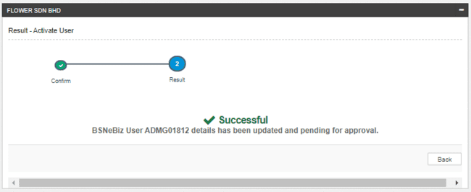

Figure 60: Activate User – Result Screen

If User Maintenance Module Maker Checker Permission set as ‘Disable’

1. IBAM saves the update information and display the successful result page.
2. IBAM shows Successful message and will shows update information without any approval process.

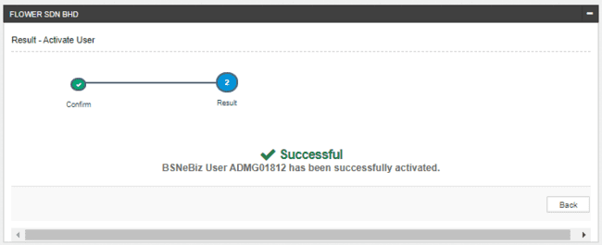

Figure 61: Activate User – Result Screen with disable Checker Maker Permission

**Display Fields:**

|  |  |  |  |
| --- | --- | --- | --- |
| **No** | **Field** | **Format** | **Description** |
|  | Result Step | Alphanumeric | To display result step |
|  | Status | Alpha numeric | To display result status. |
|  | Result Message | Alpha numeric | To display result message. |

Table 80: Activate User– Result Screen Display Field

**Action:**

|  |  |  |  |
| --- | --- | --- | --- |
| **No** | **Action** | **Type** | **Description** |
| 1. | Back | Button | Contains an action to User Maintenance page |

Table 81: Activate User– Result Screen Action

### Unlock Organization User

This feature allows IBAM UKB to unlock CDB users within a specific Organization. “Unlock” button only display for user with status:

* Locked

#### Process Flow



Diagram 15: Activate Organization User Process Flow Diagram

#### Screen Flow

***Step 1:***

1. On User Maintenance page, user clicks on “eye” icon button.
2. IBAM system displays the User Details page.
3. UKB click on “Unlock” button.

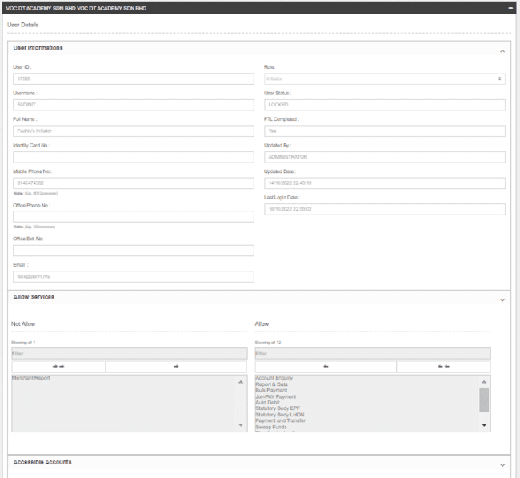

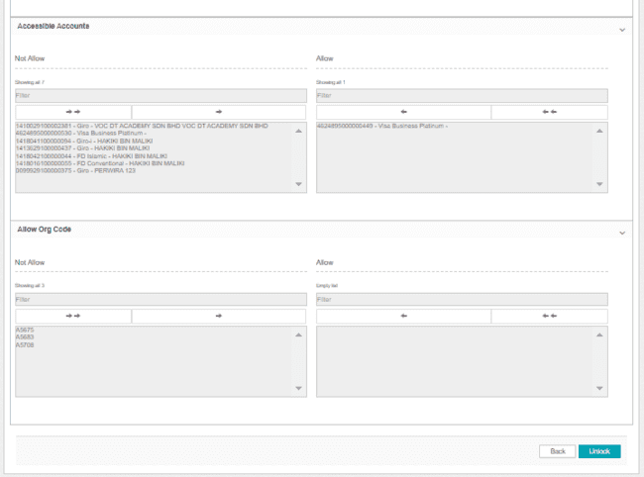

Figure 62: User Details Screen

**Action:**

| **No** | **Action** | **Type** | **Description** |
| --- | --- | --- | --- |
| 1. | Unlock | Button | Contain the action to display unlock confirmation screen. |

Table 82: User Details Action

***Step 2:***

1. IBAM display unlock confirmation screen.

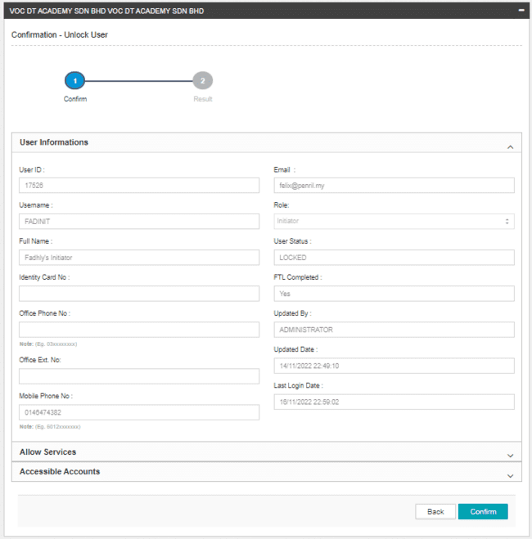

Figure 63: Unlock User Confirmation Screen

**Action:**

| **No** | **Action** | **Type** | **Description** |
| --- | --- | --- | --- |
| 1. | Confirm | Button | Contain the action to display the activate result screen. |
| 2. | Back | Button | Contain an action display back to Organization user details page. |

Table 83: Unlock User Confirmation Screen Action

***Step 3:***

1. IBAM System validates and save the changes to IB Database and displays result page.
2. Status will change to “Unlocked”.
3. IBAM shows Successful message and pending for Authorization approval process.

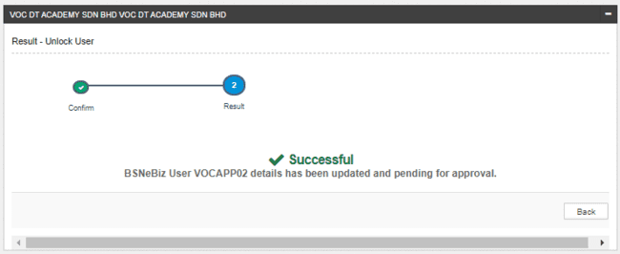

Figure 64: Unlock User – Result Screen

If User Maintenance Module Maker Checker Permission set as ‘Disable’

1. IBAM saves the update information and display the successful result page.
2. IBAM shows Successful message and will shows update information without any approval process.

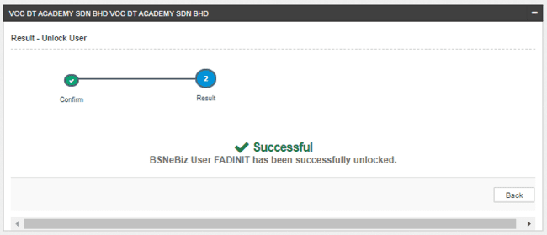

Figure 65: Unlock User – Result Screen with disable Checker Maker Permission

**Display Fields:**

|  |  |  |  |
| --- | --- | --- | --- |
| **No** | **Field** | **Format** | **Description** |
|  | Result Step | Alphanumeric | To display result step |
|  | Status | Alpha numeric | To display result status. |
|  | Result Message | Alpha numeric | To display result message. |

Table 84: Activate User– Result Screen Display Field

**Action:**

|  |  |  |  |
| --- | --- | --- | --- |
| **No** | **Action** | **Type** | **Description** |
|  | Back | Button | Contains an action to User Maintenance page |

Table 85: Activate User– Result Screen Action

### Re-send Password

This feature allows IBAM UKB to re-send password for CDB users within a specific Organization. “Re-send” button only display for user with status:

* New
* Active
* Unlocked

#### Process Flow



Diagram 16: Re-send Password for Organization User Process Flow Diagram

#### Screen Flow

***Step 1:***

1. In User Maintenance page, user clicks on “**eye**” icon button.
2. IBAM system displays the User Details page.
3. UKB clicks on the “**Re-send Password**” button.

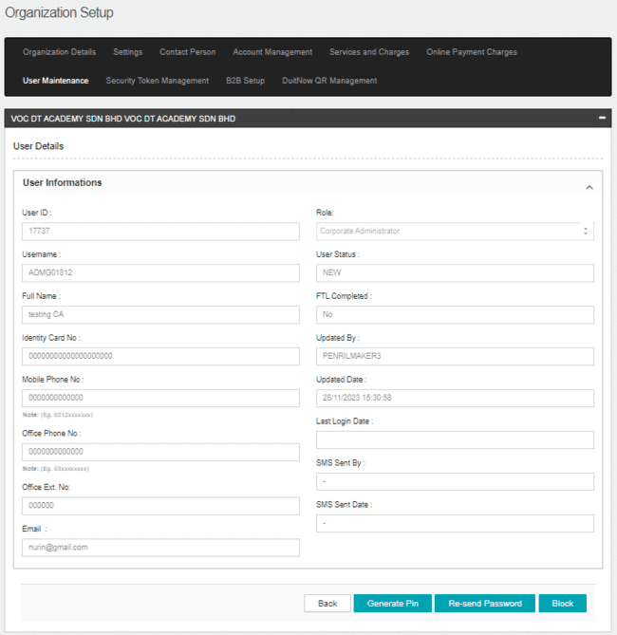

Figure 66: User Details Screen

**Action:**

| **No** | **Action** | **Type** | **Description** |
| --- | --- | --- | --- |
| 1. | Re-send Password | Button | Contain the action to display Organization Setup page. |

Table 86: User Details Action

***Step 2:***

1. IBAM system displays the Confirmation page.
2. UKB user clicks on the “Confirm” button to confirm action or “Back” button to return to the previous page.

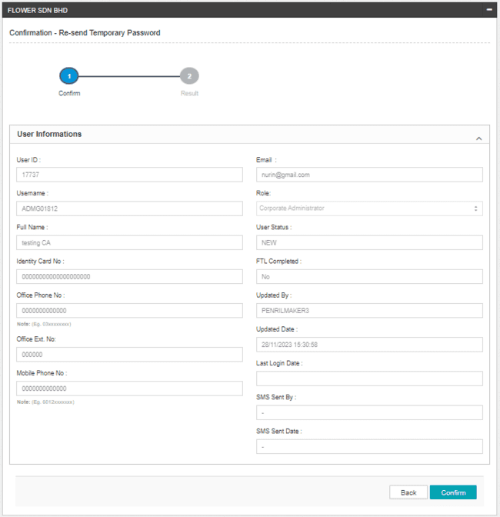

Figure 67: Re-send Password Confirmation Page

**Action:**

| **No** | **Action** | **Type** | **Description** |
| --- | --- | --- | --- |
|  | Confirm | Button | Contains an action that confirms the action and display the result screen. |
|  | Back | Button | Contain an action to display back on previous screen. |

Table 87: Organization Setup – Generate Pin Action

***Step 3:***

1. IBAM System displays result page and send the temporary password via email (after approved).
2. IBAM shows Successful message.

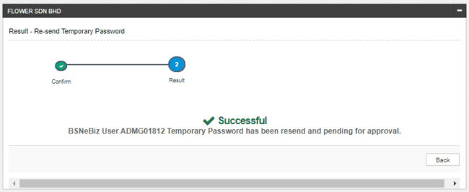

Figure 68: Re-send Password Result Screen

If User Maintenance Module Maker Checker Permission set as ‘Disable’

1. IBAM saves the update information and display the successful result page.
2. IBAM shows Successful message and will shows update information without any approval process.

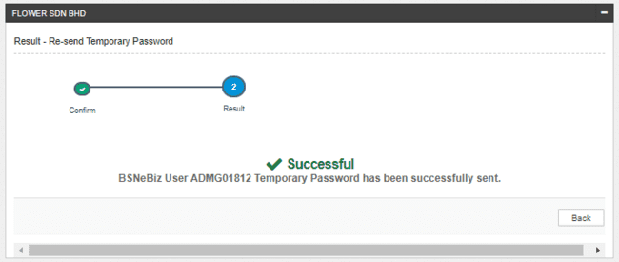

Figure 69: Re-send Password with disable Checker Maker Permission Result Screen

**Display Fields:**

| **No** | **Field** | **Format** | **Description** |
| --- | --- | --- | --- |
|  | Result Step | Alphanumeric | To display result step |
|  | Result Message | Alpha numeric | To display result message. |

Table 88: Re-send Password - Result Display Field

**Action:**

|  |  |  |  |
| --- | --- | --- | --- |
| **No** | **Action** | **Type** | **Description** |
|  | Back | Button | Contains an action to Organization Setup page |

Table 89: Re-send Password – Result Action

# Security Token Management

This feature allows IBAM UKB (IBAM UKB ) to view, add and edit secured pass to the Organization. Secured pass is used by an Approver to generate OTP for validation & authorization of a transaction.

### Add Security Token

This function allows IBAM UKB to add new secured token to the Organization.

#### Process Flow



Diagram 17: Add Secure Pass List Process Flow Diagram

#### Screen Flow

***Step 1:***

1. UKB clicks on the **Security Token Management** tab
2. IBAM system shows the list of Secured Pass assigned to Organization
3. UKB clicks on **Add** button

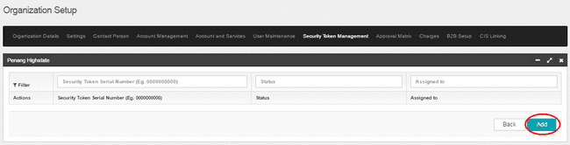

Figure 70: Security Token Management Screen

**Action:**

| **No** | **Action** | **Type** | **Description** |
| --- | --- | --- | --- |
|  | Add | Button | Contains an action to display Add New Security Token – Details screen. |
|  | Back | Button | Contain an action to display the Organization Setup screen. |

Table 90: Security Token Management Screen Action

***Step 2:***

1. IBAM system shows Add New Security Token – Details screen.
2. UKB keys in the secure pass serial number.
3. UKB clicks on the **Next** button.
4. IBAM system display the Confirmation screen.

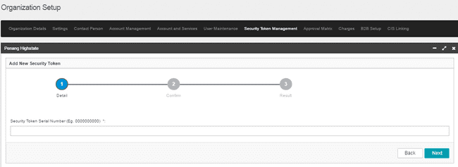

Figure 71: Add New Security Token – Details Screen

**Input Specifications:**

| **No** | **Field** | **Field Type** | **Rule** | **Description** | **Required** |
| --- | --- | --- | --- | --- | --- |
| 1 | Serial Number | Text | Max length: 10  Numeric | The serial number of the secured pass to be added to the Organization. This serial number can be found at the back of the secured pass/token | Yes |

Table 91: Add New Security Token – Details Screen Input Specification

**Action:**

| **No** | **Action** | **Type** | **Description** |
| --- | --- | --- | --- |
|  | Next | Button | Contain an action to display the confirmation screen. |
|  | Back | Button | Contain an action to display back on previous screen. |

Table 92: Add New Security Token – Details Screen Action

**List of available messages for the screen:**

| **No.** | **Event** | **Error Description in English** |
| --- | --- | --- |
| 1. | Fill in Secure Pass Serial Number field with alphabet and/or special characters | Security Token XXXXXXXXXX is not numeric |
| 2. | Did not fill in the required field. | Security Token serial number cannot be empty. |
| 3. | Fill in Security Token Serial Number with less than 10 character | The length of the Security Token must be 10 digits. |

Table 93: Add New Security Token – Details Screen Error Message

***Step 3:***

1. IBAM system shows Add New Security Token – Confirm screen.
2. UKB clicks on the **Confirm** button.
3. IBAM save changes to IB Database and display the result screen to the UKB .

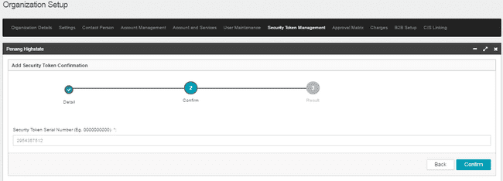

Figure 72: Add New Security Token – Confirm Screen

**Action:**

| **No** | **Action** | **Type** | **Description** |
| --- | --- | --- | --- |
|  | Confirm | Button | Contain an action save changes to IB Database and display the result screen. |
|  | Back | Button | Contain an action to display back on previous screen. |

Table 94: Add New Security Token – Confirm Screen Action

***Step 4:***

1. IBAM System displays result page.
2. IBAM shows Successful message.

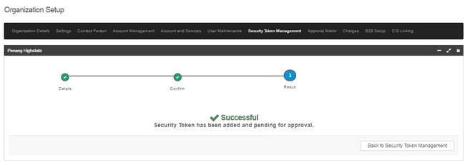

Figure 73: Add New Security Token –Result Screen

If User Maintenance Module Maker Checker Permission set as ‘Disable’

1. IBAM saves the update information and display the successful result page.
2. IBAM shows Successful message and will shows update information without any approval process.

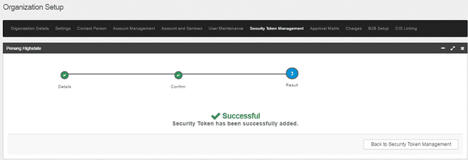

Figure 74: Add New Security Token –Result with disable Checker Maker Permission Screen

**Display Fields:**

| **No** | **Field** | **Format** | **Description** |
| --- | --- | --- | --- |
|  | Result Step | Alphanumeric | To display result step |
|  | Result Message | Alpha numeric | To display result message. |

Table 95: Add New Security Token –Result Display Field

**Action:**

|  |  |  |  |
| --- | --- | --- | --- |
| **No** | **Action** | **Type** | **Description** |
|  | Back to Security Token Management | Button | Contains an action to Security Token Management screen. |

Table 96: Add New Security Token –Result Action

### View & Update Security Token Details

This function allows IBAM UKB to view the existing secured pass assigned to the Organization.

#### Process Flow



Diagram 18: View &Update Security Token Process Flow Diagram

#### Screen Flow

***Step 1:***

1. UKB clicks on the **Security Token Management** tab.
2. IBAM system shows the list of Secured Pass assigned to Organization.
3. IBAM UKB view the Security Token details by enter Security Token Serial Number, Status, and Assigned To.
4. UKB user click on “eye” icon button to display the Security Token details.

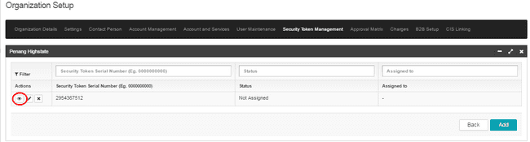

Figure 75: Security Token Management Screen

**Display Specifications:**

| **No** | **Field** | **Description** |
| --- | --- | --- |
|  | Security Token Serial Number | The serial number of secured pass |
|  | Status | The status of the secured pass, Possible values:   1. Not assigned 2. Assigned 3. Faulty |
|  | Assigned To | The secured pass owner name, if the status is “Assigned” |

Table 97: Security Token Management Screen Display Fields

**Action:**

| **No** | **Action** | **Type** | **Description** |
| --- | --- | --- | --- |
|  | “Eye” icon | Button | Contains an action to display the Security Token Details page. |

Table 98: Security Token Management Screen Action

***Step 2:***

1. IBAM system displays the Security Token Details page.
2. UKB click on **“Update”**  button.
3. Update Security Token also can be done by click on “Pencil” icon at Security Token Management screen.

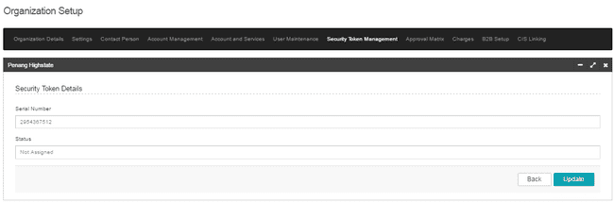

Figure 76: Security Token Details Screen

**Display Specifications:**

| No | Field | Description |
| --- | --- | --- |
|  | Serial Number | The serial number of secured pass |
|  | Status | The status of the secured pass, Possible values:   1. Not assigned 2. Assigned 3. Faulty |
|  | Assigned To | The secured pass owner name, if the status is “Assigned” |

Table 99: Security Token Display Screen Display Fields

**Action:**

| **No** | **Action** | **Type** | **Description** |
| --- | --- | --- | --- |
|  | Back | Button | Contains an action to display back on Security Token Management page. |
|  | Update | Button | Contains an action to display the Edit Security Token page. |

Table 100: Security Token Details Screen Action

***Step 3:***

1. IBAM system displays the Edit Security Token page
2. UKB update the Secured Pass status to be Not Assigned, Assigned To or Faulty.

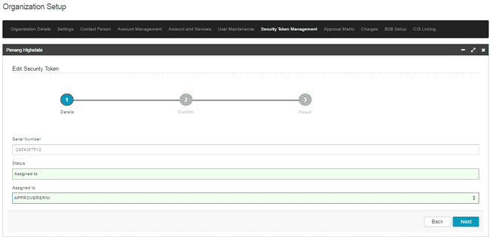

Figure 77: Edit Security Token Screen

**Input Specifications:**

| **Page** | **Field Name** | **Field Type** | **Rule** | **Description** | **Required** |
| --- | --- | --- | --- | --- | --- |
| 1 | Status | Dropdown List | One of them must be selected | The status of the secured pass.  Possible values:   * 1. Not assigned   2. Assigned to   3. Faulty * If select this, “Assigned To” will not display. * This function on display if current status = “Not Assigned”   1. Revoke * Only display if current status = “Assigned” | Yes |

Table 101: Edit Security Token Screen Input Specifications

**Action:**

| **No** | **Action** | **Type** | **Description** |
| --- | --- | --- | --- |
|  | Next | Button | Validates the submission and if successful, proceed to Confirmation page |
|  | Back | Button | Cancel the update action and display back on Security Token Management. |

Table 102: Edit Security Token Screen Action

*Step 4:*

1. IBAM system displays the Edit Security Token Confirmation page.

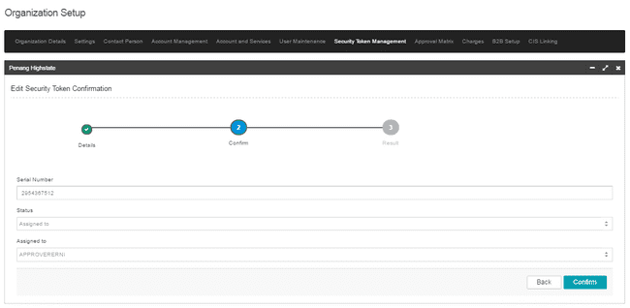

Figure 78: Edit Security Token Confirmation Screen

**Display Fields:**

|  |  |  |  |
| --- | --- | --- | --- |
| **No** | **Field** | **Format** | **Description** |
|  | Serial Number | Alphanumeric | Display the Serial Token Number |
|  | Status | Text | Display the status. |
|  | Assigned to | Text | Display the serial token number assignee username.  *\*Only display if the status is changed to “Assigned To”* |

Table 103: Security Token Confirmation Screen Display Field

**Action:**

|  |  |  |  |
| --- | --- | --- | --- |
| **No** | **Action** | **Type** | **Description** |
|  | Confirm | Button | Contains an action to Edit Security Token Result |
|  | Back | Button | Contains an action to display back on previous screen. |

Table 104: Security Token Confirmation Screen Action

*Step 5:*

1. IBAM System validates and save the changes to IB Database and displays result page.
2. IBAM shows Successful message and pending for Authorization approval process.

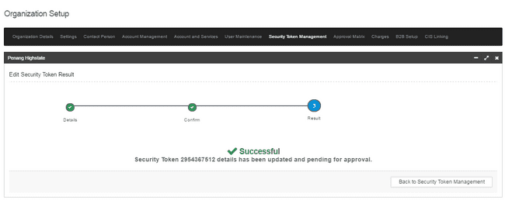

Figure 79: Edit Security Token Result Screen

If User Maintenance Module Maker Checker Permission set as ‘Disable’

1. IBAM saves the update information and display the successful result page.
2. IBAM shows Successful message and will shows update information without any approval process.

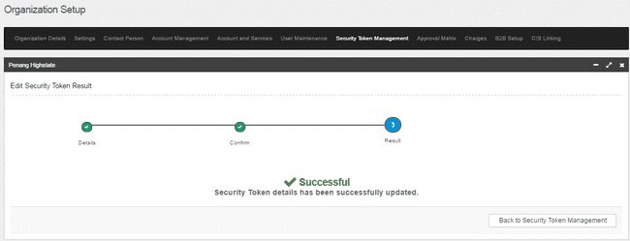

Figure 80: Edit Security Token Result Screen with disable Checker Maker Permission

**Display Fields:**

|  |  |  |  |
| --- | --- | --- | --- |
| **No** | **Field** | **Format** | **Description** |
|  | Result Step | Alphanumeric | To display result step |
|  | Status | Alpha numeric | To display result status. |
|  | Result Message | Alpha numeric | To display result message. |

Table 105: Security Token Result Screen Display Field

**Action:**

|  |  |  |  |
| --- | --- | --- | --- |
| **No** | **Action** | **Type** | **Description** |
|  | Back to Security Token Management | Button | Contains an action to Security Token Management main screen. |

Table 106: Security Token Result Screen Action

### Delete Security Token

This function allows IBAM UKB to delete the existing secured pass assigned to the Organization.

#### Process Flow



Diagram 19: Delete Security Token Process Flow Diagram

#### Screen Flow

***Step 1:***

1. UKB clicks on the **Security Token Management** tab.
2. IBAM system shows the list of Secured Pass assigned to Organization.
3. IBAM UKB click on “x” icon.

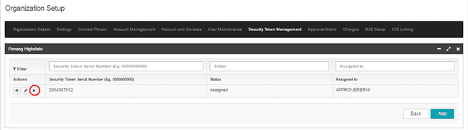

Figure 81: Security Token Management Screen

**Display Specifications:**

| **No** | **Field** | **Description** |
| --- | --- | --- |
|  | Security Token Serial Number | The serial number of secured pass |
|  | Status | The status of the secured pass, Possible values:   1. Not assigned 2. Assigned 3. Faulty |
|  | Assigned To | The secured pass owner name, if the status is “Assigned” |

Table 107: Security Token Management Screen Display Fields

**Action:**

| **No** | **Action** | **Type** | **Description** |
| --- | --- | --- | --- |
|  | “X” icon | Button | Contains an action to display the Delete Security Token - Confirmation page. |

Table 108: Security Token Management Screen Action

***Step 2:***

1. IBAM system displays the Approval Matrix - Confirmation page.
2. UKB click on **“Confirm”**  button.

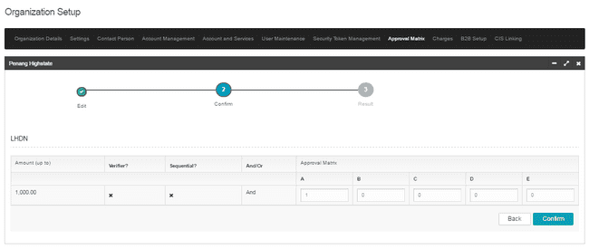

Figure 82: Approval Matrix – Confirmation Screen

**Display Fields:**

|  |  |  |  |
| --- | --- | --- | --- |
| **No** | **Field** | **Format** | **Description** |
|  | Serial Number | Alphanumeric | Display the Serial Token Number |
|  | Status | Text | Display the status. |
|  | Assigned to | Text | Display the serial token number assignee username.  *\*Only display if the status is changed to “Assigned To”* |

Table 109: Delete Security Token – Confirmation Screen Display Field

**Action:**

|  |  |  |  |
| --- | --- | --- | --- |
| **No** | **Action** | **Type** | **Description** |
|  | Confirm | Button | Contains an action to Edit Security Token Result |
|  | Back | Button | Contains an action to display back on previous screen. |

Table 110: Delete Security Token – Confirmation Screen Action

*Step 3:*

1. IBAM System validates and save the changes to IB Database and displays result page.
2. IBAM shows Successful message and pending for Authorization approval process.

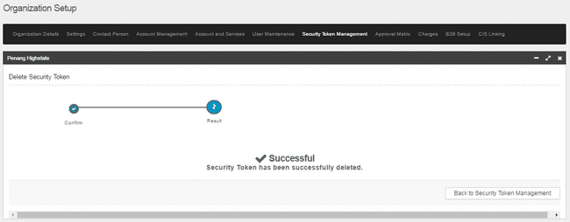

Figure 83: Delete Security Token Result Screen

If User Maintenance Module Maker Checker Permission set as ‘Disable’

1. IBAM saves the update information and display the successful result page.
2. IBAM shows Successful message and will shows update information without any approval process.



Figure 84: Delete Security Token Result Screen with disable Checker Maker Permission

**Display Fields:**

|  |  |  |  |
| --- | --- | --- | --- |
| **No** | **Field** | **Format** | **Description** |
|  | Result Step | Alphanumeric | To display result step |
|  | Status | Alpha numeric | To display result status. |
|  | Result Message | Alpha numeric | To display result message. |

Table 111: Delete Security Token Result Screen Display Field

**Action:**

|  |  |  |  |
| --- | --- | --- | --- |
| **No** | **Action** | **Type** | **Description** |
|  | Back to Security Token Management | Button | Contains an action to Security Token Management main screen. |

Table 112: Delete Security Token Result Screen Action

# Approval Matrix

Approval matrix allows IBAM UKB to view the current setup of the selected Organization’s approval matrix. The maintenance of the approval matrix will be done by respective Organization’s Corporate UKB and UKB personnel. Module for approval matrix are as below:

* Own Account Transfer
* 3rd Party Account Transfer
* Interbank Account Transfer
* Bill Payment
* Bulk Payment
* Auto Debit
* JomPAY
* EPF
* LHDN

### View & Edit Approval Matrix

#### Process Flow



Diagram 20: View Approval Matrix Flow Diagram

#### Screen Flow

***Step 1:***

1. UKB clicks on the **Approval Matrix** tab.
2. IBAM system shows details of **current approval matrix**

Based on approval matrix below;

* 1. For transaction amount up to MYR 50,000, it requires 1 Approval from Group A to approve and complete the transaction.
  2. For transaction amount up to MYR 100,000, it requires 2 approvals, 1 from Group A and 1 from Group B to approve the transaction. After obtaining the required approval from Group A & Group B respectively, the transaction will be completed by sending to Host System for processing
  3. For transaction amount up to MYR 1,000,000, it requires 2 approvals, 1 from Group A and 1 from Group C to approve the transaction. After obtaining the required approval from Group A & Group C respectively, the transaction will be completed by sending to Host System for processing

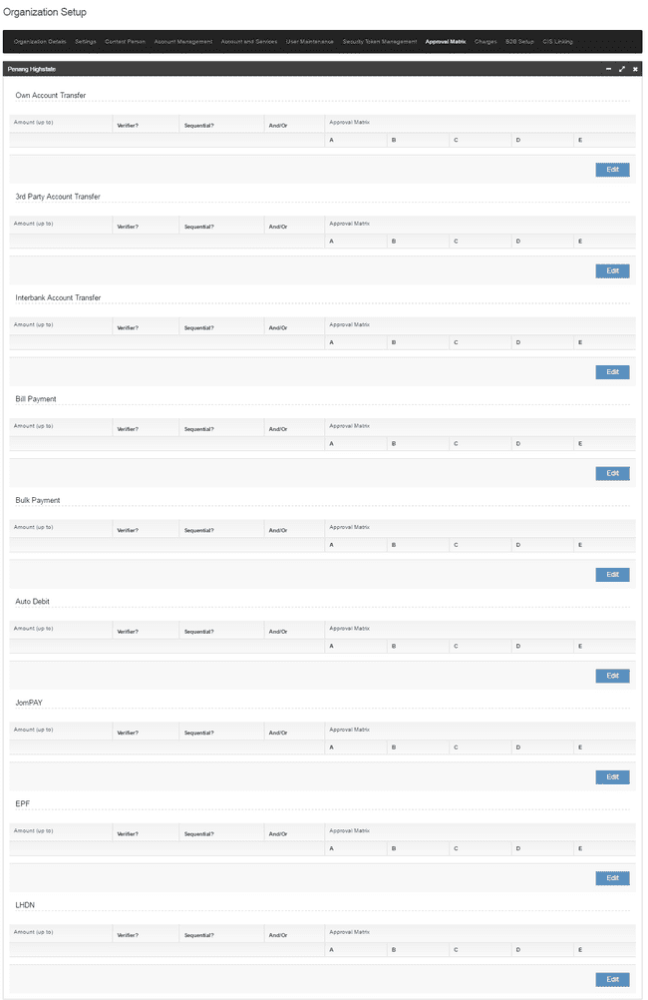

Figure 85: Approval Matrix Screen

**Display Fields:**

|  |  |  |  |
| --- | --- | --- | --- |
| **No** | **Field** | **Format** | **Description** |
|  | Amount | Numeric | The maximum amount for this group |
|  | Verifier | Checkbox | An indicator to allow/disallow verifier for the module. |
|  | Sequential | Checkbox | An indicator to allow/disallow approve by sequence for the module. |
|  | And/Or | Checkbox | AND = all user in each group have to approve  OR = any user (at least one) have to approve |
|  | Approval Matrix | Table | Approval matrix setup of this Organization |

Table 113: Approval Matrix Display Field

**Action:**

| **No** | **Action** | **Type** | **Description** |
| --- | --- | --- | --- |
|  | Edit | Button | Contains an action to display Edit Approval Matrix screen for the selected module. |

Table 114: Approval Matrix Action

***Step 2:***

1. System display Edit Approval Matrix screen for the selected module.
2. UKB click on “+” icon to add new amount for approval matrix.
3. UKB enter the changes required and click on “Next” button.

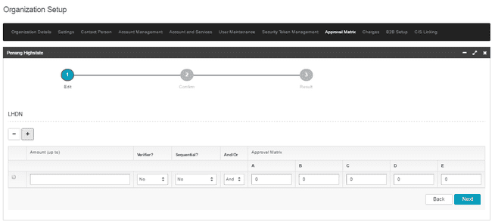

Figure 86: Edit Approval Matrix Screen

**Input Specifications:**

| **No** | **Field** | **Field Type** | **Rule** | **Description** | **REQUIRED** |
| --- | --- | --- | --- | --- | --- |
|  | Amount | Text | Max length: 17 (15.2)  Numeric | Amount for approval matrix | M |
|  | Verifier | Dropdown List | N/A | An indicator to allow/disallow verifier for the module. | M |
|  | Sequential | Dropdown List | N/A | An indicator to allow/disallow approve by sequence for the module. | M |
|  | And/Or | Dropdown List | N/A | AND = all user in each group have to approve  OR = any user (at least one) have to approve | M |
|  | Approval Matrix | Text | Max length: 1 Numeric | Approval matrix setup of this Organization  Each group cannot be empty (at least 0) | M |

Table 115: Edit Approval Matrix Screen Input Specification

**Action:**

| **No** | **Action** | **Type** | **Description** |
| --- | --- | --- | --- |
|  | Next | Button | Contains an action to display Approval Matrix Confirmation screen for the selected module. |
|  | Back | Button | Contains an action to previous screen. |

Table 116: Approval Matrix Action

***Step 2:***

1. IBAM system displays the Approval Matrix - Confirmation page.
2. UKB click on **“Confirm”**  button.



Figure 87: Approval Matrix – Confirmation Screen

**Display Fields:**

|  |  |  |  |
| --- | --- | --- | --- |
| **No** | **Field** | **Format** | **Description** |
|  | Amount | Numeric | The maximum amount for this group |
|  | Verifier | Checkbox | An indicator to allow/disallow verifier for the module. |
|  | Sequential | Checkbox | An indicator to allow/disallow approve by sequence for the module. |
|  | And/Or | Checkbox | AND = all user in each group have to approve  OR = any user (at least one) have to approve |
|  | Approval Matrix | Table | Approval matrix setup of this Organization |

Table 117: Approval Matrix – Confirmation Screen Display Field

**Action:**

| **No** | **Action** | **Type** | **Description** |
| --- | --- | --- | --- |
|  | Confirm | Button | Contains an action to display Approval Matrix Result screen for the selected module. |
|  | Back | Button | Contain an action to display back on previous screen. |

Table 118: Approval Matrix – Confirmation Screen Action

*Step 3:*

1. IBAM System validates and save the changes to IB Database and displays result page.
2. IBAM shows Successful message and pending for Authorization approval process.

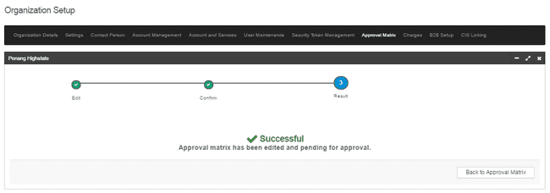

Figure 88: Approval Matrix Result Screen

If User Maintenance Module Maker Checker Permission set as ‘Disable’

1. IBAM saves the update information and display the successful result page.
2. IBAM shows Successful message and will shows update information without any approval process.

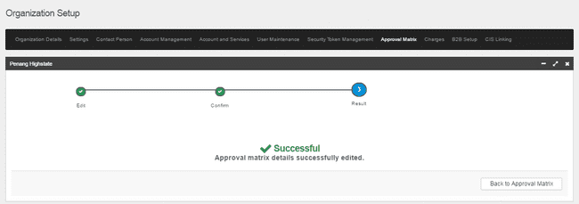

Figure 89: Approval Matrix Result Screen with disable Checker Maker Permission

**Display Fields:**

|  |  |  |  |
| --- | --- | --- | --- |
| **No** | **Field** | **Format** | **Description** |
|  | Result Step | Alphanumeric | To display result step |
|  | Status | Alpha numeric | To display result status. |
|  | Result Message | Alpha numeric | To display result message. |

Table 119: Delete Security Token Result Screen Display Field

**Action:**

|  |  |  |  |
| --- | --- | --- | --- |
| **No** | **Action** | **Type** | **Description** |
|  | Back to Approval Matrix | Button | Contains an action to Security Token Management main screen. |

Table 120: Delete Security Token Result Screen Action

# Online Payment Charges

This feature allows UKB to setup charges for Online Single Payment.

### View & Edit Charges

#### Process Flow



Diagram 21: Edit Charges Flow Diagram

#### Screen Flow

***Step 1:***

1. UKB clicks on the **Online Payment Charges** tab.
2. IBAM system display Charges details page.
3. UKB clicks on **Edit** button.

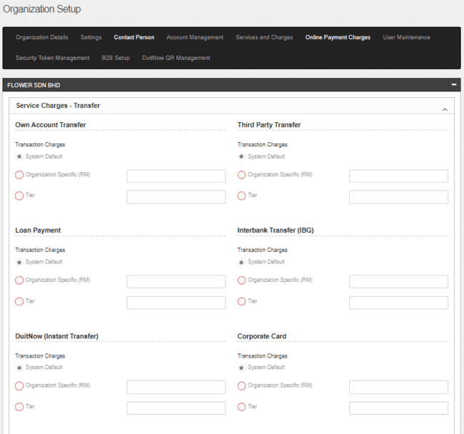

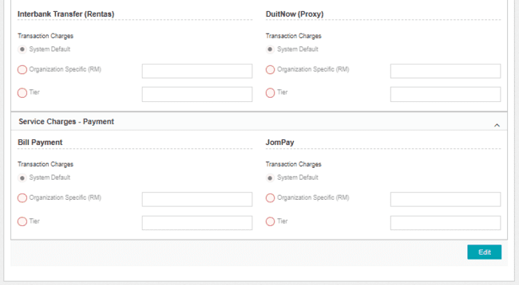

Figure 90: Online Payment Charges Screen

**Display Specifications:**

| **No** | **Field Name** | **Format** | **Description** |
| --- | --- | --- | --- |
|  | Service Charges - Transfer | Text | The charges for every online transfer services, including:   1. Own Account Transfer 2. Third Party Account Transfer 3. Loan Payment 4. Interbank Transfer (IBG) 5. DuitNow (Instant Transfer) 6. Corporate Card 7. Interbank Transfer (Rentas) 8. DuitNow (Proxy) |
|  | Service Charges – Payment | Text | The charges for every online payment services, including:   * 1. Bill Payment   2. JomPay |
|  | System Default | Radio Button | Default charges for every transfer & payment.  Can be setup at IBAM > CBE > Content > SERVICEINFO |
|  | Organization Specific (RM) | Radio Button | Charge by organization specific setup |
|  | Organization Specific (RM) value | Text | The value charges for Organization Specific (RM) |
|  | Tier | Dropdown List | Charge by tier charges.  Can be setup at IBAM > CBE > Content > TIERCHARGES |

Table 121: Online Payment Charges Display Specification

**Action:**

| **No** | **Action** | **Type** | **Description** |
| --- | --- | --- | --- |
| 1. | Edit | Button | Contains an action to display Online Payment Charges – Edit screen. |

Table 122: Online Payment Charges Action

***Step 2:***

1. IBAM system shows Online Payment Charges – Edit screen.
2. UKB keys in details of the charges.
3. UKB clicks on the **Next** button.

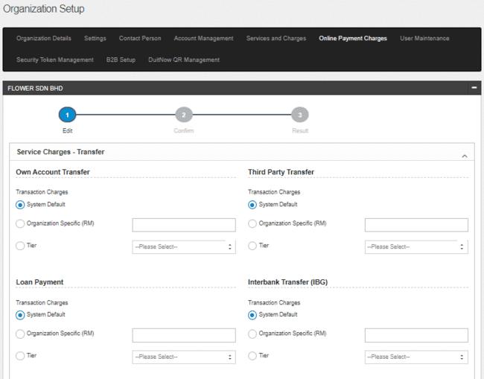

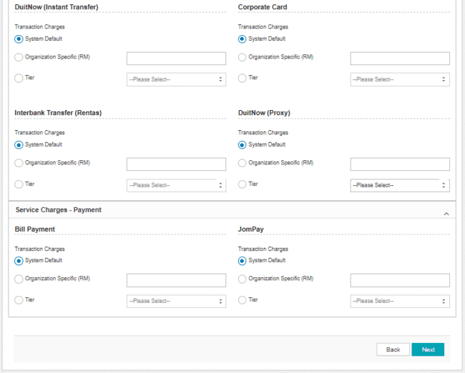

Figure 91: Online Payment Charges - Edit Screen

**Input Specifications:**

| **No** | **Field Name** | **Field Type** | **Validation Rule** | **Description** | **Required** |
| --- | --- | --- | --- | --- | --- |
|  | System Default | Radio Button | N/A | Default charges for every transfer & payment.  Can be setup at IBAM > CBE > Content > SERVICEINFO | Required at least one type of charges |
|  | Organization Specific (RM) | Radio Button | N/A | Charge by organization specific setup | Required at least one type of charges |
|  | Organization Specific (RM) value | Text | Max Length (15,2)  Numeric | The value charges for Organization Specific (RM) | Required if select on Organization Specific (RM) |
|  | Tier | Dropdown List | N/A | Charge by tier charges.  Can be setup at IBAM > CBE > Content > TIERCHARGES | Required at least one type of charges |

Table 123: Online Payment Charges – Edit Input Specification

**Action:**

| **No** | **Action** | **Type** | **Description** |
| --- | --- | --- | --- |
| 1. | Next | Button | * Contain an action to display the Online Payment Charges – Confirmation screen. |
| 2. | Toggle | Button | * Contains an action to show and hide content. |
| 3. | Back | Button | * Contains an action to display back on previous screen. |

Table 124: Online Payment Charges – Edit Action

**List of available messages for the screen:**

| **No.** | **Event** | **Error Description in English** |
| --- | --- | --- |
|  | Fill in Organization Specific with invalid value (alphabets/special character) | Own Transaction Charges is not in proper currency format. |
| Third Party Transaction Charges is not in proper currency format. |
| Loan Repayment Transaction Charges in not in proper currency format. |
| Interbank Transfer (IBG) is not in proper currency format. |
| DuitNow(Instant Transfer) is not in proper currency format. |
| Card Transaction Charges is not in proper currency format. |
| Interbank Transfer (Rentas) is not in proper currency format. |
| DuitNow(Proxy) is not in proper currency format. |
| Bill Payment Transaction Fee is not in proper currency format. |
| JomPay is not in proper currency format. |
|  | Did not Fill in Organization Specific | Own Transaction Charges is required. |
| Third Party Transfer is required. |
| Loan Repayment Transaction Charges is required. |
| Interbank Transfer (IBG) is required. |
| DuitNow (Instant Transfer) is required |
| Card Transaction Charges is required. |
| Interbank Transfer (Rentas) is required. |
| DuitNow (Proxy) Transaction Charges is required. |
| Bill Payment Transaction Fee is required. |
| JomPay is required |

Table 125: Online Payment Charges – Edit Error Message List

***Step 3:***

1. IBAM system shows Online Payment Charges – Confirm screen.
2. UKB clicks on the **Confirm** button.

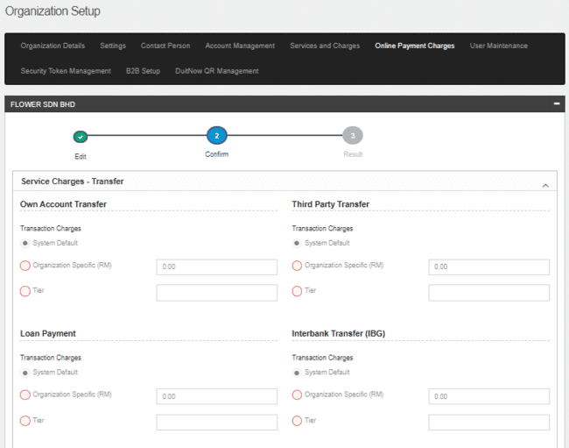

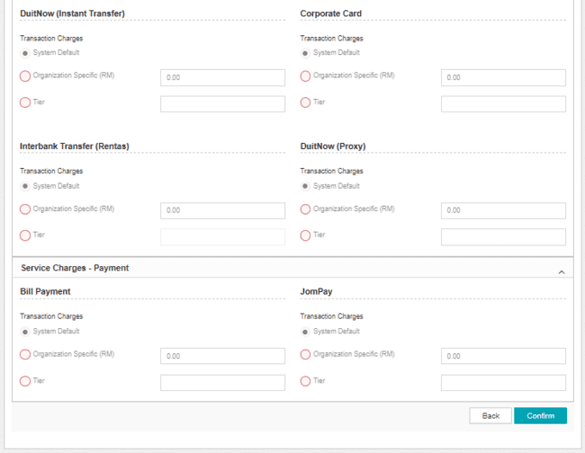

Figure 92: Online Payment Charges - Confirm Screen

**Action:**

| **No** | **Action** | **Type** | **Description** |
| --- | --- | --- | --- |
| 1. | Confirm | Button | * Contains an action to validate fields checking before it saves the record to database * Contains an action to save the new records entered to database * Forward the action to display result screen. |
| 2. | Back | Button | * Contains an action to display back on previous screen. |

Table 126: Edit Charges Action

***Step 3:***

1. IBAM System validates and save the changes to IB Database and displays result page.
2. IBAM shows Successful message and pending for Authorization approval process.

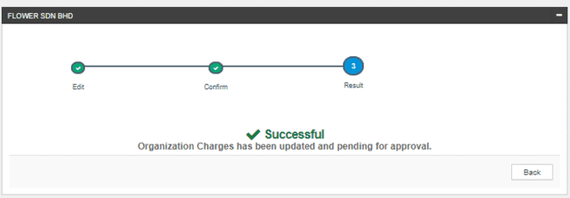

Figure 93: Online Payment Charges – Result Screen

If Organization Details Module Maker Checker Permission set as ‘Disable’

1. IBAM saves the update information and display the successful result page.
2. IBAM shows Successful message and will shows update information without any approval process.

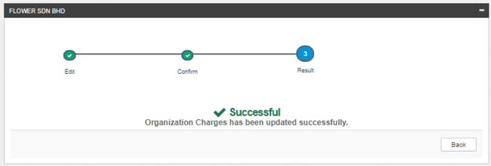

Figure 94: Online Payment Charges – Result Screen with disable Checker Maker Permission

**Display Fields:**

|  |  |  |  |
| --- | --- | --- | --- |
| **No** | **Field** | **Format** | **Description** |
|  | Result Step | Alphanumeric | To display result step |
|  | Status | Alpha numeric | To display result status. |
|  | Result Message | Alpha numeric | To display result message. |

Table 127: Online Payment Details – Result Screen Display Field

**Action:**

|  |  |  |  |
| --- | --- | --- | --- |
| **No** | **Action** | **Type** | **Description** |
|  | Back | Button | Contains an action to Online Payment Charges main page |

Table 128: Online Payment Details – Result Screen Action

# CIS Linking

IBAM system feature allows UKB (Multiple User) to update to allow or disallow CIS Linking, add and delete CIS number.

Below diagram shows the overall view of the Profile & Service Maintenance in CDB.

### To Allow CIS Linking

#### Process Flows



Diagram 22: CIS Linking Flow Diagram

#### Screen Flow

***Step 1:***

1. UKB login to IBAM
2. UKB access CBE > Organization Setup > Setting
3. UKB click on Edit button

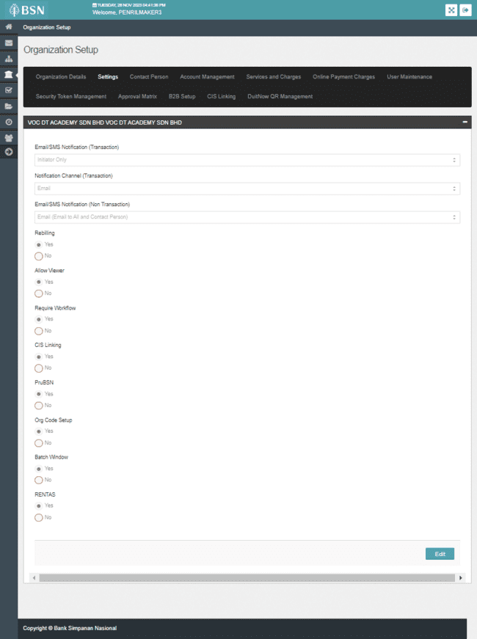

Figure 95: Organization Details Screen

Display Specification

|  |  |  |  |
| --- | --- | --- | --- |
| No | Field | Format | Description |
|  | CIS Linking | Text | Allow UKB to edit CIS Linking for specific Organization. |

Table 129: Organization Details Display Specification

**Action:**

| **No** | **Action** | **Type** | **Description** |
| --- | --- | --- | --- |
|  | Edit | Button | Contain the action to edit the profile details. |
|  | Back | Button | Contain the action to display back at Organization Setup page |

Table 130: Organization Details Action

***Step 2:***

1. System display Edit Organization Details Screen
2. UKB select “Yes” for CIS Linking
3. UKB click Next

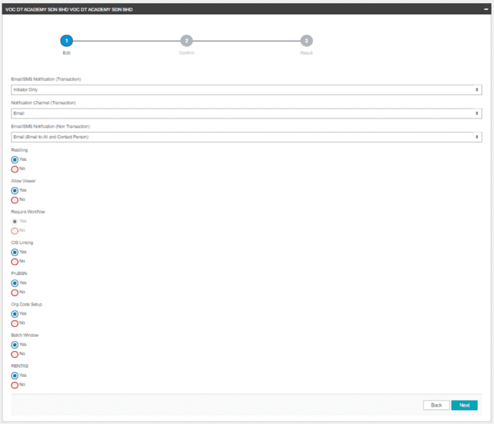

Figure 96: Organization Details - Edit Screen

**Input Specification:**

| **No** | **Field** | **Field Type** | **Rule** | **Description** | **Required** |
| --- | --- | --- | --- | --- | --- |
|  | CIS Linking | Radio Button | Default to No | Indicator to allow UKB access CIS Linking module. | No |

Table 131: Organization Details – Edit Input Specification

**Action:**

| **No** | **Action** | **Type** | **Description** |
| --- | --- | --- | --- |
| 1 | Back | Button | Contain the action to forward back to previous page |
| 2 | Next | Button | * Forward the action to save the input fields to database * Contain the action to display the Confirm Page |

Table 132: Organization Details – Edit Action

***Step 3:***

1. System display Confirm Screen
2. UKB click Confirm

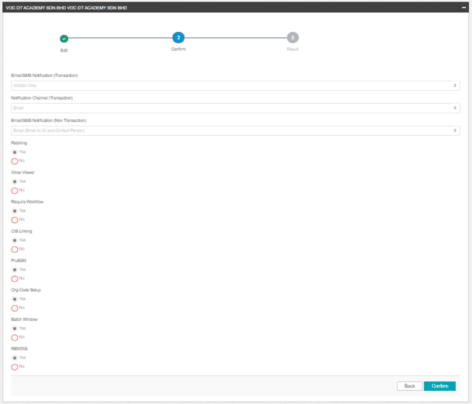

Figure 97: Organization Details - Confirm Screen

**Action:**

| **No** | **Action** | **Type** | **Description** |
| --- | --- | --- | --- |
| 1 | Back | Button | Contain the action to forward back to previous page |
| 2 | Confirm | Button | * Forward the action to save the input fields to database * Contain the action to display the Result Page |

Table 133: Organization Details – Confirm Action

***Step 4:***

1. IBAM System validates and save the changes to IB Database and displays result page.
2. IBAM shows Successful message and pending for Authorization approval process.

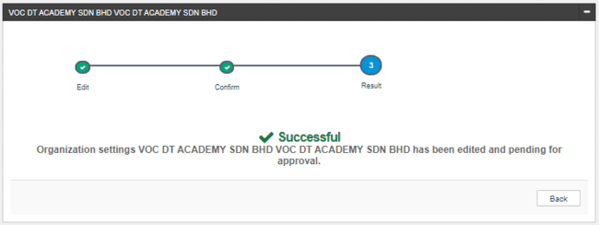

Figure 98: Organization Details – Result Screen

If Organization Details Module Maker Checker Permission set as ‘Disable’

1. IBAM saves the update information and display the successful result page.
2. IBAM shows Successful message and will shows update information without any approval process.

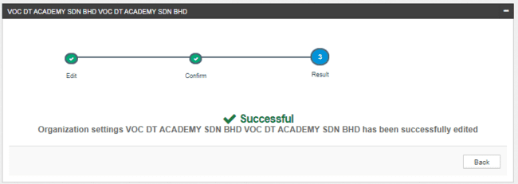

Figure 99: Organization Details - Result Screen

**Display Fields:**

|  |  |  |  |
| --- | --- | --- | --- |
| **No** | **Field** | **Format** | **Description** |
|  | Result Step | Alphanumeric | To display result step |
|  | Status | Alpha numeric | To display result status. |
|  | Result Message | Alpha numeric | To display result message. |

Table 134: Organization Details – Result Screen Display Field

**Action:**

|  |  |  |  |
| --- | --- | --- | --- |
| **No** | **Action** | **Type** | **Description** |
|  | Back | Button | Contains an action to Setting main page |

Table 135: Organization Details– Result Screen Action

### Add CIS Number

#### Process Flows



Diagram 23: Add CIS Number Flow Diagram

#### Screen Flows

***Step 1:***

1. UKB clicks on CIS Linking tab.
2. System display CIS Linking page.
3. UKB clicks on “Add” button.

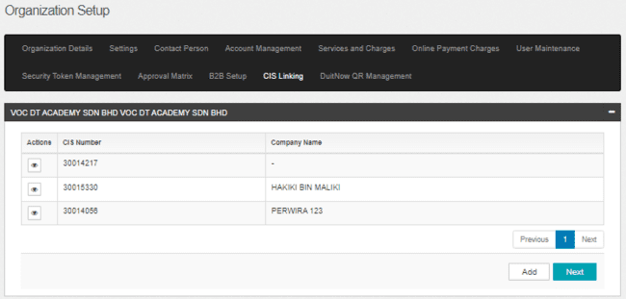

Figure 100: CIS Linking Screen

**Action:**

|  |  |  |  |
| --- | --- | --- | --- |
| No | Field | Field Type | Description |
|  | Add | Button | Contain action to display the CIS Linking Add page. |

Table 136: CIS Linking Action

***Step 2:***

1. System display CIS Linking Add page.
2. UKB enter subsidiary Organization / companies CIS Number
3. UKB clicks on “Next” button.



Figure 101: CIS Linking Add Screen

**Input Specification:**

|  |  |  |  |  |  |
| --- | --- | --- | --- | --- | --- |
| No | Field | Field Type | Validation Rule | Description | Required |
|  | CIS Number | Textbox | Numeric | CIS Number of Subsidiary Organization | Yes |

Table 137: CIS Linking Add Input Specification

**Action:**

|  |  |  |  |
| --- | --- | --- | --- |
| No | Field | Field Type | Description |
| 1. | Add | Button | Contain action to add new row |
| 2. | Next | Button | Contain action to verify the CIS Number and display the confirm page. |

Table 138: CIS Linking Add Action

***Step 3:***

1. System display CIS Linking Add – Confirm page.
2. UKB clicks on “Confirm” page.

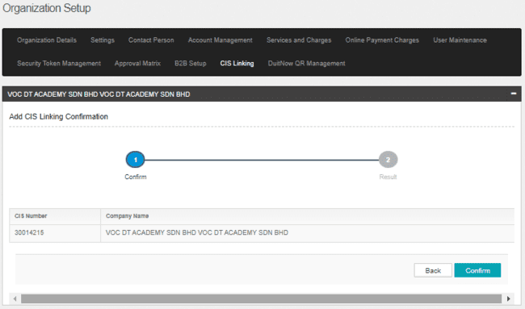

Figure 102: CIS Linking Add – Confirm Screen

**Action:**

|  |  |  |  |
| --- | --- | --- | --- |
| No | Field | Field Type | Description |
| 1. | Confirm | Button | Contain action to display the Result Page. |
| 2. | Back | Button | Contain action to display back on previous page. |

Table 139: CIS Linking Add Action

***Step 4:***

1. IBAM System validates and save the changes to IB Database and displays result page.
2. IBAM shows Successful message and pending for Authorization approval process.

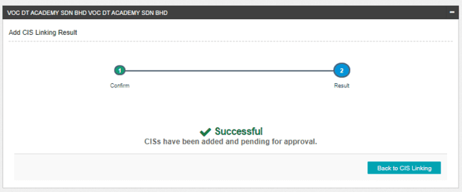

Figure 103: CIS Linking Add – Result Screen

If CIS Linking Module Maker Checker Permission set as ‘Disable’

1. IBAM saves the update information and display the successful result page.
2. IBAM shows Successful message and will shows update information without any approval processSystem display CIS Linking Add – Result page.

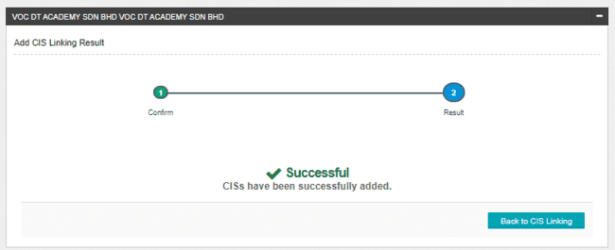

Figure 104: CIS Linking Add – Result Screen with disable Checker Maker Permission

**Display Fields:**

|  |  |  |  |
| --- | --- | --- | --- |
| **No** | **Field** | **Format** | **Description** |
|  | Result Step | Alphanumeric | To display result step |
|  | Status | Alpha numeric | To display result status. |
|  | Result Message | Alpha numeric | To display result message. |

Table 140: CIS Linking Add – Result Screen Display Field

**Action:**

|  |  |  |  |
| --- | --- | --- | --- |
| **No** | **Action** | **Type** | **Description** |
|  | Back | Button | Contains an action to CIS Linking main page |

Table 141: CIS Linking Add – Result Screen Action

### Delete CIS Number

#### Process Flows



Diagram 24: Revoke CIS Flow Diagram

#### Screen Flows

***Step 1:***

1. UKB clicks on CIS Linking tab.
2. System display CIS Linking page.
3. UKB clicks on “eye” icon button of the required CIS number.

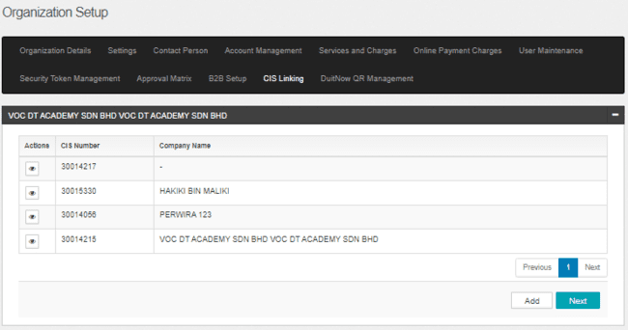

Figure 105 : CIS Linking Screen

Display Specification

|  |  |  |  |
| --- | --- | --- | --- |
| No | Field | Format | Description |
|  | CIS Number | Text | List of CIS Number |
|  | Organization Name | Text | List of Organization Name |

Table 142: CIS Linking Display Field

**Action:**

|  |  |  |  |
| --- | --- | --- | --- |
| No | Field | Field Type | Description |
| 1. | Eye | Icon Button | Contain action to display CIS Details page. |

Table 143: CIS Linking Action

***Step 2:***

1. System displays the CIS Details page
2. UKB clicks on “Delete” button.

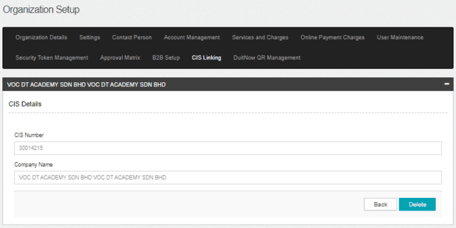

Figure 106: CIS Details Screen

**Display Specification:**

|  |  |  |  |
| --- | --- | --- | --- |
| No | Field | Format | Description |
|  | CIS Number | Text | CIS Number |
|  | Organization Name | Text | Organization name linked to |

Table 144: CIS Details Display Specification

**Action:**

|  |  |  |  |
| --- | --- | --- | --- |
| No | Field | Field Type | Description |
|  | Back | Button | Back to CIS Linking page |
|  | Delete | Button | Contain action to delete the selected CIS number |

Table 145: CIS Details Action

***Step 3:***

1. System displays the Delete CIS Linking– Confirm page.
2. UKB clicks on “Confirm” page to confirm the deletion for the selected CIS.

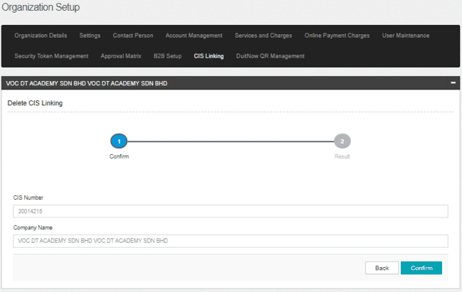

Figure 107 : CIS Delete - Confirm Screen

**Display Specification:**

|  |  |  |  |
| --- | --- | --- | --- |
| No | Field | Format | Description |
|  | CIS Number | Text | CIS Number |
|  | Organization Name | Text | Organization name linked to |

Table 146 : CIS Delete - Confirm Display Specification

**Action:**

|  |  |  |  |
| --- | --- | --- | --- |
| No | Field | Field Type | Description |
|  | Back | Button | Back to CIS Linking page |
|  | Confirm | Button | Contain action to confirm the deletion of selected CIS number and display the Result Page. |

Table 147 : CIS Revoke - Confirm Action

***Step 4:***

1. IBAM System validates and save the changes to IB Database and displays result page.
2. IBAM shows Successful message and pending for Authorization approval process.

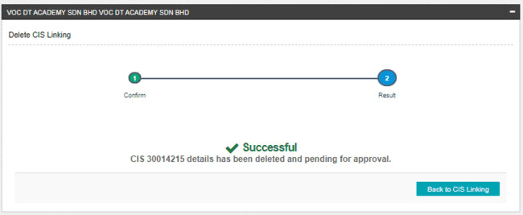

Figure 108: CIS Delete – Result Screen

If CIS Linking Module Maker Checker Permission set as ‘Disable’

1. IBAM saves the update information and display the successful result page.
2. IBAM shows Successful message and will shows update information without any approval process System display CIS Linking Delete – Result page.

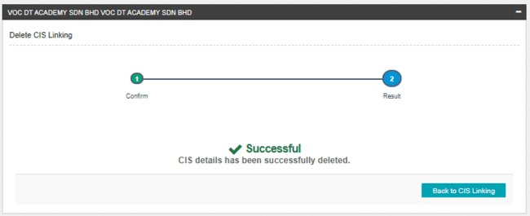

Figure 109: CIS Delete – Result Screen with disable Checker Maker Permission

**Display Fields:**

|  |  |  |  |
| --- | --- | --- | --- |
| **No** | **Field** | **Format** | **Description** |
|  | Result Step | Alphanumeric | To display result step |
|  | Status | Alpha numeric | To display result status. |
|  | Result Message | Alpha numeric | To display result message. |

Table 149: CIS Revoke – Result Screen Display Field

**Action:**

|  |  |  |  |
| --- | --- | --- | --- |
| **No** | **Action** | **Type** | **Description** |
|  | Back to CIS Linking | Button | Contains an action to CIS Linking main page |

Table 150: CIS Revoke– Result Screen Action

Appendix 1: Glossary

| **Term** | **Definition** |
| --- | --- |
| IBAM | Internet Banking Administration Module (the administration module) |
| CDB | Corporate Digital Banking |
| Bank Back End (BBE) | Admin Module for IBAM System |
| Corporate Back End (CBE) | Admin Module for Corporate Digital Banking System |
| IB | Internet Banking |
| IBS | Internet Banking System |
| SME | Small &Medium Enterprise |
| BBE Admin | System Admin for IBAM System |
| CBE Admin | Bank Admin for Corporate Digital Banking System |
| SMS PIN | An OTP send to user via SMS gateway for Corporate Admin FTO and reset password. |
| FTL | First Time Login |
| OTP | One Time Password, in this document it meant for the Secure Pass or Token 6 digit PIN from VASCO. |
| BNM | Bank Negara Malaysia |
| CASA | Current & Savings Account |
| FD | Fixed Deposit |

# 

# Appendix 2: System Security Requirements

Below table shows the requirement for the User ID and Password for the BANK:

| **No** | **Field** | **Description** |
| --- | --- | --- |
|  | User ID | System shall accept 6 to 16 characters of alpha and numeric. |
|  | Maximum password expiration | Value = 30  User is required to change password every **30 days** |
|  | Minimum password length | Value = 8  System will check for the minimum allowable password length |
|  | Inactive/Dormant ID | Value = 60  User ID is disabled by system after **60** days if inactivity. |
|  | Duplicate password control | Value = 10  Maximum of **10** generation password control that same passwords cannot be repeated. |
|  | Last sign on information display | - |
|  | First time sign on password must be forced change | System will force user to change password for first time login. |
|  | Changing of passwords by user | Users should allow changing their password.  Users may change their passwords at any time. |
|  | Passwords composition | Must be combination of 1 numeric, 1 lower case alphabet, 1 upper case alphabet and case sensitive |
|  | No deletion of User IDs from application | All user ids cannot be reuse including deleted user ids. Deleted ids are not permanently removed from IBS. |

# Appendix 3: CDB and IBAM User Status

Below table shows the statuses used for CDB and IBAM systems. All system used the same status value.

| **No** | **Status** | **Description** |
| --- | --- | --- |
|  | Active | Indicates that user account is in normal state  User is able to login to the system without any restriction. |
|  | Locked | Indicates that user account is locked when exceeded max retries on authentication failures.  User must call Call Centre/System Admin to unlock the account. |
|  | Unlock | Indicates that user has called Call Centre/Corporate Admin to unlock the account.  User is required to go through the Reset Password process to change the account status to Active. |
|  | TAC Lock | Indicates that the user exceeded max retries on the TAC authentication failures.  User must call Call Centre/Corporate Admin to unlock the account. |
|  | TAC Unlock | Indicates that user has called Call Centre/System Admin to unlock TAC after it is being TAC Lock. |
|  | New | Indicates this is a new registered user and not yet activated |
|  | Deleted | Indicates that the user account has been deleted by Admin |
|  | Dormant | Indicates that user account was not login for more than the dormancy period of 90 days. |
|  | Blocked | Indicates that user account is Blocked by Admin.  Admin is allowed toBlock a user account via the Block User feature. User has to call Call Centre/Corporate Admin to activate the account. |

# Appendix 4: Acceptable Characters for Validation

| **Validation Name** | **Acceptable characters** |
| --- | --- |
| Text | No limitations |
| Alphanumeric with Dot & Slash | a-z, A-Z  0-9  Dot / Period (.)  Slash (/) |
| Alphanumeric with Space | a-z, A-Z  0-9  Space |
| Alphanumeric with spaces and underscore | a-z, A-Z  0-9  Space  Underscore (_) |
| Alphanumeric with Space & Symbols | a-z, A-Z  0-9  Space  Ampersand (&)  Apostrophe (', `)  Left Bracket (()  Right Bracket ())  Comma (,)  Alias (@)  Question Mark (?) |
| Email | a-z, A-Z  0-9  Dot / Period (.)  Minus/Hypen (-)  Underscore (_)  Minus/Hypen (-)  Must have one alias (@)  Format: <value>@<value>.<value> |
| Character(s) acceptable for URL path  URL Path | a-z, A-Z  0-9  Dot / Period (.)  Space  Ampersand (&  Plus (+)  Minus/Hypen (-)  Slash (/)  Equal (=)  Question Mark (?)  Underscore (_) |

Table 151: Acceptable Characters for Validations

* END -