Data transaction on Hub NRT.IPF_TRANS_LOG

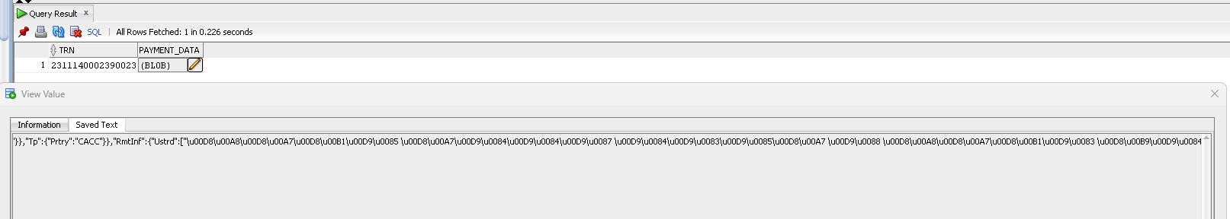

Length counted 490 via notepad contain string json escaped character

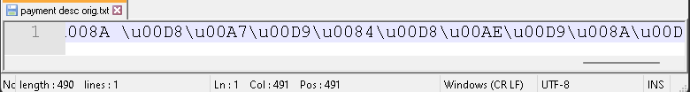

Length counted 170 via notepad contain string actual value from json escaped character

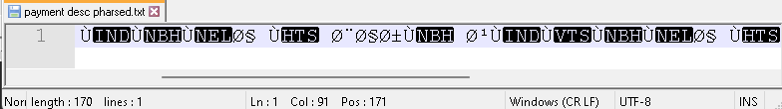

Data offloaded to portal RPP_TRNX_LOG_DATA

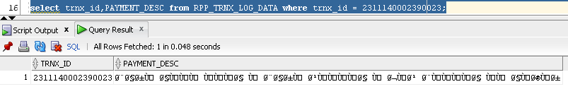

Result generated report

