Kuwait Finance House (Malaysia) Berhad
Internet Banking System

Functional Requirement and System Specification
for IBSCR2023004 – Panic Button / Kill Switch for KFH Online

^{7th} Dec 2023
Reference: KFH/FSD/IBSCR2023004
Version: 1.0

Prepared By:

Penril Datability (M) Sdn Bhd (816792-X)
Suite A-07-07 Plaza Mon’t Kiara
No. 2, Jalan Kiara, Mon’t Kiara
50480 Kuala Lumpur, Malaysia
Tel: (603) 6201 2622Fax: (603) 6201 7622

Document Management
Rev. No | Date Update | Description of Change | Update By | Review By
1.0 | 04/12/2023 | Initial release | Amir Hakim Bin Mior Kamarul Bahrain | Lizahwati  Yap Kah Yan

Table of Contents
Section A: Introduction 5
1.1 Objective 5
1.2 Scope of Delivery 6
Section B: Functional Specifications 10
[MOD01] KFH Online 10
[FUNC01] User Account Lock by Activating Panic Button 10
[MOD02] BVMC 15
[FUNC02] User Account Unlock by Deactivating Panic Button 15
Section C: Traceability Matrix 16

Functional Requirement and System Specification Acceptance

I/We hereby verify that this Functional Requirement and System Specification consist of all the requirements requested by Kuwait Finance House (M) Berhad. The implemented system will fulfill ONLY this requirement.

I/We also hereby AGREE that this satisfies our entire requirement for IBSCR2023004 Kill Switch
Any future changes to this agreed scope will be treated as an enhancement to the system. Any future changes to the project timeline will be subjected to the final approval of the project steering committee.

Kuwait Finance House (M) Berhad:

Approved by | Role | Signature | Date

Penril Datability (M) Sdn. Bhd.:

Approved by | Role | Signature | Date
Lizahwati Basirun | Professional Services

Section A: Introduction

This document served as basic/high level business requirement and system specification for KFH Online new enhancement. This new enhancement is to implement “Panic Button” or known as kill switch function in KFH Online system in order to comply with Bank Negara Malaysia (BNM) requirement to curb online fraud/scam, pursuant to YAB PM announcement in Budget 2023.
All screen designs provided in this document are samples and only illustration purpose for easy understanding. The screen designs are not final.

Objective
The base line features description and screen designs will become a reference blueprint for the development team to develop the transactional and administration module. Hence, it is crucial that all stakeholders need to ensure the correctness and adequacy of the requirements captured in this document.
All stakeholders involved are expected to review and sign off this document before the development start. By signing off the document, the stakeholder has endorsed the correctness and accuracy and adequacy of the requirements documented in this document.

Scope of Delivery

Please refer to the linked Section for the details of the proposed solution for the scope of work.
This enhancement is only applicable for KFH Online & FPX module.
Section | Description
Consumer | New hyperlink and Panic Button/Kill Switch Activation module.  - Add hyperlink at Login page to route to Panic Button/Kill Switch Activation page.  - New Panic Button/Kill Switch Activation module.  - Username page  - Security Phrase and Password page  - Confirmation page  - Acknowledgement page  - Scenario for Panic Button/Kill Switch Activation  - Successful – send “Successful SMS Notification” to customer and email successful notification to Contact Center to block debit card.  - Unsuccessful – send "Unsuccessful SMS Notification” to customer and send email unsuccessful notification to Contact Center for verification purposes.  - Customer will receive a difference notification message after business hours.  - The business hour is parameterized at config file.  - Exception scenario: Customer exceed max attempt for password.  - System will lock customer as BAU  User Status Scenario  - Normal Status  - username and password matched -> allow to activate Panic Button/Kill Switch  - Other Status  - System will prompt specific error message to customer.  Panic Button/Kill Switch Deactivation  - Customer call Contact Center to deactivate Panic Button/Kill Switch  - Contact Center will update customer status to ‘Panic button deactivated’ and manually unblock debit card.  - Customer will need to change password after login.  - Successful – send SMS to customer and email to Contact Center.  *Note: Customer and Contact Center will not receive the SMS notification and email notification during deactivation. Notification will be sent only after customer successful change their password  - The system auto logs out the user from the active login session once the kill switch activated (both KFH Online & FPX).  - Implement new checking to check on kill switch flag, if the kill switch flag is on, then need to log the user out when user clicks on next action.
FPX | Scenario:  Panic Button/Kill Switch Activated  - Enhance login screen to add new error message and return error code to PayNet  Panic Button/Kill Switch Deactivated  - Enhance login screen to add new error message and return error code to PayNet
BVMC | New Account status  - Panic button Activated  - Panic button Deactivated
Report | Panic Button/Kill Switch Activation request report by daily and monthly
Panic Button/Kill Switch Deactivation request report by daily and monthly

*Note: Report for deactivation will only be tracked after customer change their password
Database | Add new table to store Panic Button/Kill Switch request  - Panic button/kill switch table

Section B: Functional Specifications

[MOD01] KFH Online

[FUNC01] User Account Lock by Activating Panic Button
This requirement is to lock user account after system detected user clicking the Panic Button. This change is applicable for KFH Online. Once customer activate the Panic Button, KFH Online instantly blocks customer’s access anytime without calling our Contact Centre if they detected they are a victim of scam, or their login credentials have been compromised.

Status | scenario
Normal | If username and password matched, then user allow to activate Panic Button/Kill Switch
Other | System will prompt specific error message to customer.

[FUNC01.1] Panic Button Activation
- User clicks activate via KFHOnline login screen.
- User locate the “Panic Button” function which is located at the left side menu
- Upon clicking the hyperlink, system will route the customer to the “Panic Button” activation screen.
- User clicks activate via KFHOnline login screen.
- User fill in Username and press “Login” button to be routed to password screen to fill in password.
- User can click “Cancel” button to route back to KFHOnline login screen or click “Next” button to be routed to confirmaition screen.
- No TAC flow involved during the activation of the Panic Button.
- User can click “Cancel” button to be routed back KGHOnline login screen or click “Confirm” to send request to activate thr Panic Button and route customer to the Acknowledgement screen.

[FUNC01.1.1] Panic Button Activation Successful

- System will display Successful screen
- System will assign Reference No for all Panic Button request
- System will immediately deactivate customer’s KFHOnline access
- Contact Centre will receive email to block Customer’s Debit Card.
- System will flag customer’s KFHOnline access as “Panic button Activated” in BVMC.
- System will send notification to cutomer’s mobile number to notify “Panic button” activation status.

[FUNC01.1.2] Panic Button Activation Unsuccessful
- System will display Unsuccessful screen
- System will assign Reference No for all Panic Button request
- There will be no change on customer’s existing access and usage
- System will send notification to customer’s mobile number to notify on “Panic Button” activation status.
- System will send notification to Contact Centre for confirmation and verification purposes.
- If customer exceed max attempt for password, system will lock customer as BAU

[FUNC01.1.3] If Panic Button Activation Successful after business hours
- System will display Successful screen
- System will assign Reference No for all Panic Button request
- System will immediately deactivate customer’s KFHOnline access
- Contact Centre will receive email to block Customer’s Debit Card.
- System will flag customer’s KFHOnline access as “Panic button Activated” in BVMC.
- System will send notification to cutomer’s mobile number to notify “Panic button” activation status.

[FUNC01.2] Process flow

[FUNC01.3] Screen flow
User access KFHOnline
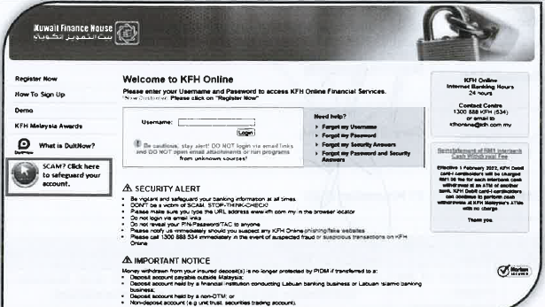
Figure 1 KFHOnline.

User clicks Panic button
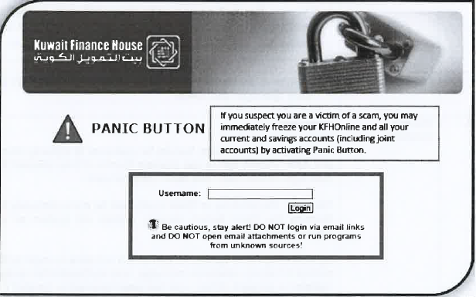
Figure 2 Login – Panic Button KFHOnline

Users fill in credentials for authentication screen
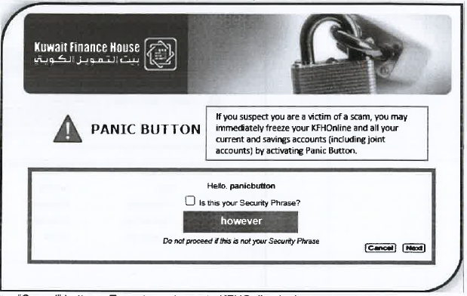
Figure 3 Confirmation Screen– Panic Button KFHOnline

User successfully perform Panic button
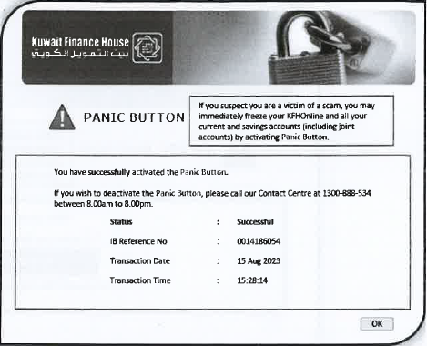

Figure 4 Acknowledgement Screen– Panic Button KFHOnline

[MOD02] BVMC
Enhancement on BVMC system to add new dropdown list for Call Centre to set customer as “ Panic Button Activated “ or “ Panic Button Deactivated “ in the Account Status.

[FUNC02] User Account Unlock by Deactivating Panic Button
This requirement is to unlock user account after system locking it after clicking the Panic Button. This change is applicable for BVMC. If customer wants to deactivate the Panic Button, customer has to call Contact Centre to change the status in BVMC.

[FUNC02.1] Panic Button Deactivation
- Customer is required to call Contact Centre to perform necessary verification to deactivate Panic button.
- Upon searching customer’s details in BVMC “User” screen, system to auto display the output base on the search criteria.
- System to auto display “Account Status” field with “Panic Button Activated” if customer has activated Panic button and Contact Centre us allowed to change to “Panic Button Deactivated” status upon completing the verification with customer which then automatically unblocks the customer.
- System will send notification to customer’s mobile number to update on Panic button deactivation status.
- Customer then needs to re-login by changing their password after “Panic Button Deactivated” status is achieved which will then change the status to “Normal”

Report

Section C: Traceability Matrix
Document Matrix
No | BRS | FSD
1 | - | -

No BRS document to map for the requirements
No | BRS | FSD

