SCPID#6897
Test Title: |  | Change BSNeBiz Mobile App Wallpaper (Android/iOS)
Test Description: |  | Issue: To change the current wallpaper to new 50th Years BSN Anniversary wallpaper for BSNeBiz Mobile Apps.  Solution:  1. Change wallpaper to new 50th Years BSN Anniversary wallpaper  2. Remove moving feature on the image
Test Functionality: |  | To test on BSNeBiz Mobile wallpaper for Android and iOS.
Test Procedure: |  | Test steps:  - Access BSNeBiz using Android and iOS  - View and verify the wallpaper
Response Message:
Test Result: | Pass: Fail: |  | Tested by: | Nor Athirah Umairah (05/01/2024)
Reason for Failure:
Remarks: |  | 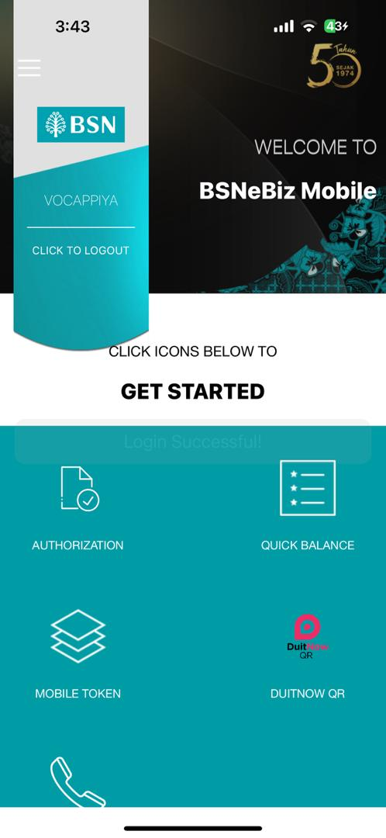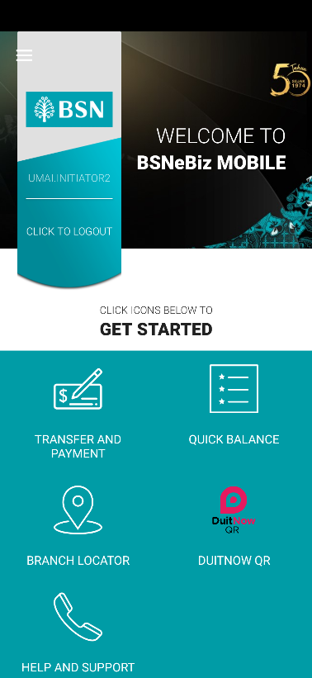  BSNeBiz Home screen (From left: iOS_v3.3.5, Android_v2.1.1)

