|  |
| --- |
|  |
| **Corporate Digital Banking**  **Goods and Services Tax (GST)**  **for**  **BSNeBiz and Mobile BSNeBiz** |
| Performance Testing Report |
|  |
| ***(PENRIL/BSN-PERF-TEST/BSNeBiz/00) – [(P2)-033])***  ***Revision: 00*** |
| **19th January 2024**  Prepared By:    **Penril Datability (M) Sdn Bhd (816792-X),**  Suite A-07-07 Plaza Mont Kiara,  No. 2, Jalan Kiara, Mont Kiara,  50480 Kuala Lumpur, Malaysia.  Tel: (603) 6201 2622, Fax: (603) 6201 7622. |

Performance Testing Acceptance

I/We hereby verify that this Performance Testing Acceptance Document consists of all the information requested by Bank Simpanan Nasional.

I/We also hereby AGREE that this satisfies our entire performance test result for DB Tech Refresh (MSSQL 2019) in UAT environment.

Bank Simpanan Nasional:

|  |  |  |  |
| --- | --- | --- | --- |
| Approved by | Role | Signature | Date |
|  |  |  |  |
|  |  |  |  |
|  |  |  |  |
|  |  |  |  |
|  |  |  |  |
|  |  |  |  |
|  |  |  |  |
|  |  |  |  |
|  |  |  |  |
|  |  |  |  |
|  |  |  |  |

Penril Datability (M) Sdn. Bhd.:

|  |  |  |  |
| --- | --- | --- | --- |
| Approved by | Role | Signature | Date |
|  |  |  |  |
|  |  |  |  |
|  |  |  |  |

**Document Management**

|  |  |  |  |  |
| --- | --- | --- | --- | --- |
| Rev. No | Date Update | Description of Change | Updated By | Reviewed By |
| 00 | 19/Jan/2024 | Initial Release | Nurin Sabrina Binti Azauddin |  |
|  |  |  |  |  |
|  |  |  |  |  |

**Table of Contents**

Chapter 1 - Introduction 7

1. Background 7

2. Purpose 7

Chapter 2 – Content 8

1. Execution Strategy 8

1.1 Type of testing: Load Testing 8

1.2 Methods of Testing 8

1.3 Process of testing – Adding GST on BSNeBIZ Transfer & Payment 12

**1.3.1** **[TS-TP-GST-STEP1] – BSNeBiz Login Page – Step 1 (commonLogin.action)** 12

**1.3.2** **[TS-TP-GST-STEP2] - BSNeBiz Login Page – Step 2 (ibPortalLoginUsername.action)** 12

**1.3.3** **[TS-TP-GST-STEP3] – BSNeBiz Home Page – Step 3 (ibPortalLogin.action)** 13

**1.3.4** **[TS-TP-GST-STEP4] – Transfer & Payment Page – Step 4 (ibTransferinit)** 14

**1.3.5** **[TS-TP-GST-STEP5] – Transfer & Payment Page – Step 5 (ibTransferForward.action)** 14

**1.3.6** **[TS-TP-GST-STEP6] – Transfer & Payment Own Account Transfer Page – Step 6 (ibOwnTransferForward.action)** 15

**1.3.7** **[TS-TP-GST-STEP7] -Transfer & Payment Confirmation Page – Step 7 (ibTransferConfirm.action)** 15

**1.3.8** **[TS-TP-GST-STEP8] – Transfer & Payment Results Page – Step 8 (ibTransferResults.action)** 16

**1.3.9** **[TS-TP-GST-STEP9] – Transfer & Payment Receipt Pdf Download Page – Step 9 (ibTransferReceiptPdfDownload.action)** 17

1.4 Process of testing – Adding GST on BSNeBIZ JomPay 19

**1.4.1** **[TS-JP-GST-STEP1] – BSNeBiz Login Page – Step 1 (commonLogin.action)** 19

**1.4.2** **[TS-JP-GST-STEP2] – BSNeBiz Login Page – Step 2 (ibPortalLoginUsername.action)** 19

**1.4.3** **[TS-JP-GST-STEP3] – BSNeBiz Home Page – Step 3 (ibPortalLogin.action)** 20

**1.4.4** **[TS-JP-GST-STEP4] – JomPay Details Page – Step 4 (ibJomPayinit)** 21

**1.4.5** **[TS-JP-GST-STEP5] – JomPay Details Page – Step 5 (ibJomPayForward.action)** 21

**1.4.6** **[TS-JP-GST-STEP6] – JomPay Confirmation Page – Step 6 (ibJomPayConfirm.action)** 22

**1.4.7** **[TS-JP-GST-STEP7] – JomPay Results Page – Step 7 (ibJomPayResults.action)** 22

**1.4.8** **[TS-JP-GST-STEP8] – JomPay Download Receipt Page– Step 8 (ibJomPayReceiptPdfDownload.action)** 23

1.5 Process of testing – Adding GST on BSNeBIZ Bulk Payment - File Upload 25

**1.5.1** **[TS-FU-GST-STEP1] – BSNeBiz Login Page – Step 1 (commonLogin.action)** 25

**1.5.2** **[TS-FU-GST-STEP2] – BSNeBiz Login Page – Step 2 (ibPortalLoginUsername.action)** 25

**1.5.3** **[TS-FU-GST-STEP3] – BSNeBiz Home Page – Step 3 (ibPortalLogin.action)** 26

**1.5.4** **[TS-FU-GST-STEP4] – File Upload Page – Step 4 (ibFileUploadDetails)** 27

**1.5.5** **[TS-FU-GST-STEP5] – File Upload Details Organization Code – Step 5 (ibFileUploadConfirmOrganizationCode.action)** 27

**1.5.6** **[TS-FU-GST-STEP6] – File Upload Details Upload File Page – Step 6 (ibFileUploadDetailsUploadFile.action)** 28

**1.5.7** **[TS-FU-GST-STEP7] – File Upload Confirmation Page – Step 7 (ibFileUploadConfirm.action)** 28

**1.5.8** **[TS-FU-GST-STEP8] – File Upload Results Page – Step 8 (ibFileUploadResults.action)** 29

**1.5.9** **[TS-FU-GST-STEP9] – File Upload Download Receipt PDF Page– Step 9 (ibFileUploadReceiptPdfDownload.action)** 29

1.6 Process of testing – Adding GST on BSNeBIZ Bulk Payment – Add New Data 31

**1.6.1** **[TS-DE-GST-STEP1] – BSNeBiz Login Page – Step 1 (commonLogin.action)** 31

**1.6.2** **[TS-DE-GST-STEP2] – BSNeBiz Login Page – Step 2 (ibPortalLoginUsername.action)** 31

**1.6.3** **[TS-DE-GST-STEP3] – BSNeBiz Home Page – Step 3 (ibPortalLogin.action)** 32

**1.6.4** **[TS-DE-GST-STEP4] – Data Entry Page – Step 4 (ibDataEntryDetails)** 33

**1.6.5** **[TS-DE-GST-STEP5] – Data Entry Details Organization Code – Step 5 (ibDataEntryConfirmOrganizationCode.action)** 34

**1.6.6** **[TS-DE-GST-STEP6] – Data Entry Details File Format – Step 6 (ibDataEntryConfirmFileFormat.action)** 34

**1.6.7** **[TS-DE-GST-STEP7] – Data Entry Check Duplicate Number – Step 7 (ibDataEntryCheckDuplicate.action)** 35

**1.6.8** **[TS-DE-GST-STEP8] – Data Entry Save File Page – Step 8 (ibDataEntrySaveFile.action)** 35

**1.6.9** **[TS-DE-GST-STEP9] – Data Entry Confirmation Page – Step 9 (ibDataEntryConfirm.action)** 36

**1.6.10** **[TS-DE-GST-STEP10] – Data Entry Result Page – Step 10 (ibDataEntryResults.action)** 36

**1.6.11** **[TS-FU-GST-STEP8] – File Upload Download Receipt PDF Page– Step 11 (ibDataEntryReceiptPdfDownload.action)** 37

1.7 Process of testing – Adding GST on BSNeBIZ Bulk Payment – Edit Data Entry 39

**1.7.1** **[TS-ED-GST-STEP1] – BSNeBiz Login Page – Step 1 (commonLogin.action)** 39

**1.7.2** **[TS-ED-GST-STEP2] – BSNeBiz Login Page – Step 2 (ibPortalLoginUsername.action)** 39

**1.7.3** **[TS-ED-GST-STEP3] – BSNeBiz Home Page – Step 3 (ibPortalLogin.action)** 40

**1.7.4** **[TS-ED-GST-STEP4] – Data Entry Page – Step 4 (ibDataEntryDetails)** 41

**1.7.5** **[TS-ED-GST-STEP5] – Edit Data Entry Page – Step 5 (ibEditData)** 41

**1.7.6** **[TS-ED-GST-STEP6] – Edit Data Organization Code – Step 6 (ibEditDataDetailOrganizationCode.action)** 42

**1.7.7** **[TS-ED-GST-STEP7] – Edit Data File Format – Step 7 (ibEditDataDetailFileFormat.action)** 42

**1.7.8** **[TS-ED-GST-STEP8] – Edit Data Upload File – Step 8 (ibEditDataDetailUploadFile.action)** 43

**1.7.9** **[TS-ED-GST-STEP9] – Edit Data Check Duplicate – Step 9 (ibEditDataConfirmCheckDuplicate.action)** 43

**1.7.10** **[TS-ED-GST-STEP10] – Edit Data Save File – Step 10 (ibEditDataConfirmSaveFile.action)** 44

**1.7.11** **[TS-ED-GST-STEP11] – Edit Data Confirmation Page – Step 11 (ibEditDataConfirmSubmit.action)** 44

**1.7.12** **[TS-ED-GST-STEP12] – Edit Data Results Page – Step 12 (ibEditDataResults.action)** 45

**1.7.13** **[TS-FU-GST-STEP13] – Edit Data Download Receipt PDF Page– Step 13 (ibEditDataReceiptPdfDownload.action)** 46

1.8 Process of testing – Adding GST on BSNeBIZ Authorization – Verifier 48

**1.8.1** **[TS-AV-GST-STEP1] – BSNeBiz Login Page – Step 1 (commonLogin.action)** 48

**1.8.2** **[TS-AV-GST-STEP2] – BSNeBiz Login Page – Step 2 (ibPortalLoginUsername.action)** 48

**1.8.3** **[TS-AV-GST-STEP3] – BSNeBiz Home Page – Step 3 (ibPortalLogin.action)** 49

**1.8.4** **[TS-AV-GST-STEP4] – Verification Page – Step 4 (ibAuthorization)** 50

**1.8.5** **[TS-AV-GST-STEP5] – Confirmation Page – Step 5 (ibMaker)** 50

**1.8.6** **[TS-AV-GST-STEP6] – Verifier Result Page – Step 6 (ibCheckerResults.action)** 51

**1.8.7**  **[TS-AV-GST-STEP7] – Verifier Download Receipt PDF Page – Step 7 (ibVerifierReceiptPdfDownload.action)** 51

1.9 Process of testing – Adding GST on BSNeBIZ Authorization – Approver 53

**1.9.1** **[TS-AA-GST-STEP1] – BSNeBiz Login Page – Step 1 (commonLogin.action)** 53

**1.9.2** **[TS-AA-GST-STEP2] – BSNeBiz Login Page – Step 2 (ibPortalLoginUsername.action)** 53

**1.9.3** **[TS-AA-GST-STEP3] – BSNeBiz Home Page – Step 3 (ibPortalLogin.action)** 54

**1.9.4** **[TS-AA-GST-STEP4] – Approval Page – Step 4 (ibAuthorization)** 55

**1.9.5** **[TS-AA-GST-STEP5] – Confirmation Page – Step 5 (ibMaker)** 55

**1.9.6** **[TS-AA-GST-STEP6] – Approver Result Page – Step 6 (ibCheckerResults.action)** 56

**1.9.7**  **[TS-AA-GST-STEP7] – Approver Download Receipt PDF Page – Step 7 (ibApproverReceiptPdfDownload.action)** 57

1.10 Process of testing – Adding GST on Transfer & Payment 59

**1.10.1** **[TS-MB-GST-STEP1] – Mobile BSNeBiz Login Page – Step 1 (Login_Generate)** 59

**1.10.2**  **[TS-MB-GST-STEP2] – Mobile BSNeBiz Home Page – Step 2 (Homepage_Generate)** 59

**1.10.3**  **[TS-MB-GST-STEP3] – Transfer & Payment Page – Step 3 (Transfer_Generate)** 60

**1.10.4**  **[TS-MB-GST-STEP4] – Transfer To Page – Step 4 (Transfer_Generate)** 60

**1.10.5**  **[TS-MB-GST-STEP5] – Transfer Details Page – Step 5 (TransferDetails_Generate)** 61

**1.10.6**  **[TS-MB-GST-STEP6] – Confirmation Page – Step 6 (Confirmation_Generate)** 61

**1.10.7**  **[TS-MB-GST-STEP7] – Pending Result Page – Step 7 (Pending_Generate)** 62

**1.10.8**  **[TS-MB-GST-STEP8] – Share PDF Receipt Page – Step 8 (PdfReceipt_Generate)** 62

1.11 Tools: Apache JMeter 5.1.1 r1855137 63

2. Business Processes Involved 64

3. Performance Test Environment 67

4. Test Scenario & Test Result with Explanation in Layman Terms 68

# Chapter 1 - Introduction

## Background

Bank implements the Goods and Service Tax (GST) for BSN’s Corporate Digital Banking (BSNeBiz) system, which is customer able to view GST charges on transactions which are linked to his/her CDB profile. However, the bank requested Penril to perform a performance report at BSNeBiz Transfer & Payment, BSNeBiz JomPay, BSNeBiz Bulk Payment, BSNeBiz Authorization and Mobile BSNeBiz Transfer & Payment.

## Purpose

Bank need to ensure that by implementing BSNeBiz Transfer & Payment, BSNeBiz JomPay, BSNeBiz Bulk Payment, BSNeBiz Authorization, Mobile BSNeBiz Transfer & Payment and integrating IB to this new system will not cause major performance degradation.

Thus, this document describes the Performance Test Result before and after IB integration to BSNeBiz Transfer & Payment, BSNeBiz JomPay, BSNeBiz Bulk Payment, BSNeBiz Authorization, Mobile BSNeBiz Transfer & Payment in the UAT environment.

# Chapter 2 – Content

## Execution Strategy

### Type of testing: Load Testing

A load test is a planned test to perform a specified number of requests to a system in order to test the query to DB under specific levels of simultaneous requests. A load test ensures that CDB is capable of handling an expected volume of traffic, and therefore is sometimes referred to as volume testing.

The goal of this load test is to prove that with new integration to BSNeBiz Transfer & Payment, BSNeBiz JomPay, BSNeBiz Bulk Payment, BSNeBiz Authorization, Mobile BSNeBiz Transfer & Payment, it can handle the expected volume with minimal to acceptable performance degradation. In this test scenario, we simulated the maximum number of requests with the goal of less than 1% of errors.

### Methods of Testing

Penril conducted load testing to the selected menu mentioned in Chapter 1 - 2 Purpose - Module to Test. The test scenarios will be New Application, because this is considered one of modules that perform heavy query to database and highest number of touch points BSNeBiz. Below is the list of detailed test modules in BSNeBiz:

|  |  |  |  |
| --- | --- | --- | --- |
| System | Function | Module | Test Case |
| **BSNeBiz** | Transfer &  Payment | BSNeBiz Login Page – Step 1  (commonLogin.action) | [TS-TP-GST-STEP1] |
| BSNeBiz Login Page – Step 2  (ibPortalLoginUsername.action) | [TS-TP-GST-STEP2] |
| BSNeBiz Home Page – Step 3  (ibPortalLogin.action) | [TS-TP-GST-STEP3] |
| BSNeBiz Transfer & Payment Page – Step 4  (ibTransferinit) | [TS-TP-GST-STEP4] |
| Transfer & Payment Details Page – Step 5  (ibTransferForward.action) | [TS-TP-GST-STEP5] |
| Transfer & Payment Own Fund Transfer Page – Step 6  (ibOwnFundTransferForward.action) | [TS-TP-GST-STEP6] |
| Transfer & Payment Confirmation Page – Step 7  (ibTransferConfirm.action) | [TS-TP-GST-STEP7] |
| Transfer & Payment Result Page – Step 8  (ibTransferResults.action) | [TS-TP-GST-STEP8] |
| Transfer & Payment Download Receipt PDF – Step 9  (ibTransferReceiptPdfDownload.action) | [TS-TP-GST-STEP9] |
| JomPay | BSNeBiz Login Page – Step 1  (ibPortalAccess) | [TS-JP-GST-STEP1] |
| BSNeBiz Login Page – Step 2  (ibPortalLoginUsername.action) | [TS-JP-GST-STEP2] |
| BSNeBiz Home Page – Step 3  (ibPortalLogin.action) | [TS-JP-GST-STEP3] |
| JomPay Page – Step 4  (ibJomPayInit) | [TS-JP-GST-STEP4] |
| JomPay Details Page – Step 5  (ibJomPayForward.action) | [TS-JP-GST-STEP5] |
| JomPay Confirmation Page – Step 6  (ibJomPayConfirm.action) | [TS-JP-GST-STEP6] |
| JomPay Results Page – Step 7  (ibJomPayResults.action) | [TS-JP-GST-STEP7] |
| JomPay Download Receipt PDF – Step 8  (ibJomPayReceiptPdfDownload.action) | [TS-JP-GST-STEP8] |
| Bulk Payment  (File Upload) | BSNeBiz Login Page – Step 1  (commonLogin.action) | [TS-FU-GST-STEP1] |
| BSNeBiz Login Page – Step 2  (ibPortalLoginUsername.action) | [TS-FU-GST-STEP2] |
| BSNeBiz Home Page – Step 3  (ibPortalLogin.action) | [TS-FU-GST-STEP3] |
| File Upload Page – Step 4  (ibFileUploadDetails) | [TS-FU-GST-STEP4] |
| File Upload Details Organization Code – Step 5  (ibFileUploadConfirmOrganizationCode.action) | [TS-FU-GST-STEP5] |
| File Upload Details Upload File – Step 6  (ibFileUploadDetailsUploadFile.action) | [TS-FU-GST-STEP6] |
| File Upload Confirmation Page – Step 7  (ibFileUploadConfirm.action) | [TS-FU-GST-STEP7] |
| File Upload Result Page – Step 8  (ibFileUploadResults.action) | [TS-FU-GST-STEP8] |
| File Upload Download Receipts PDF – Step 9  (ibFileUploadReceiptPdfDownload.action) | [TS-FU-GST-STEP9] |
| Bulk Payment  (Add New Data) | BSNeBiz Login Page – Step 1  (commonLogin.action) | [TS-DE-GST-STEP1] |
| BSNeBiz Login Page – Step 2  (ibPortalLoginUsername.action) | [TS-DE-GST-STEP2] |
| BSNeBiz Home Page – Step 3  (ibPortalLogin.action) | [TS-DE-GST-STEP3] |
| Data Entry Page – Step 4  (ibDataEntryDetails) | [TS-DE-GST-STEP4] |
| Data Entry Details Organization Code – Step 5  (ibDataEntryConfirmOrganizationCode.action) | [TS-DE-GST-STEP5] |
| Data Entry Details File Format – Step 6  (ibDataEntryConfirmFileFormat.action) | [TS-DE-GST-STEP6] |
| Data Entry Check Duplicates Number – Step 7  (ibDataEntryCheckDuplicate.action) | [TS-DE-GST-STEP7] |
| Data Entry Save File – Step 8  (ibDataEntrySaveFile.action) | [TS-DE-GST-STEP8] |
| Data Entry Confirmation Page – Step 9  (ibDataEntryConfirm.action) | [TS-DE-GST-STEP9] |
| Data Entry Results Page – Step 10  (ibDataEntryResults.action) | [TS-DE-GST-STEP10] |
| Data Entry Download Receipts PDF – Step 11  (ibDataEntryReceiptsPdfDownload.action) | [TS-DE-GST-STEP11] |
| Bulk Payment  (Edit Data Entry) | BSNeBiz Login Page – Step 1  (commonLogin.action) | [TS-ED-GST-STEP1] |
| BSNeBiz Login Page – Step 2  (ibPortalLoginUsername.action) | [TS-ED-GST-STEP2] |
| BSNeBiz Login Page – Step 3  (ibPortalLogin.action) | [TS-ED-GST-STEP3] |
| Data Entry Page – Step 4  (ibDataEntryDetails) | [TS-ED-GST-STEP4] |
| Edit Data Entry Page – Step 5  (ibEditData) | [TS-ED-GST-STEP5] |
| Edit Data Organization Code – Step 6  (ibEditDataDetailsOrganizationCode.action) | [TS-ED-GST-STEP6] |
| Edit Data File Format – Step 7  (ibEditDataDetailFileFormat.action) | [TS-ED-GST-STEP7] |
| Edit Data Upload File – Step 8  (ibEditDataDetailUploadFile.action) | [TS-ED-GST-STEP8] |
| Edit Data Check Duplicate – Step 9  (ibEditDataConfirmCheckDuplicate.action) | [TS-ED-GST-STEP9] |
| Edit Data Save File – Step 10  (ibEditDataConfirmSaveFile.action) | [TS-ED-GST-STEP10] |
| Edit Data Confirmation Page – Step 11  (ibEditDataConfirmSubmit.action) | [TS-ED-GST-STEP11] |
| Edit Data Result Page – Step 12  (ibEditDataResults.action) | [TS-ED-GST-STEP12] |
| Edit Data Download Receipts PDF – Step 13  (ibEditDataReceiptPdfDownload.action) | [TS-ED-GST-STEP13] |
| Authorization  (Verifier) | BSNeBiz Login Portal – Step 1  (commonLogin.action) | [TS-AV-GST-STEP1] |
| BSNeBiz Login Page – Step 2  (ibPortalLoginUsername.action) | [TS-AV-GST-STEP2] |
| BSNeBiz Home Page – Step 3  (ibPortalLogin.action) | [TS-AV-GST-STEP3] |
| Verification Page – Step 4  (ibAuthorization) | [TS-AV-GST-STEP4] |
| Confirmation Page – Step 5  (ibMaker) | [TS-AV-GST-STEP5] |
| Verifier Result Page – Step 6  (ibCheckerResults.action) | [TS-AV-GST-STEP6] |
| Verifier Download Receipt PDF – Step 7  (ibVerifierReceiptPdfDownload.action) | [TS-AV-GST-STEP7] |
| Authorization  (Approver) | BSNeBiz Login Portal – Step 1  (commonLogin.action) | [TS-AA-GST-STEP1] |
| BSNeBiz Login Page – Step 2  (ibPortalLoginUsername.action) | [TS-AA-GST-STEP2] |
| BSNeBiz Home Page – Step 3  (ibPortalLogin.action) | [TS-AA-GST-STEP3] |
| Approval Page – Step 4  (ibAuthorization) | [TS-AA-GST-STEP4] |
| Confirmation Page – Step 5  (ibMaker) | [TS-AA-GST-STEP5] |
| Approver Results Page – Step 6  (ibCheckerResults.action) | [TS-AA-GST-STEP6] |
| Approver Download Receipt PDF – Step 7  (ibApproverReceiptPdfDownload.action) | [TS-AA-GST-STEP7] |
| **Mobile BSNeBiz** | Transfer &  Payment | Mobile BSNeBiz Login Page – Step 1  (Login_Generate) | [TS-MB-GST-STEP1] |
| Mobile BSNeBiz Home Page – Step 2  (Homepage_Generate) | [TS-MB-GST-STEP2] |
| Transfer & Payment Page – Step 3  (Transfer_Generate) | [TS-MB-GST-STEP3] |
| Transfer To Page – step 4  (TransferTo_Generate) | [TS-MB-GST-STEP4] |
| Transfer Details Page – Step 5  (TransferDetails_Generate) | [TS-MB-GST-STEP5] |
| Confirmation Page – Step 6  (Confirmation_Generate) | [TS-MB-GST-STEP6] |
| Pending Result Page – Step 7  (Pending_Generate) | [TS-MB-GST-STEP7] |
| Share PDF Receipt Page – Step 8  (PdfReceipt_Generate) | [TS-MB-GST-STEP8] |

|  |
| --- |
| Important Notes:  This performance test case does not reflect the actual performance in the production environment. Bank need to provide the ratio between staging vs. production environment. |

### Process of testing – Adding GST on BSNeBIZ Transfer & Payment

This test scenario simulates concurrent users adding GST on BSNeBiz Transfer & Payment service. This test case depends on below test case to be executed:

#### **[TS-TP-GST-STEP1] – BSNeBiz Login Page – Step 1 (commonLogin.action)**

**In this stage, the CDB connects to:**

1. DB

**The DB fetches:**

* IB_SERVICE_INFO. IB_SERVICE_INFO contains some notes or announcements.

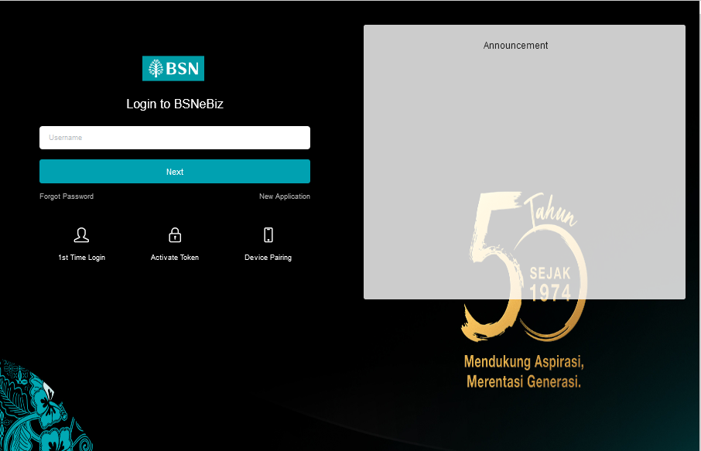

Figure 1: BSNeBiz Login page

#### **[TS-TP-GST-STEP2] - BSNeBiz Login Page – Step 2 (ibPortalLoginUsername.action)**

**In this stage, the CDB connects to:**

1. DB

**The DB fetches:**

* **Database. Database** contains data for BSNeBiz Login Details.

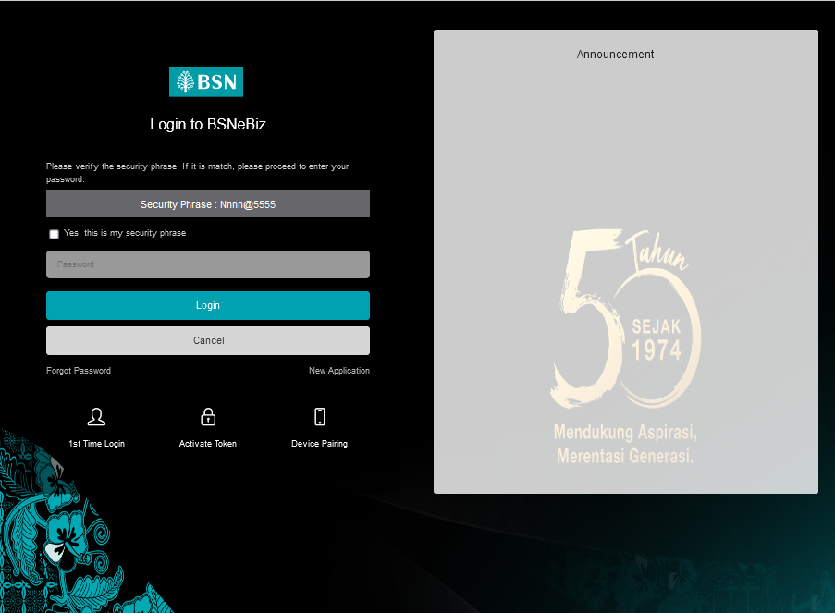

Figure 2 : BSNeBiz Login Page

#### **[TS-TP-GST-STEP3] – BSNeBiz Home Page – Step 3 (ibPortalLogin.action)**

**In this stage, the CDB connects to BSNeBiz Home page:**

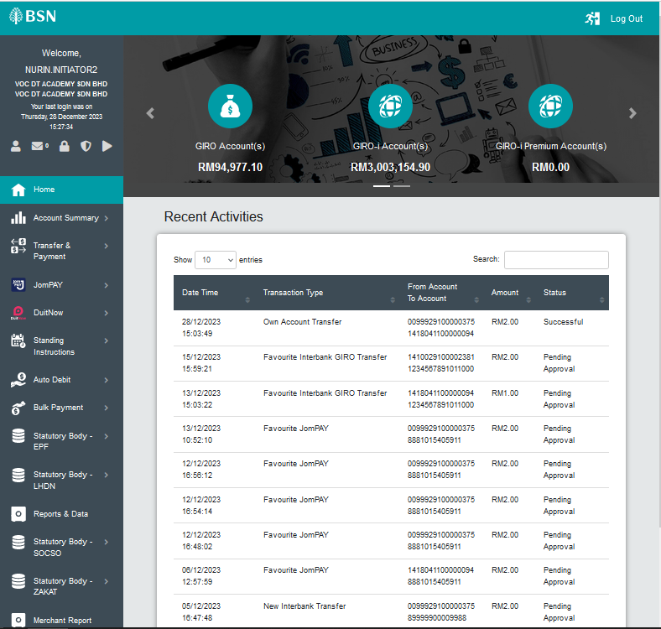

Figure 3: BSNeBiz Home page

#### **[TS-TP-GST-STEP4] – Transfer & Payment Page – Step 4 (ibTransferinit)**

**In this stage, the CDB connects to Transfer & Payment page:**

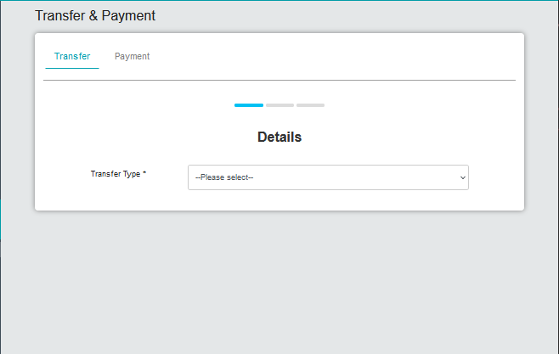

Figure 4: BSNeBiz Transfer & Payment Details page

#### **[TS-TP-GST-STEP5] – Transfer & Payment Page – Step 5 (ibTransferForward.action)**

**In this stage, the CDB connects to Transfer & Payment Details page select Transfer Type:**



Figure : Transfer & Payment page

#### **[TS-TP-GST-STEP6] – Transfer & Payment Own Account Transfer Page – Step 6 (ibOwnTransferForward.action)**

**In this stage, the CDB connects to Transfer & Payment Own Account Transfer Details page:**

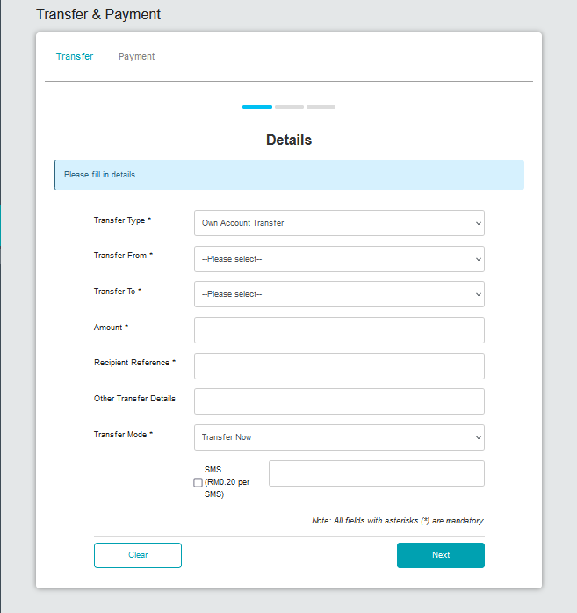

Figure 6 : Transfer type Own Account Transfer details page

#### **[TS-TP-GST-STEP7] -Transfer & Payment Confirmation Page – Step 7 (ibTransferConfirm.action)**

**In this stage, the CDB connects to Transfer & Payment Confirmation page:**

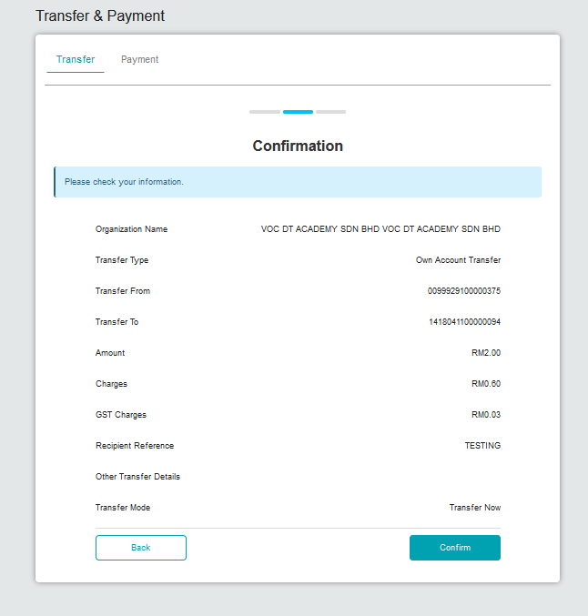

Figure 7: Transfer & Payment Confirmation details page

#### **[TS-TP-GST-STEP8] – Transfer & Payment Results Page – Step 8 (ibTransferResults.action)**

In this stage, the CDB connects to:

1. DB

**The DB fetches:**

* **Database. Database** contains data for Transfer & Payment Result details.

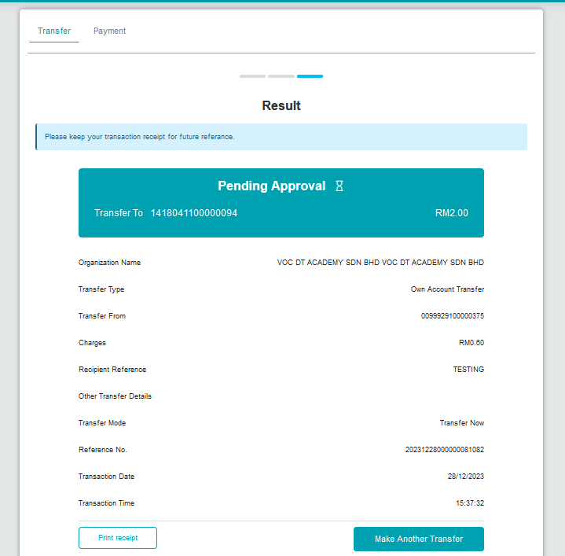

Figure 8: Transfer & Payment Result page

#### **[TS-TP-GST-STEP9] – Transfer & Payment Receipt Pdf Download Page – Step 9 (ibTransferReceiptPdfDownload.action)**

**In this stage, the CDB connects to:**

1. DB

**The DB fetches:**

* BIB_USER_PRINT_RECEIPT. BIB_USER_PRINT_RECEIPT contains data for Own Account Transfer details.

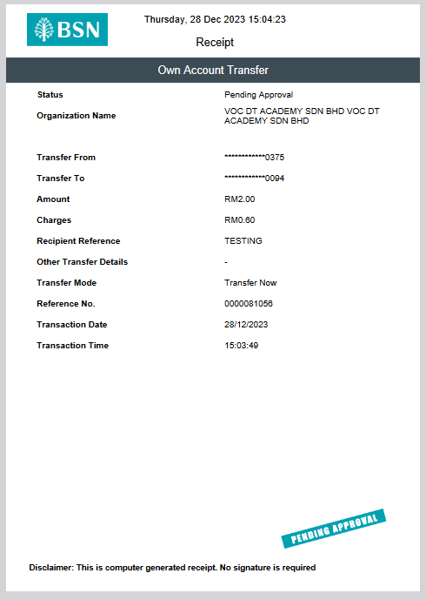

Figure 9 : Own Account Transfer receipt in pdf

### Process of testing – Adding GST on BSNeBIZ JomPay

This test scenario simulates concurrent users adding GST on BSNeBiz JomPay service. This test case depends on below test case to be executed:

#### **[TS-JP-GST-STEP1] – BSNeBiz Login Page – Step 1 (commonLogin.action)**

**In this stage, the CDB connects to:**

1. DB

**The DB fetches:**

* IB_SERVICE_INFO. IB_SERVICE_INFO contains some notes or announcements.



Figure 10 : BSNeBiz Login Page

#### **[TS-JP-GST-STEP2] – BSNeBiz Login Page – Step 2 (ibPortalLoginUsername.action)**

**In this stage, the CDB connects to:**

1. DB

**The DB fetches:**

* **Database. Database** contains data for BSNeBiz Login Details.



Figure : BSNeBiz Login Page

#### **[TS-JP-GST-STEP3] – BSNeBiz Home Page – Step 3 (ibPortalLogin.action)**

**In this stage, the CDB connects to BSNeBiz Home page:**



Figure : BSNeBiz Home page

#### **[TS-JP-GST-STEP4] – JomPay Details Page – Step 4 (ibJomPayinit)**

**In this stage, the CDB connects to JomPay Details page:**

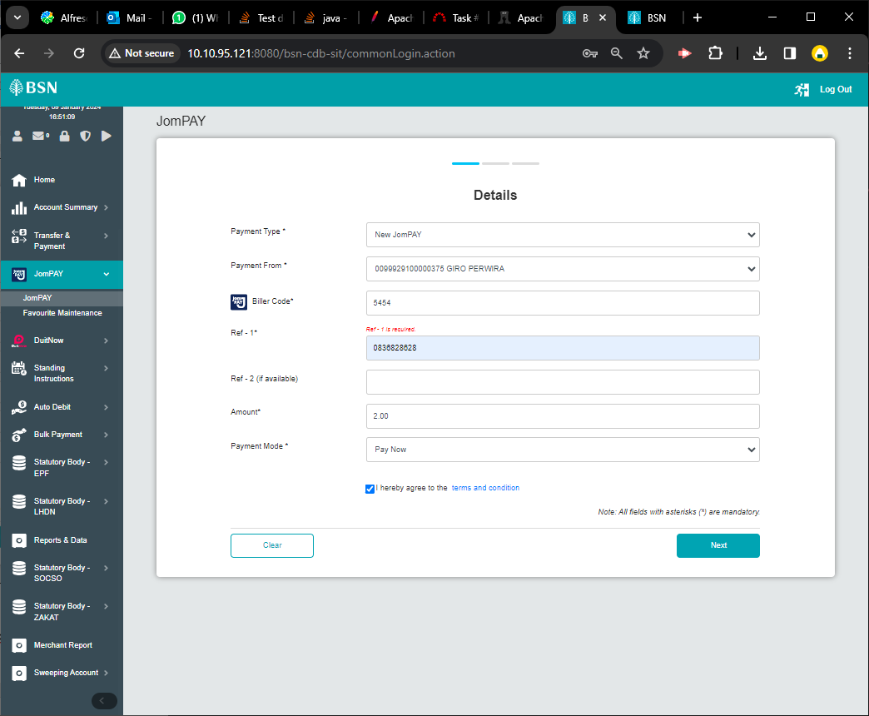

Figure : JomPay page

#### **[TS-JP-GST-STEP5] – JomPay Details Page – Step 5 (ibJomPayForward.action)**

**In this stage, the CDB connects to JomPay Details page:**



Figure : JomPay details page

#### **[TS-JP-GST-STEP6] – JomPay Confirmation Page – Step 6 (ibJomPayConfirm.action)**

**In this stage, the CDB connects to JomPay Confirmation page:**

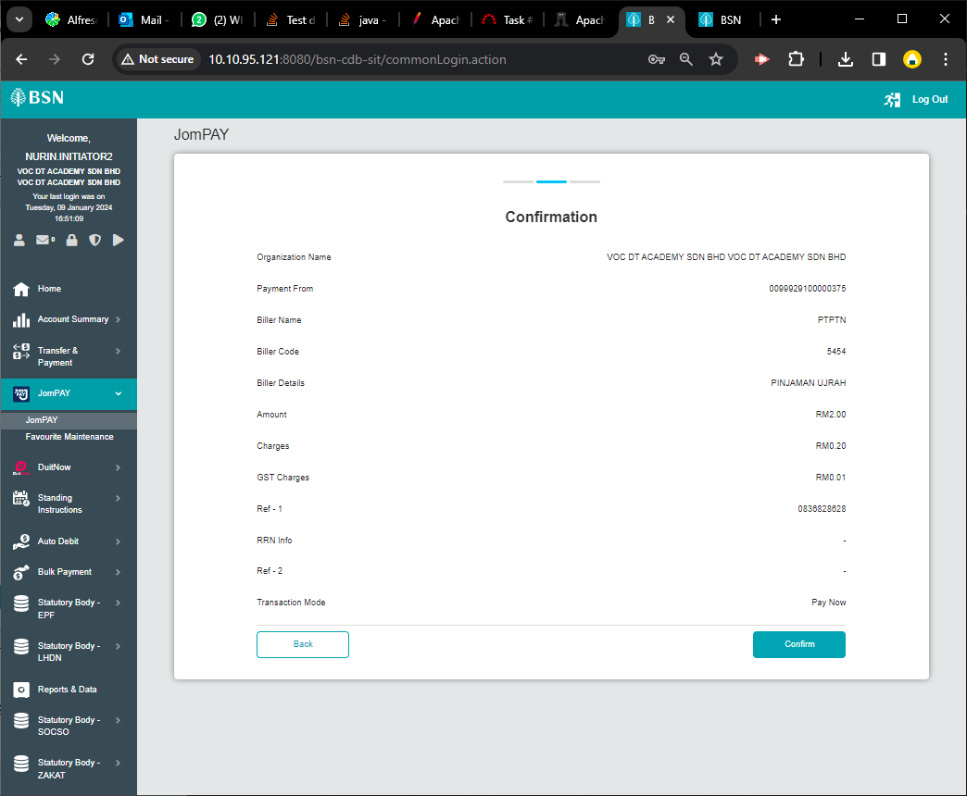

Figure : JomPay Confirmation Details page

#### **[TS-JP-GST-STEP7] – JomPay Results Page – Step 7 (ibJomPayResults.action)**

**In this stage, the CDB connects to:**

1. DB

**The DB fetches:**

* **Database. Database** contains data for JomPay Results details.

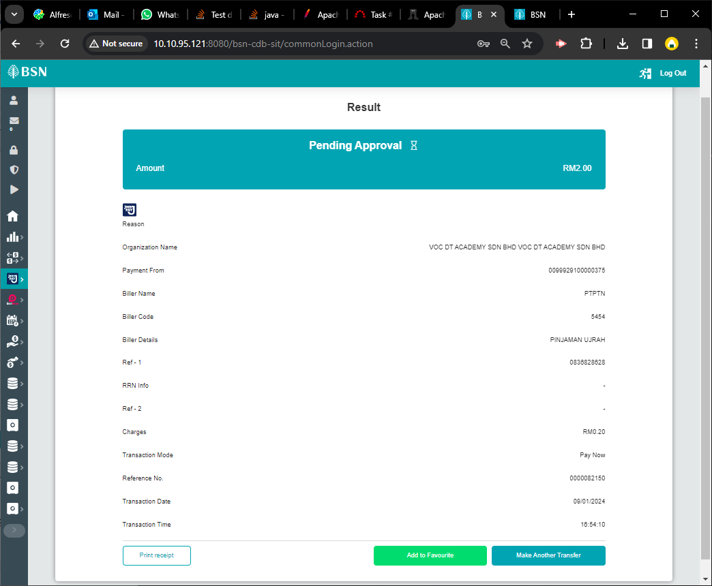

Figure : JomPay Results page

#### **[TS-JP-GST-STEP8] – JomPay Download Receipt Page– Step 8 (ibJomPayReceiptPdfDownload.action)**

**In this stage, the CDB connects to:**

1. DB

**The DB fetches:**

* BIB_USER_PRINT_RECEIPT. BIB_USER_PRINT_RECEIPT contains data for JomPay Payment details.

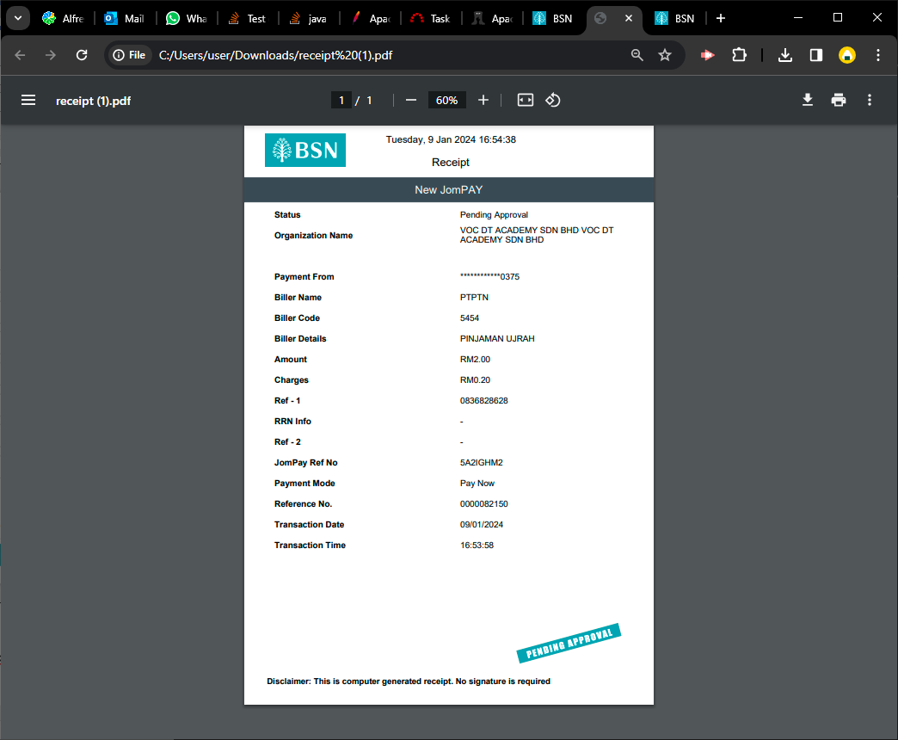

Figure : JomPay receipt in pdf

### Process of testing – Adding GST on BSNeBIZ Bulk Payment - File Upload

This test scenario simulates concurrent users adding GST on BSNeBiz Bulk Payment – File Upload service. This test case depends on below test case to be executed:

#### **[TS-FU-GST-STEP1] – BSNeBiz Login Page – Step 1 (commonLogin.action)**

**In this stage, the CDB connects to:**

1. DB

**The DB fetches:**

* IB_SERVICE_INFO. IB_SERVICE_INFO contains some notes or announcements.



Figure 18: BSNeBiz Login page

#### **[TS-FU-GST-STEP2] – BSNeBiz Login Page – Step 2 (ibPortalLoginUsername.action)**

**In this stage, the CDB connects to:**

1. DB

**The DB fetches:**

* **Database. Database** contains data for BSNeBiz Login Details.



Figure 19 : BSNeBiz Login Page

#### **[TS-FU-GST-STEP3] – BSNeBiz Home Page – Step 3 (ibPortalLogin.action)**

**In this stage, the CDB connects to BSNeBiz Home page:**



Figure 20: BSNeBiz Home page

#### **[TS-FU-GST-STEP4] – File Upload Page – Step 4 (ibFileUploadDetails)**

**In this stage, the CDB connects to Bulk Payment – File Upload page:**

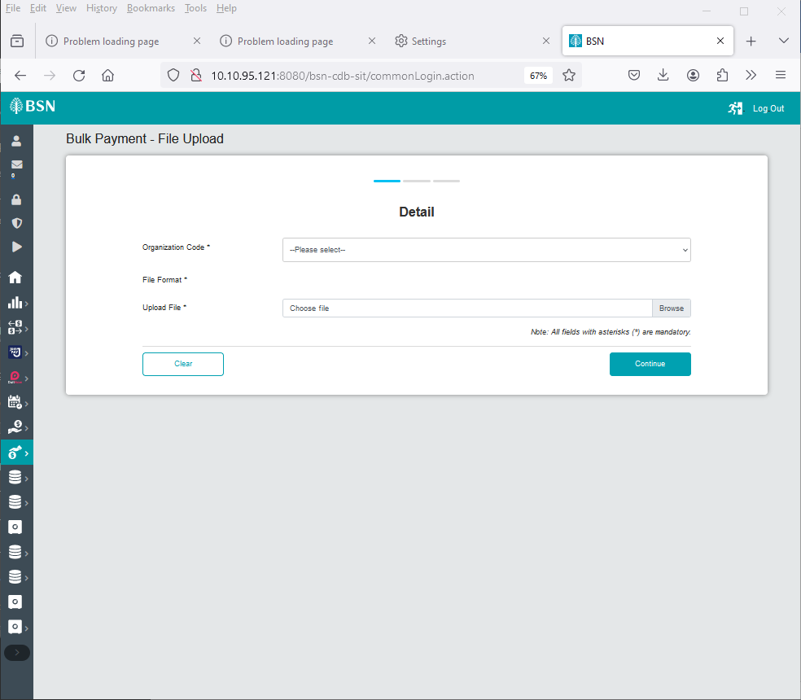

Figure : Bulk Payment - File Upload page

#### **[TS-FU-GST-STEP5] – File Upload Details Organization Code – Step 5 (ibFileUploadConfirmOrganizationCode.action)**

**In this stage, the CDB connects to Bulk Payment – Organization Code page:**

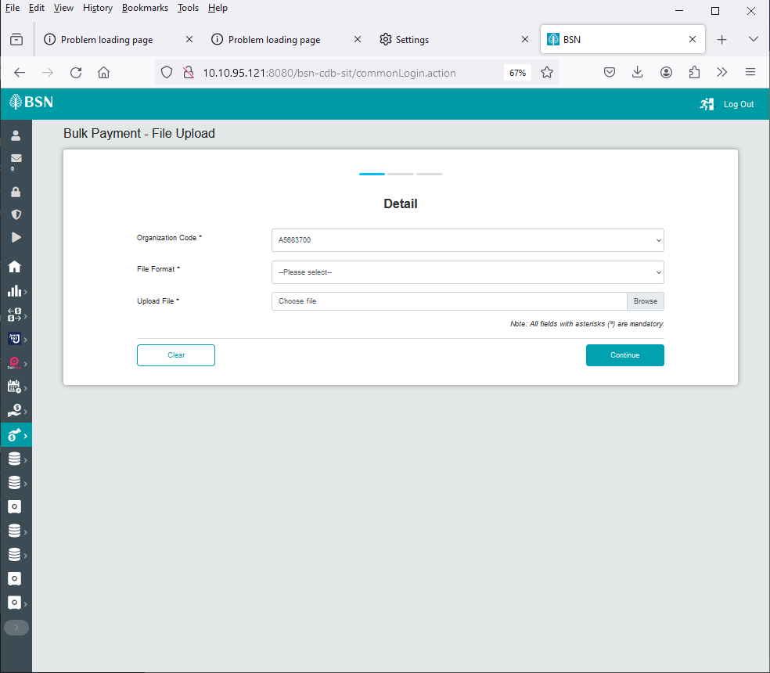

Figure : Bulk Payment - File Upload Details page select Organization Code

#### **[TS-FU-GST-STEP6] – File Upload Details Upload File Page – Step 6 (ibFileUploadDetailsUploadFile.action)**

**In this stage, the CDB connects to Bulk Payment – Upload File page:**

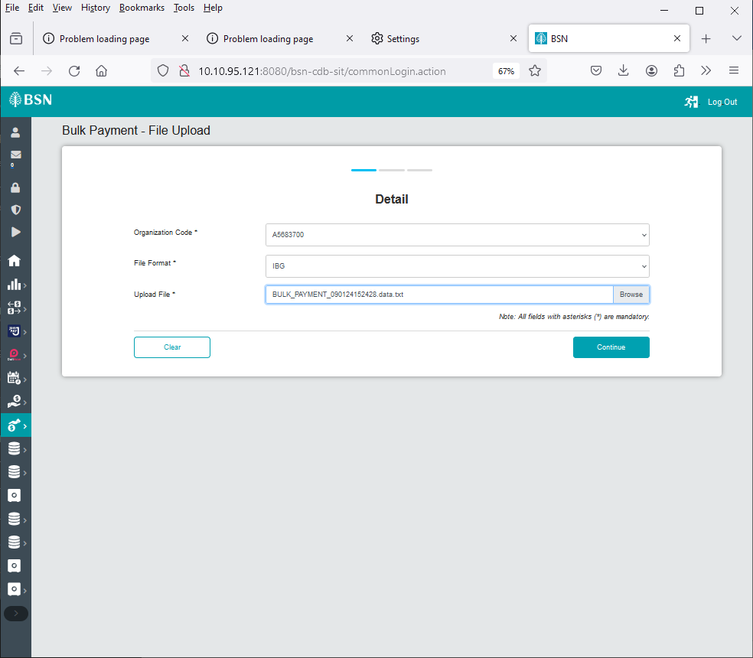

Figure : Bulk Payment - Upload File page

#### **[TS-FU-GST-STEP7] – File Upload Confirmation Page – Step 7 (ibFileUploadConfirm.action)**

**In this stage, the CDB connects to Bulk Payment – Confirmation page:**

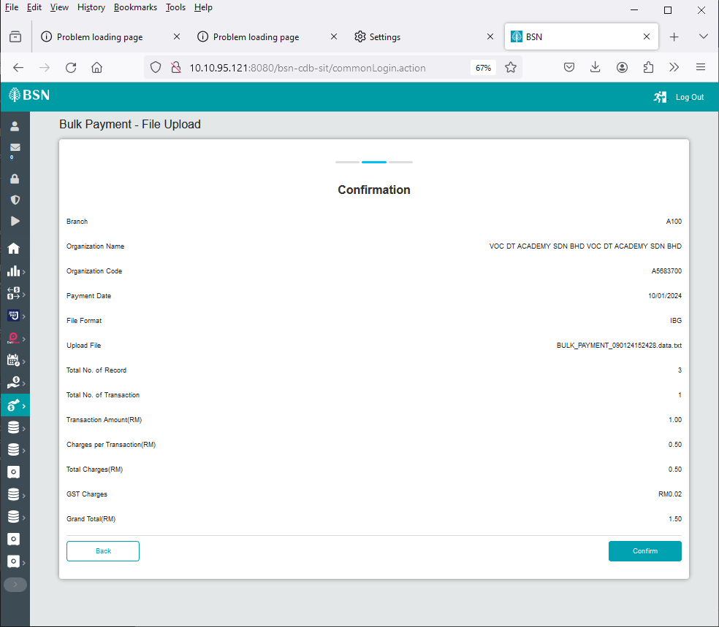

Figure : Bulk Payment - File Upload Confirmation page

#### **1.5.8 [TS-FU-GST-STEP8] – File Upload Results Page – Step 8 (ibFileUploadResults.action)**

**In this stage, the CDB connects to:**

1. DB

**The DB fetches:**

* **Database. Database** contains data for Bulk Payment – File Upload Results details.

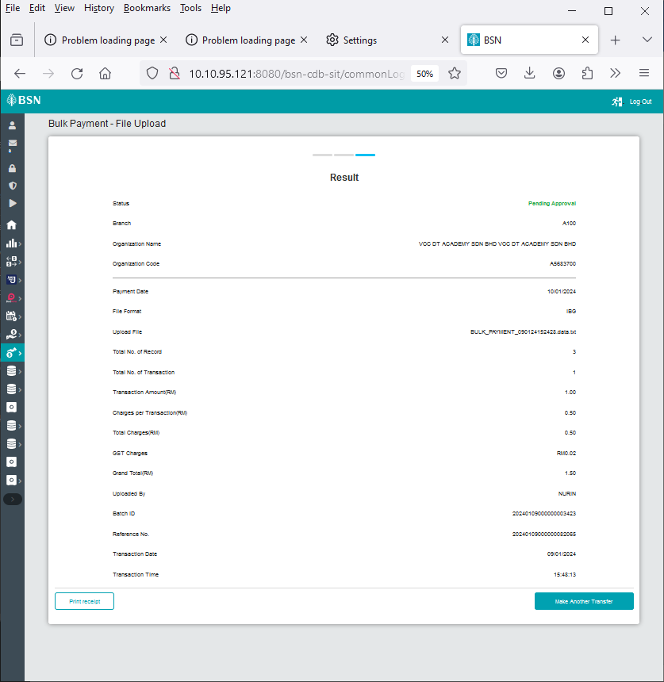

Figure : Bulk Payment - File Upload Result page

#### **1.5.9 [TS-FU-GST-STEP9] – File Upload Download Receipt PDF Page– Step 9 (ibFileUploadReceiptPdfDownload.action)**

**In this stage, the CDB connects to:**

1. DB

**The DB fetches:**

* BIB_USER_PRINT_RECEIPT. BIB_USER_PRINT_RECEIPT contains data for File Upload details.

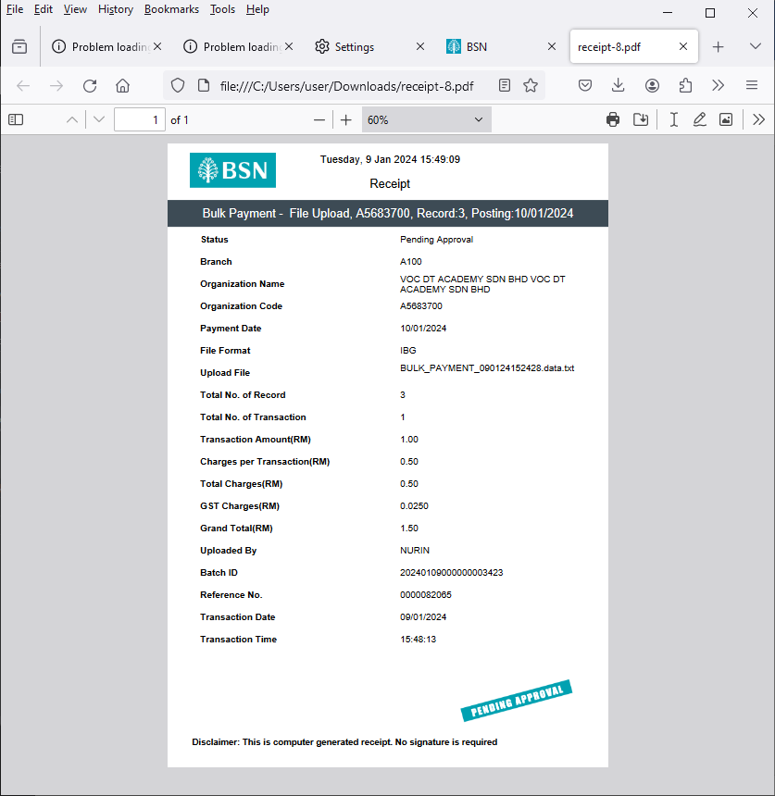

Figure : Bulk Payment - File Upload Pdf Receipts

### Process of testing – Adding GST on BSNeBIZ Bulk Payment – Add New Data

This test scenario simulates concurrent users adding GST on BSNeBiz Bulk Payment – Add New Data service. This test case depends on below test case to be executed:

#### **[TS-DE-GST-STEP1] – BSNeBiz Login Page – Step 1 (commonLogin.action)**

**In this stage, the CDB connects to:**

1. DB

**The DB fetches:**

* IB_SERVICE_INFO. IB_SERVICE_INFO contains some notes or announcements.



Figure : BSNeBiz Login page

#### **[TS-DE-GST-STEP2] – BSNeBiz Login Page – Step 2 (ibPortalLoginUsername.action)**

**In this stage, the CDB connects to:**

1. DB

**The DB fetches:**

* **Database. Database** contains data for BSNeBiz Login Details.



Figure : BSNeBiz Login page

#### **[TS-DE-GST-STEP3] – BSNeBiz Home Page – Step 3 (ibPortalLogin.action)**

**In this stage, the CDB connects to BSNeBiz Home page:**



Figure 29: BSNeBiz Home page

#### **[TS-DE-GST-STEP4] – Data Entry Page – Step 4 (ibDataEntryDetails)**

**In this stage, the CDB connects to Bulk Payment – Data Entry detail page:**

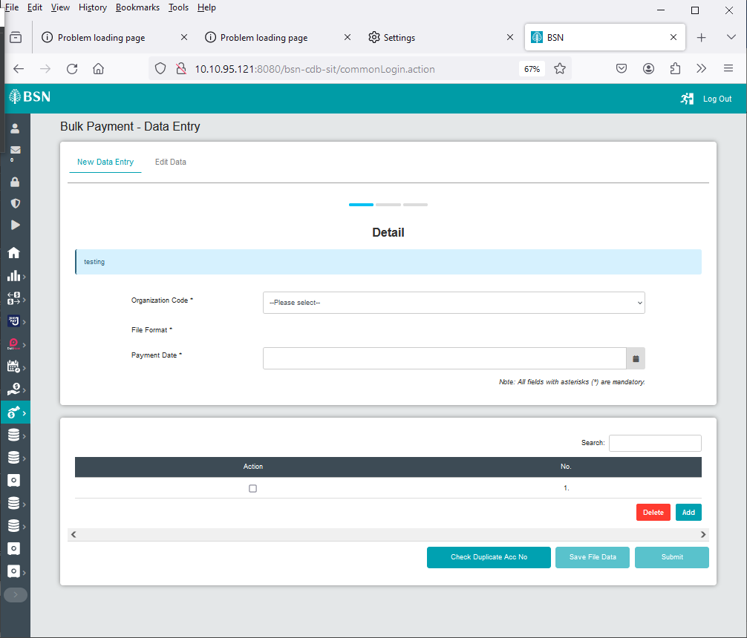

Figure : Bulk Payment – Data Entry page

#### **[TS-DE-GST-STEP5] – Data Entry Details Organization Code – Step 5 (ibDataEntryConfirmOrganizationCode.action)**

**In this stage, the CDB connects to Bulk Payment – Data Entry details page select Organization Code:**

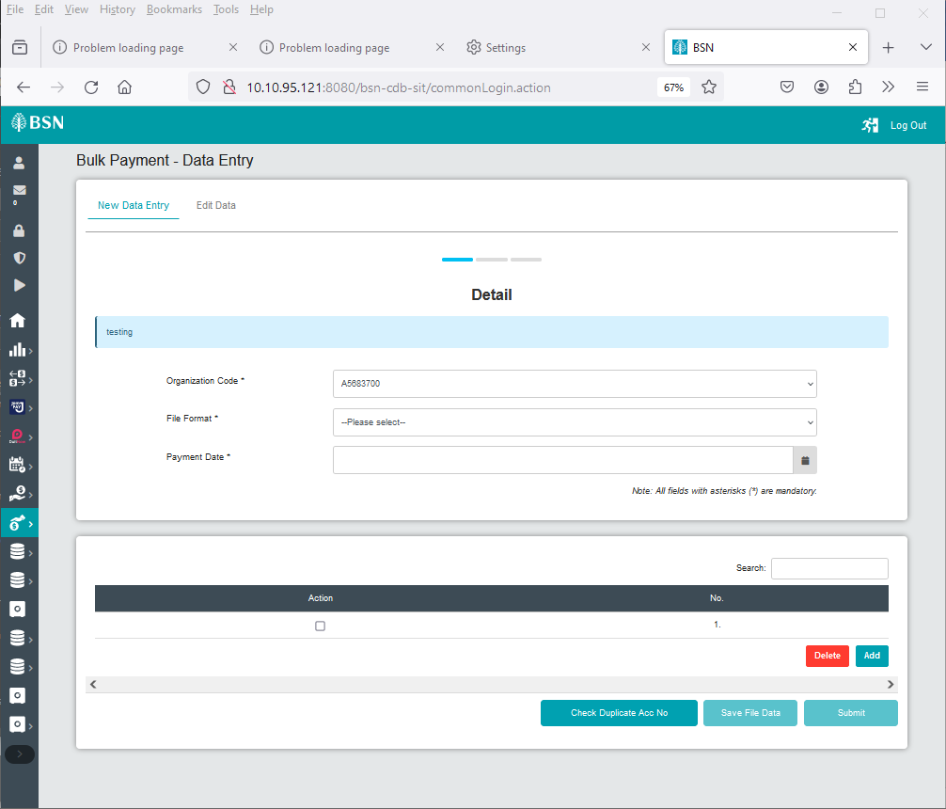

Figure : Bulk Payment – Data Entry Details page select Organization Code

#### **[TS-DE-GST-STEP6] – Data Entry Details File Format – Step 6 (ibDataEntryConfirmFileFormat.action)**

**In this stage, the CDB connects to Bulk Payment – Data Entry details page select File Format:**

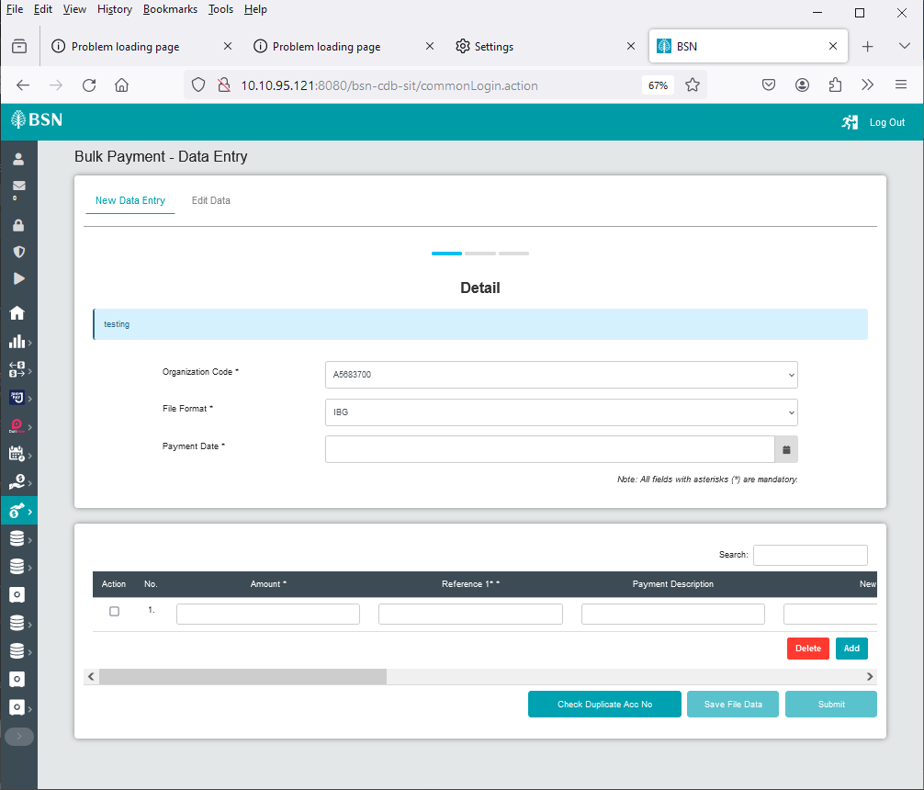

Figure : Bulk Payment – Data Entry Details page select File Format

#### **1.6.7 [TS-DE-GST-STEP7] – Data Entry Check Duplicate Number – Step 7 (ibDataEntryCheckDuplicate.action)**

**In this stage, the CDB connects to Bulk Payment – Data Entry details page:**

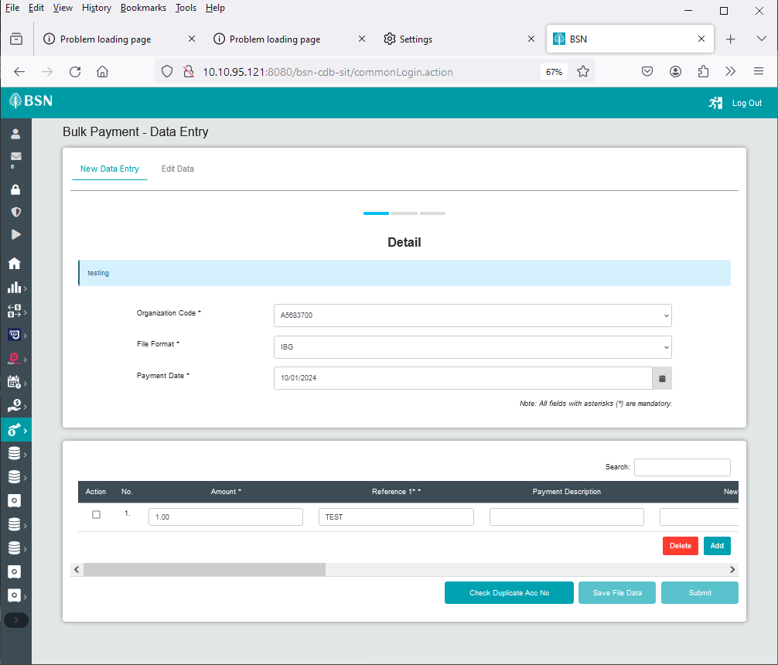

Figure : Data Entry Check Duplicate Acc. No page

#### **1.6.8 [TS-DE-GST-STEP8] – Data Entry Save File Page – Step 8 (ibDataEntrySaveFile.action)**

**In this stage, the CDB connects to Bulk Payment – Data Entry details page:**

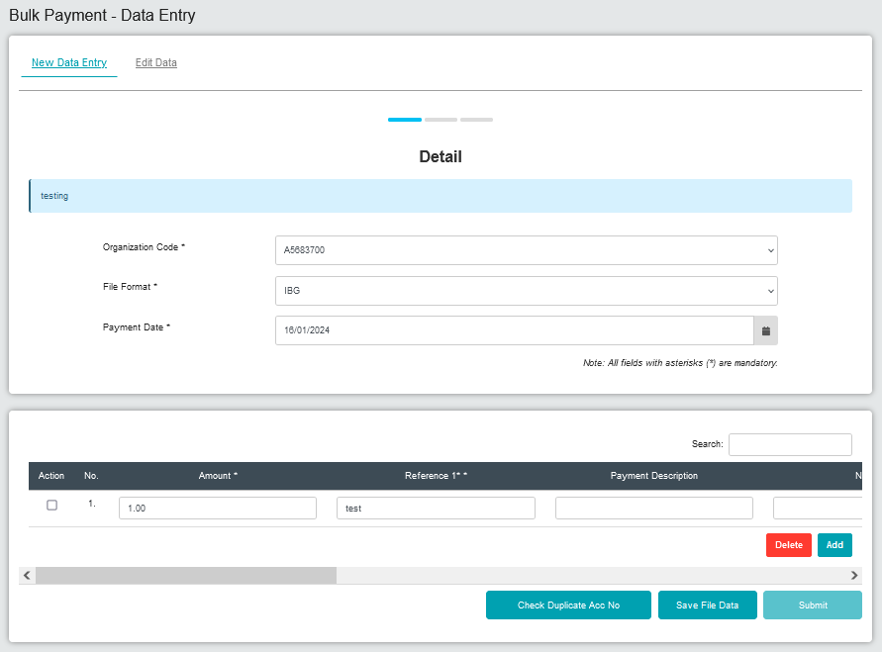

Figure : Data Entry Save File page

#### **1.6.9 [TS-DE-GST-STEP9] – Data Entry Confirmation Page – Step 9 (ibDataEntryConfirm.action)**

**In this stage, the CDB connects to Bulk Payment – Data Entry Confirmation page:**

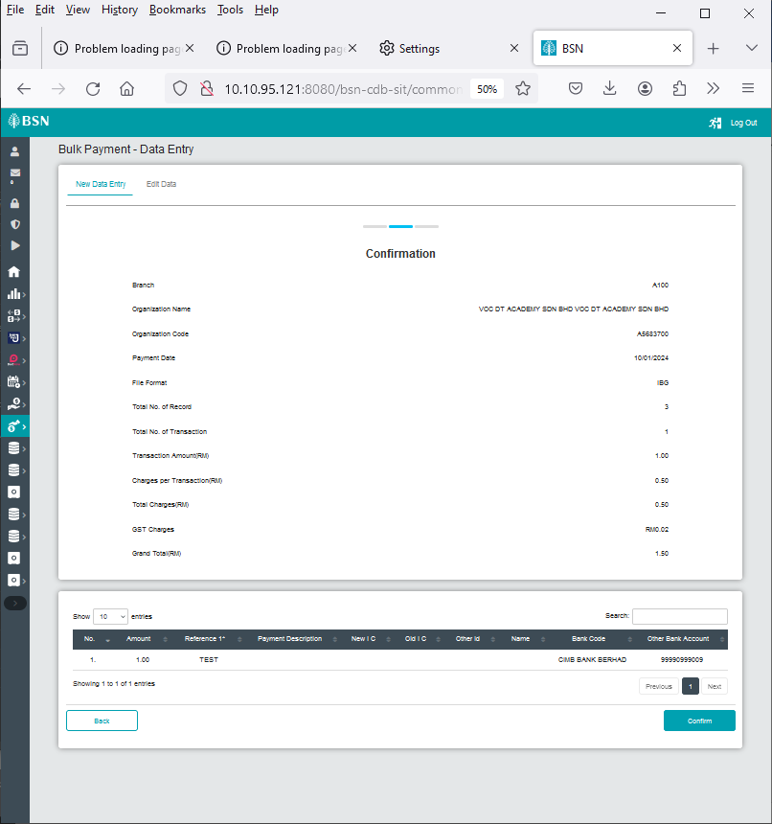

Figure : Data Entry Confirmation page

#### **1.6.10 [TS-DE-GST-STEP10] – Data Entry Result Page – Step 10 (ibDataEntryResults.action)**

**In this stage, the CDB connects to:**

1. DB

**The DB fetches:**

* **Database. Database** contains data for Bulk Payment – Data Entry Result details.

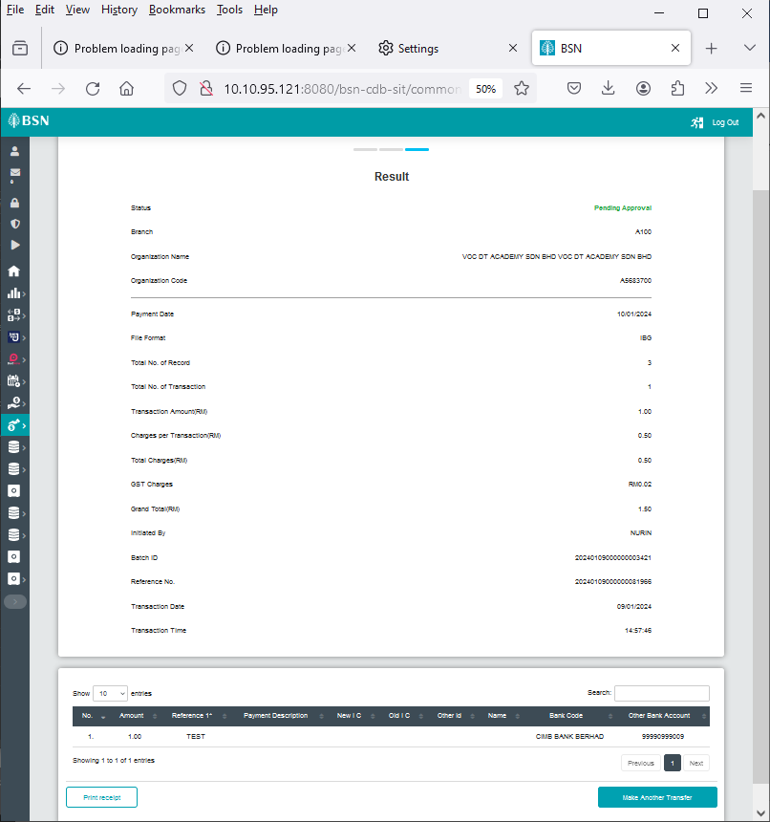

Figure : Data Entry Result page

#### **1.6.11 [TS-FU-GST-STEP8] – File Upload Download Receipt PDF Page– Step 11 (ibDataEntryReceiptPdfDownload.action)**

**In this stage, the CDB connects to:**

1. DB

**The DB fetches:**

* BIB_USER_PRINT_RECEIPT. BIB_USER_PRINT_RECEIPT contains data for Data Entry details.

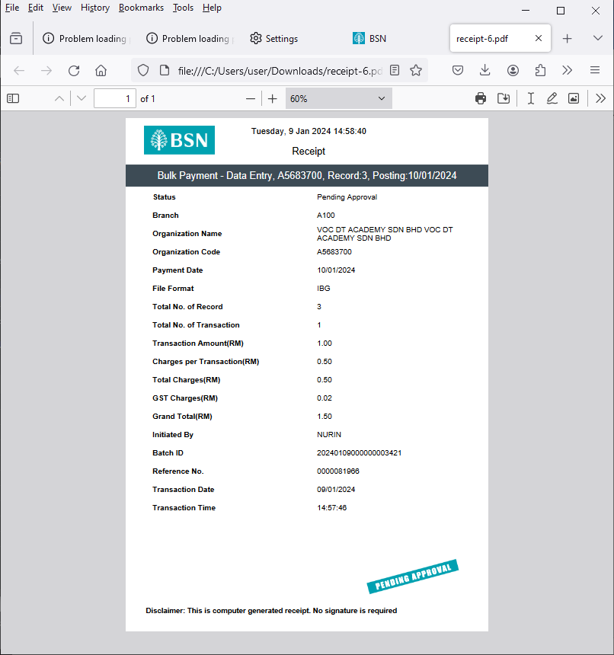

Figure : Data Entry PDF Receipt

### Process of testing – Adding GST on BSNeBIZ Bulk Payment – Edit Data Entry

This test scenario simulates concurrent users adding GST on BSNeBiz Bulk Payment – Edit Data Entry service. This test case depends on below test case to be executed:

#### **[TS-ED-GST-STEP1] – BSNeBiz Login Page – Step 1 (commonLogin.action)**

**In this stage, the CDB connects to:**

1. DB

**The DB fetches:**

* IB_SERVICE_INFO. IB_SERVICE_INFO contains some notes or announcements.



Figure : BSNeBiz Login Page

#### **[TS-ED-GST-STEP2] – BSNeBiz Login Page – Step 2 (ibPortalLoginUsername.action)**

**In this stage, the CDB connects to:**

1. DB

**The DB fetches:**

* **Database. Database** contains data for BSNeBiz Login Details.



Figure : BSNeBiz Login Page

#### **[TS-ED-GST-STEP3] – BSNeBiz Home Page – Step 3 (ibPortalLogin.action)**

**In this stage, the CDB connects to BSNeBiz Home page:**



Figure 40: BSNeBiz Home page

#### **[TS-ED-GST-STEP4] – Data Entry Page – Step 4 (ibDataEntryDetails)**

**In this stage, the CDB connects to Bulk Payment – Data Entry detail page:**



Figure : Bulk Payment – Data Entry page

#### **[TS-ED-GST-STEP5] – Edit Data Entry Page – Step 5 (ibEditData)**

**In this stage, the CDB connects to Bulk Payment – Edit Data page:**

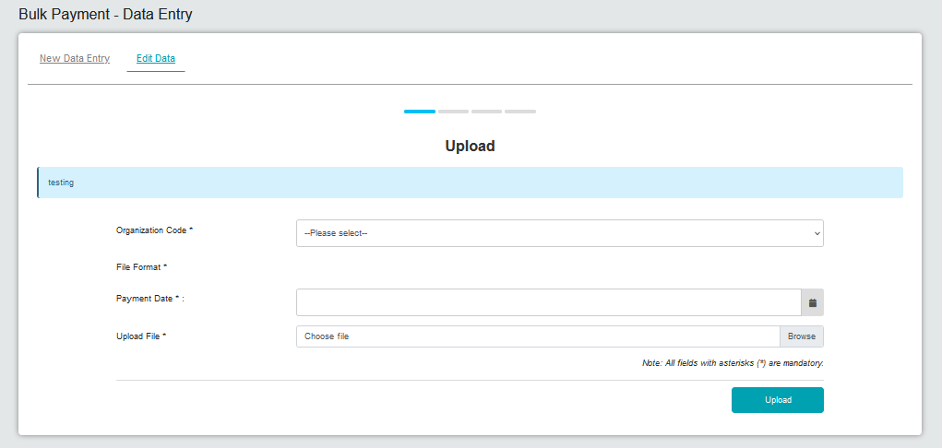

Figure : Bulk Payment – Edit Data page

#### **[TS-ED-GST-STEP6] – Edit Data Organization Code – Step 6 (ibEditDataDetailOrganizationCode.action)**

**In this stage, the CDB connects to Bulk Payment – Edit Data Upload page select Organization Code:**

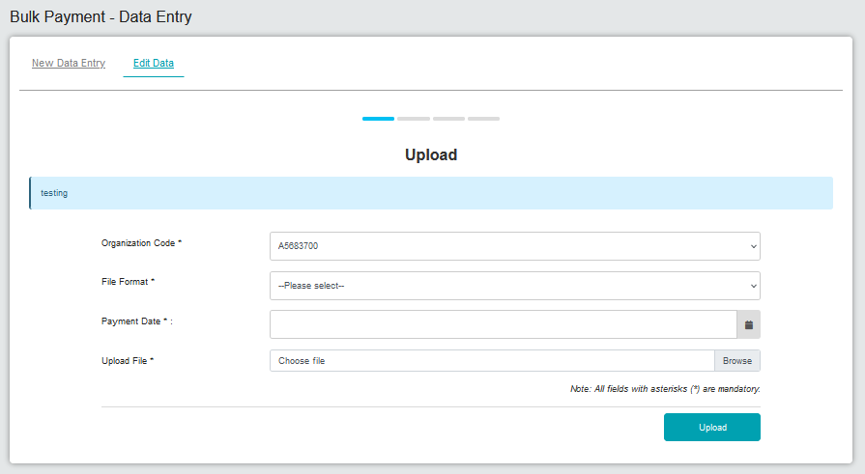

Figure : Bulk Payment – Edit Data Upload page select Organization Code

#### **1.7.7 [TS-ED-GST-STEP7] – Edit Data File Format – Step 7 (ibEditDataDetailFileFormat.action)**

**In this stage, the CDB connects to Bulk Payment – Edit Data Upload page select File Format:**

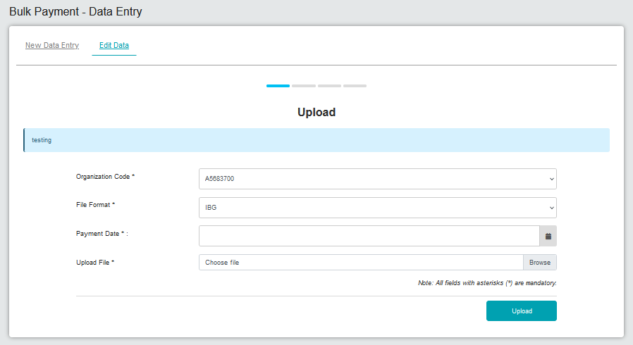

Figure : Edit Data Upload page select File Format

#### **1.7.8 [TS-ED-GST-STEP8] – Edit Data Upload File – Step 8 (ibEditDataDetailUploadFile.action)**

**In this stage, the CDB connects to Bulk Payment – Edit Data Upload page Upload File:**

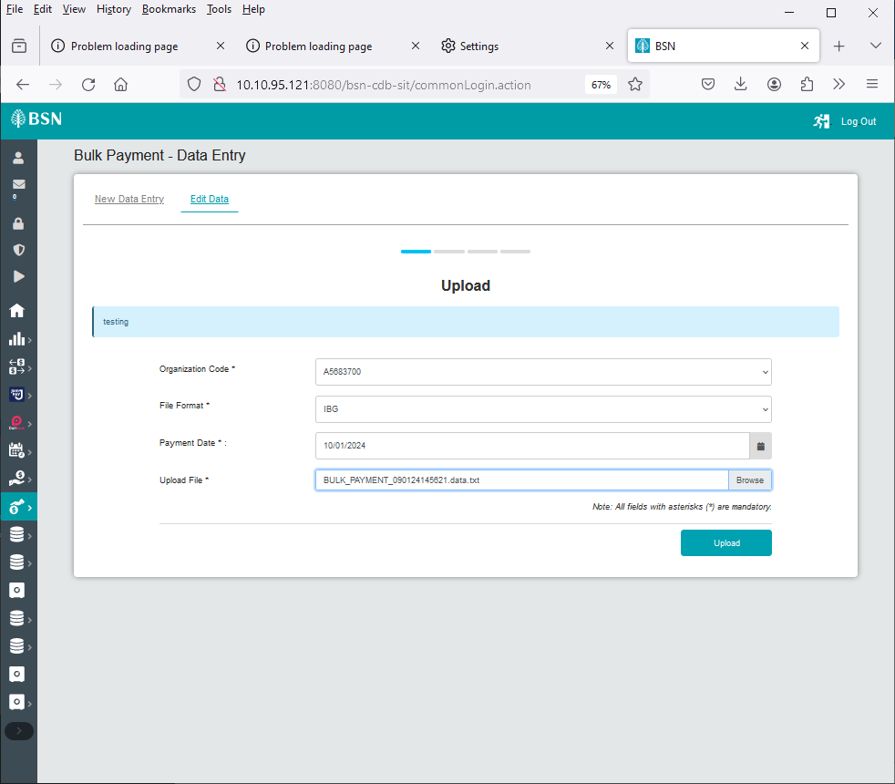

Figure : Bulk Payment - File Upload Pdf Receipts

#### **1.7.9 [TS-ED-GST-STEP9] – Edit Data Check Duplicate – Step 9 (ibEditDataConfirmCheckDuplicate.action)**

**In this stage, the CDB connects to Bulk Payment – Edit Data Detail page:**

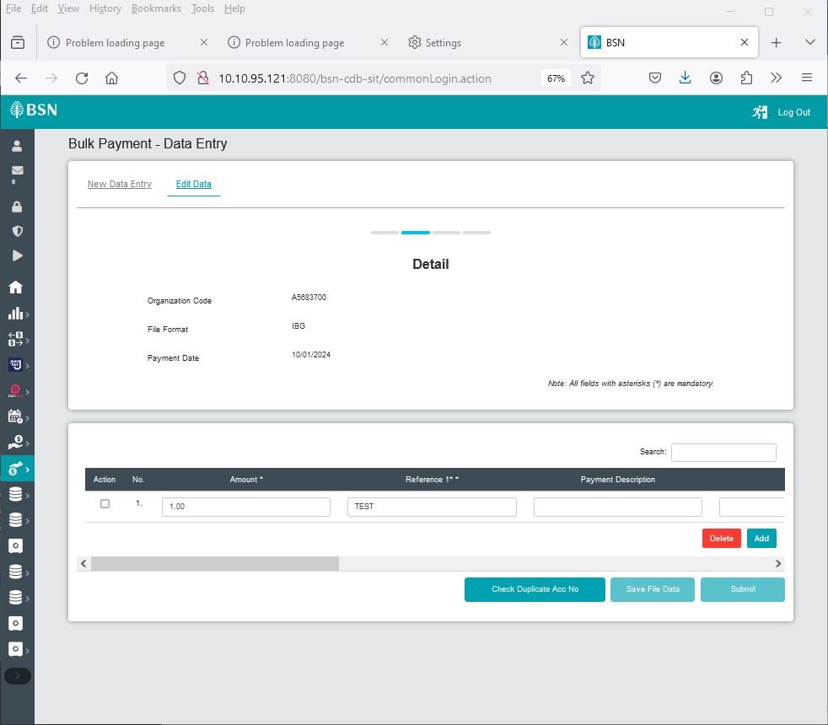

Figure : Edit Data - Details page Check Duplicate Acc No

#### **1.7.10 [TS-ED-GST-STEP10] – Edit Data Save File – Step 10 (ibEditDataConfirmSaveFile.action)**

**In this stage, the CDB connects to Bulk Payment – Edit Data Detail page:**

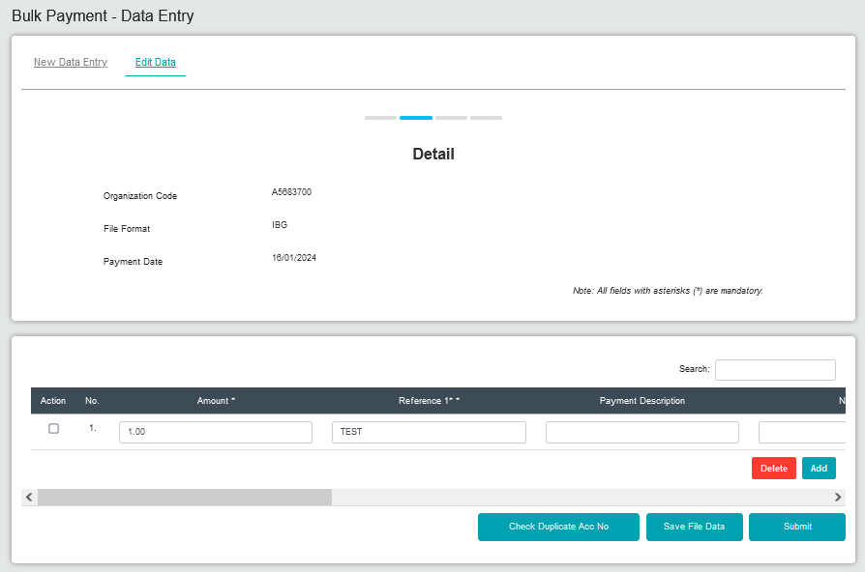

Figure : Edit Data Details page Save File Data

#### **1.7.11 [TS-ED-GST-STEP11] – Edit Data Confirmation Page – Step 11 (ibEditDataConfirmSubmit.action)**

**In this stage, the CDB connects to Bulk Payment – Edit Data Confirmation page:**

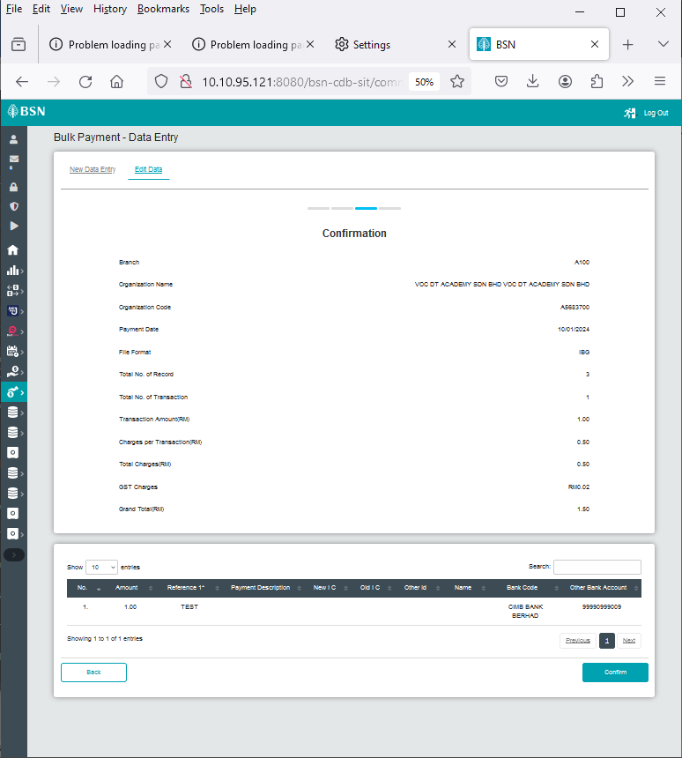

Figure : Edit Data Confirmation Page

#### **1.7.12 [TS-ED-GST-STEP12] – Edit Data Results Page – Step 12 (ibEditDataResults.action)**

**In this stage, the CDB connects to:**

1. DB

**The DB fetches:**

* **Database. Database** contains data for Bulk Payment – Edit Data Result details.

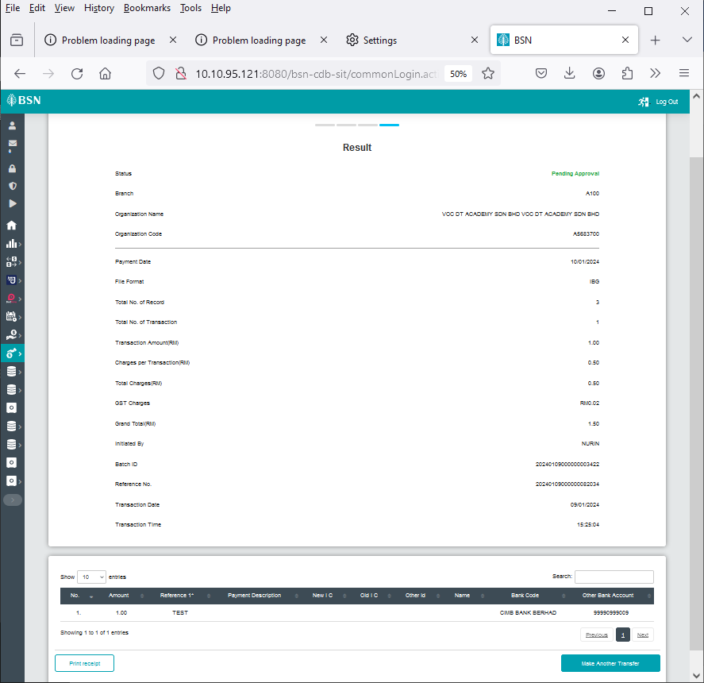

Figure : Edit Data Results page

#### **1.7.13 [TS-FU-GST-STEP13] – Edit Data Download Receipt PDF Page– Step 13 (ibEditDataReceiptPdfDownload.action)**

**In this stage, the CDB connects to:**

1. DB

**The DB fetches:**

* BIB_USER_PRINT_RECEIPT. BIB_USER_PRINT_RECEIPT contains data for Edit Data details.

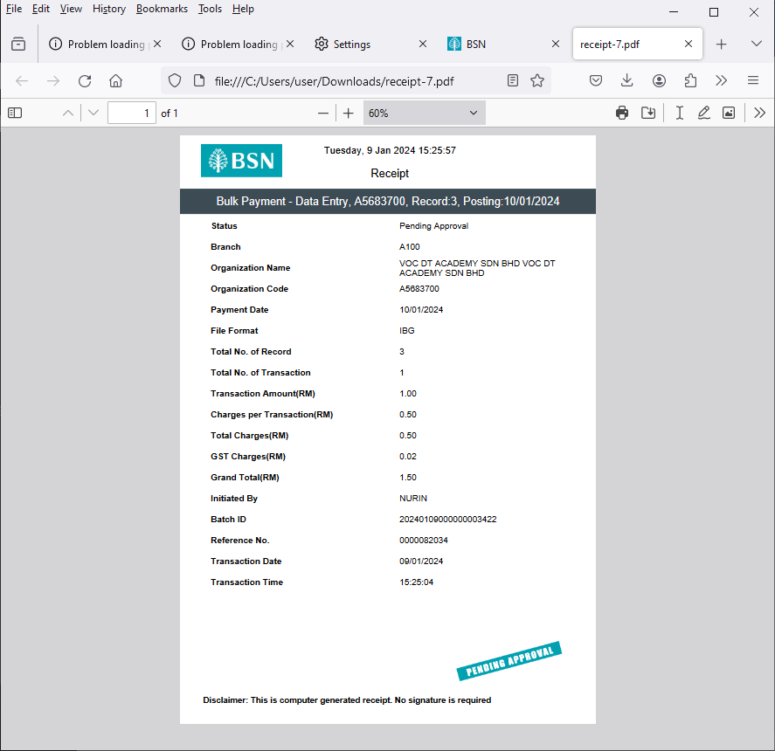

Figure : Edit Data Pdf Receipt

### Process of testing – Adding GST on BSNeBIZ Authorization – Verifier

This test scenario simulates concurrent users adding GST on BSNeBiz Authorization – Verifier service. This test case depends on below test case to be executed:

#### **[TS-AV-GST-STEP1] – BSNeBiz Login Page – Step 1 (commonLogin.action)**

**In this stage, the CDB connects to:**

1. DB

**The DB fetches:**

* IB_SERVICE_INFO. IB_SERVICE_INFO contains some notes or announcements.



Figure : BSNeBiz Login page

#### **[TS-AV-GST-STEP2] – BSNeBiz Login Page – Step 2 (ibPortalLoginUsername.action)**

**In this stage, the CDB connects to:**

1. DB

**The DB fetches:**

* **Database. Database** contains data for BSNeBiz Login Details.



Figure : BSNeBiz Login Page

#### **[TS-AV-GST-STEP3] – BSNeBiz Home Page – Step 3 (ibPortalLogin.action)**

**In this stage, the CDB connects to BSNeBiz Authorization Verifier Home page:**

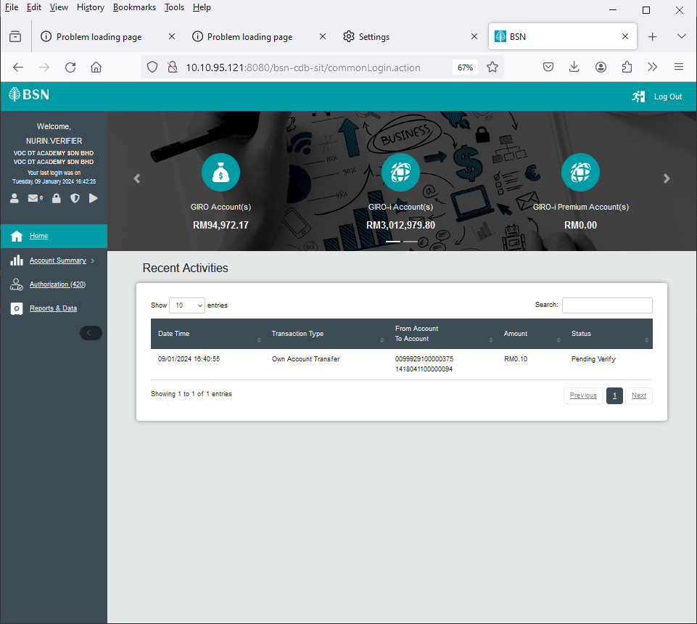

Figure 53: BSNeBiz Authorization Verifier Home page

#### **[TS-AV-GST-STEP4] – Verification Page – Step 4 (ibAuthorization)**

**In this stage, the CDB connects to Authorization – Verification page:**

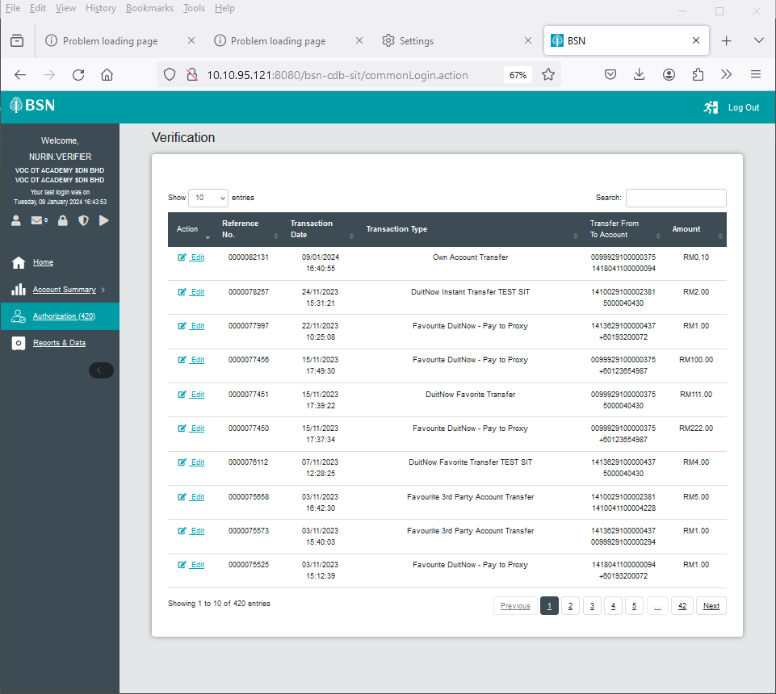

Figure : Authorization – Verification page

#### **[TS-AV-GST-STEP5] – Confirmation Page – Step 5 (ibMaker)**

**In this stage, the CDB connects to Authorization – Confirmation page:**

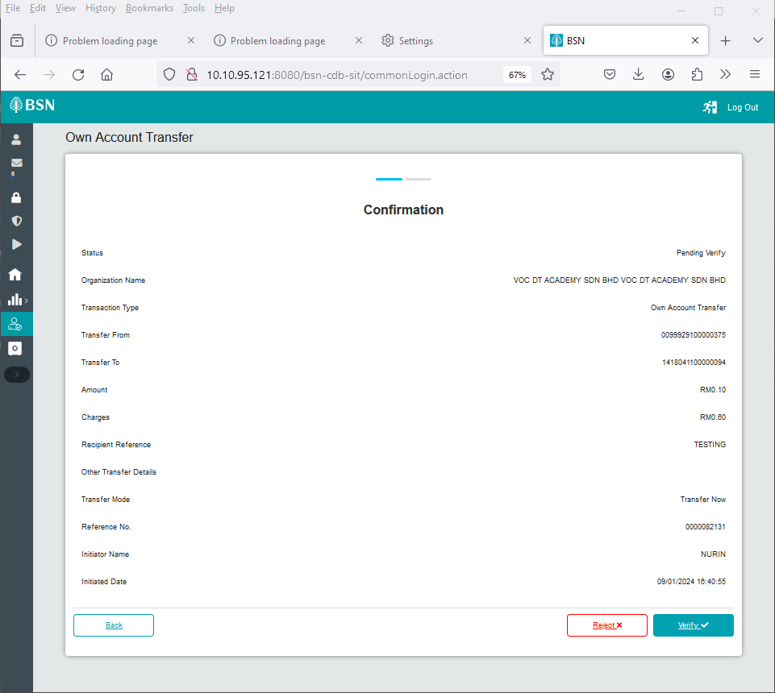

Figure : Authorization - Confirmation page

#### **[TS-AV-GST-STEP6] – Verifier Result Page – Step 6 (ibCheckerResults.action)**

**In this stage, the CDB connects to:**

1. DB

**The DB fetches:**

* **Database. Database** contains data for Authorization – Verifier Result details.

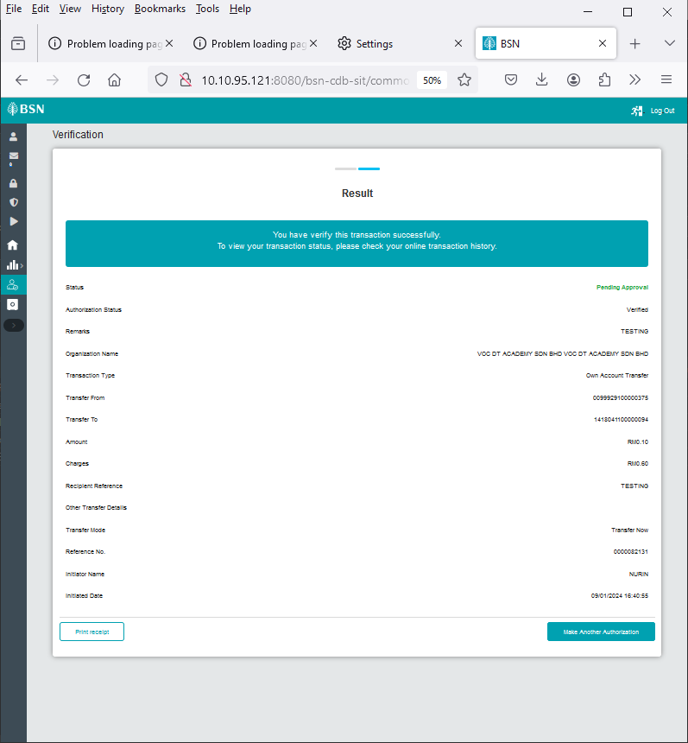

Figure : Authorization - Verifier Result page

#### **1.8.7 [TS-AV-GST-STEP7] – Verifier Download Receipt PDF Page – Step 7 (ibVerifierReceiptPdfDownload.action)**

**In this stage, the CDB connects to:**

1. DB

**The DB fetches:**

* BIB_USER_PRINT_RECEIPT. BIB_USER_PRINT_RECEIPT contains data for Authorization – Verifier details.

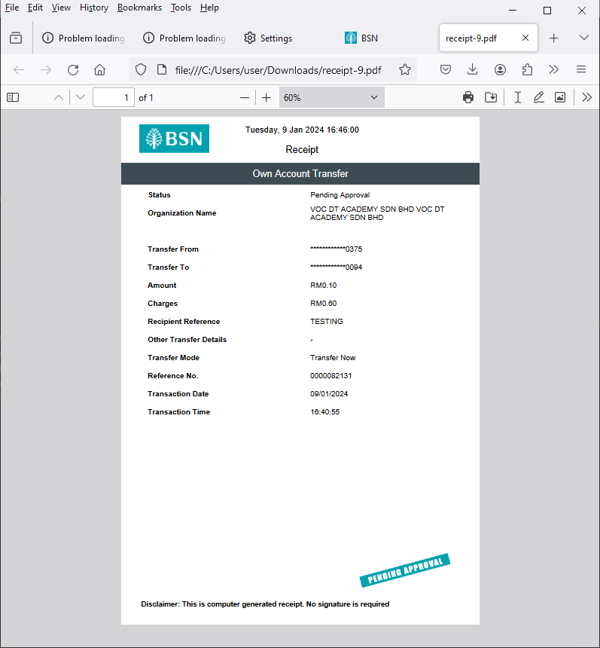

Figure : Authorization - Verifier Pdf Receipt

### Process of testing – Adding GST on BSNeBIZ Authorization – Approver

This test scenario simulates concurrent users adding GST on BSNeBiz Authorization – Approver service. This test case depends on below test case to be executed:

#### **[TS-AA-GST-STEP1] – BSNeBiz Login Page – Step 1 (commonLogin.action)**

**In this stage, the CDB connects to:**

1. DB

**The DB fetches:**

* IB_SERVICE_INFO. IB_SERVICE_INFO contains some notes or announcements.



Figure : BSNeBiz Login page

#### **[TS-AA-GST-STEP2] – BSNeBiz Login Page – Step 2 (ibPortalLoginUsername.action)**

**In this stage, the CDB connects to:**

1. DB

**The DB fetches:**

* **Database. Database** contains data for BSNeBiz Login Details.



Figure : BSNeBiz Login Page

#### **[TS-AA-GST-STEP3] – BSNeBiz Home Page – Step 3 (ibPortalLogin.action)**

**In this stage, the CDB connects to BSNeBiz Authorization Approver Home page:**

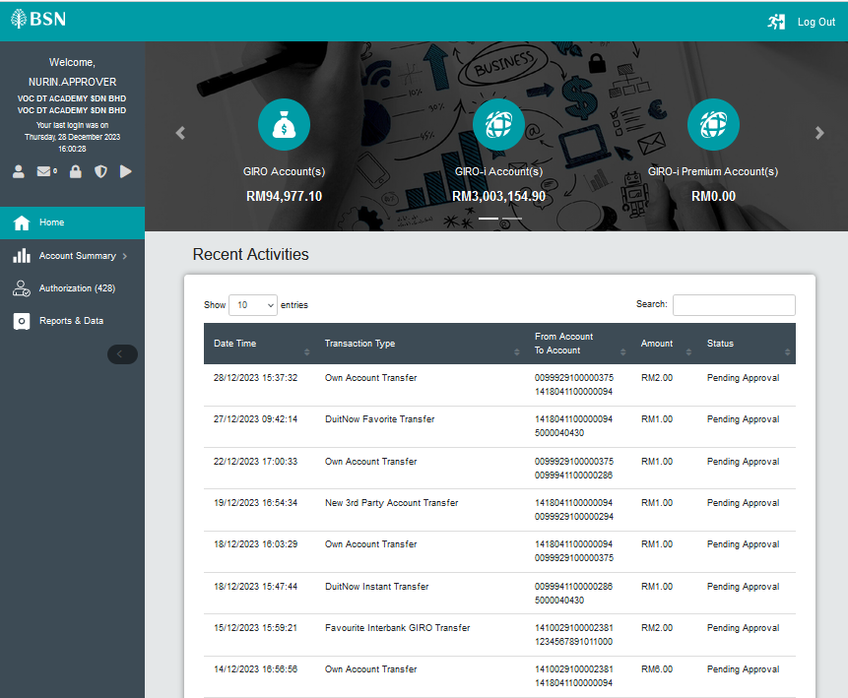

Figure : Authorization - Approver BSNeBiz Homepage

#### **[TS-AA-GST-STEP4] – Approval Page – Step 4 (ibAuthorization)**

**In this stage, the CDB connects to Authorization – Approval page:**

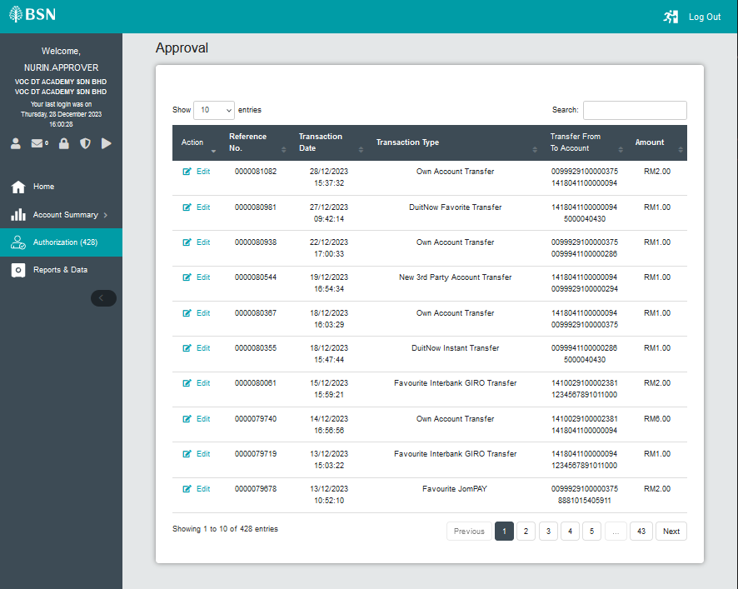

Figure : Authorization – Verification page

#### **[TS-AA-GST-STEP5] – Confirmation Page – Step 5 (ibMaker)**

**In this stage, the CDB connects to Authorization – Confirmation page:**

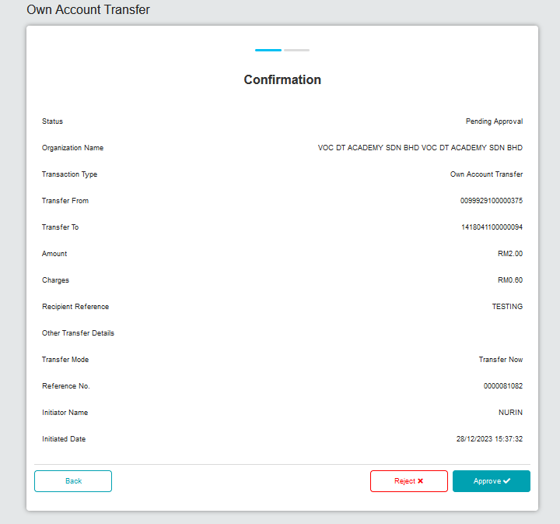

Figure : Authorization - Confirmation page

#### **[TS-AA-GST-STEP6] – Approver Result Page – Step 6 (ibCheckerResults.action)**

**In this stage, the CDB connects to:**

1. DB

**The DB fetches:**

* **Database. Database** contains data for Authorization – Approver Result details.

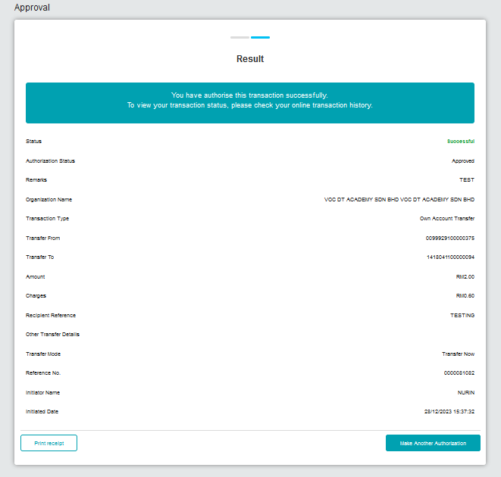

Figure : Authorization - Approver Result page

#### **1.9.7 [TS-AA-GST-STEP7] – Approver Download Receipt PDF Page – Step 7 (ibApproverReceiptPdfDownload.action)**

**In this stage, the CDB connects to:**

1. DB

**The DB fetches:**

* BIB_USER_PRINT_RECEIPT. BIB_USER_PRINT_RECEIPT contains data for Authorization – Approver details.

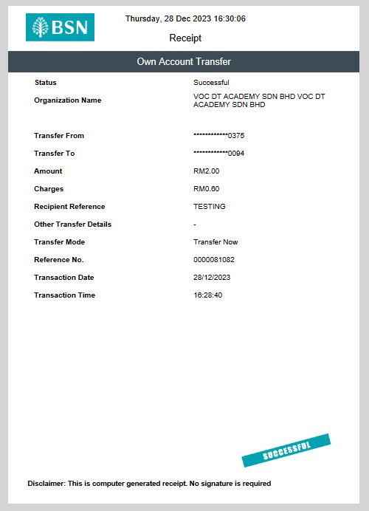

Figure : Authorization - Approver Pdf Receipt

### Process of testing – Adding GST on Transfer & Payment

This test scenario simulates concurrent users adding GST on Transfer & Payment Mobile BSNeBiz service. This test case depends on below test case to be executed:

#### **1.10.1 [TS-MB-GST-STEP1] – Mobile BSNeBiz Login Page – Step 1 (Login_Generate)**

**In this stage, the CDB connects to Mobile BSNeBiz Login page:**

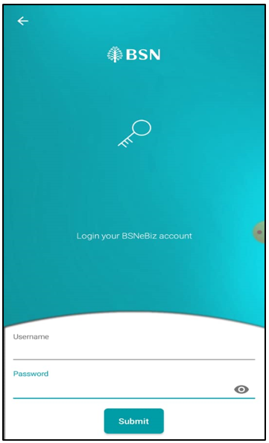

Figure : Mobile BSNeBiz Login page

#### **1.10.2 [TS-MB-GST-STEP2] – Mobile BSNeBiz Home Page – Step 2 (Homepage_Generate)**

**In this stage, the CDB connects to Mobile BSNeBiz Home page:**

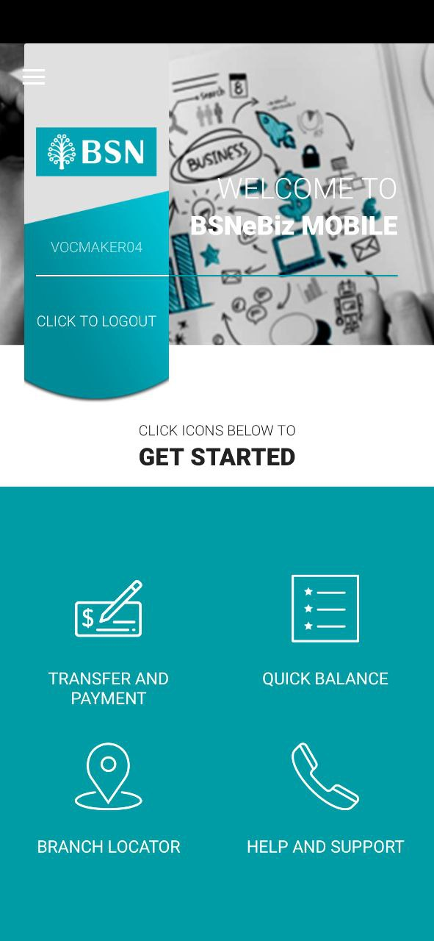

Figure : Mobile BSNeBiz Home page

#### **1.10.3 [TS-MB-GST-STEP3] – Transfer & Payment Page – Step 3 (Transfer_Generate)**

**In this stage, the CDB connects to Mobile BSNeBiz Transfer & Payment page:**

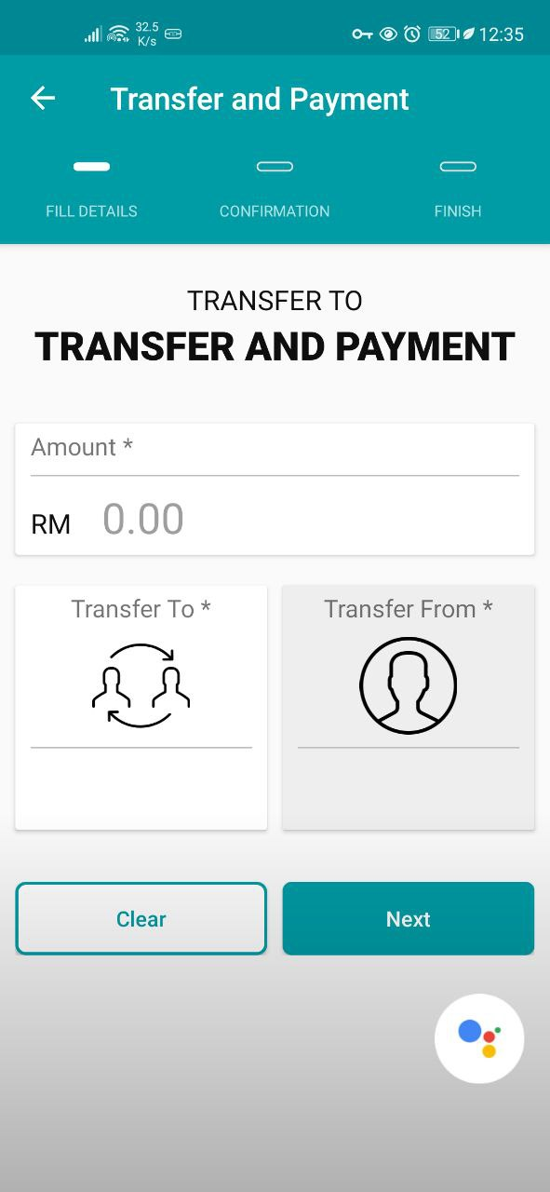

Figure : Mobile BSNeBiz Transfer & Payment page

#### **1.10.4 [TS-MB-GST-STEP4] – Transfer To Page – Step 4 (Transfer_Generate)**

**In this stage, the CDB connects to Mobile BSNeBiz Transfer To page:**

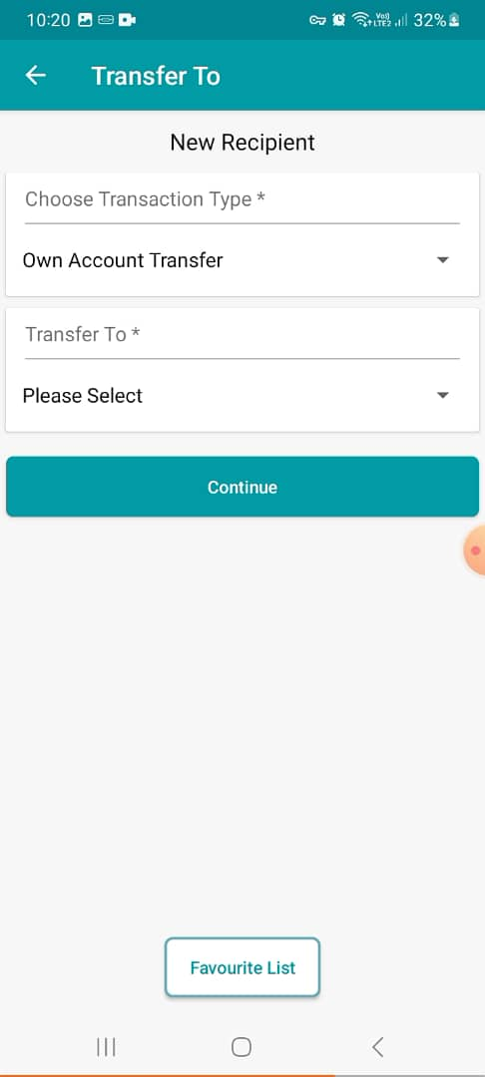

Figure : Mobile BSNeBiz Transfer To page

#### **1.10.5 [TS-MB-GST-STEP5] – Transfer Details Page – Step 5 (TransferDetails_Generate)**

**In this stage, the CDB connects to Mobile BSNeBiz Transfer Details page:**

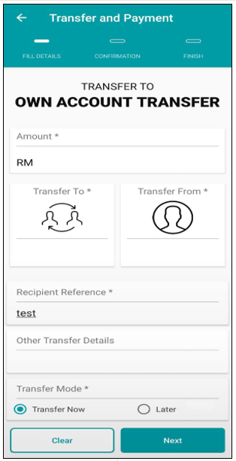

Figure : Mobile BSNeBiz Transfer Details page

#### **1.10.6 [TS-MB-GST-STEP6] – Confirmation Page – Step 6 (Confirmation_Generate)**

**In this stage, the CDB connects to Mobile BSNeBiz Transfer Confirmation page:**

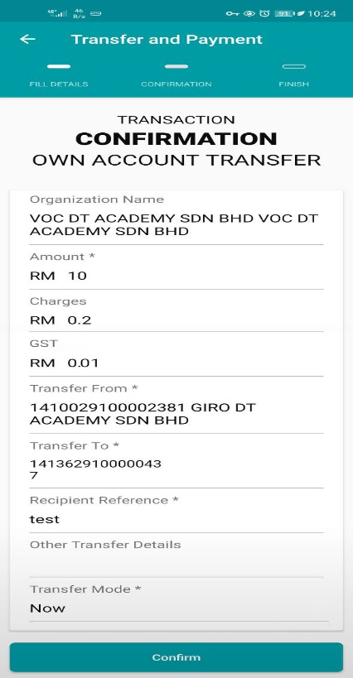

Figure : Mobile BSNeBiz Transfer Confirmation page

#### **1.10.7 [TS-MB-GST-STEP7] – Pending Result Page – Step 7 (Pending_Generate)**

**In this stage, the CDB connects to Mobile BSNeBiz Transfer Pending Result Pdf page:**

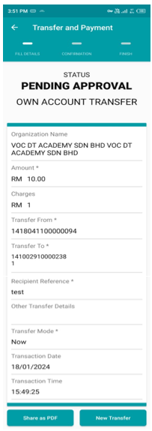

Figure : Mobile BSNeBiz Transfer Pending Result

#### **1.10.8 [TS-MB-GST-STEP8] – Share PDF Receipt Page – Step 8 (PdfReceipt_Generate)**

**In this stage, the CDB connects to Mobile BSNeBiz Transfer Pdf Receipt page:**

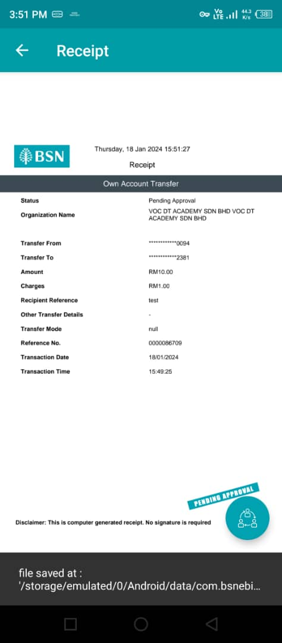

Figure : Mobile BSNeBiz PDF Receipt

### 1.11 Tools: Apache JMeter 5.1.1 r1855137

Apache JMeter is pure Java open-source software with the purpose of load testing functional behaviour and measuring performance of web applications. This app is chosen because it is platform independent, easy to install and provides better visualization on test results.

## Business Processes Involved

BSNeBiz – Adding GST on Transfer & Payment Flow Diagram

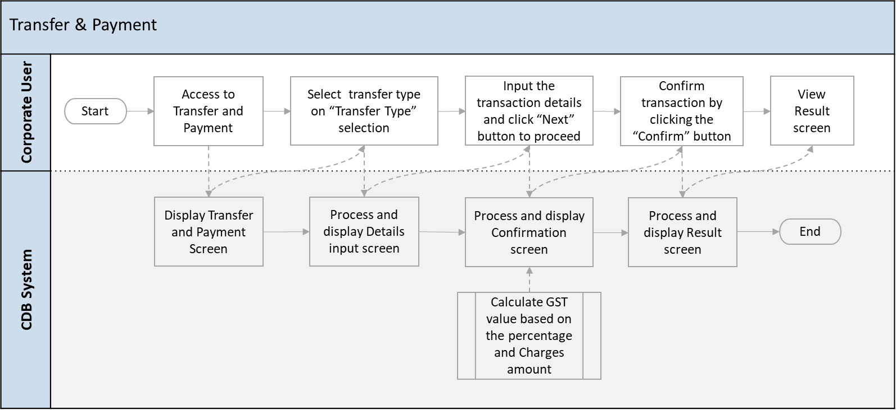

Diagram 1: Adding GST on Transfer & Payment Flow Diagram

BSNeBiz – Adding GST on JomPay Flow Diagram

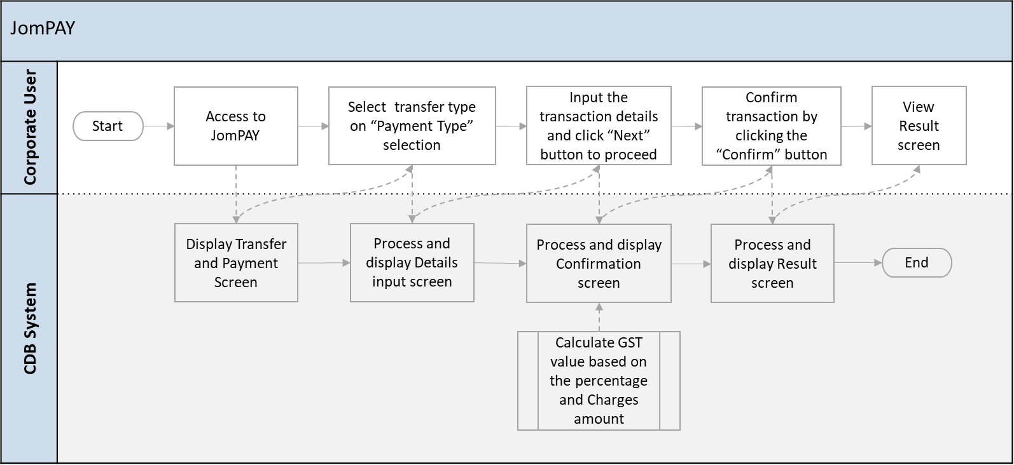

Diagram 2: Adding GST on JomPay Flow Diagram

BSNeBiz – Adding GST on Bulk Payment – File Upload Flow Diagram

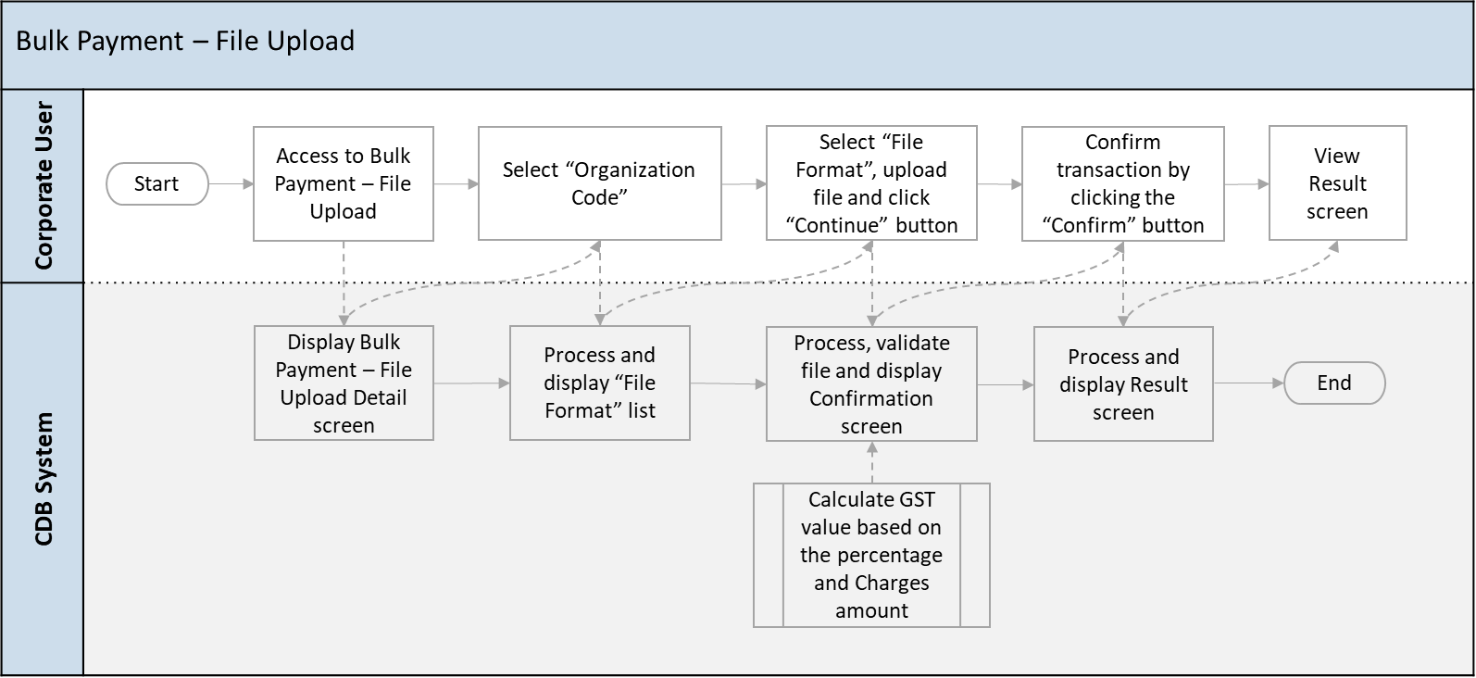

Diagram : Adding GST on Bulk Payment - File Upload Flow Diagram

BSNeBiz – Adding GST on Bulk Payment – Data Entry (New Data Entry) Flow Diagram

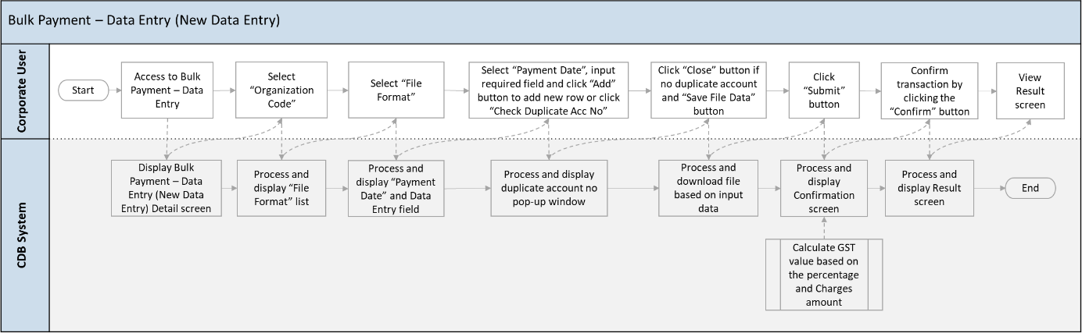

Diagram : Adding GST on Bulk Payment – Data Entry (New Data Entry) Flow Diagram

BSNeBiz – Adding GST on Bulk Payment – Data Entry (Edit Data Entry) Flow Diagram

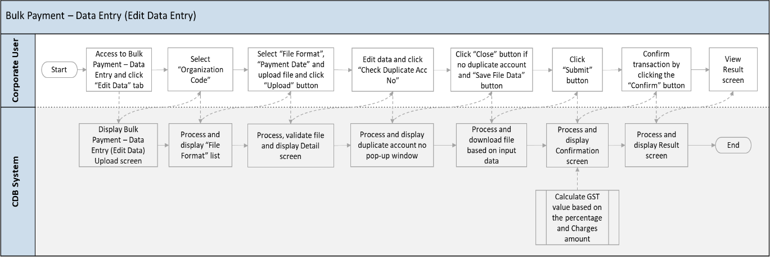

Diagram : Adding GST on Bulk Payment – Data Entry (Edit Data Entry) Flow Diagram

BSNeBiz – Adding GST on Authorization – Verifier Flow Diagram



Diagram : Adding GST on Authorization - Verifier Flow Diagram

BSNeBiz – Adding GST on Authorization – Approver Flow Diagram



Diagram : Adding GST on Authorization - Approver Flow Diagram

Mobile BSNeBiz – Adding GST on Transfer & Payment Flow Diagram

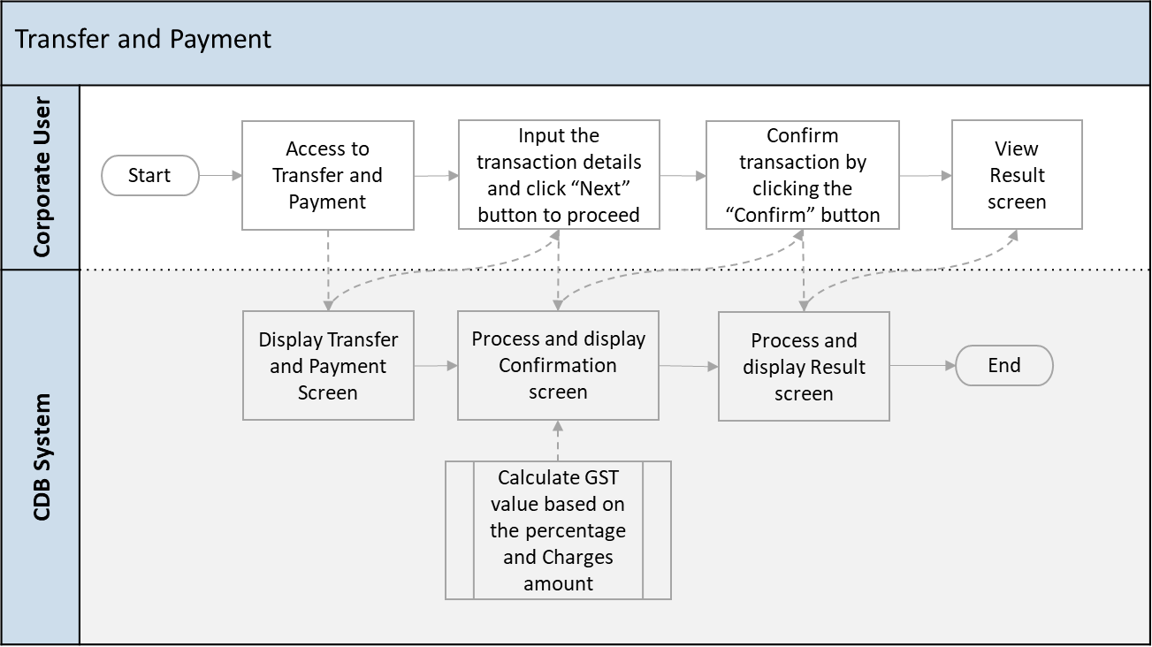

Diagram : Mobile BSNeBiz - Adding GST on Transfer & Payment Flow Diagram

This is a simplified flow diagram of load test flow scenarios representing Corporate Digital Banking Customers performing BSNeBiz Adding GST on Transfer & Payment process, BSNeBiz Adding GST on JomPay process, BSNeBiz Adding GST on Bulk Payment – File Upload process, BSNeBiz Adding GST on Bulk Payment – Data Entry (New Data Entry) process, BSNeBiz Adding GST on Bulk Payment – Data Entry (Edit Data Entry) process, BSNeBiz Adding GST on Authorization Verifier process, BSNeBiz Adding GST on Authorization Approver process and Mobile BSNeBiz Adding GST on Transfer & Payment process.

## Performance Test Environment

|  |  |  |
| --- | --- | --- |
| Test Region | : | SIT Environment |
| Instance Testing | : | BSNeBIZ – SIT Environment  Web : <http://58.27.45.179:8080/bsn-cdb-sit/commonLogin> |
| Apache JMeter | : | Version 5.6.2 |
| Java Version | : | JDK 1.8 |

## Test Scenario & Test Result with Explanation in Layman Terms

|  |
| --- |
| Testing Objective:  Bank would like to establish baseline (no. of concurrent users) of: 20 users   1. BSNeBiz Adding GST on Transfer & Payment 2. BSNeBiz Adding GST on JomPay 3. BSNeBiz Adding GST on Bulk Payment – File Upload 4. BSNeBiz Adding GST on Bulk Payment – Data Entry (New Data Entry) 5. BSNeBiz Adding GST on Bulk Payment – Data Entry (Edit Data Entry) 6. BSNeBiz Adding GST on Authorization – Verifier 7. BSNeBiz Adding GST on Authorization – Approver 8. Mobile BSNeBiz Adding GST on Transfer & Payment |

|  |
| --- |
| 1. BSNeBIZ Adding GST on Transfer & Payment |
| To simulate the maximum number of requests to perform BSNeBIZ Adding GST on Transfer & Payment with goal of:   * Error < 1%. * Criteria of throughput (second / request) & TPS for each flow:   + commonLogin.action <5 second or >0.2 TPS     - To proceed login process   + ibPortalLoginUsername.action <5 second or >0.2 TPS     - To proceed login process   + ibPortalLogin.action <5 second or >0.2 TPS     - To load the BSNeBiz home page   + ibTransferinit <5 second or >0.2 TPS     - To load the Transfer & Payment page   + ibTransferForward.action <5 second or >0.2 TPS     - To load the Transfer & Payment details page and select Transfer Type   + ibOwnTransferForward.action <5 second or >0.2 TPS     - To load the Transfer & Payment Own Account Payment details page   + ibTransferConfirm.action <5 second or >0.2 TPS     - To load the Transfer & Payment Confirmation details page   + ibTransferResults.action <5 second or >0.2 TPS     - To load the Transfer & Payment Result page   + ibTransferReceiptPdfDownload.action <5 second or >0.2 TPS     - To download the Transfer & Payment receipt in pdf format |
| I. Perform login service for 20 concurrent users |
| -Jmeter Execution Date: 19/01/2024   * Test Criteria   + Perform transaction for 20 concurrent users for 1 loop * Summary of Testing   The performance test result has passed the test against the benchmarks that have been set above (such as number of concurrent users, error percentage, and throughput).   * Declaration * ibTransferReceiptPdfDownload.action caused error because of there is no POST action to navigate to the next page when the Print Receipt button is click. * Therefore, ibTransferReceiptPdfDownload.action have error in test result. * Test Result   o The JMeter result shows that the system can support 20 concurrent users to perform transactions with 11.11% error. It takes 58 seconds to complete the transaction process for all users.   * Throughput (min/request)   The system is capable of completing a http request within 20.8 s (fastest) and 20.8 s (slowest).   * TPS (Transaction per Second)   The system is capable of performing 0.048 TPS (fastest) and 0.048 TPS (slowest).   * The reasonable ramp-up period without any error is 60 seconds for 20 users.     Image : JMeter Test Result - 20 BSNeBiz users for Transfer & Payment |

|  |
| --- |
| 1. BSNeBIZ Adding GST on JomPay |
| To simulate the maximum number of requests to perform BSNeBIZ Adding GST on JomPay with goal of:   * Error < 1%. * Criteria of throughput (second / request) & TPS for each flow:   + commonLogin.action <5 second or >0.2 TPS     - To proceed login process   + ibPortalLoginUsername.action <5 second or >0.2 TPS     - To proceed login process   + ibPortalLogin.action <5 second or >0.2 TPS     - To load the BSNeBiz home page   + ibJomPayInit <5 second or >0.2 TPS     - To load the JomPay page   + ibJomPayForward.action <5 second or >0.2 TPS     - To load the JomPay details page and select Payment Type   + ibJomPayConfirm.action <5 second or >0.2 TPS     - To load the JomPay Confirmation details page   + ibJomPayResults.action <5 second or >0.2 TPS     - To load the JomPay Result page   + ibJomPayReceiptPdfDownload.action <5 second or >0.2 TPS     - To download the JomPay receipt in pdf format |
| I. Perform login service for 20 concurrent users |
| -Jmeter Execution Date: 19/01/2024   * Test Criteria   + Perform transaction for 20 concurrent users for 1 loop * Summary of Testing   The performance test result has passed the test against the benchmarks that have been set above (such as number of concurrent users, error percentage, and throughput).   * Declaration * ibJomPayReceiptPdfDownload.action caused error because of there is no POST action to navigate to the next page when the Print Receipt button is click. * Therefore, ibJomPayReceiptPdfDownload.action have error in test result. * Test Result   o The JMeter result shows that the system can support 20 concurrent users to perform transactions with 12.5% error. It takes 58 seconds to complete the transaction process for all users.   * Throughput (min/request)   The system is capable of completing a http request within 21.2 s (fastest) and 21.1 s (slowest).   * TPS (Transaction per Second)   The system is capable of performing 0.0471 TPS (fastest) and 0.0473 TPS (slowest).   * The reasonable ramp-up period without any error is 60 seconds for 20 users.     Image : JMeter Test Result - 20 BSNeBiz users for JomPay |

|  |
| --- |
| 1. BSNeBIZ Adding GST on Bulk Payment – File Upload |
| To simulate the maximum number of requests to perform BSNeBIZ Adding GST on Bulk Payment – File Upload with goal of:   * Error < 1%. * Criteria of throughput (second / request) & TPS for each flow:   + commonLogin.action <5 second or >0.2 TPS     - To proceed login process   + ibPortalLoginUsername.action <5 second or >0.2 TPS     - To proceed login process   + ibPortalLogin.action <5 second or >0.2 TPS     - To load the BSNeBiz Home Page   + ibFileUploadDetails <5 second or >0.2 TPS     - To load the File Upload page   + ibFileUploadConfirmOrganizationCode.action <5 second or >0.2 TPS     - To confirm Organization Code   + ibFileUploadDetailsUploadFile.action <5 second or >0.2 TPS     - To upload file in file upload   + ibFileUploadConfirm.action <5 second or >0.2 TPS     - To load the File Upload Confirmation details page   + ibFileUploadResults.action <5 second or >0.2 TPS     - To load the File Upload Result page   + ibFileUploadReceiptPdfDownload.action <5 second or >0.2 TPS     - To download the JomPay receipt in pdf format |
| I. Perform login service for 20 concurrent users |
| -Jmeter Execution Date: 19/01/2024   * Test Criteria   + Perform transaction for 20 concurrent users for 1 loop * Summary of Testing   The performance test result has passed the test against the benchmarks that have been set above (such as number of concurrent users, error percentage, and throughput).   * Declaration * ibFileUploadReceiptPdfDownload.action caused error because of there is no POST action to navigate to the next page when the Print Receipt button is click. * Therefore, ibFileUploadReceiptPdfDownload.action have error in test result. * Test Result   o The JMeter result shows that the system can support 20 concurrent users to perform transactions with 11.11% error. It takes 63 seconds to complete the transaction process for all users.   * Throughput (min/request)   The system is capable of completing a http request within 21.0 s (fastest) and 19.1 s (slowest).   * TPS (Transaction per Second)   The system is capable of performing 0.047 TPS (fastest) and 0.0523 TPS (slowest).   * The reasonable ramp-up period without any error is 60 seconds for 20 users.     Image : JMeter Test Result - 20 BSNeBiz users for Bulk Payment - File Upload |

|  |
| --- |
| 1. BSNeBIZ Adding GST on Bulk Payment – Data Entry (New Data Entry) |
| To simulate the maximum number of requests to perform BSNeBIZ Adding GST on Bulk Payment – Data Entry (New Data Entry) with goal of:   * Error < 1%. * Criteria of throughput (second / request) & TPS for each flow:   + commonLogin.action <5 second or >0.2 TPS     - To proceed login process   + ibPortalLoginUsername.action <5 second or >0.2 TPS     - To proceed login process   + ibPortalLogin.action <5 second or >0.2 TPS     - To load the BSNeBiz Home Page   + ibDataEntryDetails <5 second or >0.2 TPS     - To load the Data Entry page   + ibDataEntryConfirmOrganizationCode.action <5 second or >0.2 TPS     - To confirm Organization Code in Data Entry details page   + ibDataEntryConfirmFileFormat.action <5 second or >0.2 TPS     - To confirm File Format in Data Entry details page   + ibDataEntryCheckDuplicate.action <5 second or >0.2 TPS     - To check duplicate account no in Data Entry details page   + ibDataEntrySaveFile.action <5 second or >0.2 TPS     - To save file of the data entry in Data Entry details page   + ibDataEntryConfirm.action <5 second or >0.2 TPS     - To load confirmation page   + ibDataEntryResults.action <5 second or >0.2 TPS     - To load the Data Entry Result page   + ibDataEntryReceiptPdfDownload.action <5 second or >0.2 TPS     - To download the Data Entry receipt in pdf format |
| I. Perform login service for 20 concurrent users |
| -Jmeter Execution Date: 19/01/2024   * Test Criteria   + Perform transaction for 20 concurrent users for 1 loop * Summary of Testing   The performance test result has passed the test against the benchmarks that have been set above (such as number of concurrent users, error percentage, and throughput).   * Declaration * ibDataEntryReceiptPdfDownload.action caused error because of there is no POST action to navigate to the next page when the Print Receipt button is click. * Therefore, ibDataEntryReceiptPdfDownload.action have error in test result. * Test Result   o The JMeter result shows that the system can support 20 concurrent users to perform transactions with 9.09% error. It takes 59 seconds to complete the transaction process for all users.   * Throughput (min/request)   The system is capable of completing a http request within 21.0 s (fastest) and 20.8 s (slowest).   * TPS (Transaction per Second)   The system is capable of performing 0.047 TPS (fastest) and 0.048 TPS (slowest).   * The reasonable ramp-up period without any error is 60 seconds for 20 users.     Image : JMeter Test Result - 20 BSNeBiz users for Bulk Payment - New Data Entry |

|  |
| --- |
| 1. BSNeBIZ Adding GST on Bulk Payment – Data Entry (Edit Data Entry) |
| To simulate the maximum number of requests to perform BSNeBIZ Adding GST on Bulk Payment – Data Entry (Edit Data Entry) with goal of:   * Error < 1%. * Criteria of throughput (second / request) & TPS for each flow:   + commonLogin.action <5 second or >0.2 TPS     - To proceed login process   + ibPortalLoginUsername.action <5 second or >0.2 TPS     - To proceed login process   + ibPortalLogin.action <5 second or >0.2 TPS     - To load the BSNeBiz Home Page   + ibDataEntryDetails <5 second or >0.2 TPS     - To load the Data Entry page   + ibEditData <5 second or >0.2 TPS     - To load the Edit Data page   + ibEditDataDetailOrganizationCode.action <5 second or >0.2 TPS     - To confirm Organization Code in Edit Data Upload page   + ibEditDataDetailFileFormat.action <5 second or >0.2 TPS     - To confirm File Format in Edit Data Upload page   + ibEditDataDetailUploadFile.action <5 second or >0.2 TPS     - To upload file in Edit Data Upload page   + ibEditDataConfirmCheckDuplicate.action <5 second or >0.2 TPS     - To check duplicate account no in Edit Data details page   + ibEditDataConfirmSaveFile.action <5 second or >0.2 TPS     - To save file of the data entry in Edit Data details page   + ibEditDataConfirmSubmit.action <5 second or >0.2 TPS     - To load confirmation page   + ibEditDataResults.action <5 second or >0.2 TPS     - To load the Edit Data Result page   + ibEditDataReceiptPdfDownload.action <5 second or >0.2 TPS     - To download the Edit Data receipt in pdf format |
| I. Perform login service for 20 concurrent users |
| -Jmeter Execution Date: 19/01/2024   * Test Criteria   + Perform transaction for 20 concurrent users for 1 loop * Summary of Testing   The performance test result has passed the test against the benchmarks that have been set above (such as number of concurrent users, error percentage, and throughput).   * Declaration * ibEditDataReceiptPdfDownload.action caused error because of there is no POST action to navigate to the next page when the Print Receipt button is click. * Therefore, ibEditDataReceiptPdfDownload.action have error in test result. * Test Result   o The JMeter result shows that the system can support 20 concurrent users to perform transactions with 7.69% error. It takes 60 seconds to complete the transaction process for all users.   * Throughput (min/request)   The system is capable of completing a http request within 21.0 s (fastest) and 20.5 s (slowest).   * TPS (Transaction per Second)   The system is capable of performing 0.0476 TPS (fastest) and 0.0487 TPS (slowest).   * The reasonable ramp-up period without any error is 60 seconds for 20 users.     Image : JMeter Test Result - 20 BSNeBiz users for Bulk Payment - Edit Data Entry |

|  |
| --- |
| 1. BSNeBIZ Adding GST on Authorization - Verifier |
| To simulate the maximum number of requests to perform BSNeBIZ Adding GST on Authorization – Verifier with goal of:   * Error < 1%. * Criteria of throughput (second / request) & TPS for each flow:   + commonLogin.action <5 second or >0.2 TPS     - To proceed login process   + ibPortalLoginUsername.action <5 second or >0.2 TPS     - To proceed login process   + ibPortalLogin.action <5 second or >0.2 TPS     - To load the BSNeBiz Authorization Home Page   + ibAuthorization <5 second or >0.2 TPS     - To load the Verification page   + ibMaker <5 second or >0.2 TPS     - To load confirmation page   + ibCheckerResults.action <5 second or >0.2 TPS     - To load verification results page   + ibVerifierReceiptPdfDownload.action <5 second or >0.2 TPS     - To download the Authorization Verifier receipt in pdf format |
| I. Perform login service for 20 concurrent users |
| -Jmeter Execution Date: 19/01/2024   * Test Criteria   + Perform transaction for 20 concurrent users for 1 loop * Summary of Testing   The performance test result has passed the test against the benchmarks that have been set above (such as number of concurrent users, error percentage, and throughput).   * Declaration * ibVerifierReceiptPdfDownload.action caused error because of there is no POST action to navigate to the next page when the Print Receipt button is click. * Therefore, ibVerifierReceiptPdfDownload.action have error in test result. * Test Result   o The JMeter result shows that the system can support 20 concurrent users to perform transactions with 14.29% error. It takes 60 seconds to complete the transaction process for all users.   * Throughput (min/request)   The system is capable of completing a http request within 21.0 s (fastest) and 19.9 s (slowest).   * TPS (Transaction per Second)   The system is capable of performing 0.047 TPS (fastest) and 0.05 TPS (slowest).   * The reasonable ramp-up period without any error is 60 seconds for 20 users.     Image : JMeter Test Result - 20 BSNeBiz users for Authorization – Verifier |

|  |
| --- |
| 1. BSNeBIZ Adding GST on Authorization - Approver |
| To simulate the maximum number of requests to perform BSNeBIZ Adding GST on Authorization – Approver with goal of:   * Error < 1%. * Criteria of throughput (second / request) & TPS for each flow:   + commonLogin.action <5 second or >0.2 TPS     - To proceed login process   + ibPortalLoginUsername.action <5 second or >0.2 TPS     - To proceed login process   + ibPortalLogin.action <5 second or >0.2 TPS     - To load the BSNeBiz Authorization Home Page   + ibAuthorization <5 second or >0.2 TPS     - To load the Approval page   + ibMaker <5 second or >0.2 TPS     - To load Confirmation page   + ibCheckerResults.action <5 second or >0.2 TPS     - To load the Authorization Approver result page   + ibApproverReceiptPdfDownload.action <5 second or >0.2 TPS     - To load the Authorization Approver receipt in pdf format |
| I. Perform login service for 20 concurrent users |
| -JMeter Execution Date: 19/01/2024   * Test Criteria   + Perform transaction for 20 concurrent users for 1 loop * Summary of Testing   The performance test result has passed the test against the benchmarks that have been set above (such as number of concurrent users, error percentage, and throughput).   * Declaration * ibApproverReceiptPdfDownload.action caused error because of there is no POST action to navigate to the next page when the Print Receipt button is click. * Therefore, ibApproverReceiptPdfDownload.action have error in test result. * Test Result   o The JMeter result shows that the system can support 20 concurrent users to perform transactions with 14.29% error. It takes 57 seconds to complete the transaction process for all users.   * Throughput (min/request)   The system is capable of completing a http request within 21.0 s (fastest) and 20.9 s (slowest).   * TPS (Transaction per Second)   The system is capable of performing 0.0476 TPS (fastest) and 0.0478 TPS (slowest).   * The reasonable ramp-up period without any error is 60 seconds for 20 users.     Image : JMeter Test Result - 20 BSNeBiz users for Authorization – Approver |

|  |
| --- |
| 1. Mobile BSNeBIZ Adding GST on Transfer & Payment |
| To simulate the maximum number of requests to perform Mobile BSNeBIZ Adding GST on Transfer & Payment with goal of:   * Error < 1%. * Criteria of throughput (second / request) & TPS for each flow:   + Login_Generate <5 second or >0.2 TPS     - To proceed login process   + Homepage_Generate <5 second or >0.2 TPS     - To load Mobile BSNeBiz Home page   + Transfer_Generate <5 second or >0.2 TPS     - To load the Transfer & Payment page   + TransferTo_Generate <5 second or >0.2 TPS     - To load the Transfer To details   + TransferDetails_Generate <5 second or >0.2 TPS     - To fill Transfer & Payment Details   + Confirmation_Generate <5 second or >0.2 TPS     - To load the Transfer & Payment Confirmation details page   + Pending_Generate <5 second or >0.2 TPS     - To load the Transfer & Payment Result page   + PdfReceipt_Generate <5 second or >0.2 TPS     - To load Transfer & Payment Receipt in pdf format |
| I. Perform login service for 20 concurrent users |
| -JMeter Execution Date: 19/01/2024   * Test Criteria   + Perform transaction for 20 concurrent users for 1 loop * Summary of Testing   The performance test result has passed/ not passed the test against the benchmarks that have been set above (such as number of concurrent users, error percentage, and throughput).   * Test Result   o The JMeter result shows that the system can support 20 concurrent users to perform transactions with 0.0% error. It takes 57 seconds to complete the transaction process for all users.   * Throughput (min/request)   The system is capable of completing a http request within 21.0s (fastest) and 21.0s (slowest).   * TPS (Transaction per Second)   The system is capable of performing 0.047 TPS (fastest) and 0.047 TPS (slowest).   * The reasonable ramp-up period without any error is 60 seconds for 20 users.     Image : JMeter Test Result - 20 Mobile BSNeBiz users for Transfer & Payment |