SCPID#6912
Test Title: |  | Authorization not listed
Test Description: |  | Finding:  1. Maker IBAM File Upload (small size) but the status is Pending Processing and item in Authorization cannot Approve - (batchjob issue in debug branch(sit/uat) only)  Solution:  1. Fix batchjob error in another branch  2. Update batchjob add existing method save ibam activity authorization list (save in MkTrnxMaster table) and add send email method to ibam checker.
Test Functionality: |  | To test on file upload in IBAM checker maker.
Test Procedure: |  | Test Steps:  Small file size  - Maker upload bulk payment file in ibam. Make sure status Pending Approval and appear in authorization list  - Checker approve the trnx and file status update to Pending Processing.  Large file size (can check/set file size at service info > Max BSNeBiz File Upload Size)  - Maker upload bulk payment file in ibam. Make sure status pending Validate  - Wait a couple of minute for batch to process and check the File Inquiry List and file status will update to Pending Approval  - Make sure status Pending Approval and appear in authorization list and checker receive email  - Checker approve the trnx and file status update to Pending Processing.  Please comfort test maker checker for all file format upload in ibam
Response Message:
Test Result: | Pass: Fail: |  | Tested by: | Nor Athirah Umairah (24/01/2024-26/01/2024)
Reason for Failure:
Remarks: |  | 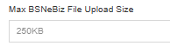  Figure 1: IBAM > Content > Service Info  Small file size  Figure 2: IBAM > File Processing > File Enquiry  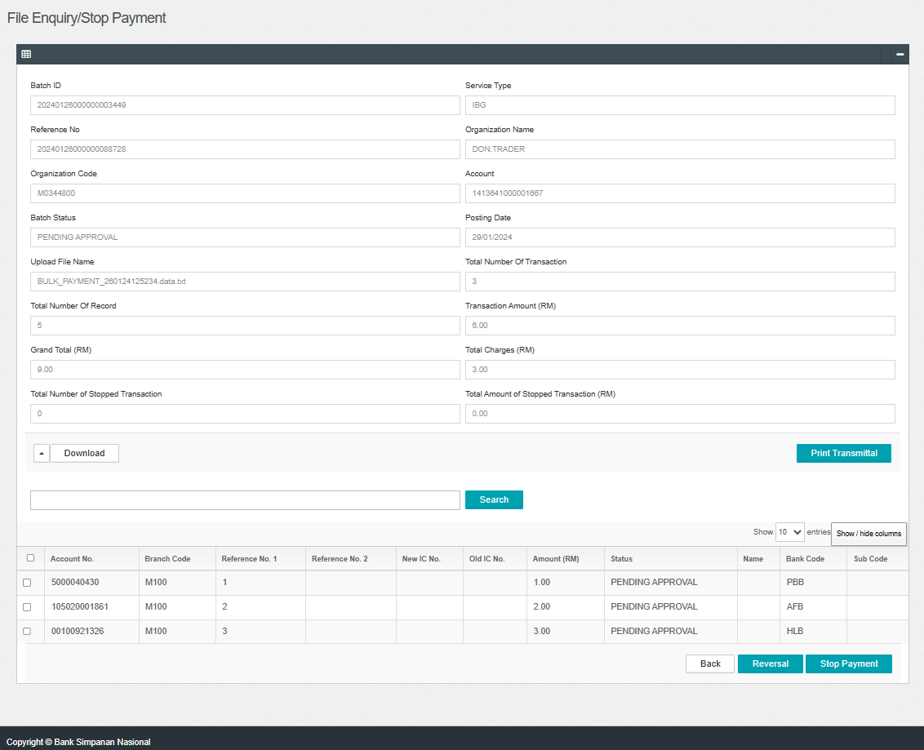  Figure 3: IBAM > File Processing > File Enquiry (Details)  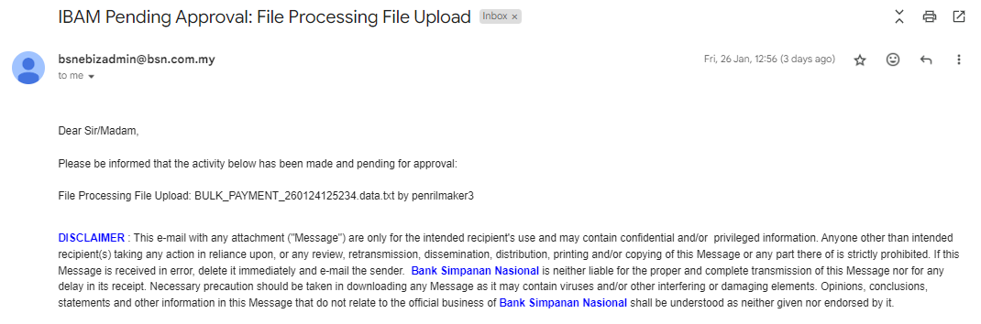  Figure 4: Email received by checker  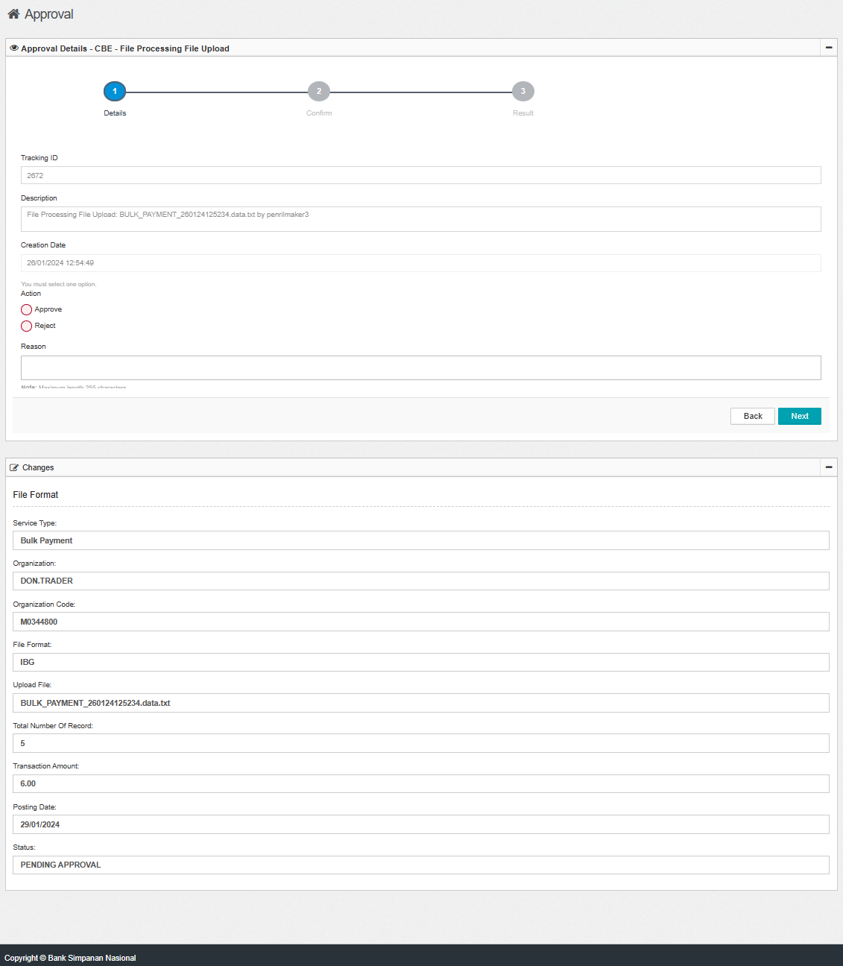  Figure 5: IBAM > Authorization > Approval  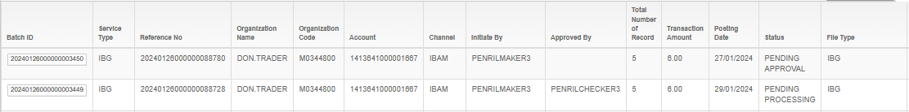  Figure 6: IBAM > File Processing > File Enquiry (Pending Processing)  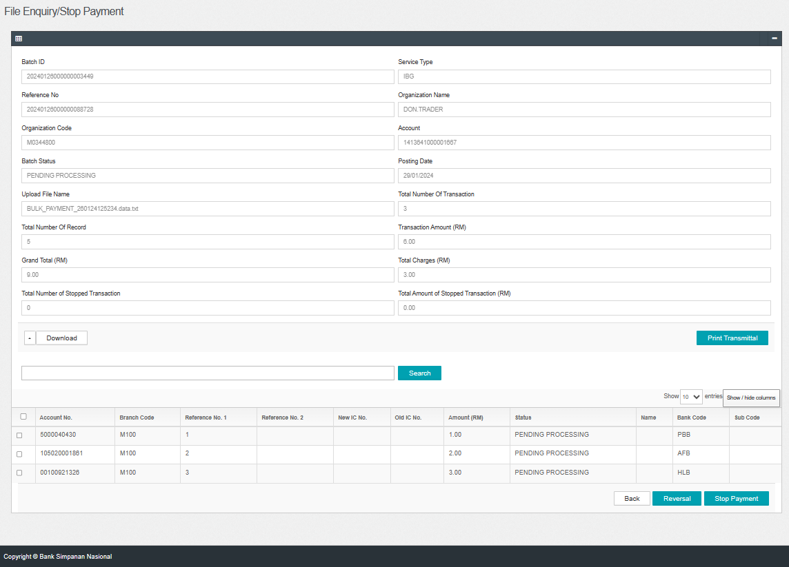  Figure 7: IBAM > File Processing > File Enquiry (Details)  Large file size  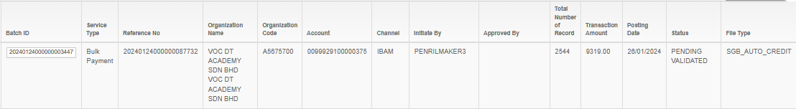  Figure 8: IBAM > File Processing > File Enquiry (Pending Validate)  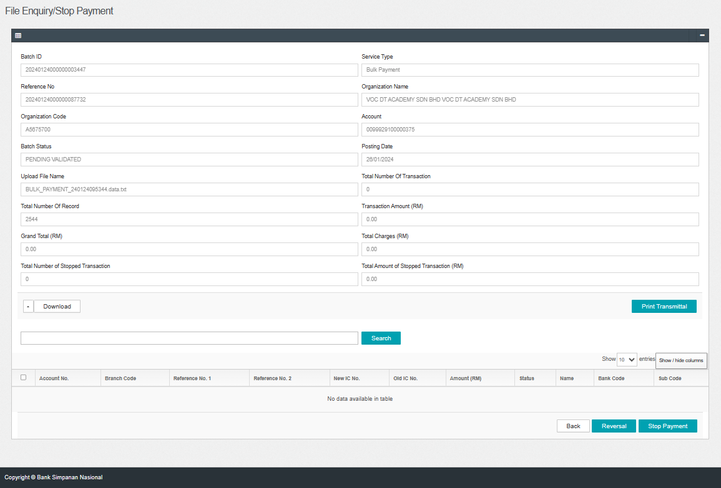  Figure 9: IBAM > File Processing > File Enquiry (Details)  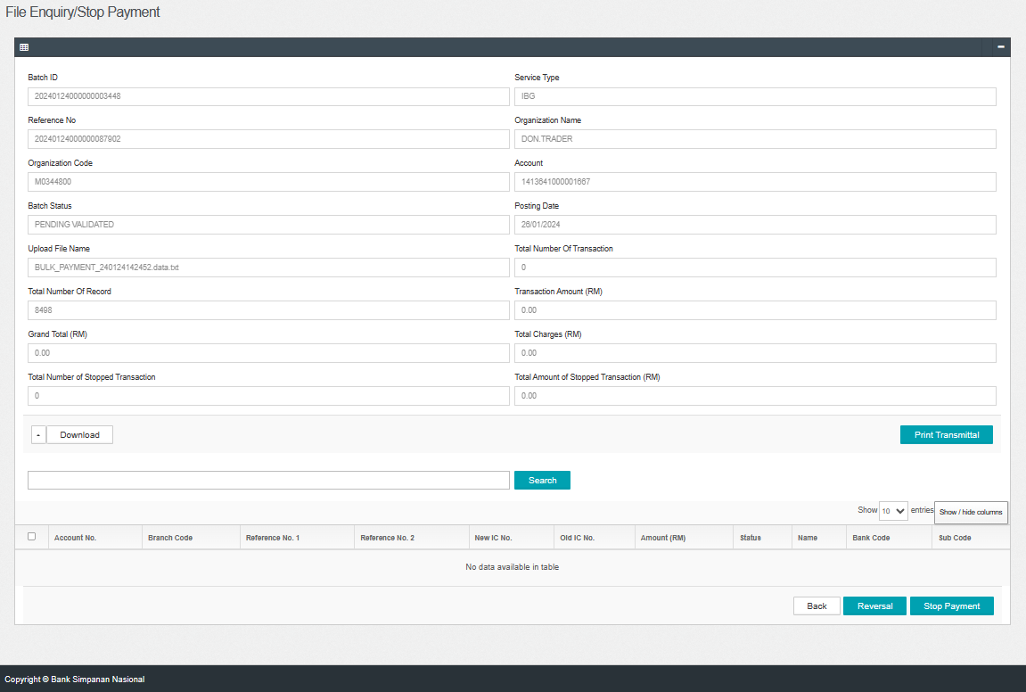  Figure 10: IBAM > File Processing > File Enquiry (Details)  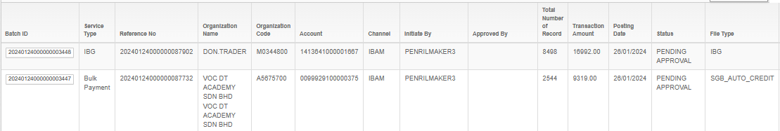  Figure 11: IBAM > File Processing > File Enquiry (Pending Approval)  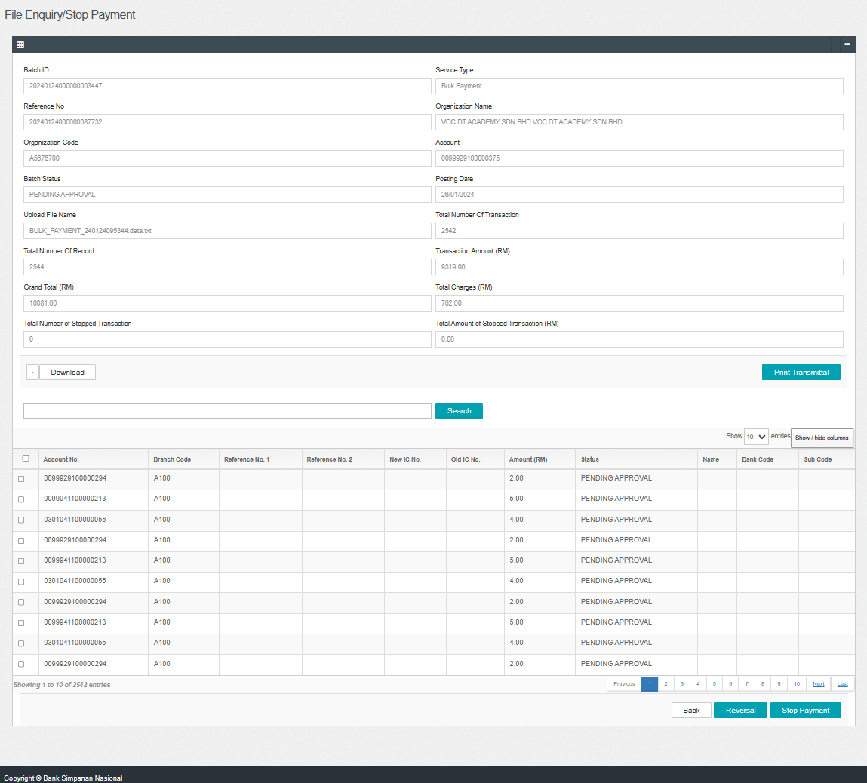  Figure 12: IBAM > File Processing > File Enquiry (Details)  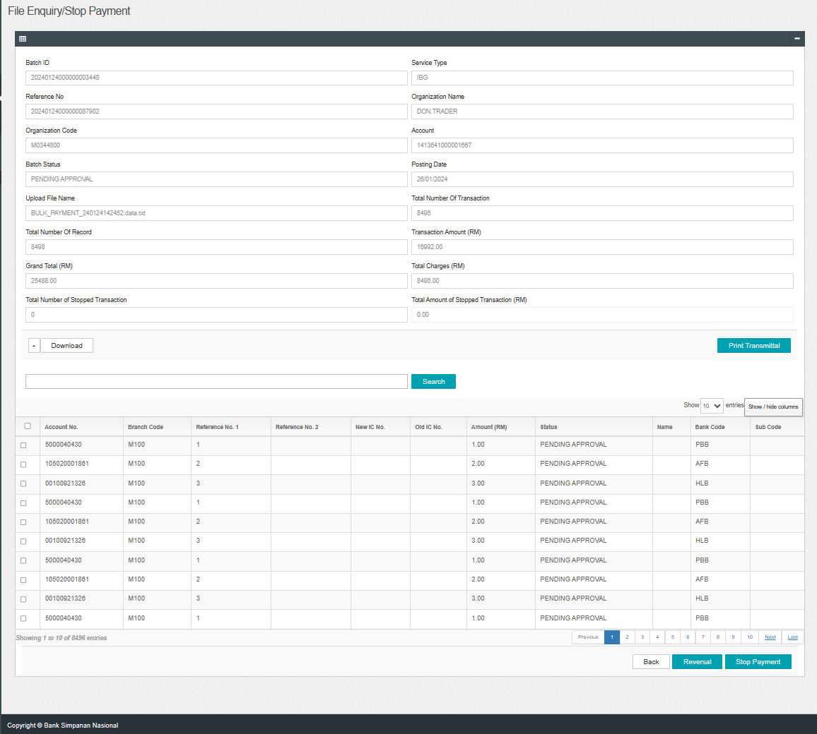  Figure 13: IBAM > File Processing > File Enquiry (Details)  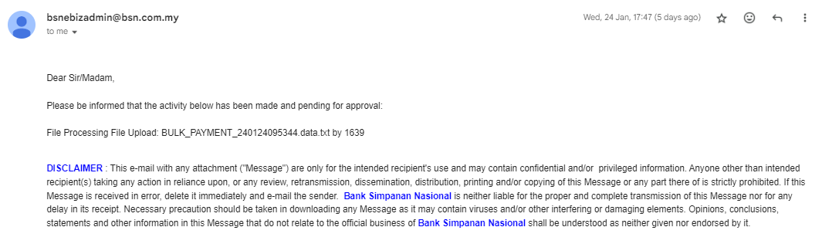  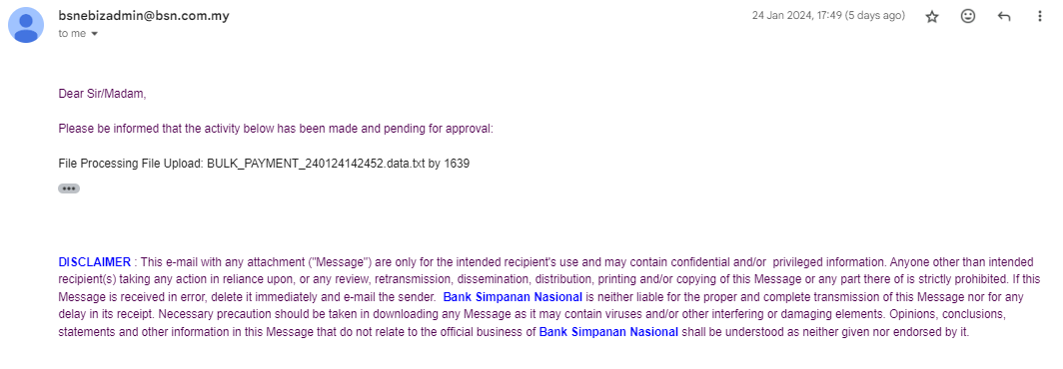  Figure 14: Email received by checker  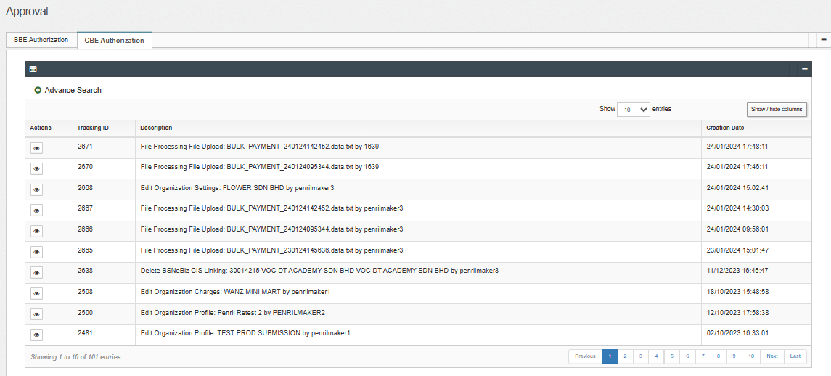  Figure 15: IBAM > Authorization > Approval  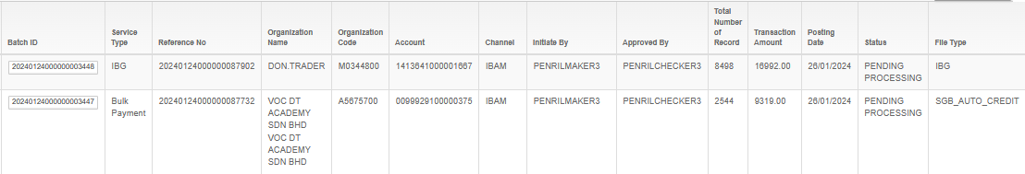  Figure 16: IBAM > File Processing > File Enquiry (Pending Processing)  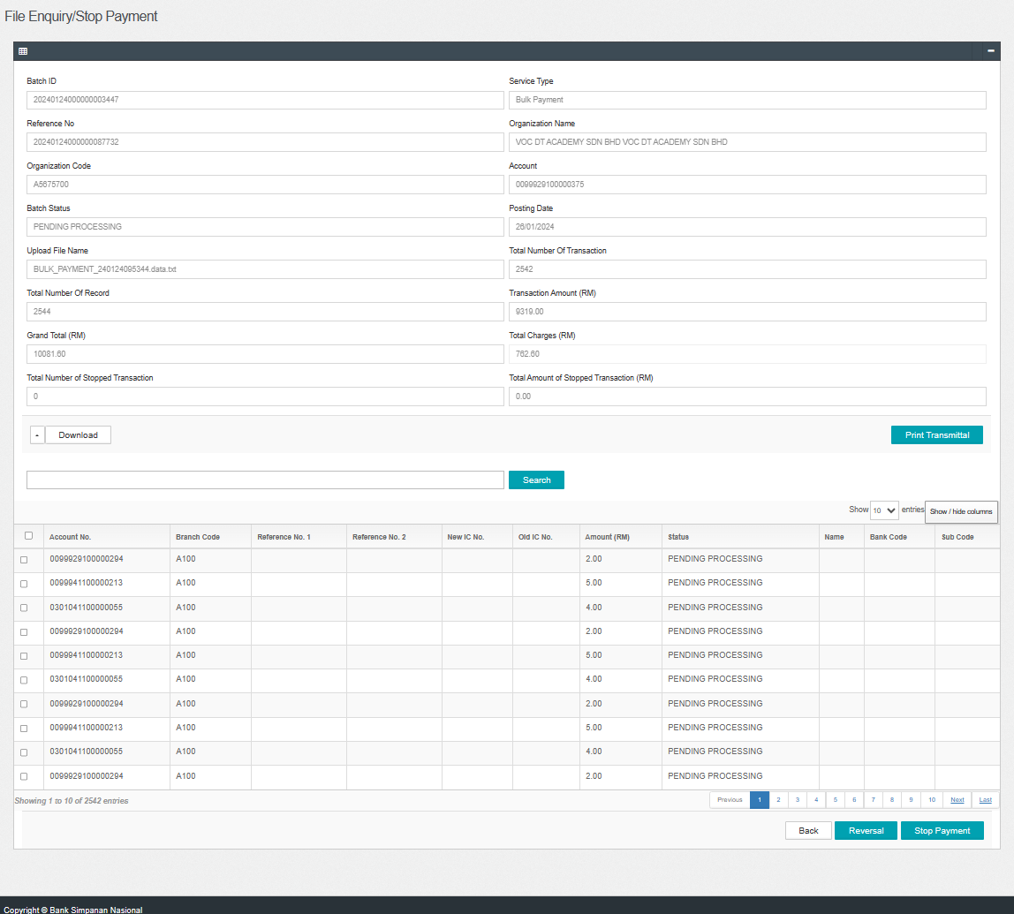  Figure 17: IBAM > File Processing > File Enquiry (Details)  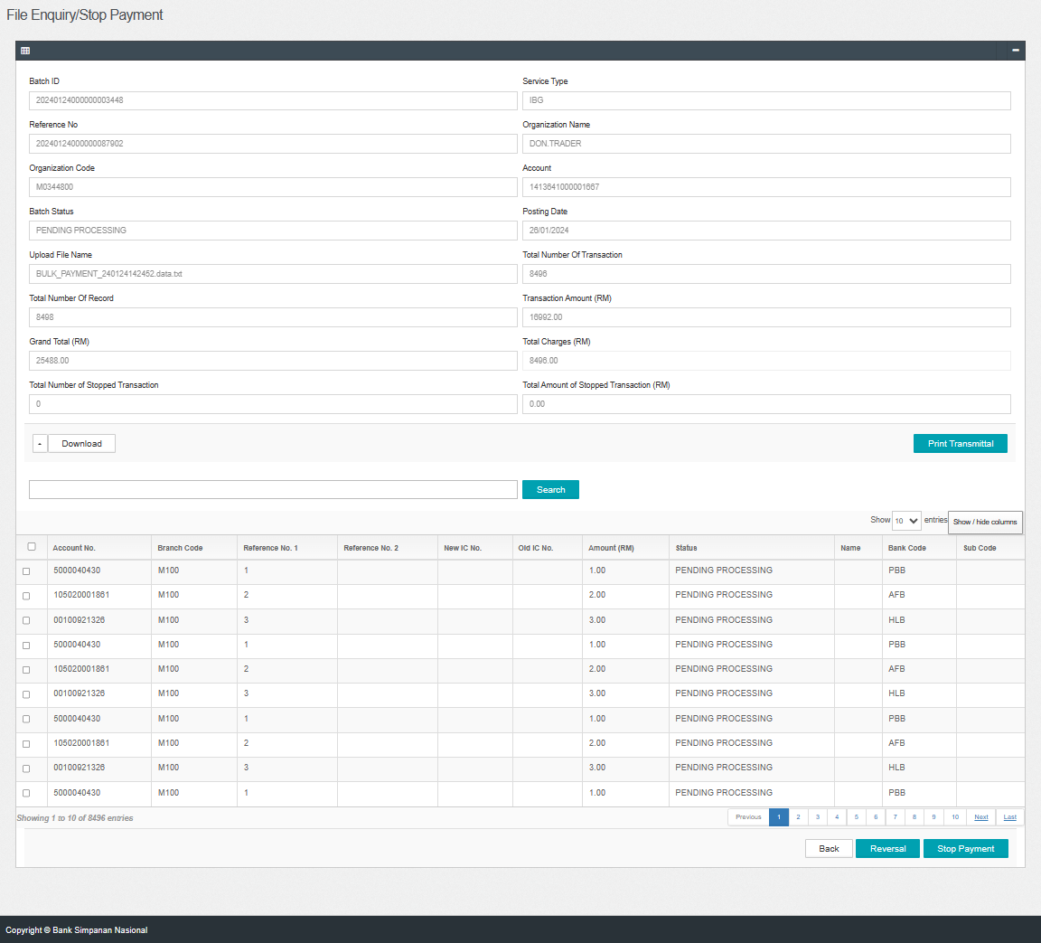  Figure 18: IBAM > File Processing > File Enquiry (Details)

