|  |
| --- |
|  |
| **Corporate Digital Banking**  **Enhancement of BSNeBiz Application and**  **Organization Setup**  **[CR22003]**  **for**  **IBAM and BSNeBiz** |
| Performance Testing Report |
|  |
| ***(PENRIL/BSN-PERF-TEST/BSNeBiz/01) – [CR22003])***  ***Revision: 00*** |
| **6 February 2024**  Prepared By:    **Penril Datability (M) Sdn Bhd (816792-X),**  Suite A-07-07 Plaza Mon’t Kiara,  No. 2, Jalan Kiara, Mon’t Kiara,  50480 Kuala Lumpur, Malaysia.  Tel: (603) 6201 2622, Fax: (603) 6201 7622. |

Performance Testing Acceptance

I/We hereby verify that this Performance Testing Acceptance Document consists of all the information requested by Bank Simpanan Nasional.

I/We also hereby AGREE that this satisfies our entire performance test result for DB Tech Refresh (MSSQL 2019) in UAT environment.

Bank Simpanan Nasional:

|  |  |  |  |
| --- | --- | --- | --- |
| Approved by | Role | Signature | Date |
|  |  |  |  |
|  |  |  |  |
|  |  |  |  |
|  |  |  |  |
|  |  |  |  |
|  |  |  |  |
|  |  |  |  |
|  |  |  |  |
|  |  |  |  |
|  |  |  |  |
|  |  |  |  |

Penril Datability (M) Sdn. Bhd.:

|  |  |  |  |
| --- | --- | --- | --- |
| Approved by | Role | Signature | Date |
|  |  |  |  |
|  |  |  |  |
|  |  |  |  |

**Document Management**

|  |  |  |  |  |
| --- | --- | --- | --- | --- |
| Rev. No | Date Update | Description of Change | Updated By | Reviewed By |
| 00 | 6/02/2024 | Initial Release | Nurin Nadia binti Md Zakri |  |
|  |  |  |  |  |
|  |  |  |  |  |

**Table of Contents**

Chapter 1 - Introduction 7

1. Background 7

2. Purpose 7

Chapter 2 – Content 8

1. Execution Strategy 8

1.1 Type of testing: Load Testing 8

1.2 Methods of Testing 8

1.3 Process of testing – Adding Delete Functionality to IBAM > CBE BSNeBiz Application Module 11

**1.3.1** **[TC-AD-AOS-1] – BSNeBiz Administration Login Page – Step 1 (PortalAccess.do)** 11

**1.3.2** **[TC-AD -AOS-2] – BSNeBiz Administration Home Page – STEP 2 (portalLogin.do)** 12

**1.3.3** **[TC-AD-AOS-3] – BSNeBiz Application Page – STEP 3 (applicationFormSearch.do)** 12

**1.3.4** **[TC-AD-AOS-4] – BSNeBiz Application – Delete Page – Step 4 (applicationFormDeleteConfirm.do)** 13

**1.3.5** **[TC-AD-AOS-5] - BSNeBiz Application Delete Result Page – Step 5 (deleteApplicationFormResult.do)** 14

1.4 Process of testing – New Application – To add an account number field in the online payment row 15

**1.4.1** **[TC-ACN-AOS-1] – New Application Page – Step 1 (ibNewApplicationFormStep1.action)** 15

**1.4.2** **[TC-ACN-AOS-2] - New Application Organization and Information Form Page – Step 2 (ibNewApplicationFormStep2.action)** 15

**1.4.3** **[TC-ACN-AOS-3] - New Application Services and Access Type Form Page – Step 3 (ibNewApplicationFormStep3.action)** 16

**1.4.4** **[TC-ACN-AOS-4] - New Application Confirmation Form Page – Step 4 (ibNewApplicationFormStep4.action)** 17

**1.4.5** **[TC-ACN-AOS-5] - New Application Terms & Conditions Page – Step 5 (ibBSN_TNC.action)** 18

**1.4.6** **[TC-ACN-AOS-6] - New Application Save and Download Declaration Pdf Page – Step 6 (ibNewApplicationFormModal.action)** 20

**1.4.7** **[TC-ACN-AOS-7] - New Application Save and Download Declaration Pdf Page – Step 7 (RegistrationSummaryPdfDownload.action)** 20

1.5 Process of testing – New Application – Rearrange the services listing 22

**1.5.1** **[TC-RSL-AOS-1] – New Application Page – Step 1 (ibNewApplicationFormStep1.action)** 22

**1.5.2** **[TC-RSL-AOS-2] - New Application Organization and Information Form Page – Step 2 (ibNewApplicationFormStep2.action)** 23

**1.5.3** **[TC-RSL-AOS-3] - New Application Services and Access Type Form Page – Step 3 (RegistrationSummaryPdfDownload.action)** 23

**1.5.4** **[TC-RSL-AOS-4] - New Application Confirmation Form Page – Step 4 (ibNewApplicationFormStep4.action)** 24

**1.5.5** **[TC-RSL-AOS-5] - New Application Terms & Conditions Page – Step 5 (BSN_TnC.pdf)** 25

**1.5.6** **[TC-RSL-AOS-6] - New Application Save and Download Declaration Pdf Page – Step 6 (ibNewApplicationFormModal.action)** 27

**1.5.7** **[TC-RSL-AOS-7] - New Application Save and Download Declaration Pdf Page – Step 7 (RegistrationSummaryPdfDownload.action)** 27

1.6 Process of testing – New Application – To update the Contact Us screen 29

**1.6.1** **[TC-UCS-AOS-1] – New Application Page – Step 1 (ibNewApplicationFormStep1.action)** 29

**1.6.2** **[TC-UCS-AOS-2] - New Application Organization and Information Form Page – Step 2 (ibNewApplicationFormStep2.action)** 29

**1.6.3** **[TC-UCS-AOS-3] - New Application Services and Access Type Form Page – Step 3 (ibNewApplicationFormStep3.action)** 30

**1.6.4** **[TC-UCS-AOS-4] - New Application Confirmation Form Page – Step 4 (ibNewApplicationFormStep4.action)** 31

**1.6.5** **[TC-UCS-AOS-5] - New Application Terms & Conditions Page – Step 5 (BSN_TnC.pdf)** 32

**1.6.6** **[TC-UCS-AOS-6] - New Application Save and Download Declaration Pdf Page – Step 6 (ibNewApplicationFormModal.action)** 34

**1.6.7** **[TC-UCS-AOS-7] - New Application Save and Download Declaration Pdf Page – Step 7 (RegistrationSummaryPdfDownload.action)** 34

**1.6.7** **[TC-UCS-AOS-8] - New Application Email Us Page – Step 8 (ibNewApplicationFormStep5.action)** 35

1.7 Process of testing – IBAM – To add checkbox in order to facilitate the “call back” has been done 36

**1.7.1** **[TC-ACF-AOS-1] – BSNeBiz Administration Login Page – Step 1 (ibPortalAccess.do)** 36

**1.7.2** **[TC-ACF-AOS-2] – BSNeBiz Administration Home Page – STEP 2 (ibPortalLogin.do)** 37

**1.7.3** **[TC-ACF-AOS-3] – BSNeBiz Application Page – STEP 3 (applicationFormSearch.do)** 37

**1.7.4** **[TC-ACF-AOS-4] – BSNeBiz Application Page – STEP 4 (applicationFormCreate.do)** 38

**1.7.5** **[TC-ACF-AOS-5] – BSNeBiz Application Search ByPage – STEP 5 (applicationFormCreateStep2.do)** 38

**1.7.6** **[TC-ACF-AOS-6] – BSNeBiz Application Create (Organization Details) Page – STEP 6 (applicationFormCreateStep3.do)** 39

**1.7.7** **[TC-ACF-AOS-7] – BSNeBiz Application Create (Services) Page – STEP 7 (applicationFormCreateStep4.do)** 40

**1.7.8** **[TC-ACF-AOS-8] – BSNeBiz Application Create (Services) Page – STEP 8 (applicationFormCreateStep5.do)** 40

**1.7.9** **[TC-ACF-AOS-9] – BSNeBiz Application Create (Charges) Page – STEP 9 (applicationFormCreateStep6.do)** 41

**1.7.10** **[TC-ACF-AOS-10] – BSNeBiz Application Create (Charges) Page – STEP 10 (applicationFormCreateStep7.do)** 42

**1.7.11** **[TC-ACF-AOS-11] – BSNeBiz Application Create (Confirmation) Page – STEP 11 (applicationFormCreateStep8.do)** 43

**1.7.12** **[TC-ACF-AOS-12] – BSNeBiz Application Create (Result) Page – STEP 12 (applicationFormCreateStep9.do)** 45

1.8 Tools: Apache JMeter 5.1.1 r1855137 45

2. Business Processes Involved 46

3. Performance Test Environment 48

4. Test Scenario & Test Result with Explanation in Layman Terms 48

# Chapter 1 - Introduction

## Background

Bank implements the Enhancement of BSNeBiz Application and Organization Setup in BSNeBiz and IBAM system, which is customer able to make new application and digital signing via online. However, the bank requested Penril to perform a performance report at BSNeBiz New Application Form.

## Purpose

Bank need to ensure that by implementing Enhancement of BSNeBiz Application and Organization Setup and integrating IB to this new system will not cause major performance degradation.

Thus, this document describes the Performance Test Result before and after IB integration to Enhancement of BSNeBiz Application and Organization Setup in the UAT environment.

# Chapter 2 – Content

## Execution Strategy

### Type of testing: Load Testing

A load test is a planned test to perform a specified number of requests to a system in order to test the query to DB under specific levels of simultaneous requests. A load test ensures that CDB is capable of handling an expected volume of traffic, and therefore is sometimes referred to as volume testing.

The goal of this load test is to prove that with new integration to Enhancement of BSNeBiz Application and Organization Setup, it can handle the expected volume with minimal to acceptable performance degradation. In this test scenario, we simulated the maximum number of requests with the goal of less than 1% of errors.

### Methods of Testing

Penril conducted load testing to the selected menu mentioned in Chapter 1 - 2 Purpose - Module to Test. The test scenarios will be Enhancement of BSNeBiz Application and Organization Setup, because this is considered one of modules that perform heavy query to database and highest number of touch points BSNeBiz. Below is the list of detailed test modules in BSNeBiz:

|  |  |  |  |
| --- | --- | --- | --- |
| System | Function | Module | Test Case |
| IBAM | New Application – Adding Delete Funtionality | BSNeBiz Administration Login Page – Step 1  (portalAccess.do) | [TC-AD-AOS-1] |
| BSNeBiz Administration Home Page – Step 2  (portalLogin.do) | [TC-AD-AOS-2] |
| BSNeBiz Application Page – Step 3  (applicationFormSearch.do) | [TC-AD-AOS-3] |
| BSNeBiz Application Delete Page -  Step 4  (applicationFormDeleteConfirm.do) | [TC-AD-AOS-4] |
| BSNeBiz Application Delete Result Page –  Step 5  (deleteApplicationFormResult.do) | [TC-AD-AOS-5] |
| BS BSNeBiz | New Application – To add an account number | New Application Page – Step 1  (ibNewApplicationFormStep1.action) | [TC-ACN-AOS-1] |
| New Application Organization and Information Form Page – Step 2  (ibNewApplicationFormStep2.action) | [TC-ACN-AOS-2] |
| New Application Services and Access Type Form Page – Step 3  (ibNewApplicationFormStep3.action) | [TC-ACN-AOS-3] |
| New Application Confirmation Form Page – Step 4  (ibNewApplicationFormStep4.action) | [TC-ACN-AOS-4] |
| New Application Terms & Condition Page – Step 5  ibBSN_TNC.action) | [TC-ACN-AOS-5] |
| New Application Save and Download Declaration Pdf Page – Step 6  (ibNewApplicationFormModal.action) | [TC-ACN-AOS-6] |
| New Application Save and Download Declaration Pdf Page - Step 7 (RegistrationSummaryPdfDownload.action) | [TC-ACN-AOS-7] |
| BS BSNeBiz | New Application – Rearrange the Services Listing | New Application Page – Step 1  (ibNewApplicationFormStep1.action) | [TC-RSL-AOS-1] |
| New Application Organization and Information Form Page – Step (ibNewApplicationFormStep2.action | [TC-RSL-AOS-2] |
| New Application Services and Access Type Form Page – Step 3  (ibNewApplicationFormStep3.action) | [TC-RSL-AOS-3] |
| New Application Confirmation Form Page – Step 4  (ibNewApplicationFormStep4.action) | [TC-RSL-AOS-4] |
| New Application Term & Conditions Page – Step 5  (BSN_TnC.pdf) | [TC-RSL-AOS-5] |
| New Application Save and Download Declaration Pdf Page – Step 6  (ibNewApplicationFormModal.action) | [TC-RSL-AOS-6] |
| New Application Save and Download Declaration Pdf Page – Step 7  (RegistrationSummaryPdfDownload.action) | [TC-RSL-AOS-7] |
| BSNeBiz | New Application –  To update the Contact Us Screen | New Application Page – Step 1  (ibNewApplicationFormStep1.do) | [TC-UCS-AOS-1] |
| New Application Organization and Information Form Page – Step 2  (ibNewApplicationFormStep2.do) | [TC-UCS-AOS-2] |
| New Application Services and Access Type Form Page – Step 3  (ibNewApplicationFormStep3.do) | [TC-UCS-AOS-3] |
| New Application Confirmation Form Page – Step 4  (ibNewApplicationFormStep4.do) | [TC-UCS-AOS-4] |
| New Application Term & Condition Page – Step 5  (BSN_TnC.pdf) | [TC-UCS-AOS-5] |
| New Application Save and Download Declaration Pdf Page – Step 6  (ibNewApplicationFormModal.do) | [TC-UCS-AOS-6] |
| New Application Save and Download Declaration Pdf Page – Step 7  (RegistrationSummaryPdfDownload.do) | [TC-UCS-AOS-7] |
| New Application Email Us Page – Step 8  (ibNewApplicationFormStep5.do) | [TC-UCS-AOS-8] |
| IBAM | To Add Checkbox in Order to Facilities | BSNeBiz Administration Login Page – Step 1  (ibPortalAccess.do) | [TC-ACF-AOS-1] |
| BSNeBiz Administration Home Page – Step 2  (ibPortalLogin.do) | [TC-ACF-AOS-2] |
| BSNeBiz Application Page – Step 3  (applicationFormSearch.do) | [TC-ACF-AOS-3] |
| BSNeBiz Application Page – Step 4  (applicationFormCreate.do) | [TC-ACF-AOS-4] |
| BSNeBiz Application Search ByPage – Step 5  (applicationFormCreateStep2.do) | [TC-ACF-AOS-5] |
| BSNeBiz Application Create (Organization Detail) Page – Step 6  (applicationFormCreateStep3.do) | [TC-ACF-AOS-6] |
| BSNeBiz Application Create (Services) Page – Step 7  (applicationFormCreateStep4.do) | [TC-ACF-AOS-7] |
| BSNeBiz Application Create (Services) Page – Page 8  (applicationFormCreateStep5.do) | [TC-ACF-AOS-8] |
| BSNeBiz Application Create (Charges) Page – Step 9  (applicationFormCreateStep6.do) | [TC-ACF-AOS-9] |
| BSNeBiz Application Create (Charges) Page – Step 10  (applicationFormCreateStep7.do) | [TC-ACF-AOS-10] |
| BSNeBiz Application Create (Confirmation) Page – Step 11  (applicationFormCreateStep8.do) | [TC-ACF-AOS-11] |
| BSNeBiz Application Create (Result) Page – Step 12  (applicationFormCreateStep9.do) | [TC-ACF-AOS-12] |

|  |
| --- |
| Important Notes:  This performance test case does not reflect the actual performance in the production environment. Bank need to provide the ratio between staging vs. production environment. |

### Process of testing – Adding Delete Functionality to IBAM > CBE BSNeBiz Application Module

This test scenario simulates concurrent users to Adding Delete Functionality to IBAM > CBE BSNeBiz Application module. This test case depends on below test case to be executed:

#### **[TC-AD-AOS-1] – BSNeBiz Administration Login Page – Step 1 (PortalAccess.do)**

**In this stage, the CDB connects to:**

1. DBO DB Schema

**The DBO fetches:**

* IB_SERVICE_INFO. IB_SERVICE_INFO contains some notes or announcements.

Figure 1: BSNeBiz Administration Login page

#### **[TC-AD -AOS-2] – BSNeBiz Administration Home Page – STEP 2 (portalLogin.do)**

**In this stage, the CDB connects to BSNeBiz Administration Home page:**

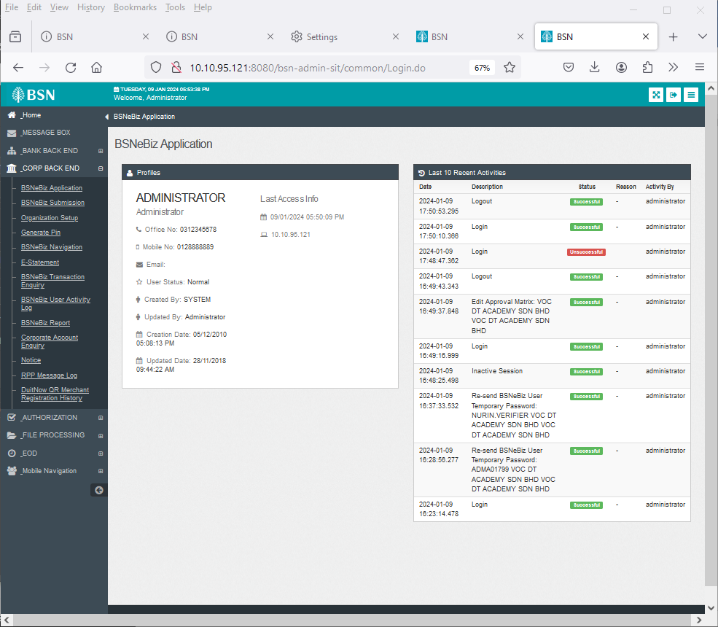

Figure 2: BSNeBiz Administration Home page

#### **[TC-AD-AOS-3] – BSNeBiz Application Page – STEP 3 (applicationFormSearch.do)**

**In this stage, the CDB connects to BSNeBiz Application page:**

Figure 3 : BSNeBiz Application page

#### **[TC-AD-AOS-4] – BSNeBiz Application – Delete Page – Step 4 (applicationFormDeleteConfirm.do)**

In this stage, the CDB connects to BSNeBiz Application – Delete page:

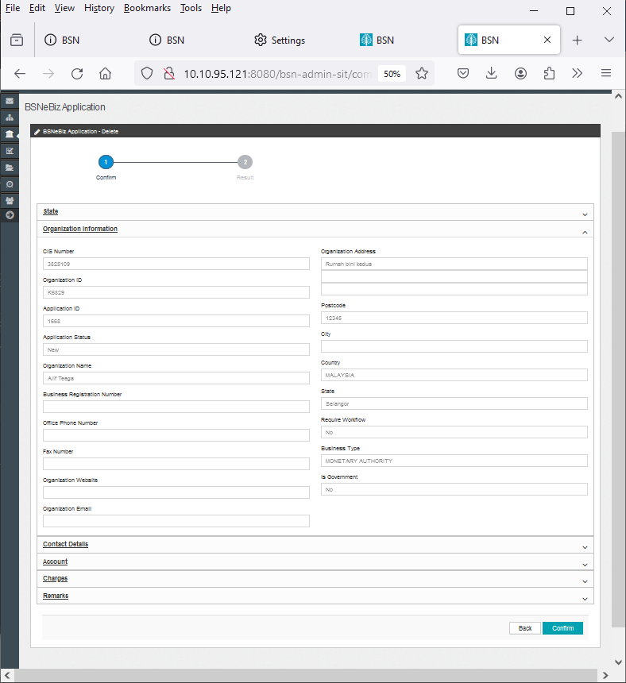

Figure 4 : BSNeBiz Application – Delete page

#### **[TC-AD-AOS-5] - BSNeBiz Application Delete Result Page – Step 5 (deleteApplicationFormResult.do)**

In this stage, the CDB connects to BSNeBiz Application Delete Result Page:

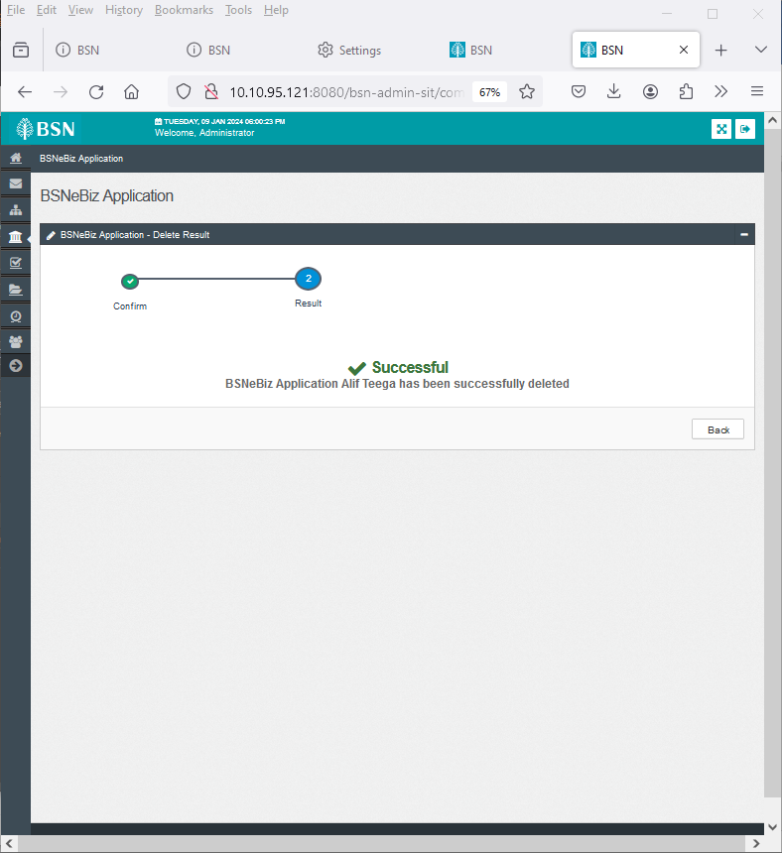

Figure 5: BSNeBiz Application Delete Result Page

### Process of testing – New Application – To add an account number field in the online payment row

This test scenario simulates concurrent users for New Application – To add an account number field in the online payment row. This test depends on below test case to be executed:

#### **[TC-ACN-AOS-1] – New Application Page – Step 1 (ibNewApplicationFormStep1.action)**

**In this stage, the CDB connects to:**

1. DBO DB Schema

**The DBO fetches:**

* IB_SERVICE_INFO. IB_SERVICE_INFO contains some notes or announcements.

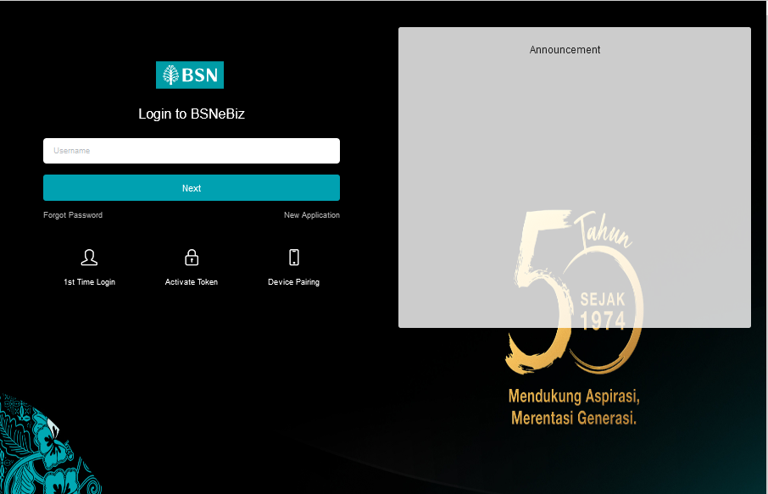

Figure 6: BSNeBiz Login page

#### **[TC-ACN-AOS-2] - New Application Organization and Information Form Page – Step 2 (ibNewApplicationFormStep2.action)**

In this stage, the CDB connects to New Application Organization and Information Form page:

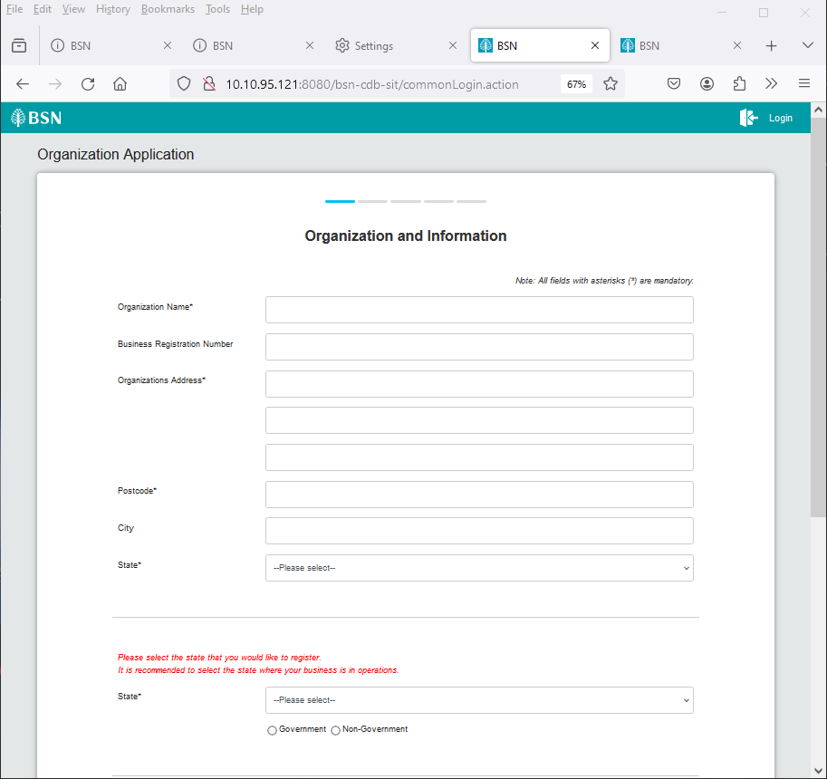

Figure 6 : BSNeBiz New Application > Organization and Information page

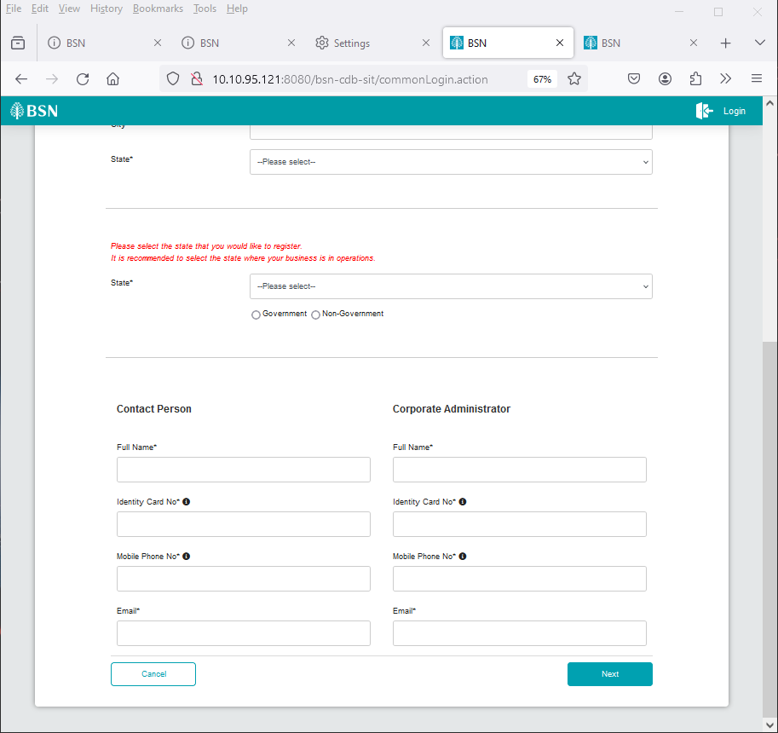

Figure 7 : BSNeBiz New Application > Organization and Information page

#### **1.4.3 [TC-ACN-AOS-3] - New Application Services and Access Type Form Page – Step 3 (ibNewApplicationFormStep3.action)**

In this stage, the CDB connects to:

1. DBO DB Schema

**The DBO fetches:**

* Table BIB_LHDN_EMPLOYER_NO. Table BIB_LHDN_EMPLOYER_NO contains id number validation details.

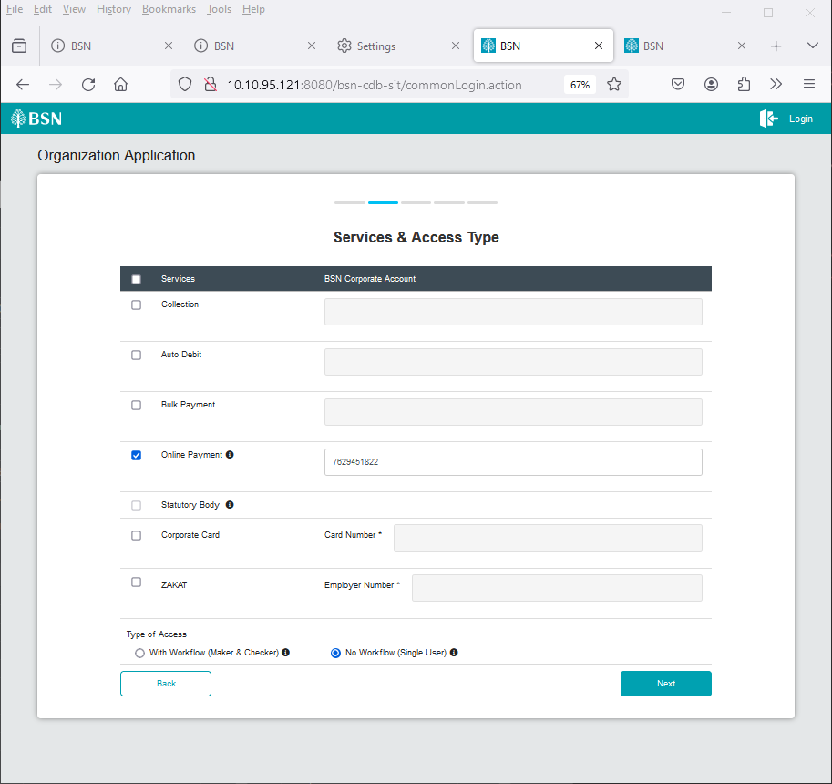

Figure 8 : BSNeBiz New Application > Services and Access Type page

#### **1.4.4 [TC-ACN-AOS-4] - New Application Confirmation Form Page – Step 4 (ibNewApplicationFormStep4.action)**

In this stage, the CDB connects to New Application Confirmation Form Page:

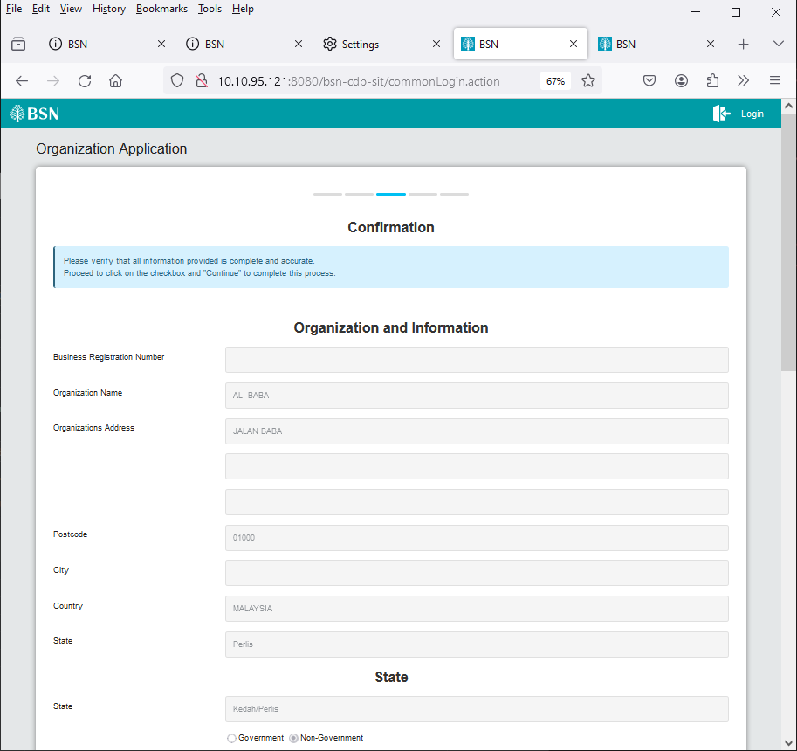

Figure 9 : BSNeBiz New Application > Confirmation page

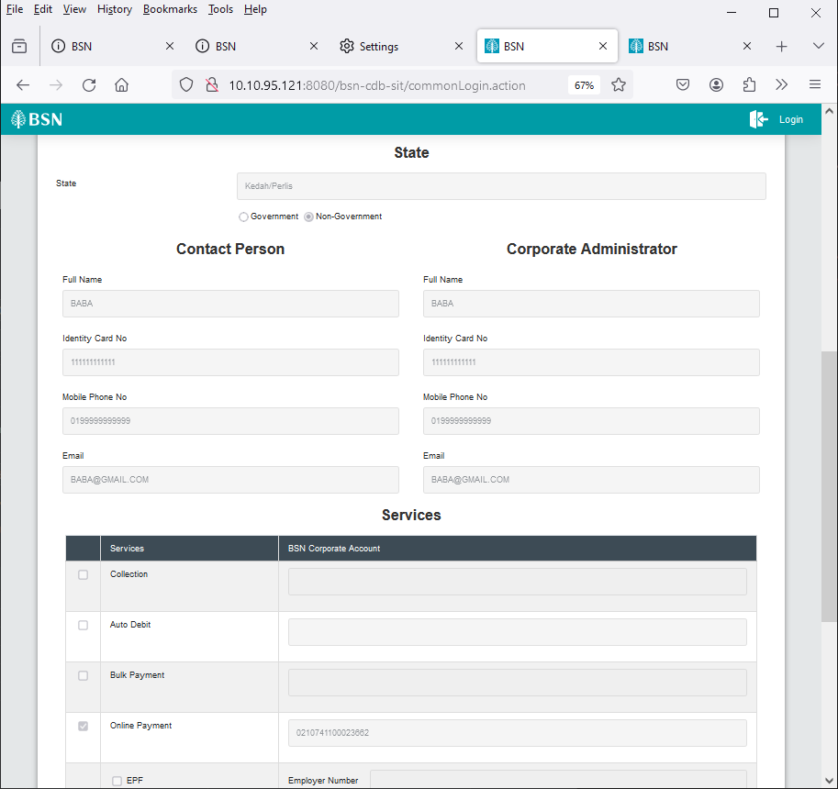

Figure 10 : B BSNeBiz New Application > Confirmation page

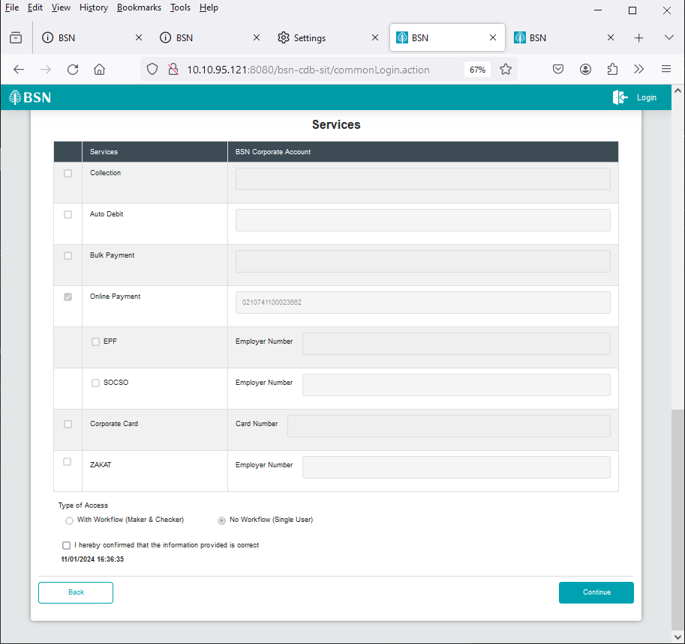

Figure 11 : BSNeBiz New Application > Confirmation page

#### **1.4.5 [TC-ACN-AOS-5] - New Application Terms & Conditions Page – Step 5 (ibBSN_TNC.action)**

In this stage, the CDB connects to:

1. SACDA947 Server

**The SACDA947 fetches:**

* BSN folder. BSN folder contains BSN_TNC.pdf file for Terms And Condition of BSNeBIZ pdf.

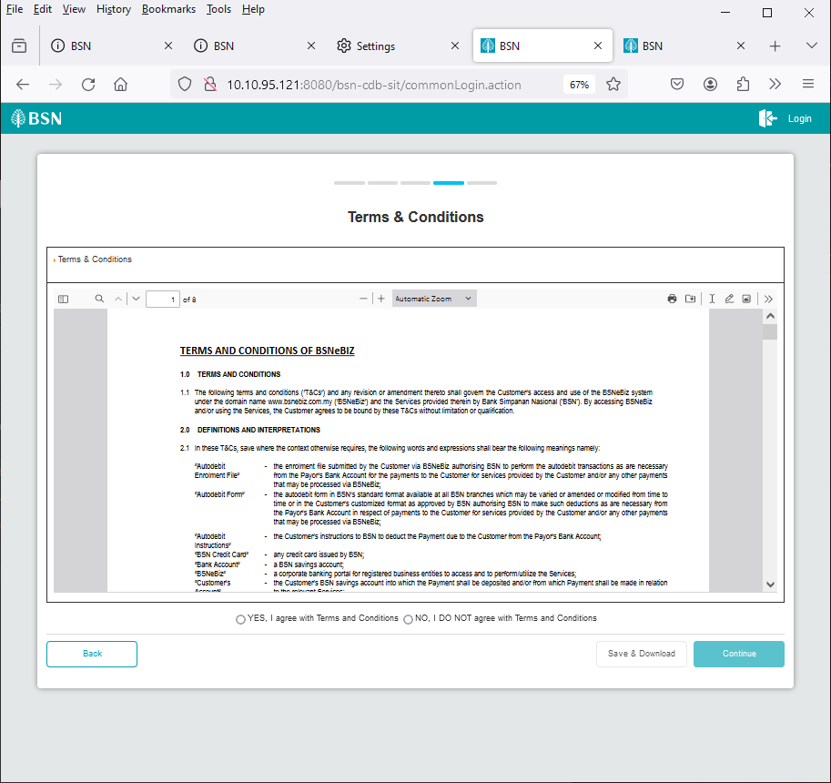

Figure 12: BSNeBiz > New Application > Terms and Condition screen

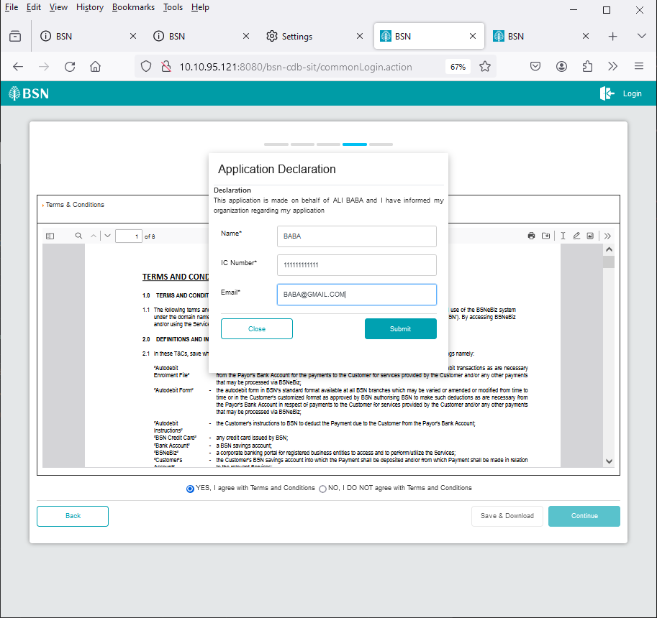

Figure 13: BSNeBiz > New Application > TNC >Application declaration popup

#### **1.4.6 [TC-ACN-AOS-6] - New Application Save and Download Declaration Pdf Page – Step 6 (ibNewApplicationFormModal.action)**

In this stage, the CDB connects to:

1. SACDA947 Server

**The SACDA947 fetches:**

* BSN folder. BSN folder contains BSN_TNC.pdf file for Terms And Condition of BSNeBIZ pdf.



Figure 14: BSNeBiz > New Application > Terms and Condition screen

#### **1.4.7 [TC-ACN-AOS-7] - New Application Save and Download Declaration Pdf Page – Step 7 (RegistrationSummaryPdfDownload.action)**

In this stage, the CDB connects to:

1. DBO DB Schema

**The DBO fetches:**

* Table BIB_APPLICATION_FORM. Table BIB_APPLICATION_FORM contains data for New Application Form details.

1. SACDA947 Server

**The SACDA947 fetches:**

* IBApplicationResources_en.properties. IBApplicationResources_en.properties contain the Result page details.
* appConfig.file. appConfig file contains the email value inside Result page.

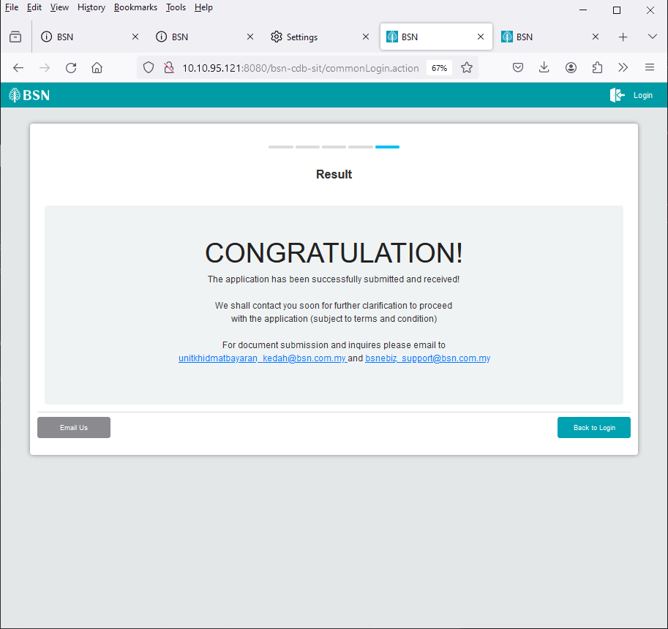

Figure 15 : BSNeBiz New Application > Result page

### Process of testing – New Application – Rearrange the services listing

This test scenario simulates concurrent users for New Application – To rearrange the services listing. This test depends on below test case to be executed:

#### **[TC-RSL-AOS-1] – New Application Page – Step 1 (ibNewApplicationFormStep1.action)**

**In this stage, the CDB connects to:**

1. DBO DB Schema

**The DBO fetches:**

* IB_SERVICE_INFO. IB_SERVICE_INFO contains some notes or announcements.



Figure 16 : BSNeBiz Login page

#### **[TC-RSL-AOS-2] - New Application Organization and Information Form Page – Step 2 (ibNewApplicationFormStep2.action)**

In this stage, the CDB connects to New Application Organization and Information Form page:



Figure 17 : BSNeBiz New Application > Organization and Information page



Figure 18 : BSNeBiz New Application > Organization and Information page

#### **1.5.3 [TC-RSL-AOS-3] - New Application Services and Access Type Form Page – Step 3 (RegistrationSummaryPdfDownload.action)**

In this stage, the CDB connects to:

1. DBO DB Schema

**The DBO fetches:**

* Table BIB_LHDN_EMPLOYER_NO. Table BIB_LHDN_EMPLOYER_NO contains id number validation details.



Figure 19 : BSNeBiz New Application > Services and Access Type page

#### **1.5.4 [TC-RSL-AOS-4] - New Application Confirmation Form Page – Step 4 (ibNewApplicationFormStep4.action)**

In this stage, the CDB connects to New Application Confirmation Form Page:



Figure 20 : BSNeBiz New Application > Confirmation page



Figure 21 : B BSNeBiz New Application > Confirmation page



Figure 22 : BSNeBiz New Application > Confirmation page

#### **1.5.5 [TC-RSL-AOS-5] - New Application Terms & Conditions Page – Step 5 (BSN_TnC.pdf)**

In this stage, the CDB connects to:

1. SACDA947 Server

**The SACDA947 fetches:**

* BSN folder. BSN folder contains BSN_TNC.pdf file for Terms And Condition of BSNeBIZ pdf.



Figure 23: BSNeBiz > New Application > Terms and Condition screen



Figure 24: BSNeBiz > New Application > TNC >Application declaration popup

#### **1.5.6 [TC-RSL-AOS-6] - New Application Save and Download Declaration Pdf Page – Step 6 (ibNewApplicationFormModal.action)**

In this stage, the CDB connects to:

1. SACDA947 Server

**The SACDA947 fetches:**

* BSN folder. BSN folder contains BSN_TNC.pdf file for Terms And Condition of BSNeBIZ pdf.



Figure 25: BSNeBiz > New Application > Terms and Condition screen

#### **1.5.7 [TC-RSL-AOS-7] - New Application Save and Download Declaration Pdf Page – Step 7 (RegistrationSummaryPdfDownload.action)**

In this stage, the CDB connects to:

1. DBO DB Schema

**The DBO fetches:**

* Table BIB_APPLICATION_FORM. Table BIB_APPLICATION_FORM contains data for New Application Form details.

1. SACDA947 Server

**The SACDA947 fetches:**

* IBApplicationResources_en.properties. IBApplicationResources_en.properties contain the Result page details.
* appConfig.file. appConfig file contains the email value inside Result page.



Figure 26 : BSNeBiz New Application > Result page

### Process of testing – New Application – To update the Contact Us screen

This test scenario simulates concurrent users for New Application – To update the Contact Us screen. This test depends on below test case to be executed:

#### **[TC-UCS-AOS-1] – New Application Page – Step 1 (ibNewApplicationFormStep1.action)**

**In this stage, the CDB connects to:**

1. DBO DB Schema

**The DBO fetches:**

* IB_SERVICE_INFO. IB_SERVICE_INFO contains some notes or announcements.



Figure 27 : BSNeBiz Login page

#### **1.6.2 [TC-UCS-AOS-2] - New Application Organization and Information Form Page – Step 2 (ibNewApplicationFormStep2.action)**

In this stage, the CDB connects to New Application Organization and Information Form page:



Figure 28 : BSNeBiz New Application > Organization and Information page



Figure 29 : BSNeBiz New Application > Organization and Information page

#### **1.6.3 [TC-UCS-AOS-3] - New Application Services and Access Type Form Page – Step 3 (ibNewApplicationFormStep3.action)**

In this stage, the CDB connects to:

1. DBO DB Schema

**The DBO fetches:**

* Table BIB_LHDN_EMPLOYER_NO. Table BIB_LHDN_EMPLOYER_NO contains id number validation details.



Figure 30 : BSNeBiz New Application > Services and Access Type page

#### **1.6.4 [TC-UCS-AOS-4] - New Application Confirmation Form Page – Step 4 (ibNewApplicationFormStep4.action)**

In this stage, the CDB connects to New Application Confirmation Form Page:



Figure 31 : BSNeBiz New Application > Confirmation page



Figure 32 : B BSNeBiz New Application > Confirmation page



Figure 33 : BSNeBiz New Application > Confirmation page

#### **1.6.5 [TC-UCS-AOS-5] - New Application Terms & Conditions Page – Step 5 (BSN_TnC.pdf)**

In this stage, the CDB connects to:

1. SACDA947 Server

**The SACDA947 fetches:**

* BSN folder. BSN folder contains BSN_TNC.pdf file for Terms And Condition of BSNeBIZ pdf.



Figure 34: BSNeBiz > New Application > Terms and Condition screen



Figure 35: BSNeBiz > New Application > TNC >Application declaration popup

#### **1.6.6 [TC-UCS-AOS-6] - New Application Save and Download Declaration Pdf Page – Step 6 (ibNewApplicationFormModal.action)**

In this stage, the CDB connects to:

1. SACDA947 Server

**The SACDA947 fetches:**

* BSN folder. BSN folder contains BSN_TNC.pdf file for Terms And Condition of BSNeBIZ pdf.



Figure 36: BSNeBiz > New Application > Terms and Condition screen

#### **1.6.7 [TC-UCS-AOS-7] - New Application Save and Download Declaration Pdf Page – Step 7 (RegistrationSummaryPdfDownload.action)**

In this stage, the CDB connects to:

1. DBO DB Schema

**The DBO fetches:**

* Table BIB_APPLICATION_FORM. Table BIB_APPLICATION_FORM contains data for New Application Form details.

1. SACDA947 Server

**The SACDA947 fetches:**

* IBApplicationResources_en.properties. IBApplicationResources_en.properties contain the Result page details.
* appConfig.file. appConfig file contains the email value inside Result page.



Figure 37 : BSNeBiz New Application > Result page

#### **1.6.7 [TC-UCS-AOS-8] - New Application Email Us Page – Step 8 (ibNewApplicationFormStep5.action)**

In this stage, the CDB connects to BSNeBiz New Application Email Us page:

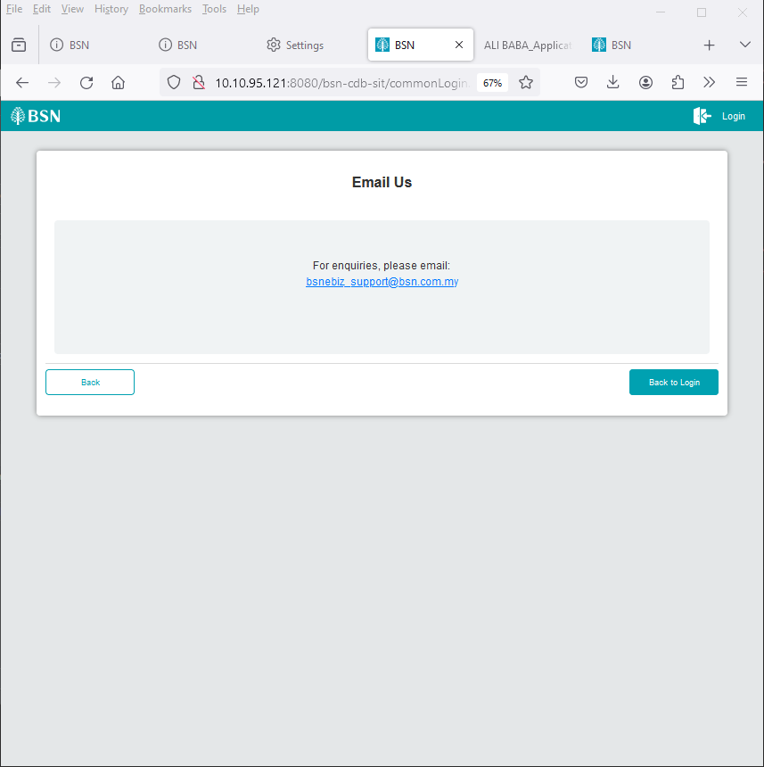

Figure 38 : BSNeBiz New Application > Email Us

### Process of testing – IBAM – To add checkbox in order to facilitate the “call back” has been done

This test scenario simulates concurrent users for IBAM – To add checkbox in order to facilitate the “call back: has been done. This test depends on below test case to be executed:

#### **[TC-ACF-AOS-1] – BSNeBiz Administration Login Page – Step 1 (ibPortalAccess.do)**

**In this stage, the CDB connects to:**

1. DBO DB Schema

**The DBO fetches:**

* IB_SERVICE_INFO. IB_SERVICE_INFO contains some notes or announcements.

Figure 39 : BSNeBiz Administration Login page

#### **[TC-ACF-AOS-2] – BSNeBiz Administration Home Page – STEP 2 (ibPortalLogin.do)**

**In this stage, the CDB connects to BSNeBiz Administration Home page:**



Figure 40 : BSNeBiz Administration Home page

#### **[TC-ACF-AOS-3] – BSNeBiz Application Page – STEP 3 (applicationFormSearch.do)**

**In this stage, the CDB connects to BSNeBiz Application page:**

Figure 41 : BSNeBiz Application page

#### **[TC-ACF-AOS-4] – BSNeBiz Application Page – STEP 4 (applicationFormCreate.do)**

**In this stage, the CDB connects to BSNeBiz Application - Create page:**

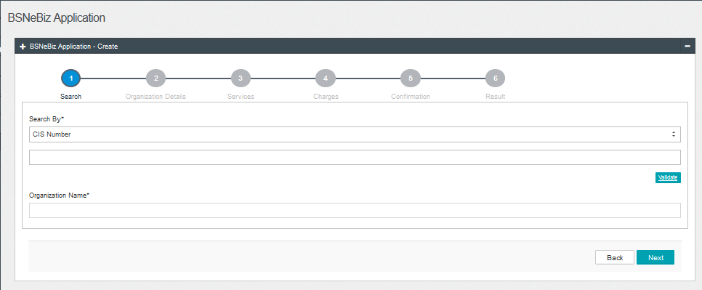

Figure 42 : BSNeBiz Application - Create page

#### **1.7.5 [TC-ACF-AOS-5] – BSNeBiz Application Search ByPage – STEP 5 (applicationFormCreateStep2.do)**

**In this stage, the CDB connects to BSNeBiz Application - Create (Search by) page:**

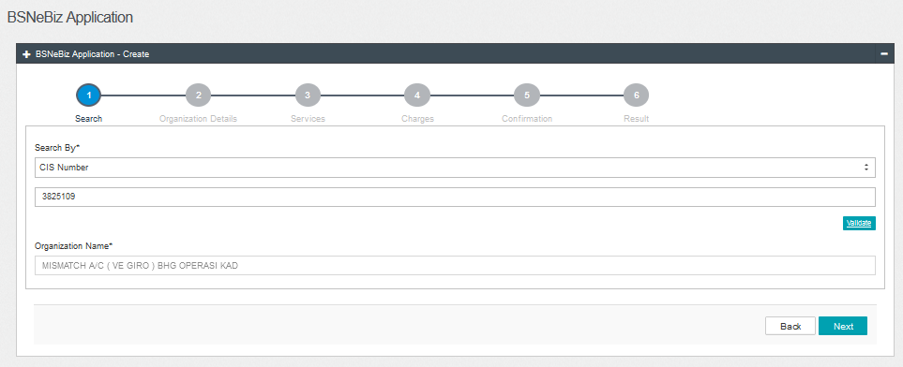

Figure 43 : BSNeBiz Application - Create (Search by)

#### **1.7.6 [TC-ACF-AOS-6] – BSNeBiz Application Create (Organization Details) Page – STEP 6 (applicationFormCreateStep3.do)**

**In this stage, the CDB connects to BSNeBiz Application – Create (Organization Detail) page:**

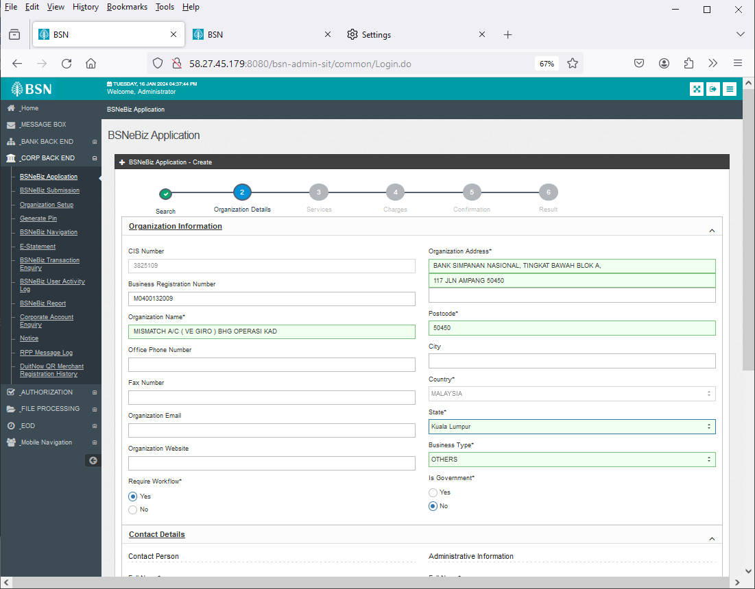

Figure 44 : BSNeBiz Application - Create (Organization Details)

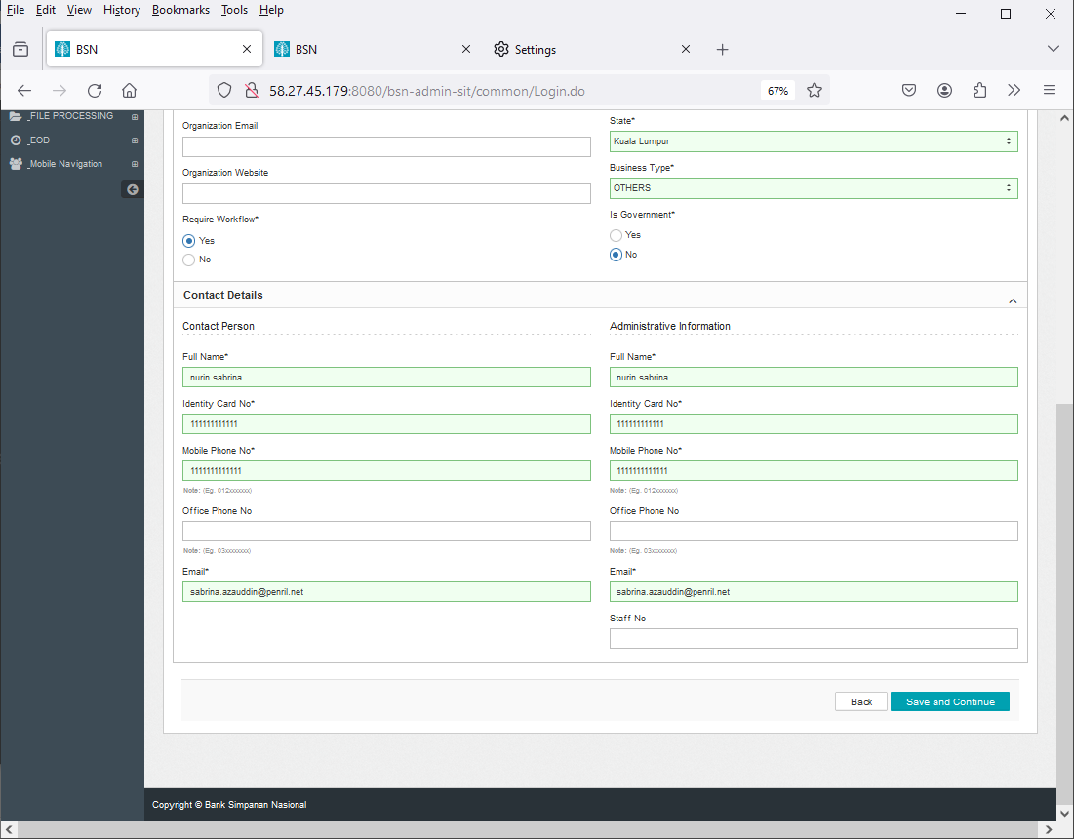

Figure 45 : BSNeBiz Application - Create (Organization Details)

#### **1.7.7 [TC-ACF-AOS-7] – BSNeBiz Application Create (Services) Page – STEP 7 (applicationFormCreateStep4.do)**

**In this stage, the CDB connects to BSNeBiz Application – Create (Services) generate Organization ID page:**

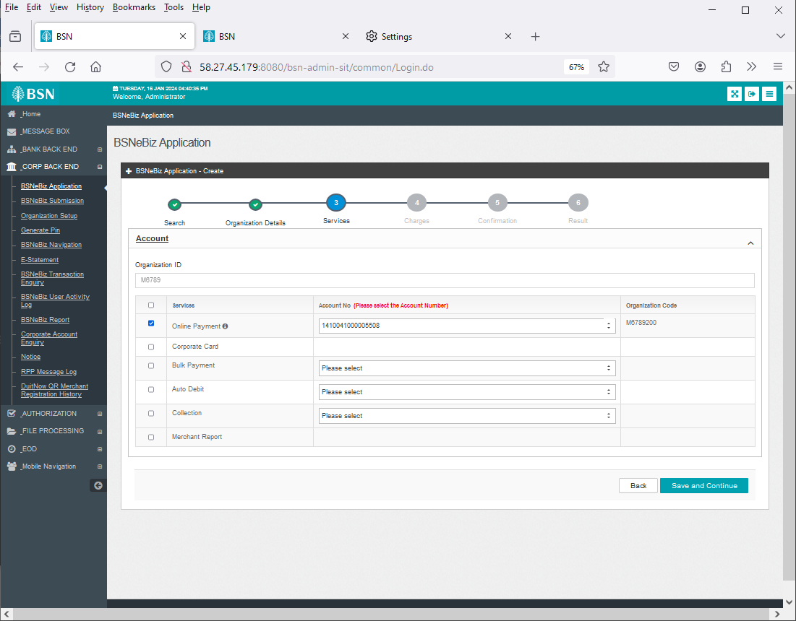

Figure 46 : BSNeBiz Application – Create (Services) page

#### **1.7.8 [TC-ACF-AOS-8] – BSNeBiz Application Create (Services) Page – STEP 8 (applicationFormCreateStep5.do)**

**In this stage, the CDB connects to BSNeBiz Application – Create (Services) page:**



Figure 47 : BSNeBiz Application – Create (Services) page

#### **1.7.9 [TC-ACF-AOS-9] – BSNeBiz Application Create (Charges) Page – STEP 9 (applicationFormCreateStep6.do)**

**In this stage, the CDB connects to BSNeBiz Application – Create (Charges) select Charges Package page:**

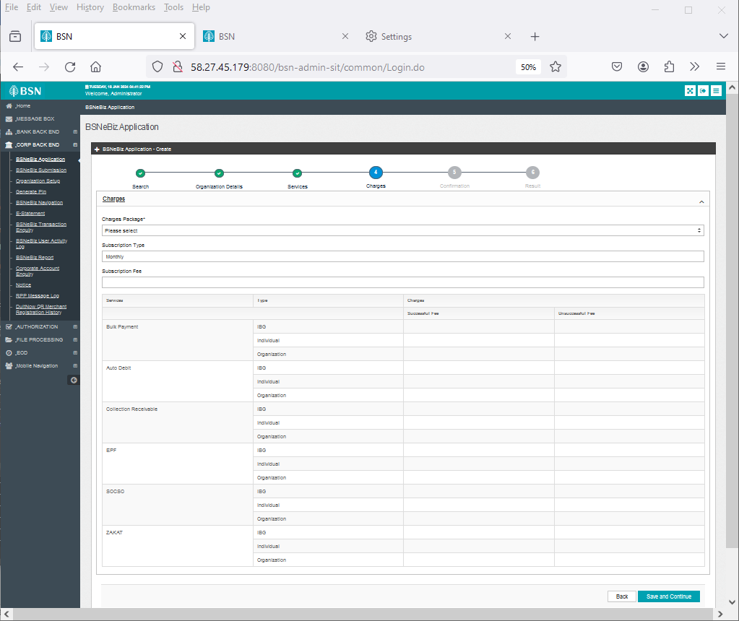

Figure 48 : BSNeBiz Application - Create (Charges) page

#### **1.7.10 [TC-ACF-AOS-10] – BSNeBiz Application Create (Charges) Page – STEP 10 (applicationFormCreateStep7.do)**

**In this stage, the CDB connects to BSNeBiz Application – Create (Charges) page:**

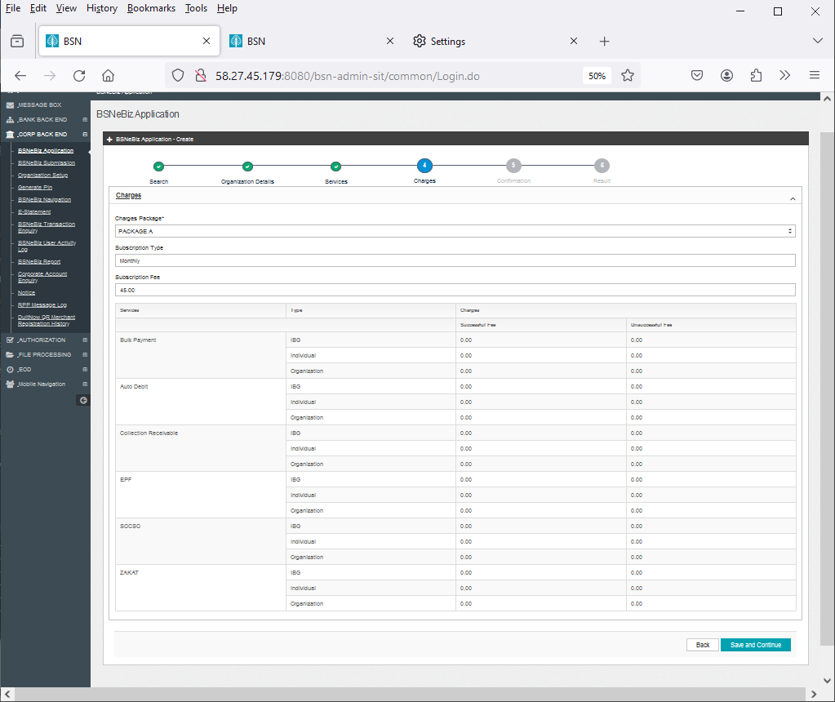

Figure 49 : BSNeBiz Application - Create (Charges) page

#### **1.7.11 [TC-ACF-AOS-11] – BSNeBiz Application Create (Confirmation) Page – STEP 11 (applicationFormCreateStep8.do)**

**In this stage, the CDB connects to BSNeBiz Application – Create (Confirmation) page:**

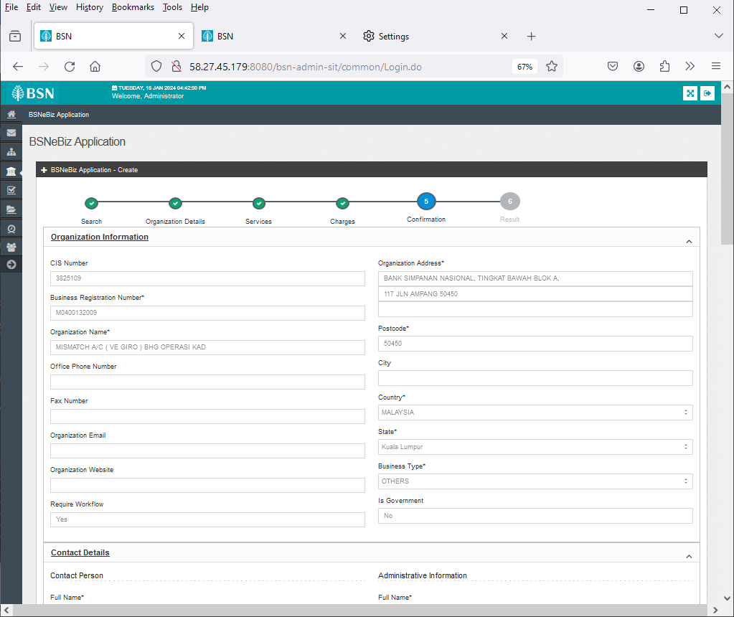

Figure 50 : BSNeBiz Application - Confirmation page

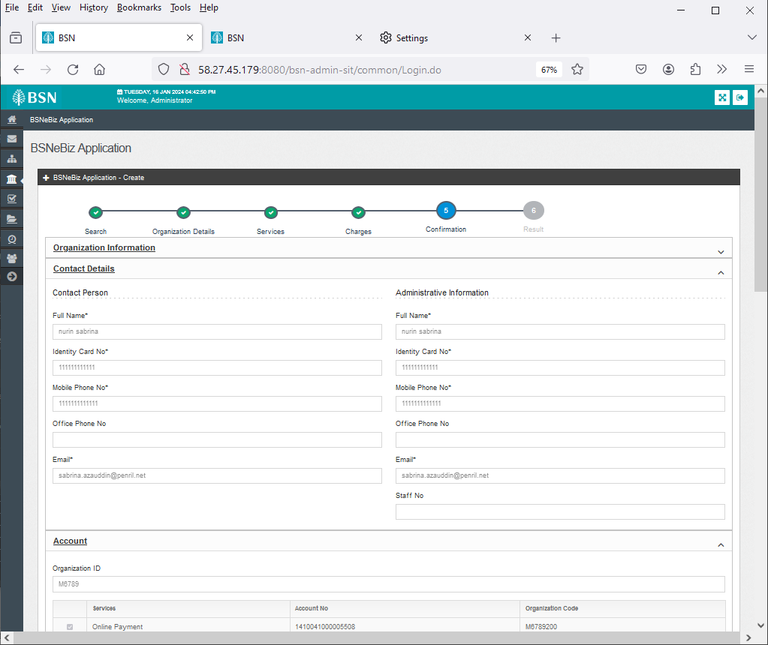

Figure 51 : BSNeBiz Application - Confirmation page

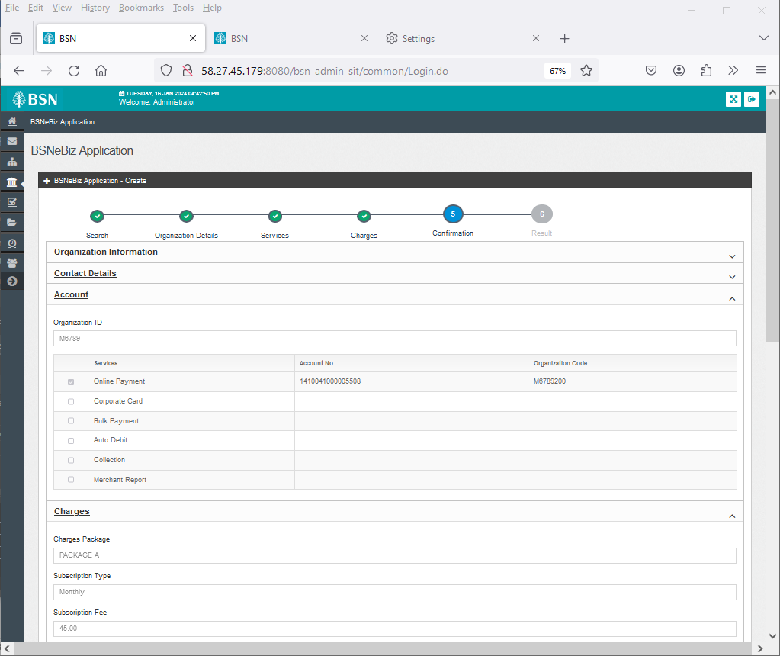

Figure 52 : BSNeBiz Application - Confirmation page

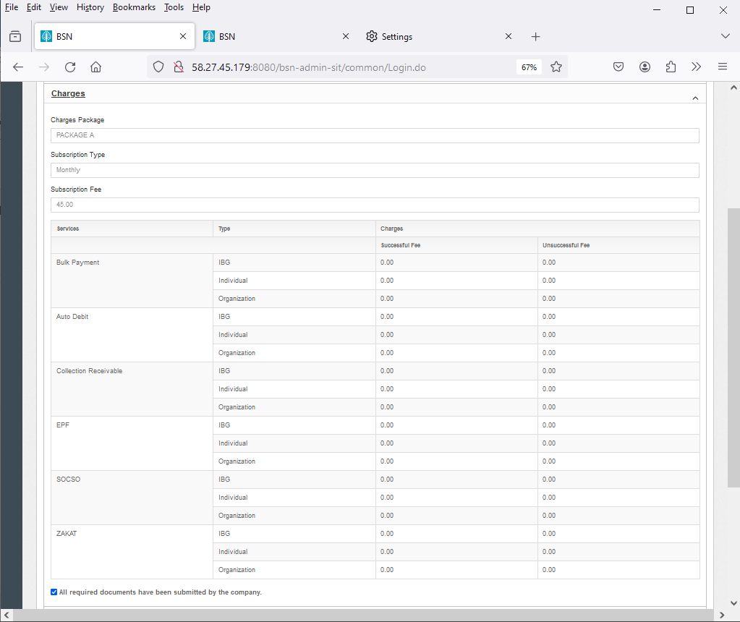

Figure 53 : BSNeBiz Application - Confirmation page

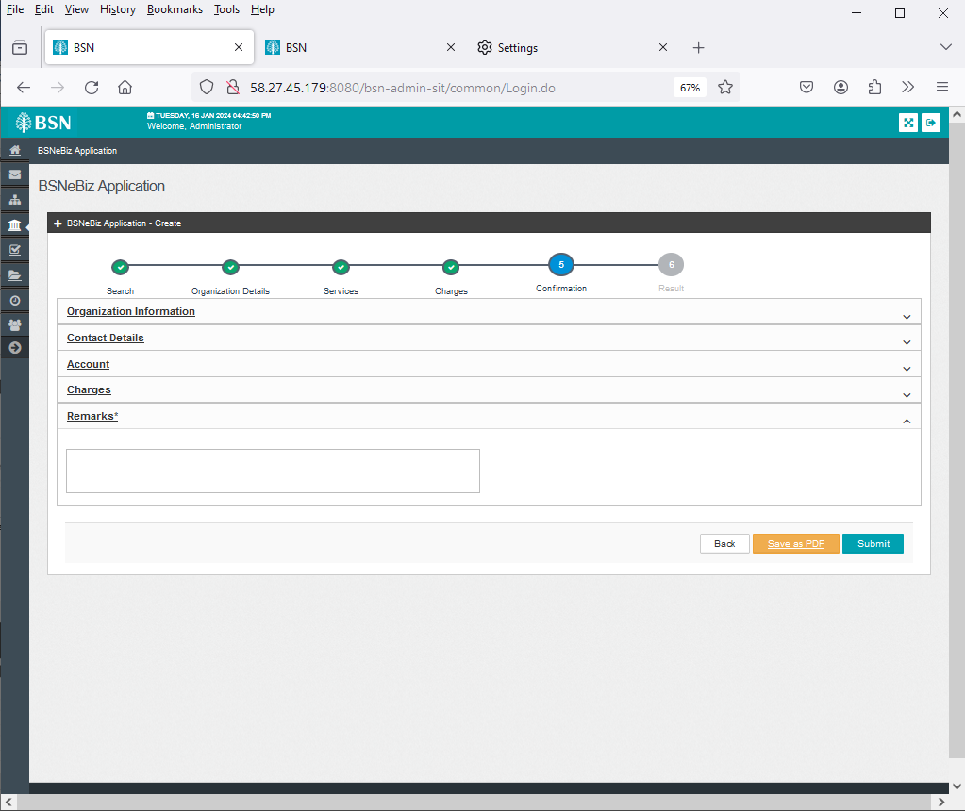

Figure 54 : BSNeBiz Application - Confirmation page

#### **1.7.12 [TC-ACF-AOS-12] – BSNeBiz Application Create (Result) Page – STEP 12 (applicationFormCreateStep9.do)**

**In this stage, the CDB connects to BSNeBiz Application – Create (Result) page:**

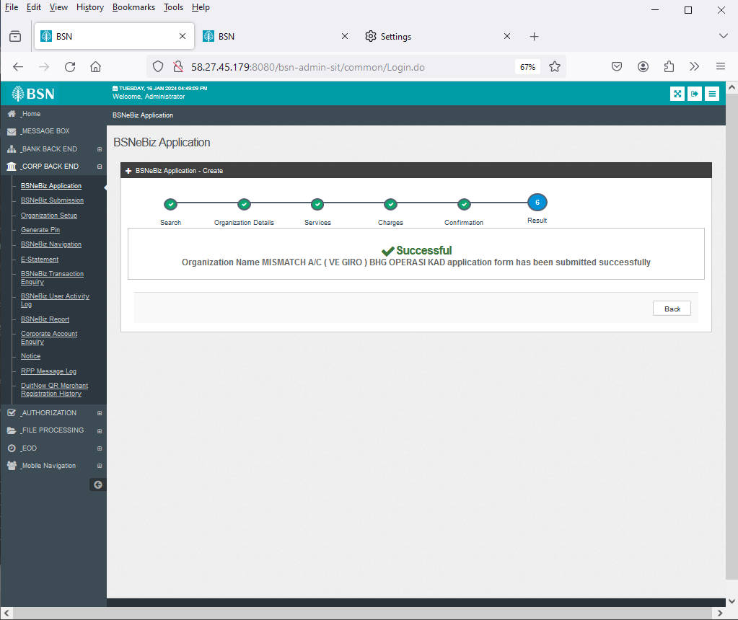

Figure 55 : BSNeBiz Application Result page

### 1.8 Tools: Apache JMeter 5.1.1 r1855137

Apache JMeter is pure Java open-source software with the purpose of load testing functional behaviour and measuring performance of web applications. This app is chosen because it is platform independent, easy to install and provides better visualization on test results.

## Business Processes Involved

Adding Delete Functionality to IBAM > CBE BSNeBiz Application Module Process Flow



Diagram 1: Delete functionality at BSNeBiz New Application Process Flow

New Application – To add an account number field in the online payment row Process Flow

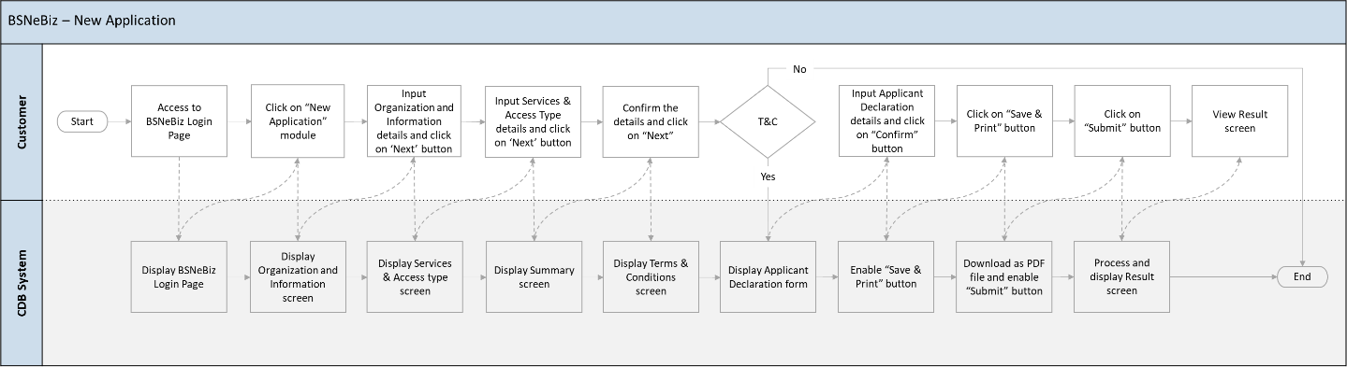

Diagram 2: New Application Process flow

New Application – Rearrange the services listing Process Flow

Diagram 3 : New Application Process Flow

New Application – To update the Contact Us Screen Process Flow

Diagram 4 : New Application Process Flow

IBAM – To add checkbox in order to facilitate the “call back” has been done Process Flow

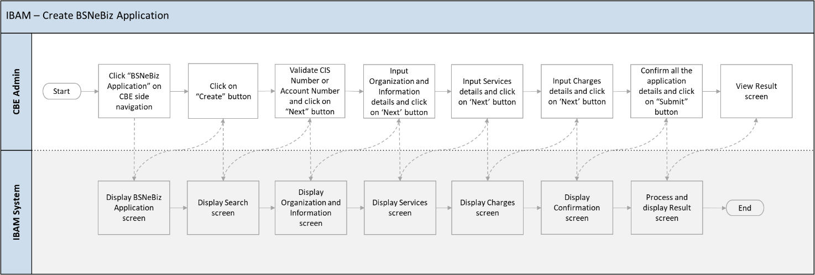

Diagram 5 : BSNeBiz Application(Create) Process Flow

This is a simplified flow diagram of load test flow scenarios representing Corporate Digital Banking Customers performing Delete Functionality to IBAM > CBE BSNeBiz Application Module and New Application process.

## Performance Test Environment

|  |  |  |
| --- | --- | --- |
| Test Region | : | SIT Environment |
| Instance Testing | : | BSNeBIZ – SIT Environment  Web : <http://58.27.45.179:8080/bsn-cdb-sit/commonLogin> |
| Apache JMeter | : | Version 5.6.2 |
| Java Version | : | JDK 1.8 |

## Test Scenario & Test Result with Explanation in Layman Terms

|  |
| --- |
| Testing Objective:  Bank would like to establish baseline (no. of concurrent users) of:   1. IBAM – Adding Delete Functionality to IBAM > CBE BSNeBiz Application Module 2. New Application – To have account number field at New Application Form 3. New Application – Rearrange the services listing 4. New Application – To update the Contact Us screen 5. IBAM – To add checkbox in order to facilitate the “call back” has been done |

|  |
| --- |
| A. IBAM – Adding Delete Functionality to IBAM > CBE BSNeBiz Application Module |
| To simulate the maximum number of requests to perform Enhancement of BSNeBIZ Application and Organization Setup with goal of:   * Error < 1%. * Criteria of throughput (second / request) & TPS for each flow:   + Login.do <5 second or >0.2 TPS     - To proceed login process   + PortalAccess <5 second or >0.2 TPS     - To proceed login process   + PotralLogin.do <5 second or >0.2 TPS     - To load the IBAM Home Page   + ApplicationFormDeleteComfirm.do <5 second or >0.2 TPS     - To load the Confirmation page   + DeleteApplicationFormResult.do <5 second or >0.2 TPS     - To load the Application Declaration form page |
| I.Perform login service for 50 concurrent users |
| -Jmeter Execution Date: 23/01/2024   * Test Criteria   + Perform transaction for 50 concurrent users for 1 loop * Summary of Testing   The performance test result has passed/ not passed the test against the benchmarks that have been set above (such as number of concurrent users, error percentage, and throughput).   * Test Result   o The JMeter result shows that the system can support 50 concurrent users to perform transactions with 0.00 % error. It takes 45 seconds to complete the transaction process for all users.   * Throughput (min/request)   The system is capable of completing a http request within 1.2 s (fastest) and 18.9 s (slowest).   * TPS (Transaction per Second)   The system is capable of performing 0.023 TPS (fastest) and 0.004 TPS (slowest).   * The reasonable ramp-up period without any error is 60 seconds for 50 users.     *Image 1: JMeter Test Result - 50 Enhancement of BSNeBIZ users application and Organization Setup* |

|  |
| --- |
| B. BSNeBiz – To Add an Account Number Field in the Online Payment Row |
| To simulate the maximum number of requests to perform Enhancememt of BSNeBIZ Application and Organization Setup with goal of:   * Error < 1%. * Criteria of throughput (second / request) & TPS for each flow:   + ibNewApplicationFormStep1.action <5 second or >0.2 TPS     - This step is to load the page of IB   + ibNewApplicationFormStep2.action <5 second or >0.2 TPS     - To load the Organization and Information form page   + ibNewApplicationFormStep3.action <5 second or >0.2 TPS     - To load the Services and Access type form page   + ibNewApplicationFormStep4.action <5 second or >0.2 TPS     - To load the Confirmation page   + ibBSN_TnC.action <5 second or >0.2 TPS     - To load the Application Declaration form page   + ibNewApplicationFormModal.action <5 second or >0.2 TPS     - To load the Registration Summary page in PDF format     - To save and download the Registration Summary page in PDF format   + RegistrationSummaryPdfDownload.action <5 second or >0.2 TPS     - To load the Result page |
| I. Perform login service for 50 concurrent users |
| -Jmeter Execution Date: 23/1/2024   * Test Criteria   + Perform transaction for 50 concurrent users for 1 loop * Summary of Testing   The performance test result has passed/ not passed the test against the benchmarks that have been set above (such as number of concurrent users, error percentage, and throughput).   * Declaration * RegistrationSummaryPdfDownload.action caused error because of the interceptor token cannot capture and modify the HTTP request and responses. As token only allow one click per action, token interceptor cannot be applied at RegistrationSummaryPdfDownload.action while Save and Download button can be click multiple time per action. * Therefore, RegistrationSummaryPdfDownload.action have error in test result. * Test Result   o The JMeter result shows that the system can support 50 concurrent users to perform transactions with 12.50% error. It takes 181 seconds to complete the transaction process for all users.   * Throughput (min/request)   The system is capable of completing a http request within 2.2 s (fastest) and 36.6 s (slowest).   * TPS (Transaction per Second)   The system is capable of performing 0.454 TPS (fastest) and 0.027 TPS (slowest).   * The reasonable ramp-up period without any error is 60 seconds for 50 users.     *Image 2: JMeter Test Result - 50 Enhancement of BSNeBIZ users application and Organization Setup* |

|  |
| --- |
| C. BSNeBiz – Rearrange the Service Listings |
| To simulate the maximum number of requests to perform Enhancement of BSNeBIZ Application and Organization Setup with goal of:   * Error < 1%. * Criteria of throughput (second / request) & TPS for each flow:   + ibNewApplicationFormStep1.action <5 second or >0.2 TPS     - This step is to load the page of IB   + ibNewApplicationFormStep2.action <5 second or >0.2 TPS     - To load the Organization and Information form page   + ibNewApplicationFormStep3.action <5 second or >0.2 TPS     - To load the Services and Access type form page   + ibNewApplicationFormStep4.action <5 second or >0.2 TPS     - To load the Confirmation page   + BSN_TnC.pdf <5 second or >0.2 TPS     - To load the Application Declaration form page   + ibNewApplicationFormModal.action <5 second or >0.2 TPS     - To load the Registration Summary page in PDF format     - To save and download the Registration Summary page in PDF format   + RegistrationSummaryPdfDownload.action <5 second or >0.2 TPS     - To load the Result page |
| I. Perform login service for 50 concurrent users |
| -Jmeter Execution Date: 23/01/2024   * Test Criteria   + Perform transaction for 50 concurrent users for 1 loop * Summary of Testing   The performance test result has passed/ not passed the test against the benchmarks that have been set above (such as number of concurrent users, error percentage, and throughput).   * Declaration * RegistrationSummaryPdfDownload.action caused error because of the interceptor token cannot capture and modify the HTTP request and responses. As token only allow one click per action, token interceptor cannot be applied at RegistrationSummaryPdfDownload.action while Save and Download button can be click multiple time per action. * Therefore, RegistrationSummaryPdfDownload.action have error in test result. * Test Result   o The JMeter result shows that the system can support 50 concurrent users to perform transactions with 12.50% error. It takes 60 seconds to complete the transaction process for all users.   * Throughput (min/request)   The system is capable of completing a http request within 4.9 s (fastest) and 36.5 s (slowest).   * TPS (Transaction per Second)   The system is capable of performing 0.345 TPS (fastest) and 0.101 TPS (slowest).   * The reasonable ramp-up period without any error is 60 seconds for 50 users.     *Image 3: JMeter Test Result - 50 Enhancement of BSNeBIZ users application and Organization Setup* |

|  |
| --- |
| D. BSNeBiz – To Update the Contact Us Screen |
| To simulate the maximum number of requests to perform Enhancement of BSNeBIZ Application and Organization Setup with goal of:   * Error < 1%. * Criteria of throughput (second / request) & TPS for each flow:   + ibNewApplicationFormStep1.action <5 second or >0.2 TPS     - This step is to load the page of IB   + ibNewApplicationFormStep2.action <5 second or >0.2 TPS     - To load the Organization and Information form page   + ibNewApplicationFormStep3.action <5 second or >0.2 TPS     - To load the Services and Access type form page   + ibNewApplicationFormStep4.action <5 second or >0.2 TPS     - To load the Confirmation page   + BSN_TnC.pdf <5 second or >0.2 TPS     - To load the Application Declaration form page   + ibNewApplicationFormModal.action<5 second or >0.2 TPS     - To load the Registration Summary page in PDF format     - To save and download the Registration Summary page in PDF format   + RegistrationSummaryPdfDownload.action <5 second or >0.2 TPS     - To load the Result page   + ibNewApplicationFormStep5.action<5 second or >0.2 TPS     - To load the Registration Summary page in PDF format     - To save and download the Registration Summary page in PDF format |
| I. Perform login service for 50 concurrent users |
| -Jmeter Execution Date: 23/01/2024   * Test Criteria   + Perform transaction for 50 concurrent users for 1 loop * Summary of Testing   The performance test result has passed/ not passed the test against the benchmarks that have been set above (such as number of concurrent users, error percentage, and throughput).   * Declaration * RegistrationSummaryPdfDownload.action caused error because of the interceptor token cannot capture and modify the HTTP request and responses. As token only allow one click per action, token interceptor cannot be applied at RegistrationSummaryPdfDownload.action while Save and Download button can be click multiple time per action. * Therefore, RegistrationSummaryPdfDownload.action have error in test result. * Test Result   o The JMeter result shows that the system can support 50 concurrent users to perform transactions with 11.11% error. It takes 60 seconds to complete the transaction process for all users.   * Throughput (min/request)   The system is capable of completing a http request within 49.8 s (fastest) and 50.9 s (slowest).   * TPS (Transaction per Second)   The system is capable of performing 0.4 TPS (fastest) and 0.025 TPS (slowest).   * The reasonable ramp-up period without any error is 60 seconds for 50 users.     *Image 4: JMeter Test Result - 50 Enhancement of BSNeBIZ users application and Organization Setup* |

|  |
| --- |
| E. IBAM – To Add Checkbox in Order to Facilitate the “Call Back” has Been Done |
| To simulate the maximum number of requests to perform Enhancement of BSNeBIZ Application and Organization Setup with goal of:   * Error < 1%. * Criteria of throughput (second / request) & TPS for each flow:   + ibPotralAccess.do <5 second or >0.2 TPS     - This step is to load the page of IB   + ibPortalLogin.do <5 second or >0.2 TPS     - To load the IBAM Home Page   + applicationFormSearch.do <5 second or >0.2 TPS     - To load the Services and Access type form page   + applicationFormCreate.do <5 second or >0.2 TPS     - To load the Application page   + applicationFormCreateStep2.do <5 second or >0.2 TPS     - To load the Application page Bypage   + applicationFormCreateStep3.do <5 second or >0.2 TPS     - To load the Application Organization Detail form page   + applicationFormCreateStep4.do <5 second or >0.2 TPS     - To load the Services page   + applicationFormCreateStep5.do <5 second or >0.2 TPS     - To load the Services page   + applicationFormCreateStep6.do <5 second or >0.2 TPS     - To load the Charges page   + applicationFormCreateStep7.do <5 second or >0.2 TPS     - To load the Charges page   + applicationFormCreateStep8.do <5 second or >0.2 TPS     - To load the Comfirmation page   + applicationFormCreateStep9.do <5 second or >0.2 TPS     - To load the Result page |
| I.Perform login service for 50 concurrent users |
| -Jmeter Execution Date:23/01/2024   * Test Criteria   + Perform transaction for 50 concurrent users for 1 loop * Summary of Testing   The performance test result has passed/ not passed the test against the benchmarks that have been set above (such as number of concurrent users, error percentage, and throughput).   * Test Result   o The JMeter result shows that the system can support 50 concurrent users to perform transactions with 0.00% error. It takes 60 seconds to complete the transaction process for all users.   * Throughput (min/request)   The system is capable of completing a http request within 17.5 s (fastest) and 2.3 s (slowest).   * TPS (Transaction per Second)   The system is capable of performing 0.5 TPS (fastest) and 0.057 TPS (slowest).   * The reasonable ramp-up period without any error is 60 seconds for 50 users.     *Image 5: JMeter Test Result - 50 Enhancement of BSNeBIZ users application and Organization Setup* |