SCPID#6950
Test Title: |  | si enquiry duitnow bug
Test Description: |  | Finding: Duitnow services are not included in SI Enquiry  Solution: Add duitnow services in SI Enquiry.
Test Functionality: |  | To test on SI Stop, Start and Update function in SI Enquiry module for DuitNow.
Test Procedure: |  | Test steps:  - Make DuitNow Transaction – Recurring/Pay Later  - Access to BSNeBiz>SI Enquiry  - Update, Stop or Start selected SI DuitNow transaction.  - Expected result, successful.  - Comfort test using single user and workflow.
Response Message:
Test Result: | Pass: Fail: |  | Tested by: | Nor Athirah Umairah (22/02/2024-29/02/2024)
Reason for Failure:
Remarks: |  | Scenario 1: Single User (Update)  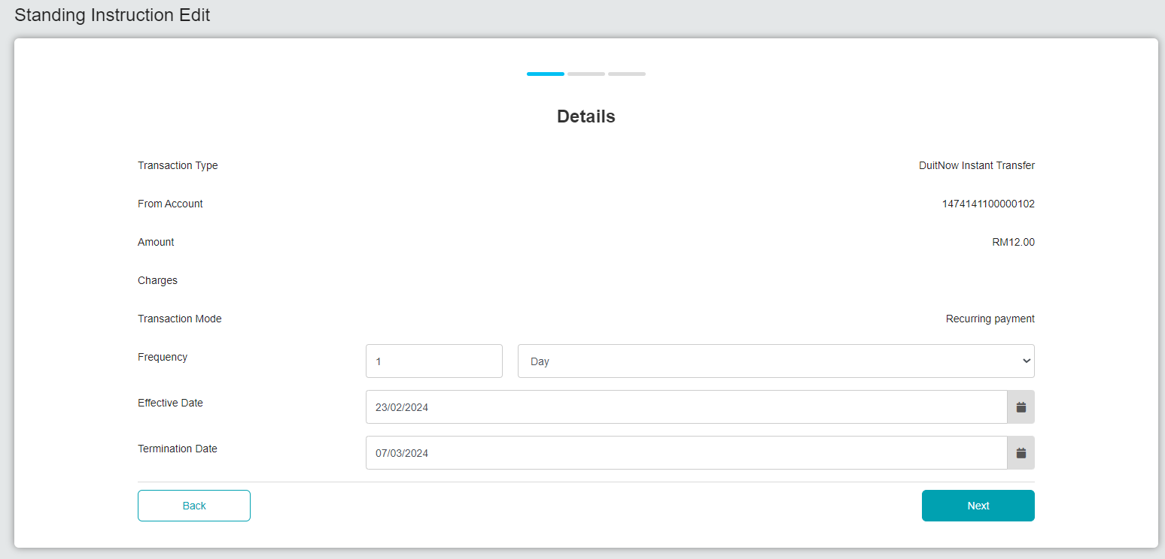  Figure 1: SI Enquiry – Edit (Details)  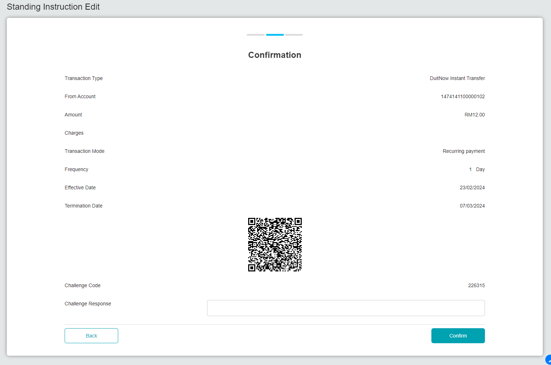  Figure 2: SI Enquiry – Edit (Confirmation)  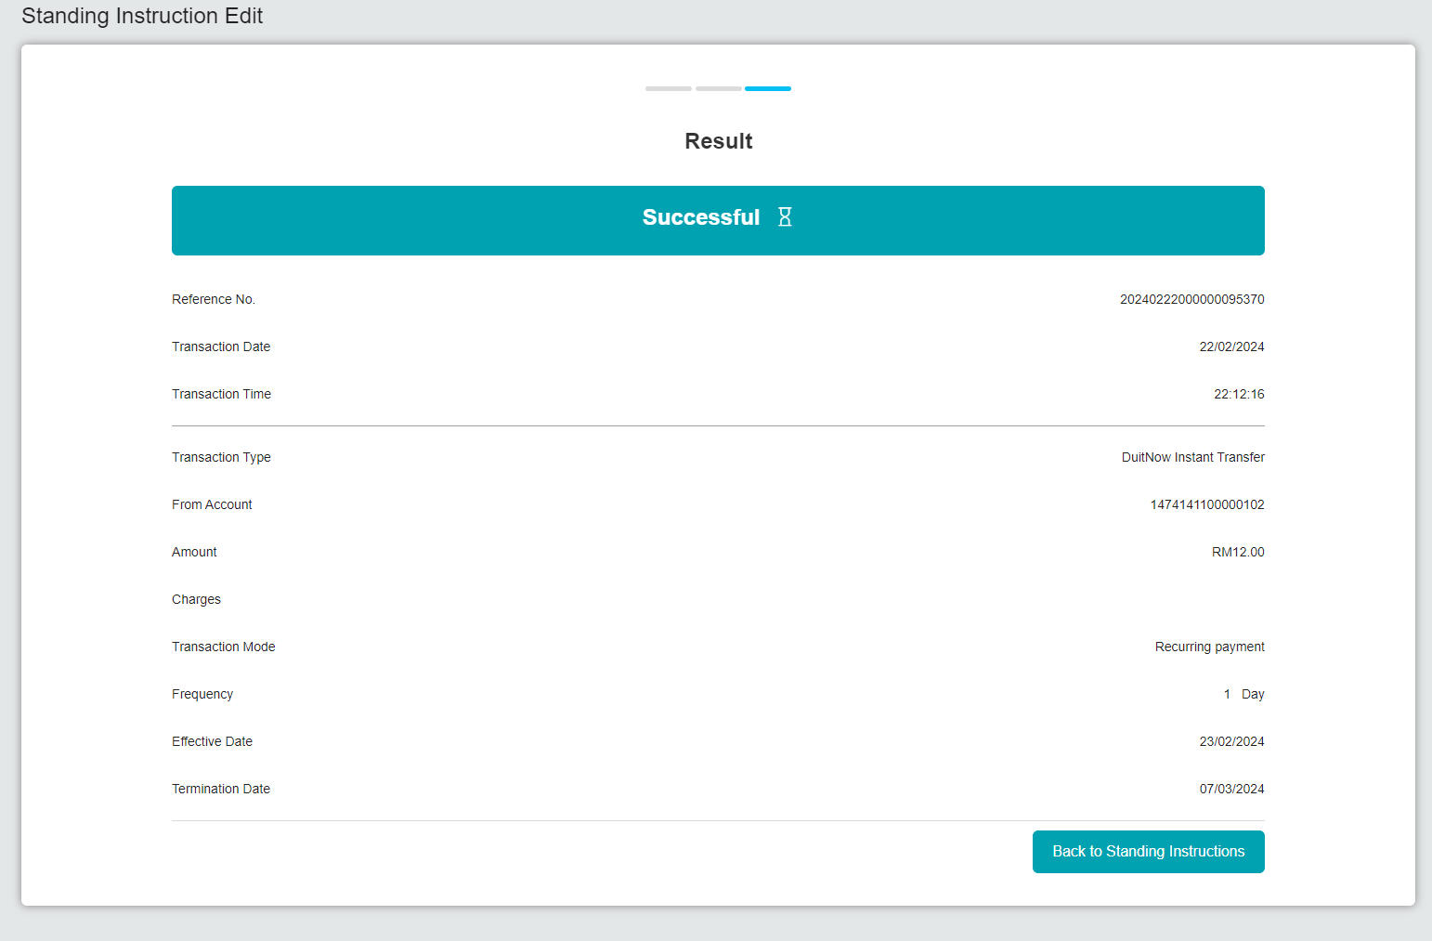  Figure 3: SI Enquiry – Edit (Result)  Scenario 2: Single User (Stop)  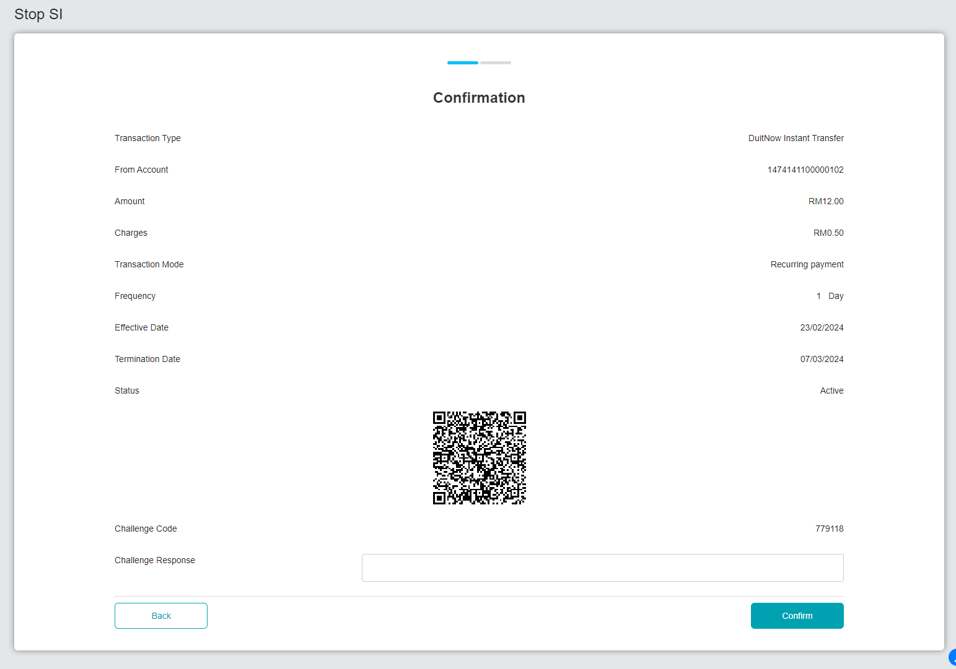  Figure 4: SI Enquiry – Stop (Confirmation)  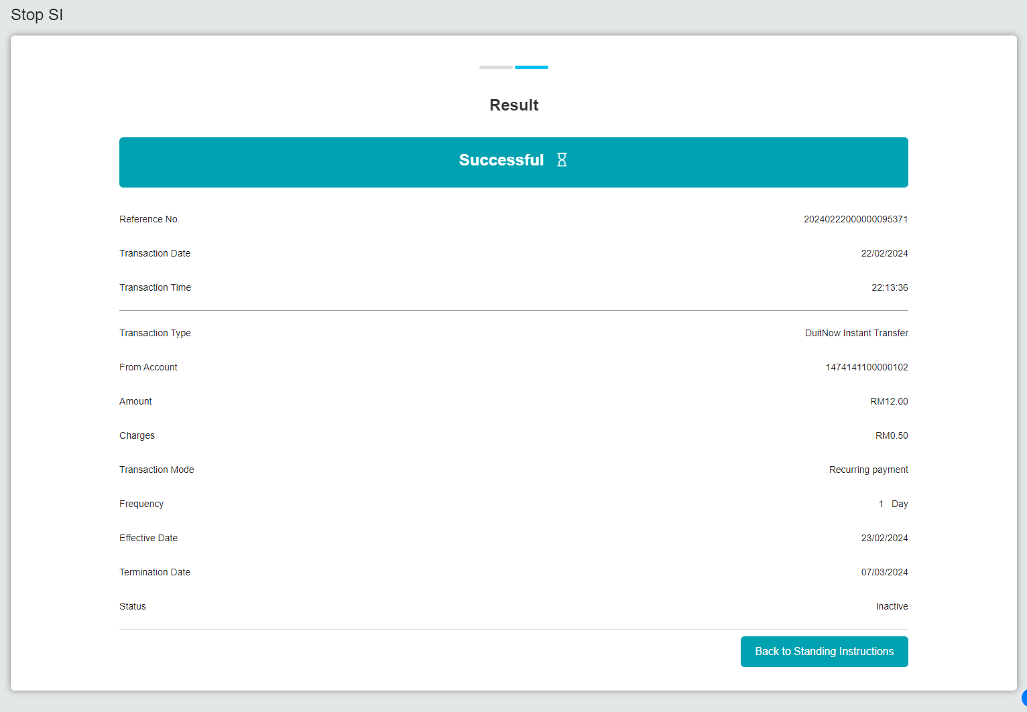  Figure 5: SI Enquiry – Stop (Result)  Scenario 3: Single User (Start)  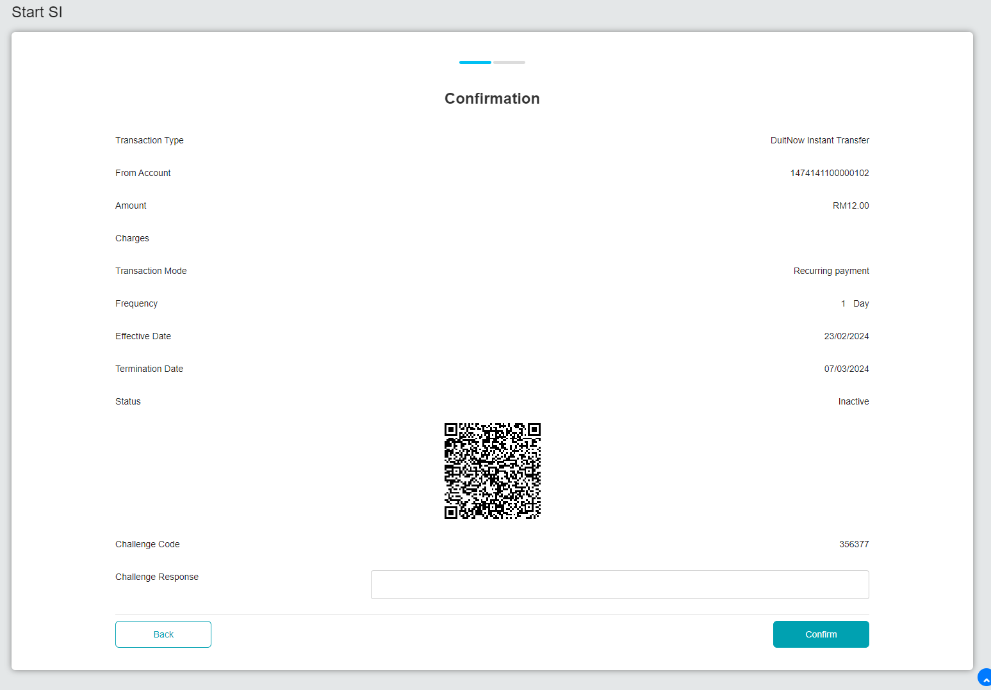  Figure 6: SI Enquiry – Start (Confirmation)  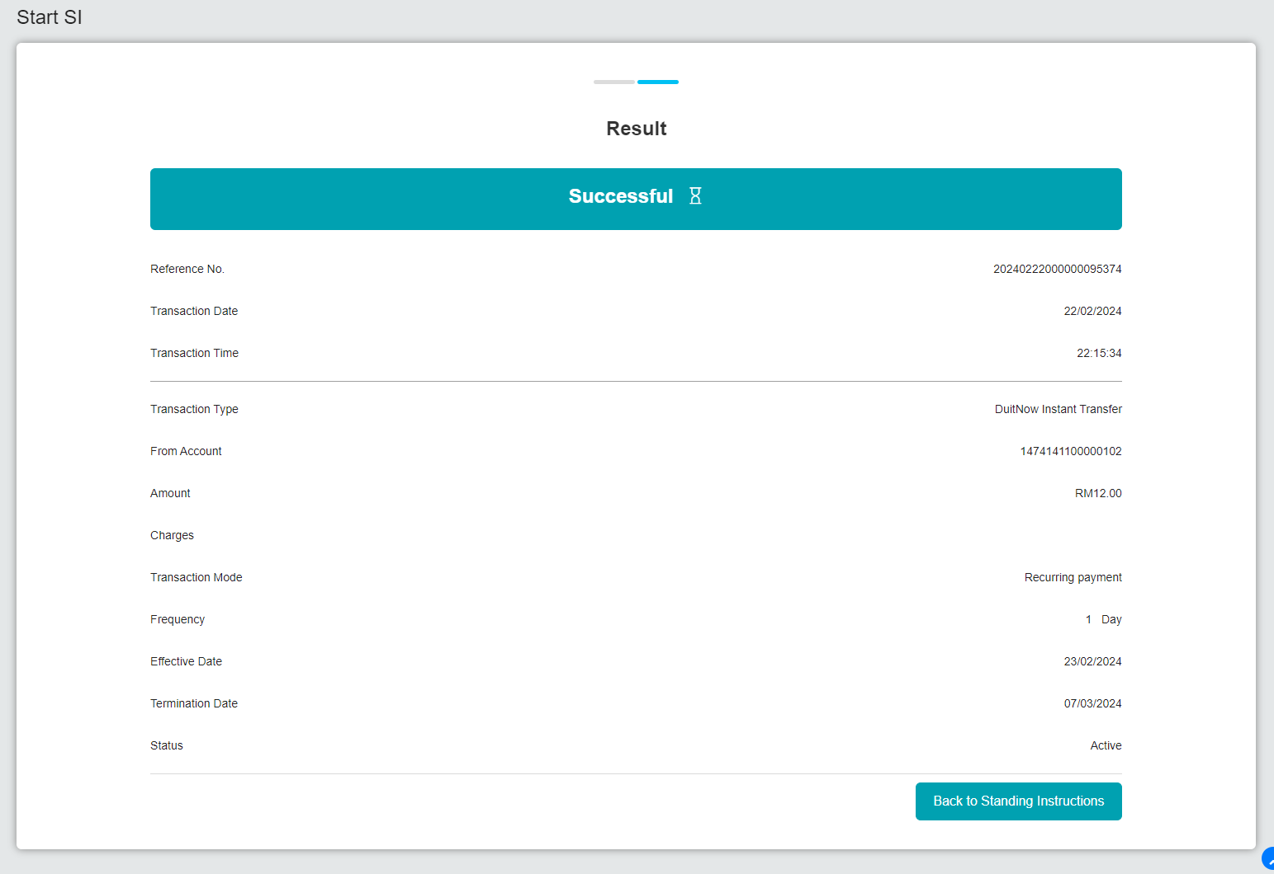  Figure 7: SI Enquiry – Start (Result)  Figure 8: IBAM – BSNeBizTransaction Enquiry  Scenario 4: Workflow (Start)  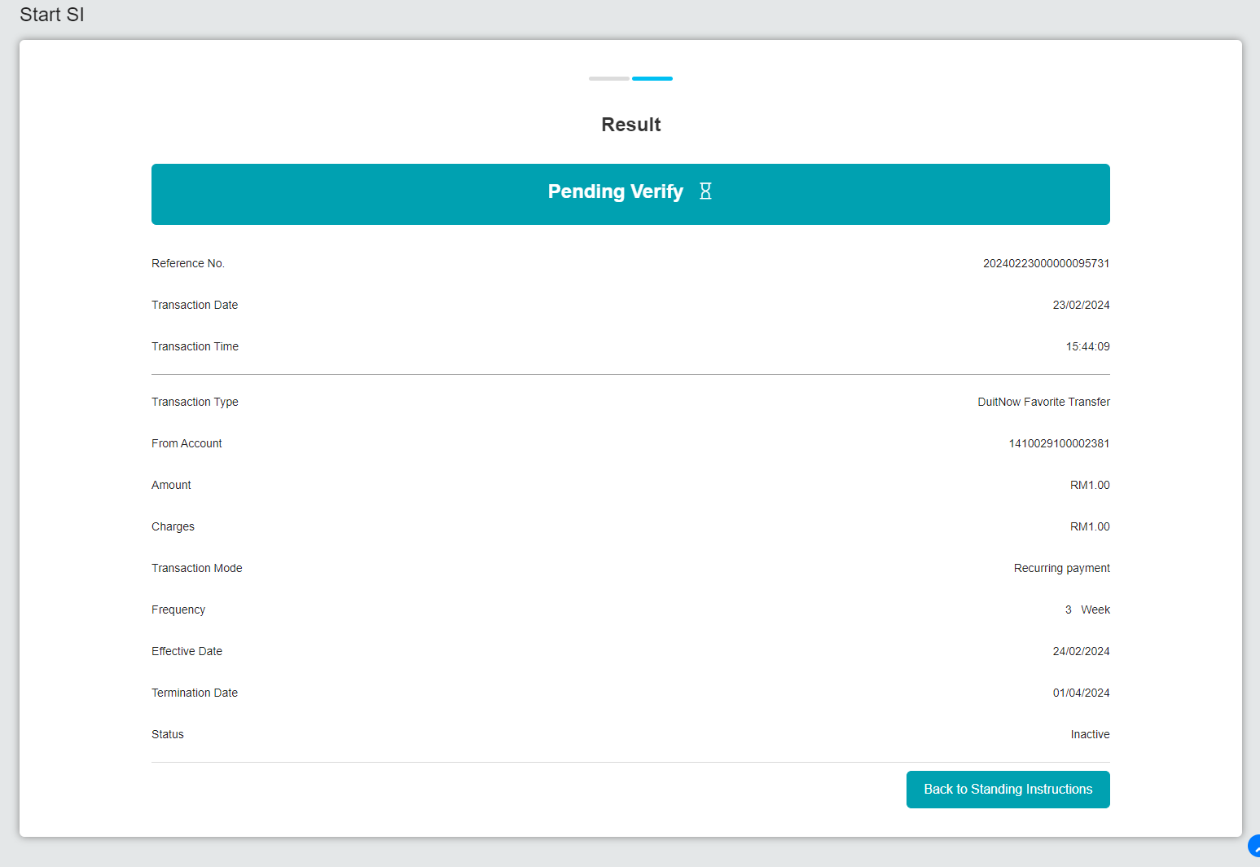  Figure 9: SI Enquiry – Start (Initiator)  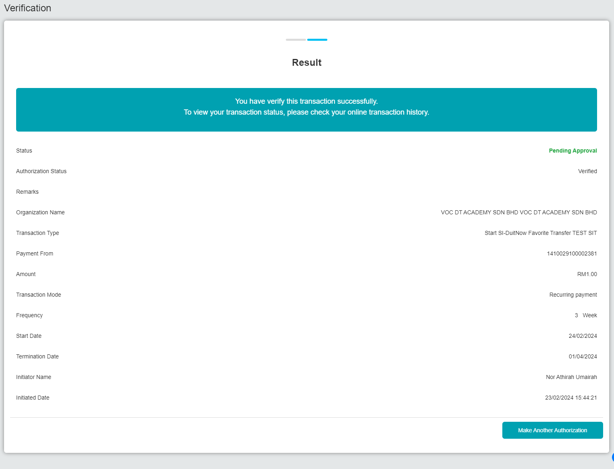  Figure 10: SI Enquiry – Start (Verifier)  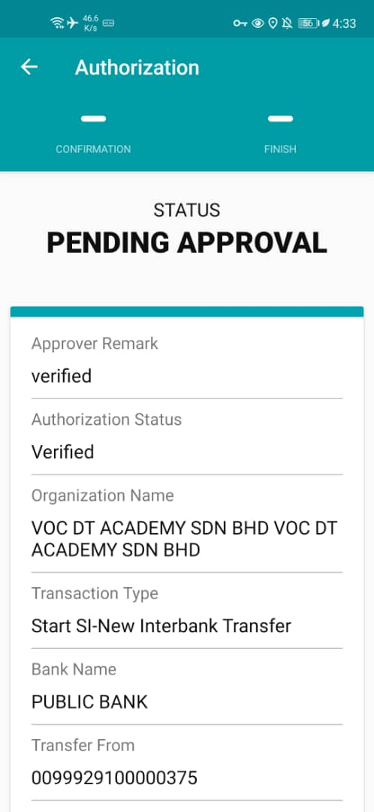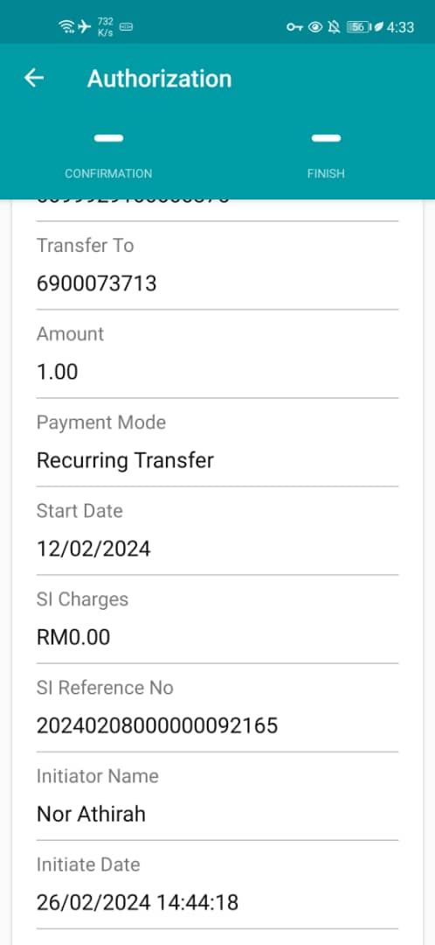  Figure 11: SI Enquiry – Start (Verifier-Android)  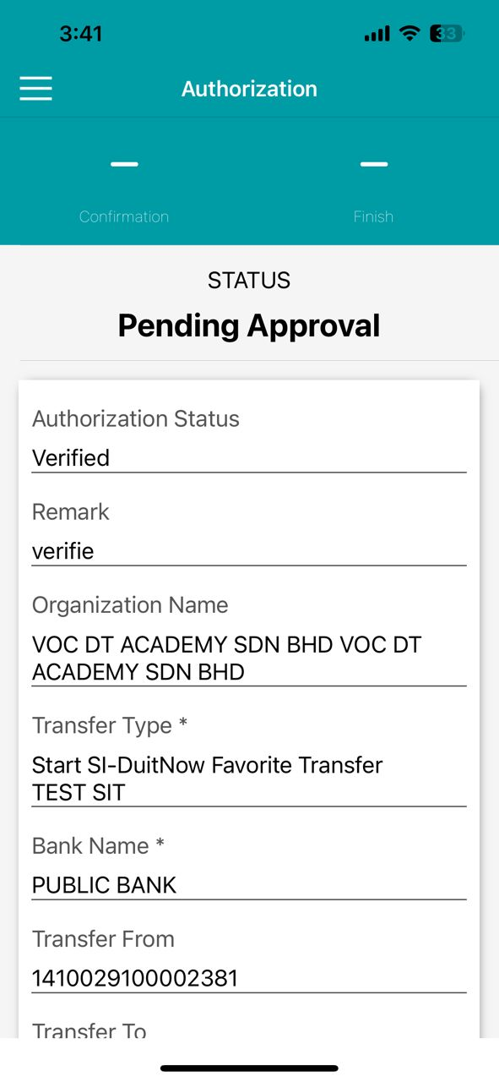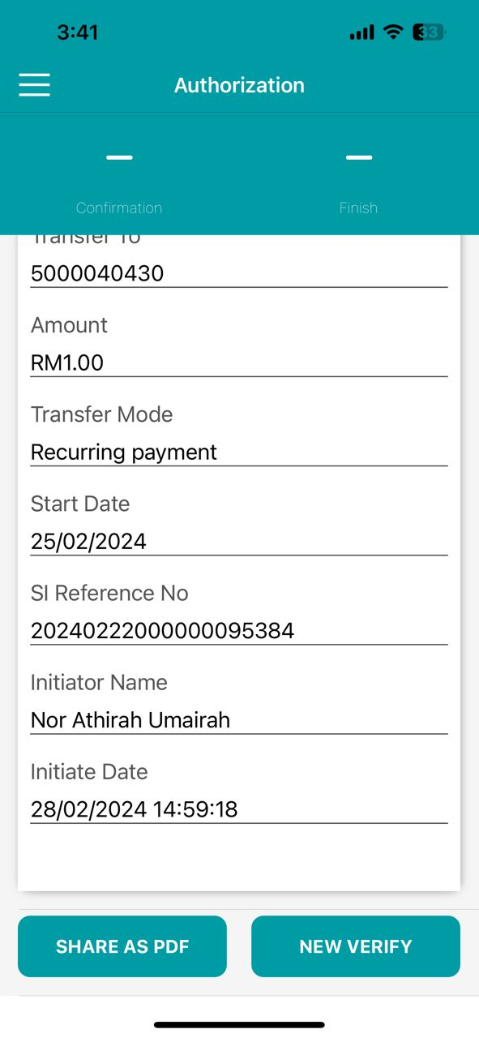  Figure 12: SI Enquiry – Start (Verifier-iOS)  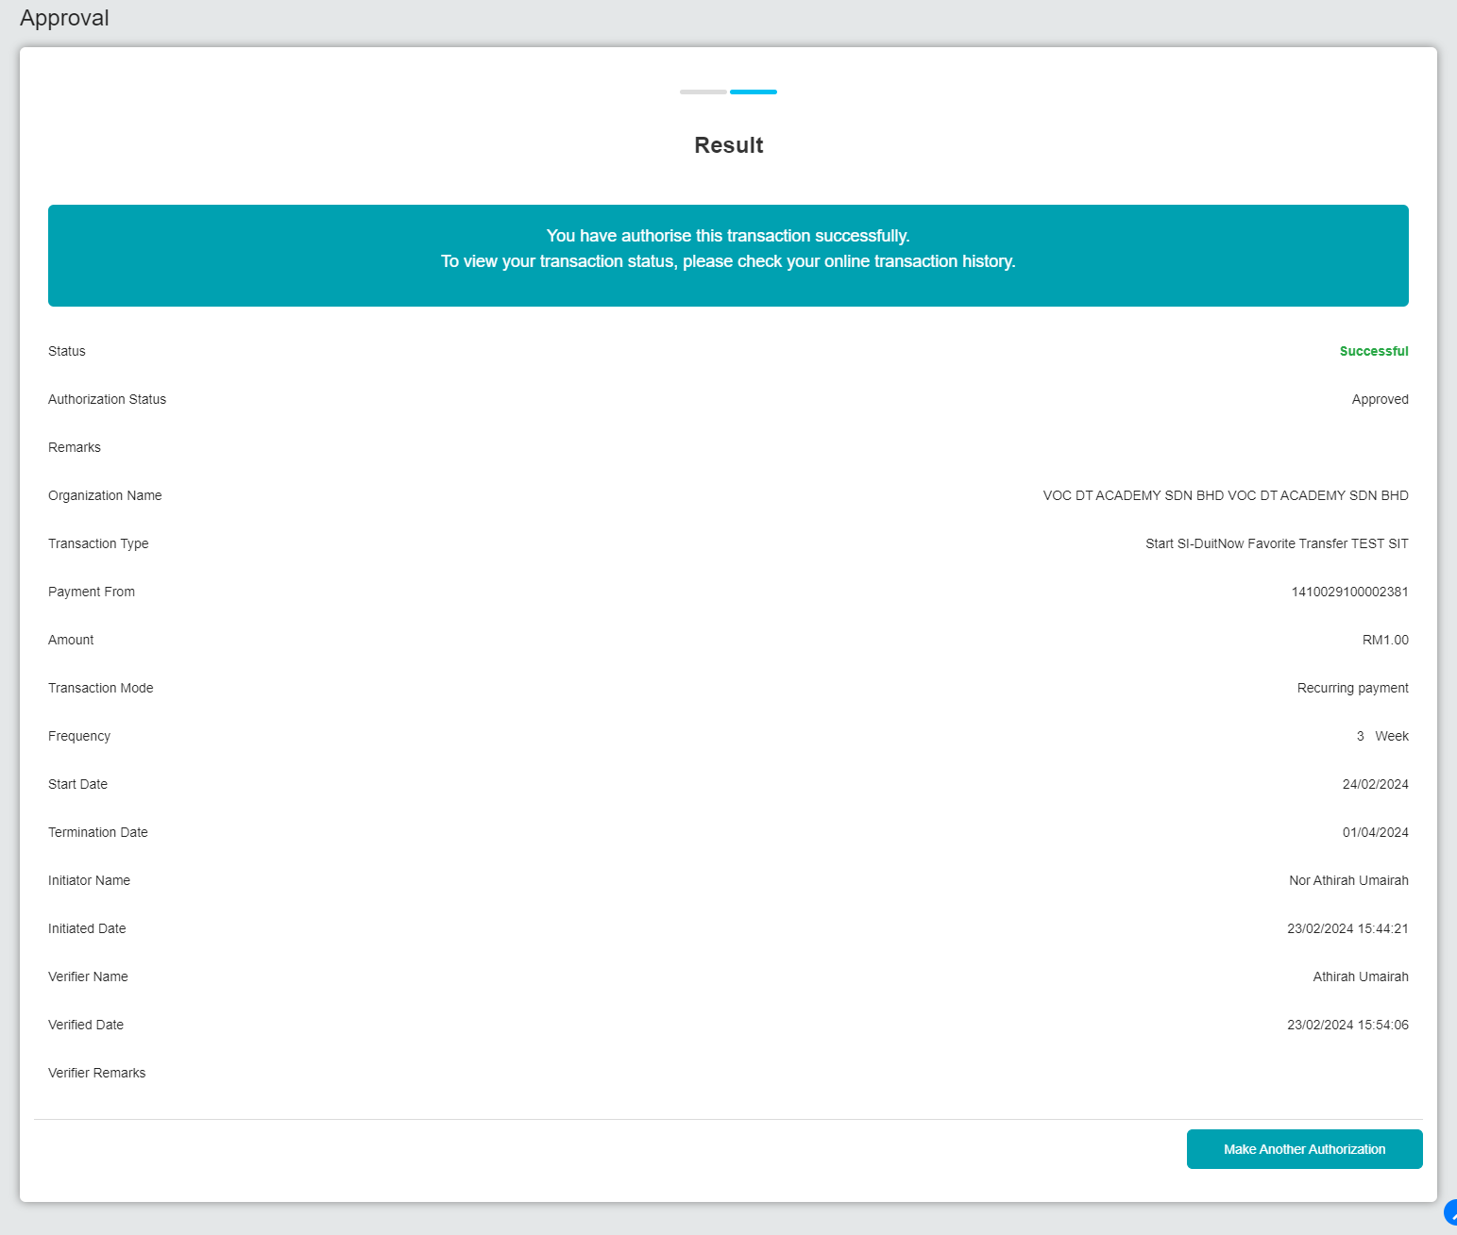  Figure 13: SI Enquiry – Start (Approver)  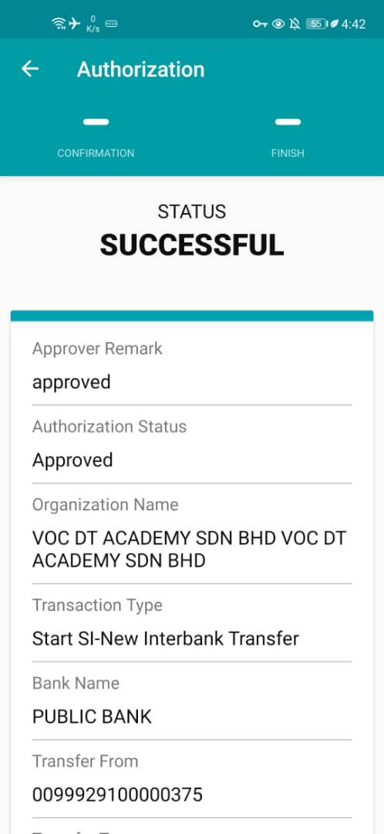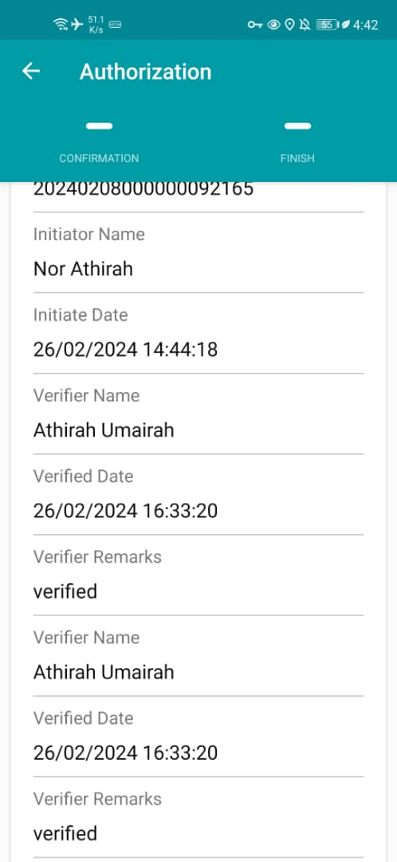  Figure 14: SI Enquiry – Start (Approver-Android)  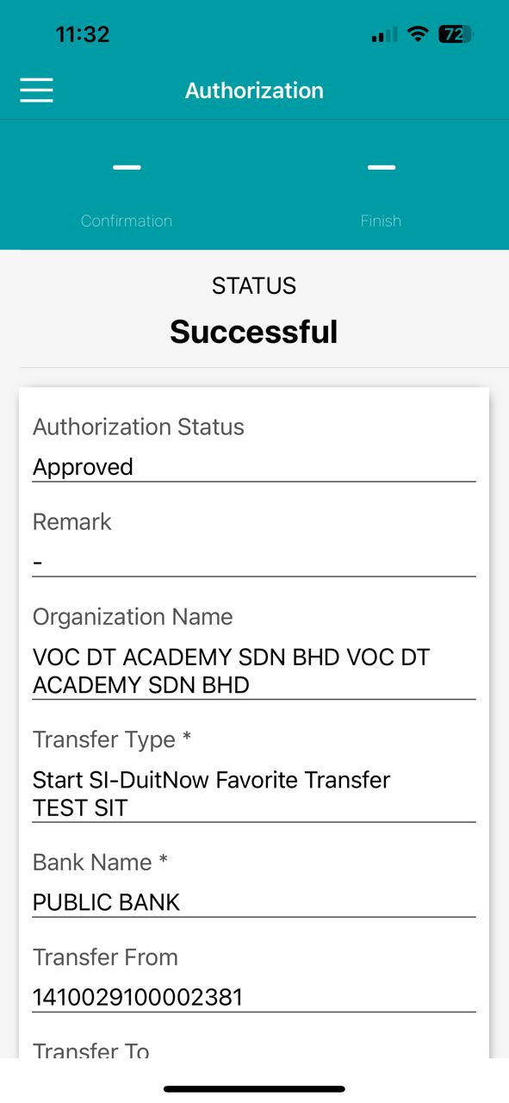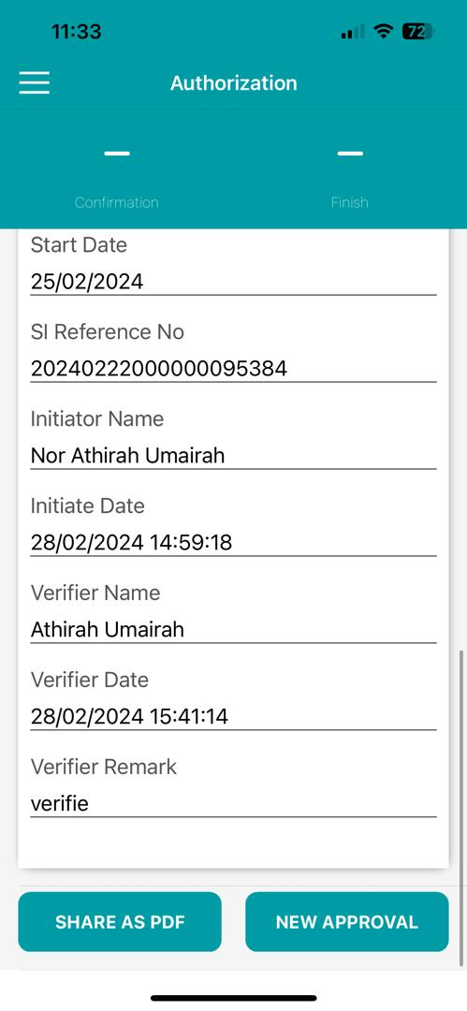  Figure 15: SI Enquiry – Start (Approver-iOS)  Scenario 5: Workflow (Stop)  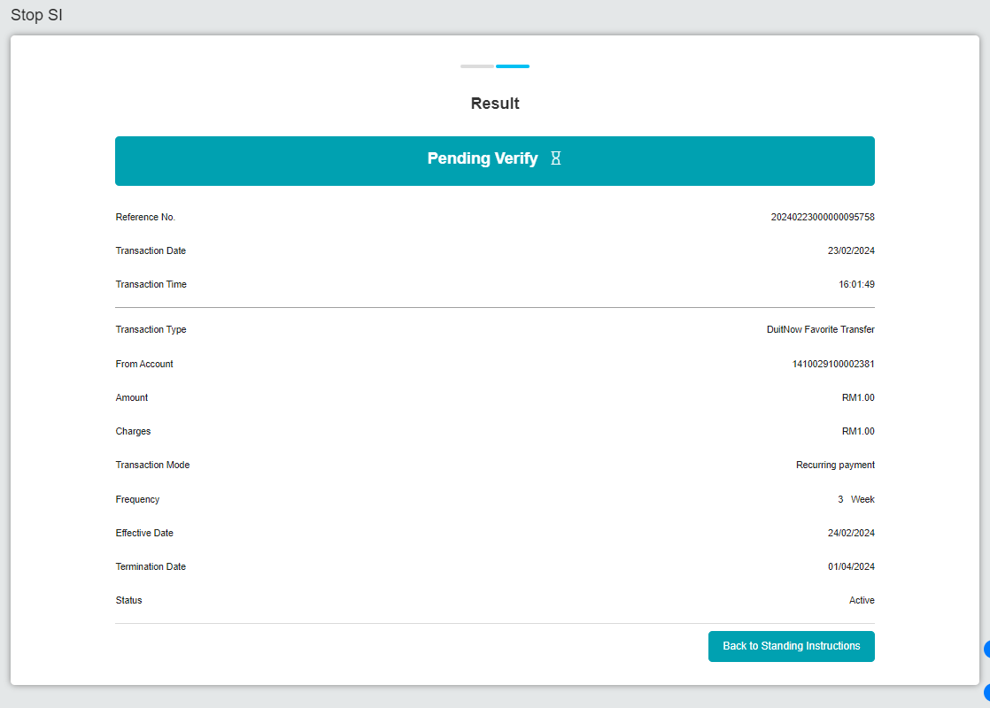  Figure 16: SI Enquiry – Stop (Initiator)  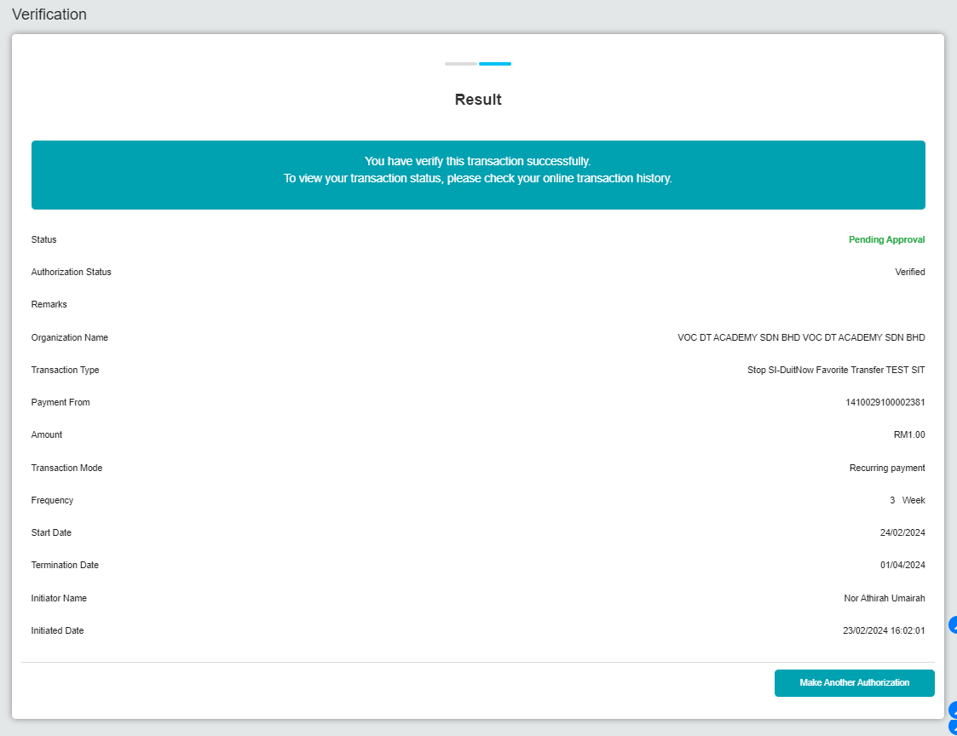  Figure 17: SI Enquiry – Stop (Verifier)  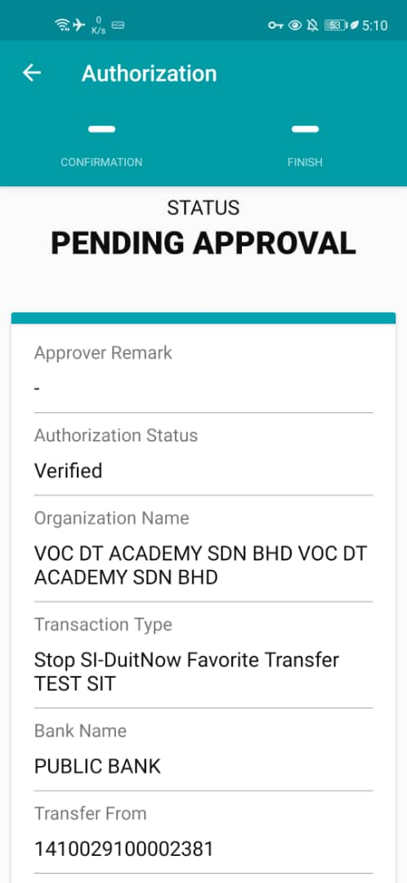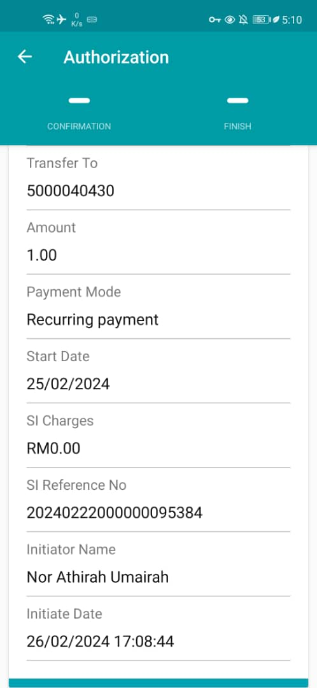  Figure 18: SI Enquiry – Stop (Verifier-Android)  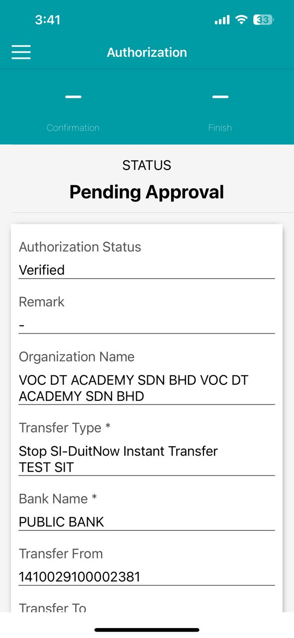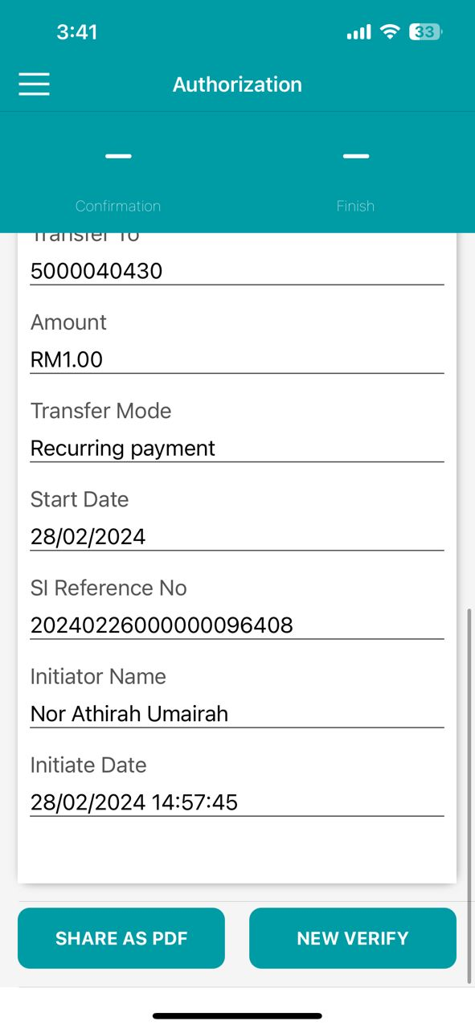  Figure 19: SI Enquiry – Stop (Verifier-iOS)  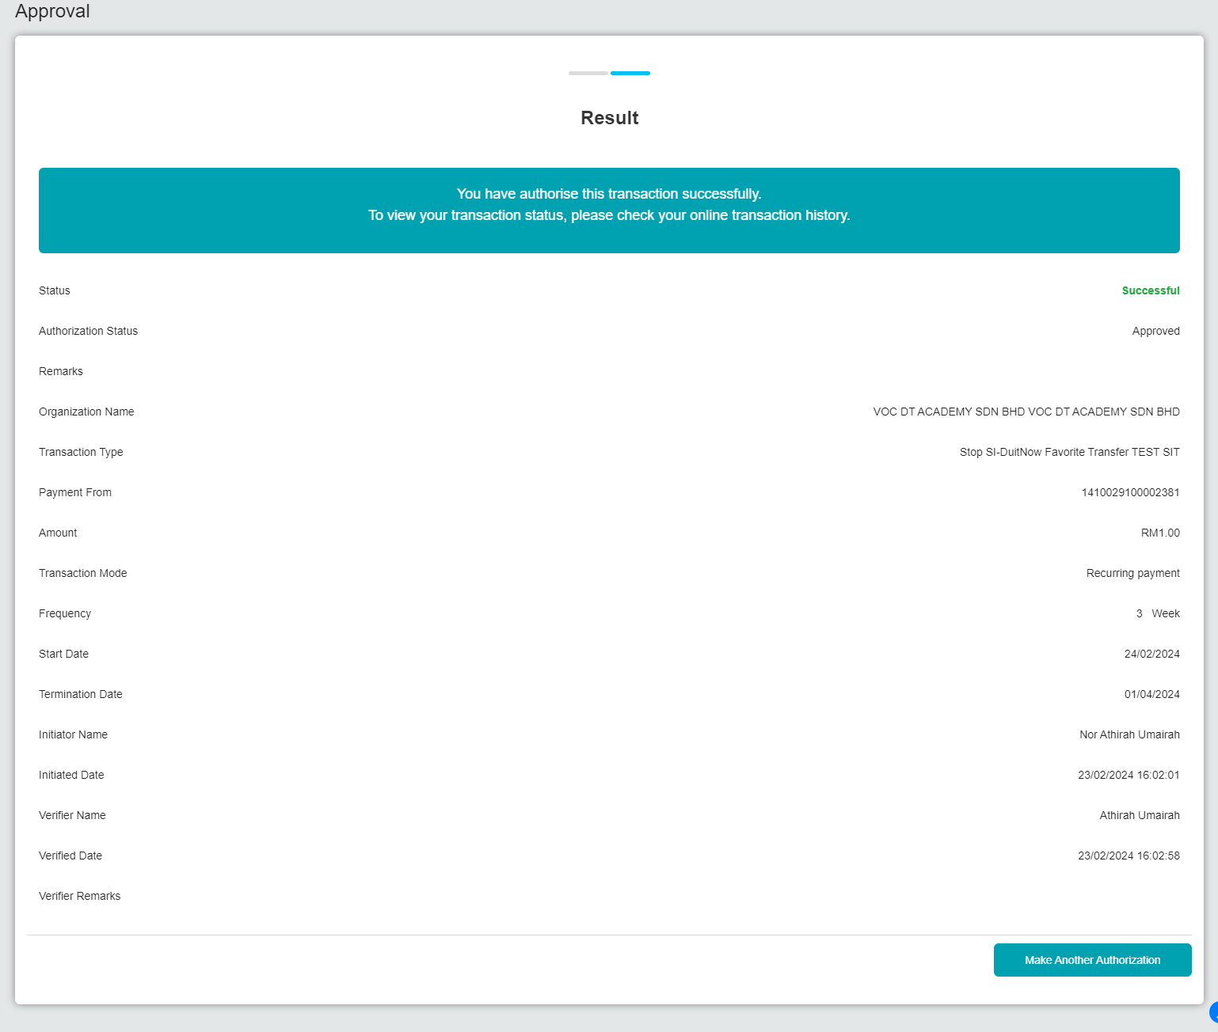  Figure 20: SI Enquiry – Stop (Approver)  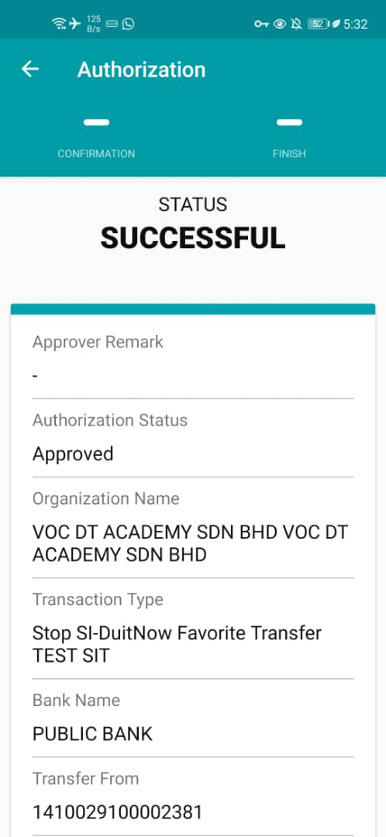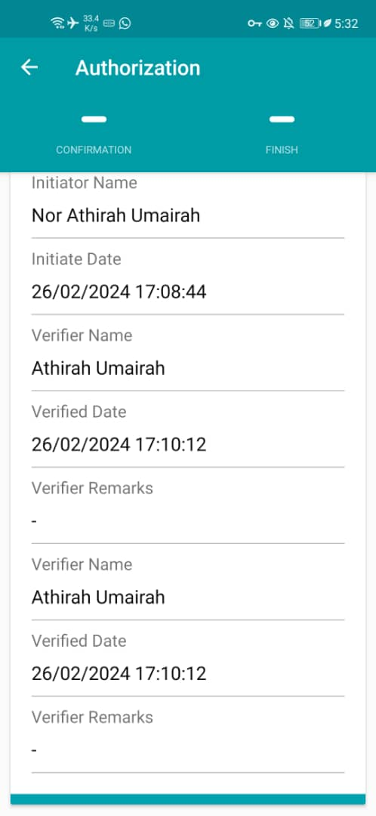  Figure 21: SI Enquiry – Stop (Approver-Android)  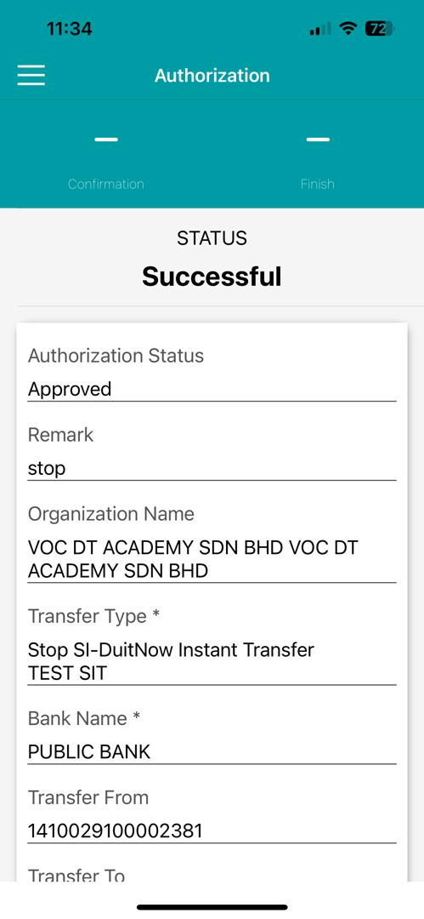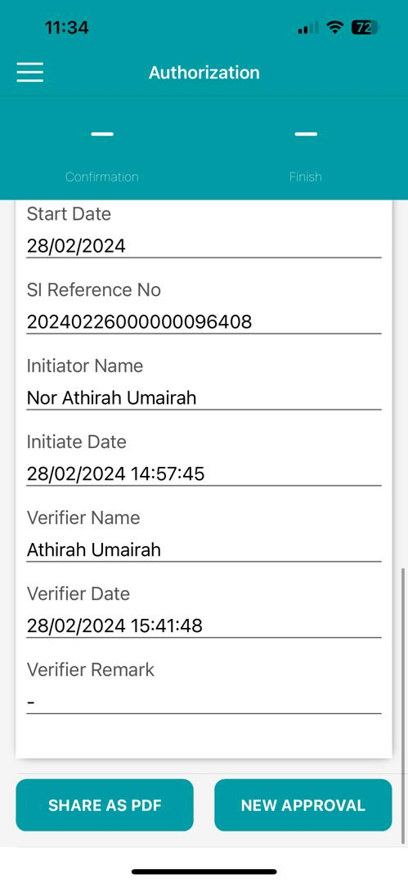  Figure 22: SI Enquiry – Stop (Approver-iOS)  Scenario 6: Workflow (Update)  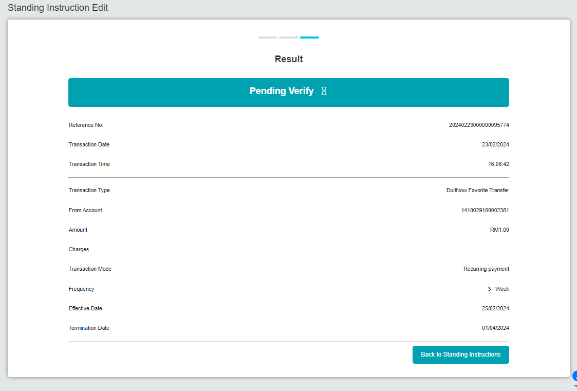  Figure 23: SI Enquiry – Update (Initiator)  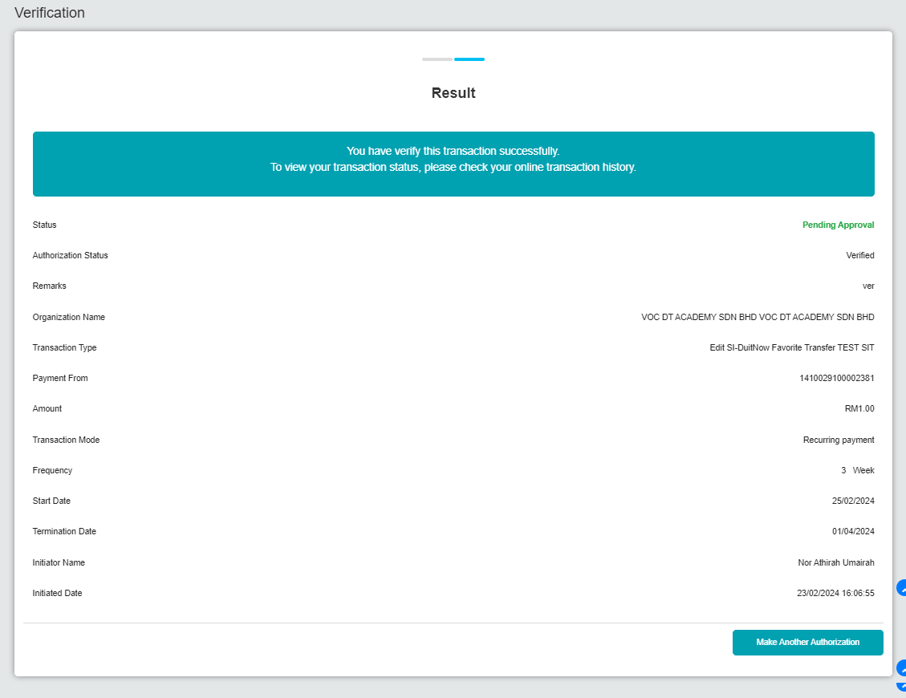  Figure 24: SI Enquiry – Update (Verifier)  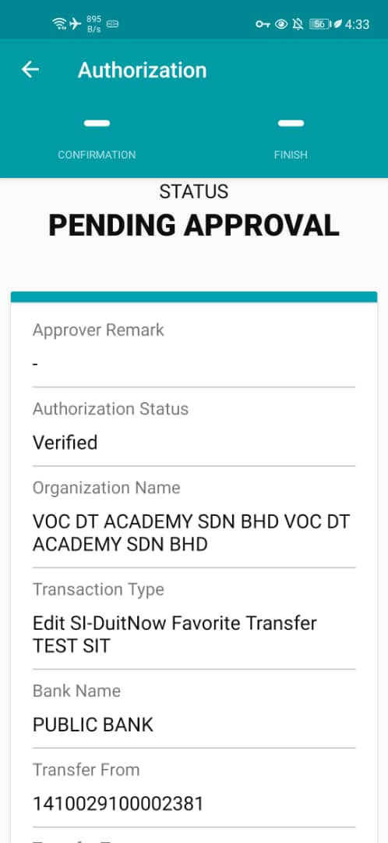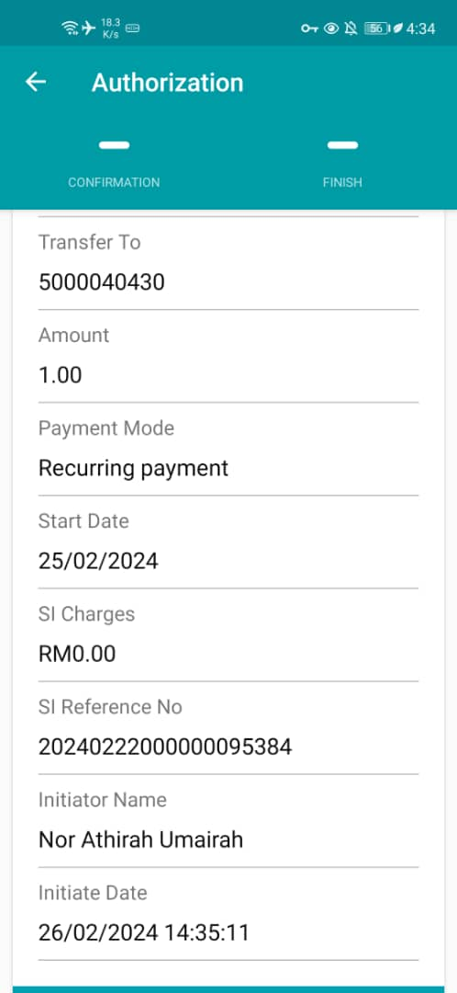  Figure 25: SI Enquiry – Update (Verifier-Android)  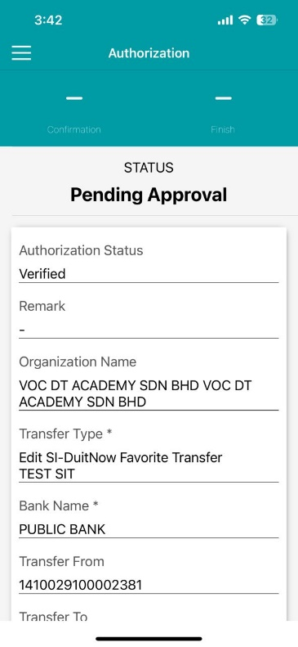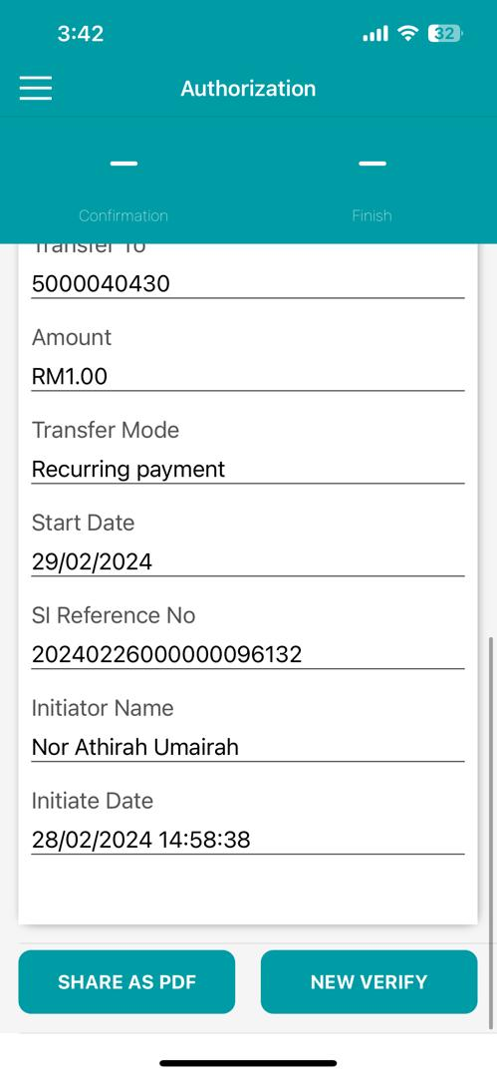  Figure 26: SI Enquiry – Update (Verifier-iOS)  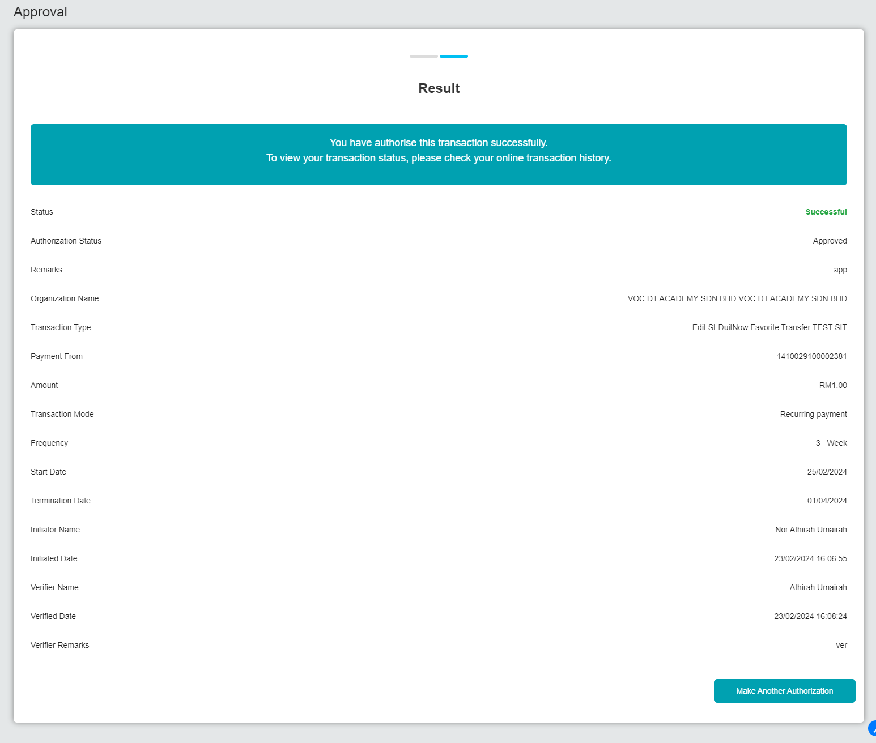  Figure 27: SI Enquiry – Update (Approver)  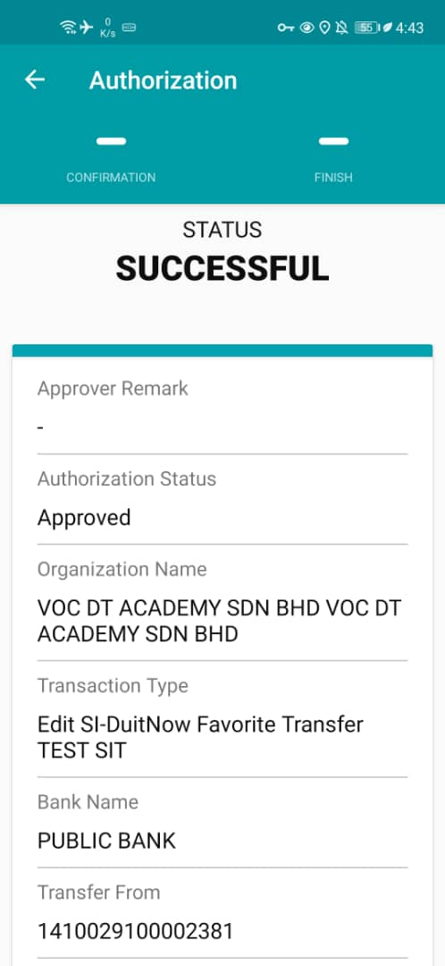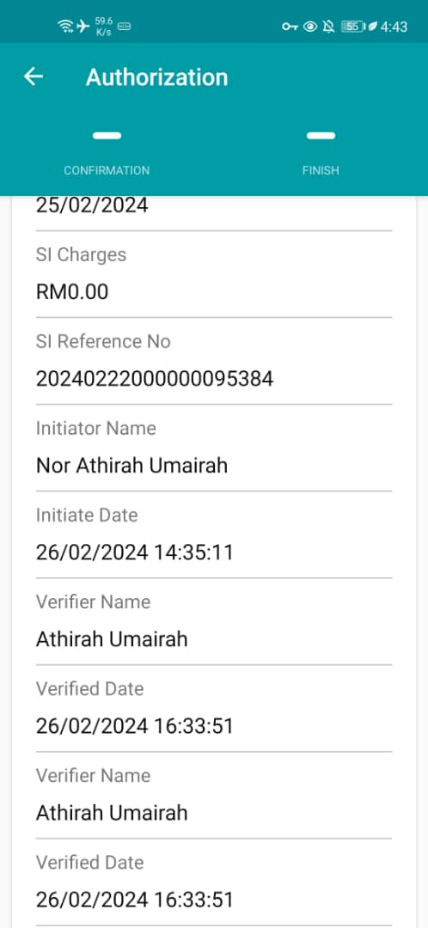  Figure 28: SI Enquiry – Update (Approver-Android)  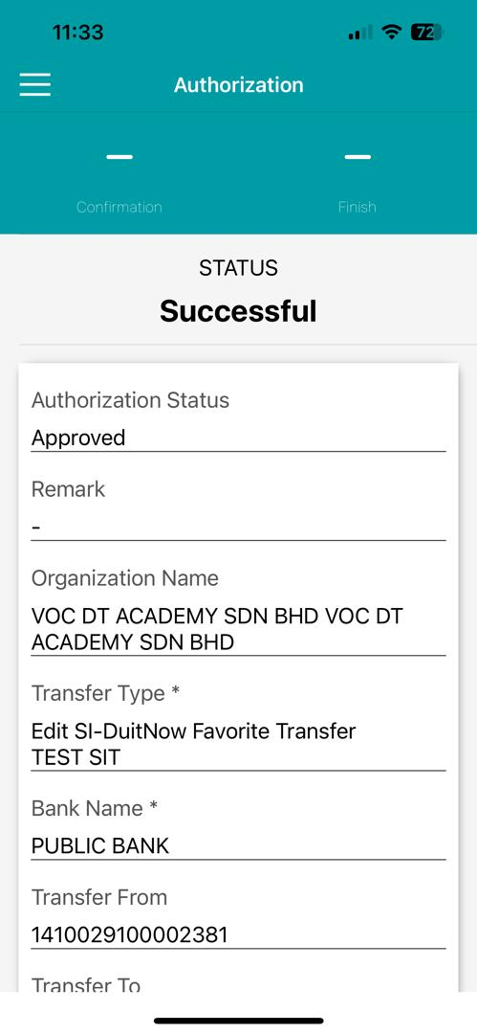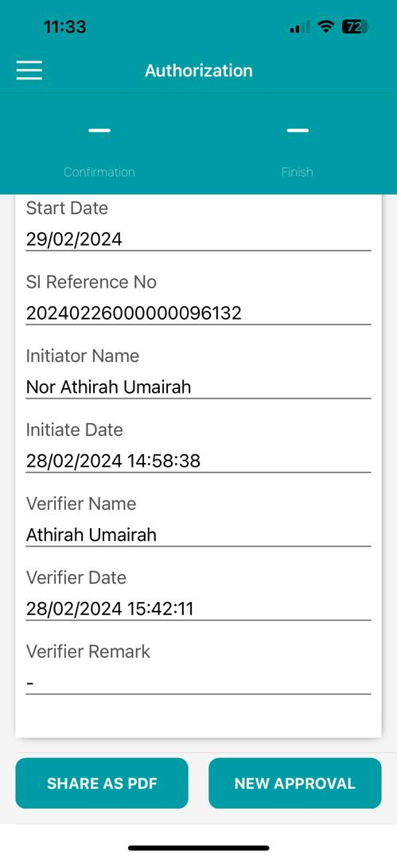  Figure 29: SI Enquiry – Update (Approver-iOS)

